Additional file 6. Hyperinflation at PEEP 15 cmH₂O on CT as a function of classification status with the R/I ratio regarding lung recruitability.

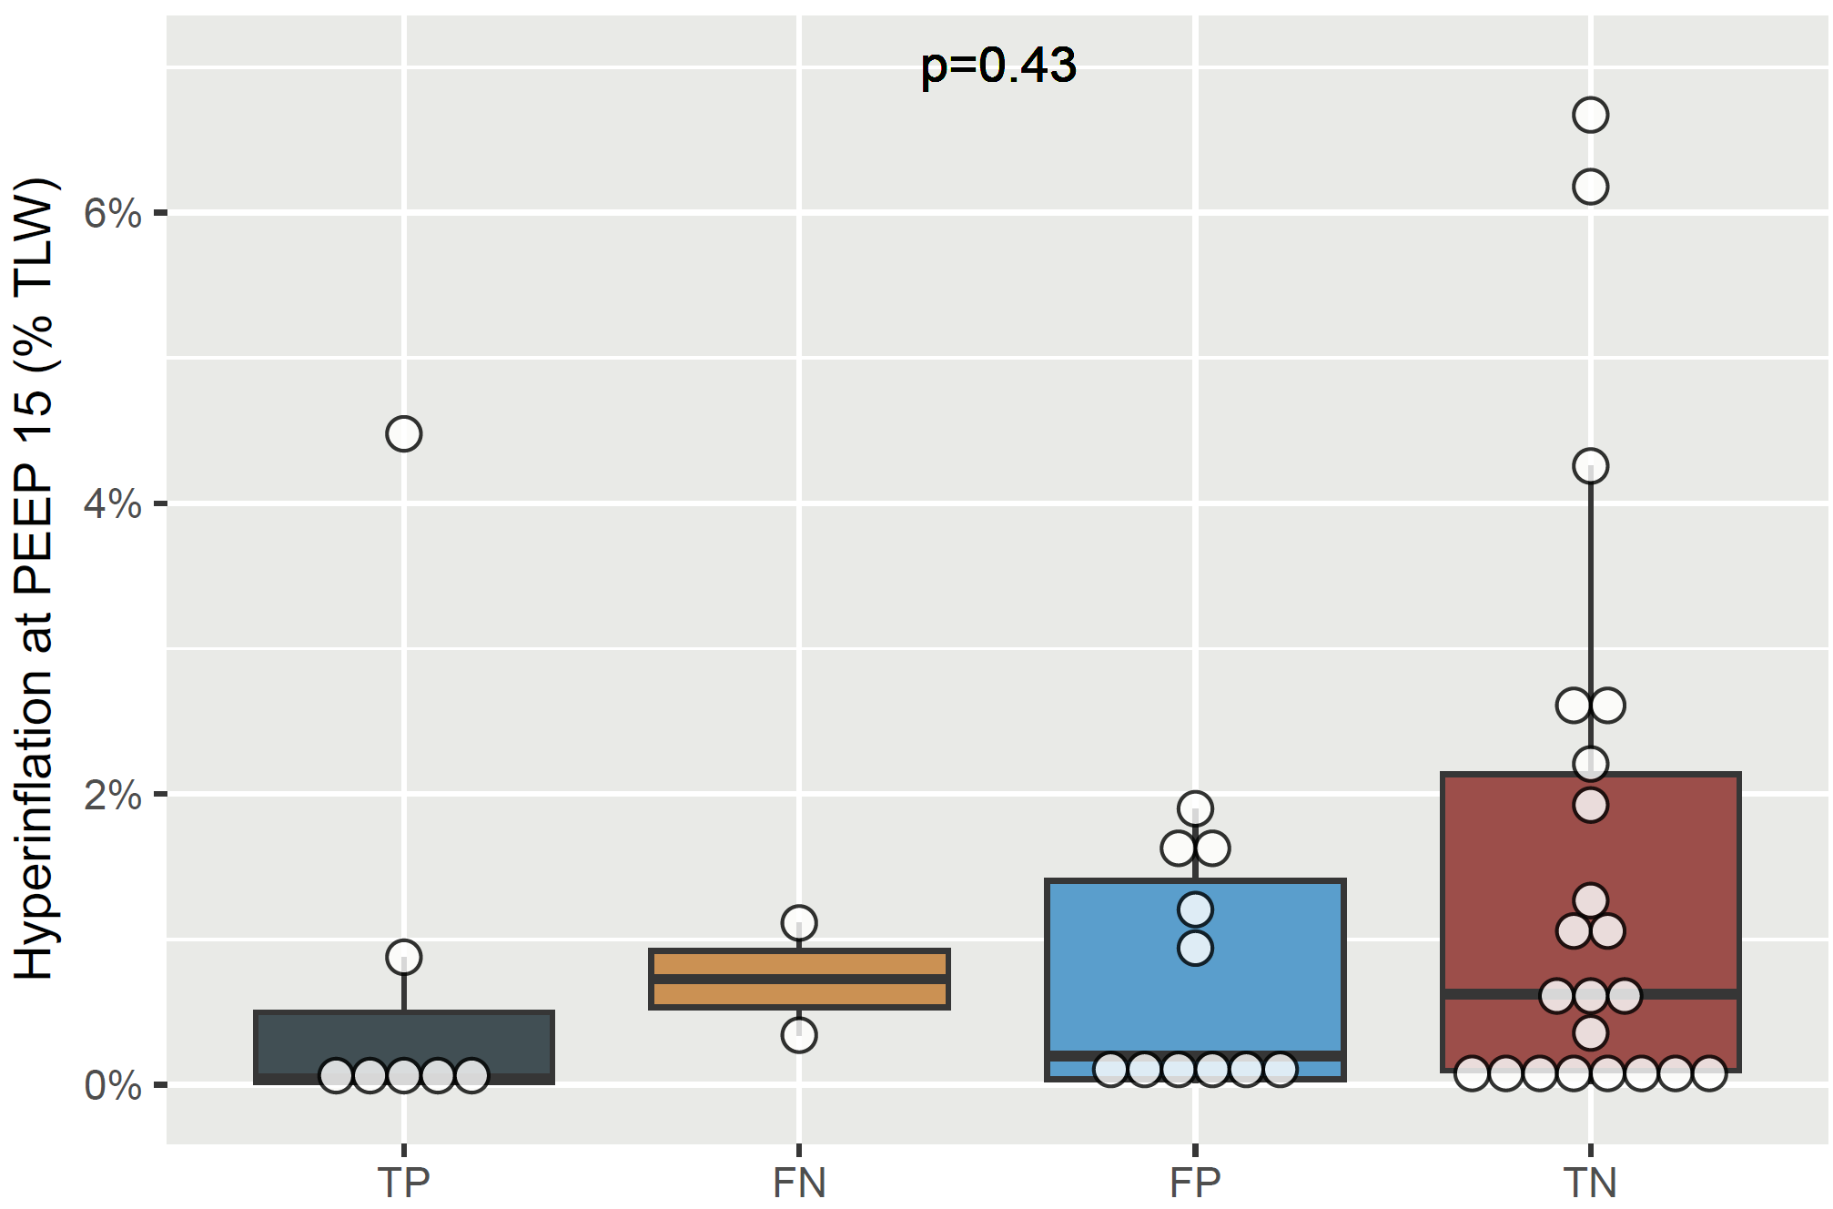
TLW = total lung weight; TP = true positive, TN = true negative; FP = false positive, TN = false negative.

