Additional file 7. Bland and Altman representation of the relationships between each component of the R/I ratio_{ventilator} and its CT counterpart.

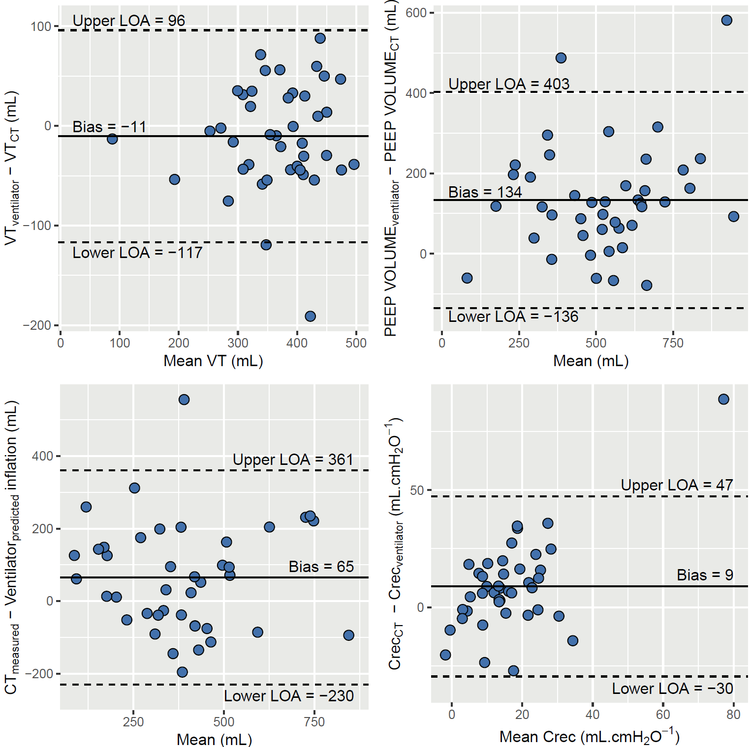
Crec_{CT} denotes compliance of the recruited lung assessed by computed tomography; Crec_{ventilator}, compliance of the recruited lung assessed with the ventilator; CT, computed tomography; CT_{measured}, CT-measured inflation of already aerated lung units at PEEP 5 cmH₂O; LOA, limit of agreement; PEEP, positive end-expiratory pressure; PEEP volume_{CT}, change in aerated lung volume between PEEP 5 and 15 cmH₂O assessed with CT; PEEP volume_{ventilator}, change in aerated lung volume between PEEP 5 and 15 cmH₂O assessed with the ventilator; Ventilator_{predicted}, predicted inflation of already aerated lung units at PEEP 5 cmH₂O with the ventilator; VT, tidal volume; VT_{CT}, tidal volume measured on computed tomography; VT_{ventilator}, tidal volume measured on the ventilator.

