Supplemental materials
Supplemental Figure 1
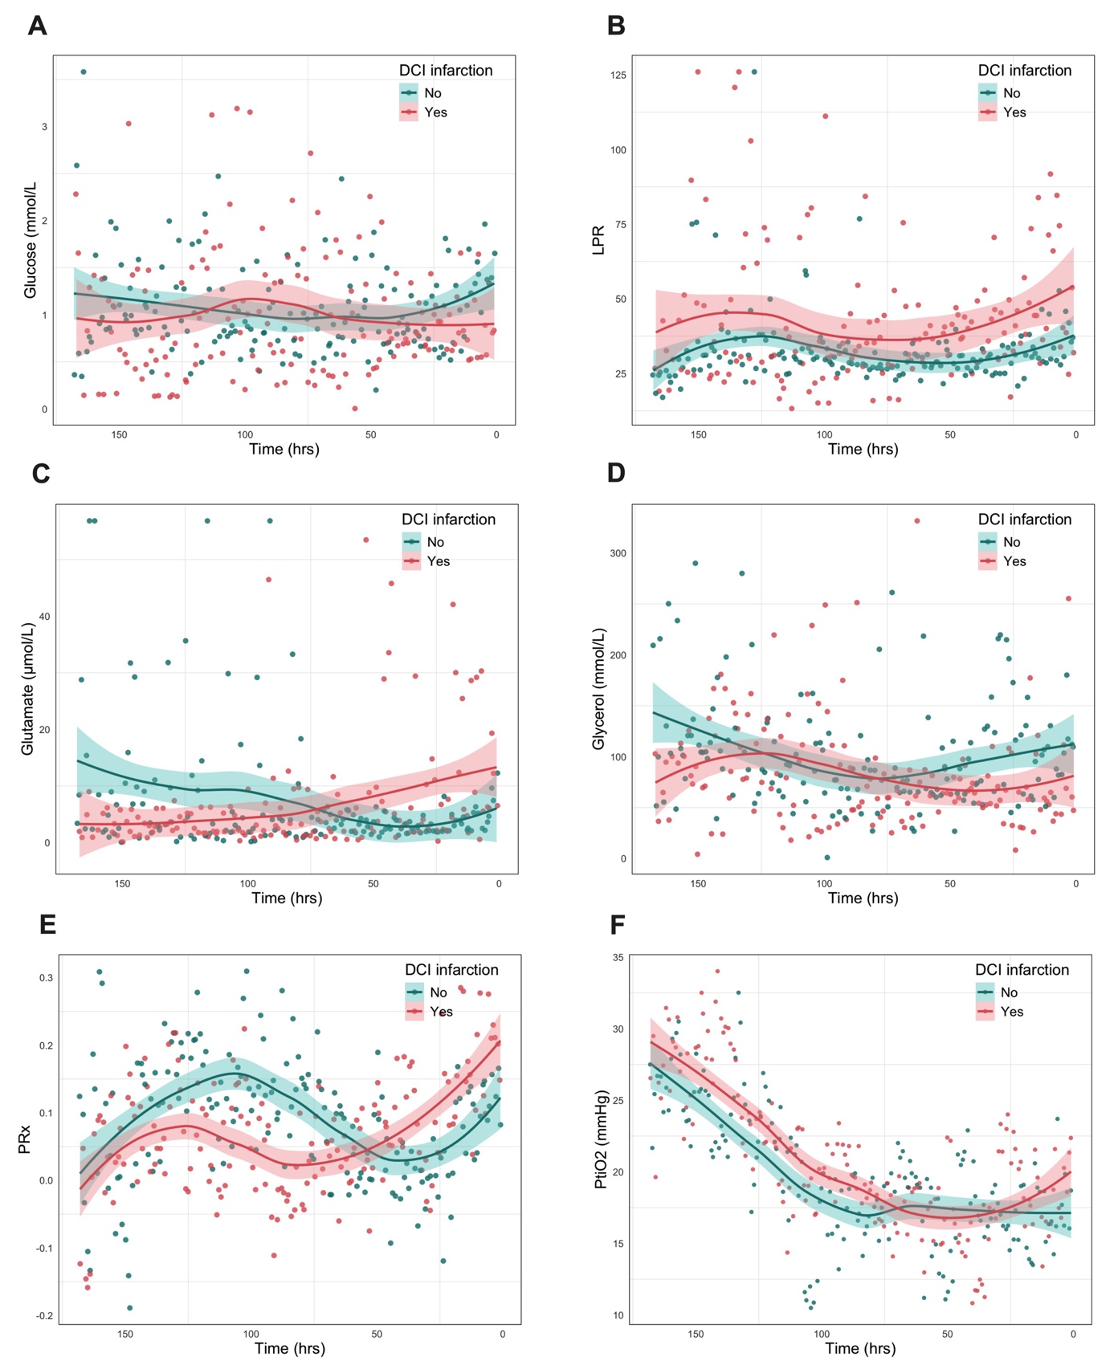
Supplemental Figure 1. Scatterplot of A. median glucose (mmol/L), B. median lactate-to-pyruvate ratio (LPR), C. median glutamate (µmol/L), D. median glycerol (mmol/L), E. mean pressure reactivity index (PRx), F. median brain tissue oxygen pressure (PtiO₂ (mmHg)) over 7 days (168 hours) preceding cerebral hypoperfusion and treatment initiation. Data has been dichotomized based on treatment response (development of DCI-related infarction or not). Locally estimated scatterplot smoothing lines are plotted for each outcome group with shaded areas representing 95% confidence intervals.
DCI, delayed cerebral ischemia; hrs, hours; L, litter; mmHg, millimeters of mercury, µmol, micromole; mmol, millimole.

Supplemental Figure 2
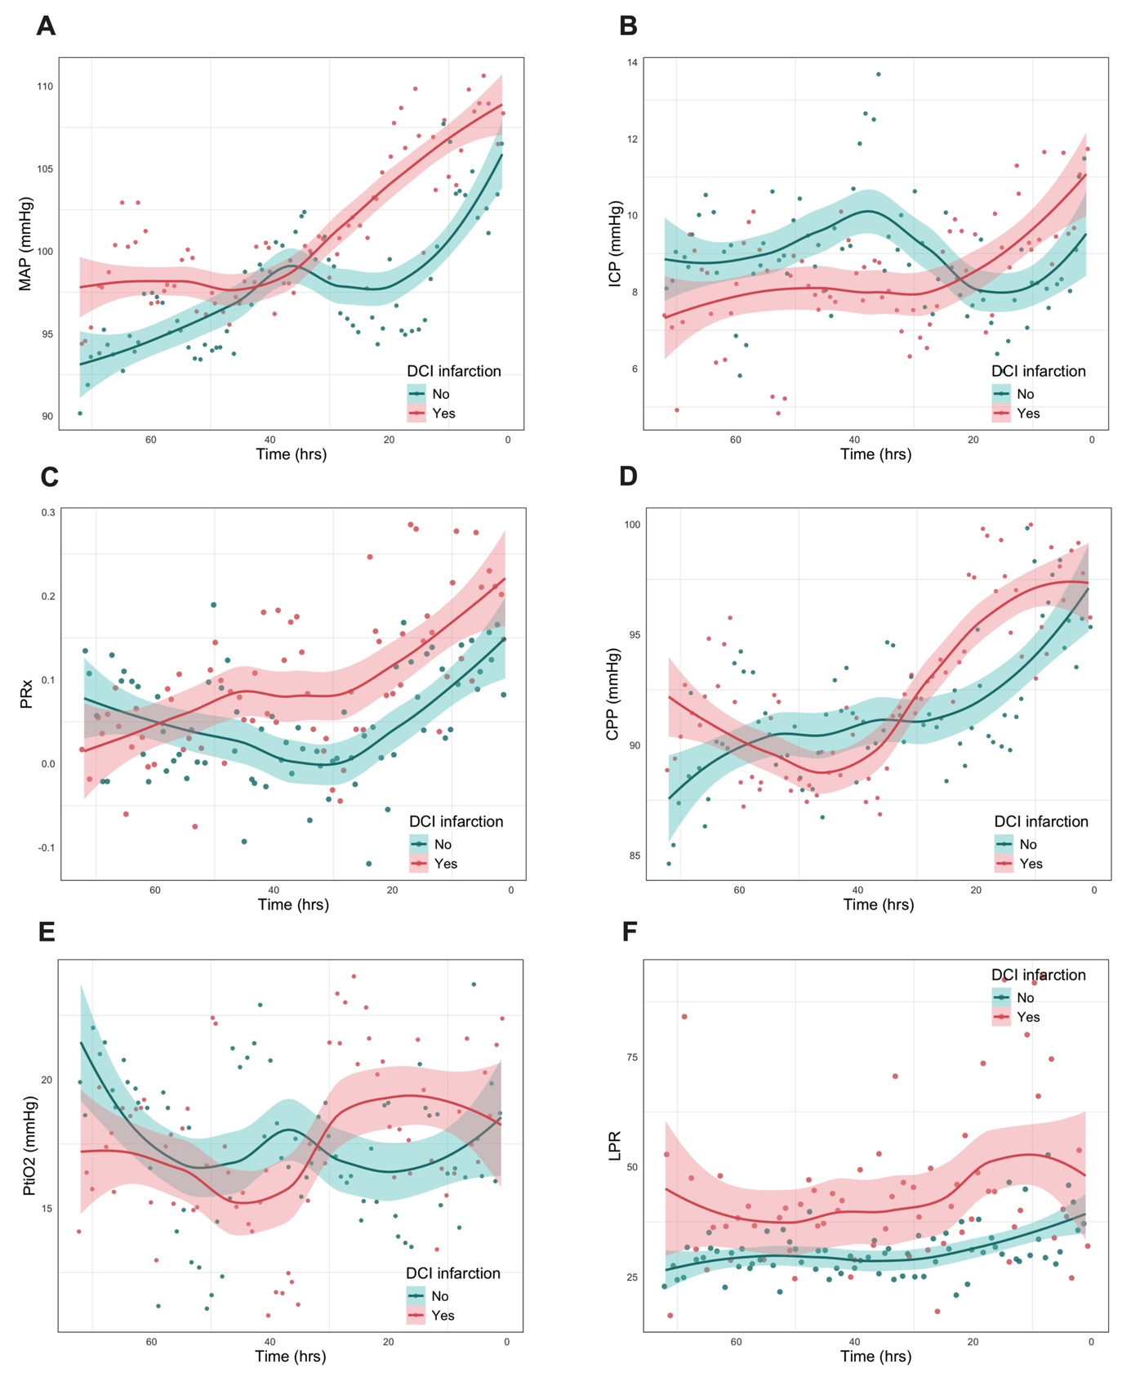
Supplemental Figure 2. Scatterplot of A. average mean arterial pressure (MAP (mmHg)), B. mean intracranial pressure (ICP (mmHg)), C. mean cerebral perfusion pressure (CPP (mmHg)), D. mean pressure reactivity index (PRx), E. median brain tissue oxygen pressure (PtiO₂ (mmHg)), F. median lactate-to-pyruvate ratio (LPR), over 3 days (72 hrs.) preceding cerebral hypoperfusion. Data has been dichotomized based on treatment response (development of DCI-related infarction or not). Locally estimated scatterplot smoothing lines are plotted for each outcome group with shaded areas representing 95% confidence intervals.
DCI, delayed cerebral ischemia; hrs, hours; mmHg, millimeter of mercury.

Supplemental Table 1
Year | Total number of SAH | Patients with PtiO2 | Patients with CMD | Patients with INM | Proportion of patients with INM (%) | Proportion of patients with dual INM (%)
2014 | 31 | 12 | 3 | 12 | 38,7 | 9,7
2015 | 41 | 24 | 23 | 24 | 58,5 | 56,1
2016 | 37 | 13 | 13 | 13 | 35,1 | 35,1
2017 | 31 | 13 | 13 | 13 | 41,9 | 41,9
2018 | 40 | 21 | 15 | 21 | 52,5 | 27,5
2019 | 42 | 26 | 22 | 26 | 61,9 | 52,4
2020 | 46 | 17 | 8 | 17 | 37,0 | 17,4
Total | 268 | 126 | 97 | 126

Supplemental Table 1. Overview of absolute and relative (%) numbers of patients with invasive neuromonitoring stratified by year of presentation over the study’s inclusion time period from 2014 until 2020.
CMD, cerebral microdialysis; INM, invasive neuromonitoring; PtiO2, brain tissue oxygen saturation measurement; SAH, aneurysmal subarachnoid hemorrhage.

