Additional file 1
Effects of inhaled nitric oxide on ventilation/perfusion mismatch assessed by electrical impedance tomography in patients with ARDS: a prospective observational study
Hongling Zhang; Xuehui Gao; Yongran Wu; Yaqi Ouyang; Xiangzhi Fang; Ruiting Li; Huaqing Shu; Xiaobo Yang; Hong Qi; Xiaojing Zou; You Shang
Methods
Administration and management of inhaled nitric oxide (iNO)
In this study, a state-of-the-art iNO generator, the INOwill N200 Nitric Oxide (NO) Generator and Delivery System (manufactured by Novlead Biotechnology Co., Ltd, China), was employed to facilitate the instantaneous production of NO gas at a concentration from zero to 200 ppm. This cutting-edge device utilized the electrochemical reduction method to convert nitrite/Cu (II)-ligand solution into NO gas in a real-time, stable, and safe manner [1]. This approach efficiently delivers NO gas using nitrogen as the carrier gas, ensuring precise mixing with the respiratory gas and synchronized delivery during the inspiratory phase. A flow sensor in the inspiratory circuit enables real-time NO flow adjustments, conserving gas, minimizing environmental emissions, and reducing impurities like nitrogen dioxide (NO₂). A strategically placed sampling port near the patient end ensures accurate monitoring of NO, NO₂, and O₂ concentrations in real time.
Electrical impedance tomography (EIT) assessment
EIT functional images and data were generated using the PulmoVista 500 (Dräger Medical, Lübeck, Germany). A 16-electrode EIT belt was placed around the thorax at the 3rd, 4th, or 5th intercostal space along the parasternal line, as appropriate. To ensure intra-patient repeatability, the EIT belt was not removed throughout the study, and patients were positioned semi-recumbent with a 15° bed incline during EIT measurements. EIT images were continuously recorded at 20 Hz. After a 2-minute baseline recording, lung perfusion was assessed using a hypertonic saline bolus method. A 10 mL bolus of hypertonic saline (10% NaCl) was injected via a central venous catheter for perfusion assessment. The injection took less than 2 seconds and was performed during a short end-expiratory apnea of approximately 10 seconds. During the apnea, the airway was maintained at end-expiratory pressure (PEEP level), which varied between patients according to their clinical setting. To reduce baseline drift and non-perfusion-related fluctuations, high-pass filtering (0.05–0.1 Hz) was applied to the raw EIT signals, isolating transient changes from the saline bolus. Perfusion maps were reconstructed based on the first-pass conductivity kinetics [2,3].
The EIT data were analyzed offline with custom software developed in MATLAB (R2023a, The MathWorks Inc., Natick, MA). Regional functional ventilation maps were calculated by subtracting end-expiration impedance from end-inspiration impedance. Regional functional perfusion maps were generated by analyzing the slope of the time-impedance curve after saline injection, with removal of the time period when the saline bolus still within the cardiac region. Ventilated and perfused regions were defined as pixels exceeding 10% of the maximum value in the functional ventilation and perfusion maps, respectively [3,4]. For quantitative analysis, the lungs were divided into ventral and dorsal regions. The sum of these two regions represented the whole lung in our analysis [5]. Based on the analysis and integration of ventilation and perfusion maps, we assessed the following measures:
- Ventilation (%) and perfusion (%)，corresponding to the proportions of ventilation and perfusion distribution [6, 7].
- Only ventilated units (%), corresponding to the non-perfused pixels divided by the total number of pixels classified as ventilated and/or perfused [7].
- Only perfused units (%), corresponding to the non-ventilated pixels divided by the total number of pixels ventilated and/or perfused [7].
- Unmatched units (%), calculated by summing the proportion of only ventilated units and the proportion of only perfused units [7,8].
Sample Size Calculation
As a pilot study, no formal sample size calculation was performed due to the lack of prior reference data. Thirty patients were enrolled based on similar physiological studies [3,4].
Table S1. Exclusion criteria
- Contraindications to the use of electrical impedance tomography (e.g., chest surgical wounds dressing or presence of pacemaker)
- A history of cerebral hemorrhage within the past six months
- Active bleeding,
- Pneumothorax or moderate to massive pleural effusion
- Refractory shock
- Atrial fibrillation or other malignant arrhythmias that result in reduced cardiac output
- Chronic kidney disease
- Pregnancy

Table S2 Gas exchange, respiratory and hemodynamic parameters at different time points between groups
Variables | Overall  (n = 30) | Responders  (n = 11) | Non-responders  (n = 19) | P value
Gas exchange
PaO₂/FiO₂ – mmHg
0h | 167.39 ± 56.27 | 159.00 ± 51.78 | 172.25 ± 59.53 | 0.544
30min | 194.67 ± 68.19 * | 215.14 ± 65.43 * | 182.83 ± 68.62# | 0.217
3h | 190.10 ± 73.50 * | 213.30 ± 79.81 * | 176.70 ± 68.16 | 0.193
P value | <0.001 | <0.001 | 0.017
PaCO₂ – mmHg
0h | 41.07 ± 6.22 | 40.35 ± 6.96 | 41.49 ± 5.91 | 0.638
30min | 40.24 ± 6.44 | 39.33 ± 6.03 | 40.76 ± 6.77 | 0.565
3h | 40.39 ± 6.97 | 39.36 ± 7.58 | 40.98 ± 6.73 | 0.550
P value | 0.447 | 0.475 | 0.670
Respiratory parameters
Tidal volume – ml
0h | 446.1 ± 94.70 | 439.1 ± 77.78 | 450.2 ± 105.1 | 0.763
30min | 449.2 ± 92.58 | 440.5 ± 81.11 | 454.2 ± 100.4 | 0.705
3h | 448.6 ± 93.18 | 440.2 ± 79.09 | 453.4 ± 102.2 | 0.715
P value | 0.509 | 0.863 | 0.500
Positive end-expiratory pressure – cmH₂O
0h | 12.00 [10.00–15.00] | 12.10 [10.00–15.40] | 12.00 [10.00–14.00] | 0.331
30min | 12.00 [10.00–15.00] | 12.10 [11.00–15.50] | 12.00 [10.00–14.00] | 0.354
3h | 12.00 [10.00–15.00] | 12.00 [10.70–15.20] | 12.00 [10.00–14.00] | 0.401
P value | 0.337 | 0.896 | 0.217
Driving pressure – cmH₂O
0h | 14.00 [12.00–15.00] | 14.00 [12.60–15.00] | 14.00 [12.00–15.00] | 0.756
30min | 13.05 [12.00–15.00] | 13.10 [12.40–15.00] | 13.00 [12.00–15.00] | 0.823
3h | 13.50 [12.45–14.25] | 14.00 [12.80–15.00] | 13.00 [12.00–14.00] | 0.460
P value | 0.534 | 0.292 | 0.756
Static respiratory system compliance – mL/cmH₂O
0h | 31.86 ± 11.14 | 32.56 ± 7.01 | 31.46 ± 13.11 | 0.798
30min | 34.17 ± 10.58 | 32.90 ± 7.00 | 34.91 ± 12.32 | 0.625
3h | 33.88 ± 10.10 | 32.23 ± 6.06 | 34.84 ± 11.88 | 0.505
P value | 0.289 | 0.466 | 0.292
Ventilatory Ratio
0h | 1.70±0.68 | 1.46±0.51 | 1.84±0.73 | 0.150
30min | 1.68±0.69 | 1.45±0.58 | 1.81±0.73 | 0.167
3h | 1.69±0.72 | 1.45±0.60 | 1.83±0.75 | 0.161
P value | 0.784 | 0.829 | 0.807
Hemodynamic parameters
Heart rate – cycles/min
0h | 103.40 ± 20.82 | 106.30 ± 17.28 | 101.70 ± 22.89 | 0.570
30min | 102.60 ± 20.03 | 104.90 ± 17.64 | 101.20 ± 21.64 | 0.634
3h | 101.30 ± 20.21 | 104.40 ± 19.31 | 99.47 ± 21.02 | 0.532
P value 0h vs. 30min | 0.278 | 0.402 | 0.436
Mean arterial pressure – mmHg
0h | 86.53 ± 13.25 | 85.05 ± 12.58 | 87.38 ± 13.89 | 0.651
30min | 85.28 ± 12.74 | 83.79 ± 11.33 | 86.15 ± 13.71 | 0.633
3h | 83.06 ± 11.76 | 86.69 ± 11.64 | 80.96 ± 11.61 | 0.203
P value | 0.215 | 0.359 | 0.072
Norepinephrine dose – μg/kg/min
0h | 0.13 [0.00–0.35] | 0.07 [0.00–0.15] | 0.14 [0.00–0.43] | 0.285
30min | 0.11 [0.00–0.31] | 0.07 [0.00–0.16] | 0.14 [0.00–0.43] | 0.327
3h | 0.11 [0.00–0.29] | 0.07 [0.00–0.25] | 0.14 [0.00–0.33] | 0.444
P value | 0.417 | 0.333 | 0.115
PaO₂/FiO₂, ratio of partial pressure arterial oxygen and fraction of inspired oxygen
Variables measured at different time points were analyzed by one-way repeated measures ANOVA or the Friedman test, with post-hoc multiple comparisons performed using the Bonferroni or Dunn tests. Variables measured at the same time point between groups were analyzed using the Student's t-test or the Mann-Whitney U test
* Post-hoc Bonferroni’s multiple comparisons within groups, P < 0.05 vs. 0 h

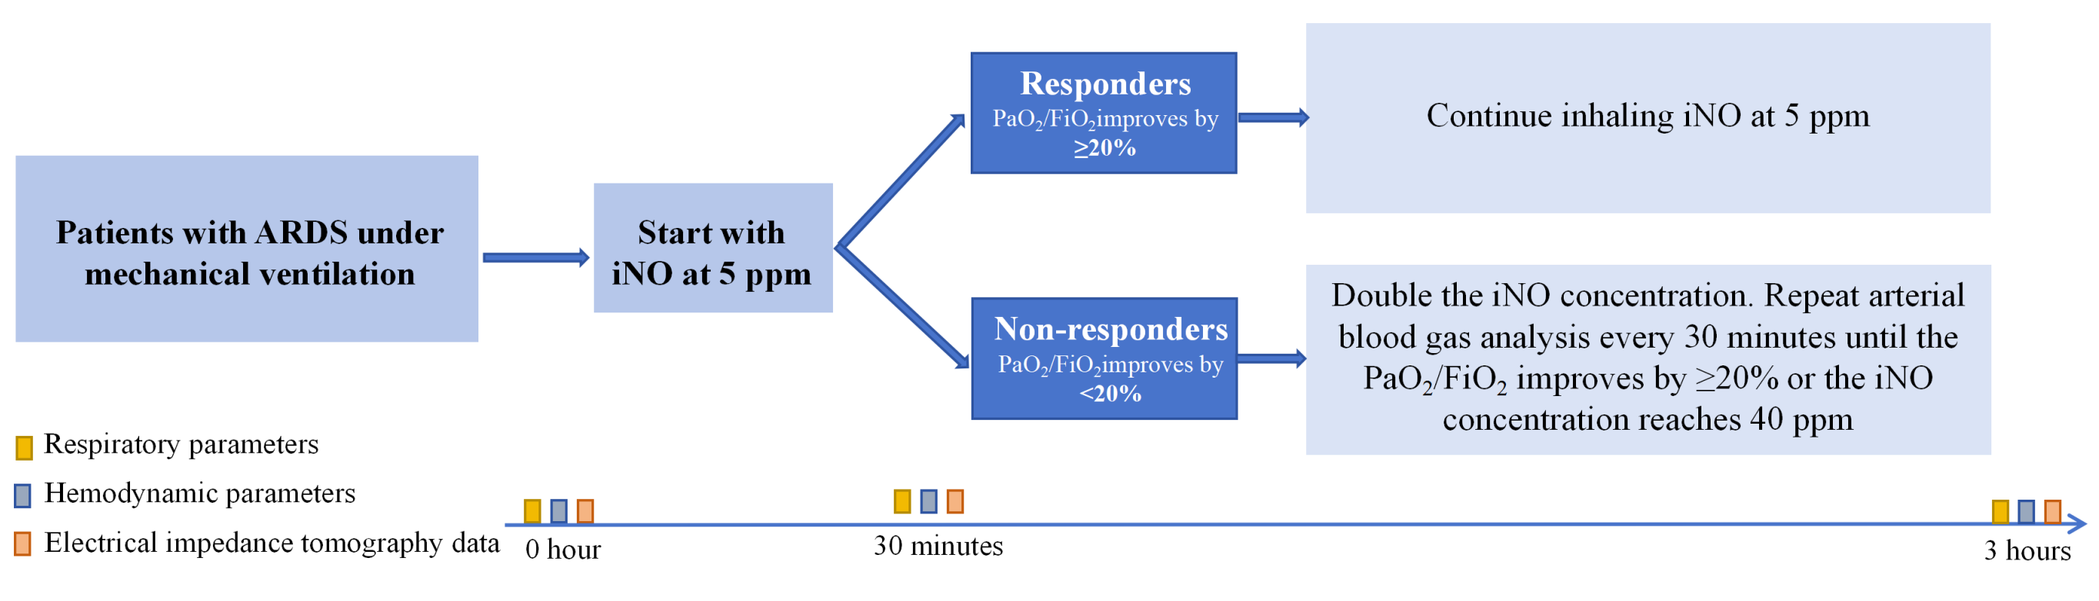Figure S1. Trail protocol. ARDS, acute respiratory distress syndrome; iNO, inhaled nitric oxide
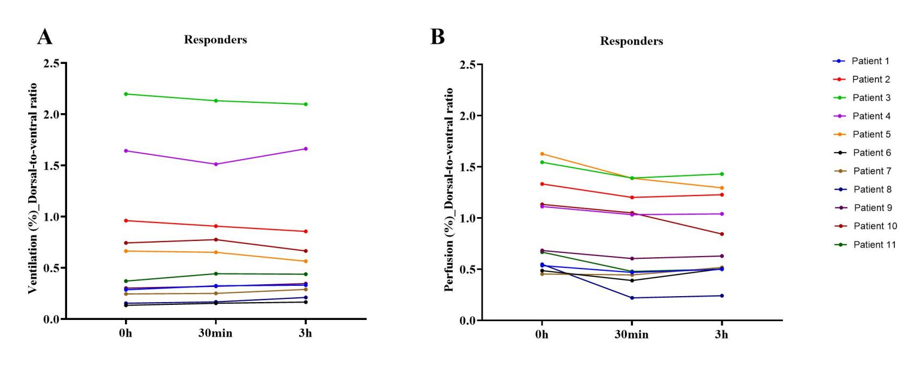
Figure S2. Individual changes in dorsal-to-ventral ratios of (A) ventilation (%) and (B) perfusion (%) in 11 responders during inhaled nitric oxide administration. V/Q, ventilation/perfusion
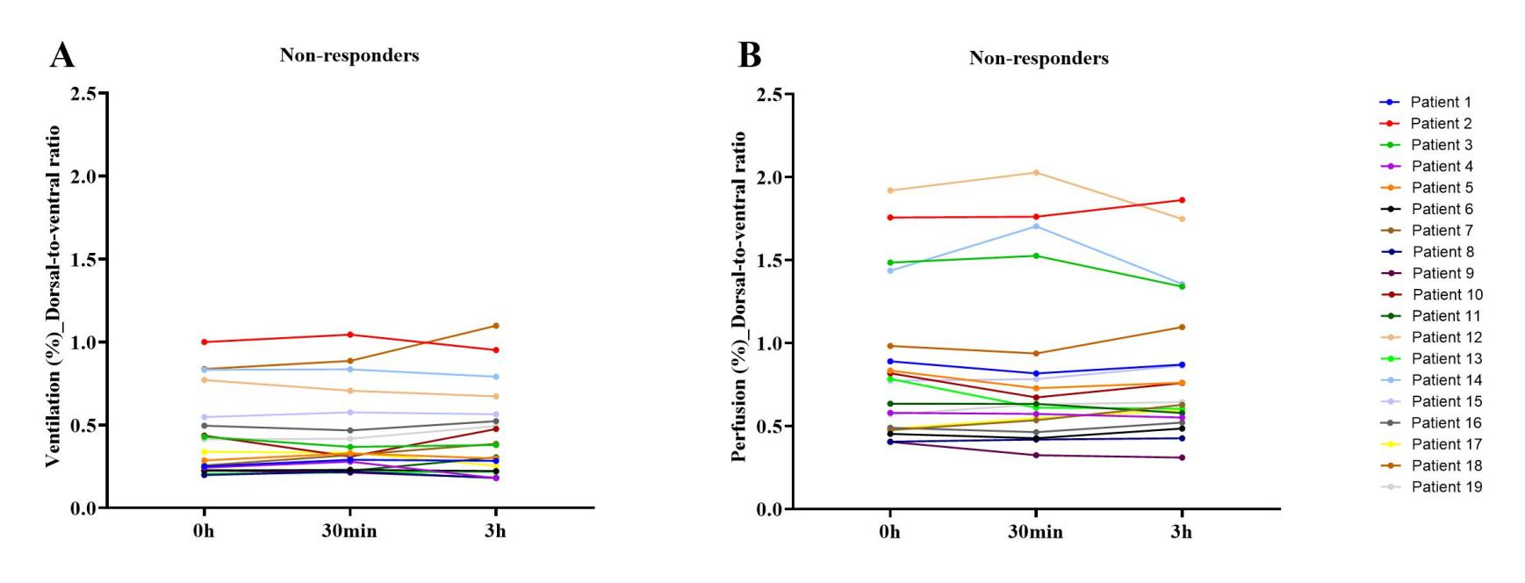
Figure S3. Individual changes in dorsal-to-ventral ratios of (A) ventilation (%) and (B) perfusion (%) in 19 non-responders during inhaled nitric oxide administration. V/Q, ventilation/perfusion

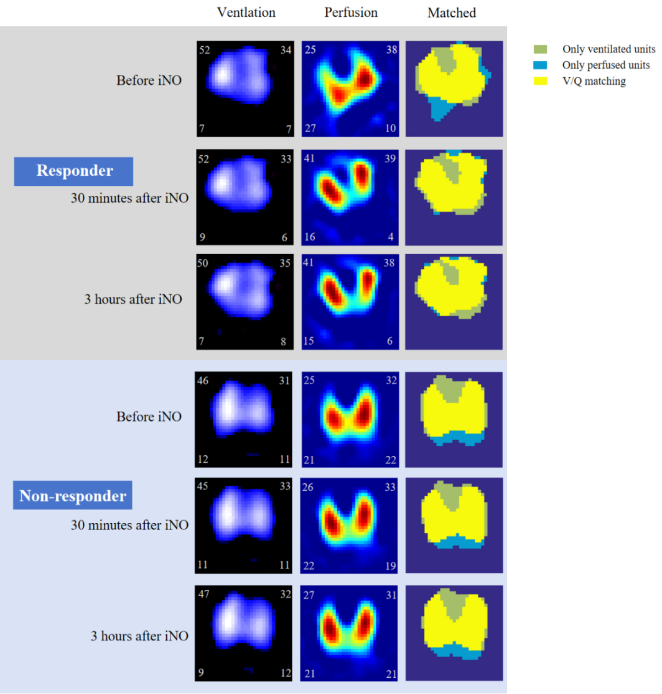
Figure S4. Representative EIT images from a responder (top) and a non-responder (bottom) during inhaled nitric oxide (iNO) administration. The left panel shows the proportion of ventilation distribution, the middle panel the proportion of perfusion distribution, and the right panel the integrated ventilation-perfusion map: the yellow area represents matched units that are both ventilated and perfused, the light green area represents only ventilated units, and the blue area represents only perfused units. In the responder, after 30 minutes of iNO administration, the proportion of dorsal perfusion decreased from 37% to 20% and the proportion of dorsal only perfused units dropping from 12.9% to 1.37%. This phenomenon was absent in the non-responder. V/Q, ventilation/perfusion
References
1. Liu Y, Zhu Y, Jiang C, Su Z, Yan Y, Feng B, et al. An electrochemical nitric oxide generator for in-home inhalation therapy in pulmonary artery hypertension. BMC Med. 2022;20:481.
2. He H, Long Y, Frerichs I, Zhao Z. Detection of Acute Pulmonary Embolism by Electrical Impedance Tomography and Saline Bolus Injection. Am J Respir Crit Care Med. 2020;202:881–2.
3. Wang Y, Zhong M, Dong M, Song J, Zheng Y, Wu W, et al. Prone positioning improves ventilation–perfusion matching assessed by electrical impedance tomography in patients with ARDS: a prospective physiological study. Crit Care. 2022;26:154.
4. Pavlovsky B, Pesenti A, Spinelli E, Scaramuzzo, G, Marongiu, I, Tagliabue, P, et al. Effects of PEEP on regional ventilation-perfusion mismatch in the acute respiratory distress syndrome. Crit Care. 2022;26(1):211.
5. Fossali T, Pavlovsky B, Ottolina D, et al. Effects of Prone Position on Lung Recruitment and Ventilation-Perfusion Matching in Patients With COVID-19 Acute Respiratory Distress Syndrome: A Combined CT Scan/Electrical Impedance Tomography Study. Crit Care Med. 2022;50(5):723-732.
6. He H, Chi Y, Long Y, Yuan S, Zhang R, Frerichs I, et al. Bedside Evaluation of Pulmonary Embolism by Saline Contrast Electrical Impedance Tomography Method: A Prospective Observational Study. Am J Respir Crit Care Med. 2020;202:1464–8.
7. Spinelli E, Kircher M, Stender B, Ottaviani I, Basile MC, Marongiu I, et al. Unmatched ventilation and perfusion measured by electrical impedance tomography predicts the outcome of ARDS. Crit Care. 2021;25:192.
8. Spinelli E, Giani M, Slobod D, Pavlovsky B, di Pierro M, Crotti S, et al. Physiologic Effects of Extracorporeal Membrane Oxygenation in Patients with Severe Acute Respiratory Distress Syndrome. Am J Respir Crit Care Med. 2024;210:629–38.

