Lamarche et al. Cardiac Output Monitors in Septic Shock: Do They Deliver What Matters? A Systematic Review and Meta-Analysis

Electronic Supplementary Material

ESM-1 Detailed search strategy & studies testing multiple devices
ESM-2 Formulas used for data extraction
ESM-3 Quality assessment tool
ESM-4 Quality control: risk of bias assessment results
ESM-5 Performance of CO monitoring devices based on ROC analysis
ESM-6 Detailed pooled analysis of all studies
ESM-7 Sensitivity analysis of pure sepsis studies

ESM-1 Detailed search strategy & studies testing multiple devices

Database | Search Strategy
Ovid MEDLINE ALL (1946–Jan 24, 2025) | (1) exp Cardiac Output/ OR (cardiac output OR cardiac index OR heart output OR heart index).mp. (133,446)  (2) monitoring, physiologic/ OR exp hemodynamic monitoring/ OR minimally invasive.mp. OR ((hemodynamic OR cardiac output OR cardiac index OR pulse OR arterial pressure) adj3 (waveform* OR monitor* OR evaluat* OR contour* OR system OR systems)).mp. (194,960)  (3) 1 AND 2 (7932)  (4) (FloTrac OR Vigileo OR EV1000 OR LiDCO* OR ProAQT OR PulsioFlex OR MostCare OR Argos OR Esophageal Doppler monitor* OR EDM OR CardioQ).mp. (2276)  (5) (radial artery applanation tonometry OR RAAT OR thoracic bioimpedance OR finger cuff OR pulse wave analysis OR noninvasive OR non-invasive).mp. (258,304)  (6) OR/3-5 (266,467)  (7) (pulmonary artery catheter OR PAC OR PiCCO OR thermodilution OR TTE OR transthoracic echocardio*).mp. (44,897)  (8) exp Sepsis/ (149,277)  (9) exp Septic Shock/ (25,846)  (10) (((distributive OR septic) adj3 shock) OR sepsis).mp. (189,148)  (11) OR/8-10 (235,437)  (12) 6 AND 7 AND 11 (213)  (13) 12 NOT (editorial OR letter).pt. = 212
Embase (1974–Jan 24, 2025) | (1) exp heart output/ OR exp cardiac index/ OR (cardiac output OR cardiac index OR heart output OR heart index).mp. (113,754)  (2) physiologic monitoring/ OR exp hemodynamic monitoring/ OR minimally invasive.mp. OR ((hemodynamic OR cardiac output OR cardiac index OR pulse OR arterial pressure) adj3 (waveform* OR monitor* OR evaluat* OR contour* OR system OR systems)).mp. (294,452)  (3) 1 AND 2 (12,434)  (4) (FloTrac OR Vigileo OR EV1000 OR LiDCO* OR ProAQT OR PulsioFlex OR MostCare OR Argos OR Esophageal Doppler monitor* OR EDM OR CardioQ).mp. (3769)  (5) (radial artery applanation tonometry OR RAAT OR thoracic bioimpedance OR finger cuff OR pulse wave analysis OR noninvasive OR non-invasive).mp. (392,716)  (6) OR/3-5 (405,190)  (7) exp pulmonary artery catheter/ OR transthoracic echocardiography/ OR (pulmonary artery catheter OR PAC OR PiCCO OR thermodilution OR TTE OR transthoracic echocardio*).mp. (135,257)  (8) exp sepsis/ (365,954)  (9) exp septic shock/ (76,569)  (10) (((distributive OR septic) adj3 shock) OR sepsis).mp. (338,322)  (11) OR/8-10 (415,846)  (12) 6 AND 7 AND 11 (661)  (13) 12 NOT (editorial OR letter OR conference abstract).pt. = 468
Web of Science – Core Collection (1965–Present) | (1) TS=(cardiac output OR cardiac index OR heart output OR heart index)  (2) TS=(physiologic monitoring OR hemodynamic monitoring) OR TS=(minimally invasive) OR TS=(hemodynamic OR "cardiac output" OR "cardiac index" OR pulse OR "arterial pressure") NEAR/3 (waveform* OR monitor* OR evaluat* OR contour* OR system OR systems)  (3) #1 AND #2  (4) TS=(FloTrac OR Vigileo OR EV1000 OR LiDCO* OR ProAQT OR PulsioFlex OR MostCare OR Argos OR Esophageal Doppler monitor* OR EDM OR CardioQ)  (5) TS=(radial artery applanation tonometry OR RAAT OR thoracic bioimpedance OR finger cuff OR pulse wave analysis OR noninvasive OR non-invasive)  (6) #3 OR #4 OR #5  (7) TS=(pulmonary artery catheter OR PAC OR PiCCO OR thermodilution OR TTE OR transthoracic echocardio*)  (8) TS=sepsis OR TS=septic shock OR TS=((distributive OR septic) NEAR/3 shock)  (9) #6 AND #7 AND #8 AND (Excluded 'Editorial Material' or 'Meeting Abstract' Document Types) = 361
Web of Science – BIOSIS Citation Index (1969–Present) | (1) TS=(cardiac output OR cardiac index OR heart output OR heart index)  (2) TS=(physiologic monitoring OR hemodynamic monitoring) OR TS=(minimally invasive) OR TS=(hemodynamic OR "cardiac output" OR "cardiac index" OR pulse OR "arterial pressure") NEAR/3 (waveform* OR monitor* OR evaluat* OR contour* OR system OR systems)  (3) #1 AND #2  (4) TS=(FloTrac OR Vigileo OR EV1000 OR LiDCO* OR ProAQT OR PulsioFlex OR MostCare OR Argos OR Esophageal Doppler monitor* OR EDM OR CardioQ)  (5) TS=(radial artery applanation tonometry OR RAAT OR thoracic bioimpedance OR finger cuff OR pulse wave analysis OR noninvasive OR non-invasive)  (6) #3 OR #4 OR #5  (7) TS=(pulmonary artery catheter OR PAC OR PiCCO OR thermodilution OR TTE OR transthoracic echocardio*)  (8) TS=sepsis OR TS=septic shock OR TS=((distributive OR septic) NEAR/3 shock)  (9) #6 AND #7 AND #8 AND (Excluded 'Meeting' and 'Letter' Document Types) = 79
Cochrane (Wiley) – Central Register of Controlled Trials | (1) [mh "Cardiac Output"] OR (cardiac output OR cardiac index OR heart output OR heart index):ti,ab,kw (45,799)  (2) [mh ^"monitoring, physiologic"] OR [mh "hemodynamic monitoring"] OR (minimally invasive):ti,ab,kw OR ((hemodynamic OR "cardiac output" OR "cardiac index" OR pulse OR "arterial pressure") NEAR/3 (waveform* OR monitor* OR evaluat* OR contour* OR system OR systems)):ti,ab,kw (17,373)  (3) #1 AND #2 (1735)  (4) (FloTrac OR Vigileo OR EV1000 OR LiDCO* OR ProAQT OR PulsioFlex OR MostCare OR Argos OR Esophageal Doppler monitor* OR EDM OR CardioQ):ti,ab,kw (532)  (5) (radial artery applanation tonometry OR RAAT OR thoracic bioimpedance OR finger cuff OR pulse wave analysis OR noninvasive OR non-invasive):ti,ab,kw (28,176)  (6) {OR #3-#5} (29,955)  (7) (pulmonary artery catheter OR PAC OR PiCCO OR thermodilution OR TTE OR transthoracic echocardio*):ti,ab,kw (5554)  (8) {#6 AND #7 AND #11 in Trials} = 51

Studies testing multiple devices

Study (Year) | Devices Tested | Entries in Quantitative Analysis
Raaijmakers (1998)¹ | Double Indicator Dilution, Thoracic Electrical Bioimpedance (Sramek Bernstein, Kubicek) | 3
De Backer (2010)² | PAC CCO, FloTrac/Vigileo 1.14, FloTrac/Vigileo 3 | 3
Spohr (2007)³ | PCA PiCCO PCA, TPTD PiCCO | 2
Ganter (2016)⁴ | PAC CCO, FloTrac/Vigileo 3 | 2
Monnet (2010)⁵ | PCA PiCCO, FloTrac/Vigileo 1.1 | 2
Slagt (2015)⁶ | FloTrac/Vigileo 3.02, PCA Volume View | 2
Slagt (2010)⁷ | FloTrac/Vigileo 1.07, FloTrac/Vigileo 1.1 | 2
Monnet (2015)⁸ | FloTrac/Vigileo 3.02, Autocalibrated PulsioFlex, PCA PiCCO | 3

ESM-2 Formulas used for data extraction

- Conversion from Cardiac Index (CI) to Cardiac Output (CO)

When only CI was reported, CO was calculated as:

CO = CI × BSA

When not reported, body surface area (BSA) was estimated using the Mosteller formula—applied in only two studies^{9,10}:

BSA (m²) = √[(Height in cm × Weight in kg) / 3600]

If height and weight were unavailable, a default BSA of 2.0 m² was assumed. This was applied for three studies.^{5,11,12}

- Percentage Error (PE)

PE was calculated using one of two formulas, depending on available data. Preferred formula (accounts for imprecision in both methods):

PE = [1.96 × SD_{bias} / 0.5 × (mean CO_{test} + mean CO_{reference})] x 100

Alternative formula (used when only the reference mean CO was reported):

PE = [1.96 × SD_{bias} / mean CO_{reference}] x 100

- Estimation of Standard Deviation (SD)

If SD of the bias was not reported, it was estimated as:

SD_{bias} = (Upper LoA – Mean bias) / 1.96

- Precision

Where CV is the coefficient of variation for single measurements, CE is the coefficient of variation for the mean of n repeated measurements, and n is the number of repetitions. When only one measurement is used, CE equals CV. Precision is defined as 2 × CV (or 2 × CE for repeated measures).

CV = SD/mean CO

CE = CV/√n

- Precision derived from the PE and reference’s precision

Precision_{tested device} = √[(PE_{combined})² - (precision_{reference})²]

ESM-3 Adapted Quality Assessment of Diagnostic Accuracy Studies (QUADAS-2) Tool

Risk of bias is judged as “low,” “high,” or “unclear.” If the answers to all signaling questions for a domain are “yes,” then risk of bias can be judged low. If any signaling question is answered “no,” potential for bias exists. Review authors must then use the guidelines developed in phase 2 to judge risk of bias. The “unclear” category should be used only when insufficient data are reported to permit a judgment.

Review authors are asked to record the information on which the judgment of applicability is made and then to rate their concern that the study does not match the review question.

Domain 1: Patient Selection

Risk of Bias: Could the selection of patients have introduced bias?  (Two Nos = High) | Low | High | Unclear
Signaling question 1: Did the study describe population of interest and demographic data (e.g., sex, age,)? | Yes | No | Unclear
Signaling question 2: Were the inclusion and exclusion criteria clearly described? | Yes | No | Unclear
Applicability: Are there concerns that the included patients and setting do not match the review question? | Low | High | Unclear

Domain 2: Index test (CO devices)

Risk of bias: Could the conduct or interpretation of CO measured by CO devices have introduced bias? (No = High) | Low | High | Unclear
Signaling question: Was CO monitor use described clearly?  (e.g., type and generation -if more than one- of CO monitor, measures taken to avoid or address conditions known to impair the accuracy of the device; if the accuracy of the CO monitor is dependent on the quality of the arterial line waveform, is there explicit evaluation and confirmation of waveform acceptability, etc.) | Yes | No | Unclear
Applicability: Are there concerns that the index test, its conduct, or its interpretation differ from the review question? | Low | High | Unclear

Domain 3: Reference standard (TD by PAC, TPTD by PiCCO and/or echocardiography)
Risk of bias: Could the reference method, its conduct, or its interpretation have introduced bias? (No = High) | Low | High | Unclear
Signaling question: Is the reference cardiac output reference standard likely to correctly measure cardiac output (e.g., correct PAC placement, description of bolus application; for TPTD by PiCCO were standard procedures followed for bolus injection; for echocardiography was the method of CO determination described, were echocardiography operators qualified)? | Yes | No | Unclear
Applicability: Are there concerns that the reference standard, its conduct, or its interpretation does not match the review question? | Low | High | Unclear

Domain 4: Flow and timing

Could the patient flow have introduced bias? Could the analysis of flow and timing have introduced bias? (Unclear: ≥2 unclear, 1 No + 1 unclear) (High: ≥2 No) | Low | High | Unclear
Signaling question 1: Were the number of patients enrolled and who dropped out clearly described in the result (e.g., number of enrolled patients = reported number of patients in results section OR drop out clearly described)? | Yes | No | Unclear
Signaling question 2: Were the reference and index test cardiac output (or cardiac index) measured simultaneously? | Yes | No | Unclear
Signaling question 3: Was the method of acquiring paired measurements well described? | Yes | No | Unclear
Signaling question 4: In case of the mean of the differences being described in both the article and the figure(s), do they match? | Yes | No | Unclear

ESM-4 Quality control: risk of bias assessment results

STUDY | PATIENT SELECTION | INDEX TEST | REFERENCE STANDARD | FLOW AND TIMING
Scolletta 2016 | Low | Low | High | Unclear
Raue 2009 | Low | Low | Low | Low
Khwannimit 2020 | Low | Low | Low | Low
Galarza 2018 | Low | Low | Low | Low
Raaijmakers 1998 | Low | Low | Low | Low
De Backer 2010 | Low | Low | Low | Low
Spöhr 2007 | Low | Low | Low | Unclear
Ganter 2016 | Low | Low | Low | Low
Monnet 2010 | Low | Unclear | Low | Low
Sakka 2007 | Low | Unclear | Low | Low
Spathoulas 2022 | Low | Low | Low | Low
Slagt 2013 | Low | Unclear | Low | Low
Slagt 2015 | Low | Low | Low | Low
Böttger 2010 | Low | Unclear | Unclear | Low
Persona 2021 | Low | Low | Low | Low
Gopal 2014 | Low | Low | Low | Low
Slagt 2010 | Low | Low | Low | Low
Marqué 2013 | Low | Unclear | Low | Low
Monnet 2015 | Low | Low | Low | Low
Chew 2009 | Low | Low | Low | Low
Feissel 2015 | Low | Low | Low | Low
Franchi 2011 | Low | Low | Low | Low
Jellema 1999 | Low | Low | Low | Unclear
Kupersztych-Hagege 2013 | Low | Low | Low | Low
Monnet 2012 | Unclear | Unclear | Low | Low
Sharma 2024 | Low | Low | Low | Low

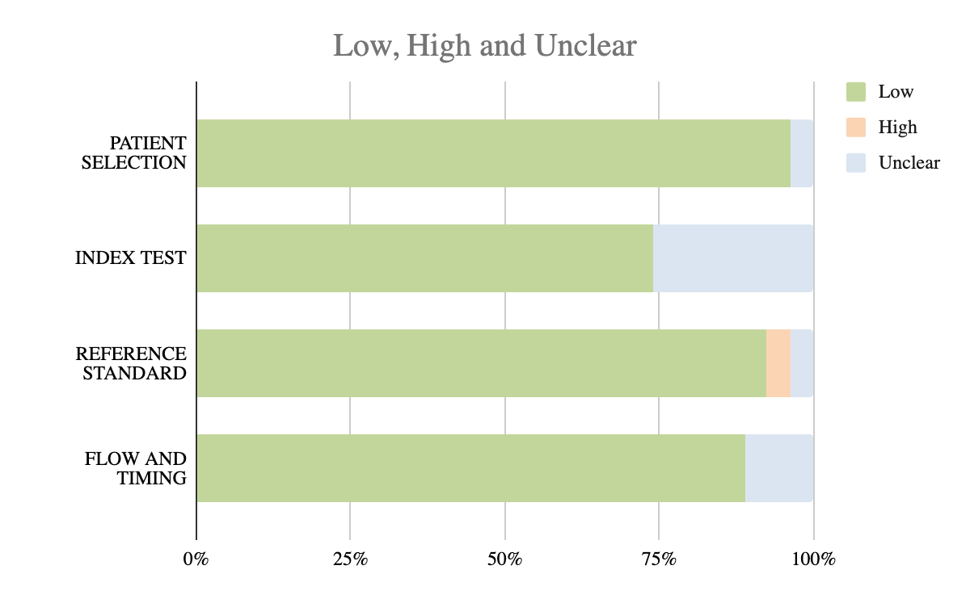

 | PATIENT SELECTION | INDEX TEST | REFERENCE STANDARD | FLOW AND TIMING
Low | 96.3% | 74.1% | 92.3% | 88.9%
High | 0.0% | 0.0% | 3.8% | 0.0%
Unclear | 3.7% | 25.9% | 3.8% | 11.1%

ESM-4 Quality control: applicability results

STUDY | PATIENT SELECTION | INDEX TEST | REFERENCE STANDARD
Scolletta 2016 | Low | Low | High
Raue 2009 | Low | Low | Low
Khwannimit 2020 | Low | Low | Low
Galarza 2018 | Low | Low | Low
Raaijmakers 1998 | Unclear | Low | Low
De Backer 2010 | Low | Low | Low
Spöhr 2007 | Low | Low | Low
Ganter 2016 | Low | Low | Low
Monnet 2010 | Low | Low | Low
Sakka 2007 | Low | Low | Low
Spathoulas 2022 | Low | Low | Low
Slagt 2013 | Low | Low | Low
Slagt 2015 | Low | Low | Low
Böttger 2010 | Low | Low | Low
Persona 2021 | Low | Low | Low
Gopal 2014 | Low | Low | Low
Slagt 2010 | Low | Low | Low
Marqué 2013 | Low | Low | Low
Monnet 2015 | Low | Low | Low
Chew 2009 | Low | Low | Low
Feissel 2015 | Low | Low | Low
Franchi 2011 | Low | Low | Low
Jellema 1999 | Low | Low | Low
Kupersztych-Hagege 2013 | Low | Low | Low
Monnet 2012 | Low | Low | Low
Sharma 2024 | Low | Low | Low

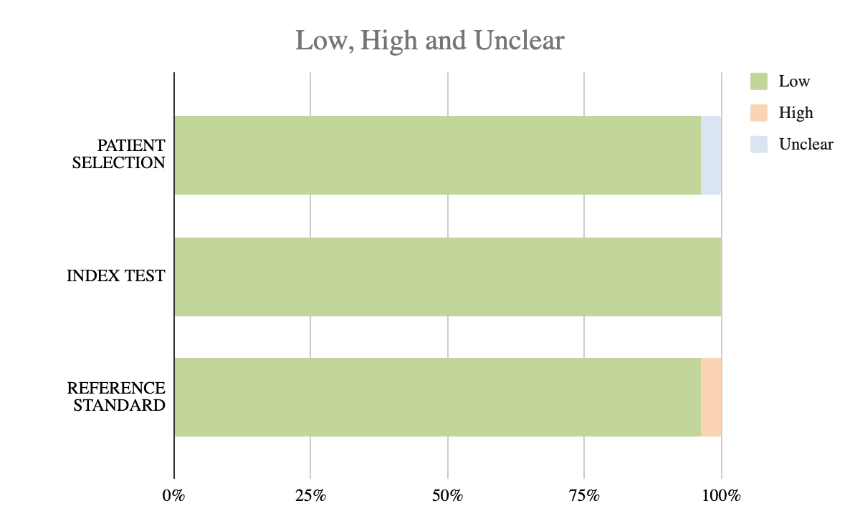

 | PATIENT SELECTION | INDEX TEST | REFERENCE STANDARD
Low | 96.2% | 100.0% | 96.2%
High | 0.0% | 0.0% | 3.8%
Unclear | 3.8% | 0.0% | 0.0%

ESM-5 Performance CO monitoring devices based on ROC analysis

ROC analysis was reported in 14 studies. Thoracic electrical bioreactance showed variable performance, with one study (Galarza et al.) reporting an AUC of 0.88 and another (Kupersztych-Hagege et al.) reporting no discrimination (AUC = 0.5). FloTrac/Vigileo performance varied by software version and intervention. Version 4 during vasopressor titration yielded AUCs of 0.82–0.85. Earlier versions and lower-intensity interventions showed reduced discrimination (AUC 0.54–0.72). TPTD (PiCCO) consistently showed strong performance (AUC 0.88–0.92).

Authors | Device Name | RM | Population | N/data pairs | Hemodynamic intervention | Receiver Operating Curve Results | Δ CO/CI Correlation, r
Thoracic electrical bioreactance (TEBr)

Galarza et al (2018)¹³ | Starling | TPTD PiCCO | >70% sepsis (ICU) | 13/13 | 500 mLs NS over 10 min in participants with positive PLR | Youden: Δ CO ≥ 10% detected PiCCO TPTD ≥ 10% during PLR  AUC: 0.88 (P= 0.06)  Sensitivity: 0.9  Specificity: 0.8 | r=0.94 (P<0.001)
Kupersztych-Hagege et al (2013)¹² | NICOM | TPTD PiCCO | >70% sepsis | 48/144 | 500 mLs NS over 10 min  PLR | Youden: NR  AUC: 0.5 (P= 0.77) | NR
Pulse contour analysis (PCA)

Khwannimit et al (2020)¹⁴ | FloTrac/Vigileo 4 | PiCCO TPTD | All sepsis (ICU) | 30/56 | Vasoactive dose change | Youden: Δ CI ≥ 17.5% detected PiCCO TPTD CI ≥ 15%  AUC: 0.85 (95% CI: 0.74–0.95)  Sensitivity: 0.9  Specificity: 0.7 | r = 0.8 (P<0.0001)
Khwannimit et al (2020)¹⁴ | FloTrac/Vigileo 4 | PiCCO TPTD | All sepsis (ICU) | 11/16 | 500mLs of NS over 30 min | Youden: Δ CI ≥ 13% detected PiCCO TPTD CI ≥ 15%  AUC: 0.82 (95% CI: 0.57- 1)  Sensitivity: 0.7  Specificity: 0.7 | r = 0.49 (P=0.05)
Marque et al (2013)¹⁵ | FloTrac/Vigileo 3.02 | CCO PAC | All sepsis  (ICU) | 18/30 | ≥10 mL/kg crystalloids/colloids within 30 min | Youden: Δ CO ≥ 14% detected ITD PAC ≥ 15%  AUC: 0.72 (95% CI: 0.53–0.87)  Sensitivity: 0.67  Specificity: 0.73 | NR
Monnet et al (2012)¹¹ | FloTrac/Vigileo 3 | TPTD PiCCO | >70% sepsis | 20/40 | 500 mLs of NS over 30 min | AUC: 0.5 for detecting TPTD Δ CI  12% | r= 0.51 (P=0.02)
Slagt et al (2013)¹⁶ | FloTrac/Vigileo 3.02 | ITD PAC | All sepsis (ICU) | 19/314 | Volume expansion  Vasoactive dose change | Youden: Δ CO ≥ 10% detected ITD PAC ≥ 10%  AUC: 0.72 (P<0.001) | r=0; 67 (P<0.001)
De Backer et al (2011)² | FloTrac/Vigileo 1.14 | ITD PAC | All sepsis (ICU) | 58/401 | Measurements every 4 hours, or to evaluate effect of therapeutic interventions | Youden: Δ CO ≥ 15% detected ITD PAC ≥ 15%  AUC: 0.78 (95% CI: 0.7–0.86)  Sensitivity: 0.76  Specificity: 0.75 | NR
De Backer et al (2011)² | FloTrac/Vigileo 3 | ITD PAC | All sepsis (ICU) | 58/401 | Measurements every 4 hours, or to evaluate effect of therapeutic interventions | Youden: Δ CO ≥ 15% detected ITD PAC ≥ 15%  AUC: 0.79 (95% CI: 0.72–0.87)  Sensitivity: 0.78  Specificity: 0.78 | NR
De Backer et al (2011)² | CCO | ITD PAC | All sepsis (ICU) | 58/401 | Measurements every 4 hours, or to evaluate effect of therapeutic interventions | Youden: Δ CO ≥ 15% detected ITD PAC ≥ 15%  AUC: 0.75 (95% CI: 0.66–0.84)  Sensitivity: 0.72  Specificity: 0.72 | NR
Monnet et al (2010)⁵ | PiCCO | TPTD PiCCO | All sepsis  (ICU) | 40/80 | 500 mls NS over 30 min | Youden: Δ CI ≥ 12% detected TPTD ≥ 15%  AUC: 0.88 (95% CI: 0.736–0.96)  Sensitivity: 0. 74  Specificity: 0.95 | r=0.72 (P<0.05)
Monnet et al (2010)⁵ | PiCCO | TPTD PiCCO | All sepsis  (ICU) | 40/80 | Vasoactive dose change | Youden: Δ CI ≥ 15% detected TPTD ≥ 15%  AUC: 0.92 (95% CI: 0.795–0.983)  Sensitivity: 0.93  Specificity: 0.88 | r=0.78 (P<0.05)
Monnet et al (2010)⁵ | Flotrac/Vigileo 1.10 | TPTD PiCCO | All sepsis  (ICU) | 40/80 | 500 mls NS over 30 min | Youden: Δ CI ≥ 8% detected TPTD ≥ 15%  AUC: 0.56 (95% CI: 0.398–0.720)  Sensitivity: 0.56  Specificity: 0.71 | r=0.33 (P<0.05)
Monnet et al (2010)⁵ | Flotrac/Vigileo 1.10 | TPTD PiCCO | All sepsis  (ICU) | 40/80 | Vasoactive dose change | Youden: Δ CI ≥ 34% detected TPTD ≥ 15%  AUC: 0.541 (95% CI: 0.377–0.7)  Sensitivity: 0.27  Specificity: 0.96 | r=0.003 (P=0.65)
Pulse wave transit time (PWTT) -obtained by pulse oximetry and ECG leads-

Feissel et al (2015)¹⁷ | EsCCO | TTE | All septic (ICU) | 25/50 | 500 mLs over 20 min | Youden: Δ CO ≥ 11% detected TTE ≥ 15%  AUC: 0.85 (95% CI: 0.69–0.99)  Sensitivity: 0.83  Specificity: 0.77 | 0.83 (P<0.0001)

Summary of receiver operating characteristic (ROC) analysis from included studies evaluating the ability of cardiac output (CO) monitoring devices to detect clinically significant changes during hemodynamic interventions as compared to established reference methods.

Abbreviations:
AUC = area under the ROC curve;
CO = cardiac output;
CI = cardiac index;
CRRT = continuous renal replacement therapy;
ITD PAC = intermittent thermodilution via pulmonary artery catheter;
MAP = mean arterial pressure;
NR = not reported;
NS = normal saline;
PAC-CCO = continuous cardiac output via pulmonary artery catheter;
PLR = passive leg raise;
PWTT = pulse wave transit time;
ROC = receiver operating characteristic;
TPTD = transpulmonary thermodilution;
Δ = change.

ESM-6 Detaled pooled analysis of all studies

Overall

Pooled Mean CO | Pooled SD | Pooled LoA | Pooled PE | k | MD [95% CI] (P value) | τ² | I²
6.98 | 1.7614 | 3.45 | 49.44 | 37 | 0.1487 [-0.1402; 0.4377] | 0.7257 | 97.5%

By Device

Subgroup | Pooled Mean CO | Pooled SD | Pooled LoA | Pooled PE | k | MD (95% CI) | τ² | I²
TEB+TEBr | 7.9465 | 2.911 | 5.70556 | 71.8% | 6 | 0.7093 [-1.0134; 2.4321] | 2.5591 | 97.3%
TEB | 6.8901 | 2.002 | 3.9239 | 56.97% | 4 | 1.4889 [-0.4468; 3.4246] | 1.3346 | 93.3%
PRAM | 6.3095 | 1.4178 | 2.7788 | 44.04% | 20 | -0.0313 [-0.4765; 0.4140] | 0.0613 | 79%
PCA | 6.875 | 1.6895 | 3.3114 | 48.16% | 4 | -0.0177 [-0.3646; 0.3292] | 0.5326 | 97%
Flotrac/Vigileo | 6.6847 | 1.8060 | 3.54 | 52.95% | 14 | -0.0179 [-0.5342; 0.4983] | 0.7781 | 97.9%
Other PCA | 7.8215 | 1.0929 | 2.14 | 27.39% | 6 | -0.0134 [-0.1781; 0.1513] | 0.0189 | 79.2%
Calibrated | 7.7919 | 0.9836 | 1.927 | 24.74% |  | 0.02 [-0.17-0.21] | 0.0175 | 81.9%
Non calibrated | 6.6942 | 1.7959 | 3.5199 | 52.58% |  | -0.03 [-0.51-0.45] | 0.7232 | 97.7%

PCA | PRAM | TEB +TEBr

Q = 1.18, df = 2, p = 0.5553

No statistically significant subgroup differecne for mean bias.

PCA | PRAM | TEB

Q = 5.96, df = 2, p = 0. 0.0507

The difference between subgroups is borderline significant
TEB likely drives the overall difference.

Flotrac/Vigileo | Other PCA

Calibrated | Non calibrated

No significant difference between subgroups.

By Reference

Subgroup | Pooled Mean CO | Pooled SD | Pooled LoA | Pooled PE | k | MD (95% CI) | τ² | I²
PAC | 6.9951 | 1.6333 | 3.20 | 45.77 % | 18 | 0.2331 [-0.2566; 0.7227] | 0.9421 | 98.0%
TPTD | 7.0673 | 2.0081 | 3.92 | 55.69 % | 16 | 0252 [-0.2942; 0.3447] | 0. 0.5814 | 91.3%
TTE | 6.5064 | 1.7801 | 3.4888 | 53.63% | 3 | 0.4023 [-3.2377; 4.0424] | 2.1240 | 99.5%

Q = 0.70, df = 2, P =0.7
No significant difference between subgroups.

Meta-regression

- tau^2 (estimated residual heterogeneity): 0.9948 (SE = 0.3854)
- I^2 (residual heterogeneity / unaccounted variability): 98.92%
- H^2 (unaccounted variability / sampling variability): 92.76
- R^2 (amount of heterogeneity accounted for): 0.00%

Variable | Estimate | 95% CI | p-value
Intercept | 116.60 | [-199.97, 433.18] | 0.4703
Year | -0.0571 | [-0.2153, 0.1012] | 0.4796
Industry Funded | -0.0050 | [-1.7049, 1.6950] | 0.9954
Country | Mixed | Mixed | All p > 0.70
Blinded | -0.5227 | [-4.2973, 3.2518] | 0.7861
Co-Test Type | Mixed | Mixed | All p > 0.46
Reference | Mixed | Mixed | All p > 0.65

📌 Egger: P = 0.1602

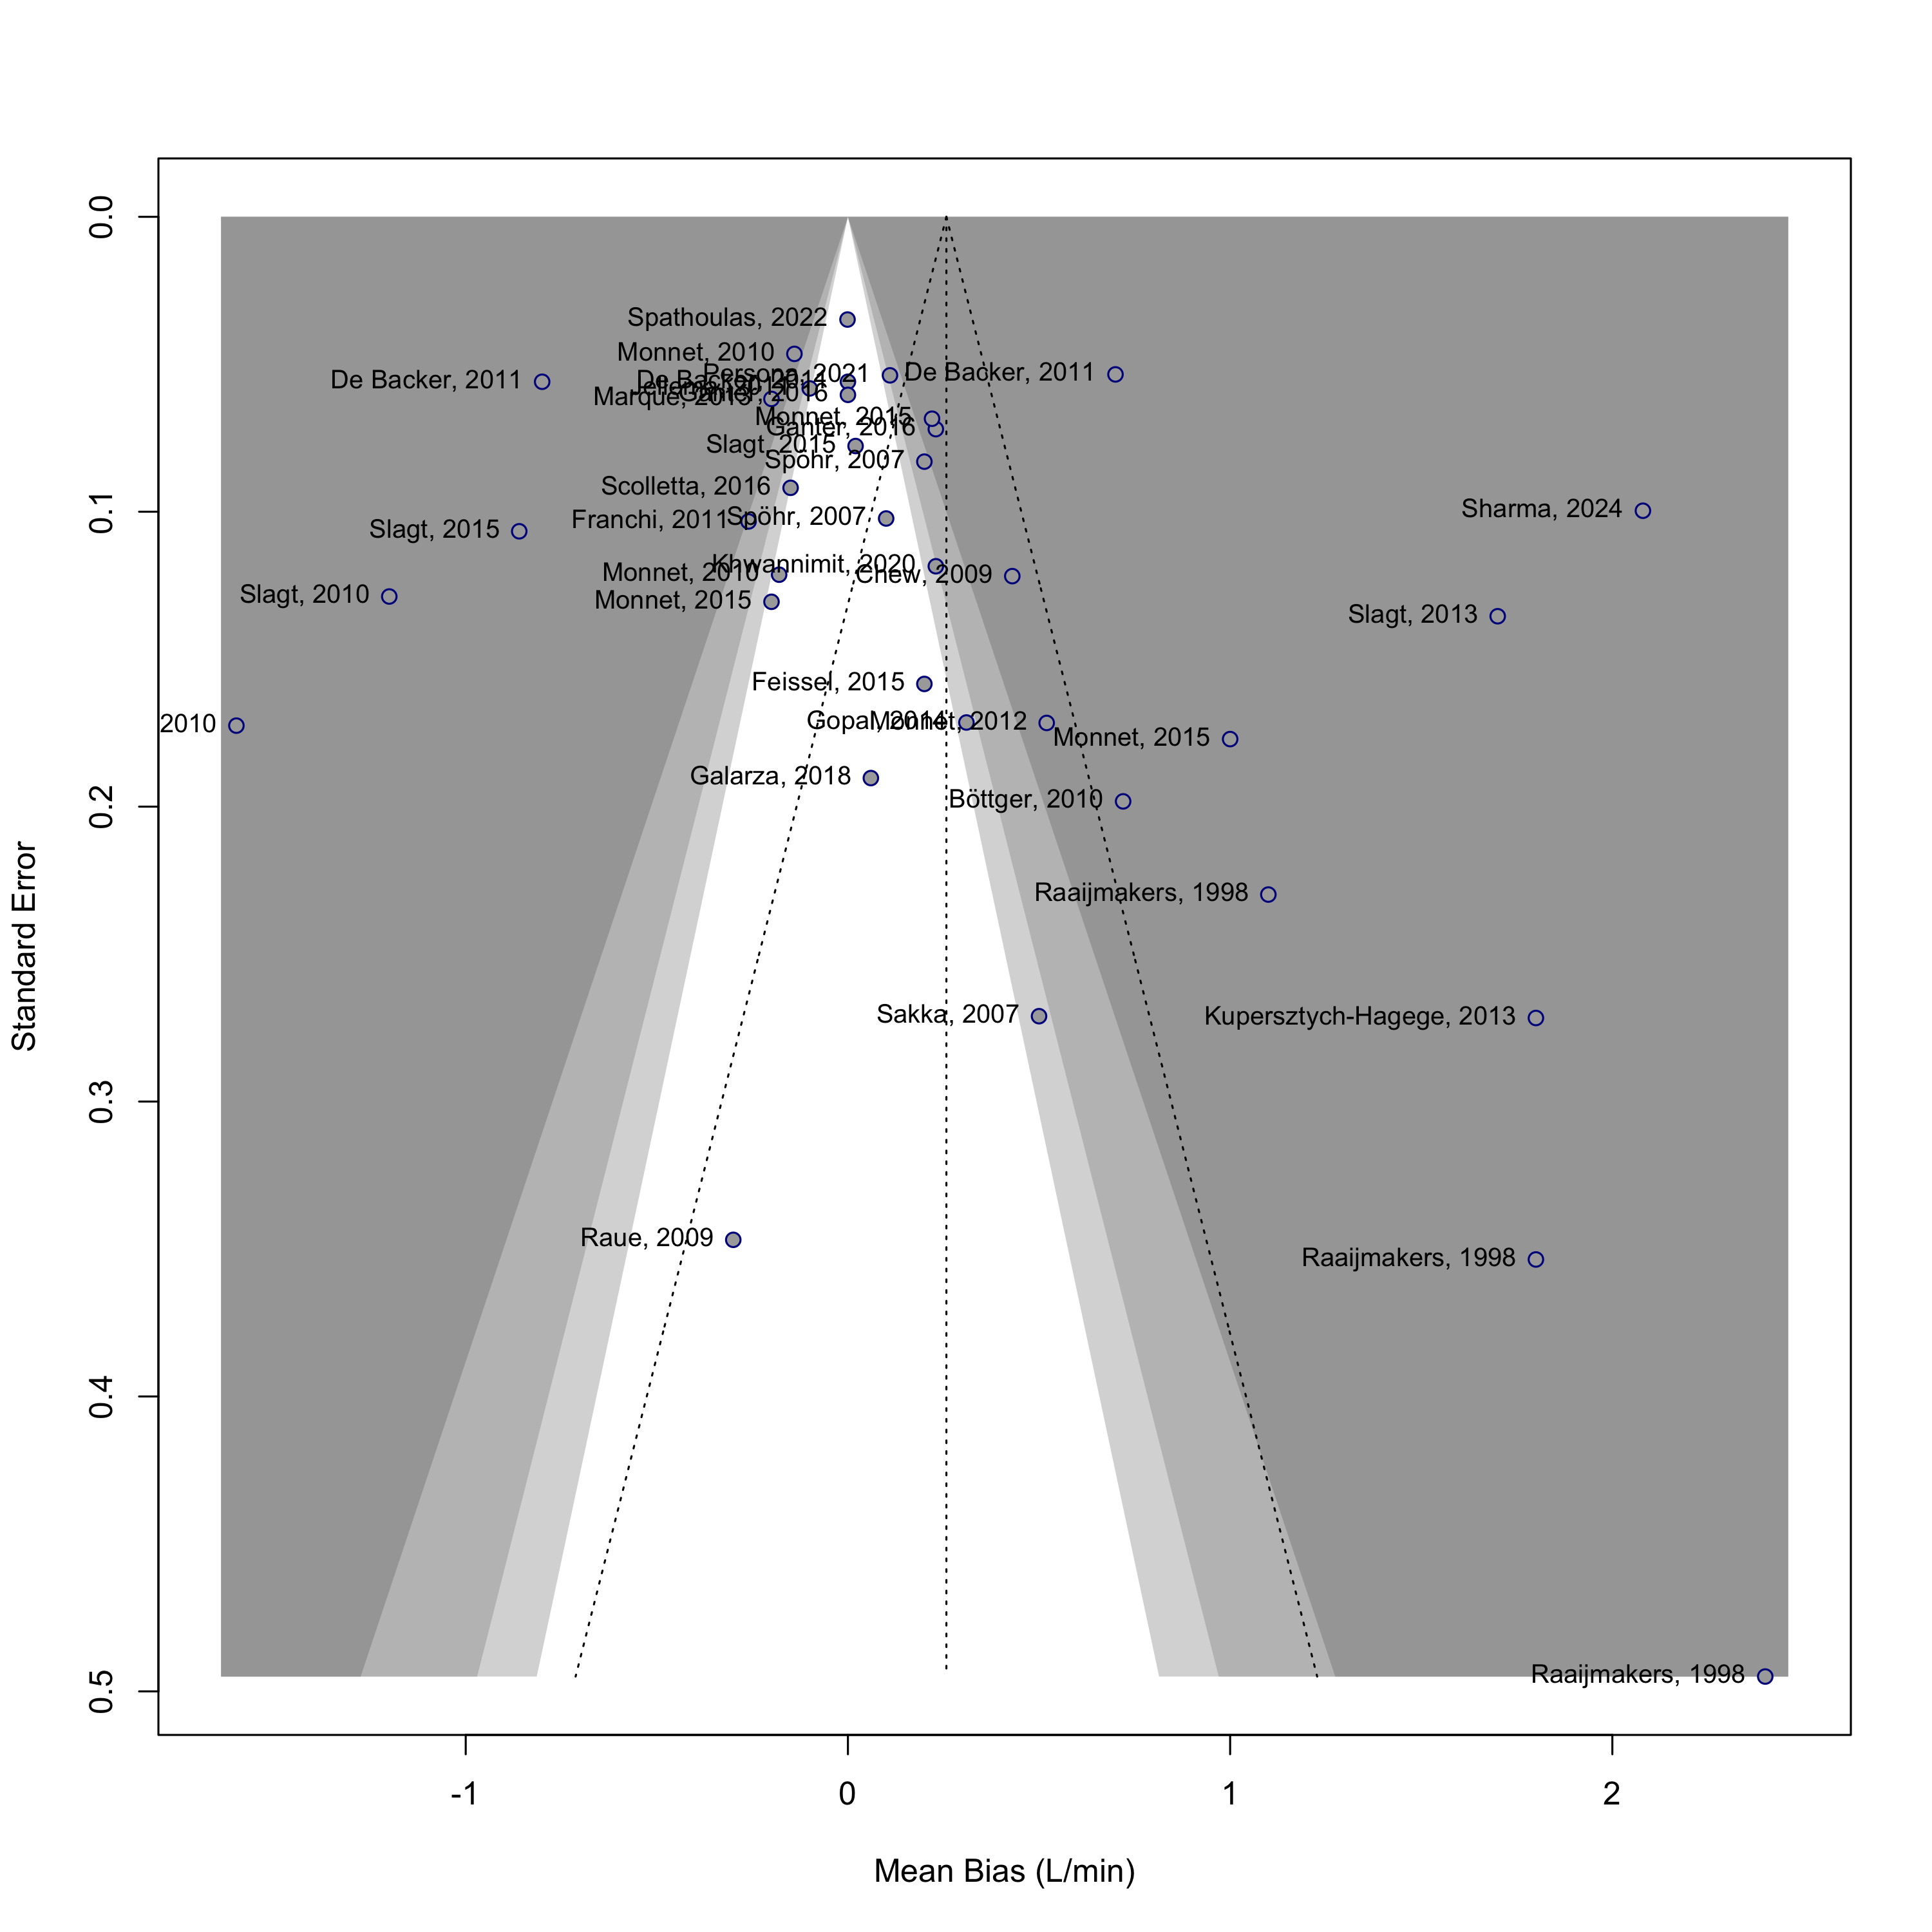

Forest plot displaying the mean bias and 95% confidence intervals (CI) from studies comparing cardiac output (CO) measurements obtained using CO monitoring devices versus reference methods, stratified by reference method. PAC pulmonary artery catheter, TPTD transpulmonary thermodilution, TTE echocardiography. Data sorted by year and device type.

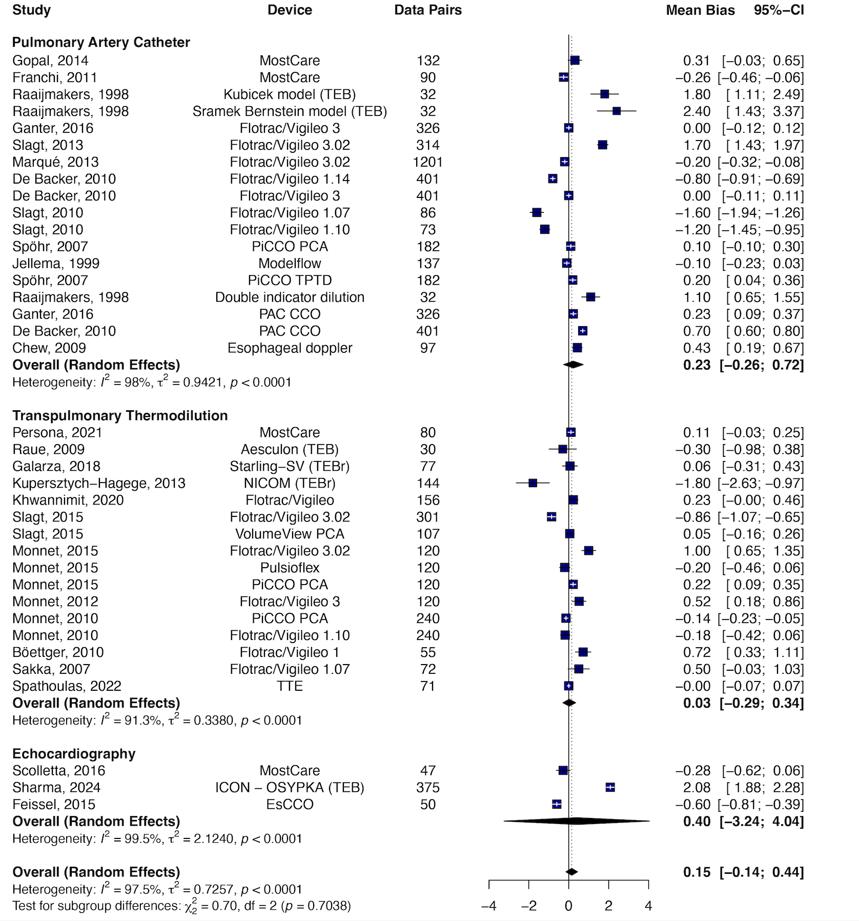

ESM-7 Sensitivity analysis of pure sepsis studies

Synthesis

Symmetrical aspect of the funnel plot was confirmed by the Egger test (P=0.2559)

Meta-regression found no significant associations between mean bias and year, funding, country, blinding, monitoring type, or reference method (all p > 0.46). High residual heterogeneity (I² = 99.09%) suggests unmeasured factors influence bias estimates.

Overall

Pooled Mean CO | Pooled SD | Pooled LoA | Pooled PE | k | MD [95% CI] (P value) | τ² | I²
 |  |  |  | 33 | 0.2015 [-0.1010; 0.5041] | 0.7047 | 97.8%
  6.886
  1.6155
  3.16
  46%

By Device

Subgroup | Pooled Mean CO | Pooled SD | Pooled LoA (1.96 × SD) | Pooled PE | k | MD (95% CI) | τ² | I²
TEB | 6.8902 | 2.0026 | 3.92 | 57% | 4 | 1.4889 [-0.4468; 3.4246] | 1.3346 | 93.3%
PCA | 6.877 | 1.6843 | 3.30 | 48% | 19 | -0.0452 [-0.4068; 0.3165] | 0.5465 | 97.2%
PRAM | 6.3576 | 1.4484 | 2.83 | 44.65 | 3 | 0.0370 [-0.6658; 0.7397] | 0.5467 | 84%
Flotrac/Vigileo | 6.6811 | 1.8036 | 3.53 | 52.91% | 13 | -0.0586 [-0.6124; 0.4953] | 0.8191 | 98.0%
Other PCA | 7.8215 | 1.0929 | 2.14 | 27.39% | 6 | -0.0134 [-0.1781; 0.1513] | 0.0189 | 79.2%
Calibrated PCA | 7.7919 | 0.9836 | 1.9278 | 24.74 % | 4 | 0.02 [−0.17; 0.21] | 0.0175 | 81.9%
Non-calibrated PCA | 6.691 | 1.7933 | 3.5148 | 52.53 % | 15 | −0.07 [−0.58; 0.44] | 0.7558 | 97.2%,

PCA | PRAM | TEB

Q = 5.91, df = 2, p = 0. 0.0521

The difference between subgroups is borderline significant
TEB likely drives the overall difference.

Flotrac/Vigileo | Other PCA

No significant difference between subgroups

By Reference

Subgroup | Pooled Mean CO | Pooled SD | Pooled LoA (1.96 × SD) | Pooled PE | k | MD (95% CI) | τ² | I²
PAC | 6.9951 | 1.6333 | 3.2 | 46% | 18 | 0.2330 [-0.2566; 0.7227] | 0.9421 | 98.0%
TPTD | 6.6832 | 1.5078 | 2.95 | 44% | 13 | 0.0765 [-0.2060; 0.3591] | 0.1976 | 91.7%

No significant difference between subgroups

Meta-regression

- tau^2 (estimated residual heterogeneity): 1.0680 (SE = 0.4493)
- I^2 (residual heterogeneity / unaccounted variability): 99.09%
- H^2 (unaccounted variability / sampling variability): 110.04
- R^2 (amount of heterogeneity accounted for): 0.00%

Variable | Estimate | 95% CI | p-value
Intercept | 77.22 | [-314.40, 468.85] | 0.6727
Year | -0.037 | [-0.233, 0.158] | 0.6815
Industry Funded | -0.011 | [-2.225, 2.202] | 0.9914
Country | Mixed | Mixed | All p > 0.70
Blinded | -0.576 | [-5.201, 4.048] | 0.7889
Co_test_type | Mixed | Mixed | All p > 0.46
Reference | Mixed | Mixed | All p > 0.65
Mean CO | -0.0165 | [-1.5179, 1.4849] | 0.98
SVR | 0.0019 | [-0.0105, 0.0143] | 0.76

📌 Egger: P = 0.2559
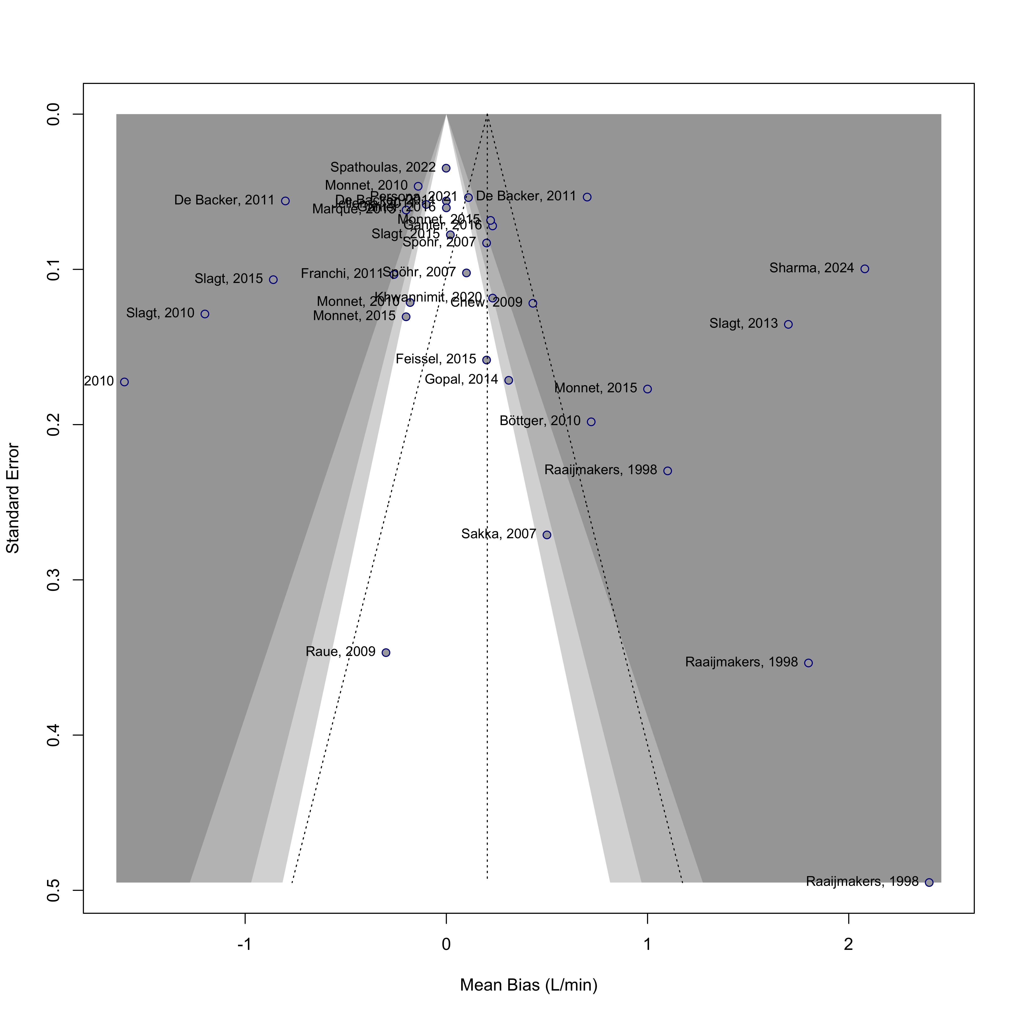

Forest plot displaying the mean bias and 95% confidence intervals (CI) from studies comparing cardiac output (CO) measurements obtained using various CO monitoring devices versus reference methods. Data were derived from Bland–Altman analysis of the included studies.

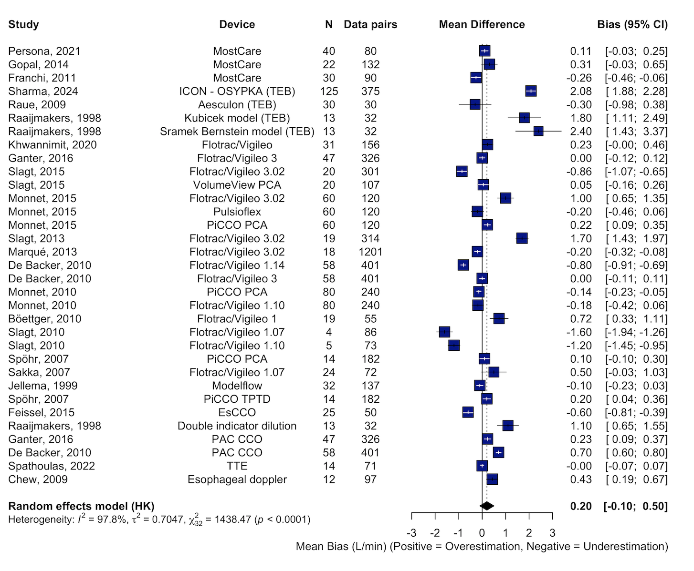

Forest plot displaying the mean bias and 95% confidence intervals (CI) from studies comparing cardiac output (CO) measurements obtained using CO monitoring devices versus reference methods, stratified by device type. Data were derived from Bland–Altman analysis of the included studies. PCA Pulse Contour Analysis, TEB Thoracic Electrical Bioimpedance.
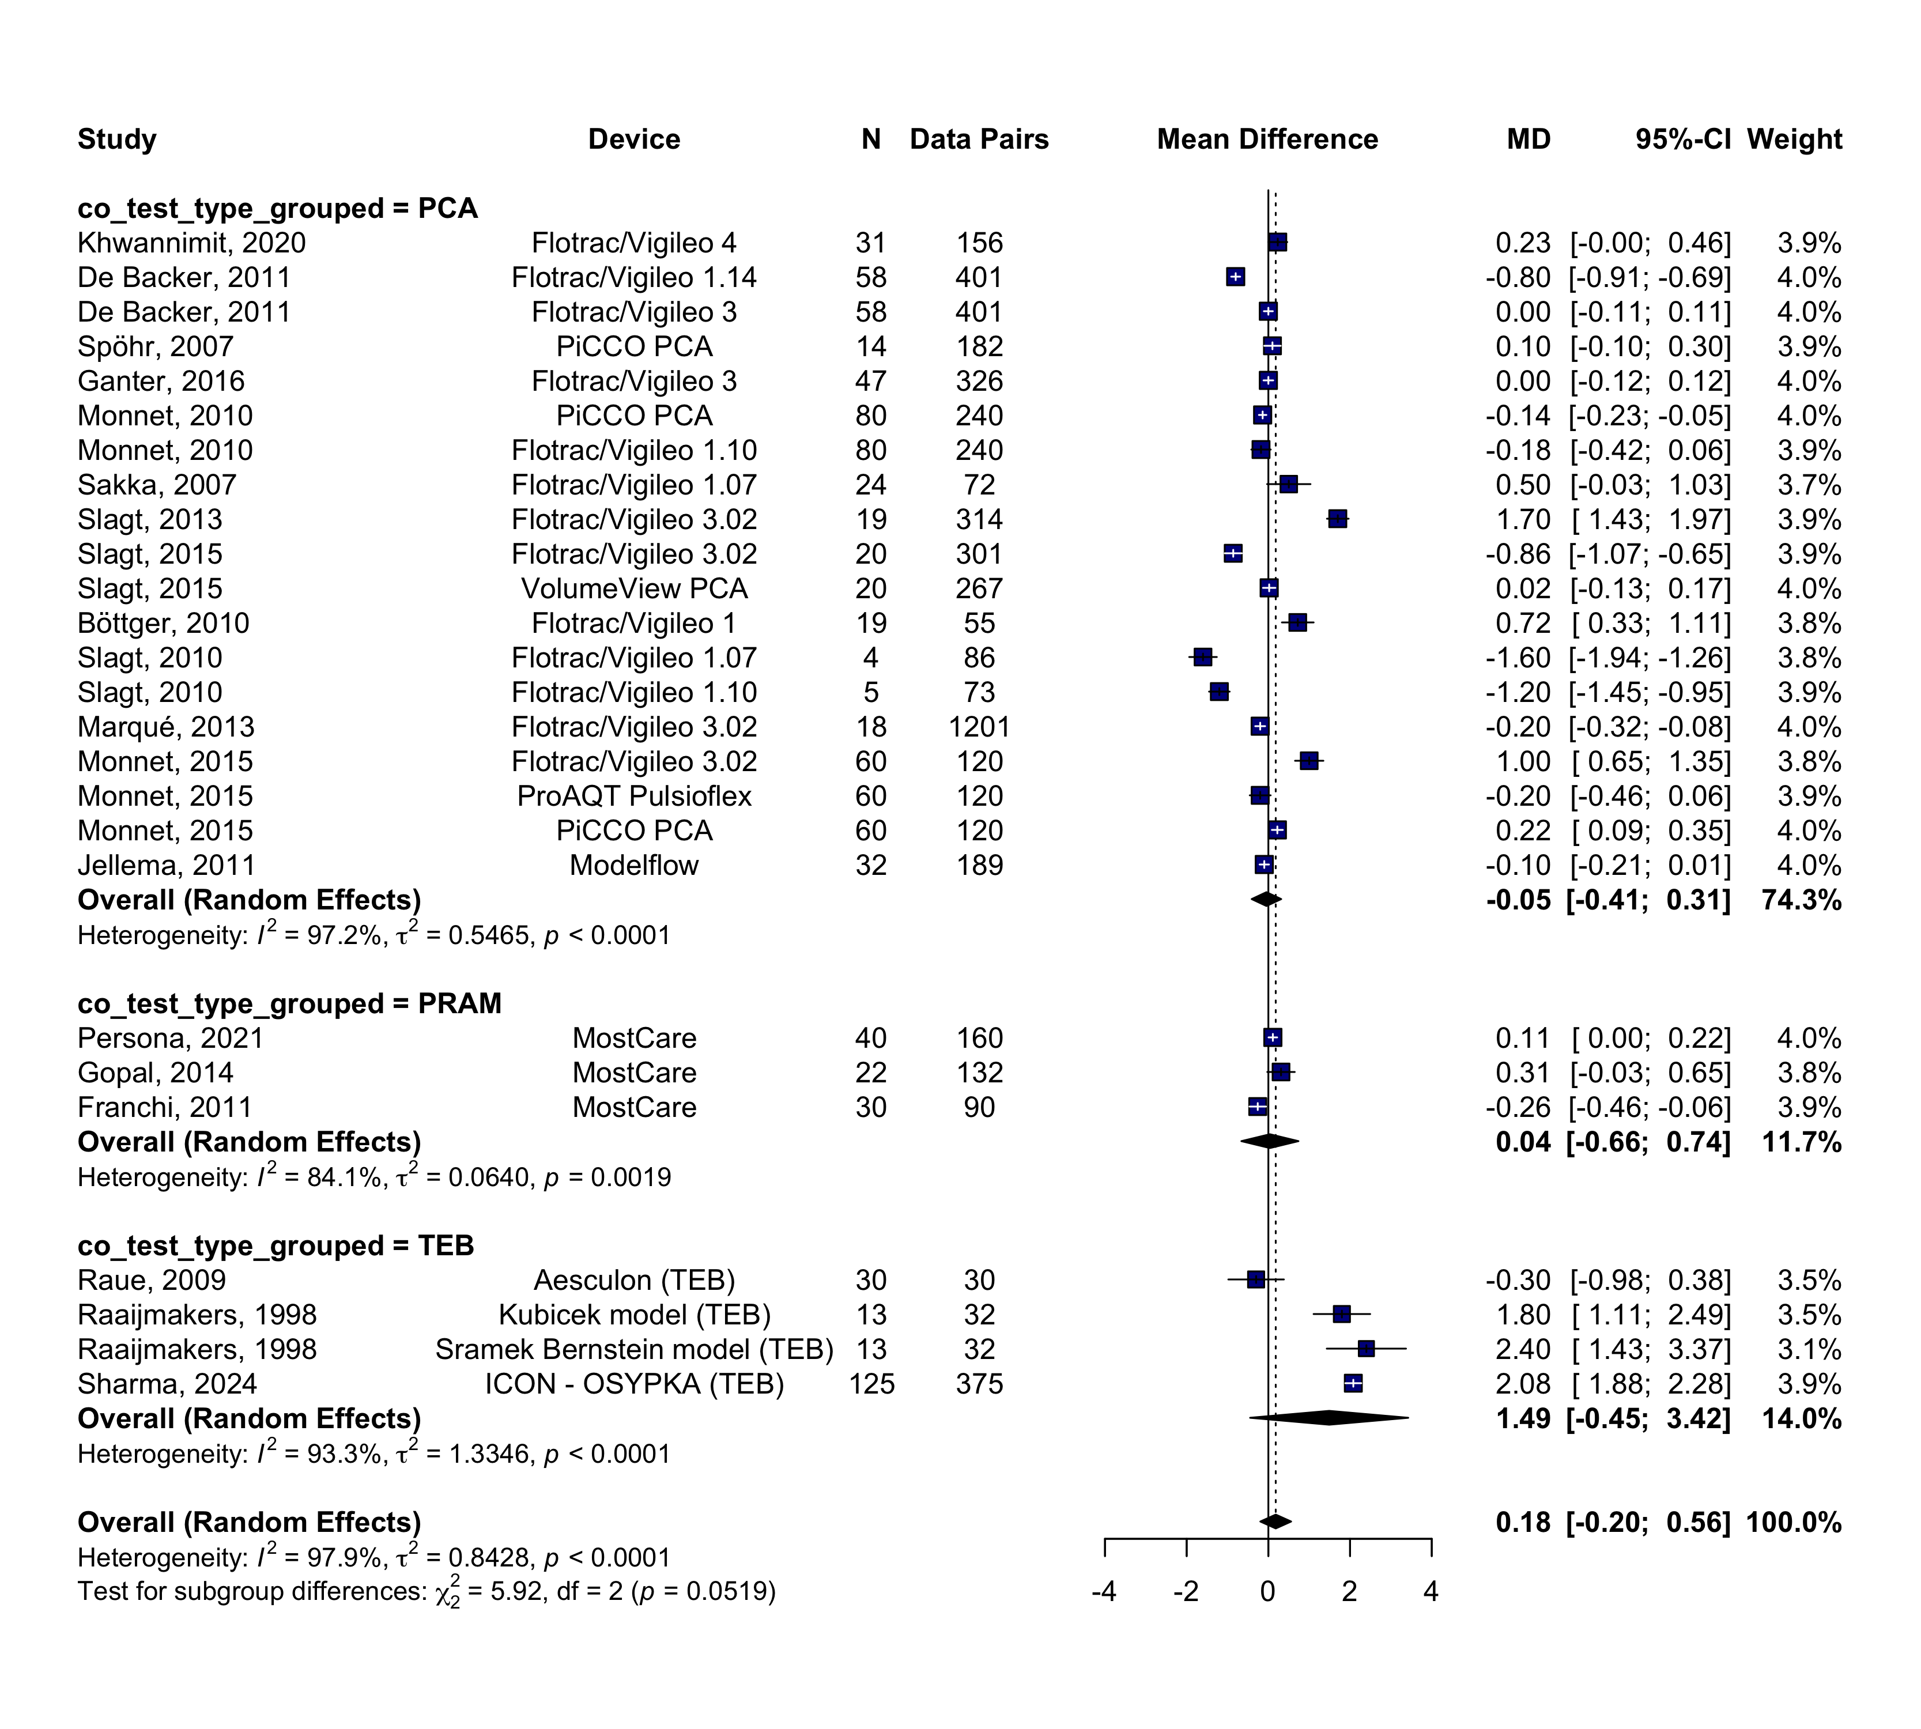

Forest plot displaying the mean bias and 95% confidence intervals (CI) from studies comparing cardiac output (CO) measurements obtained using CO monitoring devices versus reference methods, stratified by reference method. PAC pulmonary artery catheter, TPTD transpulmonary thermodilution, TTE echocardiography.

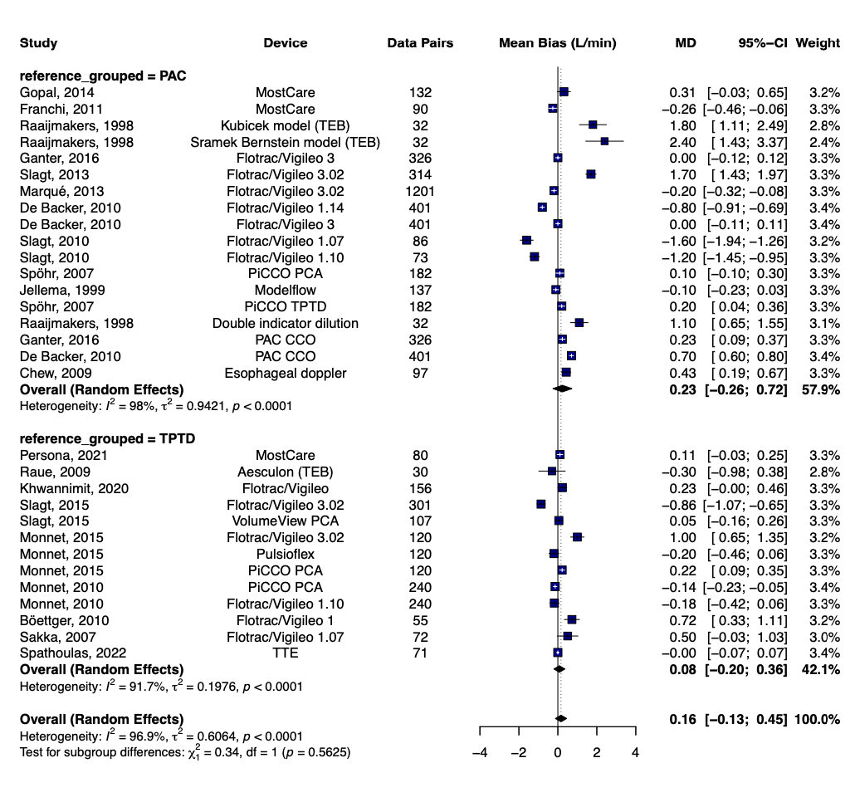

Forest plot displaying the mean bias and 95% confidence intervals (CI) from studies comparing cardiac output (CO) measurements obtained using CO monitoring devices versus reference methods, stratified by pulse contour analysis device type (calibrated vs non-calibrated).

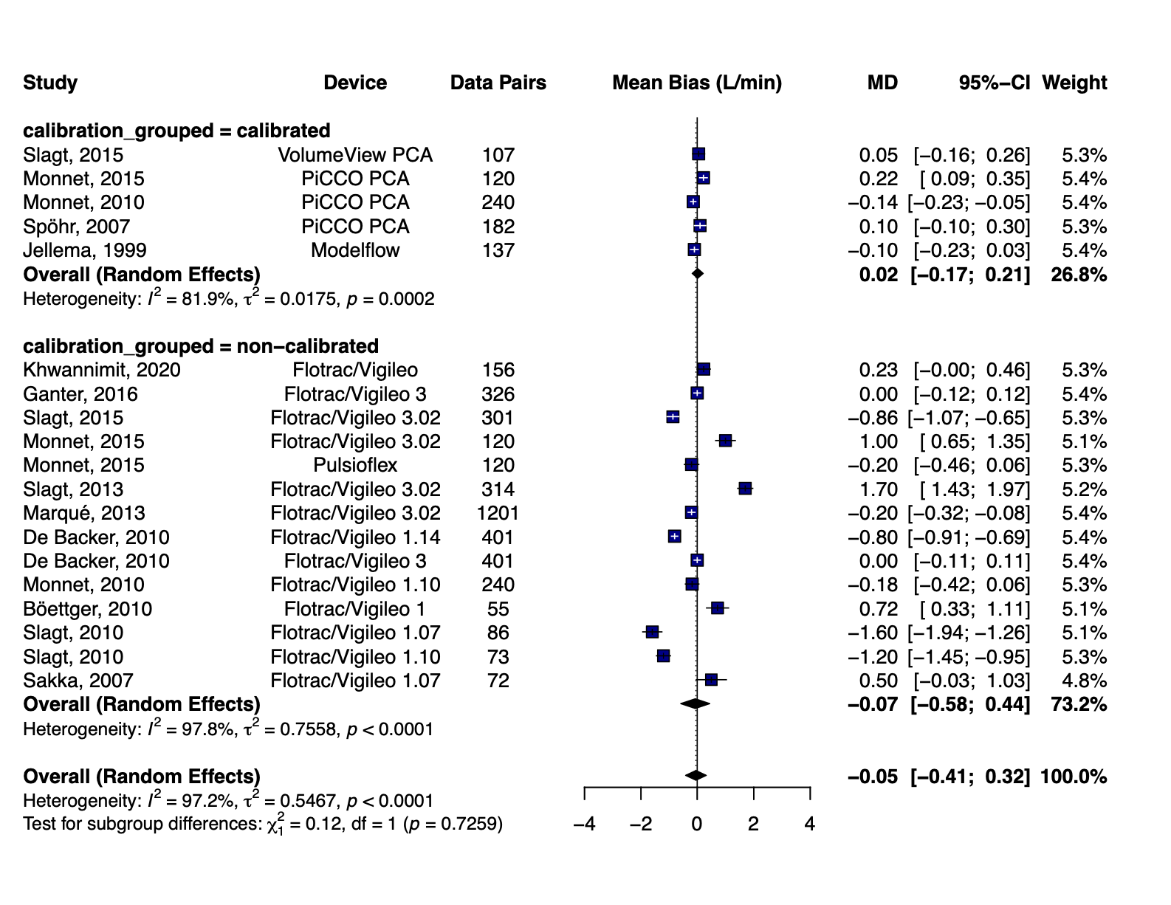

References

1. Raaijmakers E, Faes TJ, Kunst PW, et al. The influence of extravascular lung water on cardiac output measurements using thoracic impedance cardiography. Physiol Meas. 1998;19(4):491-499. doi:10.1088/0967-3334/19/4/004
2. De Backer D, Marx G, Tan A, et al. Arterial pressure-based cardiac output monitoring: a multicenter validation of the third-generation software in septic patients. Intensive Care Med. 2011;37(2):233-240. doi:10.1007/s00134-010-2098-8
3. Spöhr F, Hettrich P, Bauer H, Haas U, Martin E, Böttiger BW. Comparison of two methods for enhanced continuous circulatory monitoring in patients with septic shock. Intensive Care Med. 2007;33(10):1805-1810. doi:10.1007/s00134-007-0703-2
4. Ganter MT, Alhashemi JA, Al-Shabasy AM, et al. Continuous cardiac output measurement by un-calibrated pulse wave analysis and pulmonary artery catheter in patients with septic shock. J Clin Monit Comput. 2016;30(1):13-22. doi:10.1007/s10877-015-9672-0
5. Monnet X, Anguel N, Naudin B, Jabot J, Richard C, Teboul JL. Arterial pressure-based cardiac output in septic patients: different accuracy of pulse contour and uncalibrated pressure waveform devices. Crit Care Lond Engl. 2010;14(3):R109. doi:10.1186/cc9058
6. Slagt C, Helmi M, Malagon I, Groeneveld ABJ. Calibrated versus uncalibrated arterial pressure waveform analysis in monitoring cardiac output with transpulmonary thermodilution in patients with severe sepsis and septic shock: an observational study. Eur J Anaesthesiol. 2015;32(1):5-12. doi:10.1097/EJA.0000000000000173
7. Slagt C, Beute J, Hoeksema M, Malagon I, Mulder JWR, Groeneveld JAB. Cardiac output derived from arterial pressure waveform analysis without calibration vs. thermodilution in septic shock: evolving accuracy of software versions. Eur J Anaesthesiol. 2010;27(6):550-554. doi:10.1097/EJA.0b013e3283333a92
8. Monnet X, Vaquer S, Anguel N, et al. Comparison of pulse contour analysis by Pulsioflex and Vigileo to measure and track changes of cardiac output in critically ill patients. Br J Anaesth. 2015;114(2):235-243. doi:10.1093/bja/aeu375
9. Chew HC, Devanand A, Phua GC, Loo CM. Oesophageal Doppler ultrasound in the assessment of haemodynamic status of patients admitted to the medical intensive care unit with septic shock. Ann Acad Med Singapore. 2009;38(8):699-703.
10. Scolletta S, Franchi F, Romagnoli S, et al. Comparison Between Doppler-Echocardiography and Uncalibrated Pulse Contour Method for Cardiac Output Measurement: A Multicenter Observational Study. Crit Care Med. 2016;44(7):1370-1379. doi:10.1097/CCM.0000000000001663
11. Monnet X, Anguel N, Jozwiak M, Richard C, Teboul JL. Third-generation FloTrac/Vigileo does not reliably track changes in cardiac output induced by norepinephrine in critically ill patients. Br J Anaesth. 2012;108(4):615-622. doi:10.1093/bja/aer491
12. Kupersztych-Hagege E, Teboul JL, Artigas A, et al. Bioreactance is not reliable for estimating cardiac output and the effects of passive leg raising in critically ill patients. Br J Anaesth. 2013;111(6):961-966. doi:10.1093/bja/aet282
13. Galarza L, Mercado P, Teboul JL, et al. Estimating the rapid haemodynamic effects of passive leg raising in critically ill patients using bioreactance. Br J Anaesth. 2018;121(3):567-573. doi:10.1016/j.bja.2018.03.013
14. Khwannimit B, Jomsuriya R. Comparison the accuracy and trending ability of cardiac index measured by the fourth- generation of FloTrac with the PiCCO device in septic shock patients. Turk J Med Sci. 2020;50(4):860-869. doi:10.3906/sag-1909-58
15. Marqué S, Gros A, Chimot L, et al. Cardiac output monitoring in septic shock: evaluation of the third-generation Flotrac-Vigileo. J Clin Monit Comput. 2013;27(3):273-279. doi:10.1007/s10877-013-9431-z
16. Slagt C, de Leeuw MA, Beute J, et al. Cardiac output measured by uncalibrated arterial pressure waveform analysis by recently released software version 3.02 versus thermodilution in septic shock. J Clin Monit Comput. 2013;27(2):171-177. doi:10.1007/s10877-012-9410-9
17. Feissel M, Aho LS, Georgiev S, et al. Pulse Wave Transit Time Measurements of Cardiac Output in Septic Shock Patients: A Comparison of the Estimated Continuous Cardiac Output System with Transthoracic Echocardiography. PloS One. 2015;10(6):e0130489. doi:10.1371/journal.pone.0130489

