PROTECMO - List of Contributors and Institutions
Europe
Antonio Arcadipane | Istituto Mediterraneo per i Trapianti e Terapie ad alta specializzazione. IRCCS-ISMETT
Marco Barbara
Paolo Capuano
Claudia Costantino
Gennaro Martucci
Nicolò Rizzitello
Monica Rizzo
Matteo Rossetti
Fabio Tuzzolino
Antonio Pesenti | Department of Anesthesia, Intensive Care and Emergency, Fondazione IRCCS Ca' Granda Ospedale Maggiore Policlinico, Milan, Italy; Department of Pathophysiology and Transplantation, University of Milan, Italy
Giacomo Grasselli
Matteo Brioni
Gennaro De Pascale | Dipartimento di Scienze dell’Emergenza, Anestesiologiche e della Rianimazione, Fondazione Policlinico Universitario A. Gemelli IRCCS, Rome, Italy;
Luca Montini
Marco Giani | Fondazione IRCCS San Gerardo dei Tintori Monza, Università degli Studi di Milano Bicocca
Giuseppe Foti
Emanuele Rezoagli
Luca Brazzi | Department of Surgical Sciences, University of Turin, Italy.  Department of Anesthesia, Critical Care and Emergency - Città della Salute e della Scienza Hospital – University of Turin, Italy.
Pierfrancesco Curcio
Vito Fanelli
Eugenio Garofalo | Mater Domini University Hospital
Luis Martin-Villen | Hospital Universitario Virgen Del Rocio
Raquel Garcìa-Álvarez | Universitary Hospital 12 de Octubre
Marta Lopez Sanchez | Hospital Universitario Marqués de Valdecilla – Santander
Nuno Principe | Department of Emergency and Intensive Care Medicine, Centro Hospitalar Universitário de São João, Porto, Portugal
Violeta Chica Saez | Hospital Universitario Virgen De Las Nieves
Juan Ignacio Chico | Critical Care Department. Alvaro Cunqueiro University Hospital; Vigo (Spain).
Vanesa Gomez
Joaquin Colomina-Climent | Hospital Universitario Son Espases
Jordi Riera | Critical Care Department, Hospital Universitari Vall d'Hebron, Barcelona, Spain; SODIR, Vall d'Hebron Institut de Recerca, Barcelona, Spain; CIBERES. Instituto de Salud Carlos III
Andres Francisco Pacheco
Camilo Bonilla
Eduard Argudo
María Martínez-Martínez
María Martínez-Pla
Pau Torrella
Bet Gallart
Vojka Gorjup | Ecmo center Ljubljana
Julien Goutay | CHRU Lille, Hôpital Roger Salengro
Duburcq Thibault | CHRU Lille, Hôpital Roger Salengro
Konstanty Szułdrzyński | Central Clinical Hospital of the Ministry of Interior and Administration in Warsaw;  Faculty of Medicine, Jagiellonian University Medical College, Krakow
Mariusz Kowalewski | Department of Cardiac Surgery and Transplantology, Central Clinical Hospital of the Ministry of Interior, Centre of Postgraduate Medical Education, Warsaw, Poland
Philipp Eller | Medical University Graz
Nina Buchtele | Department of Medicine I, Intensive Care Unit 13i2, Center of Excellence in Medical Intensive Care (CEMIC), Medical University of Vienna, Vienna, Austria
Elisabeth Lobmeyr
Peter Schellongowski
Matthieu Schmidt | Sorbonne Université, INSERM, UMRS_1166-ICAN, Institute of Cardiometabolism and Nutrition, and Service de médecine intensive-réanimation, Institut de Cardiologie, APHP Sorbonne Université Hôpital Pitié–Salpêtrière, F-75013 PARIS, France
Alain Combes
Roberto Lorusso | Cardiothoracic Surgery Department - Hart+Vaat Centrum - Maastricht University Medical Center (MUMC+), CARIM - Cardiovascular Research Institute Maastricht - Maastricht University
Silvia Mariani
Marco Vito Ranieri | Alma Mater Studiorum, University of Bologna
Pavel Suk | Department of Anaesthesia and Intesive Care, International Clinical Research Center, St. Anne's University Hospital Brno, Brno, Czech Republic
Michal Maly | 1st Medical Faculty and General University Hospital, Prague
Martin Balik | 1st Medical Faculty and General University Hospital, Prague
Jakob Forestier | ECMO Centre Karolinska, Karolinska University Hospital; Department of Physiology and Pharmacology, Karolinska Institutet, Stockholm, Sweden
Lars Mikael Broman
Nicolò Rizzitello | Statistics and Data Management Services. Istituto Mediterraneo per i Trapianti e Terapie ad alta specializzazione. IRCCS-ISMETT
Marco Barbara
Monica Rizzo
Fabio Tuzzolino
North America
Kenichi Tanaka | The University of Oklahoma College of Medicine
Tyler Holsworth | Meijer Heart Center Butterworth Hospital,Spectrum Health, Grand Rapids, Michigan 49506
Brian Trethowan
Alexis Serra | Department of Medicine and Center for Acute Respiratory Failure, Columbia University, Irving Medical Center, New York, USA
Cara Agerstrand
Darryl Abrams
Daniel Brodie | Department of Medicine, School of Medicine, Johns Hopkins University
Yiorgos Alexandros Cavayas | Division of Critical Care, Department of Medicine, Hôpital du Sacré-Coeur de Montréal, Université de Montréal, Canada
Ali Tabatabai | University of Maryland St. Joseph Medical Center, Towson, MD, USA
Jay Menaker | University of Maryland School of Medicine, Baltimora, MD, USA
Samuel Galvagno
Whitney D. Gannon | Department of Allergy, Pulmonary, and Critical Care Medicine.Vanderbilt University Medical Center, Nashville, TN, USA
Todd W. Rice
Wilson E. Grandin | Beth Israel Deaconess Medical Center
Jose Nunez | Beth Israel Deaconess Medical Center
Collette Cheplic | University of Pittsburgh Medical Center
Raj Ramanan | University of Pittsburgh Medical Center
Ryan Rivosecchi | University of Pittsburgh Medical Center
Harikesh Subramanian | University of Pittsburgh Medical Center
Asia
Young-Jae Cho | Seoul National University Bundang Hospital
Sarah Buabbas | Kuwait ECLS center. Department of anesthesia, critical care and pain medicine. Jaber Al-Ahmad and Al-Amiri hospital
Huda Alfoudri
Kyeongman Jeon | Samsung Medical Center, Sungkyunkwan University School of Medicine
Ming Chit Kwan | Tuen Mun Hospital
Hend Sallam | King Faisal Specialist Hospital & Research Center
Joy Ann Villanueva | Hamad Medical Corporation
Jeffrey Aliudin | Hamad Medical Corporation
Ali Ait Hssain | Hamad Medical Corporation
Kota Hoshino | Fukuoka University Hospital
Yoshitaka Hara | Fujita Health University School of Medicine
Kollengode Ramanathan | National University of Singapore
Graeme Maclaren | National University of Singapore
Australia
Hergen Buscher | St Vincent’s Hospital

Recruiting Centers
University of Maryland Medical Center
Hamad Medical Corporation - Quatar
CHRU Lille, Hôpital Roger Salengro
Fondazione IRCCS San Gerardo Monza
University of Pittsburgh
ISMETT
Ospedale Maggiore Policlinico Milano
Vanderbilt University Medical Center
HOSPITAL ALVARO CUNQUEIRO
Ministry of Health_kuwait
Universita Cattolica
Vall dHebron University Hospital
Ecmo center Ljubljana
Maastricht UMC
Universita di Torino
Columbia University Irving Medical Center
Samsung Medical Center
Meijer heart Center
Charles University, Prague
Medical University Graz
ECMO Centre Karolinska
St Vincents Hospital, Sidney
Fujita Health University School of Medicine
St. Annes University Hospital Brno
Mater Domini, University Hospital
University of Paris
Beth Israel Deaconess Medical Center
King Faisal Specialist Hospital
Tuen Mun Hospital
Fukuoka University Hospital
HOSPITAL UNIVERSITARIO VIRGEN DEL ROCIO
UNIVERSITARY HOSPITAL 12 DE OCTUBRE
Medical University of Vienna
Hospital Universitario Marqués de Valdecilla – Santander
Hospital Universitario Son Espases
Centro Hospitalar São João
Uniwersytet Jagiellonski W Krakowie
HOSPITAL UNIVERSITARIO VIRGEN DE LAS NIEVES
National University of Singapore
Hopital du Sacre-Cœur de Montreal

Table E1. Transfusion requirements and clinical outcome according to baseline platelet count
Variables | All Patients N=652 | No Thrombocytopenia N=470 | Mild Thrombocytopenia N=96 | Moderate Thrombocytopenia N=57 | Severe Thrombocytopenia N=29
PRBC transfusion during ECMO (mL), median (IQR) | 1432 (3867-3000) | 1464 (400-3084) | 1195 (350-2525) | 1710 (600-2686) | 1530 (450-3000)
Platelets transfusion during ECMO (mL), median (IQR) | 0 (0-454) | 0 (0-240) | 0 (0-546) | 296 (0-1336) | 1060 (250-2000)
Successful ECMO weaning, n (%) | 445 (68.25%) | 317 (67.45%) | 75 (78.13%) | 39 (68.42%) | 14 (48.28%)
ECMO duration (days), median (IQR) | 10.8 (5.9-19.9) | 11.5 (6.2 - 21.0) | 9.2 (6.1 - 19.5) | 7.1 (4.6 - 17.1) | 8.0 (5.3 – 21.0)
ICU survival, n (% column) | 396 (60.74%) | 288 (61.28%) | 66 (68.75%) | 32 (56.14%) | 10 (34.48%)
ICU length of stay (days), median (IQR) | 26.3 (15.5-43.7) | 26.7 (16.0 - 44.7) | 22.7 (15.6 - 41.8) | 28.7 (14.1 - 41.8) | 21.2 (13.1-41.7)
Hospital survival, n (% column) | 387 (59.36%) | 281 (59.79%) | 66 (68.75%) | 31 (54.39%) | 9 (31.03%)
Hospital length of stay (days), median (IQR) | 38.1 (23.0-60.1) | 37.0 (22.8 - 59.8) | 39.3 (24.5 - 54.6) | 41.7 (29.8 - 72.1) | 34.6 (14.3-50.1)
6 Months Status (Alive), n (% column) | 371 (56.90%) | 268 (57.02%) | 65 (67.71%) | 30 (52.63%) | 8 (27.59%)
Bleeding rate, n (%) | 344 (52.8%) | 247 (52.6%) | 53 (55.2%) | 29 (50.9%) | 15 (51.7%)
Abbreviations: ECMO, extracorporeal membrane oxygenation; ICU, intensive care unit; IQR, interquartile range

Table E2. Severity of thrombocytopenia and associated risk of bleeding; Reference for hazard ratios: no thrombocytopenia.
Variable | Hazard Ratio (HR) | 95% CI | p-value
Thrombocytopenia
Mild | 1.611 | 1.230- 2.109 | 0.0005
Moderate | 1.944 | 1.484- 2.545 | <0.0001
Severe | 1.876 | 1.275- 2.760 | 0.0014

Variable | Hazard Ratio (HR) | 95% CI | p-value
Thrombocytopenia
Mild | 1.611 | 1.230- 2.109 | 0.0005
Moderate+Severe | 1.925 | 1.504- 2.464 | <0.0001

Table E3. Time-dependent cox proportional hazards regression of absolute platelet count adjusted by baseline thrombocytopenia severity on the first bleeding event.
Parameter | Hazard Ratio (HR) | 95% CI | p-value
Platelet Count (10·10⁹/L) | 0.963 | 0.950-0.976 | <.0001

Table E4. Binary logistic regression of relative platelet drop, baseline platelet count and thrombocytopenia severity on the first bleeding event. Relative platelet drop is computed by (baseline platelet count (1·10⁹/L) – platelet nadir (1·10⁹/L))/baseline platelet count (1·10⁹/L).
Parameter | Odds Ratio (OR) | 95% CI | p-value
Relative platelet drop (%) | 1.003 | 0.803- 1.254 | 0.9772
Baseline platelet count (1·10⁹/L) | 1.000 | 0.998- 1.002 | 0.9278
Mild thrombocytopenia (baseline) | 1.126 | 0.676- 1.876 | 0.6478
Moderate thrombocytopenia (baseline) | 0.950 | 0.500- 1.804 | 0.8756
Severe thrombocytopenia (baseline) | 0.990 | 0.409- 2.399 | 0.9824

Table E5. Binary logistic regression of absolute platelet drop, baseline platelet count and thrombocytopenia severity on the first bleeding event.
Variable | Odds Ratio (OR) | 95% CI | p-value
Absolute platelet drop (unit=50·10⁹/L) | 0.859 | 0.767- 0.962 | 0.0084
Baseline platelet count (unit=50·10⁹/L) | 1.133 | 1.002- 1.282 | 0.0469
Baseline thrombocytopenia class: Mild vs Normal | 1.218 | 0.727- 2.039 | 0.4542
Baseline thrombocytopenia class: Moderate vs Normal | 1.086 | 0.566- 2.082 | 0.8043
Baseline thrombocytopenia class: Severe vs Normal | 1.16 | 0.487- 2.762 | 0.738

Table E6. Time-dependent cox proportional hazards regression of the first bleeding event on thrombocytopenia duration and severity
Parameter |  | Hazard  Ratio | 95% CI | p-value
Consecutive days with thrombocytopenia |  | 0.945 | 0.901-0.993 | 0.0240
Thrombocytopenia | Mild | 1.419 | 1.063-1.896 | 0.0177
Thrombocytopenia | Moderate | 1.749 | 1.317-2.323 | 0.0001
Thrombocytopenia | Severe | 1.737 | 1.174-2.570 | 0.0058

Table E7. GEE Model Parameter Estimates for Platelet Count as a Continuous Outcome. The analysis is adjusted for baseline platelet count and platelet transfusion volume within the previous 24 hours. A multiple analysis was conducted, including all parameters significant in the univariate analysis at p < 0.1. The univariate analysis is not presented.

Analysis Of GEE Parameter Estimates
Empirical Standard Error Estimates
Parameter | Estimate | Standard  Error | 95% Confidence Limits |  | p-value
Age | -0.4363 | 0.1778 | -0.7848 | -0.0877 | 0.0142
Postoperative state | -17.8077 | 7.1522 | -31.8257 | -3.7897 | 0.0128
Immunocompromised status | -23.5648 | 5.0388 | -33.4407 | -13.6890 | <.0001
Continuous renal replacement therapy | -10.2096 | 3.8421 | -17.7400 | -2.6792 | 0.0079
Septic shock | -18.7437 | 3.7494 | -26.0924 | -11.3950 | <.0001
Hemoglobin | 4.9372 | 1.5306 | 1.9372 | 7.9372 | 0.0013
Fibrinogen | 0.0333 | 0.0097 | 0.0142 | 0.0524 | 0.0006
Bleeding | -6.6011 | 2.1201 | -10.7565 | -2.4458 | 0.0018
ECMO Circuit change | -17.8128 | 3.5136 | -24.6994 | -10.9262 | <.0001
ECMO revolutions per minute (rpm) | -0.0065 | 0.0025 | -0.0115 | -0.0015 | 0.0104

Table E8. Summary of Covariates in GEE Models Using Platelet Count ≥100 G/L as the Outcome Variable. The analysis was adjusted for baseline platelet count and platelet transfusion volume within the past 24 hours. Multivariate analysis included all parameters that were significant in the univariate analysis at p < 0.1. The univariate analysis is not presented.
Analysis Of GEE Parameter Estimates
Empirical Standard Error Estimates
Parameter | Estimate | Standard  Error | 95% Confidence Limits |  | p-value
Days in ICU prior to ECMO | -0.0310 | 0.0101 | -0.0507 | -0.0113 | 0.0020
No postoperative admission | 0.4350 | 0.2026 | 0.0379 | 0.8320 | 0.0318
Not immunocompromised | 0.5658 | 0.1632 | 0.2460 | 0.8856 | 0.0005
No continuous renal replacement therapy | 0.8067 | 0.1272 | 0.5574 | 1.0560 | <.0001
No septic shock | 0.5309 | 0.1266 | 0.2829 | 0.7790 | <.0001
Hemoglobin | 0.1036 | 0.0402 | 0.0249 | 0.1823 | 0.0099
No circuit exchange | 0.3423 | 0.1699 | 0.0093 | 0.6753 | 0.0440

Table E9. Summary of the Number of Events
Number of platelets transfusions | Number of patients
1 | 210
2 | 126
3 | 97
4 | 68
5 | 49
6 | 23
7 | 21
8 | 16
9 | 11
10 | 9
11 | 9
12 | 7
13 | 7
14 | 5
15 | 3
16 | 2
17 | 1
18 | 1
19 | 1
20 | 1

Table E10. Results from the Prentice-Williams-Peterson model with common and non-common effects. Baseline platelet count only had an effect on patients, who received platelet transfusions 4 times. Besides bleeding itself, transfusions of pRBCs and plasma, as well as substitution of fibrinogen and tranexamic acid and the fluid balance had a non-common effect on platelet transfusions, indicating effect variation across number of platelet transfusions. Presence of septic shock and circuit exchange had a strong common effect across all strata
Parameter | Parameter  Estimate | Standard  Error | Chi-Square | Hazard  Ratio | p-value
Daily platelet count_1 | -0.02114 | 0.00143 | 218.6277 | 0.979 | <.0001
Daily platelet count_2 | -0.01288 | 0.00222 | 33.8063 | 0.987 | <.0001
Daily platelet count_3 | -0.01403 | 0.00333 | 17.7397 | 0.986 | <.0001
Daily platelet count_4 | -0.01702 | 0.00380 | 20.0240 | 0.983 | <.0001
Baseline platelet count_1 | -0.00539 | 0.0007335 | 53.9960 | 0.995 | <.0001
Baseline platelet count_2 | -0.0002302 | 0.0007839 | 0.0862 | 1.000 | 0.7690
Baseline platelet count_3 | 0.0007707 | 0.00100 | 0.5927 | 1.001 | 0.4414
Baseline platelet count_4 | 0.00355 | 0.00121 | 8.6871 | 1.004 | 0.0032
Fluid balance_1 | 0.0001959 | 0.0000258 | 57.5315 | 1.000 | <.0001
Fluid balance_2 | 0.0000284 | 0.0000445 | 0.4075 | 1.000 | 0.5232
Fluid balance_3 | 0.0001315 | 0.0000572 | 5.2936 | 1.000 | 0.0214
Fluid balance_4 | 0.0001434 | 0.0000649 | 4.8814 | 1.000 | 0.0271
Fibrinogen_1 | -0.00203 | 0.0003366 | 36.2786 | 0.998 | <.0001
Fibrinogen_2 | -0.0001406 | 0.0003706 | 0.1440 | 1.000 | 0.7044
Fibrinogen_3 | -0.0003673 | 0.0004698 | 0.6113 | 1.000 | 0.4343
Fibrinogen_4 | -0.0001912 | 0.0006107 | 0.0980 | 1.000 | 0.7542
Bleeding_1 | -1.64650 | 0.14077 | 136.7971 | 0.193 | <.0001
Bleeding_2 | -0.80661 | 0.19354 | 17.3697 | 0.446 | <.0001
Bleeding_3 | -0.60442 | 0.22541 | 7.1902 | 0.546 | 0.0073
Bleeding_4 | -0.15107 | 0.29663 | 0.2594 | 0.860 | 0.6105
RBC transfusion_1 | 0.0007603 | 0.0000434 | 307.5187 | 1.001 | <.0001
RBC transfusion_2 | 0.0004156 | 0.0001016 | 16.7505 | 1.000 | <.0001
RBC transfusion_3 | 0.00101 | 0.0002698 | 14.1493 | 1.001 | 0.0002
RBC transfusion_4 | 0.00104 | 0.0002298 | 20.4673 | 1.001 | <.0001
Plasma transfusion_1 | 0.0007652 | 0.0000613 | 155.9490 | 1.001 | <.0001
Plasma transfusion_2 | 0.0003270 | 0.0001099 | 8.8525 | 1.000 | 0.0029
Plasma transfusion_3 | 0.0000914 | 0.0002686 | 0.1159 | 1.000 | 0.7336
Plasma transfusion_4 | 0.00110 | 0.0002959 | 13.8070 | 1.001 | 0.0002
Fibrinogen administration_1 | 0.0007152 | 0.0000759 | 88.6900 | 1.001 | <.0001
Fibrinogen administration_2 | 0.0003965 | 0.0001181 | 11.2711 | 1.000 | 0.0008
Fibrinogen administration_3 | 0.0002655 | 0.0001543 | 2.9599 | 1.000 | 0.0854
Fibrinogen administration_4 | 0.0004591 | 0.0001742 | 6.9463 | 1.000 | 0.0084
Tranexamic acid_1 | 0.00165 | 0.0001750 | 89.2910 | 1.002 | <.0001
Tranexamic acid_2 | 0.00106 | 0.0002746 | 14.9160 | 1.001 | 0.0001
Tranexamic acid_3 | 0.0005501 | 0.0002668 | 4.2517 | 1.001 | 0.0392
Tranexamic acid_4 | 0.00160 | 0.0006147 | 6.8008 | 1.002 | 0.0091
No circuit change | -0.65371 | 0.19507 | 11.2296 | 0.520 | 0.0008
No septic shock | -0.42363 | 0.10256 | 17.0609 | 0.655 | <.0001

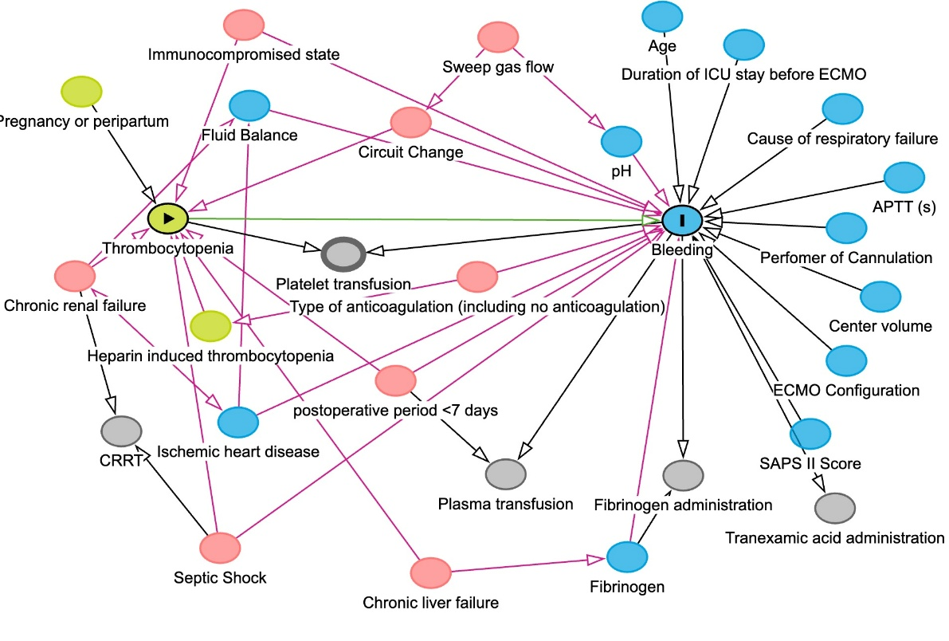

Figure E1. Directed Acyclic Graph (DAG). This DAG illustrates the relationship between clinical, procedural, and patient-related factors influencing thrombocytopenia (exposure) and bleeding (outcome).

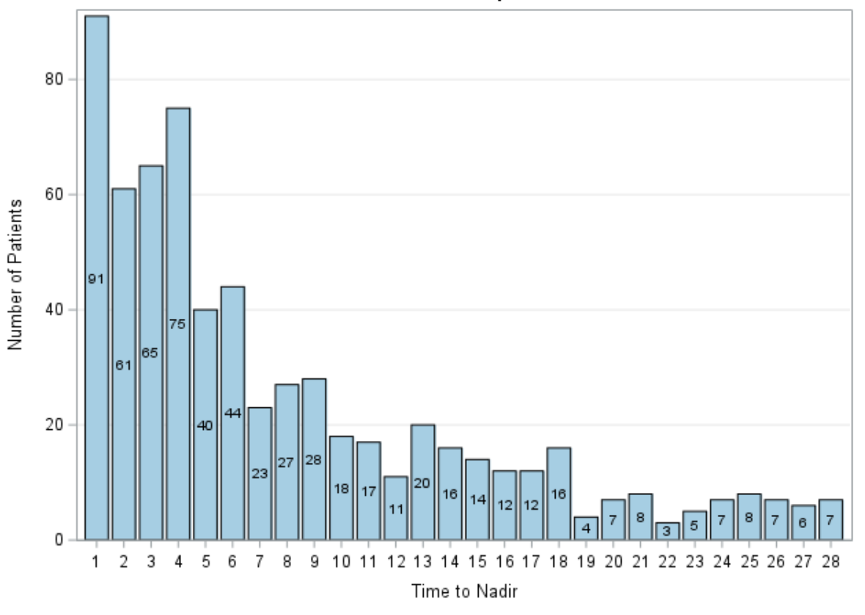
Figure E2. Distribution of patients (y-axis) by time to nadir in days (x-axis).

Case Report Form

BASELINE CASE FORM

Record ID

Refused transfusion Yes
No

Jehovah's Witness Yes
No

Other reason to refuse transfusion Yes
No

Included in other interventional study Yes
No

Other study Specify

Age

Gender Female
Male

Weight (kg)

Height (cm)

Body mass index

ECMO start

ECMO configuration Femoro-Jugular
Femoro-Femoral
Double Lumen Cannula
Femoro-Jugular-Femoral
Jugular-Femoral
Subclavian-Femoral

Pre-ECMO hospital admission
Pre-ECMO hospital stay
Pre-ECMO ICU admission Pre-ECMO ICU stay
Pre-ECMO start of mechanical ventilation Pre-ECMO days of mechanical ventilation

PRE-EXISTING PULMONARY DISEASE

No Yes
Asthma
Cystic fibrosis
Chronic obstructive pulmonary disease Disease
Pulmonary hypertension
Pulmonary fibrosis
Chronic restrictive lung disease
Other

Other-Specify

MAIN COMORBIDITIES

No Yes
Diabetes mellitus Chronic renal failure Ischemic heart disease
Heart failure Chronic liver failure Neurological impairment Other

Other-Specify

Lung transplantation waiting list Yes
No

Postoperative period <7 Days Yes
No

Pregnancy or peripartum Yes
No

Cause of acute respiratory failure COVID-19
Bacterial pneumonia
Viral pneumonia
Trauma/burns
Aspiration pneumonia
Asthma
Pancreatitis
Non-respiratory and chronic respiratory diagnoses
Graft failure after lung transplantation
Other acute respiratory diagnosis

Cause of ARF-non-respiratory diagnosis
Cause of ARF-Other Diagnosis

SOFA SCORE see below

SAPS2 score

PaO2/FiO2 (mmHg) value
Glasgow Coma Scale
Mean arterial pressure(mmHg)

Dopamine ≤5mcg/kg/minor dobutamine (any dose) Yes
No

Dopamine>5mcg/kg/minoradrenaline≤0.1 Yes
mcg/kg/minor noradrenaline≤0.1mcg/kg/min. No

Dopamine >15mcg/kg/minor adrenaline>0.1 Yes
mcg/kg/minor noradrenaline>0.1mcg/kg/min. No
Bilirubin (mg/dl)
Platelets×1000/microlCCreatinine (mg/dl)
SOFA score
Immunocompromised Yes
(hematologic malignancies, solid tumor, solid organ No
transplantation, high dose or long-term steroids,
immunosuppressive agents, HIV)

Prone positioning before ECMO Yes
No

PEEP<10cmH2O Yes
No

Plateau pressure>30cmH2O Yes
No

PRESERVE Score

RESP SCORE

Central nervous system dysfunction Yes
No

Acute associated non-pulmonary infection Yes
No

Neuromuscular blockade before ECMO Yes
No

Nitric oxide use before ECMO Yes
No

Bicarbonate infusion before ECMO Yes
No

Cardiac arrest before ECMO Yes
No

PaCO2 ≥75mmHg/10kpa Yes
No

Peak inspiratory pressure ≥42cmH2O Yes
No

RESP Score

ECMOnet

Hematocrit (%)
Hemoglobin (g/dl)

DAY1

Daily data were recorded for each day on ECMO and for the first day after ECMO weaning for those patients who survived the ECMO run.

Record ID

Still on ECMO Yes
No
Date

Richmond Agitation-Sedation Scale (RASS) +4 Combative
+3 Very agitated
+2 Agitated
+1 Restless
0 Alert and calm
-1 Drowsy
-2 Light sedation
-3 Moderate sedation
-4 Deep sedation
-5 Unarousable

Fluid balance in the last 24 hours Positive
Negative

Fluid balance value
Diuresis
Continuous Renal Replacement Therapy Yes
No

Mean arterial pressure
Heart rate
Septic shock Yes
No

Vasopressor Yes
No

Dobutamine (mcg/kg/min)
Adrenaline (mcg/kg/min)
Noradrenaline (mcg/kg/min)
Dopamine (mcg/kg/min)
Vasopressin (unit/hour)

DAILY LAB

Hemoglobin (g/dl)
Hematocrit
Platelet count x1000/microL
Creatinine [mg/dl]
Fibrinogen (mg/dl)

Coagulation Test

No Yes
APTT
APTT ratio ACT r-TEG
Anti-Xa
Other

APTT sec
APTT ratio
ACT sec
r-TEG

Anti-Xa (units/ml)
Other
Antithrombin III activity level

Hemogas analysis

pH
PaO2
PaCO2
HCO3
SaO2
Lactates (mmol/L)

Type of anticoagulation/antiaggregation Heparin IV
Heparin SC
Bivalirudin
Argatroban
Other
No anticoagulant
Aspirin

Type of other anticoagulant
Heparin IV dose (units/hrs)
Heparin IV dose (units/kg/hrs)
Heparin SC dose

Bivalirudin dose

Argatroban dose

Other anticoagulant dose

Antithrombin III administration Yes
No

Antithrombin dosage

ECMO SETTINGS

Revolutions per minute (RPM)
Blood flow (L/min)
Sweep gas flow
FiO2%
ECMO weaning TRIAL Yes
No

ECMO removal Yes
No

ECMO modification Yes
No

Type of modification Add a third cannula
Switch to VA o VVA
Other

MAJOR EVENTS DURING THE PAST 24 HRs

Death Yes
No

Major hemolysis Yes
No

Cardiac arrest Yes
No

Bleeding Yes
No

Bleeding site Airway
Oronasal
Gastric
Intestinal
Intrathoracic
Abdominal
Urinary tract
Cannulation site
Cerebral

Bleeding severity (modified Bleeding Academic Type 1 (bleeding that requires reduction of heparin infusion Research Consortium-BARC score) rate OR PRBC transfusion, provided Hb
drop related to bleeding)
Type 2 (bleeding that requires reduction of heparin infusion rate AND PRBC transfusion, provided Hb drop related to bleeding, OR non-surgical procedure to stop bleeding)
Type3 (life-threatening bleeding that required PRBC transfusion AND surgical intervention to control the bleeding or ECMO discontinuation)
Type4 (any fatal bleeding)

Circuit change Yes
No

Main cause for change Thrombocytopenia
Hypofibrinogenemia Evidence of clots Membrane dysfunction

PRBC transfused Yes
No

Reason for transfusion Low hemoglobin
Hemodynamic impairment
Low ECMO blood flow Bleeding
Other

Other-specify

PRE-TRANSFUSION

Hemoglobin (g/dl)
SvO2
SaO2

ECMO blood flow
ECMO RPM
Bleeding severity (modified Bleeding Academic Type 0(no bleeding)
Research Consortium-BARC score) Type 1 (bleeding that requires reduction of heparin infusion rate OR PRBC transfusion, provided Hb drop related to bleeding)
Type 2 (bleeding that requires reduction of heparin infusion rate AND PRBC transfusion, provided Hb drop related to bleeding, OR non surgical procedure to stop bleeding)
Type3 (life-threatening bleeding that required PRBC transfusion AND surgical intervention to control the bleeding or ECMO discontinuation)
Type4 (any fatal bleeding)

POST-TRANSFUSION

Hemoglobin (g/dl)
SvO2
SaO2

ECMO blood flow
ECMO RPM

TRANSFUSIONS

PRBC total transfusion (mL) in the last 24h
Plasma total transfusion (mL) in the last 24h
Platelets (mL) in the last 24h
Fibrinogen administration (mg) in the last 24h
Tranexamic acid administration (mg) in the last 24h

OUTCOME DATA

Record ID

Cannulation site thrombosis Yes
No

Heparin-induced thrombocytopenia Yes
No

Total PRBC during ECMO (mL)
Total plasma during ECMO (mL)
Total platelets during ECMO (mL)
Total fibrinogen during ECMO (mg)
Total cryoprecipitates during ECMO (mL)
Total antithrombin III during ECMO (Unit)
ECMO successful weaning Yes
No
Treatment withdrawal

Treatment withdrawal decision date
Last ECMO day
Total ECMO days

Mechanical ventilation weaning Yes
No

Mechanical ventilation weaning date
Post-ECMO mechanical ventilation days
Lung transplantation performed Yes
No

Lung transplantation date
Pre-lung Tx ECMO days
ICU discharge status Alive
Died

Last ICU date

ICU length of stay

Hospital discharge status Alive
Died

Last hospital stay date
Hospital length of stay
Death date

6-month status Alive
Died

Date of death

