Supplementary Material

Summary

Supplementary Table S1 – Search Strategy 3
Supplementary Table S2 – Risk of Bias Assessment (RoB 2 Tool) 4
Supplementary Table S3 – Summary of Included Studies 5
Supplementary Table S4 – GRADE Assessment of Certainty of Evidence 6
Supplementary Table S5 – Definitions of primary outcomes and antibiotic adequacy across included trials. 7
Supplementary Table S6. Results of exploratory meta-regression assessing pneumonia subtype (community-acquired vs. nosocomial) as a moderator of antibiotic adequacy effect size. 10
Supplementary Table S7. Distribution of Pneumonia Subtypes by Study and Treatment Group 11
Supplementary Figure S1. Funnel plot assessing publication bias for the outcome of adequate antimicrobial therapy. 12
Supplementary Figure S2. Funnel plot for the outcome of time to targeted therapy. 13
Supplementary Figure S3. Sensitivity Analysis for antibiotic adequacy without inhale WP3. 14
Supplementary Figure S4. Sensitivity analysis for antibiotic adequacy without the FLAGSHIP II trial. 15
Supplementary Figure S5. Sensitivity analysis for antibiotic adequacy without the Poole study 16
Supplementary Figure S6. Sensitivity analysis for antibiotic adequacy without the Virk study 17
Supplementary Figure S7. Sensitivity analysis for time to effective therapy without the Poole study. 18
Supplementary Figure S8. Sensitivity analysis for time to effective therapy without the FLAGSHIP II trial. 19
Supplementary Figure S9. Sensitivity analysis for time to effective therapy without the Virk trial. 20
Supplementary Figure S10. Meta-regression evaluating pneumonia subtype (community-acquired vs. nosocomial) as a moderator of the effect size for antimicrobial adequacy. 21

Supplementary Table S1 – Search Strategy
Pubmed | ("Pneumonia"[Mesh] OR pneumonia[tiab] OR "ventilator-associated pneumonia"[tiab] OR VAP[tiab] OR "hospital-acquired pneumonia"[tiab] OR "nosocomial pneumonia"[tiab])  AND  ("Intensive Care Units"[Mesh] OR "Critical Care"[Mesh] OR ICU[tiab] OR "intensive care"[tiab] OR "critical care"[tiab])  AND  ("Polymerase Chain Reaction"[Mesh] OR PCR[tiab] OR "multiplex PCR"[tiab] OR "syndromic PCR"[tiab] OR "rapid molecular diagnostics"[tiab] OR "molecular testing"[tiab] OR "nucleic acid amplification"[tiab] OR "panel testing"[tiab])  AND  (randomized[tiab] OR randomised[tiab] OR RCT[tiab] OR "randomized trial"[tiab] OR "randomised trial"[tiab] OR "clinical trial"[tiab] OR multicenter[tiab])
EMBASE | ('pneumonia'/exp OR 'pneumonia':ti,ab,kw OR 'ventilator-associated pneumonia':ti,ab,kw OR 'vap':ti,ab,kw OR 'hospital-acquired pneumonia':ti,ab,kw OR 'nosocomial pneumonia':ti,ab,kw) AND ('intensive care unit'/exp OR 'intensive care'/exp OR 'icu':ti,ab,kw OR 'intensive care':ti,ab,kw OR 'critical care':ti,ab,kw) AND ('polymerase chain reaction'/exp OR 'pcr':ti,ab,kw OR 'multiplex pcr':ti,ab,kw OR 'syndromic pcr':ti,ab,kw OR 'rapid molecular diagnostics':ti,ab,kw OR 'molecular testing':ti,ab,kw OR 'nucleic acid amplification':ti,ab,kw OR 'panel testing':ti,ab,kw) AND ('randomized':ti,ab,kw OR 'randomised':ti,ab,kw OR 'rct':ti,ab,kw OR 'randomized trial':ti,ab,kw OR 'randomised trial':ti,ab,kw OR 'clinical trial':ti,ab,kw OR 'multicenter':ti,ab,kw)
Cochrane Library | (pneumonia:ti,ab,kw OR "ventilator-associated pneumonia":ti,ab,kw OR vap:ti,ab,kw OR "hospital-acquired pneumonia":ti,ab,kw OR "nosocomial pneumonia":ti,ab,kw)  AND  ("intensive care":ti,ab,kw OR "critical care":ti,ab,kw OR icu:ti,ab,kw)  AND  ("polymerase chain reaction":ti,ab,kw OR pcr:ti,ab,kw OR "multiplex pcr":ti,ab,kw OR "syndromic pcr":ti,ab,kw OR "rapid molecular diagnostics":ti,ab,kw OR "molecular testing":ti,ab,kw OR "nucleic acid amplification":ti,ab,kw OR "panel testing":ti,ab,kw)  AND  (randomized:ti,ab,kw OR randomised:ti,ab,kw OR rct:ti,ab,kw OR "randomized trial":ti,ab,kw OR "randomised trial":ti,ab,kw OR "clinical trial":ti,ab,kw OR multicenter:ti,ab,kw)

Supplementary Table S2 – Risk of Bias Assessment (RoB 2 Tool)

Study | Randomization process | Deviations from intended interventions | Missing outcome data | Measurement of the outcome | Selection of the reported result | Overall Risk of bias
INHALE WP3 (2025) | Low | Low | Low | Low | Low | Low
FLAGSHIP II (2022) | Low | Some concerns | Low | Low | Some concerns | Some concerns
Virk et al. (2024) | Low | Low | Low | Low | Low | Low
Poole et al. (2022) | Low | Low | Low | Low | Low | Low
MULTI-CAP (2025) | Low | Some concerns | Low | Low | Low | Some concerns

Supplementary Table S3 – Summary of Included Studies
CAP: Community-acquired pneumonia; HAP: Hospital-acquired pneumonia; VAP: Ventilator-associated pneumonia

Study | Country | Sample Size (PCR/Control) | PCR Platform | Pneumonia Type | Follow-up Duration | Main Outcomes Assessed
INHALE WP3 (2025) | UK | 223 / 219 | FilmArray® | HAP, VAP | 28 days | - Superiority in antibiotic stewardship at 24h  - Clinical cure at 14 days.
FLAGSHIP II (2022) | Switzerland | 100/108 | Seegene, RespiFinder® | CAP, HAP | 30 days | Time on inappropriate antibiotics (hours)
Virk et al. (2024) | USA | 563 / 589 | FilmArray® | HAP, VAP | 30 days | Median time to first antibiotic modification at 96 hours
Poole et al. (2022) | UK | 100 / 100 | FilmArray® | Mixed | 60 days | Proportion of patients receiving therapy guided by PCR results
MULTI-CAP (2025) | France | 188/197 | FilmArray® | CAP | 90 days | Number of antibiotic-free days

Supplementary Table S4 – GRADE Assessment of Certainty of Evidence

Outcome | Risk of Bias | Inconsistency | Indirectness | Imprecision | Publication Bias | Overall Certainty
Adequacy of initial antimicrobial therapy | Low to moderate | High (I² = 83%) | None | Moderate (wide CI) | Possible (n=4) | Moderate
Time to effective antibiotic therapy | Low to moderate | Very high (I² = 100%) | None | High (wide CI) | Possible (n=4) | Low
In-hospital mortality | Low | None (I² = 0%) | None | Moderate | Unlikely | Moderate

Supplementary Table S5 – Definitions of primary outcomes and antibiotic adequacy across included trials.
BAL: bronchoalveolar lavagem, SOFA: Sequential Organ Failure Assessment, PELOD-2: Pediatric Logistic Organ Dysfunction 2.

Study | Primary Outcome Definition | Antibiotic Adequacy Definition
MULTI-CAP (2025) | Number of antibiotic-free days alive at day 28 after randomization. | Antibiotic therapy considered adequate if active against the identified or presumed pathogen(s) based on standard culture or molecular detection, and not unnecessarily broad. The trial emphasized the need to avoid inadequate or overly broad-spectrum therapy, although no specific operational definition was provided for adequacy.
INHALE WP3 (2025) | - Proportion of patients receiving active and appropriate antibiotics at 24h based on susceptibility testing.  - Non-inferiority in clinical cure of pneumonia at 14 days post-randomisation.  Cure was defined as the absence of:  (i) death where pneumonia was considered causative or contributory;  (ii) septic shock (unless due to a non-respiratory infection);  (iii) relapse of pneumonia (defined by clinical/radiological signs or ≥2-point worsening in SOFA/PELOD-2);  (iv) other evidence that the original pneumonia was not cured. | Antibiotic therapy deemed appropriate if active against the pathogen(s) in vitro, and proportionate if not excessively broad-spectrum for the identified pathogen(s), assessed within 24h of clinical diagnosis.
Virk et al. (2024) | Median time to first antibiotic modification (escalation or de-escalation) within 96h. | Adequacy was inferred from timely escalation or de-escalation to an antibiotic regimen with improved pathogen coverage or narrower spectrum, based on microbiology or resistance markers.  Appropriate therapy was interpreted as treatment aligned with susceptibility or stewardship principles; therapy that corrected previous mismatch or excessive spectrum was deemed adequate.
Poole et al. (2022) | Results-directed antimicrobials were defined as agents started, continued, de-escalated, or discontinued within 48 hours based on the appropriateness for a detected pathogen or the absence of one, aiming to reflect pathogen-guided optimization of therapy. | Adequate therapy was defined as the use, adjustment, or discontinuation of antimicrobials based on pathogen detection (or absence), with coverage matched to plausible pathogens.  Appropriate therapy was defined as the narrowest effective spectrum for identified organisms, or justified cessation in the absence of pathogens, as determined by study investigators.
FLAGSHIP II (2022) | Time (in hours) on inappropriate antibiotic therapy from BAL to discharge or day 30. | Inappropriate therapy was defined as antibiotics without in vitro activity against identified pathogens, intrinsically resistant, or overly broad-spectrum relative to the organisms detected by BAL-PCR or culture.  Appropriate therapy required matching antimicrobial activity and spectrum to microbiological findings, with proportionate duration, as adjudicated by expert reviewers.

Supplementary Table S6. Results of exploratory meta-regression assessing pneumonia subtype (community-acquired vs. nosocomial) as a moderator of antibiotic adequacy effect size.
CAP: Community-acquired pneumonia;

Term | Estimate | Standard Error | z-value | p-value | 95% CI (Lower–Upper)
Intercept | 0.1585 | 0.4779 | 0.33 | 0.740 | -0.7782 to 1.0951
CAP_proportion | 0.8561 | 0.7927 | 1.08 | 0.280 | -0.6975 to 2.4098

Model statistics:
Tau² (residual heterogeneity): 0.2374 (SE = 0.2579)
I² (residual heterogeneity): 94.84%
R² (heterogeneity accounted for): 2.5%
QM (test for moderators): 1.17 (df = 1), p = 0.280
QE (test for residual heterogeneity): 56.89 (df = 2), p < 0.0001

Supplementary Table S7. Distribution of Pneumonia Subtypes by Study and Treatment Group
The table presents the number of patients with community-acquired pneumonia (CAP), hospital-acquired pneumonia (HAP), and ventilator-associated pneumonia (VAP), when reported, stratified by study arm (intervention vs. control) for each included trial. Data were extracted from the original publications or supplementary materials.

Study | Group | CAP | HAP | VAP | Total
INHALE WP3 | Intervention |  | 84 | 191 | 276
INHALE WP3 | Control |  | 87 | 182 | 259
Poole 2022 | Intervention | 42 | 30 | 28 | 100
Poole 2022 | Control | 43 | 39 | 18 | 100
Flagship II | Intervention | 77 | 23* |  | 100
Flagship II | Control | 80 | 28 |  | 108
Virk 2024 | Intervention | 106 | 98 | 50 | 254
Virk 2024 | Control | 128 | 83 | 49 | 260
MULTI-CAP 2025 | Intervention | 188 |  |  | 188
MULTI-CAP 2025 | Control | 197 |  |  | 197

* Flagship II did not distinguish between HAP and VAP; the combined HAP/VAP count is reported as “HAP” here.

Supplementary Figure S1. Funnel plot assessing publication bias for the outcome of adequate antimicrobial therapy.
The x-axis represents the effect size (log-transformed risk ratio), and the y-axis corresponds to the standard error. Each point denotes an individual study. Visual inspection suggests potential asymmetry, which may reflect small-study effects or publication bias. However, due to the limited number of included trials (n = 4), this assessment is underpowered and should be interpreted with caution.

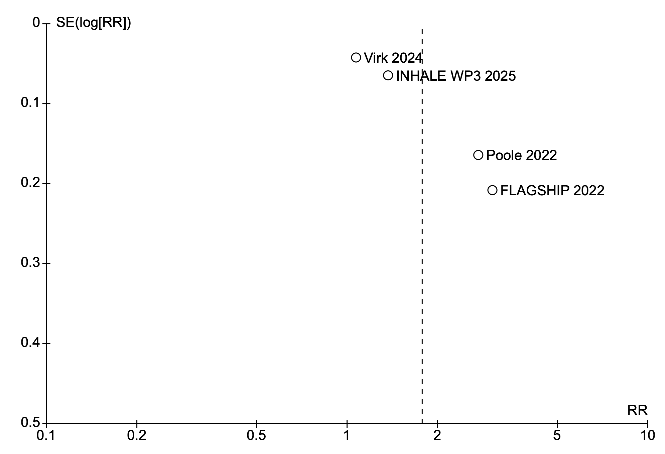

Supplementary Figure S2. Funnel plot for the outcome of time to targeted therapy.
Each point represents a study included in the meta-analysis. The x-axis shows the mean difference (MD) in hours between syndromic PCR testing and standard microbiology, and the y-axis represents the standard error (SE) of the effect size. Visual inspection reveals no clear evidence of asymmetry. However, the small number of included studies (n = 3) limits the ability to formally assess publication bias, and findings should be interpreted with caution.

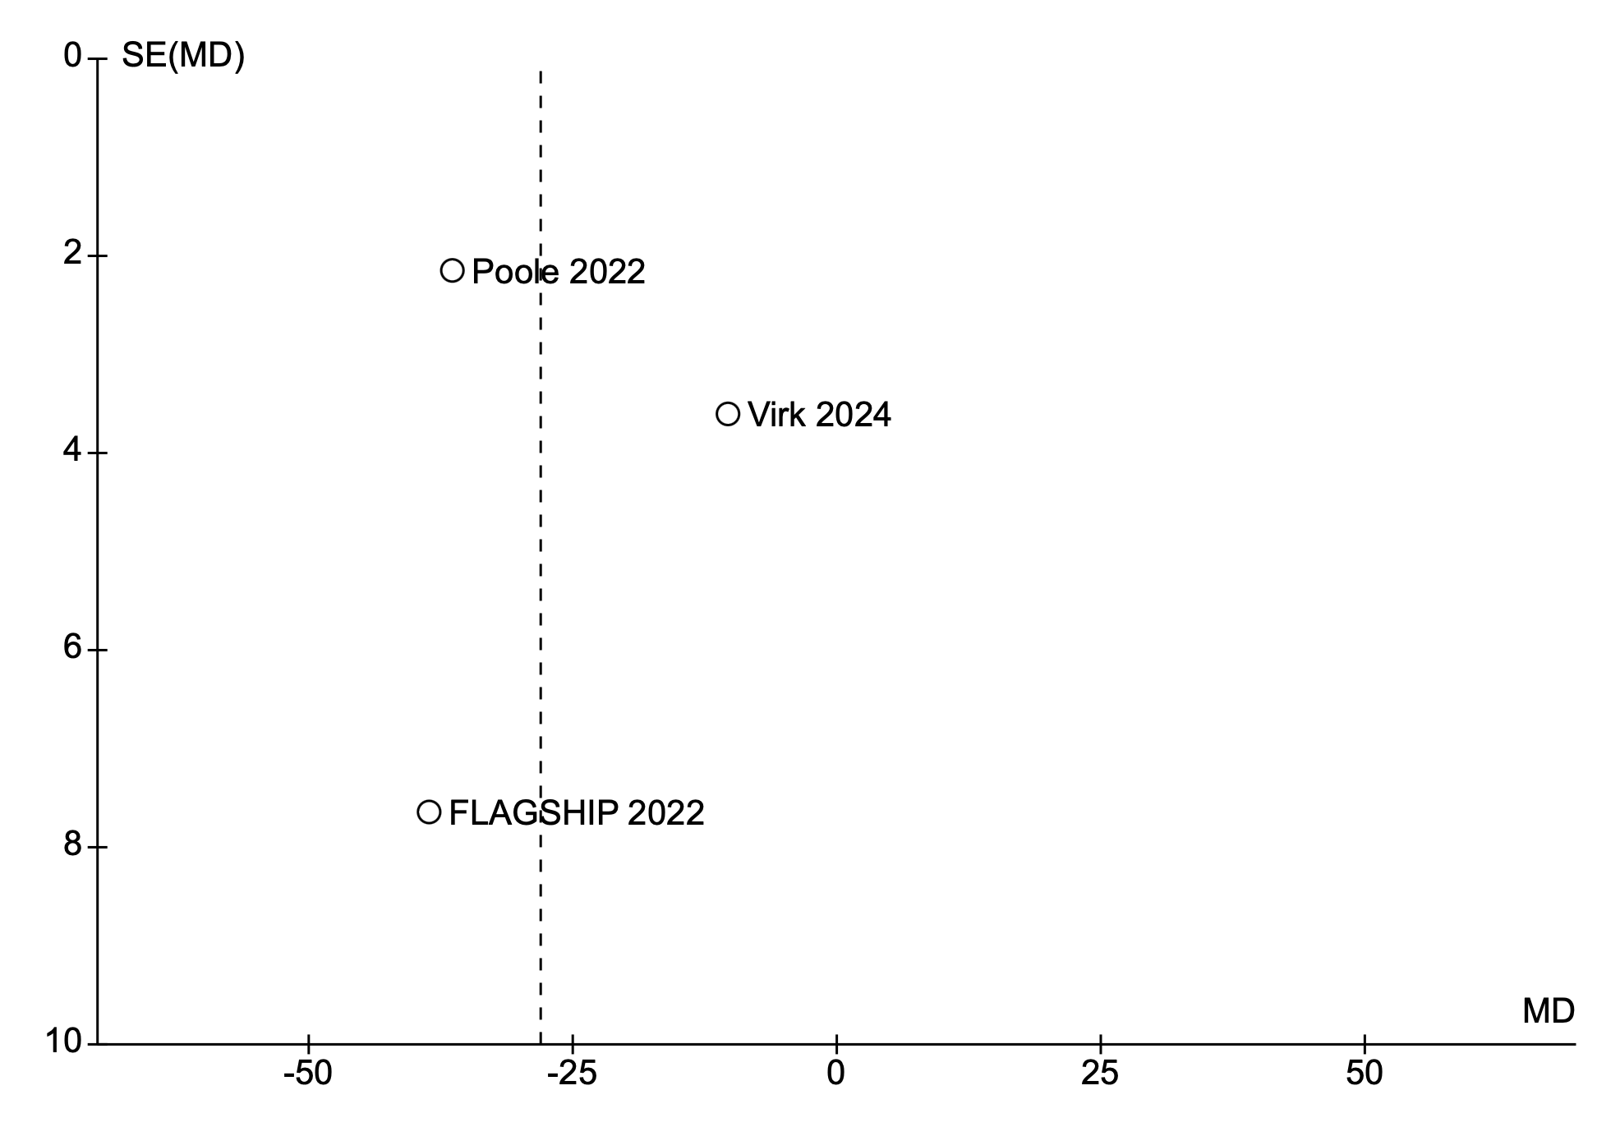

Supplementary Figure S3. Sensitivity Analysis for antibiotic adequacy without inhale WP3.
Pooled analysis excluding INHALE WP3 demonstrated no statistically significant difference in adequacy of initial antimicrobial therapy between syndromic PCR panels and conventional microbiology (risk ratio 2.04; 95% CI: 0.94–4.44; p = 0.07; I² = 96%).

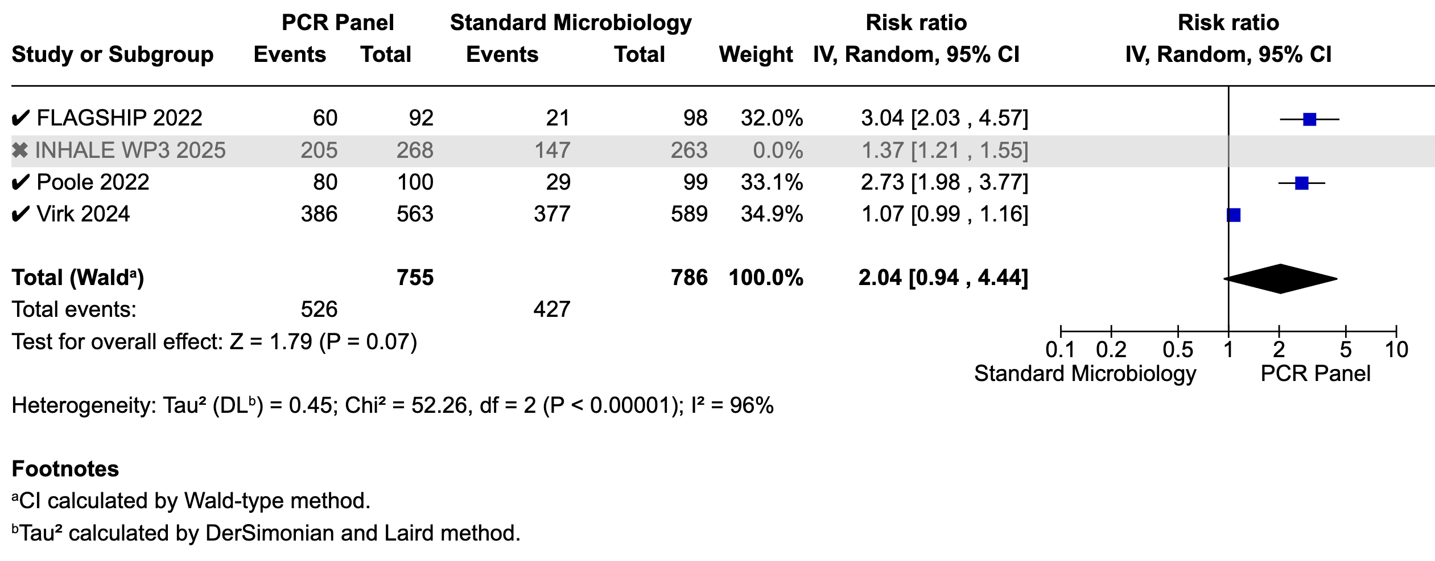

Supplementary Figure S4. Sensitivity analysis for antibiotic adequacy without the FLAGSHIP II trial.
Pooled analysis excluding the FLAGSHIP trial showed a statistically significant improvement in adequacy of initial antimicrobial therapy with syndromic PCR panels compared to standard microbiology (risk ratio 1.52; 95% CI: 1.07–2.17; p = 0.02; I² = 95%).

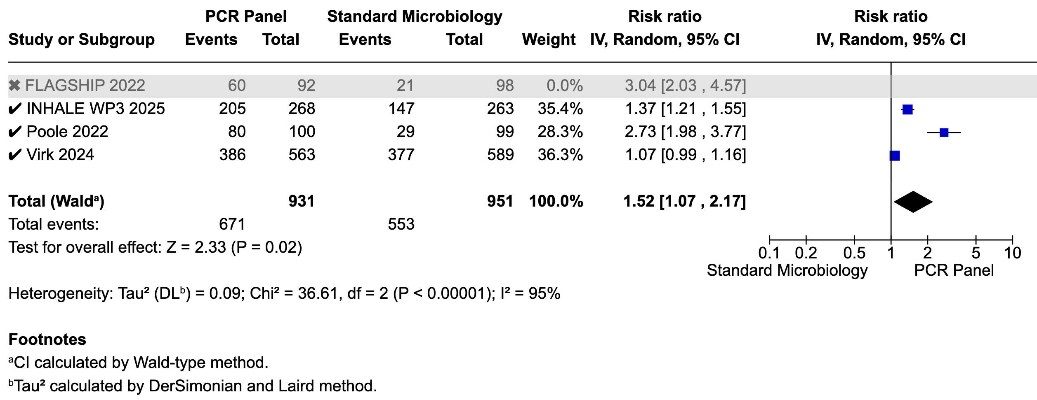

Supplementary Figure S5. Sensitivity analysis for antibiotic adequacy without the Poole study
Pooled analysis excluding the Poole study demonstrated a statistically significant benefit of syndromic PCR panels for adequacy of initial antimicrobial therapy (risk ratio 1.52; 95% CI: 1.08–2.15; p = 0.02), with substantial heterogeneity (I² = 94%).

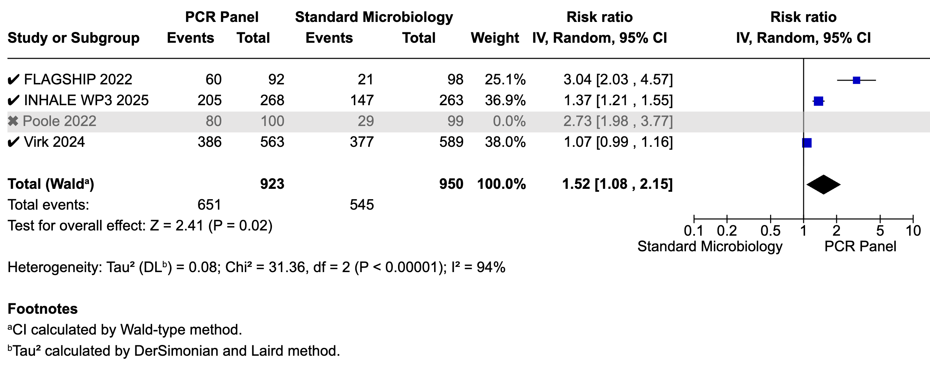

Supplementary Figure S6. Sensitivity analysis for antibiotic adequacy without the Virk study
Pooled analysis excluding the Virk study demonstrated a statistically significant benefit of syndromic PCR panels for adequacy of initial antimicrobial therapy (risk ratio 2.20; 95% CI: 1.24–3.92; p = 0.007), with substantial heterogeneity (I² = 92%).

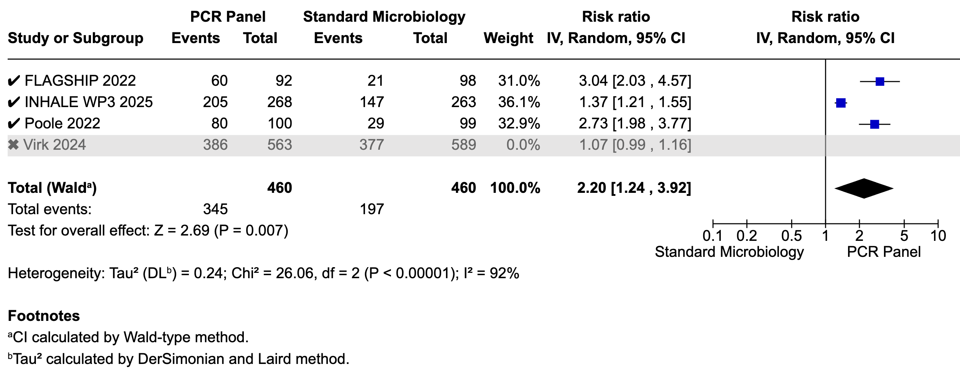

Supplementary Figure S7. Sensitivity analysis for time to effective therapy without the Poole study.
Pooled analysis excluding the Poole trial demonstrated no statistically significant reduction in time to effective antibiotic therapy with syndromic PCR testing (mean difference: –23.65 hours; 95% CI: –51.34 to 4.04; p = 0.09), with persistently high heterogeneity (I² = 91%).

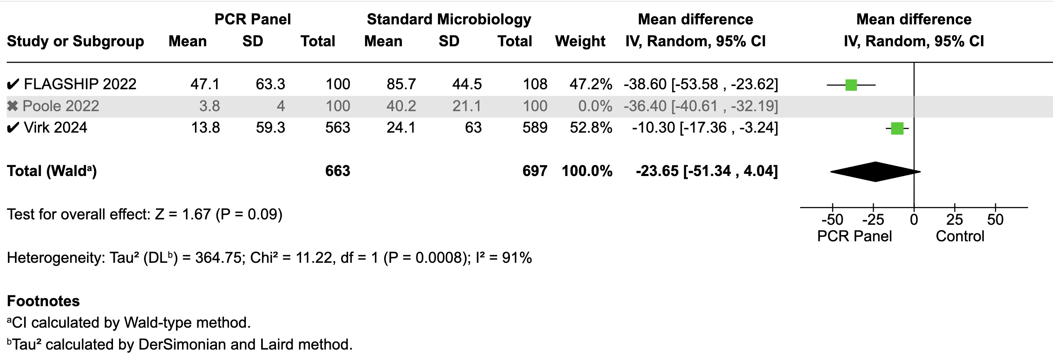

Supplementary Figure S8. Sensitivity analysis for time to effective therapy without the FLAGSHIP II trial.
Pooled analysis excluding the FLAGSHIP II trial demonstrated no statistically significant reduction in time to effective antibiotic therapy with syndromic PCR testing (mean difference: –23.51 hours; 95% CI: –49.09 to 2.07; p = 0.07), with persistently high heterogeneity (I² = 97%).

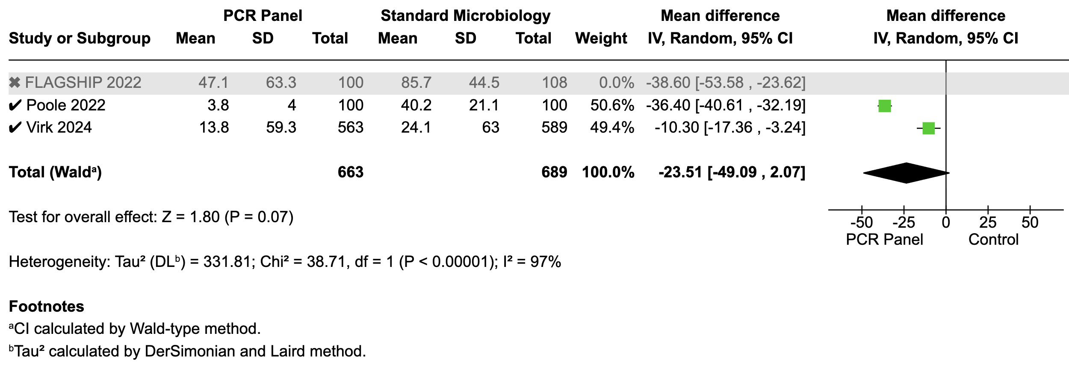

Supplementary Figure S9. Sensitivity analysis for time to effective therapy without the Virk trial.
Pooled analysis excluding the Virk trial demonstrated a statistically significant reduction in time to effective antibiotic therapy with syndromic PCR testing (mean difference: –28.03 hours; 95% CI: –47.49 to –8.58; p = 0.005), despite persistently high heterogeneity (I² = 95%).

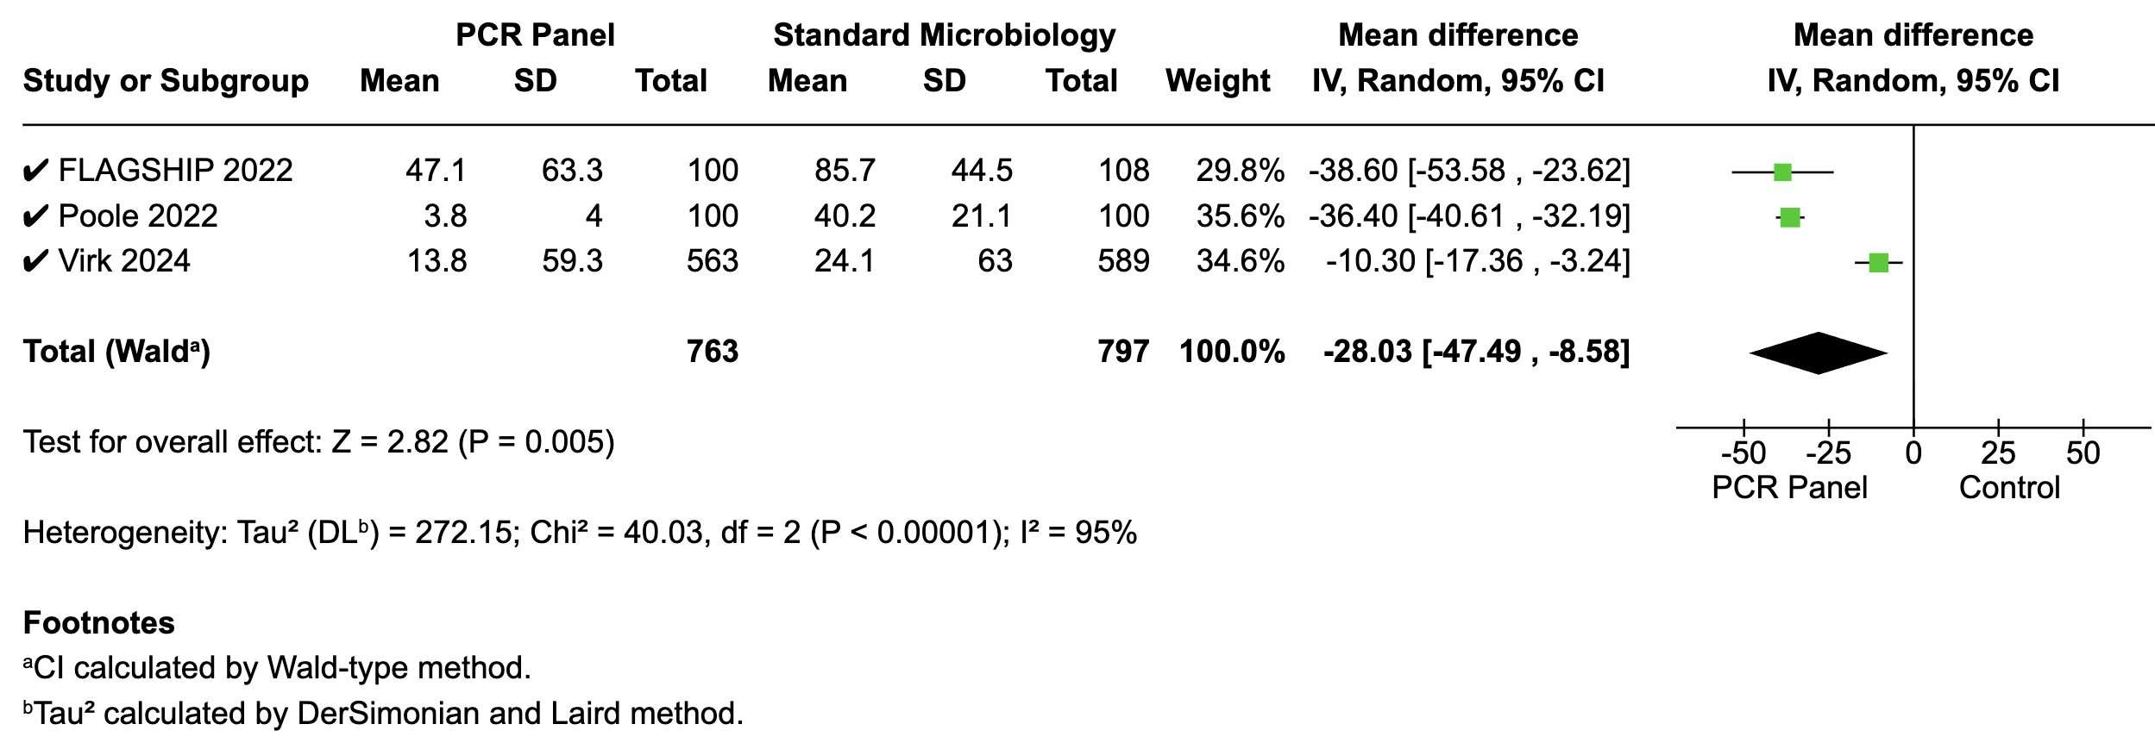

Supplementary Figure S10. Meta-regression evaluating pneumonia subtype (community-acquired vs. nosocomial) as a moderator of the effect size for antimicrobial adequacy.
Each point represents an individual study with its observed log risk ratio (logRR) and corresponding CAP proportion. The solid blue line represents the fitted meta-regression model, and the dashed lines indicate the 95% confidence interval. The meta-regression showed a non-significant trend toward greater effect size in studies with higher CAP prevalence (β = 0.86; 95% CI –0.70 to 2.41; p = 0.280), explaining 2.5% of between-study heterogeneity (R² = 2.5%).

