Online Data Supplement

eSupplemental Method 1. Search strategy

eTable 1. Characteristics according to the sex of the senior author
eTable 2. Characteristics of trials with a woman as first or senior author
eTable 3. Characteristics trials with women as both first and senior author
eTable 4. Characteristics of trials with at least half women authors
eTable 5. Univariate analysis of factors associated with the proportion of women authors

eFigure 1. Evolution over time of the proportion of women in all authors
eFigure 2. Evolution over time of the proportion of women in first authors
eFigure 3. Evolution over time of the proportion of women in senior authors
eFigure 4. Evolution over time of the H-index
eFigure 5. Proportion of women in the authors according to the topic of the RCT
eFigure 6. Proportion of women in the authors over time according to the continent of the first author (Europe vs World).

eSupplemental Method 1. Search strategy

Medline
# | Searches | Results
1 | 2019/01/01:2024/01/01[Date - MeSH] AND "JAMA"[Journal] AND ("clinical trials as topic"[MeSH Terms] OR ("clinical"[All Fields] AND "trials"[All Fields] AND "topic"[All Fields]) OR "clinical trials as topic"[All Fields] OR "trial"[All Fields] OR "trial s"[All Fields] OR "trialed"[All Fields] OR "trialing"[All Fields] OR "trials"[All Fields] OR ("random allocation"[MeSH Terms] OR ("random"[All Fields] AND "allocation"[All Fields]) OR "random allocation"[All Fields] OR "random"[All Fields] OR "randomization"[All Fields] OR "randomized"[All Fields] OR "randomisation"[All Fields] OR "randomisations"[All Fields] OR "randomise"[All Fields] OR "randomised"[All Fields] OR "randomising"[All Fields] OR "randomizations"[All Fields] OR "randomize"[All Fields] OR "randomizes"[All Fields] OR "randomizing"[All Fields] OR "randomness"[All Fields] OR "randoms"[All Fields])) | 912
2 | 2019/01/01:2024/01/01[Date - MeSH] AND "Lancet"[Journal] AND ("clinical trials as topic"[MeSH Terms] OR ("clinical"[All Fields] AND "trials"[All Fields] AND "topic"[All Fields]) OR "clinical trials as topic"[All Fields] OR "trial"[All Fields] OR "trial s"[All Fields] OR "trialed"[All Fields] OR "trialing"[All Fields] OR "trials"[All Fields] OR ("random allocation"[MeSH Terms] OR ("random"[All Fields] AND "allocation"[All Fields]) OR "random allocation"[All Fields] OR "random"[All Fields] OR "randomization"[All Fields] OR "randomized"[All Fields] OR "randomisation"[All Fields] OR "randomisations"[All Fields] OR "randomise"[All Fields] OR "randomised"[All Fields] OR "randomising"[All Fields] OR "randomizations"[All Fields] OR "randomize"[All Fields] OR "randomizes"[All Fields] OR "randomizing"[All Fields] OR "randomness"[All Fields] OR "randoms"[All Fields])) | 1,020
3 | 2019/01/01:2024/01/01[Date - MeSH] AND "N Engl J Med"[Journal] AND ("clinical trials as topic"[MeSH Terms] OR ("clinical"[All Fields] AND "trials"[All Fields] AND "topic"[All Fields]) OR "clinical trials as topic"[All Fields] OR "trial"[All Fields] OR "trial s"[All Fields] OR "trialed"[All Fields] OR "trialing"[All Fields] OR "trials"[All Fields] OR ("random allocation"[MeSH Terms] OR ("random"[All Fields] AND "allocation"[All Fields]) OR "random allocation"[All Fields] OR "random"[All Fields] OR "randomization"[All Fields] OR "randomized"[All Fields] OR "randomisation"[All Fields] OR "randomisations"[All Fields] OR "randomise"[All Fields] OR "randomised"[All Fields] OR "randomising"[All Fields] OR "randomizations"[All Fields] OR "randomize"[All Fields] OR "randomizes"[All Fields] OR "randomizing"[All Fields] OR "randomness"[All Fields] OR "randoms"[All Fields])) | 1,150
4 | 2019/01/01:2024/01/01[Date - MeSH] AND "Intensive Care Med"[Journal] AND ("clinical trials as topic"[MeSH Terms] OR ("clinical"[All Fields] AND "trials"[All Fields] AND "topic"[All Fields]) OR "clinical trials as topic"[All Fields] OR "trial"[All Fields] OR "trial s"[All Fields] OR "trialed"[All Fields] OR "trialing"[All Fields] OR "trials"[All Fields] OR ("random allocation"[MeSH Terms] OR ("random"[All Fields] AND "allocation"[All Fields]) OR "random allocation"[All Fields] OR "random"[All Fields] OR "randomization"[All Fields] OR "randomized"[All Fields] OR "randomisation"[All Fields] OR "randomisations"[All Fields] OR "randomise"[All Fields] OR "randomised"[All Fields] OR "randomising"[All Fields] OR "randomizations"[All Fields] OR "randomize"[All Fields] OR "randomizes"[All Fields] OR "randomizing"[All Fields] OR "randomness"[All Fields] OR "randoms"[All Fields])) | 360
5 | 2019/01/01:2024/01/01[Date - MeSH] AND "Am J Respir Crit Care Med"[Journal] AND ("clinical trials as topic"[MeSH Terms] OR ("clinical"[All Fields] AND "trials"[All Fields] AND "topic"[All Fields]) OR "clinical trials as topic"[All Fields] OR "trial"[All Fields] OR "trial s"[All Fields] OR "trialed"[All Fields] OR "trialing"[All Fields] OR "trials"[All Fields] OR ("random allocation"[MeSH Terms] OR ("random"[All Fields] AND "allocation"[All Fields]) OR "random allocation"[All Fields] OR "random"[All Fields] OR "randomization"[All Fields] OR "randomized"[All Fields] OR "randomisation"[All Fields] OR "randomisations"[All Fields] OR "randomise"[All Fields] OR "randomised"[All Fields] OR "randomising"[All Fields] OR "randomizations"[All Fields] OR "randomize"[All Fields] OR "randomizes"[All Fields] OR "randomizing"[All Fields] OR "randomness"[All Fields] OR "randoms"[All Fields])) | 508
6 | 2019/01/01:2024/01/01[Date - MeSH] AND "Crit Care Med"[Journal] AND ("clinical trials as topic"[MeSH Terms] OR ("clinical"[All Fields] AND "trials"[All Fields] AND "topic"[All Fields]) OR "clinical trials as topic"[All Fields] OR "trial"[All Fields] OR "trial s"[All Fields] OR "trialed"[All Fields] OR "trialing"[All Fields] OR "trials"[All Fields] OR ("random allocation"[MeSH Terms] OR ("random"[All Fields] AND "allocation"[All Fields]) OR "random allocation"[All Fields] OR "random"[All Fields] OR "randomization"[All Fields] OR "randomized"[All Fields] OR "randomisation"[All Fields] OR "randomisations"[All Fields] OR "randomise"[All Fields] OR "randomised"[All Fields] OR "randomising"[All Fields] OR "randomizations"[All Fields] OR "randomize"[All Fields] OR "randomizes"[All Fields] OR "randomizing"[All Fields] OR "randomness"[All Fields] OR "randoms"[All Fields])) | 553
7 | 1 OR 2 OR 3 OR 4 OR 5 OR 6 | Total results: 4,503

CENTRAL
# | Searches | Results
1 | ("critical care") | 24,986
2 | ("intensive care") | 43,146
3 | ("emergency") OR ("intensive") OR ("critical") | 145,327
4 | ("controlled clinical trial"):ti,ab,kw | 174,755
5 | (JAMA) OR (Journal of the American Medical Association) | 19,215
6 | (NEJM) OR (N Eng J Med) OR (New England Journal of Medicine) | 9,002
7 | (Lancet) OR (The Lancet) | 17,719
8 | (ICM) OR (Intensive Care Med) OR (Intensive Care Medicine) | 35,692
9 | (AJRCCM) OR (Am J Respir Crit Care Med) OR (American Journal of Respiratory and Critical Care Medicine) | 9,016
10 | (CCM) OR (Crit Care Med) OR (Critical Care Medicine) | 22,340
11 | #1 OR #2 OR #3 | 268,237
12 | #6 OR #7 OR #8 OR #9 OR #10 OR #11 | 94,154
13 | #4 AND #11 AND #12 | Total results: 8,091

Web of Science
# | Searches | Results
1 | AB=("critical" OR "critically") | 2,182,944
2 | TI="care" | 686,472
3 | AB="intensive" | 460,947
4 | #3 OR #2 OR #1 | 3,211,383
5 | SO= (NEW ENGLAND JOURNAL OF MEDICINE OR JOURNAL OF THE AMERICAN MEDICAL ASSOCIATION OR LANCET OR INTENSIVE CARE MEDICINE OR AMERICAN JOURNAL OF RESPIRATORY AND CRITICAL CARE MEDICINE OR CRITICAL CARE MEDICINE) | 605,141
6 | #5 AND #4 | 29,839
7 | PY=2019-2023 | 17,782,826
8 | #6 AND #7 | Total results: 4,307

eTable 1. Characteristics according to the sex of the senior author
Characteristic | Overall (n=1199) | RCT with man as senior author (n=1025) | RCT with woman as senior author (n=174) | p-value
Sample size, median [IQR] | 152 [54;446] | 144 [50;419] | 239 [85;668] | <0.001
Multicenter | 661 (55%) | 553 (54%) | 108 (62%) | 0.056
International | 219 (18%) | 184 (18%) | 35 (20%) | 0.56
Primary outcome |  |  |  | 0.25
Mortality | 213 (18%) | 177 (17%) | 36 (21%)
Composite with mortality | 56 (5%) | 45 (4%) | 11 (6%)
Other | 930 (77%) | 803 (79%) | 127 (73%)
Topic |  |  |  | <0.001
Ventilation | 322 (27%) | 292 (29%) | 30 (17%)
Sepsis | 231 (19%) | 197 (19%) | 34 (20%)
Other | 646 (54%) | 536 (52%) | 110 (63%)
Superiority design | 1,164 (97%) | 997 (97%) | 167 (96%) | 0.49
Positive result on primary outcome | 525 (44%) | 454 (44%) | 71 (41%) | 0.57
Public funding | 571 (48%) | 476 (46%) | 95 (55%) | 0.35
Continent |  |  |  | 0.07
Africa | 6 (1%) | 4 (1%) | 2 (1%)
Asia | 50 (4%) | 40 (4%) | 10 (4%)
Europe | 697 (58%) | 615 (60%) | 82 (47%)
Middle-East | 21 (2%) | 17 (2%) | 4 (2%)
North-America | 333 (28%) | 274 (27%) | 59 (34%)
South-America | 6 (1%) | 5 (1%) | 1 (1%)
Oceania | 86 (7%) | 70 (7%) | 16 (9%)
Endorsed by a study group | 374 (31%) | 312 (30%) | 62 (36%) | 0.20
Published in a general journal | 350 (29%) | 291 (28%) | 59 (34%) | 0.16
Number of women in the authors, mean (±SD) | 4 (±4) | 3 (±4) | 5 (±4) | <0.001
Number of publications of the first author, mean (±SD) | 79 (±139) | 79 (±140) | 83 (±135) | 0.68
h-index of the first author, mean (±SD) | 21 (±21) | 21 (±21) | 22 (±21) | 0.55
Number of publications of the senior author, mean (±SD) | 138 (±202) | 145 (±182) | 101 (±292) | <0.01
h-index of the senior author, mean (±SD) | 32 (±26) | 33 (±26) | 24 (±23) | <0.001

RCT: Randomized controlled trial, IQR: Interquartile Range, SD: Standard deviation.

eTable 2. Characteristics of trials with a woman as first or senior author
Characteristic | Overall (n=1199) | RCT without woman as first or senior author (n=823) | RCT with woman as first or senior author (n=376) | p-value
Sample size, median [IQR] | 152 [54;446] | 150 [51;419] | 166 [60;508] | <0.001
Multicenter | 661 (55%) | 462 (56%) | 199 (53%) | 0.33
International | 219 (18%) | 155 (19%) | 64 (17%) | 0.50
Primary outcome |  |  |  | 0.69
Mortality | 213 (18%) | 151 (18%) | 62 (17%)
Composite with mortality | 56 (5%) | 37 (5%) | 19 (5%)
Other | 930 (77%) | 635 (77%) | 295 (78%)
Topic |  |  |  | <0.001
Ventilation | 322 (27%) | 251 (30%) | 71 (19%)
Sepsis | 231 (19%) | 164 (20%) | 67 (18%)
Other | 646 (54%) | 408 (50%) | 238 (63%)
Superiority design | 1,164 (97%) | 799 (97%) | 365 (97%) | 0.99
Positive result on primary outcome | 525 (44%) | 362 (44%) | 163 (43%) | 0.32
Public funding | 571 (48%) | 378 (46%) | 193 (51%) | 0.84
Continent |  |  |  | 0.81
Africa | 6 (1%) | 3 (1%) | 3 (1%)
Asia | 50 (4%) | 35 (4%) | 15 (4%)
Europe | 697 (58%) | 481 (58%) | 216 (57%)
Middle-East | 21 (2%) | 15 (2%) | 6 (2%)
North-America | 333 (28%) | 229 (28%) | 104 (28%)
South-America | 6 (1%) | 5 (1%) | 1 (1%)
Oceania | 86 (7%) | 55 (7%) | 31 (8%)
Endorsed by a study group | 374 (31%) | 267 (32%) | 107 (28%) | 0.19
Published in a general journal | 350 (29%) | 241 (29%) | 109 (29%) | 0.97
Number of women in the authors, mean (±SD) | 4 (±4) | 3 (±3) | 5 (±5) | <0.001
Number of publications of the first author, mean (±SD) | 79 (±139) | 88 (±150) | 60 (±108) | <0.001
h-index of the first author, mean (±SD) | 21 (±21) | 23 (±22) | 18 (±18) | <0.001
Number of publications of the senior author, mean (±SD) | 138 (±202) | 138 (±177) | 139 (±249) | 0.96
h-index of the senior author, mean (±SD) | 32 (±26) | 32 (±26) | 31 (±26) | 0.64

RCT: Randomized controlled trial, IQR: Interquartile Range, SD: Standard deviation.

eTable 3. Characteristics of trials with women as both first and senior author
Characteristic | Overall (n=1199) | RCT with a man as first or senior author (n=1154) | RCT with women as both first and senior author (n=45) | p-value
Sample size, median [IQR] | 152 [54;446] | 166 [55;450] | 126 [52;413] | 0.70
Multicenter | 661 (55%) | 632 (55%) | 29 (64%) | 0.26
International | 219 (18%) | 212 (18%) | 7 (16%) | 0.78
Primary outcome |  |  |  | 0.77
Mortality | 213 (18%) | 206 (17%) | 7 (16%)
Composite with mortality | 56 (5%) | 53 (5%) | 3 (6%)
Other | 930 (77%) | 895 (78%) | 35 (78%)
Topic |  |  |  | <0.001
Ventilation | 322 (27%) | 315 (27%) | 7 (16%)
Sepsis | 231 (19%) | 227 (20%) | 4 (9%)
Other | 646 (54%) | 612 (53%) | 34 (74%)
Superiority design | 1,164 (97%) | 1,120 (97%) | 44 (98%) | 0.99
Positive result on primary outcome | 525 (44%) | 509 (44%) | 16 (36%) | 0.52
Public funding | 571 (48%) | 542 (47%) | 29 (64%) | 0.17
Continent |  |  |  | <0.01
Africa | 6 (1%) | 5 (1%) | 1 (2%)
Asia | 50 (4%) | 45 (4%) | 5 (11%)
Europe | 697 (58%) | 681 (59%) | 16 (36%)
Middle-East | 21 (2%) | 21 (2%) | 0 (0%)
North-America | 333 (28%) | 316 (27%) | 17 (38%)
South-America | 6 (1%) | 6 (1%) | 0 (0%)
Oceania | 86 (7%) | 80 (7%) | 6 (13%)
Endorsed by a study group | 374 (31%) | 362 (31%) | 12 (27%) | 0.61
Published in a general journal | 350 (29%) | 338 (29%) | 12 (27%) | 0.83
Number of women in the authors, mean (±SD) | 4 (±4) | 4 (±4) | 5 (±3) | <0.001
Number of publications of the first author, mean (±SD) | 79 (±139) | 81 (±141) | 29 (±39) | <0.001
h-index of the first author, mean (±SD) | 21 (±21) | 22 (±21) | 11 (±11) | <0.001
Number of publications of the senior author, mean (±SD) | 138 (±202) | 141 (±205) | 72 (±78) | 0.02
h-index of the senior author, mean (±SD) | 32 (±26) | 32 (±26) | 21 (±15) | <0.01

RCT: Randomized controlled trial, IQR: Interquartile Range, SD: Standard deviation.

eTable 4. Characteristics of trials with at least half women authors
Characteristic | Overall (n=1198) | Less than 50% women authors (n=1061) | At least 50% women authors (n=137) | p-value
Sample size, median [IQR] | 152 [54;446] | 155 [56;468] | 129 [49;350] | <0.01
Multicenter | 661 (55%) | 600 (57%) | 61 (45%) | <0.01
International | 219 (18%) | 203 (19%) | 16 (12%) | 0.045
Primary outcome |  |  |  | <0.01
Mortality | 213 (18%) | 202 (19%) | 11 (8%)
Composite with mortality | 56 (5%) | 48 (5%) | 8 (6%)
Other | 929 (77%) | 811 (76%) | 118 (86%)
Topic |  |  |  | <0.001
Ventilation | 322 (27%) | 297 (28%) | 25 (18%)
Sepsis | 231 (19%) | 218 (21%) | 13 (10%)
Other | 646 (54%) | 546 (51%) | 99 (72%)
Superiority design | 1,163 (97%) | 1,028 (97%) | 135 (99%) | 0.42
Positive result on primary outcome | 525 (44%) | 464 (44%) | 61 (45%) | 0.80
Public funding | 571 (48%) | 501 (47%) | 70 (51%) | 0.90
Continent |  |  |  | <0.001
Africa | 6 (1%) | 4 (1%) | 2 (2%)
Asia | 50 (4%) | 44 (4%) | 6 (4%)
Europe | 696 (58%) | 640 (59%) | 56 (41%)
Middle-East | 21 (2%) | 19 (2%) | 2 (2%)
North-America | 333 (28%) | 274 (26%) | 59 (42%)
South-America | 6 (1%) | 6 (1%) | 0 (0%)
Oceania | 86 (7%) | 74 (7%) | 12 (9%)
Endorsed by a study group | 374 (31%) | 348 (33%) | 26 (19%) | <0.001
Published in a general journal | 350 (29%) | 320 (30%) | 30 (22%) | 0.057
Number of women in the authors, mean (±SD) | 4 (±4) | 3 (±4) | 6 (±3) | <0.001
Number of publications of the first author, mean (±SD) | 80 (±139) | 83 (±145) | 49 (±77) | <0.01
H-index of the first author, mean (±SD) | 21 (±21) | 22 (±21) | 15 (±16) | <0.001
Number of publications of the senior author, mean (±SD) | 138 (±202) | 139 (±179) | 132 (±330) | 0.71
H-index of the senior author, mean (±SD) | 32 (±26) | 32 (±26) | 29 (±24) | 0.23

RCT: Randomized controlled trial, IQR: Interquartile Range, SD: Standard deviation.

eTable 5. Univariate analysis of factors associated with the proportion of women authors

Characteristic | Odd Ratio | 95%CI | p-value
Year | 1.05 | [1.02 – 1.08] | <0.01
Sample size (per 100 patients increase) | 1.006 | [1.001 – 1.011] | <0.01
Multicenter | 0.80 | [0.51 – 1.26] | 0.34
International | 0.86 | [0.74 – 0.99] | 0.04
Primary outcome
Mortality | 0.29 | [0.12 – 0.73] | <0.01
Composite with mortality | 1.45 | [0.60 – 3.51] | 0.41
Other | reference | - | -
Topic
Ventilation | 0.47 | [0.26 – 0.84] | 0.01
Sepsis | 0.25 | [0.11 – 0.60] | <0.01
Other | reference | - | -
Superiority design | 1.22 | [0.29 – 5.16] | 0.79
Positive result on primary outcome | 1.06 | [0.70 – 1.59] | 0.78
Public funding | 1.73 | [0.67 – 4.45] | 0.26
Continent
Europe | 0.36 | [0.23 – 0.59] | <0.001
World | reference | - | -
Endorsed by a study group | 0.43 | [0.24 – 0.78] | <0.01
Published in a general journal | 0.83 | [0.49 – 1.38] | 0.46

CI: Confidence interval

eFigure 1. Evolution over time of the proportion of women in all authors

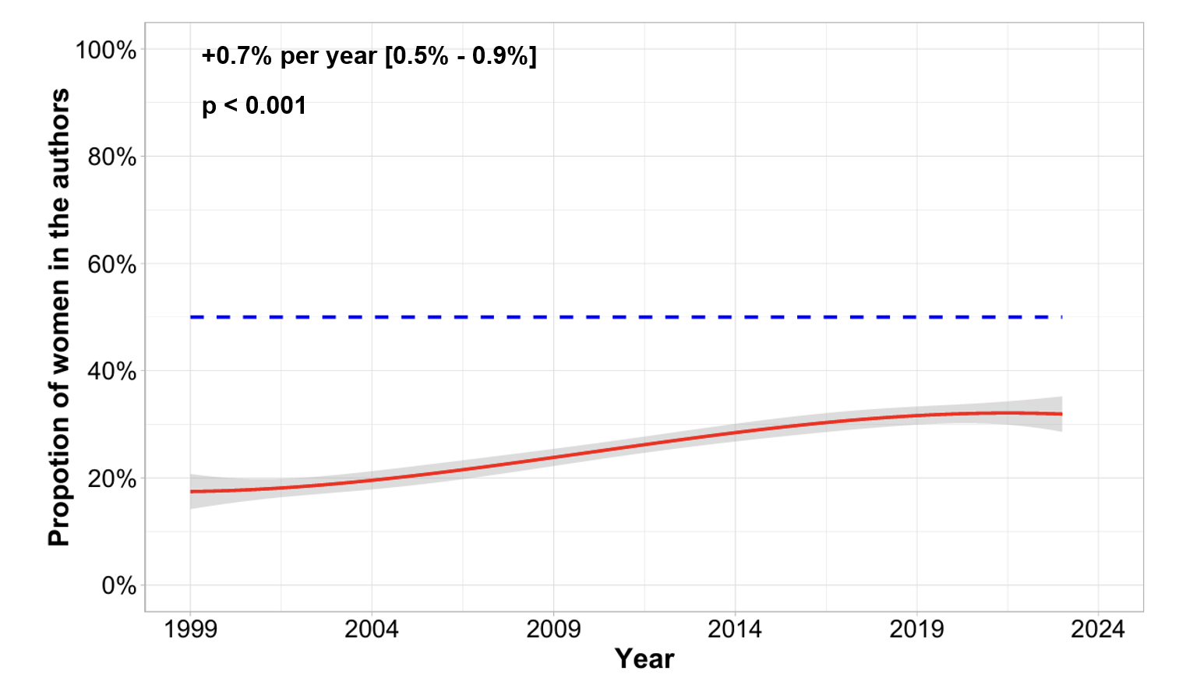

eFigure 2. Evolution over time of the proportion of women in first authors

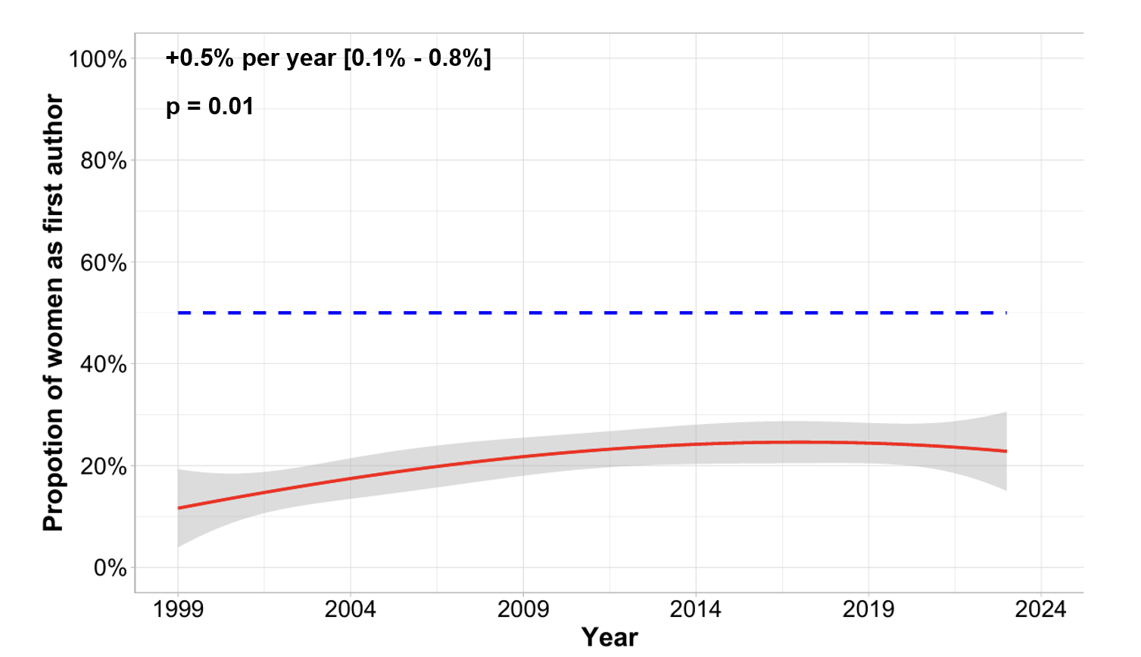

eFigure 3. Evolution over time of the proportion of women in senior authors

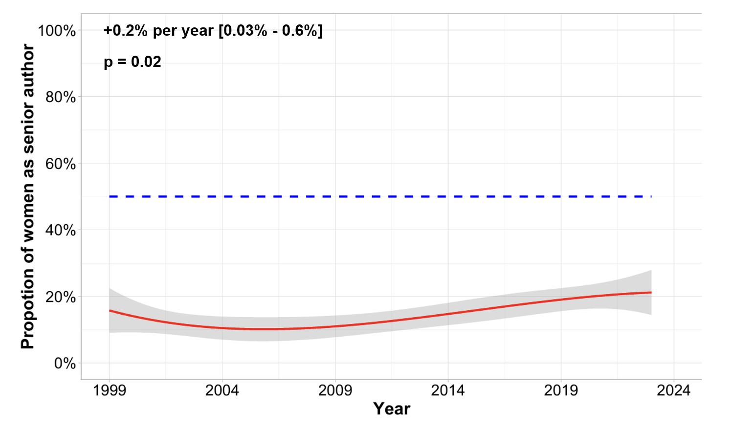
eFigure 4. Evolution over time of the H-index
- Among first authors
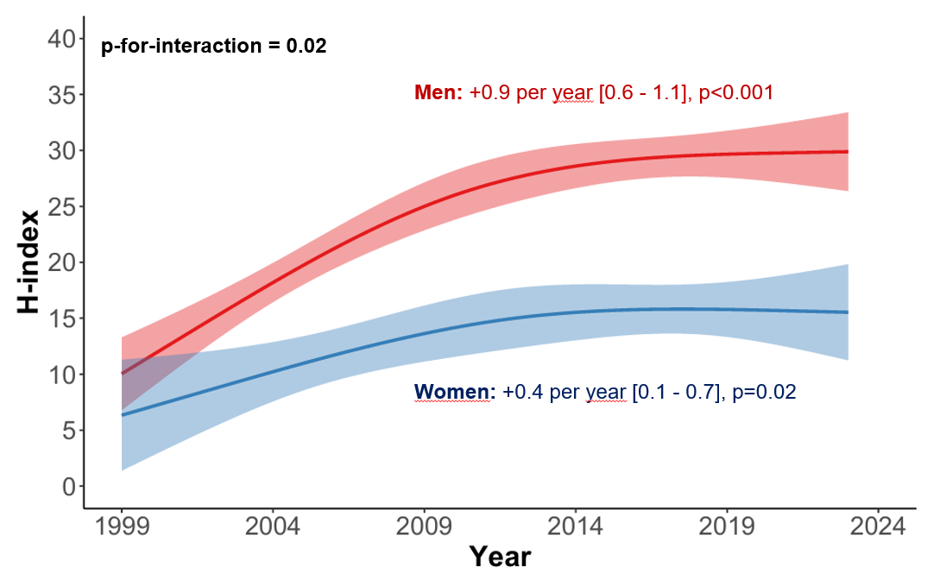

- Among senior authors
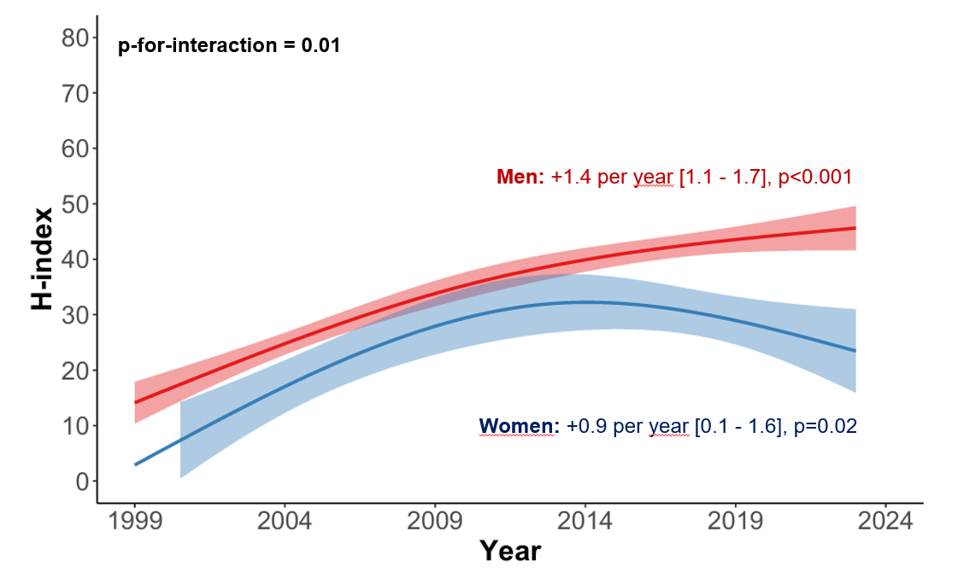

eFigure 5. Proportion of women in the authors according to the topic of the RCT

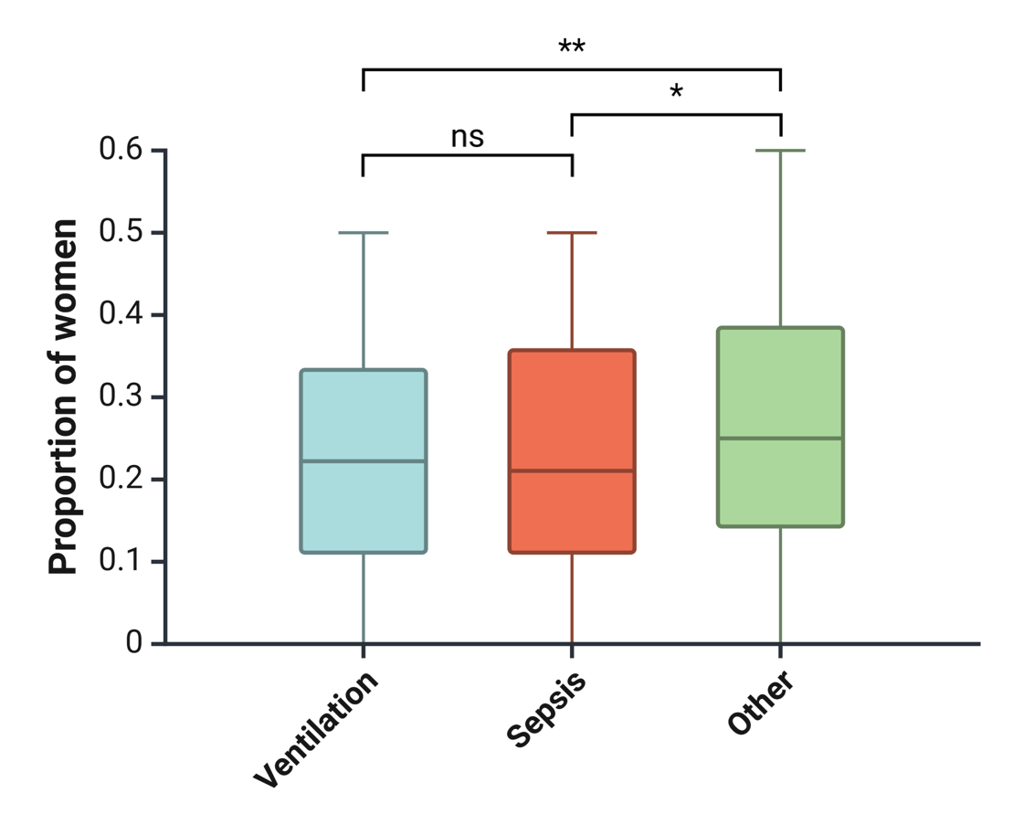

RCT: Randomized controlled trial
* p = 0.02
** p<0.01

eFigure 6. Proportion of women in the authors over time according to the continent of the first author (Europe vs World).

