Supplementary data

Association between respiratory-related cortical activation and weaning from mechanical ventilation: a physiological study

PATIENTS AND METHODS (644 words)

Patients
Patients were eligible for participation if they had been intubated for more than 24 hours and were ready for a SBT according to the following criteria: an awake state defined as a score on the Richmond Agitation and Sedation Scale (RASS) of −2 to +1 (1), no continuous sedation, respiratory rate ≤ 35 breaths/min, adequate oxygenation defined as SpO₂ at least 92% with fraction of inspired oxygen (FiO₂) ≤ 40% and positive end-expiratory pressure (PEEP) ≤ 8 cm H₂O, heart rate < 140 beats/minute and no use of vasopressors (2). Patients with neuromuscular or central nervous disease as main reason for intubation, and patients with psychiatric disorders or agitation were not included. Patients and/or their next of kin were informed and gave their consent before being included in the study.

Spontaneous breathing trials
Patients enrolled in the study underwent a 1-hour SBT using a T-piece placed at the end of the intubation tube with additional oxygen (2). SBT failure was defined (in accordance with the usual criteria from practice guidelines (2), the weaning protocol of the unit and a recent clinical trial conducted in the unit (3)) as occurrence of any of the following events during the trial: a respiratory rate higher than 35 breaths per minute; increased accessory-muscle activity; oxygen saturation persistently lower than 90% while the patient was receiving oxygen at a flow rate of at least 6 liters per minute; hemodynamic instability, defined as either a heart rate persistently higher than 140 beats per minute or systolic blood pressure of less than 90 mmHg or more than 180 mmHg with signs of hypoperfusion; or depressed mental status or agitation. A SBT was considered to be successful if none of these events occurred in one hour after the start of the SBT. The investigator was not implicated in the decision of SBT.

Respiratory-related cortical activation assessment
EEG activity was recorded with a cup electrode (pierced electrode Capsulex D. 10 mm, m.e.i., La Farlède, France) bonded (SAC2 Electrode Cream, spes medica, Genoa, Italy) at Cz (International 10-20 system) after gentle abrasion and cleaning of the scalp to ensure impedance below 5 kΩ (controlled by ohmmeter), with two reference electrodes placed on mastoids, and a ground electrode placed at Fpz. Electro-oculograms (EOG) were recorded using two electrodes placed at the upper right eye canthus and at the lower left eye canthus and referenced to the opposite mastoid. The electrodes were connected to an EEG preamplifier (EEG100C and EOG 100C, Biopac System Inc, Goleta, CA, USA) with 20,000-fold gain, band-pass frequency of 0.5-35 Hz digitalized at 1000 Hz (MP160, Biopac system Inc Goleta, CA, USA) and stored as computer files for offline analysis. If the EEG signal was too noisy, preventing its interpretation, in the case of 50 Hz frequency pollution visually obvious to the trained neurologist, a power spectral density analysis was performed to objectify it, after which a low pass filter at 25 Hz was applied. This concerned 5 patients.

Physiological parameters
Global drive to breathe was assessed by measuring airway occlusion pressure during the first 100 ms after initiation of an inspiratory effort (P0.1) under mechanical ventilation. The measurement was carried out first with the patient's ventilatory settings and then using a pressure-support level of 8 cmH₂O without positive end-expiratory pressure, in order to mimic a spontaneous breathing trial (3). P0.1 was obtained as the mean of 3 consecutive measurements.
We also calculated the rapid shallow breathing index (RSBI) under mechanical ventilation as the ratio of the respiratory rate to the patient's tidal volume (F/V_{T}). Yang and Tobin (4) demonstrated the value of RSBI, performed under T-piece during one minute of spontaneous breathing, in predicting weaning outcome in patients 24 hours after SBT. It has been shown it was possible to measure RSBI under mechanical ventilation with pressure support of 5 cmH₂O and continuous positive airway pressure of 5 cmH₂O (5).
Supplemental figure

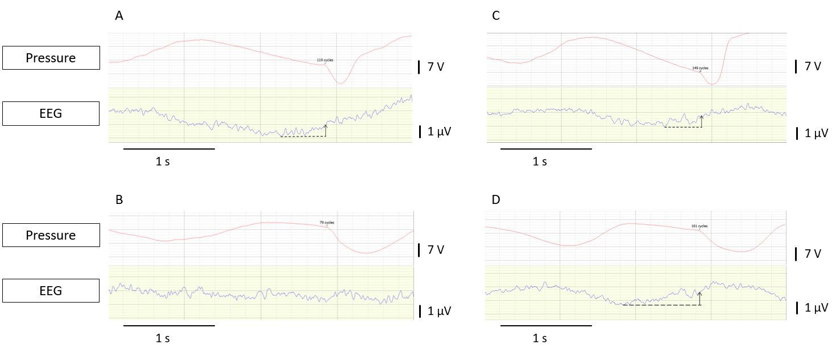
Supplemental figure E1: Illustration of measurement of pre-inspiratory potential (PIP) amplitude in a patient who passed (A and B) and in a patient who failed (C and D) the spontaneous breathing trial (SBT). EEG: electroencephalogram. A: example of PIP amplitude measured under mechanical ventilation in a patient who passed the SBT. B: example of PIP amplitude measured during the SBT in a patient who passed the SBT. No PIP was present in the example. C: example of PIP amplitude measured under mechanical ventilation in a patient who failed the SBT. D: example of PIP amplitude measured during the SBT in a patient who failed the SBT.
References
1. Ely EW, Truman B, Shintani A, Thomason JW, Wheeler AP, Gordon S, et al. Monitoring sedation status over time in ICU patients: reliability and validity of the Richmond Agitation-Sedation Scale (RASS). JAMA. 2003;289(22):2983-91.
2. Boles JM, Bion J, Connors A, Herridge M, Marsh B, Melot C, et al. Weaning from mechanical ventilation. Eur Respir J. 2007;29(5):1033-56.
3. Thille AW, Gacouin A, Coudroy R, Ehrmann S, Quenot JP, Nay MA, et al. Spontaneous-Breathing Trials with Pressure-Support Ventilation or a T-Piece. N Engl J Med. 2022;387(20):1843-54.
4. Yang KL, Tobin MJ. A prospective study of indexes predicting the outcome of trials of weaning from mechanical ventilation. N Engl J Med. 1991;324(21):1445-50.
5. Souza LC, Lugon JR. The rapid shallow breathing index as a predictor of successful mechanical ventilation weaning: clinical utility when calculated from ventilator data. J Bras Pneumol. 2015;41(6):530-5.

