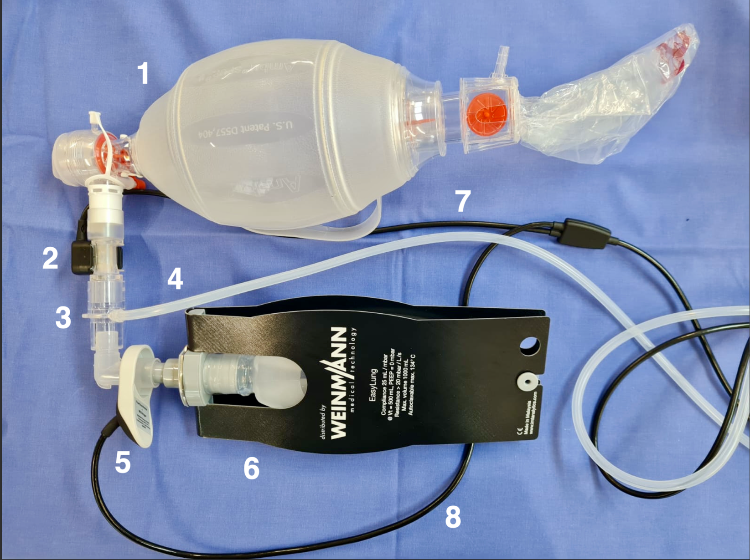
Supplement 1 – Figure of the airway pressure measurement
Legend: 1 - disposable resuscitator¹, 2 - FlowCheck sensor², 3 – connector for CO₂ measuring tube² ,4 – pressure measuring tube², 5 – MEDUtrigger², 6 - testing bag² (as visualization of connected device), 7 – FlowCheck sensor connection line², 8 – MEDUtrigger connection line²
¹ Ambu Spur II, Ambu GmbH
² WEINMANN Emergency, Medical Technology GmbH + Co. KG

Supplement 2 – Table of measured ventilation parameters and calculation methods

Parameters | Description | Calculation
∆Vt (ml) | Parameter for visualizing effective ventilation | ∆Vt = Vt_{ideal}–Vt_{e}
Vt_{ideal} (ml) | Calculated tidal volume based on the ideal body weight (IBW) | Calculated by the mechanical ventilator:  IBW female (kg) = 45 + 2.3 x (height in cm/2.54−60)  IBW male (kg) = 50 + 2.3 x (height in cm/2.54−60)  multiplicated with 6 ml
Vt_{e} (ml) | Expiratory tidal volume | Mean value over the last 5 expiratory volumes. Vt_{e} (single) calculates as integral over the expiration  ( with Ti as begin and Te as end of the expiration).  Measured by the mechanical ventilator.
Vt_{i} (ml) | Inspiratory tidal volume | Mean value over the last 5 inspiratory volumes. Vt_{i} (single) calculates as integral over all positive flows in one breath  (with 0 as start of breath and Te as end).  Measured by the mechanical ventilator.
V_{leak} (%) | Relative leakage volume | 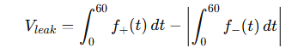  Integral of the flows over one minute (positive flows - negative flows) divided by the inspiratory minute volume.  Measured by the mechanical ventilator.
MV_{e} (l/min) | Expiratory volume per minute | Minute average of the expiratory tidal volume measured by the device.  MVe=Vt×F, averaged over 5 breaths
P_{mean} (mbar) | Mean pressure | Average value of the pressure over one minute. All pressure values measured by the mechanical ventilator during a breath were totaled and divided by the number of time intervals in which the measurement was taken.
P_{peak} (mbar) | Peak pressure | Mean value of the maximum airway pressure (peak pressure) per respiratory cycle over 1 minute.  Measured by the mechanical ventilator.
F_{manual} (x/min) | Manual ventilation frequency | Trend value measured by the device, averaged over 5 breaths.

