Supplemental material
In a randomized, blinded crossover study of eight 60-kg pigs, animals received infusions of hypertonic sodium lactate (HSL; Monico, S.P.A., Italy) and tonicity-matched hypertonic saline (SAL) in random order, separated by a one-hour washout period. A detailed description of the methods is available elsewhere.¹ Cardiac output was measured hourly by thermodilution via a right heart catheter. Arterial lactate, pH, bicarbonate, sodium, and chloride concentrations were analyzed immediately after sampling using an ABL800 FLEX blood gas analyzer. Strong ion difference (SID) was calculated according to Stewart’s principle.²

Infusion with HSL as the first intervention produced a rapid rise in arterial lactate accompanied by a parallel increase in cardiac output (Supplemental figure; black line). During washout, lactate concentrations fell quickly, and cardiac output returned to pre-HSL levels during the subsequent SAL infusion. In animals receiving SAL as the first intervention (pink line), no significant changes in arterial lactate or cardiac output were observed. In contrast, during the following HSL infusion, lactate levels rose rapidly with a concomitant increase in cardiac output. HSL infusion also increased arterial pH, SID, and bicarbonate, while decreasing chloride concentrations; notably, these changes persisted through the washout period and into the subsequent SAL phase (black line).

Supplemental figure: Arterial lactate, cardiac output, pH, strong ion difference, bicarbonate, and chloride during LAC compared with SAL infusion
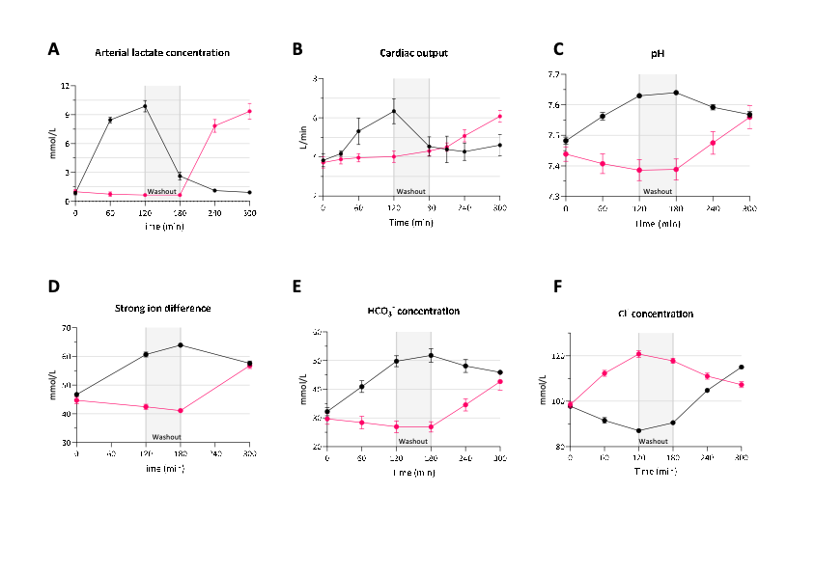
Legend: Black indicated infusion sequence LAC -> SAL; Pink indicates SAL -> LAC
References
1. Hørsdal OK, Moeslund N, Berg-Hansen K, Nielsen R, Møller N, Eiskjær H, Wiggers H, Gopalasingam N. Lactate infusion elevates cardiac output through increased heart rate and decreased vascular resistance: a randomised, blinded, crossover trial in a healthy porcine model. J Transl Med. 2024;22:1–14.
2. Stewart PA. Modern quantitative acid-base chemistry. Can J Physiol Pharmacol. 1983;61:1444–1461.

