Supplement 3: Renal outcomes

Mortality Effect Of Higher Versus Lower Blood Pressure Targets In Vasodilatory Shock: An Updated Systematic Review And Meta-Analysis

Henrique Mendes, MD, MRCEM, PGCE
Jesse King, MD BSc
Nikhil Kumar, FCICM, M.Clin Epi, MBBS, BSc
Kush Deshpande, MBBS, MD, FCICM
Rakshit Panwar, PhD, MBBS, MD, DNB, FCICM
Frank MP van Haren, MD PhD FCICM EDIC PgDipEcho

- Renal replacement therapy (RRT)-use

In contrast to the detrimental effect on days alive and free of RRT at 28 days (RRT-free days), a higher Mean Arterial Pressure (MAP) target was not associated with increased or decrease in RRT-use (Relative Risk 0.96 Confidence Interval [CI] 0.80 – 1.17). However, in hypertensive patients, a higher MAP target was actually associated with reduced RRT use (RR 0.83, 95% CI 0.71–0.98). See eFigure 1.

eFigure 1: RRT-use by chronic hypertensive status
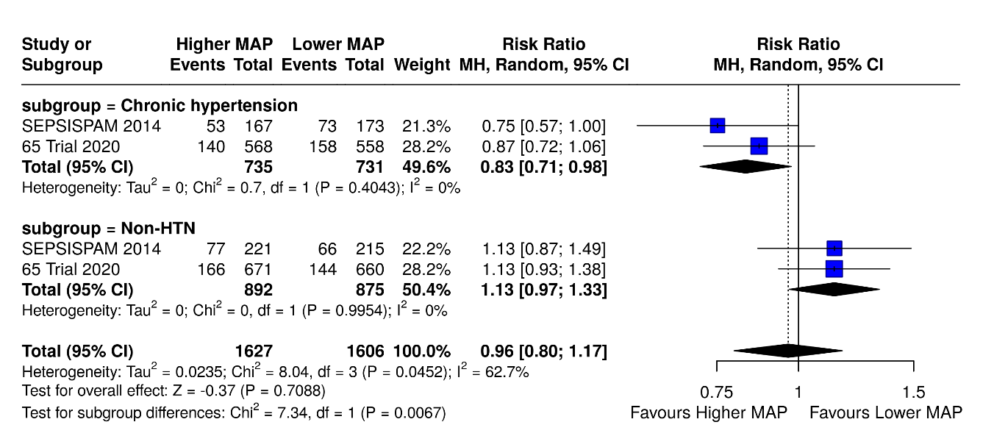

While the mortality signal is clear and consistent in our primary analysis, the renal data revealed nuanced effects that warrant careful interpretation, particularly regarding the subgroup of patients with chronic hypertension. Higher MAP targets reduced the RRT-use only in the chronic hypertensive cohort (RR 0.83; 95% CI 0.71–0.98). Nevertheless, this did not translate into increased days alive and free of RRT at 28 days (RRT-free days). In fact, higher MAP targets reduced RRT-free days by 1.3 days (95% CI, -3.05 to -0.23), closely mirroring the effect observed in the overall population (MD -1.6 days; 95% CI, -3 to -0.23). The explanation for these dissonant metrics is both methodological and pathophysiological.
Primarily, the most consistent finding in our study is the detrimental effect of higher MAP targets on overall survival. Thus, for both hypertensive and non-hypertensive patients, this increased mortality leads to the phenomenon of competing risks: death prevents some patients from living long enough to undergo RRT. This may explain why the RRT-free days metric worsens for both subgroups, as higher mortality truncates the time patients can be alive and free of RRT.
The reduction in RRT-use observed specifically in the chronic hypertensive cohort is a more nuanced finding. While the competing risk effect contributes to this reduction, it likely does not fully account for the observed difference, particularly since a similar reduction was not found in the non-hypertensive group. These findings suggest a potential pathophysiological benefit specific to hypertensive patients. Their renal autoregulation curves are right-shifted¹, meaning that they require greater pressure to maintain adequate renal blood flow. However, this potential benefit may be counteracted by the global adverse effects of high-dose vasopressors, such as increased left ventricular afterload, reduced cardiac output, and impaired systemic perfusion.² Furthermore, excessive vasopressor use can lead to persistent renal cortical hypoperfusion, even if global renal blood flow is restored.³ Ultimately, while a higher MAP target may offer a small, physiologically plausible renal benefit in hypertensive patients, this benefit is outweighed by the systemic harm and increased mortality associated with high-dose vasopressors.
Finally, our analysis of renal endpoints is limited by the competing risk of mortality, which we have highlighted in our above interpretation. Ideally, time-to-event analyses with competing risks (e.g., Fine-Gray models) or multistate models would provide more nuanced insights into the relationship between MAP targets and renal outcomes. However, such analyses were not feasible with the available aggregate trial data, which reported only summary statistics for RRT-free days and RRT use rather than individual patient-level time-to-event data. Therefore, aware of these constraints, these analyses were not contemplated in our prospective protocol. Future individual patient data meta-analyses could address this methodological gap by employing more sophisticated competing risk approaches.
References:

1. Carlstrom M, Wilcox CS, Arendshorst WJ. Renal autoregulation in health and disease. Physiol Rev 2015;95(2):405-511. DOI: 10.1152/physrev.00042.2012.
2. Aneman A, Wilander P, Zoerner F, Lipcsey M, Chew MS. Vasopressor Responsiveness Beyond Arterial Pressure: A Conceptual Systematic Review Using Venous Return Physiology. Shock 2021;56(3):352-359. DOI: 10.1097/SHK.0000000000001762.
3. Watchorn J, Huang D, Bramham K, Hutchings S. Decreased renal cortical perfusion, independent of changes in renal blood flow and sublingual microcirculatory impairment, is associated with the severity of acute kidney injury in patients with septic shock. Crit Care 2022;26(1):261. DOI: 10.1186/s13054-022-04134-6.

