- Detailed inclusion criteria and exclusion criteria
Inclusion criteria
- Age ≥18 years.
- Diagnosis of moderate-to-severe ARDS per the Berlin definition, requiring endotracheal intubation and mechanical ventilation with prone positioning within 48 hours of intubation.
- PaO₂/FiO₂ <150 mmHg with positive end-expiratory pressure (PEEP) ≥ 5 cmH₂O according to the Berlin definition [1].
Exclusion criteria
(1) Contraindications of EIT, such as chest wound dressing, installation of a pacemaker, defibrillator, etc.
(2) Unstable vertebral fracture;
(3) Within 15 days after severe facial trauma or facial surgery;
(4) within 15 days after tracheal surgery or sternotomy;
(5) Hemodynamic instability or recent cardiac arrest;
(6) Increased intraocular pressure;
(7) Unstable femoral or pelvic fractures and pelvic external fixation;
(8) Severe chest wall deformity or unstable rib fractures;
(9) Recent cardiothoracic surgery;
(10) Pneumothorax;
(11) Chronic lung disease: severe obstructive pulmonary disease, severe asthma, interstitial lung disease;
(12) Pregnancy or postpartum status;
(13) Extracorporeal membrane oxygenation (ECMO) had been administered on admission to the ICU;
(14) Intracranial hypertension;
(15) Pulmonary embolism, acute or chronic right heart failure;
(16) Severe cardiac dysfunction (New York Heart Association class III or IV, acute coronary syndrome, or sustained ventricular tachyarrhythmia), cardiogenic shock;
(17) No informed consent was obtained.
- Procedures for electrical impedance tomography (EIT) measurements:
EIT functional images and data were obtained using the PulmoVista 500 (Dräger Medical, Lübeck, Germany). The EIT belt with 16 surface electrodes was placed around the thorax between the 4th or 5th parasternal intercostal space. To ensure intra-patient repeatability, the belt position was marked on the skin. All measurements were performed with patients in the supine position.
EIT images were continuously recorded at 20 Hz. First, a 2-minute baseline EIT recording was obtained for ventilation analysis. Second, an end-inspiratory breath-hold was performed for 15 seconds. After the emergence of a plateau phase in the EIT impedance waveform induced by the end-inspiratory breath hold maneuver, a bolus of 10 ml of 10% NaCl solution was manually injected via the central venous (internal jugular or subclavian vein) catheter. Third, after the injection was completed, when the EIT impedance waveform was continuously rising from the lowest point, we ended the breath hold and continued to record the EIT images for 1 minute afterwards.
Figure S1 A pictorial representation of the belt placement and regions of interest (ROIs). Only one electrode is marked as an example on the left side.
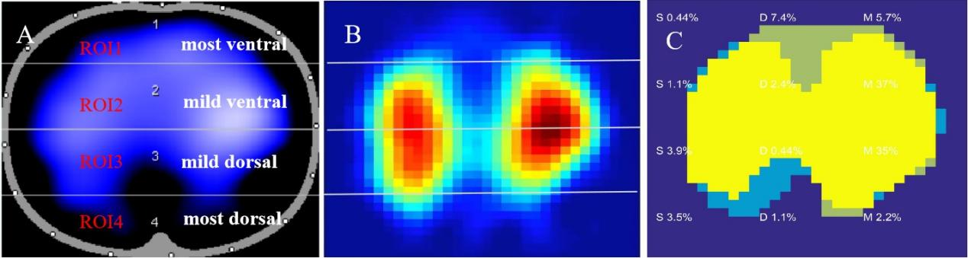
Figure S2 Illustration of the regions of interest (ROIs) segmentation for EIT ventilation and perfusion maps, along with an illustration shunt fraction (%), dead space volume (%), and ventilation-perfusion(V/Q) matched region (%). (A) The lungs were subdivided into ventral and dorsal regions, and the regions of interest were divided into four layers, from the ventral to the dorsal side. (B) The segmentation of the ROIs in the offline software analysis of perfusion maps aligns consistently with that of ventilation maps. (C) The shunt (%), dead space (%), and ventilation/perfusion (V/Q) matching (%) for each ROI were obtained through offline software analysis of the ventilation and perfusion map. S: shunt, D: dead space, M: V/Q matched region.
- Procedures for prone position ventilation
Before PPV, patients were ventilated in volume-controlled (VC) mode with low tidal volumes (6-8 ml/kg). The level of PEEP was selected in accordance with the ARDSnet FiO₂-PEEP table, with a goal for peripheral blood oxygen saturation (SpO₂) of at least 88%, or arterial partial pressure of oxygen (PaO2) ≥55 mmHg, and partial pressure of carbon dioxide (PaCO₂) ≤50 mmHg.
All patients were deeply sedated (target RASS score: -3 to -4) and given sufficient analgesia (target CPOT score: 0), and administered neuromuscular blocking agents as needed. Before PPV, all patients were required to have a central venous catheter with at least a double-lumen in either the internal jugular vein or the subclavian vein. The decision to initiate PPV was made by clinicians after the patient maintained a stable hemodynamic status and stable ventilation settings for at least 2 hours.
There were 3 to 4 clinicians or nurses were required for the procedure. As PPV has been a routine therapy in our center for over 10 years, the detailed procedure was based on the video from the 2013 PROSEVA trial [2]. Particular attention was given to positioning the EIT belt and avoiding disconnecting the ventilator or kinking the vascular lines during postural changes.
Clinicians could decide to withdraw from PPV if any new-onset severe hemodynamic instability emerged or if VV-ECMO was considered due to refractory hypoxemia or hypercapnia based on ELSO guidelines [3].
- Detailed procedures for ventilation setting adjustment during the study session.
Patients were ventilated in volume-controlled, assist/control mode. We applied the following settings:
- Initially, patients were continuously ventilated in volume-controlled assist/control mode following the ARDS Network protocol [4].
- Adjusted the V_{T} and respiratory rate as follows: if Pplat >30 cmH₂O or DP >14 cmH₂O, V_{T} was decreased by 1mL/kg PBW steps (minimum 4 mL/kg), with appropriate adjustments in respiratory rate to target equivalent minute volume. If the patient developed severe patient-ventilator asynchrony, V_{T} was increased by 1mL/kg PBW steps (maximum 8 mL/kg PBW) if Pplat ≤30 cmH₂O and DP ≤14 cmH₂O. If asynchrony persisted, patients were deeply sedated and, if necessary, paralyzed. If the patient presented respiratory acidosis (pH: 7.15-7.30), the respiratory rate was increased to a maximum of 35 cycles/min until pH >7.30. In case of severe respiratory acidosis (pH <7.15), V_{T} was increased in 1 ml/kg steps until pH > 7.15 (Pplat target of 30 cm H₂O may be exceeded). In case of respiratory alkalosis (pH >7.45), the respiratory rate was decreased if possible.
References
1. Force ADT, Ranieri VM, Rubenfeld GD, Thompson BT, Ferguson ND, Caldwell E, Fan E, Camporota L, Slutsky AS: Acute respiratory distress syndrome: the Berlin Definition. JAMA 2012, 307(23):2526-2533.
2. Cornejo RA, Diaz JC, Tobar EA, Bruhn AR, Ramos CA, Gonzalez RA, Repetto CA, Romero CM, Galvez LR, Llanos O et al: Effects of prone positioning on lung protection in patients with acute respiratory distress syndrome. Am J Respir Crit Care Med 2013, 188(4):440-448.
3. Tonna JE, Abrams D, Brodie D, Greenwood JC, Rubio Mateo-Sidron JA, Usman A, Fan E: Management of Adult Patients Supported with Venovenous Extracorporeal Membrane Oxygenation (VV ECMO): Guideline from the Extracorporeal Life Support Organization (ELSO). ASAIO J 2021, 67(6):601-610.
4. Brower RG, Matthay MA, Morris A, Schoenfeld D, Thompson BT, Wheeler A: Ventilation with lower tidal volumes as compared with traditional tidal volumes for acute lung injury and the acute respiratory distress syndrome. The New England journal of medicine 2000, 342(18):1301-1308.

