Table S1 Detailed multivariate logistic regression analysis
Variables | β | Standard error | P value | Adjusted Odds ratio (95% CI)
Model 1
ROI 3 shunt, % | 0.171 | 0.084 | 0.042 | 1.187 (1.007-1.399)
ROI 3 Dead space, % | -0.074 | 0.135 | 0.583 | 0.929 (0.713-1.210)
COV, % | -0.023 | 0.083 | 0.780 | 0.977 (0.830-1.151)
Global V/Q matching, % | 0.003 | 0.039 | 0.936 | 0.997 (0.923-1.077)
Crs, ml/cmH₂O | -0.126 | 0.061 | 0.040 | 0.882 (0.782-0.994)
Model 2
Dorsal shunt, %, | 0.109 | 0.066 | 0.096 | 1.115 (0.981-1.268)
Dorsal Dead space, % | -0.073 | 0.104 | 0.482 | 0.930 (0.759-1.139)
COV, % | -0.048 | 0.079 | 0.541 | 0.953 (0.816-1.112)
Global V/Q matching, % | -0.011 | 0.038 | 0.771 | 0.989 (0.918-1.065)
Crs, ml/cmH₂O | -0.110 | 0.059 | 0.060 | 0.798 (0.782-1.005)
Model 3
ROI 3 mismatch, %, | 0.142 | 0.076 | 0.062 | 1.152 (0.993-1.337)
COV, % | -0.115 | 0.070 | 0.100 | 0.891 (0.777-1.022)
Global V/Q matching, % | 0.027 | 0.036 | 0.456 | 1.027 (0.957-1.103)
Crs, ml/cmH₂O | -0.095 | 0.053 | 0.072 | 0.909 (0.820-1.009)
ROI: region of interest, COV: Center of ventilation, V/Q: ventilation-perfusion, β: estimated coefficient, Crs: static compliance of the respiratory system.

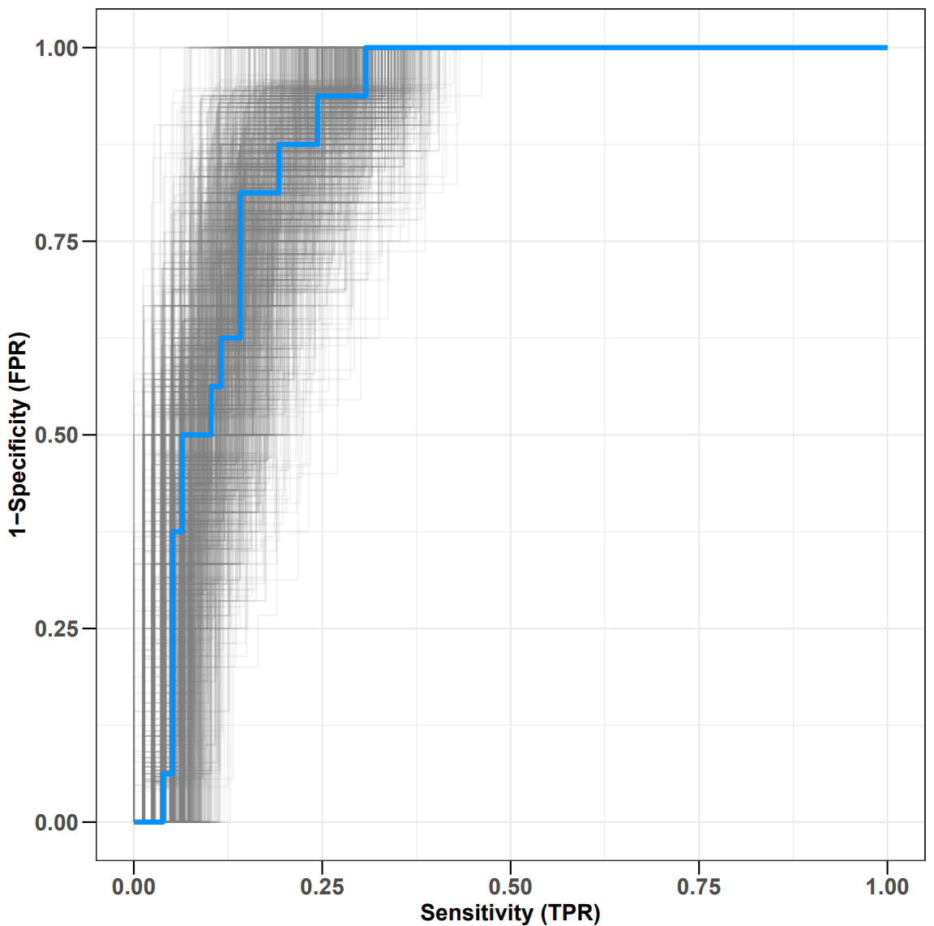
Figure S3 Evaluating the calibration of the model using 1000 bootstrap resamples of the shunt% of ROI 3 before PPV to predict the responsiveness of PPV. The gray lines in the figure depict the ROC curves derived from different bootstrap-sampled datasets. The grey curves are concentrated and closely aligned with the blue curve, which indicates that the model's performance is relatively stable.
Table S2 Respiratory mechanics parameters and gas exchange
Variable | PPV 0h |  |  | PPV-16h
Variable | Responsive group  N=78 | Non-responsive group  N=16 | p value | Responsive group  N=78 | Non-responsive group  N=16 | p value
Respiratory mechanics parameters
Ppeak, cmH₂O | 30.0 (27.8-33.0) | 32.0 (30.3-34.8) | 0.128 | 29.0 (25.8-32.3) | 36.0 (31.3-41.0) | < 0.001
Pplat, cmH₂O | 23.9±3.4 | 25.6±2.5 | 0.065 | 22.7±3.4 | 26.9±3.5 | < 0.001
DP, cmH₂O | 12.0 (10.5-14.0) | 13.1 (12.3-14.0) | 0.184 | 11.0(8.7-13.0) | 15.3(12.3-17.0) | < 0.001
PEEP, cmH₂O | 12.0 (10.0-12.0) | 12.0(10.0-14.0) | 0.506 | 12.0 (10.0-13.0) | 12.0 (10.0-14.0) | 0.706
Crs, mL/cmH₂O | 35.6±7.5 | 31.4±5.8 | 0.037 | 40.0 (33.3-50.0) | 29.1 (24.3-34.8) | 0.001
Result of ABG
PaO₂/FiO₂, mmHg | 119.5(96.6-135.3) | 118.7(110.0-136.7) | 0.491 | 234.8(184.5-340.8) | 116.5(82.2-132.3) | < 0.001
PaCO₂, mmHg | 44.1±9.1 | 48.1±13.6 | 0.269 | 41.0 (37.4-45.8) | 49.2 (38.5-59.3) | 0.034
Ppeak: peak pressure, Pplat: plateau pressure, DP: driving pressure, PEEP: positive end-expiratory pressure, Crs: static compliance of the respiratory system, ABG: Arterial blood gas, PaO₂/FiO₂: ratio of arterial oxygen partial pressure to fraction of inspired oxygen, PaCO₂: arterial carbon dioxide partial pressure.

Table S3 Hemodynamic parameters
Variable | PPV 0h |  |  | PPV 16h
Variable | Responder group  N=78 | Non-responder group  N=16 | P value | Responder group  N=78 | Non-responder group  N=16 | P value
MAP, mmHg | 80.5 (73.6-92.8) | 87.7 (79.0-105.8) | 0.084 | 84.0±12.2 | 80.0±9.4 | 0.220
HR, beats/min | 100.7±22.8 | 112.6±17.5 | 0.052 | 94.9±19.0 | 107.2±18.9 | 0.020
CVP, mmHg | 13.0 (11.5-17.6) | 16.0 (14.9-18.8) | 0.059 | 14.0 (11.0-19.0) | 18.0 (13.0-25.2) | 0.080
Serum lactate of ABG, mmol/L | 1.7 (1.1-2.4) | 1.8 (1.2-3.1) | 0.471 | 1.4 (1.1-2.0) | 1.6 (1.2-3.2) | 0.240
Norepinephrine, ug/kg/min | 0.06 (0.00-0.21) | 0.03 (0.00-0.39) | 0.606 | 0.03 (0.0-0.18) | 0.20 (0.0-0.92) | 0.164
MAP: mean arterial pressure, HR: heart rate, CVP: central venous pressure, NE: norepinephrine, ABG: arterial blood gas.

