Online Data Supplement

Effect of Noninvasive Ventilation on Tracheal Reintubation Among Patients With Hypoxemic Respiratory Failure Following Abdominal Surgery. A Bayesian post-hoc analysis of the NIVAS trial

Bayesian Primer.
eMethods 1. Systematic review
eMethods 2. Sensitivity analysis with different priors
eMethods 3. Bayesian meta-analysis of priors
eTable 1. Detailed Characteristics of the 9 Included Studies, and Number of Patients Randomized to Included Therapies.
eTable 2. Posterior distribution and probability of treatment effect of NIV compared to oxygen therapy over day-7 reintubation in multivariable analysis
eTable 3. Posterior distribution and probability of treatment effect of NIV compared to oxygen therapy over day-30 mortality in multivariable analysis
eTable 4. Posterior probabilities and effect estimate for later secondary endpoints under each prior
eTable 5. Posterior probabilities and effect estimate for lengths of stay under each prior
eTable 6. Sensitivity analysis: Posterior distribution and probability of treatment effect of NIV compared to oxygen therapy over day-7 reintubation with various priors
eTable 7. Sensitivity analysis: Posterior distribution and probability of treatment effect of NIV compared to oxygen therapy over day-7 reintubation with informative intercepts
eFigure 1. Flow diagram summarizing electronic search for evidence before NIVAS study
eFigure 2. Risk of bias assessment for RCT (A) and non-interventional studies (B) according to the Cochrane risk of bias tool
eFigure 3. Posterior probability distributions for OR and ARR comparing NIV versus oxygen on reintubation to day-7 reintubation in multivariable analysis
eFigure 4. Posterior probability distributions for OR and ARR comparing NIV versus oxygen on reintubation to day-30 mortality in multivariable analysis
eFigure 5. Posterior probability distributions for OR and ARR comparing NIV versus oxygen on day-90 mortality according to each prior
eFigure 6. Posterior probability distributions for OR and ARR comparing NIV versus oxygen on day-7 overall healthcare-associated infections according to each prior
eFigure 7. Posterior probability distributions for OR and ARR comparing NIV versus oxygen on day-7 pneumonia according to each prior
eFigure 8. Posterior probability distributions for OR and ARR comparing NIV versus oxygen on day-30 reintubation according to each prior
eFigure 9. Posterior probability distributions for OR and ARR comparing NIV versus oxygen on day-30 pneumonia according to each prior
eFigure 10. Posterior probability distributions for OR and ARR comparing NIV versus oxygen on day-30 overall healthcare-associated infections according to each prior
eFigure 11. Posterior estimations in the sub-group from the stratum of randomization under minimally informative prior
eFigure 12. Bayesian meta-analysis. Forest plot for the results after each prior (A) and resulting heterogeneity for all tau distribution (B)

eFigure 13. Posterior probability distributions for OR comparing NIV versus oxygen on day-7 reintubation according to each prior with intercept prior 1
eFigure 14. Posterior probability distributions for OR and ARR comparing NIV versus oxygen on reintubation to day-7 according to each prior with intercept prior 2
eFigure 15. Posterior density of treatment effect for NIV versus oxygen on reintubation to day-7 according to each prior with intercept prior 3
eFigure 16. Convergence diagnosis of Markov Chain Monte Carlo simulations for day-7 reintubation according to the No-U-Turn Sampler algorithm
eFigure 17. Convergence diagnosis of Markov Chain Monte Carlo simulations for day-7 reintubation in multivariable analysis according to the No-U-Turn Sampler algorithm
eFigure 18. Convergence diagnosis of Markov Chain Monte Carlo simulations for day-7 reintubation with informative intercept 1 according to the No-U-Turn Sampler algorithm
eFigure 19. Convergence diagnosis of Markov Chain Monte Carlo simulations for day-7 reintubation with informative prior on intercept 2 according to the No-U-Turn Sampler algorithm
eFigure 20. Convergence diagnosis of Markov Chain Monte Carlo simulations for day-7 reintubation with informative prior on intercept 3 according to the No-U-Turn Sampler algorithm
eFigure 21. Convergence diagnosis of Markov Chain Monte Carlo simulations for day-30 mortality according to the No-U-Turn Sampler algorithm
eFigure 22. Convergence diagnosis of Markov Chain Monte Carlo simulations for day-7 overall healthcare-associated infection according to the No-U-Turn Sampler algorithm
eFigure 23. Convergence diagnosis of Markov Chain Monte Carlo simulations for day-30 mortality in multivariable analysis according to the No-U-Turn Sampler algorithm
eFigure 24. Convergence diagnosis of Markov Chain Monte Carlo simulations for day-7 pneumonia infection according to the No-U-Turn Sampler algorithm
eFigure 25. Convergence diagnosis of Markov Chain Monte Carlo simulations for day-30 reintubation according to the No-U-Turn Sampler algorithm
eFigure 26. Convergence diagnosis of Markov Chain Monte Carlo simulations for day-90 mortality according to the No-U-Turn Sampler algorithm
eFigure 27. Convergence diagnosis of Markov Chain Monte Carlo simulations for day-30 overall healthcare-associated infection according to the No-U-Turn Sampler algorithm
eFigure 28. Convergence diagnosis of Markov Chain Monte Carlo simulations for day-30 pneumonia infection according to the No-U-Turn Sampler algorithm

Bayesian Primer
While Bayesian statistics may seem abstract, most clinicians already use Bayesian reasoning daily without realizing it. Consider the familiar process of interpreting diagnostic tests.
A patient presents with chest pain and has a troponin test. If the troponin level is elevated, you immediately consider myocardial infarction. Conversely, if an asymptomatic patient with a normal ECG has an unexpectedly elevated troponin (perhaps ordered inadvertently), you would first suspect a laboratory error or alternative causes.
This reasoning process is inherently Bayesian. You intuitively estimate a pre-test probability (moderate for chest pain, very low for an asymptomatic patient), then combine it with the test result to arrive at a post-test probability of disease.
Bayesian statistics formalizes this intuitive process for research. Instead of pre-test probability, we specify a "prior probability" for our research hypothesis. In our study, this represents our belief about NIV's effect on day-7 reintubation before examining the trial data.
This prior can be based on existing evidence (eMethods 2), expert opinion, or explicitly stated assumptions about plausible treatment effects. Alternatively, we can express complete uncertainty—equivalent to saying "this treatment could have any effect from very harmful to very beneficial, and I have no reason to favor one over the other." This lets the trial data speak for itself. These beliefs are expressed mathematically as probability distributions (in our case, normal distributions). Finally, we combine the prior with the observed trial data to calculate the "posterior probability": our updated belief about the treatment effect given both our prior assumptions and the new evidence.

Rather than p-values, Bayesian statistics answer clinical questions directly with probability statements:
- What is the probability that NIV is beneficial?
- What is the probability of a clinically meaningful benefit?

eMethods 1. Systematic review
We performed a computerized search of MEDLINE (1998 to 2016), for studies comparing noninvasive ventilation to oxygen therapy in which researchers reported reintubation rates of the patients. We included non-English publications. The keywords search strategy is described below. References in the retrieved articles were also examined for relevant publications. We identified and deleted any duplicate papers. All potentially eligible papers were retrieved in full.
First, two authors (AN and JP) independently screened the retrieved studies by title and then by abstract for exclusion. They assessed the full text of the possible relevant studies for inclusion and exclusion criteria. Disagreement was resolved by discussion and arbitrated, if necessary, by a third author (NM). Data were then entered into an Excel database specifically designed for this review.

Risk of bias and quality assessment:
Risk of bias was evaluated using the Cochrane Risk of Bias Tools for RCTs (RoB 2) and for Non-randomized Studies (ROBINS-I V2). eFigure 2 presents the risk of bias assessment of each included study.

Databases Searched:
- PubMed/Medline
- Web Of Science

PubMed/MEDLINE
1 | "noninvasive ventilation"[MeSH Terms] OR ("noninvasive"[All Fields] AND "ventilation"[All Fields]) OR "noninvasive ventilation"[All Fields] OR "noninvasive ventilation"[MeSH Terms] OR (("noninvasive"[All Fields] OR "noninvasively"[All Fields] OR "noninvasiveness"[All Fields]) AND ("ventilated"[All Fields] OR "ventilates"[All Fields] OR "ventilating"[All Fields] OR "ventilation"[MeSH Terms] OR "ventilation"[All Fields] OR "ventilate"[All Fields] OR "ventilations"[All Fields] OR "ventilation s"[All Fields] OR "ventilator s"[All Fields] OR "ventilators, mechanical"[MeSH Terms] OR ("ventilators"[All Fields] AND "mechanical"[All Fields]) OR "mechanical ventilators"[All Fields] OR "ventilator"[All Fields] OR "ventilators"[All Fields] OR "ventillation"[All Fields])) | 18,005
2 | "postoperative period"[MeSH Terms] OR ("postoperative"[All Fields] AND "period"[All Fields]) OR "postoperative period"[All Fields] OR ("post"[All Fields] AND "operative"[All Fields]) OR "post operative"[All Fields] OR ("postoperative period"[MeSH Terms] OR ("postoperative"[All Fields] AND "period"[All Fields]) OR "postoperative period"[All Fields] OR "postop"[All Fields] OR "postoperative"[All Fields] OR "postoperatively"[All Fields] OR "postoperatives"[All Fields]) OR ("surgery"[MeSH Subheading] OR "surgery"[All Fields] OR "surgical procedures, operative"[MeSH Terms] OR ("surgical"[All Fields] AND "procedures"[All Fields] AND "operative"[All Fields]) OR "operative surgical procedures"[All Fields] OR "general surgery"[MeSH Terms] OR ("general"[All Fields] AND "surgery"[All Fields]) OR "general surgery"[All Fields] OR "surgery s"[All Fields] OR "surgerys"[All Fields] OR "surgeries"[All Fields] | 6,207,407
3 | "reintubate"[All Fields] OR "reintubated"[All Fields] OR "reintubation"[All Fields] OR "reintubations"[All Fields] OR "intubate"[All Fields] OR "intubated"[All Fields] OR "intubates"[All Fields] OR "intubating"[All Fields] OR "intubation"[MeSH Terms] OR "intubation"[All Fields] OR "intubations"[All Fields] OR "intubator"[All Fields] OR "intubator s"[All Fields] OR "intubators"[All Fields] | 110,177
4 | #1 AND #2 AND #3 Filters: from 1998 - 2016 | 406

Web of Science
1. | ALL=(( ( positive AND pressure AND ventilation ) OR bipap OR ( face AND mask ) OR ( nasal AND cannu* ) OR ( non AND invasive AND ventilation ) ) AND ( reintub* OR intub*) AND ( abdominal surgery OR ( general AND anesth* ) OR ( post AND anesthesia ) ) ) | 712

eMethods 2. Sensitivity analysis with different priors
Sensitivity Analysis for Prior Strength of Belief
To address potential concerns about prior construction, we conducted two complementary sensitivity analyses of the primary outcome, day-7 reintubation.
Our primary analysis used two informative priors following the normal law of distribution, where the mean was the OR derived from the calculation of the sample size. The SD was estimated according to Zampieri et al., assuming a 15% probability of harm (enthusiastic prior) or benefit (pessimistic prior). To assess sensitivity to this threshold, we recalculated prior standard deviations allowing 5%, 10%, and 20% probabilities of crossing the null effect.
- Enthusiastic priors (varying probability of harm):
  - 20% chance: N(−1.02, 1.22)
  - 15% chance: N(−1.02, 0.99) [primary analysis]
  - 10% chance: N(−1.02, 0.80)
  - 5% chance: N(−1.02, 0.63)
- Pessimistic priors (symmetric, varying probability of benefit):
  - 20% chance: N(1.02, 1.22)
  - 15% chance: N(1.02, 0.99) [primary analysis]
  - 10% chance: N(1.02, 0.80)
  - 5% chance: N(1.02, 0.63)
Sensitivity Analysis with meta-analysis-informed priors

To incorporate empirical evidence while accounting for population differences and study limitations identified in our systematic review (eMethods 1), we constructed an alternative prior based on the Cochrane meta-analysis by Faria et al. (2015). This meta-analysis pooled two RCTs comparing NIV versus standard oxygen (NIV: 4/135 events; control: 18/134 events), yielding a log odds ratio of −1.55 (SE = 0.57).
Given concerns about the applicability of these data to the NIVAS population (see eMethods 1), we applied a downweighting approach to reduce prior influence on the posterior distribution. Following established methods for incorporating historical data with uncertainty (1), we inflated the standard error by dividing by √weight, examining three scenarios:
- Full weight (100%): N(−1.55, 0.57)
- Moderate downweighting (50%): N(−1.55, 0.81)
- Substantial downweighting (25%): N(−1.55, 1.14)

Sensitivity Analysis for Intercept Priors
We further examined whether incorporating prior knowledge about baseline reintubation risk could influence treatment effect estimates in our Bayesian models. In logistic regression, the relationship between predictors and the outcome is modeled as: logit(p) = α + βX
where α represents the intercept (baseline risk in the control group, when all predictors equal zero), and β
Represents treatment effect (the logarithm of the odds-ratio). In Bayesian analysis, a prior distribution on the intercept can be used to specify our knowledge about baseline risk before model fitting. Primary analyses were conducted using the default intercept prior from the brms R package: a Student's t-distribution with parameters t(3, 0, 2.5), which is weakly informative and equivalent to making no strong assumptions about baseline risk. We conducted sensitivity analyses to test whether incorporating prior knowledge about baseline day-7 reintubation risk in the control group could improve coefficient estimation in our Bayesian model.

1. Prior intercept according to sample size calculation assumptions
In the sample size calculation for the original trial, it was assumed that the reintubation rate in the oxygen group would be 65%. The mean of our informative prior on the intercept was therefore defined as log(0.65/(1-0.65)) = 0.619.
For the standard deviation, we chose 0.7, corresponding to a 95% probability that the baseline risk lies between 35% and 95%—a reasonable assumption given the clinical context.
Prior 1: α ~ N(0.619, 0.7)
2. Other priors intercept
Since reintubation rates in our literature review ranged from 33% to 48% in populations slightly less severe than those in the NIVAS trial, we assessed whether more conservative priors on baseline risk would alter our estimates. We defined two alternative priors:
Prior 2: α ~ N(0, 0.7)
Baseline risk ≈ 50% (95% CI: 20-80%)
This translates the assumption that the baseline reintubation rate in the control group has a 95% probability of being between 20 and 80%.
Moderate uncertainty about the exact baseline rate
Prior 3: α ~ N(0, 0.454)
Baseline risk ≈ 50% (95% CI: 30-70%)
Higher confidence in baseline risk estimate

eMethods 3. Bayesian meta-analysis of priors
We performed a Bayesian meta-analysis to quantify the influence of prior specifications on our conclusions. We treated each prior-specific reanalysis (minimally informative, enthusiastic, pessimistic, and skeptical) as a separate analysis and pooled the posterior estimates for day-7 reintubation using a random-effects model.
We specified a moderately skeptical prior for the pooled effect (μ ~ N(0, 0.355)). For between-analysis heterogeneity (τ), we used the DuMouchel prior where P(τ) = s₀/(s₀+τ)² and s₀ is the harmonic mean of the four standard errors. This prior assigns lower probability to larger heterogeneity values.
Since all analyses used identical data, any observed heterogeneity reflects variability induced by the choice of priors rather than true differences between studies. We present results as a forest plot with pooled estimates and I²-τ curves. Low heterogeneity indicates that conclusions remain robust across different prior assumptions.

eTable 1. Detailed Characteristics of the 9 Included Studies, and Number of Patients Randomized to Included Therapies.
Author  (Trial Name) | Year | Journal | Design | Sites | Country | Inclusion Criteria | Exclusion Criteria | Treatment Arms | Outcomes | N | Mean Age | % Male
Gao | 2002 | Clinical Medical Journal of China | RCT | 1 | China | Elderly participants with a respiratory rate over 30 breaths/minute after upper abdominal surgery in an ICU | indication of endotracheal intubation PaO2 ≤ 60 mm Hg or PaCO2 ≥ 50 mm Hg under oxygen mask or NPPV with oxygen flow rate of 5 L/min | Control: routine oxygen mask with oxygen flow rate of 5 L/min  Intervention: NPPV. Assisted mechanical ventilation using an oxygen mask/ | Endotracheal intubation; ICU and hospital length of stay; incidence of pneumonia, infection, and sepsis within the first month after surgery; and hospital mortality. | 60 | 65 | 73.3
Squadrone | 2005 | JAMA | RCT | 15 | Italia | Abdominal surgery requiring laparotomy and a time of viscera exposure longer than 90 minutes, PaO2/FiO2 < 300. | NYHA>1; valvular heart disease; dilated cardiomyopathy; pacemaker; instable ischemic heart disease; surgery <3m; COPD; Asthma; infection; BMI>40; tracheostomy; emergency… | Control: Venturi mask at an FiO2 of 0.5  Intervention: oxygen at an FiO2 of 0.5 plus a CPAP of 7.5 cm H2O | Reintubation within 7days; ICU and hospital length of stay; incidence of pneumonia; infection; and sepsis within the first month after surgery2; hospital mortality | 209 | 65 | 65.2
Conti | 2007 | Respiratory Care | Prospective cohort | 2 | Italia | ARF after abdominal surgery |  | Control: face mask  Intervention: NPPV via helmet | PaO2/FiO2; intubation; intolerance; physiological parameters; | 50
Michelet | 2009 | The British Journal of Surgery | Prospective cohort | 1 | France | ARF after oesophagectomy with severe respiratory distress with dyspnea; RR> 30 c/min; radiographic infiltrates; T>38·5°C; purulent; PaO2/FiO2 < 200 mmHg while breathing oxygen through a Venturi mask. | Early surgical complications; postoperative atelectasis >1 lobe; cardiopulmonary resuscitation; immediate intubation; coma; seizures; cardiogenic and septic shock; refusal or intolerance of NPPV; anastomotic dehiscence. | Cases: NPPV was delivered through a total facial mask  Match: Standard | Reintubation within ICU stay; anastomotic leakage; septic shock; ARDS; ICU and hospital LOS; postoperative death; pneumonia | 72 | 63 | 83.3
Narita | 2010 | Internal Medicine | Retrospective before after study | 1 | Japan | Respiratory failure or massive atelectasis after liver resection. PaO2/FiO2 < 300; atelectasis > 1 lobe. |  | Before (Control): oxygen for SpO2 > 90%; broncho  After (NPPV): NIV bilevel via full-face mask or a nasal mask. | Hospital mortality; respiratory mortality; reintubation; ICU and hospital LOS; PaO2/ FiO2; PaCO2 after 24h. | 26 | 63 | 80.7

Abbreviations: NPPV= Noninvasive Positive Pressure Ventilation; CPAP= Continuous Positive Airway Pressure; ARF= Acute Respiratory Faillure; ARDS= Acute Respiratory Distress Syndrome; LOS= Length Of Stay; ICU= Intensive Care Unit;

eTable 2. Posterior distribution and probability of treatment effect of NIV compared to oxygen therapy over day-7 reintubation in multivariable analysis
Prior Belief | Posterior Median OR (95% CrI) | P(OR < 1)% | Posterior Median ARR, % (95% CrI) | P(ARR > 2)% | P(ARR ≥5)% | P(ARR ≥10)%
Minimally informative | 0.50 (0.28 to 0.88) | 99% | 13.1% (2.5% to 23.5%) | 98% | 93% | 73%
Enthusiastic | 0.52 (0.31 to 0.86) | 99% | 13.5% (3.0% to 23.9%) | 98% | 94% | 74%
Pessimistic | 0.58 (0.36 to 0.98) | 98% | 11.1% (0.7% to 21.6%) | 96% | 87% | 58%
Skeptical | 0.68 (0.46 to 1.03) | 97% | 8.6% (-0.6% to 17.4%) | 92% | 78% | 38%

Multivariable analysis with adjustment on center, age < 60 years, COPD, surgical site (supra or submesocolic), epidural analgesia, postoperative sepsis, history of ischemic heart disease and chronic heart failure, BMI > 30
Abbreviations: OR, odds ratio; CrI, Credible interval; P, probability; ARR, absolute risk reduction; NNT = Number Needed to Treat (of patients to avoid one event)

eTable 3. Posterior distribution and probability of treatment effect of NIV compared to oxygen therapy over day-30 mortality in multivariable analysis
Prior Belief | Posterior Median OR (95% CrI) | P(OR < 1) | Posterior Median ARR, % (95% CrI) | P(ARR > 2)% | P(ARR ≥5)% | P(ARR ≥10)%
Minimally informative | 0.47 (0.18 to 1.19) | 95% | 5.1% (-1.1% to 11.4%) | 83% | 51% | 6%
Skeptical | 0.82 (0.48 to 1.38) | 77% | 1.8% (-3.0% to 6.8%) | 46% | 10% | 0%

Multivariable analysis with adjustment on center , surgical site (supra or submesocolic), epidural analgesia, COPD , SOFA score, age, IGS score
Abbreviations: OR, odds ratio; CrI, Credible interval; P, probability; ARR, absolute risk reduction; NNT = Number Needed to Treat (of patients to avoid one event)

eTable 4. Posterior probabilities and effect estimate for later secondary endpoints under each prior
Prior Belief | Posterior Median OR (95% CrI) | P(OR < 1) | Posterior Median ARR, % (95% CrI) | P(ARR ≥2%)  NNT = 50 | P(ARR ≥5%)  NNT = 20 | P(ARR ≥10%)  NNT = 10
Day-30 reintubation
Minimally informative | 0.63 (0.40 to 1.02) | 97% | 11.1% (-0.2% to 22.1%) | 94% | 86% | 58%
Enthusiastic | 0.61 (0.38 to 0.95) | 98% | 12.0% (0.9% to 22.7%) | 96% | 90% | 64%
Pessimistic | 0.69 (0.43 to 1.07) | 95% | 9.2% (-1.9% to 20.0%) | 90% | 78% | 44%
Skeptical | 0.73 (0.50 to 1.08) | 95% | 7.7% (-1.6% to 16.9%) | 88% | 71% | 31%
Day-90 mortality
Minimally informative | 0.64 (0.34 to 1.13) | 93% | 6.4% (-2.2% to 15.2%) | 84% | 63% | 21%
Skeptical | 0.78 (0.49 to 1.22) | 87% | 3.7% (-3.1% to 10.5%) | 69% | 36% | 3%
Day-30 healthcare-associated infection
Minimally informative | 0.47 (0.28 to 0.77) | 100% | 18.0% (6.2% to 29.3%) | 100% | 98% | 91%
Skeptical | 0.61 (0.40 to 0.91) | 99% | 11.9% (2.2% to 21.3%) | 98% | 92% | 65%
Day-30 pneumonia
Minimally informative | 0.40 (0.22 to 0.74) | 100% | 15.1% (5.4% to 24.7%) | 100% | 98% | 85%
Skeptical | 0.59 (0.38 to 0.93) | 99% | 8.8% (1.2% to 16.5%) | 96% | 83% | 38%

Abbreviations: OR, odds ratio; CrI, Credible interval; P, probability; ARR, absolute risk reduction; NNT = Number Needed to Treat (of patients to avoid one event).

eTable 5. Posterior probabilities and effect estimate for lengths of stay under each prior
Prior Belief | Mean Difference (days) (95% CrI) | P(MD < 0)
ICU length of stay to day 30
Minimally informative | 0.48 (-1.91 to 2.06) | 52%
Hospital length of stay to day 30
Minimally informative | 2.26 (-2.77 to 7.37) | 81%

Abbreviations: CrI, Credible interval; P, probability; MD, mean difference; ICU, intensive care unit

eTable 6. Sensitivity analysis: Posterior distribution and probability of treatment effect of NIV compared to oxygen therapy over day-7 reintubation with various priors
Prior Belief | Posterior Median OR (95% CrI) |  | P(OR < 1) |  | Posterior Median ARR, % (95% CrI) |  | P(ARR ≥2%)  NNT = 50 |  | P(ARR ≥5%)  NNT = 20 |  | P(ARR ≥10%)  NNT = 10
20% Opposing tail probability¹
Enhusiastic  sd = 1.22 | 0.58 (0.37 to 0.92) | 99% |  | 12.9% (2.0% to 23.4%) |  | 98% |  | 92% |  | 71%
Pessimistic  sd = 1.22 | 0.63 (0.40 to 1.03) | 98% |  | 11.0% (0.1% to 21.9%) |  | 95% |  | 86% |  | 58%
10% Opposing tail probability
Enhusiastic  sd = 0.8 | 0.57 (0.36 to 0.88) | 99% |  | 13.4% (3.0% to 23.8%) |  | 98% |  | 94% |  | 74%
Pessimistic  sd = 0.8 | 0.67 (0.44 to 1.06) | 96% |  | 9.3% (-1.2% to 19.8%) |  | 92% |  | 79% |  | 45%
5% Opposing tail probability
Enhusiastic  sd = 0.63 | 0.55 (0.35 to 0.87) | 99% |  | 14.0% (3.3% to 24.4%) |  | 99% |  | 95% |  | 77%
Pessimistic  sd = 0.63 | 0.72 (0.46 to 1.11) | 93% |  | 7.7% (-2.6% to 18.0%) |  | 86% |  | 69% |  | 33%
Data-driven priors from Farial et al.
0% Down-weighting | 0.50 (0.32 to 0.78) | 100% |  | 16.3% (6.0% to 26.6%) |  | 100% |  | 98% |  | 89%
50% Down-weighting | 0.54 (0.34 to 0.85) | 100% |  | 14.6% (3.9% to 25.0%) |  | 99% |  | 96% |  | 80%
75% Down-weighting | 0.56 (0.35 to 0.89) | 99% |  | 13.5% (2.7% to 24.4%) |  | 98% |  | 94% |  | 75%

¹Opposing tail probability: proportion of prior probability mass in the direction opposite to the prior mean. For enthusiastic priors (centered on OR < 1), this represents the prior probability that oxygen therapy is superior. For pessimistic priors (centered on OR > 1), this represents the prior probability that NIV is superior.

eTable 7. Sensitivity analysis: Posterior distribution and probability of treatment effect of NIV compared to oxygen therapy over day-7 reintubation with informative intercepts
Prior Belief | Posterior Median OR (95% CrI) |  | P(OR < 1) |  | Posterior Median ARR, % (95% CrI) |  | P(ARR ≥2%)  NNT = 50 |  | P(ARR ≥5%)  NNT = 20 |  | P(ARR ≥10%)  NNT = 10
Intercept 1¹
Minimally informative | 0.59 (0.36 to 0.94) | 98% |  | 12.4% (1.3% to 23.6%) |  | 97% |  | 90% |  | 66%
Enthusiastic | 0.58 (0.37 to 0.90) | 99% |  | 13.2% (2.4% to 23.4%) |  | 98% |  | 93% |  | 71%
Pessimistic | 0.65 (0.40 to 1.00) | 97% |  | 10.4% (-0.6% to 21.0%) |  | 93% |  | 84% |  | 53%
Skeptical | 0.70 (0.48 to 1.04) | 96% |  | 8.6% (-0.8% to 17.7%) |  | 92% |  | 78% |  | 39%
Intercept 2
Minimally informative | 0.59 (0.37 to 0.96) | 98% |  | 12.5% (1.2% to 23.5%) |  | 96% |  | 90% |  | 67%
Enthusiastic | 0.58 (0.37 to 0.92) | 99% |  | 13.1% (2.2% to 23.6%) |  | 98% |  | 92% |  | 71%
Pessimistic | 0.64 (0.41 to 1.02) | 97% |  | 10.5% (-0.4% to 21.1%) |  | 94% |  | 84% |  | 54%
Skeptical | 0.70 (0.48 to 1.04) | 96% |  | 8.5% (-0.9% to 17.5%) |  | 92% |  | 77% |  | 38%
Intercept 3
Minimally informative | 0.59 (0.37 to 0.93) | 99% |  | 12.4% (1.4% to 22.9%) |  | 97% |  | 91% |  | 67%
Enthusiastic | 0.58 (0.36 to 0.90) | 99% |  | 13.1% (2.2% to 23.7%) |  | 98% |  | 93% |  | 71%
Pessimistic | 0.64 (0.40 to 1.01) | 97% |  | 10.4% (-0.5% to 21.1%) |  | 93% |  | 83% |  | 53%
Skeptical | 0.70 (0.47 to 1.03) | 96% |  | 8.6% (-0.7% to 17.7%) |  | 91% |  | 77% |  | 38%
Sensitivity analysis examining the influence of different priors on baseline reintubation risk (via informative intercept priors) on treatment effect estimates.
¹Intercept 1: Baseline risk prior centered at 65% (95% CrI: 35-95%).
²Intercept 2: Baseline risk prior centered at 50% (95% CrI: 20-80%).
³Intercept 3: Baseline risk prior centered at 50% (95% CrI: 30-70%).
Abbreviations: OR, odds ratio; CrI, Credible interval; P, probability; ARR, absolute risk reduction; NNT = Number Needed to Treat (of patients to avoid one event).

.

eFigure 1. Flow diagram summarizing electronic search for evidence before NIVAS study
Identification of studies via databases and registers

1218 Records identified from*:
WOS (n =812)
PUBMED (n = 406)

Records removed before screening:
Duplicate records removed (n = 42)
Records retracted (n = 4)
Identification

Records excluded (n = 1158)
Records screened
(n = 1172)

Reports sought for retrieval
(n = 14)
Screening

Reports excluded:
No comparison of interest (n = 7)
Preventive indication (n = 1)
Posterior to NIVAS study (n = 1)
Reports assessed for eligibility
(n = 14)

Studies included in review
(n = 5)
- Interventional (n =2)
- Non interventional (n =3)

Included

. Posterior distribution and probability of treatment effect of NIV compare to oxygen therapy over day-7 reintubation in multivariate analysis

eFigure 2. Risk of bias assessment for RCT (A) and non-interventional studies (B) according to the Cochrane risk of bias tool

A
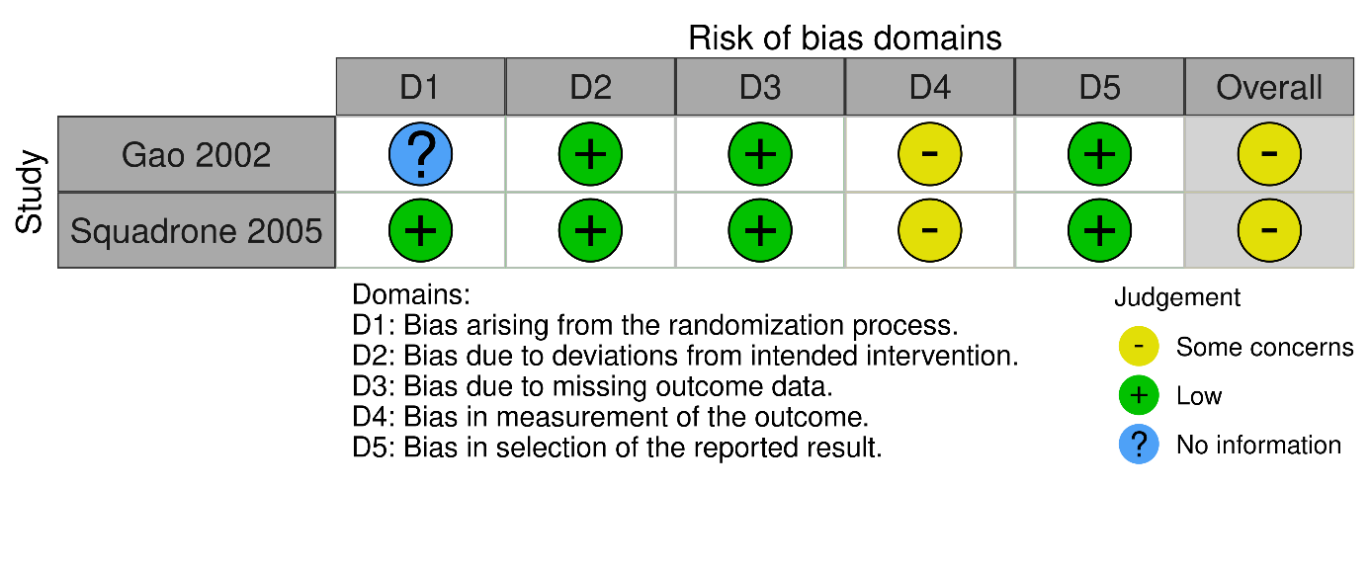
B
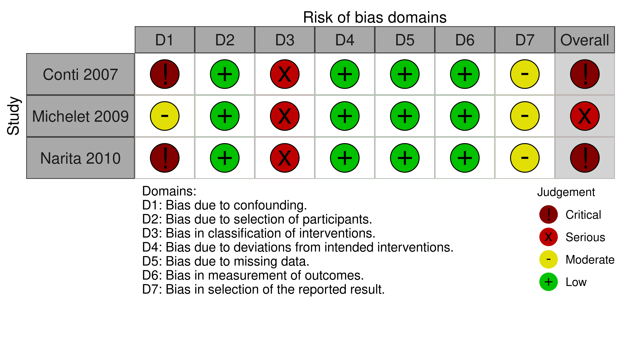

eFigure 3. Posterior probability distributions for OR and ARR comparing NIV versus oxygen on reintubation to day-7 reintubation in multivariable analysis
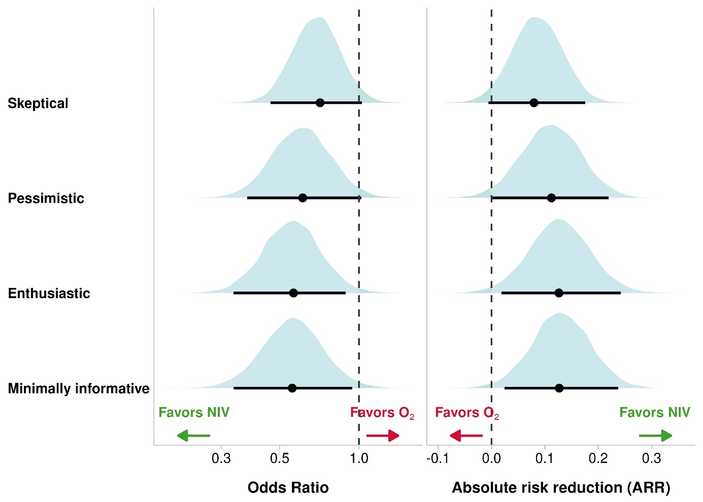

Multivariable analysis with adjustment on center, age < 60 years, COPD, surgical site (supra or submesocolic), epidural analgesia, postoperative sepsis, history of ischemic heart disease and chronic heart failure, BMI > 30
. Posterior distribution and probability of treatment effect of NIV compare to oxygen therapy over day-7 reintubation in multivariate analysis

eFigure 4. Posterior probability distributions for OR and ARR comparing NIV versus oxygen on reintubation to day-30 mortality in multivariable analysis
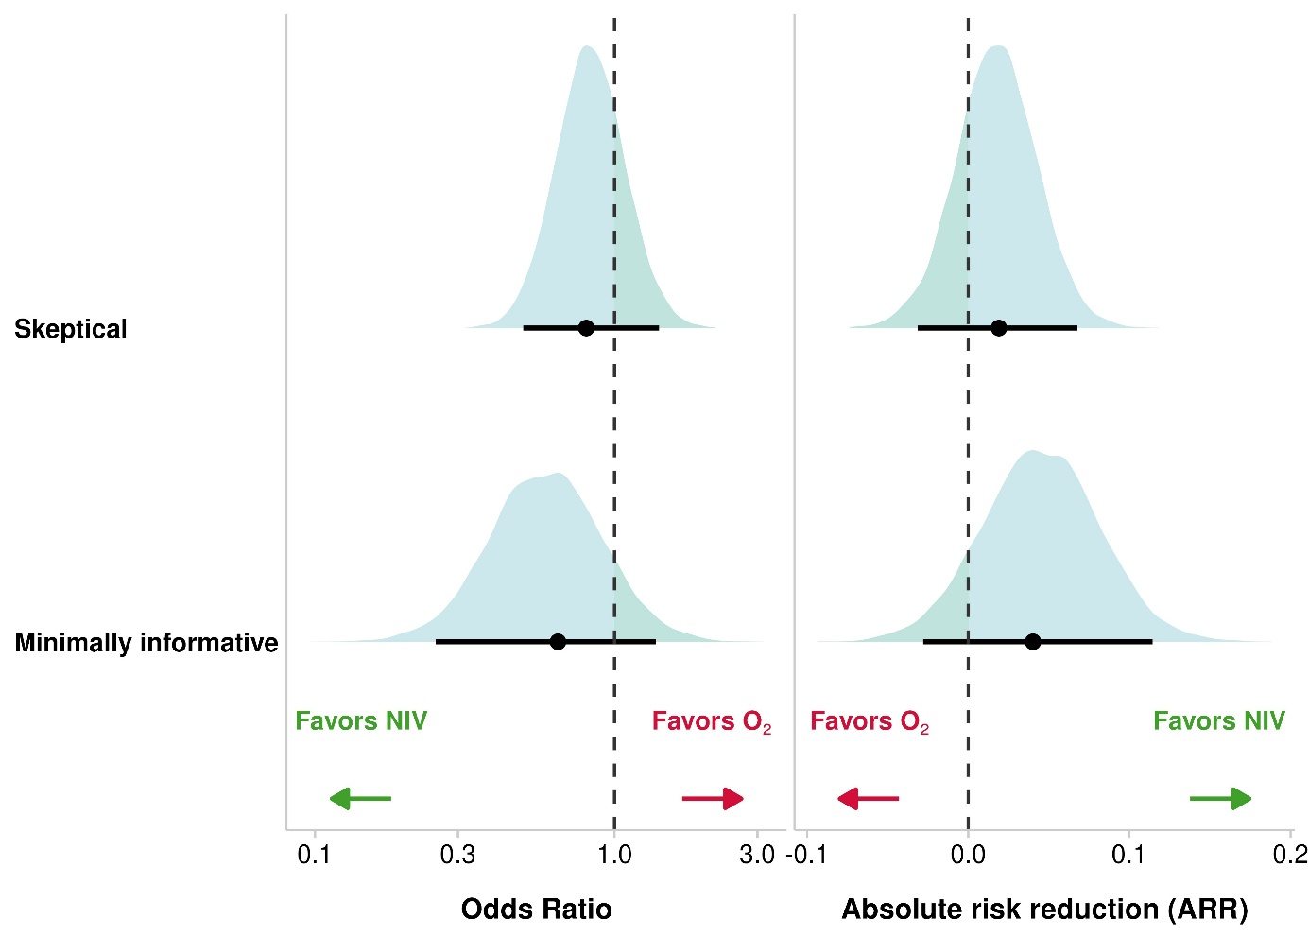

Multivariable analysis with adjustment on center , surgical site (supra or submesocolic), epidural analgesia, COPD , SOFA score, age, IGS score

eFigure 5. Posterior probability distributions for OR and ARR comparing NIV versus oxygen on day-90 mortality according to each prior

eFigure 6. Posterior probability distributions for OR and ARR comparing NIV versus oxygen on day-7 overall healthcare-associated infections according to each prior

eFigure 7. Posterior probability distributions for OR and ARR comparing NIV versus oxygen on day-7 pneumonia according to each prior

eFigure 8. Posterior probability distributions for OR and ARR comparing NIV versus oxygen on day-30 reintubation according to each prior

eFigure 9. Posterior probability distributions for OR and ARR comparing NIV versus oxygen on day-30 pneumonia according to each prior

eFigure 10. Posterior probability distributions for OR and ARR comparing NIV versus oxygen on day-30 overall healthcare associated infections according to each prior

eFigure 11. Posterior estimations in the sub-group from the stratum of randomization under minimally informative prior

eFigure 12. Bayesian meta-analysis. Forest plot for the results after each prior (A) and resulting heterogeneity for all tau distributions (B)

At the mean tau value, 8.7% of the heterogeneity is explained by the priors. This suggests that the ART results are relatively robust to the different priors used

eFigure 13. Posterior probability distributions for OR comparing NIV versus oxygen on day-7 reintubation according to each prior with intercept prior 1
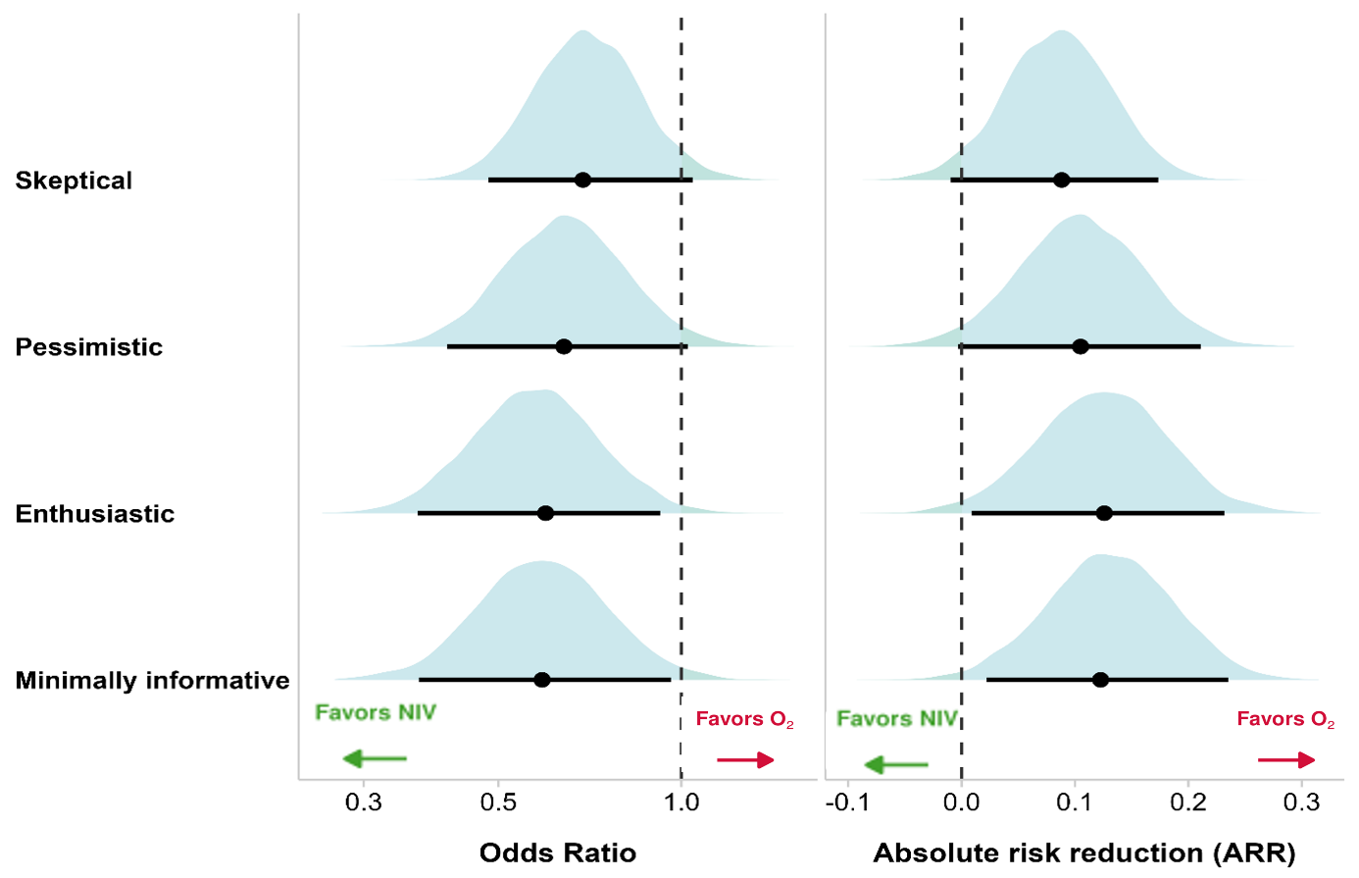

eFigure 134. Posterior probability distributions for OR and ARR comparing NIV versus oxygen on reintubation to day-7 according to each prior with intercept prior 2
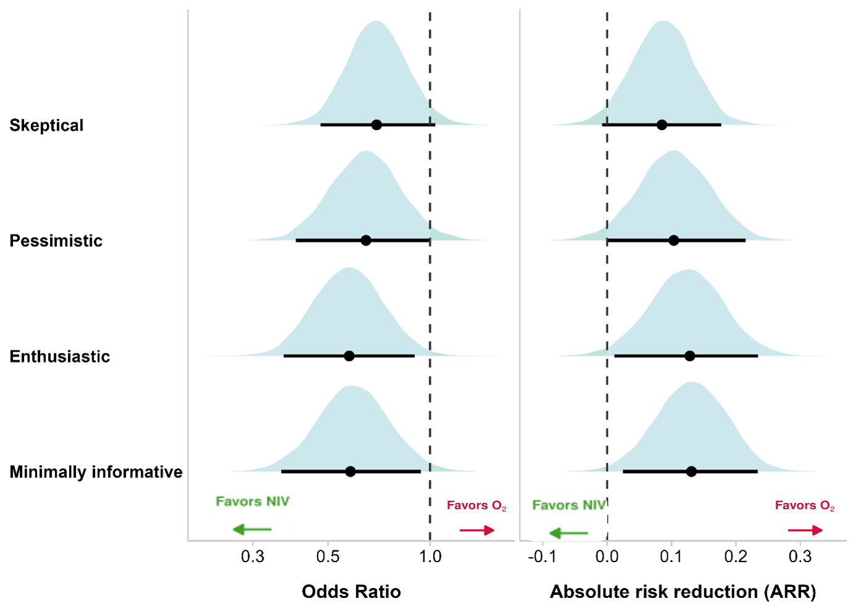

eFigure 145. Posterior density of treatment effect for NIV versus oxygen on reintubation to day-7 according to each prior with intercept prior 3
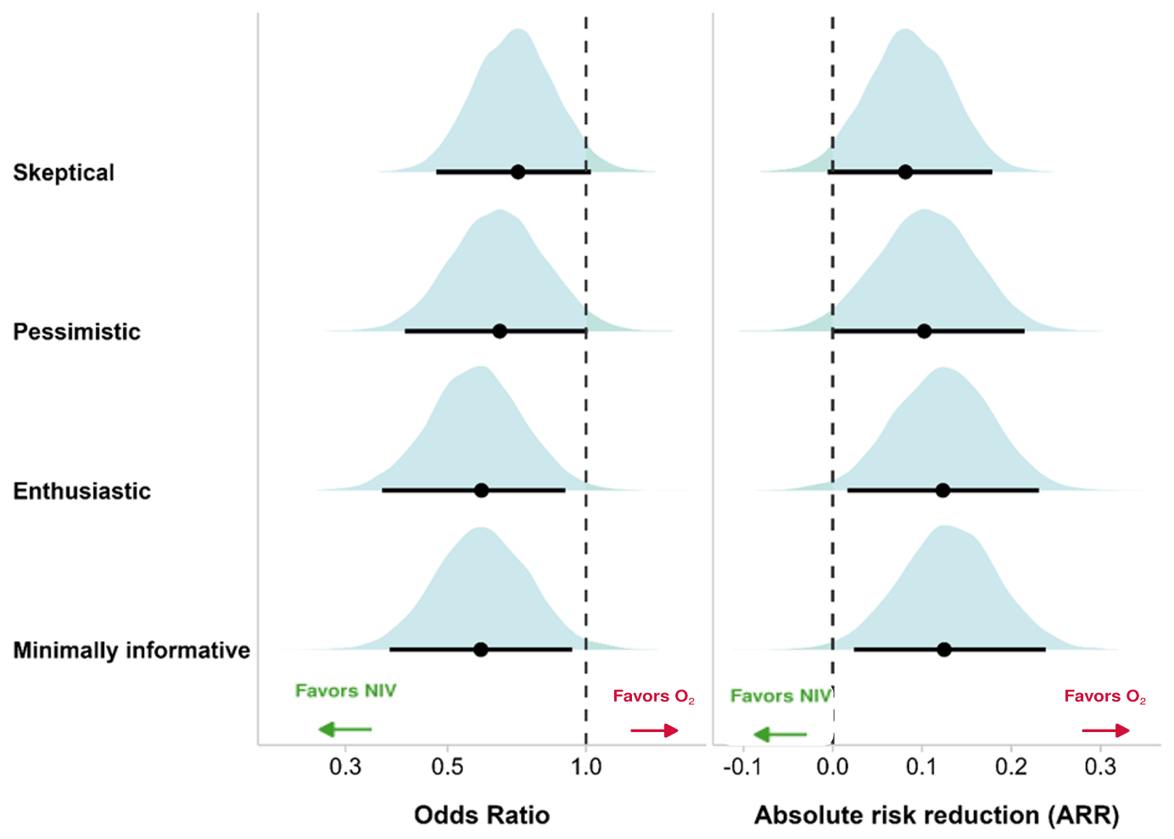

eFigure 16. Convergence diagnosis of Markov Chain Monte Carlo simulations for day-7 reintubation according to the No-U-Turn Sampler algorithm
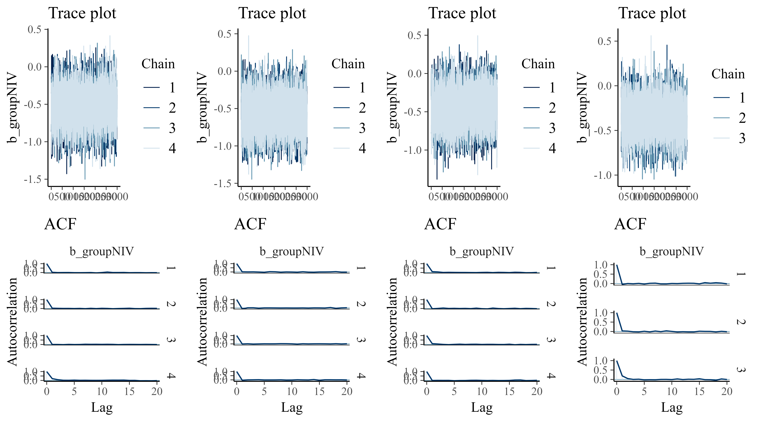
Legend: At the top, the trace plot depicts the posteriors draws from the MCMC simulations for each chain. Notes that the four chains colors are mixed, values hover around a stable level, and no drift is apparent testifying to the fact that the model has converged well. At the bottom, the autocorrelogram shows no correlation between simulation iterations beyond the 2nd iteration.

eFigure 157. Convergence diagnosis of Markov Chain Monte Carlo simulations for day-7 reintubation in multivariable analysis according to the No-U-Turn Sampler algorithm
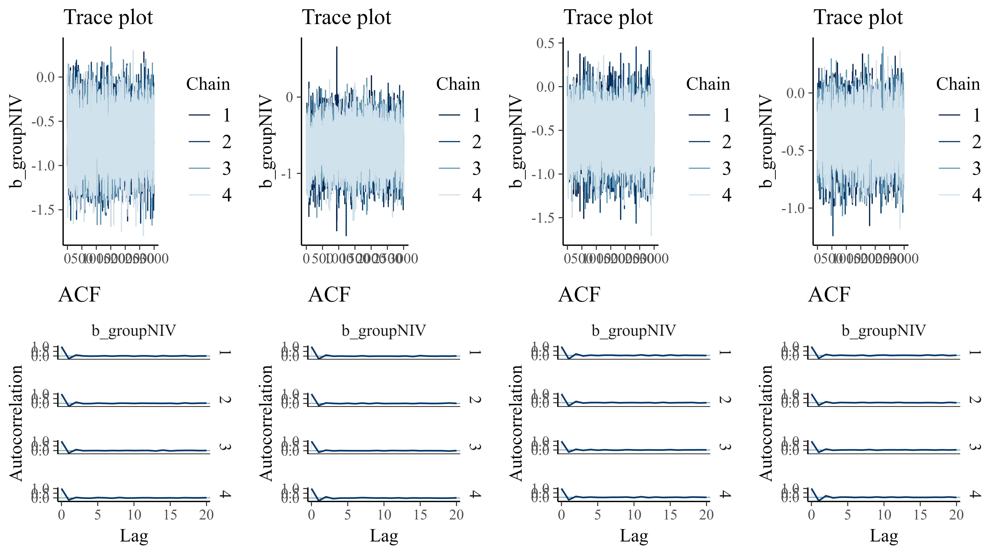

eFigure 18. Convergence diagnosis of Markov Chain Monte Carlo simulations for day-7 reintubation with informative intercept 1 according to the No-U-Turn Sampler algorithm

eFigure 169. Convergence diagnosis of Markov Chain Monte Carlo simulations for day-7 reintubation with informative prior on intercept 2 according to the No-U-Turn Sampler algorithm

eFigure 20. Convergence diagnosis of Markov Chain Monte Carlo simulations for day-7 reintubation with informative prior on intercept 3 according to the No-U-Turn Sampler algorithm

eFigure 21. Convergence diagnosis of Markov Chain Monte Carlo simulations for day-30 mortality according to the No-U-Turn Sampler algorithm
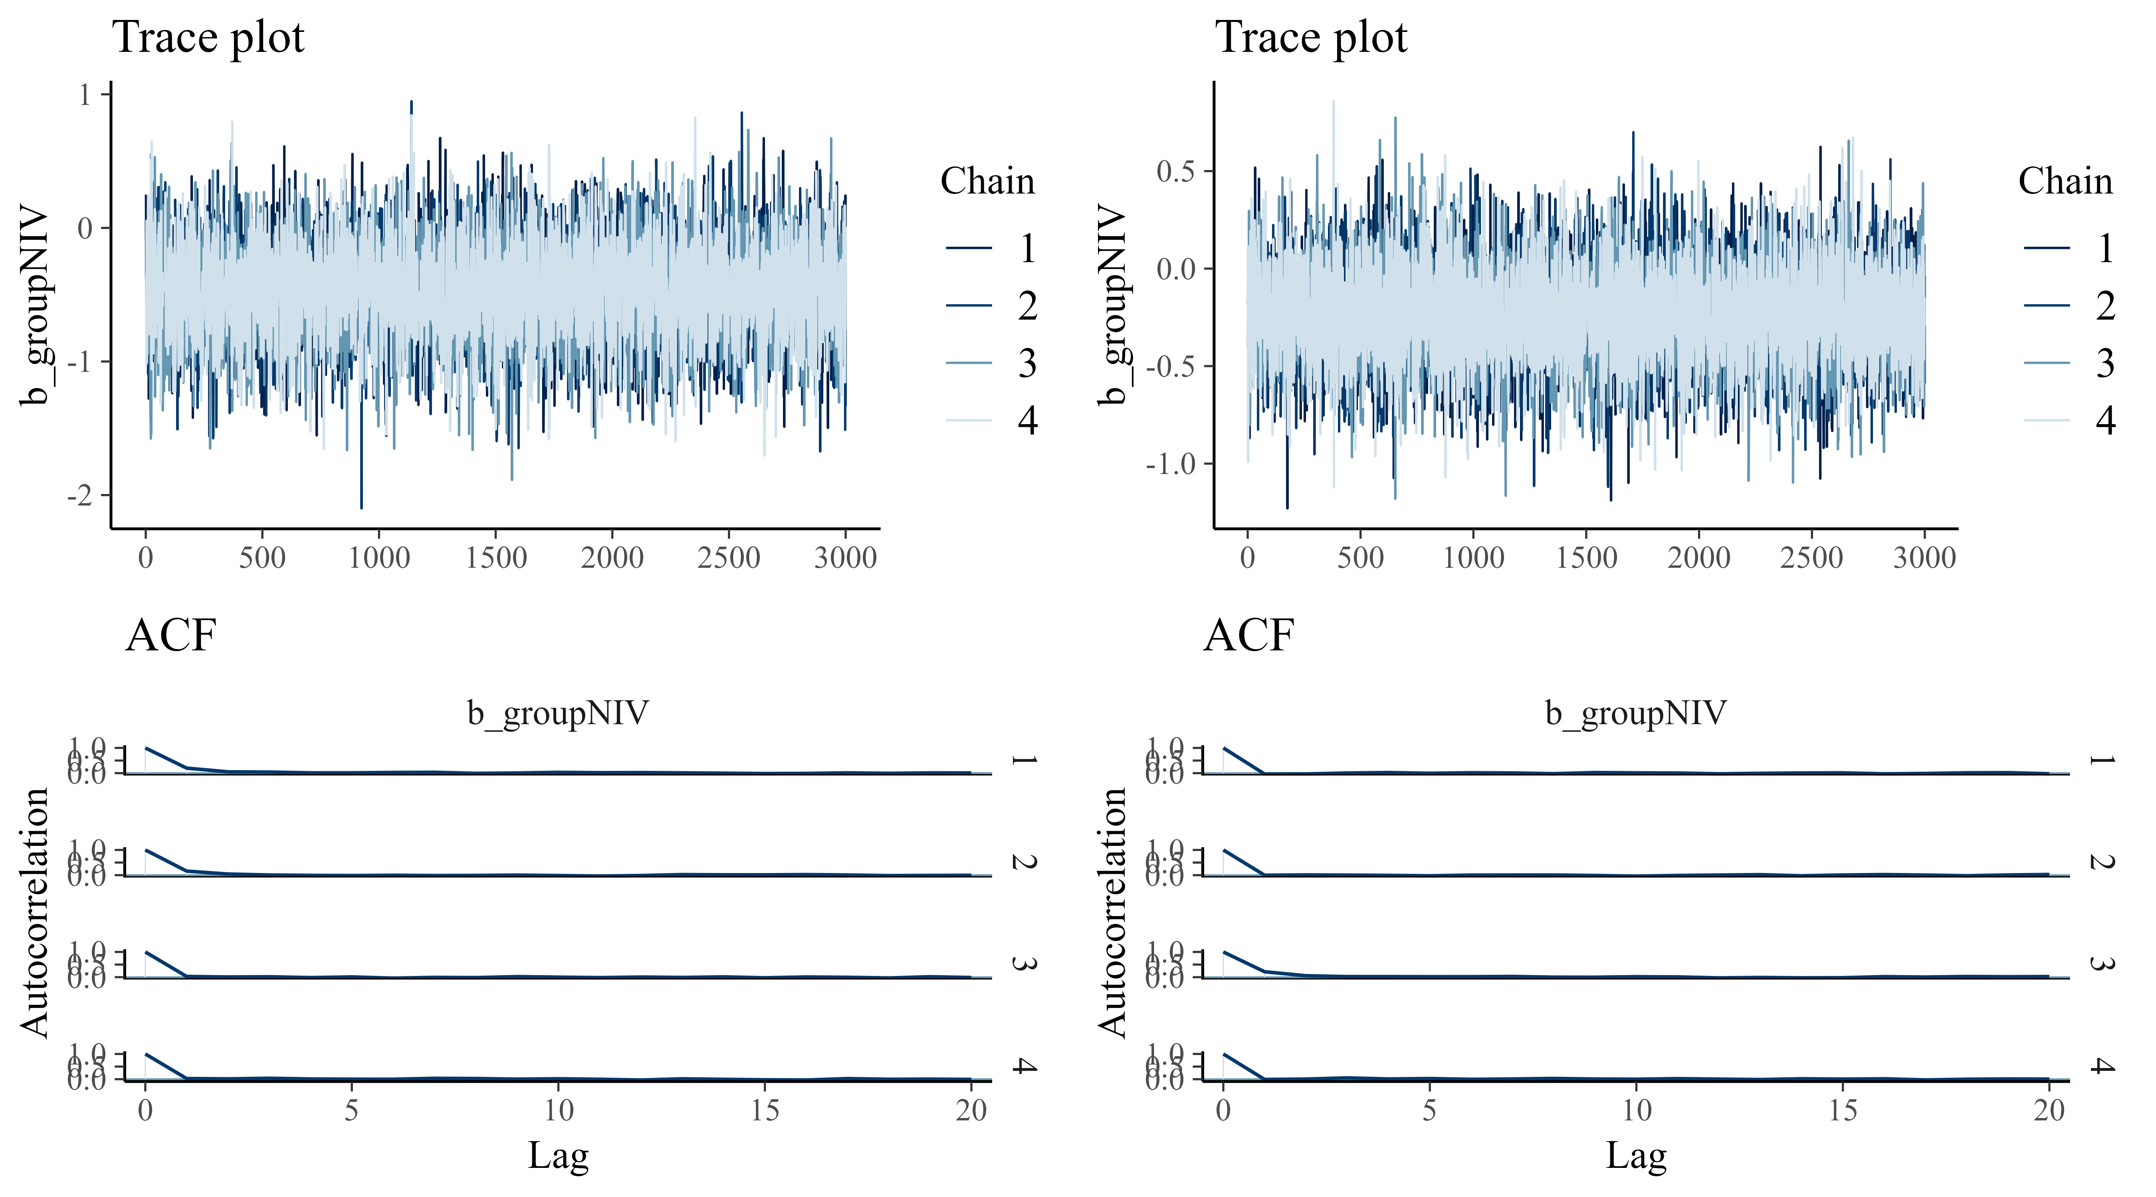

eFigure 22. Convergence diagnosis of Markov Chain Monte Carlo simulations for day-30 mortality in multivariable analysis according to the No-U-Turn Sampler algorithm

eFigure 23. Convergence diagnosis of Markov Chain Monte Carlo simulations for day-7 overall healthcare associated infection according to the No-U-Turn Sampler algorithm
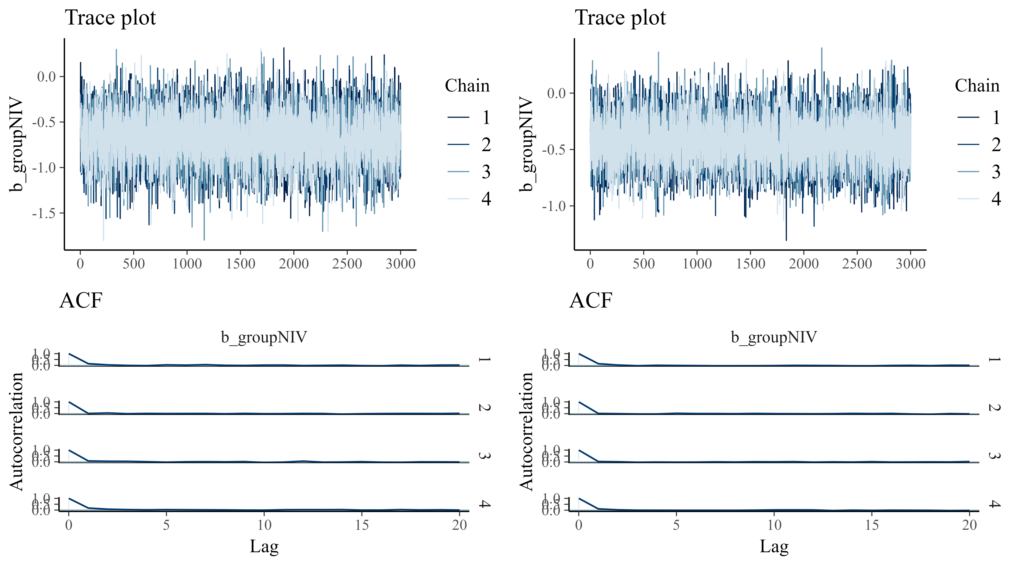

eFigure 24. Convergence diagnosis of Markov Chain Monte Carlo simulations for day-7 pneumonia infection according to the No-U-Turn Sampler algorithm
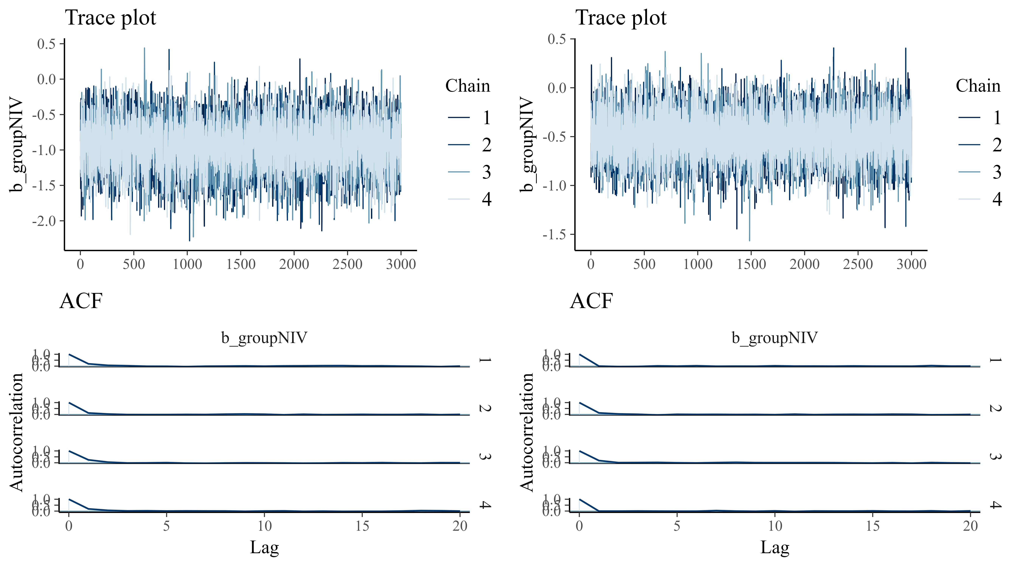

eFigure 25. Convergence diagnosis of Markov Chain Monte Carlo simulations for day-30 reintubation according to the No-U-Turn Sampler algorithm

eFigure 26. Convergence diagnosis of Markov Chain Monte Carlo simulations for day-90 mortality according to the No-U-Turn Sampler algorithm

eFigure 177. Convergence diagnosis of Markov Chain Monte Carlo simulations for day-30 overall healthcare-associated infection according to the No-U-Turn Sampler algorithm

eFigure 188. Convergence diagnosis of Markov Chain Monte Carlo simulations for day-30 pneumonia infection according to the No-U-Turn Sampler algorithm

