Fluid responsiveness and changes in venous congestion and lung water during volume expansion in critically ill patients

Xiang Si^{1,3,6#}*, Daiyin Cao^{2,3#}, Rui Shi^{1,6#}, Wenliang Song^{1,6}, Riccardo Antolini³, Marion Beuzelin³, Allegra Blandina³, Francesca Botta³, Federico Davì³, Giovanni Lorenzo Rumi³, Martina Fracazzini³, Marta Lauritano³, Riccardo La Rosa³, Rui Filipe Gomes³, Sung Yoon Lim^{3,5}, Ronglin Chen⁴, Jianfeng Wu^{1,6}*, Xiangdong Guan^{1,6}*, Tai Pham³, Christopher Lai³, Xavier Monnet³

1. Department of Critical Care Medicine, The First Affiliated Hospital of Sun Yat-sen University, 510080, Guangzhou, China.
2. Department of Critical Care Medicine, The Sixth Affiliated Hospital of Sun Yat-sen University, 510655, Guangzhou, China.
3. Service de Médecine Intensive-Réanimation, Hôpital de Bicêtre, DMU CORREVE, Inserm UMR S_999, IHU SEPSIS, Groupe de Recherche Clinique CARMAS, Université Paris-Saclay, AP-HP, Le Kremlin-Bicêtre, France.
4. Department of Critical Care Medicine, Longgang center hospital, 518116, Shenzhen, China
5. Division of Pulmonology and Critical Care Medicine, Department of Internal Medicine, Seoul National University Bundang Hospital, Seoul National University College of Medicine, Korea.
6. Guangdong Clinical Research Centre for Critical Care Medicine (2020B1111170005)
# XS, DC and RS contributed equally to this work.

*Correspondence:
Xiang Si, sixiang@mail.sysu.edu.cn
Jianfeng Wu, wujianf@mail.sysu.edu.cn
Xiangdong Guan, guanxd@mail.sysu.edu.cn

Contents
Methods Supplement. Haemodynamic and venous congestion assessment. 3
Figure S1. Flowchart of the study population. 4
Figure S2. Coexistence of fluid responsiveness and venous congestion. 5
Figure S3. Alluvial diagram showing the profiles of VExUS grade evolution following a fluid challenge in fluid-responsive (a) and non-responsive patients (b). 6
Figure S4. Comparison of individual vein congestion variables in VExUS and their progression following a fluid challenge in fluid-responsive and non-responsive patients. (a) IVC expiratory diameter, (b) Hepatic S/D ratio, (c) Portal vein pulsatility index, (d) Renal vein stasis index. ªp < 0.05: pre- vs. post-; ^{b}p < 0.05: FR+ vs. FR-. 7
Figure S5. Correlation matrix to explore the relationship between the changes (Δ) in haemodynamic and congestion variables during the fluid challenge. 8
Figure S6. Repeated-measures correlation between CVP and VExUS points. 9
Figure S7. Receiver operating characteristic curves of CVP and its optimal threshold for detecting venous congestion. 10
Table S1. Absolute changes (Δ) in haemodynamic and congestion variables in fluid responsive and non-responsive patients during fluid expansion. 11
Table S2. Univariate and multivariate logistic regression analyses of variables associated with fluid-induced increase of VExUS 12
Table S3. Diagnostic performance of CVP in detecting different degrees of venous congestion. 13
Table S4. Slopes of fluid-induced changes in haemodynamic and congestion variables vs. fluid-induced changes in cardiac preload in fluid responsive and non-responsive patients. 14
Table S5. Baseline characteristics in ARDS and non-ARDS patients. 15
Table S6. Baseline haemodynamic and congestion variables in ARDS and non-ARDS patients. 17
Table S7. Evolution of haemodynamic variables before and after volume expansion in the subgroup of patients with ARDS (n=25). 18
Table S8. Left- and right-sided congestion changes in ARDS and non-ARDS patients stratified by fluid responsiveness. 20

Methods Supplement. Haemodynamic and venous congestion assessment.

Haemodynamic measurements
Thermodilution measurements were obtained by injecting three consecutive boluses of 15 mL cold saline (<4°C) into the central venous catheter, with averaged values used for analysis.
The ProAQT/PulsioFlex system consists of a radial artery catheter connected to a ProAQT sensor, which interfaces with a PulsioFlex monitor. CI was externally calibrated using echocardiographic methods, while CI trends were continuously assessed via pulse contour analysis.
The pressure sensors connected to both arterial and central venous catheters were fixed on the upper arm of the patient at the mid-axillary line.

Venous congestion assessment

The VExUS were recorded using an abdominal convex probe as part of the current care. The IVC diameter was measured in the intrahepatic portion, 2 cm from its junction with the right atrium, in a longitudinal view using a subxiphoid or transhepatic approach. The hepatic vein was assessed from a right lateral view by placing the Doppler sample volume across the hepatic vein to obtain flow waveforms. Portal venous pulsatility was evaluated by positioning the Doppler sample volume across the portal vein and calculating the pulsatility index. Renal venous flow was recorded by placing the probe along the posterior axillary line, with the Doppler sample volume over interlobar veins in the renal cortex, outside the renal hilum.

A maximum IVC diameter <2 cm was classified as Grade 0 (no congestion). For an IVC ≥2 cm, the hepatic, portal, and renal venous waveforms were categorized as normal, mildly abnormal, or severely abnormal based on the following criteria:
(i) Hepatic vein: Normal flow shows a small retrograde a-wave followed by anterograde S and D waves with an S:D ratio > 1. Mildly abnormal flow shows an S:D ratio ≤ 1, and severe abnormality is defined by reversal of the S wave.
(ii) Portal vein: Normal flow shows minimal pulsatility with a pulsatility index < 30%. A pulsatility index of 30–49% indicates mild abnormality, and ≥ 50% indicates severe abnormality.
(iii) Renal vein: Normal flow is a continuous, monophasic anterograde waveform. Mild abnormality is defined by discontinous biphasic anterograde flow with systolic and diastolic phases, and severe abnormality by discontinuous monophasic diastolic-only flow.
An assessment in which all veins are either normal or mildly abnormal is designated as Grade 1, whereas the presence of one severely abnormal vein results in a Grade 2 assignment; two or more severely abnormal veins warrant a Grade 3 classification.

The quantitative measurements for hepatic, portal, and renal vein were also assessed between the 9th and 11th intercostal spaces on the right axillary line. The hepatic vein systolic to diastolic wave was calculated as S/D ratio. Portal vein pulsatility index was determined from the maximum (Vmax) and minimum (Vmin) velocities using the formula: (Vmax − Vmin)/Vmax. Renal venous stasis index was measured in the interlobar renal veins as the proportion of the cardiac cycle without renal venous flow.

Figure S1. Flowchart of the study population.
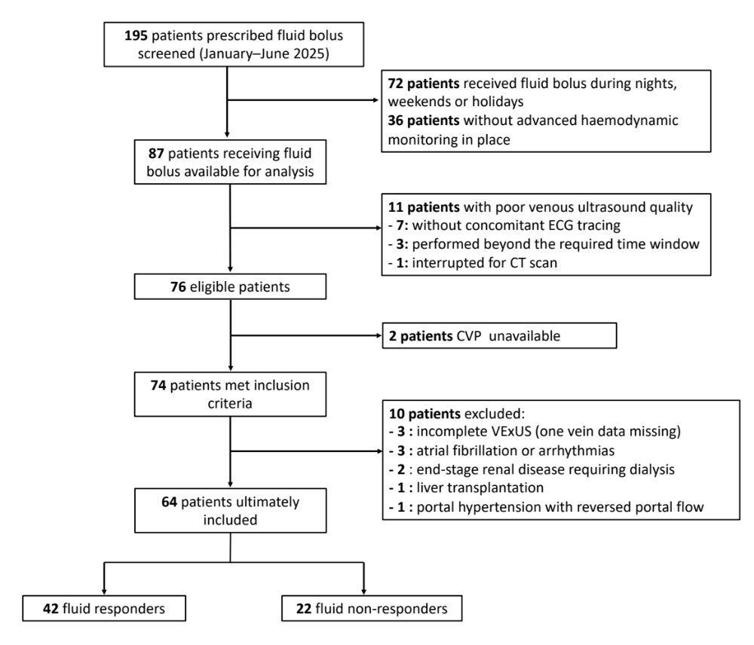
CVP central venous pressure, VExUS venous excess ultrasound

Figure S2. Coexistence of fluid responsiveness and venous congestion.

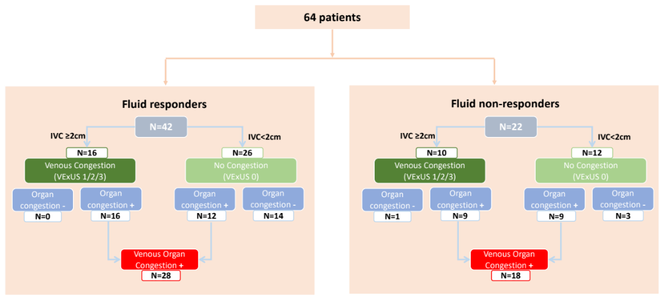
Coexistence of fluid responsiveness and venous congestion occurred in 25% (16/64) of patients by VExUS grade and in 44% (28/64) by VExUS organ points.
IVC inferior vena cava

Figure S3. Alluvial diagram showing the profiles of VExUS grade evolution following a fluid challenge in fluid-responsive (a) and non-responsive patients (b).
a . VExUS grade worsened in 2/42 (5%) fluid responders.
b. VExUS grade worsened in 16/22 (73%) fluid non-responders.

Figure S4. Comparison of individual vein congestion variables in VExUS and their progression following a fluid challenge in fluid-responsive and non-responsive patients. (a) IVC expiratory diameter, (b) Hepatic S/D ratio, (c) Portal vein pulsatility index, (d) Renal vein stasis index. ªp < 0.05: pre- vs. post-; ^{b}p < 0.05: FR+ vs. FR-.

The red represents before fluid expansion and the green represents after fluid expansion. VExUS venous excess ultrasound, IVC inferior vena cava

Figure S5. Correlation matrix to explore the relationship between the changes (Δ) in haemodynamic and congestion variables during the fluid challenge.

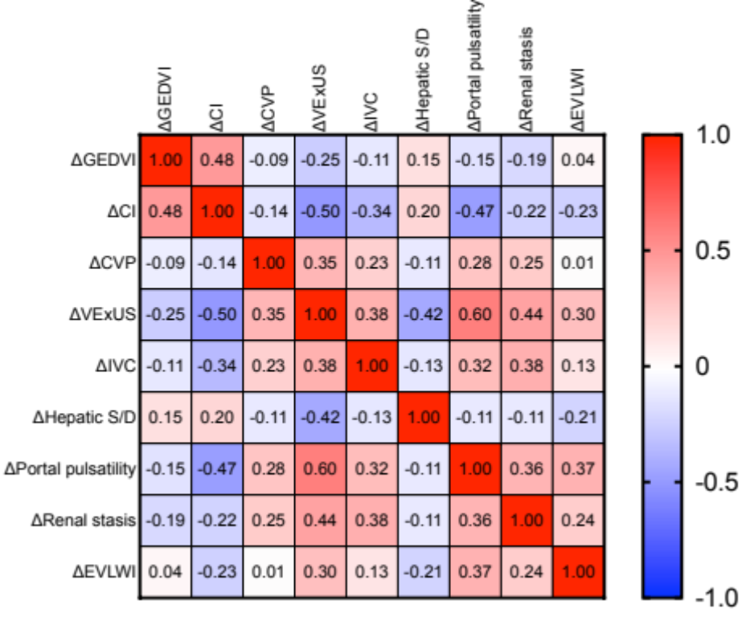

Numerical values correspond to Spearman’s correlation coefficients. The red color represents a positive correlation, while the blue color signifies a negative correlation. The color saturation reflects the strength of the correlation, with deeper shades indicating stronger positive or negative associations. GEDV global end-diastolic volume index, CI cardiac index, CVP central venous pressure, VExUS venous excess ultrasound, IVC inferior vena cava, EVLWI extravascular lung water index.

Figure S6. Repeated-measures correlation between CVP and VExUS points.

Each individual’s data are shown in a distinct color, with paired points of the same color representing measurements before and after volume expansion. A common regression slope was estimated for all points, and parallel regression lines were fitted to each individual’s data in the corresponding color. CVP central venous pressure, VExUS venous excess ultrasound

Figure S7. Receiver operating characteristic curves of CVP and its optimal threshold for detecting venous congestion.
AUC area under the receiver operating characteristic curve, CVP central venous pressure, VExUS venous excess ultrasound

Table S1. Absolute changes (Δ) in haemodynamic and congestion variables in fluid responsive and non-responsive patients during fluid expansion.
Characteristic | Overall, N = 64 | Fluid responders, N = 42 | Fluid non-responders, N = 22 | p-value¹
ΔGEDVI (mL/m2), Median (IQR) | +78 (+27, +127) | +90 (+60,+145) | +38 (+13, +92) | 0.041
ΔCI (L/min/m2), Median (IQR) | +0.50 (+0.26, +0.80) | +0.69 (+0.50, +1.04) | +0.10 (-0.17, +0.26) | < 0.001
ΔCVP (mmHg), Median (IQR) | +1.6 (+0.7, +2.4) | +1.4 (+0.4, +2,4) | +2.0 (+1.1, +3.5) | 0.064
ΔVExUS organ points, Median (IQR) | +1 (+0, +1) | 0 (0, +1) | +2 (+1, +2) | < 0.001
ΔIVC expiration (mm), Median (IQR) | +1.5 (+0.3, +3.0) | +1.0 (0, +2.4) | +2.9 (+1.2, +3.4) | 0.003
ΔHepatic vein S/D, Median (IQR) | 0 (-0.1, +0.2) | +0.1 (0, +0.3) | -0.1 (-0.3, 0) | < 0.001
ΔPortal vein pulsatility index (%), Median (IQR) | +6.0% (-0.1%, +11.5%) | +3.0% (-0.9%, +7.7%) | +14.6% (+8.9%, +20.4%) | < 0.001
ΔRenal vein stasis index (%), Median (IQR) | +0.4% (0%, +10%) | 0% (-1.2%, +2.8%) | +9.2% (+1.8%, +19.8%) | < 0.001
ΔEVLWI (mL/kg PBW), Median (IQR)I | +0.4 (-0.3, +1.2) | 0 (-0.6, +1.0) | +1 (+0.4, +2.0) | 0.009
¹Wilcoxon rank-sum test
CI cardiac index, GEDVI global end-diastolic volume indexed for body surface, CVP central venous pressure, VExUS venous excess ultrasound, IVC inferior vena cava, EVLWI extravascular lung water indexed for body weight, IQR, interquartile range
GEDVI and EVLWI available in 40 responders and 20 non-responders.

Table S2. Univariate and multivariate logistic regression analyses of variables associated with fluid-induced increase of VExUS

 | Univariate analysis |  |  | Multivariate analysis
Variable | OR | 95% CI | P value | OR | 95% CI | P value
ΔCI | 0.87 | 0.80–0.93 | 0.0002 | 0.89 | 0.80–0.95 | 0.004
TAPSE | 0.96 | 0.85–1.10 | 0.595 | 0.90 | 0.71–1.09 | 0.286
RV/LV areas ratio | 1.40 | 0.03–45.91 | 0.852 | 5.33 | - | 0.578
PEEP | 0.98 | 0.76–1.20 | 0.767 | 0.68 | - | >0.999
Plateau pressure | 1.01 | 0.88–1.15 | 0.935 | 1.31 | - | >0.999
Driving pressure | 1.01 | 0.92–1.12 | 0.831 | 0.75 | - | >0.999
Tidal volume | 1.00 | 0.99–1.00 | 0.340 | 0.99 | 0.97–1.00 | 0.222
CI cardiac index, LV left ventricle, RV right ventricle, TAPSE tricuspid annular plane systolic excursion, PEEP Positive end-expiratory pressure

Table S3. Diagnostic performance of CVP in detecting different degrees of venous congestion.

 | AUC | p vs 0.5 | CVP threshold | Sensitivity | Specificity | Positive Likelihood Ratio | Negative  Likelihood Ratio
VExUS points ≥ 2 | 0.78 (0.69– 0.86) | ＜0.001 | ≥ 8 mmHg | 78 (68– 86) | 74 (60– 84) | 3.0 (1.9– 4.9) | 0.3 (0.2– 0.5)
VExUS points ≥ 3 | 0.75 (0.66– 0.83) | ＜0.001 | ≥ 9 mmHg | 81(69– 89) | 63 (51– 73) | 2.2 (1.6– 3.0) | 0.3 (0.2– 0.5)
VExUS points ≥ 4 | 0.83 (0.75– 0.90) | ＜0.001 | ≥ 10 mmHg | 86 (69– 94) | 70 (60– 78) | 2.9 (2.0– 4.0) | 0.2 (0.1– 0.5)
AUC area under the receiver operating characteristic curve, CVP central venous pressure, VExUS venous excess ultrasound

Table S4. Slopes of fluid-induced changes in haemodynamic and congestion variables vs. fluid-induced changes in cardiac preload in fluid responsive and non-responsive patients.
Characteristic | Overall, N = 64 | Fluid responders, N = 42 | Fluid non-responders, N = 22 | p-value¹
ΔCI/ ΔGEDVI, Median (IQR) | 0.66 (-0.26, 1.0) | 0.77 (0.39, 1.0) | 0.08 (-0.63, 0.33) | 0.011
ΔCVP/ ΔGEDVI, Median (IQR) | 1.8 (0.6, 4.3) | 1.6 (0.5, 2.7) | 4.2 (1.5, 17.8) | 0.005
ΔVExUS / ΔGEDVI, Median (IQR) | 0 (0, 2.0) | 0 (0, 0.2) | 4.7 (1.7, 9.0) | < 0.001
ΔIVC expiration/ ΔGEDVI, Median (IQR) | 1.4 (0.2, 3.9) | 0.9 (-0.2, 3.0) | 4.0 (0.5, 14.5) | 0.011
ΔHepatic vein S/D/ ΔGEDVI, Median (IQR) | 0 (-0.3, 0.3) | 0.1 (0, 0.32) | -0.5 (-1.5, 0) | < 0.001
ΔPortal vein pulsatility index/ ΔGEDVI, Median (IQR) | 7.0% (-1.6%, 17.7%) | 4.6% (-1.7%, 10.0%) | 27.0% (3.7%, 65.7%) | 0.002
ΔRenal vein stasis index/ ΔGEDVI, Median (IQR) | 1.5% (0%, 13.2%) | 0% (0%, 7.7%) | 20.0% (0%, 62.1%) | 0.011
ΔEVLWI/ ΔGEDVI, Median (IQR) | 0 (-0.6, 1.6) | 0 (-1.2, 1.0) | 1.8 (-0.2, 6.9) | 0.031
¹Wilcoxon rank-sum test
CI cardiac index, GEDVI global end-diastolic volume indexed for body surface, CVP central venous pressure, VExUS venous excess ultrasound, IVC inferior vena cava, EVLWI extravascular lung water indexed for body weight, IQR, interquartile range
GEDVI and EVLWI available in 40 responders and 20 non-responders.

Table S5. Baseline characteristics in ARDS and non-ARDS patients.
Characteristic | ARDS, N = 25 | Non-ARDS, N = 39 | p-value¹
Age (years), Mean ± SD | 65 ± 12 | 62 ± 14 | 0.478
Gender (male), n (%) | 20 (80.0%) | 27 (69.2%) | 0.392
SAPS II, Mean ± SD | 66 ± 14 | 63 ± 19 | 0.473
SOFA, Mean ± SD | 10 ± 3 | 8 ± 2 | 0.001
Lactate (mmol/L), Median (IQR) | 2.2 (1.5, 4.1) | 2.1 (1.3, 3.2) | 0.178
Shock type, n (%) |  |  | 0.163
Septic | 22 (88.0%) | 26 (66.7%)
Hypovolaemic | 3 (12.0%) | 7 (17.9%)
Cardiogenic | 0 (0%) | 5 (12.8%)
Obstructive | 0 (0%) | 1 (2.6%)
Echocardiography
LV ejection fraction (%), Mean ± SD | 60 ± 9 | 62 ± 12 | 0.656
RV/LV end-diastolic areas ratio, Mean ± SD | 0.65 ± 0.18 | 0.58 ± 0.14 | 0.123
TAPSE (mm), Mean ± SD | 18 ± 4 | 18 ± 5 | 0.489
Catecholamines
Administration of norepinephrine, n (%) | 22 (88.0%) | 35 (89.7%) | 0.827
Norepinephrine tartrate dose (μg/kg/min), Median (IQR) | 1.0 (0.4, 1.5) | 0.4 (0.2, 1.0) | 0.021
Vasopressin or terlipressin infusion, n (%) | 4 (16.0%) | 6 (15.4%) | 0.947
Administration of dobutamine, n (%) | 0 (0%) | 6 (15.4%) | 0.056
Administration corticosteroids, n (%) | 5 (20.0%) | 8 (20.5%) | 0.960
Mechanical ventilation, n (%) | 25 (100%) | 32 (82%) | 0.024
Respiratory settings (in ventilated patients)
Tidal volume (mL/kg PBW), Mean ± SD | 6.0 ± 1.6 | 6.3 ± 1.5 | 0.142
Plateau pressure (cm H₂O), Mean ± SD | 20 ± 5 | 18 ± 4 | 0.067
Positive end-expiratory pressure (cm H₂O), Mean ± SD | 8 ± 3 | 8 ± 3 | 0.554
PaO₂/FiO₂ (mmHg), Median (IQR) | 180 (109, 249) | 328 (275, 400) | <0.001
ICU length of stay (day), Median (IQR) | 11 (7, 27) | 10 (7, 19) | 0.432
28-day mortality, n (%) | 8 (32%) | 9 (23.1%) | 0.430
¹Welch Two Sample t-test; Wilcoxon rank-sum test; Pearson's Chi-squared test; Fisher's exact test
ARDS acute respiratory distress syndrome, SAPS II simplified acute physiology score II, SOFA sequential organ failure assessment, LV left ventricle, RV right ventricle, TAPSE tricuspid annular plane systolic excursion, PBW predicted body weight, PaO₂/FiO₂ oxygen arterial partial pressure over inspired fraction of oxygen, ICU intensive care unit

Table S6. Baseline haemodynamic and congestion variables in ARDS and non-ARDS patients.
Characteristic | ARDS, N = 25 | Non-ARDS, N = 39 | p-value¹
Heart rate (beats/min), Median (IQR) | 106 (90, 117) | 101(88, 114) | 0.747
Systolic arterial pressure (mmHg), Median (IQR) | 112 (101, 125) | 119 (108, 142) | 0.218
Diastolic arterial pressure (mmHg), Median (IQR) | 51 (46, 58) | 56 (47, 72) | 0.274
Mean arterial pressure (mmHg), Median (IQR) | 73 (61, 81) | 82 (68, 91) | 0.119
Central venous pressure (mmHg), Median (IQR) | 9.0 (5.4, 10.4) | 8.0 (3.3, 11.4) | 0.467
Cardiac index (L/min/m2), Median (IQR) | 2.87 (2.34, 3.72) | 2.75 (2.17, 3.29) | 0.404
GEDVI (mL/m2), Median (IQR) | 713 (577, 849) | 620 (528, 734) | 0.113
EVLWI (mL/kg PBW), Median (IQR) | 10.0 (9.3, 13.0) | 7.0 (6.0, 8.6) | <0.001
PVPI, Median (IQR) | 2.8 (2.1, 3.2) | 1.7 (1.3, 2.0) | <0.001
VExUS, n (%) |  |  | 0.128
Grade 0 | 12 (48%) | 26 (67%)
Grade 1 | 8 (32%) | 11 (28%)
Grade 2 | 5 (20%) | 2 (5%)
Grade 3 | 0 (0%) | 0 (0%)
VExUS organ points, Median (IQR) | 2.0 (1.0, 3.0) | 1.0 (0, 2.5) | 0.143
IVC expiratory diameter (mm), Median (IQR) | 17.6 (15.0, 21.8) | 16.7 (12.0, 19.0) | 0.120
Hepatic vein S/D, Median (IQR) | 1.4 (1.1, 1.5) | 1.3 (0.9, 1.5) | 0.409
Portal vein pulsatility index (%), Median (IQR) | 26.7 (18.2, 34.5) | 22.7 (14.2, 28.4) | 0.205
Renal vein stasis index (%), Median (IQR) | 13.7 (1.8, 26.1) | 11.2 (0, 21.7) | 0.270
¹Welch Two Sample t-test; Wilcoxon rank-sum test; Pearson's Chi-squared test; Fisher's exact test
ARDS acute respiratory distress syndrome, GEDVI global end-diastolic volume indexed for body surface, EVLWI extravascular lung water indexed, PBW predicted body weight, PVPI pulmonary vascular permeability index, VExUS venous excess ultrasound, IVC inferior vena cava, IQR, interquartile range
GEDVI/EVLWI/PVPI available in 25 ARDS and 35 non-ARDS patients.

Table S7. Evolution of haemodynamic variables before and after volume expansion in the subgroup of patients with ARDS (n=25).
 | Before volume expansion | After volume expansion
Heart rate (beats/min), Median (IQR)
Fluid responders (n=13) | 99 (84, 118) | 99 (84, 112)
Fluid non-responders (n=12) | 112 (106, 121) | 111 (96, 126)
Systolic arterial pressure (mmHg), Median (IQR)
Fluid responders (n=13) | 120 (111, 136) | 135 (124, 160) ª
Fluid non-responders (n=12) | 108 (80, 110) | 113 (99, 135)
Diastolic arterial pressure (mmHg), Median (IQR)
Fluid responders (n=13) | 52 (46, 61) | 59 (56, 70) ª
Fluid non-responders (n=12) | 51 (45, 55) | 55 (49, 64)
Mean arterial pressure (mmHg), Median (IQR)
Fluid responders (n=13) | 75 (66, 82) | 88 (80, 92) ª
Fluid non-responders (n=12) | 70 (59, 80) | 74 (66, 90)
Central venous pressure (mmHg), Median (IQR)
Fluid responders (n=13) | 7.7 (4.7, 10.1) | 9.6 (7.4, 11.3) ª
Fluid non-responders (n=12) | 10.5 (8.2, 13.4) ^{b} | 12.8 (10.5, 16.3) ^{ab}
Cardiac index (L/min/m2), Median (IQR)
Fluid responders (n=13) | 2.39 (1.82, 2.89) | 3.16 (2.44, 4.32) ª
Fluid non-responders (n=12) | 3.42 (2.70, 4.78) ^{b} | 3.58 (2.81, 4.52)
GEDVI (mL/m2), Median (IQR)
Fluid responders (n=13) | 587 (516, 740) | 667 (612, 854) ª
Fluid non-responders (n=12) | 798 (706, 996) ^{b} | 828 (734, 1021) ^{b}
EVLWI (mL/kg PBW), Median (IQR)
Fluid responders (n=13) | 10.0 (9.1, 12.0) | 11.3 (9.0, 14.6) ª
Fluid non-responders (n=12) | 11.5 (9.3, 16.0) | 14.5 (11.0, 18.3) ^{ab}
PVPI, Median (IQR)
Fluid responders (n=13) | 2.8 (2.3, 3.3) | 2.7 (2.2, 3.5)
Fluid non-responders (n=12) | 2.7 (2.1, 3.2) | 2.9 (2.4, 3.5)
ARDS acute respiratory distress syndrome, GEDVI global end-diastolic volume indexed for body surface, EVLWI extravascular lung water indexed, PBW predicted body weight, PVPI pulmonary vascular permeability index, IQR, interquartile range
ªp < 0.05 after vs. before volume expansion, a: Wilcoxon signed-rank test
^{b}p < 0.05 fluid responders vs non-responders, b: Wilcoxon rank-sum test

Table S8. Left- and right-sided congestion changes in ARDS and non-ARDS patients stratified by fluid responsiveness.
 | Before volume expansion | After volume expansion
EVLWI (mL/kg PBW), Median (IQR)
Fluid responders (n=40)
ARDS (n=13) | 10.0 (9.1, 12.0) ^{b} | 11.3 (9.0, 14.6) ^{ab}
Non-ARDS(n=27) | 6.5 (6.0, 8.0) | 6.5 (5.9, 8.1)
Fluid non-responders (n=20)
ARDS (n=12) | 11.5 (9.3, 16.0) ^{b} | 14.5 (11.0, 18.3) ^{abc}
Non-ARDS (n=8) | 7.0 (6.0, 9.0) | 8.0 (6.9, 10.0) ª
PVPI, Median (IQR)
Fluid responders (n=40)
ARDS (n=13) | 2.8 (2.3, 3.3) ^{b} | 2.7 (2.2, 3.5) ^{b}
Non-ARDS(n=27) | 1.7 (1.3, 2.1) | 1.6 (1.1, 1.8)
Fluid non-responders (n=20)
ARDS (n=12) | 2.7 (2.1, 3.2) ^{b} | 2.9 (2.4, 3.5) ^{b}
Non-ARDS (n=8) | 1.6 (1.3, 1.9) | 1.8 (1.3, 2.1)
Central venous pressure (mmHg), Median (IQR)
Fluid responders (n=42)
ARDS (n=13) | 7.7 (4.7, 10.1) | 9.6 (7.4, 11.3) ª
Non-ARDS(n=29) | 7.0 (2.7, 10.8) | 8.6 (3.6, 12.0) ª
Fluid non-responders (n=22)
ARDS (n=12) | 10.5 (8.2, 13.4) ^{c} | 12.8 (10.5, 16.3) ^{ac}
Non-ARDS (n=10) | 10.8 (8.6, 13.2) ^{c} | 13.4 (12.0, 15.0) ^{ac}
VExUS organ points, Median (IQR)
Fluid responders (n=42)
ARDS (n=13) | 2 (1, 3) | 2 (1, 3)
Non-ARDS(n=29) | 1 (0, 2) | 1 (0.3, 3) ª
Fluid non-responders (n=22)
ARDS (n=12) | 2 (1, 3) | 4 (3, 6) ^{ac}
Non-ARDS (n=10) | 1 (1, 3) | 3 (3, 5) ^{ac}
ARDS acute respiratory distress syndrome, EVLWI extravascular lung water indexed, PBW predicted body weight, PVPI pulmonary vascular permeability index, VExUS venous excess ultrasound, IQR, interquartile range
ªp < 0.05 after vs. before volume expansion, a: Wilcoxon signed-rank test
^{b}p < 0.05 ARDS patients vs non-ARDS patients, b: Wilcoxon rank-sum test
^{c}p < 0.05 fluid responders vs non-responders, b: Wilcoxon rank-sum test

