Supplementary Material
SUPPLEMENTARY APPENDIX
Appendix S1. Search strategy
Table S1. Summary of effect size for other outcomes
Table S2. Blood products transfusion
Table S3. Quality assessment of cohort and case-control studies using the Newcastle-Ottawa scale
Table S4. Begg and Egger’s for publication bias
Table S5. Quality of evidence
Figure S1. Cumulative meta-analysis for bleeding risk of NM in comparison with conventional anticoagulants
Figure S2. Forest plot of filter life by blood purification modality in subgroup analyses comparing NM with conventional anticoagulants
Figure S3. Risk of bias graph
Figure S4. Risk of bias summary

Supplementary Table 1. Summary of effect size for other outcomes
Outcomes | CT | Effect size | 95% CI
Clotting (Effect size: RR)
Li, 2025 | citrate | 0.16 | 0.05–0.55
Lim, 2016 | UFH | 0.25 | 0.03–2.19
Lee, 2014 | NA | 1.10 | 0.89–1.36
ICU-mortality (Effect size: RR)
Kamijo, 2020 | CT | 0.68 | 0.49–0.94
Kim, 2024 | NA | 0.82 | 0.71–0.95
Kameda, 2023 | UFH | 1.71 | 0.63–1.27
28-day mortality (Effect size: RR)
Lee, 2014 | NA | 1.23 | 0.85-1.80
Zhan, 2025 | UFH | 0.62 | 0.22-1.75
Overall hospitalization stay (Effect size: MD)
Zhan, 2025 | UFH | -4.49 | -7.80–6.85
Kameda, 2023 | UFH | 1.4 | -19.90–22.70
Kim, 2024 | NA | 3.83 | -0.77–8.43
ICU stay (Effect size: MD)
Kameda, 2023 | UFH | -65 | -80.17–-49.83
Kim, 2024 | NA | 1.83 | -0.72–4.38

Abbreviations: CT, conventional treatment; 95% CI, 95% confidence intervals; UFH, unfractionated heparin; NA, non-anticoagulation; RR, risk ratio; MD, mean difference; ICU, intensive care unit.

Supplementary Table 2. Blood product transfusion
Author | Transfusion percentage | RBC | HB percentage | PLT concentrate | PLT percentage | FFP | FFP percentage
Han, 2011 |  | 1.6 ± 1.6 vs. 7.5 ± 6.5 |  | 5.0 ± 4.6 vs. 4.3 ± 4.3 |  | 1.2 ± 1.0 vs. 6.3 ± 5.7
Lee, 2014 |  | 3.19±3.18 vs. 3.56±3.79 |  | 24.31±25.64 vs. 38.67±50.16 |  | 6.72±8.06 vs. 6.72±8.06
Choi, 2015 |  |  | 41.9% vs. 33.3%
Kim, 2024 | 66.9% vs. 77.1% |  | 51.4% vs. 56.5% |  | 41.2% vs. 48.4% |  | 43.3% vs. 51.2%
Kameda, 2023 |  | 112 vs. 112 mL(48h) |  | 30 vs. 18 mL(48h) |  | 108 vs. 24 mL(48h)
Abbreviations: RBC, red blood cell; HB, hemoglobin; PLT, platelet; fresh frozen plasma.

Table S3. Quality assessment of cohort and case-control studies using the Newcastle-Ottawa scale
Study | Selection |  |  |  | Comparability | Outcome |  |  | Quality score
Study | Representativeness of the exposed cohort | Selection of the non-exposed cohort | Ascertainment of exposure | Demonstration that outcome of interest was not present at the start of the design or analysis | Comparability of cohorts on the basis of the design or analysis | Assessment of outcome | Was follow-up long enough for outcomes to occur | Adequacy of follow up of cohorts | Quality score
Han, 2011 | 1 | 1 | 1 | 1 | 1 | 1 | 1 | 1 | 8
Lim, 2016 | 1 | 1 | 1 | 1 | 2 | 1 | 1 | 1 | 9
Makino, 2016 | 1 | 1 | 1 | 1 | 2 | 1 | 1 | 1 | 9
Liu, 2024 | 0 | 1 | 1 | 1 | 0 | 0 | 1 | 1 | 5
Hwang, 2013 | 1 | 1 | 1 | 1 | 1 | 1 | 1 | 1 | 8
Kamijo, 2020 | 0 | 1 | 1 | 1 | 2 | 1 | 1 | 1 | 8
Li, 2025 | 1 | 1 | 1 | 1 | 1 | 1 | 1 | 1 | 8
Liu, 2024 | 1 | 1 | 1 | 1 | 1 | 1 | 1 | 1 | 8
Kim, 2024 | 1 | 1 | 1 | 1 | 2 | 1 | 1 | 1 | 9
Kameda, 2023 | 1 | 1 | 1 | 1 | 2 | 1 | 1 | 1 | 9
Zhan, 2025 | 0 | 1 | 1 | 1 | 1 | 1 | 1 | 1 | 7
Yue, 2023 | 0 | 1 | 1 | 1 | 1 | 1 | 1 | 1 | 7
Ohtake, 1991 | 0 | 1 | 1 | 1 | 0 | 0 | 1 | 1 | 5
Uchino, 2007 | 1 | 1 | 1 | 1 | 1 | 1 | 1 | 1 | 8

Supplementary Table 4. Begg’s and Egger’s test for publication bias
Outcomes | Egger's test | Begg's test
Filter life | 0.901 | 0.743
Bleeding complications | 0.070 | 0.093
In-hospital mortality | 0.367 | 0.348

Supplementary Table 5. Quality of evidence
Outcomes | № of studies | Study design | Downgrading factors |  |  |  |  | Upgrading factors |  |  | GRADE
Outcomes | № of studies | Study design | Risk of bias | Inconsistency | Indirectness | Imprecision | Publication bias | Large Magnitude of Effect | Dose-Response Gradient | All Plausible Confounding Would Reduce the Effect | GRADE
Filter life | 11 | 2 RCTs  9 observational studies | not serious | seriousª | not serious | serious^{b} | none | none | none | none | ⨁◯◯◯  Very low
Clotting | 3 | 1 RCT  2 observational studies | not serious | seriousª | not serious | serious^{b} | likely^{c} | none | none | none | ⨁◯◯◯  Very low
Bleeding complication | 10 | 1 RCT  9 observational studies | not serious | seriousª | not serious | not serious | none | none | none | none | ⨁◯◯◯  Very low
In-hospital mortality | 7 | 2 RCTs  9 observational studies | not serious | not serious | not serious | not serious | none | none | none | none | ⨁⨁◯◯  Low
ICU mortality | 3 | 3 observational studies | not serious | seriousª | not serious | serious^{b} | likely^{c} | none | none | none | ⨁◯◯◯  Very low
Hospital stay | 3 | 3 observational studies | not serious | seriousª | not serious | serious^{b} | likely^{c} | none | none | none | ⨁◯◯◯  Very low
ICU stay | 2 | 2 observational studies | seriousª | not serious | not serious | not serious | none |  |  |  | ⨁⨁⨁◯  Moderate
Abbreviations: GRADE, Grading of Recommendations Assessment, Development, and Evaluation; RCT, randomized controlled study; ICU, intensive care unit.
Explanations
- Downgrading one level for the heterogeneity ≥ 50%.
- Downgrading one level for the effect size not significant.
- Downgrading one level for potential publication bias.
Supplementary Figure 1. Cumulative meta-analysis for bleeding risk of NM in comparison with conventional anticoagulants

Supplementary Figure 2. Forest plot of filter life by blood purification modality in subgroup analyses comparing NM with conventional anticoagulants
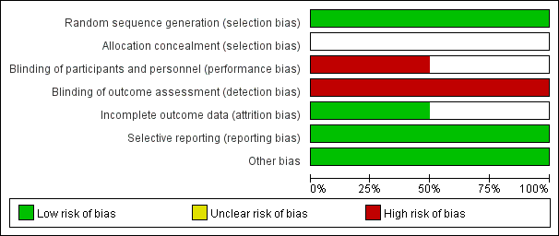
Supplementary Figure 3. Risk of bias graph

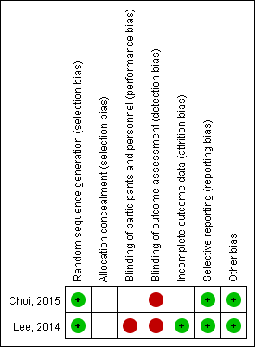
Supplementary Figure 4. Risk of bias summary

