Additional file 1:
Clinical subphenotypes of sepsis based on mixed continuous and categorical data and differences in treatment effects

Authors
Yuta Yokokawa Ph.D,¹ Rieko Sakurai Ph.D,² Daisuke Kudo Ph.D,¹ Gen Tamiya Ph.D,^{2,3,4} Shigeki Kushimoto Ph.D,¹

Table of Contents
Supplemental ｍethods…………………………………………………………………….…….….……..4
Description of the four sepsis cohorts included in our study…………………………….…..………4
Sepsis identification in each dataset……………………………………………………..……….……4
Table S1. Clinical Variables and Clinical Outcomes used in the study……...……………...………5
Clustering methods……………………………………………………………………….………….…7
Table S2. Parameter setting for clustering methods……………………………………………...….9
Statistical model of treatment effects………………………………………………………………….9
Table S3. R packages used in the study………………………………………………………………10
Supplemental results.……………………………………………………………………………………..12
Figure S1 Influence of the ratio of categorical variables to continuous variables on clustering performance in simulation studies. ………………………………………………………………...…..12
Table S4. Missing data (no., %) across registries for variables…………………………………....13
Figure S2. Density plot comparing observed versus imputed data. ……………………………….16
Figure S3. Independence of variable introduced in analysis. …………………...…………............17
Figure S4 Adjusted Rand Indexes between clustering methods at cluster number 2………….....18
Figure S5Adjusted Rand Indexes between clustering methods at cluster number 3…………......18
Figure S6 Adjusted Rand Indexes between clustering methods at cluster number 4………….....19
Figure S7 Adjusted Rand Indexes between clustering methods at cluster number 5………….....19
Figure S8 Adjusted Rand Indexes between clustering methods at cluster number 6………….....20
Figure S9 Adjusted Rand Indexes between clustering methods at cluster number 7………….....20
Figure S10. Consensus clustering results of k-UMAP [nn=100]…………...………………………21
Figure S11. Consensus clustering results of k-UMAP [nn=200]…………………………………...22
Figure S12. Consensus clustering results of KAMILA…………...…………………………...........23
Figure S13. Patients transition of k-UMAP [nn=100, k=3] and k-UMAP [nn=200, k=5]..............24
Figure S14. Consensus clustering results of k-UMAP [nn=100] in validation dataset…...………25
Figure S15. UMAP plot of derivation and validation cluster for k-UMAP [nn=100, k=3]……….26
Figure S16. UMAP plot of derivation and validation cluster for k-UMAP [nn=200, k=5]……….27
Figure S17. UMAP plot of derivation and validation cluster for KAMILA [k=3]……….……….28
Table S5. Characteristics of patients clustered using k-UMAP [nn=200]……...………………….29
Table S6. Characteristics of patients clustered using KAMILA……...……………………............32
Table S7. Characteristics of patients clustered using k-UMAP [nn=100, k=3] in validation dataset…………………………………………………………………………………………………….35
Figure S18. Odds ratios for interaction of the treatment and subphenotypes for hospital mortality in each clustering methods in septic shock patients…………..………….............................................38
Table S8. Comparisons of subphenotypes of sepsis identified in our study and that reported in the literature..………………………………………………………………………………...........................39
References…………………………………………………………………………………………...........40

Supplemental Methods

Description of the four sepsis cohorts included in our study
・Tohoku Sepsis Registry
The Tohoku Sepsis Registry (UMIN000010297) was a prospective observational study involving 616 patients admitted to 10 institutions (three university hospitals and seven community hospitals) in Tohoku District, Northeastern Japan, between January 2015 and December 2015 [S1].
・FORECAST sepsis study
The Focused Outcomes Research in Emergency Care for Acute Respiratory Distress Syndrome, Sepsis, and Trauma (FORECAST) sepsis study (UMIN000019742) was a multicenter, prospective study that enrolled 1,184 patients admitted to 59 intensive care units (ICUs) in Japan, between January 2016 and March 2017 [S2].
・JAAM SPICE-ICU
Japanese Association for Acute Medicine Sepsis Prognostication in the Intensive Care Unit and Emergency Room (JAAM SPICE-ICU) was a multicenter, prospective cohort study conducted in 22 intensive care units in Japan from December 2017 to May 2018 [S3].
・JAAM MAESTRO
Japanese Association for Acute Medicine Multicenter Assessment for Sepsis Treatment and Outcome (JAAM MAESTRO) was a multicenter observational study that was conducted in 17 intensive care units (ICUs) at tertiary hospitals in Japan from July 2019 to August 2020 [S4].

Sepsis identification in each dataset
TSR and FORECAST included patients with severe sepsis based on the sepsis-2 criteria [S5].
JAAM SPICE-ICU and JAAM MAESTRO included patients with severe sepsis based on the sepsis-3.0 criteria [S6].

Table S1. Clinical Variables and treatments used in the study
Variables | Descriptions
Age | measured at admission
Sex | Male/Female
BMI | Body Mass Index measured in kg/m2 at admission
Location Before ICU | Admission route to intensive care unit: from emergency room, already admitted to the ICU with other disease, others
AMI | Past medical history of acute myocardial infarction at admission
AHF | Past medical history of acute heart failure at admission
PAD | Past medical history of peripheral arterial disease at admission
Stroke | Past medical history of Stroke at admission
Chronic Lung Disease | Past medical history of chronic lung disease at admission
Collagen Disease | Past medical history of collagen disease at admission
Peptic Ulcer | Past medical history of peptic ulcer at admission
Liver Disease | Past medical history of liver disease at admission
DM | Past medical history of diabetes at admission
CKD | Past medical history of chronic kidney disease at admission
Malignancy | Past medical history of malignancy at admission
Metastatic Neoplasm | Past medical history of metastatic neoplasm at admission
Steroid | Medication of steroid at admission
Immunosuppressant | Medication of immunosuppressant at admission
Statin | Medication of statin at admission
Antiplatelet | Medication of antiplatelet at admission
Beta Blocker | Medication of beta blocker at admission
Radiotherapy | Treatment history of radiotherapy at admission
GCS | Glasgow Coma Scale measured at admission
RR | Respiratory rate measured in /minutes at admission
HR | Heart Rate measured in /minutes at admission
SBP | Systolic blood pressure measured in mmHg at admission
DBP | Diastolic blood pressure measured in mmHg at admission
BT | Body Temperature measured in degree at admission
WBC | White blood cell count in × 10³/µL at admission
Hct | Hematocrit measured in percent at admission
Plt | Platelet count measured in 10⁴/µL at admission
Cre | Serum creatinine measured in mg/dL at admission
Bil | Total bilirubin measured in mg/dL at admission
Glu | Serum glucose measured in mg/dL at admission
Na | Serum sodium measured in mEq/L at admission
K | Serum potassium measured in mEq/L at admission
CRP | Serum C-reactive protein measured in mg/dL at admission
PT-INR | Prothrombin Time-International Normalized Ratio measured at admission
APTT | Serum activated partial thromboplastin time measured in second at admission
DD | Serum D-dimer measured in µg/mL at admission
Fbg | Serum fibrinogen measured in mg/mL at admission
pH | Serum pH at admission
PaCO₂ | measured in mmHg at admission
PaO₂ | measured in mmHg at admission
BE | Serum base excess measured in mEq/L at admission
Lactate | Serum lactate measured in mmol/L at admission
SOFA.PFR | Respiratory component of the SOFA score at admission.  0 point: PaO₂/FiO₂ > 400mmHg; 1 point: PaO₂/FiO₂ < 400mmHg; 2 points: PaO₂/FiO₂ < 300mmHg; 3 points: PaO₂/FiO₂ < 200mmHg with respiratory support; 4 points: PaO₂/FiO₂ < 100mmHg with respiratory support
SOFA.Coag | Coagulation component of the SOFA score at admission.  0 point: Platelets > 150×10³/mm³; 1 point: Platelets < 150×10³/mm³; 2 points: Platelets < 100×10³/mm³; 3 points: Platelets < 50×10³/mm³; 4 points: Platelets < 20×10³/mm³
SOFA.Liver | Hepatic component of the SOFA score at admission.  0 point: Bilirubin < 1.2 mg/dl; 1 point: Bilirubin 1.2-1.9 mg/dl; 2 points: Bilirubin 2.0-3.4 mg/dl; 3 points: Bilirubin 3.5-4.9 mg/dl; 4 points: Bilirubin > 5.0 mg/dl;
SOFA.CV | Cardiovascular component of the SOFA score at admission.  0 point: MAP > 70 mmHg; 1 point: MAP < 70 mm/Hg; 2 points: Dopamine ≤ 5μg/kg/min or dobutamine (any dose); 3 points: Dopamine > 5μg/kg/min or epinephrine ≤ 0.1 μg/kg/min or norepinephrine ≤ 0.1μg/kg/min; 4 points: Dopamine > 15 μh/kg/min or epinephrine > 0.1μg/kg/min or norepinephrine > 0.1 μg/kg/min
SOFA.GCS | Central Nervous System component of the SOFA score at admission.  0 point: Glasgow Coma Score 15; 1 point: Glasgow Coma Score 13-14; 2 points: Glasgow Coma Score 10-12; 3 points: Glasgow Coma Score 6-9; 4 points: Glasgow Coma Score <6
SOFA.Renal | Renal component of the SOFA score at admission.  0 point: Creatinine < 1.2 mg/dl; 1 point: Creatinine 1.2-1.9 mg/dl; 2 points: Creatinine 2.0-3.4 mg/dl; 3 points: Creatinine 3.5-4.9 mg/dl or urine output < 500ml/day; 4points: Creatinine > 5.0 mg/dl or urine output < 200ml/day
Treatments | Descriptions
VAS | Administration of vasopressin during hospitalization
Corticosteroids | Administration of corticosteroids during hospitalization
rTM | Administration of recombinant thrombomodulin during hospitalization
ATⅢ | Administration of antithrombin III during hospitalization
IVIg | Administration of immunoglobulin during hospitalization
PMX | Treatment of Direct hemoperfusion with polymyxin B-immobilized fibers during hospitalization
Abbreviation: BMI = Body Mass Index, AMI = acute myocardial infarction, AHF = acute heart failure, PAD = peripheral arterial disease, DM = diabetes, CKD = chronic kidney disease, GCS = Glasgow Coma Scale, RR = Respiratory rate, HR = Heart Rate, SBP = Systolic blood pressure, DBP = Diastolic blood pressure, BT = Body Temperature, WBC = White blood cell, Hct = Hematocrit, Plt = Platelet, Cre = creatinine, Bil = Total bilirubin, Glu = glucose, Na = sodium, K = potassium, CRP = C-reactive protein, PT-INR = Prothrombin Time-International Normalized Ratio, APTT = activated partial thromboplastin time, DD = D-dimer, Fbg = fibrinogen, BE = base excess, SOFA.PFR = Respiratory component of the SOFA score, SOFA.Coag = Coagulation component of the SOFA score, SOFA.Liver = Hepatic component of the SOFA score, SOFA.CV = Cardiovascular component of the SOFA score, SOFA.GCS = Central Nervous System component of the SOFA score, SOFA.Renal = Renal component of the SOFA score, ATⅢ= antithrombin III, IVIg = immunoglobulin, PMX = polymyxin B-immobilized fiber column hemoperfusion, rTM = recombinant thrombomodulin, VAS = vasopressin

Clustering methods
Our dataset contains numeric and categorical data, called “heterogeneous” or “mixed” data. We considered the k-prototype and KAymeans for MIxed LArge data (KAMILA), which were recommended in a previous study [S7], and k-means for the Uniform Manifold Approximation and Projection for Dimension Reduction [S8], we called k-UMAP. k-UMAP is an analogy of the Principal Component Analysis (PCA). The primary motivation for using PCA is dimension reduction, so we can reduce noise but not apply it to mixed data. In contrast, UMAP is also used for dimension reduction and can select proper metrics depending on the data. Therefore, we adapted UMAP. The study [S9] reported that UMAP has the effect of refining clustering and that it is better to use clustering methods, for example, k-means and Density-Based Spatial Clustering of Applications with Noise (DBSAN), on UMAP than alone. However, this is the first study to examine the characteristics of the k-UMAP using mixed data.
The clustering method for mixed data has struggled to determine the balance of contribution between numerical and categorical data to a clustering result because of different metrics that cannot be linked together consistently. Thus, they set the weights as hyperparameters and leave the decision to the user. Although k-UMAP has no parameters for such balancing, it integrates the graphs for each metric generated by UMAP. The details of the balancing for each method are as follows.

1. k-prototype
In the case of the k-prototype, the weight parameters are given as $λ$. The distance function was defined as follows:
$$d\left(x_{i},μ_{j}\right)=\sum_{m=1}^{q}{{\left(x_{i}^{m}-μ_{j}^{m}\right)}^{2}}+λ\sum_{m=q+1}^{p}{δ\left(x_{i}^{m},μ_{j}^{m}\right)} (E1)$$
Where m is an index of the overall variables in the data, the first q variables are numeric, and the remaining p-q variables are categorical. Note that $δ\left(a,b\right)=0$ for a=b and $δ\left(a,b\right)=1$ for $a≠b$. Thus, the distance for categorical data corresponds to the count of mismatches. In the optimization, the following objective function is minimized in the same manner as k-means.
$$O_{kproto}=\sum_{i}^{n}{\sum_{j}^{k}{u_{ij}d\left(x_{i},μ_{j}\right)}}$$
where $u_{ij}$ represents the elements of the n × k binary partition matrix U satisfying $\sum_{j}^{k}{u_{ij}}=1$. The k-prototype has been extended to estimate the optimal lambda, $λ_{est}$ssatisfying $λ_{est}=a/b$ where a is either the mean of standard deviation or variance of overall numerical variables, and b is either the mean of $1-\max_{j}{P_{mj}} or 1-\sum_{j}^{J}{P_{mj}^{2}}$ where j is an indicator of several categories such that j=1,2,…,J so as to make the variation of the second term of [S1] equivalent to that of the first term for the contribution to the distance d [S10].

2. KAMILA
In the case of KAMILA, the kernel density estimation technique was applied to the numerical data, and the multinomial probability mass function was assessed for categorical data. In the optimization, the following objective function is maximized:
$$O_{KAMILA}=\sum_{i}^{N}{\max_{g}{H_{i}\left(g\right)}}, H_{i}^{}\left(g\right)=\log\left[f\left(d_{ig}^{}\right)\right]+\log\left[c_{ig}^{}\right]$$
where $g$ is an indicator of clusters, such that $g=1,2,…,G$. The first term of $H_{i}^{}\left(g\right)$ represents for numeric data, and $f$is the kernel density estimate derived using the distance, $d_{ig}^{}$ such that
$$d_{ig}^{}=\sqrt{\sum_{p=1}^{P}{{\left[ξ_{p}\left(x_{ip}-μ_{gp}^{}\right)\right]}^{2}}}$$
, where $x_{ip}$ is data of i-th sample and p-th numeric variable, and $μ_{gp}^{}$ is a centroid of p-th numeric variable of g-th cluster. The second term of $H_{i}^{}\left(g\right)$ is used for categorical data such that
$$\log\left[c_{ig}^{}\right]=\sum_{q}^{Q}{ξ_{q}\log\left(m\left(x_{iq};θ_{gq}\right)\right)}$$
, where m is the multinomial probability mass function with parameters $θ$ for q-th variable and g-th cluster and $x_{iq}$ is data of i-th sample and q-th categorical variable. Note that $ξ_{p}$ and $ξ_{q}$ are the weight parameters set to 1 as default so as to be equivalent contribution for all over the variables.

3. k-UMAP
In the case of k-UMAP, the UMAP minimizes the following function [UMAP for t-SNE].
$$O_{UMAP}=\sum_{ij}{v_{ij}\log\left(\frac{v_{ij}}{w_{ij}}\right)+\left(1-v_{ij}\right)\log\left(\frac{1-v_{ij}}{1-w_{ij}}\right)}$$
where $v_{ij}$ is the weight of the edge on the graph in the high-dimensional input space and is calculated as follows:
$$v_{ij}=\left(v_{j|i}+v_{i|j}\right)-v_{j|i}v_{i|j}, v_{j|i}=\exp\left(-\left(r_{ij}-ρ_{i}\right)/σ_{i}\right)$$
, where $r_{ij}$ is the distance between inputs $x_{i}$ and$x_{j}$, $ρ_{i}$ is the distance to the nearest neighbor, and $σ_{i}$ is analogous to the parameter of the perplexity calibration used in the Stochastic Neighbor Embedding (SNE) [S11]. $w_{ij}$ is the weight of the edge on the graph in the low-dimensional output space as follows:
$$w_{ij}=\frac{1}{1+ad_{ij}^{2b}}$$
where $d_{ij}$ is the distance between outputs $y_{i}$ and $y_{j}$, called embedding. $a$ and $b$ are the UMAP parameters. The sampling of the positive edge is proportional to the weight of the edge, $v_{ij}$ and the value of the gradient is calculated by assuming $v_{ij}=1$. In other words, the nearest neighbor samples in the input space contribute to the first term of the objective function, whereas the other samples contribute to the second term, which adds strength to the weight of the edges. The objective function of UMAP does not need to calculate all the output pairwise distances, which is amenable to stochastic gradient descent techniques and is effective for application to large-scale datasets.
In k-UMAP, the embeddings $y$ are input to k-means. The k-UMAP has no parameter that balances numeric and categorical data contributions. Alternatively, the graphs of UMAP on different metrics (the set of $w_{ij}$ estimated depending on the distance functions) can be integrated by intersecting the edges. R package uwot [S12] provides such an approach, and we can select the same distance functions as the k-prototype: the Euclidean distance for numeric data and the Hamming distance for categorical data. The Hamming distance corresponds to the distance for categorical data in the k-prototype when the two input datasets are binary and of equal length.

The behavior of k-UMAP was validated using the same simulation data as in [S7], the results of which are provided in the Supplement. From the simulation, we found that k-UMAP was dominant in clustering datasets with many categorical variables. Therefore, we considered it for the exploration of a wide range of patient characteristics.

Table S2. Parameter setting for clustering methods
Clustering methods | Approaches for different data types | Parameters | Number of clusters
k-prototype | Distance function approach (Numeric: Euclidean, Categorical/Binary: Hamming) | lambda = 0.01, 1, 10, 20, 50 | 2,3,4,5,6,7
KAMILA | Density function approach (Numeric: kernel density functions, Categorical/Binary: Multinomial distribution function) | ξ=1 | 2,3,4,5,6,7
k-UMAP | Graph approach with distance function (Numeric: Euclidean, Categorical/Binary: Hamming) | number of neighbors = 50, 100, 200, 300  number of components = 2 | 2,3,4,5,6,7

Statistical model of treatment effects
We considered the treatment work for specific cluster members. Therefore, we use the following regression model with interactions:
$$y= β_{0}+β_{1}^{}x_{treat}+β_{2}^{T}\left({X_{cluster}^{}}^{T}x_{treat}\right)$$
where $y$and $x_{treat}$are a $n×1$ vectors for the outcome and target treatments, respectively, and $X_{cluster}$ is an $n×\left(p-1\right)$ matrix of dummy variables for cluster identification. $n$ is the sample size, and $p$ is the number of clusters. This means that the odds ratios were conservatively estimated for the treated group in a particular cluster, in contrast to all untreated groups. Other interactions due to sampling bias, such as target treatment $×$ other treatments or target treatment $×$covariates, were adjusted by inversely weighting the propensity score [S13, 14].

Table S3. R packages used in the study
Packages | Version | Description
mice | 3.14.0 | The mice package creates multiple imputations (replacement values) for multivariate missing data and is based on Fully Conditional Specification, where each incomplete variable is imputed by a separate model. The MICE algorithm can impute mixes of continuous, binary, unordered categorical and ordered categorical data.  https://github.com/amices/mice, https://amices.org/mice/
mitools | 2.4 | The mitools package performs analyses and combines results from multiple-imputation datasets.
survey | 4.1-1 | The survey package performs the following analyses: summary statistics, two-sample tests, rank tests, generalized linear models, cumulative link models, Cox models, log-linear models, general maximum pseudolikelihood estimation for multistage stratified, cluster-sampled, unequally weighted survey samples, variances by Taylor series linearisation or replicate weights, post-stratification, calibration, and raking, two-phase subsampling designs, graphics. PPS sampling without replacement, and small-area estimation.
dplyr | 1.2.2 | The dplyr package is a grammar of data manipulation, providing a consistent set of verbs that help you solve the most common data manipulation challenges.  https://github.com/tidyverse/dplyr, https://dplyr.tidyverse.org/
ggplot2 | 3.3.6 | The ggplot2 package is a system for declaratively creating graphics, based on The Grammar of Graphics.  https://github.com/tidyverse/ggplot2, https://ggplot2.tidyverse.org/
RColorBrewer | 1.1-3 | The RColorBrewer package provides color schemes for maps (and other graphics) designed by Cynthia Brewer as described at http://colorbrewer2.org.
Rcpp | 1.0.9 | The Rcpp package helps to integrate R and C++ via R functions and a (header-only) C++ library.  https://github.com/RcppCore/Rcpp, https://dirk.eddelbuettel.com/code/rcpp.html
uwot | 0.1.14 | The uwot package is an R implementation of the Uniform Manifold Approximation and Projection (UMAP) method for dimensionality reduction of McInnes et al. (2018).
parallel | 4.2.2 | The parallel package supports parallel computation, including forking (taken from package multicore), sockets (taken from package snow), and random-number generation.
doParallel | 1.0.17 | The doParallel package provides a parallel backend for the %dopar% function using the parallel package.
flexclust | 1.4-1 | The flexclust package performs the following cluster analyses: k-centroids cluster analysis supporting arbitrary distance measures and centroid computation, hard competitive learning, neural gas, and QT clustering.
clustMixType | 0.3-9 | The clustMixType package performs k-prototypes partitioning clustering for mixed variable-type data.
foreach | 1.5.2 | This foreach package provides support for the foreach looping construct. Foreach is an idiom that allows for iterating over elements in a collection, without the use of an explicit loop counter.  https://github.com/RevolutionAnalytics/foreach
lattice | 0.20-45 | The lattice add-on package is an implementation of Trellis graphics for R. It is a powerful and elegant high-level data visualization system with an emphasis on multivariate data..  https://lattice.r-forge.r-project.org/
stringr | 1.5.0 | The Strings play a big role in many data cleaning and preparation tasks. The stringr package provides a cohesive set of functions designed to make working with strings as easy as possible.  ]https://stringr.tidyverse.org, https://github.com/tidyverse/stringr
magrittr | 2.0.3 | The magrittr package offers a set of operators which make your code more readable by: structuring sequences of data operations left-to-right (as opposed to from the inside and out), avoiding nested function calls, minimizing the need for local variables and function definitions, and making it easy to add steps anywhere in the sequence of operations.  https://magrittr.tidyverse.org, https://github.com/tidyverse/magrittr
twang | 2.5 | The twang package provides functions for propensity score estimating and weighting, nonresponse weighting, and diagnosis of the weights.

Supplemental Results

Figure S1 Influence of the ratio of categorical variables to continuous variables on clustering performance in simulation studies.

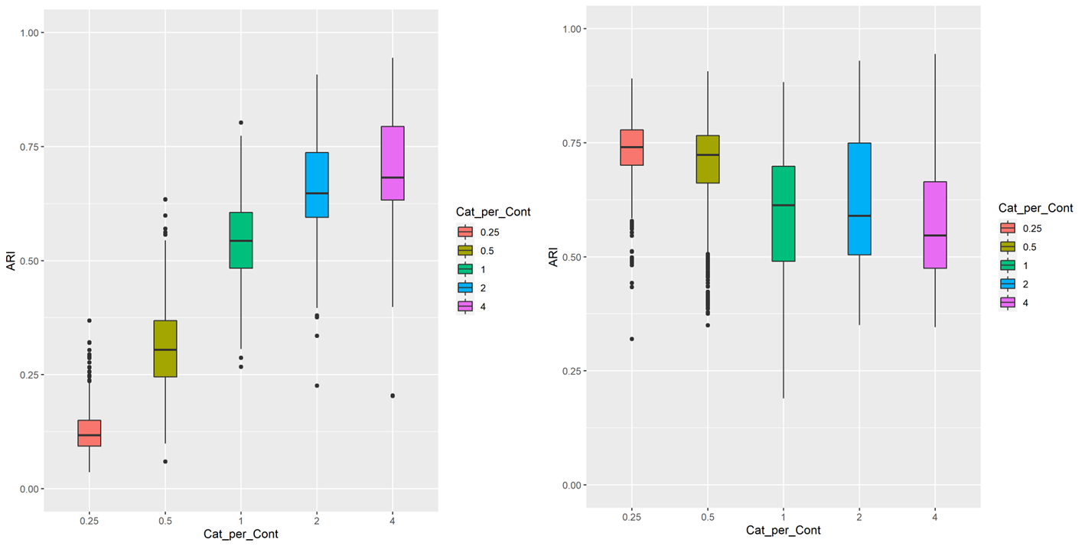

b
a

In k-UMAP (a), Adjusted Rand Indexes (ARI) increased as the ratio of categorical variables to continuous variables (Cat_per_Cont) increased. On the other hands, the opposite trend was observed in KAMILA (b).

Table S4. Missing data (no., %) across registries for variables
Registries | Derivation dataset | Tohoku Sepsis Registry | Forecast sepsis study | Validation dataset | JAAM  SPICE-ICU | JAAM MAESTRO
No. of patients | n = 1,756 | n = 573 | n = 1,183 | n = 672 | n = 494 | n = 178
Age | 0 (0%) | 0 (0%) | 0 (0%) | 0 (0%) | 0 (0%) | 0 (0%)
Sex Male | 0 (0%) | 0 (0%) | 0 (0%) | 0 (0%) | 0 (0%) | 0 (0%)
BMI | 28 (1.6%) | 2 (0.3%) | 26 (2.2%) | 7 (1.0%) | 5 (1.0%) | 2 (1.1%)
Admission from ER | 2 (0.1%) | 0 (0%) | 2 (0.2%) | 0 (0%) | 0 (0%) | 0 (0%)
Past Medical history
Acute myocardial infarction | 0 (0%) | 0 (0%) | 0 (0%) | 0 (0%) | 0 (0%) | 0 (0%)
Acute Heart Failure | 0 (0%) | 0 (0%) | 0 (0%) | 0 (0%) | 0 (0%) | 0 (0%)
Peripheral Arterial Disease | 0 (0%) | 0 (0%) | 0 (0%) | 0 (0%) | 0 (0%) | 0 (0%)
Stroke | 0 (0%) | 0 (0%) | 0 (0%) | 0 (0%) | 0 (0%) | 0 (0%)
Chronic Lung Disease | 0 (0%) | 0 (0%) | 0 (0%) | 0 (0%) | 0 (0%) | 0 (0%)
Collagen Disease | 0 (0%) | 0 (0%) | 0 (0%) | 0 (0%) | 0 (0%) | 0 (0%)
Peptic Ulcer | 0 (0%) | 0 (0%) | 0 (0%) | 0 (0%) | 0 (0%) | 0 (0%)
Liver Disease | 0 (0%) | 0 (0%) | 0 (0%) | 0 (0%) | 0 (0%) | 0 (0%)
Diabetes | 0 (0%) | 0 (0%) | 0 (0%) | 0 (0%) | 0 (0%) | 0 (0%)
Chronic kidney disease | 0 (0%) | 0 (0%) | 0 (0%) | 0 (0%) | 0 (0%) | 0 (0%)
Malignancy | 0 (0%) | 0 (0%) | 0 (0%) | 0 (0%) | 0 (0%) | 0 (0%)
Metastatic Neoplasm | 0 (0%) | 0 (0%) | 0 (0%) | 1 (0.1%) | 0 (0%) | 0 (0%)
Medication
Steroid | 2 (0.1%) | 2 (0.3%) | 0 (0%) | - | - | 0 (0%)
Immunosuppressant | 2 (0.1%) | 2 (0.3%) | 0 (0%) | - | - | 0 (0%)
Statin | 2 (0.1%) | 2 (0.3%) | 0 (0%) | - | - | 0 (0%)
Antiplatelet | 2 (0.1%) | 2 (0.3%) | 0 (0%) | - | - | 0 (0%)
Beta Blocker | 2 (0.1%) | 2 (0.3%) | 0 (0%) | - | - | 0 (0%)
Radiotherapy | 2 (0.1%) | 3 (0.5%) | 0 (0%) | - | - | 0 (0%)
Vital signs, median (IQR)
Glasgow Coma Scale | 16 (0.9%) | 8 (1.4%) | 8 (0.7%) | 0 (0%) | 0 (0%) | 0 (0%)
Respiratory rate (/min) | 9 (0.5%) | 1 (0.2%) | 8 (0.7%) | 2 (0.3%) | 0 (0%) | 2 (1.1%)
Heart Rate (/min) | 4 (0.2%) | 0 (0%) | 4 (0.3%) | 1 (0.1%) | 1 (0.2%) | 0 (0%)
Systolic blood pressure (mmHg) | 27 (1.5%) | 0 (0%) | 27 (2.3%) | 4 (0.6%) | 1 (0.2%) | 3 (1.7%)
Diastolic blood pressure (mmHg) | 43 (2.4%) | 0 (0%) | 43 (3.6%) | 13 (1.9%) | 7 (1.4%) | 6 (3.4%)
Body Temperature (℃) | 41 (2.3%) | 0 (0%) | 41 (3.5%) | 3 (0.4%) | 1 (0.2%) | 2 (1.1%)
Blood test Data, median (IQR)
WBC (10³/µL) | 0 (0%) | 0 (0%) | 0 (0%) | 0 (0%) | 0 (0%) | 0 (0%)
Hematocrit (%) | 7 (0.4%) | 1 (0.2%) | 6 (0.5%) | 2 (0.3%) | 1 (0.2%) | 1 (0.6%)
Platelets (10⁴/µL) | 6 (0.3%) | 0 (0%) | 6 (0.5%) | 0 (0%) | 0 (0%) | 0 (0%)
Creatinine (mg/dL) | 10 (0.6%) | 2 (0.3%) | 8 (0.7%) | 0 (0%) | 0 (0%) | 0 (0%)
Bilirubin (mg/dL) | 18 (1.0%) | 1 (0.2%) | 17 (1.4%) | 2 (0.3%) | 1 (0.2%) | 1 (0.6%)
Glucose (mg/dL) | 33 (1.9%) | 7 (1.2%) | 26 (2.2%) | 11 (1.6%) | 3 (0.6%) | 8 (4.5%)
Sodium (mEq/L) | 7 (0.4%) | 0 (0%) | 7 (0.6%) | 0 (0%) | 0 (0%) | 0 (0%)
Potassium (mEq/L) | 7 (0.4%) | 0 (0%) | 7 (0.6%) | 0 (0%) | 0 (0%) | 0 (0%)
C-reactive protein (mg/dL) | 24 (1.4%) | 6 (1.0%) | 18 (1.5%) | 1 (0.1%) | 1 (0.2%) | 0 (0%)
Procalcitonin | 964 (54.9%) | 413 (72.1%) | 551 (46.6%) | - | - | 122 (68.5%)
PT-INR | 67 (3.8%) | 29 (5.1%) | 38 (3.2%) | 4 (0.6%) | 2 (0.4%) | 2 (1.1%)
APTT (sec) | 72 (4.1%) | 30 (5.2%) | 42 (3.6%) | - | - | -
FDP | 494 (28.1%) | 119 (20.8%) | 375 (31.7%) | 169 (25.1%) | 122 (24.7%) | 47 (26.4%)
D-dimer (µg/mL) | 356 (20.3%) | 56 (9.8%) | 300 (25.4%) | 80 (11.9 %) | 59 (11.9%) | 21 (11.8%)
Fibrinogen (mg/mL) | 364 (20.7%) | 138 (24.1%) | 226 (19.1%) | 73 (10.9) | 45 (9.1%) | 28 (15.7%)
pH | 84 (4.8%) | 7 (1.2%) | 77 (6.5%) | 7 (1.0%) | 5 (1.0%) | 2 (1.1%)
PaCO2 (mmHg) | 118 (6.7%) | 38 (6.6%) | 80 (6.8%) | 8 (1.2%) | 5 (1.0%) | 3 (1.7%)
PaO2 (mmHg) | 132 (7.5%) | 41 (7.2%) | 91 (7.6%) | 12 (1.8%) | 6 (1.2%) | 6 (3.4%)
Base excess (mEq/L) | 92 (5.2%) | 11 (1.9%) | 81 (6.8%) | - | - | -
Lactate (mmol/L) | 45 (2.6%) | 9 (1.6%) | 36 (3.0%) | 8 (1.2%) | 6 (1.2%) | 2 (1.1%)
SOFA score, median (IQR) | 236 (13.4%) | 53 (9.2%) | 183 (15.5%) | 26 (3.9%) | 0 (0%) | 26 (14.6%)
Respiration | 133 (7.6%) | 35 (6.1%) | 98 (8.3%) | 34 (5.1%) | 8 (1.6%) | 26 (14.6%)
Coagulation | 0 (0%) | 0 (0%) | 0 (0%) | 0 (0%) | 0 (0%) | 0 (0%)
Liver | 18 (1.0%) | 1 (0.2%) | 17 (1.4%) | 2 (0.3%) | 1 (0.2%) | 1 (0.6%)
Cardiovascular | 20 (1.1%) | 8 (1.4%) | 12 (1.0%) | 0 (0%) | 0 (0%) | 0 (0%)
Central Nervous System | 244 (13.9%) | 236 (41.2%) | 8 (0.7%) | 0 (0%) | 0 (0%) | 0 (0%)
Renal | 125 (7.1%) | 2 (0.3%) | 123 (10.4%) | 0 (0%) | 0 (0%) | 0 (0%)
APACHE II score, median (IQR) | 219 (12.5%) | 57 (9.9%) | 162 (13.7%) | 37 (5.5%) | 0 (0%) | 37 (20.8%)
SIRS, median (IQR) | 43 (2.4%) | 0 (0%) | 43 (3.6%) | 5 (0.7%) | 0 (0%) | 5 (2.8%)
JAAM DIC score, median (IQR) | 200 (11.4%) | 31 (5.4%) | 169 (14.3%) | 11 (1.6%) | 0 (0%) | 11 (6.2%)
Management
Noradrenaline | 2 (0.1%) | 2 (0.3%) | 0 (0%) | - | - | -
Vasopressin | 2 (0.1%) | 2 (0.3%) | 0 (0%) | - | - | -
Corticosteroids | 43 (2.4%) | 1 (0.2%) | 42 (3.6%) | - | - | 0 (0%)
Thrombomodulin | 46 (2.6%) | 4 (0.7%) | 42 (3.6%) | - | - | 0 (0%)
Antithrombin III | 45 (2.6%) | 4 (0.7%) | 41 (3.5%) | - | - | 0 (0%)
Immunoglobulin | 50 (2.8%) | 5 (0.9%) | 45 (3.8%) | - | - | 0 (0%)
PMX-DHP | 40 (2.3%) | 3 (0.5%) | 37 (3.1%) | - | - | 0 (0%)
Abbreviation: SD = standard deviation, IQR = interquartile range, ER = emergency room., APTT = Activated partial thromboplastin time
SOFA score = Sequential Organ Failure Assessment score, APACHE II score = Acute Physiology and Chronic Health Evaluation II score, SIRS = Systemic Inflammatory Response Syndrome, JAAM DIC score = Japanese Association for Acute Medicine Disseminated Intravascular Coagulation score. PMX-DHP = polymyxin B-immobilized fiber column hemoperfusion

Figure S2. Density plot comparing observed versus imputed data.
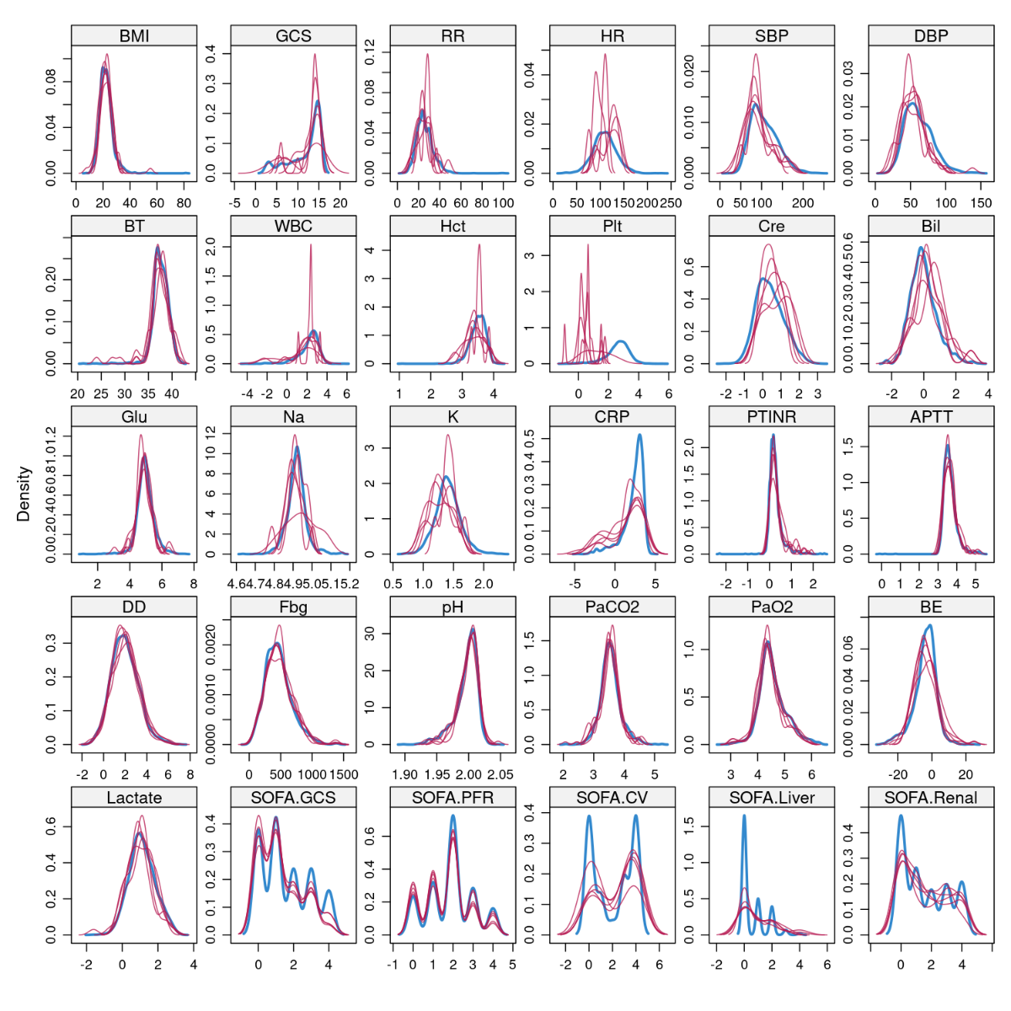

A density plot is a data visualization technique that shows the distribution of a continuous numerical variable, offering a smoothed alternative to histogram. It helps visualize the shape, spread, and skewness of the data. In the plot, the red line represents imputed values, while the blue line represents observed values.
Abbreviation: BMI = Body Mass Index, GCS = Glasgow Coma Scale, RR = Respiratory rate, HR = Heart Rate, SBP = Systolic blood pressure, DBP = Diastolic blood pressure, BT = Body Temperature, WBC = White blood cell, Hct = Hematocrit, Plt = Platelet, Cre = creatinine, Bil = Total bilirubin, Glu = glucose, Na = sodium, K = potassium, CRP = C-reactive protein, PT-INR = Prothrombin Time-International Normalized Ratio, APTT = activated partial thromboplastin time, DD = D-dimer, Fbg = fibrinogen, BE = base excess, SOFA.PFR = Respiratory component of the SOFA score, SOFA.Coag = Coagulation component of the SOFA score, SOFA.Liver = Hepatic component of the SOFA score, SOFA.CV = Cardiovascular component of the SOFA score, SOFA.GCS = Central Nervous System component of the SOFA score, SOFA.Renal = Renal component of the SOFA score
Figure S3. Independence of variable introduced in analysis.
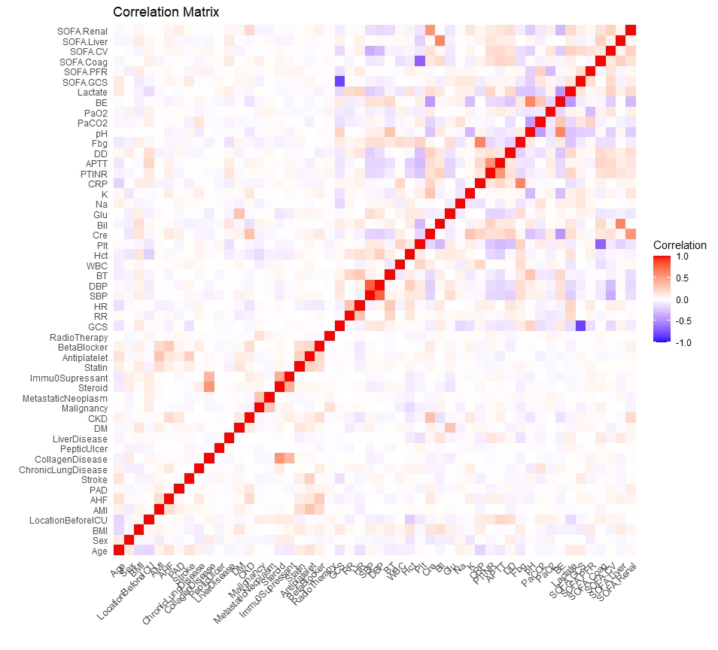
Positive correlations are displayed in red and negative correlations in blue, and the color intensity is proportional to the correlation coefficient.
Abbreviation: BMI = Body Mass Index, AMI = acute myocardial infarction, AHF = acute heart failure, PAD = peripheral arterial disease, DM = diabetes, CKD = chronic kidney disease, GCS = Glasgow Coma Scale, RR = Respiratory rate, HR = Heart Rate, SBP = Systolic blood pressure, DBP = Diastolic blood pressure, BT = Body Temperature, WBC = White blood cell, Hct = Hematocrit, Plt = Platelet, Cre = creatinine, Bil = Total bilirubin, Glu = glucose, Na = sodium, K = potassium, CRP = C-reactive protein, PT-INR = Prothrombin Time-International Normalized Ratio, APTT = activated partial thromboplastin time, DD = D-dimer, Fbg = fibrinogen, BE = base excess, SOFA.PFR = Respiratory component of the SOFA score, SOFA.Coag = Coagulation component of the SOFA score, SOFA.Liver = Hepatic component of the SOFA score, SOFA.CV = Cardiovascular component of the SOFA score, SOFA.GCS = Central Nervous System component of the SOFA score, SOFA.Renal = Renal component of the SOFA score
Figure S4. Adjusted Rand Indexes between clustering methods at cluster number 2
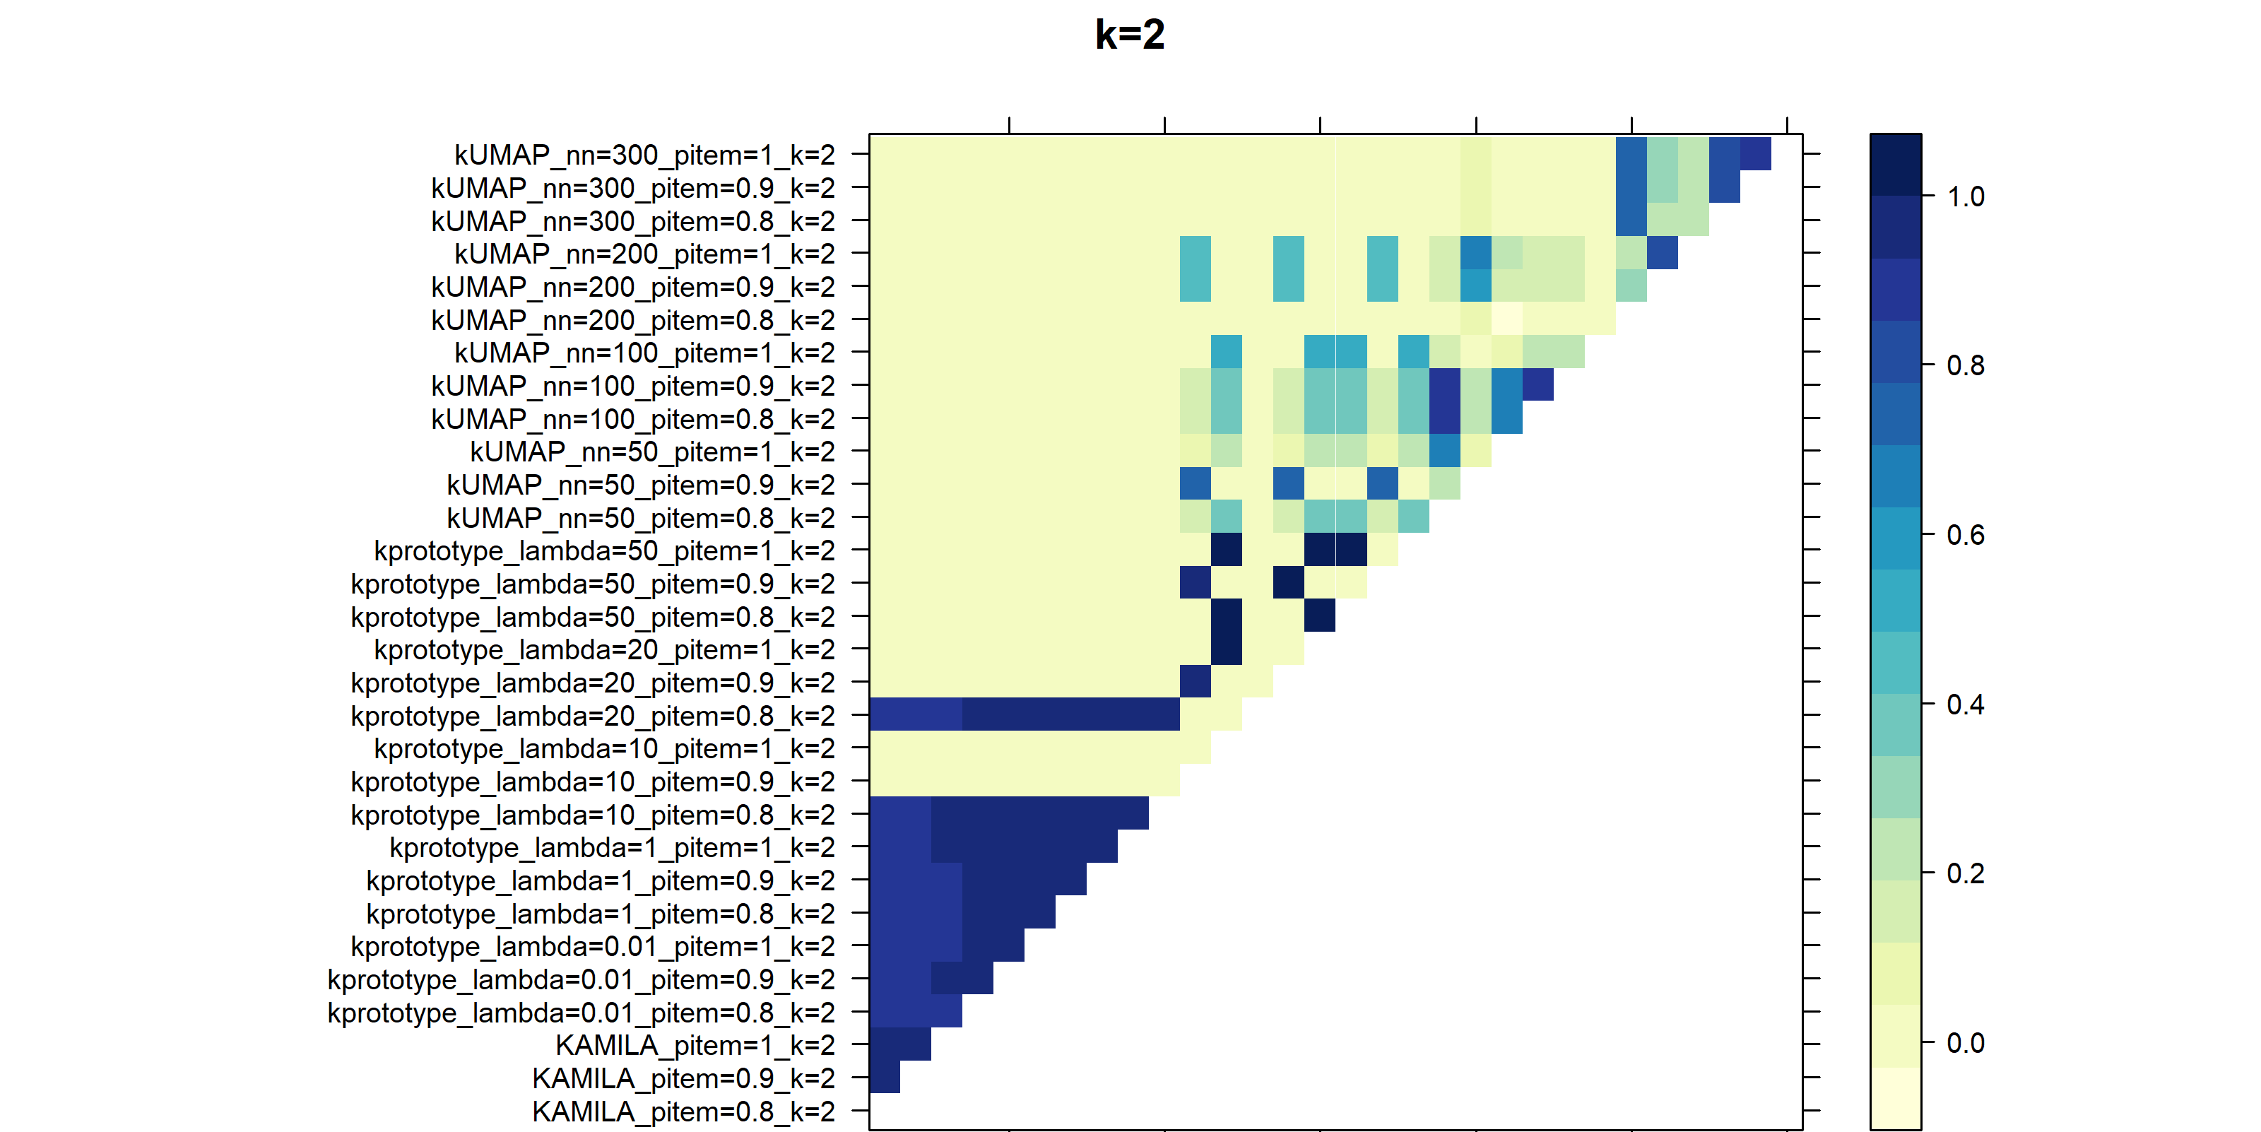
The blue color intensity is proportional to the Adjusted Rand Indexes. The higher the ARI, the deeper the blue displayed.
Abbreviation: nn = number of neighbors, KAMILA: KAymeans for MIxed LArge data

Figure S5. Adjusted Rand Indexes between clustering methods at cluster number 3
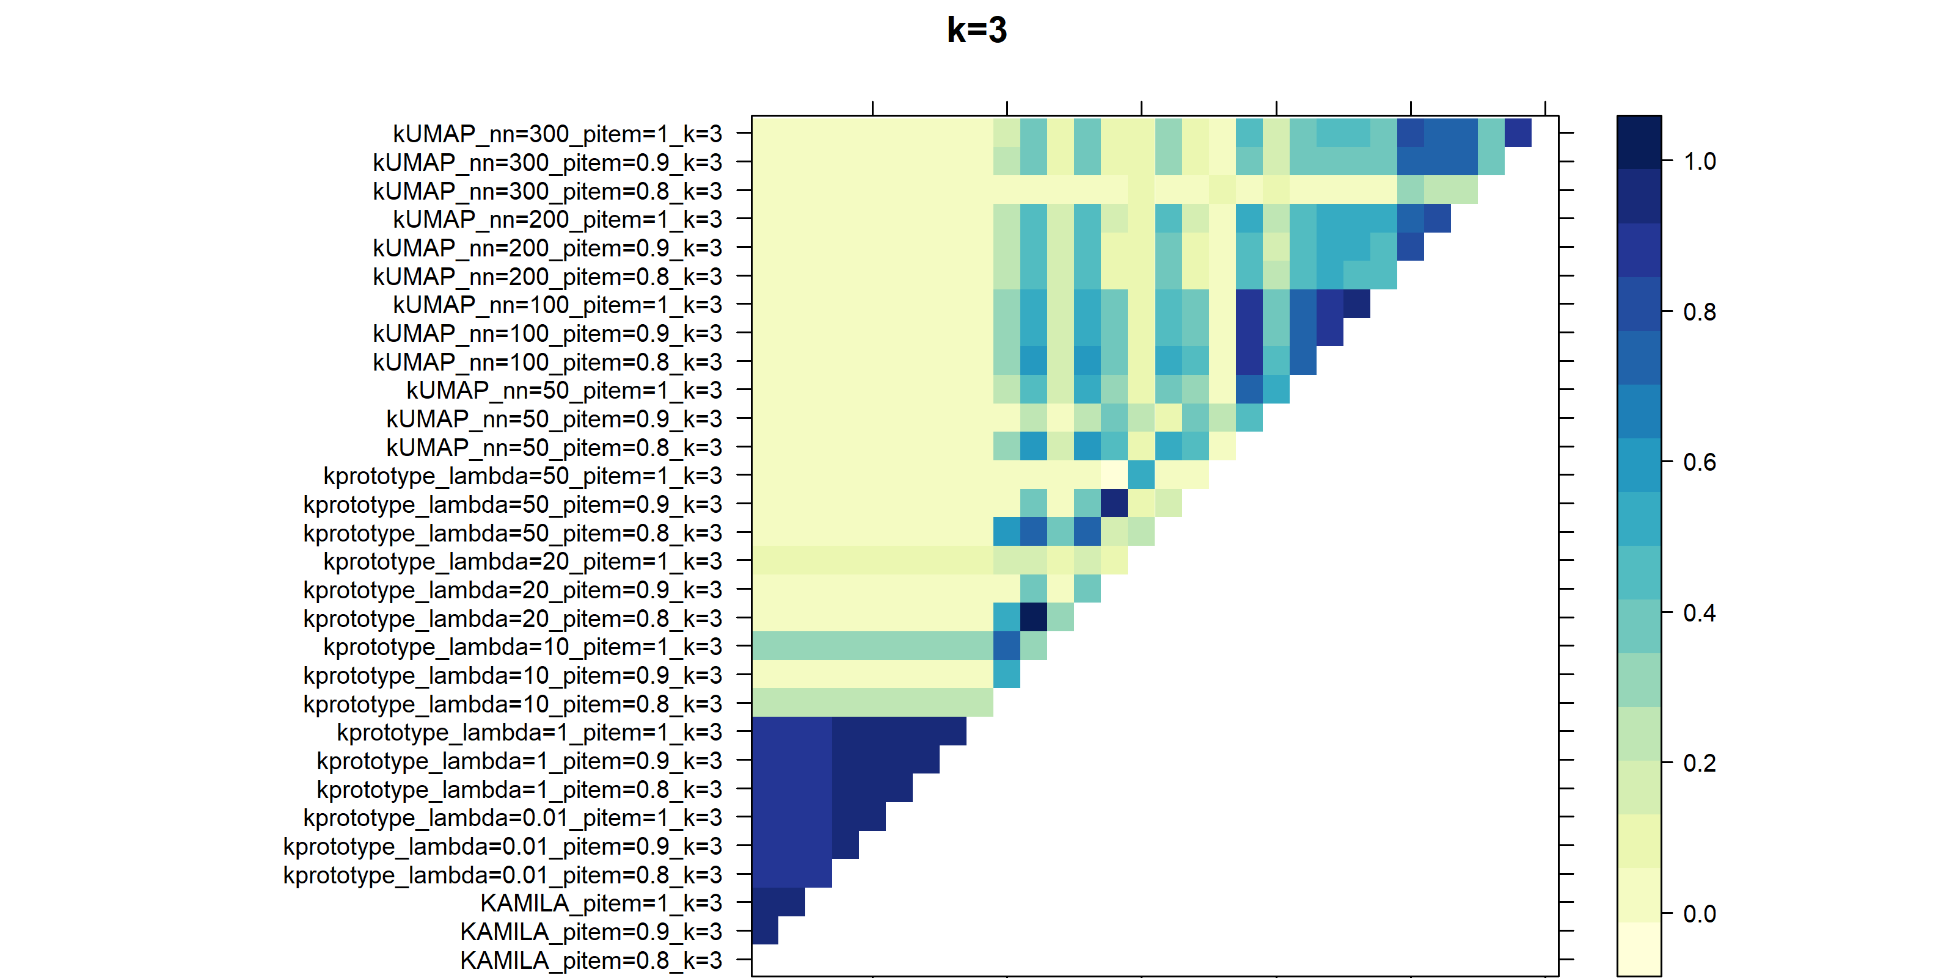
The blue color intensity is proportional to the Adjusted Rand Indexes. The higher the ARI, the deeper the blue displayed.
Abbreviation: nn = number of neighbors, KAMILA: KAymeans for MIxed LArge data

Figure S6. Adjusted Rand Indexes between clustering methods at cluster number 4
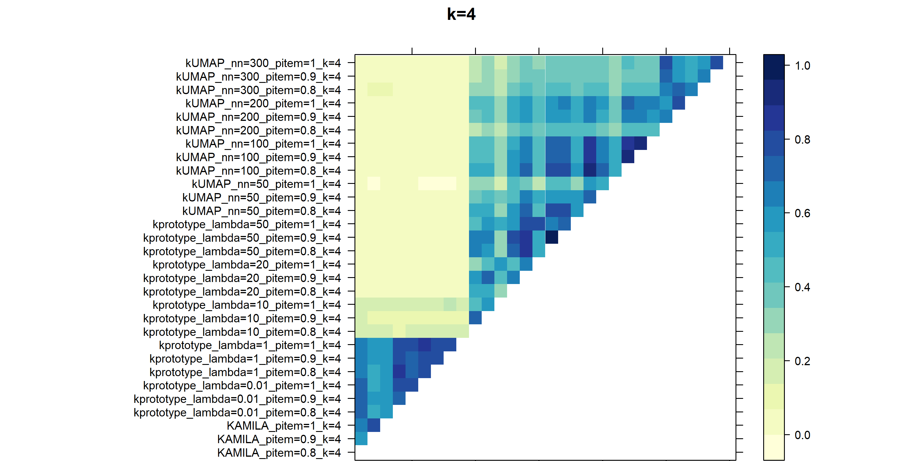
The blue color intensity is proportional to the Adjusted Rand Indexes. The higher the ARI, the deeper the blue displayed.
Abbreviation: nn = number of neighbors, KAMILA: KAymeans for MIxed LArge data

Figure S7. Adjusted Rand Indexes between clustering methods at cluster number 5
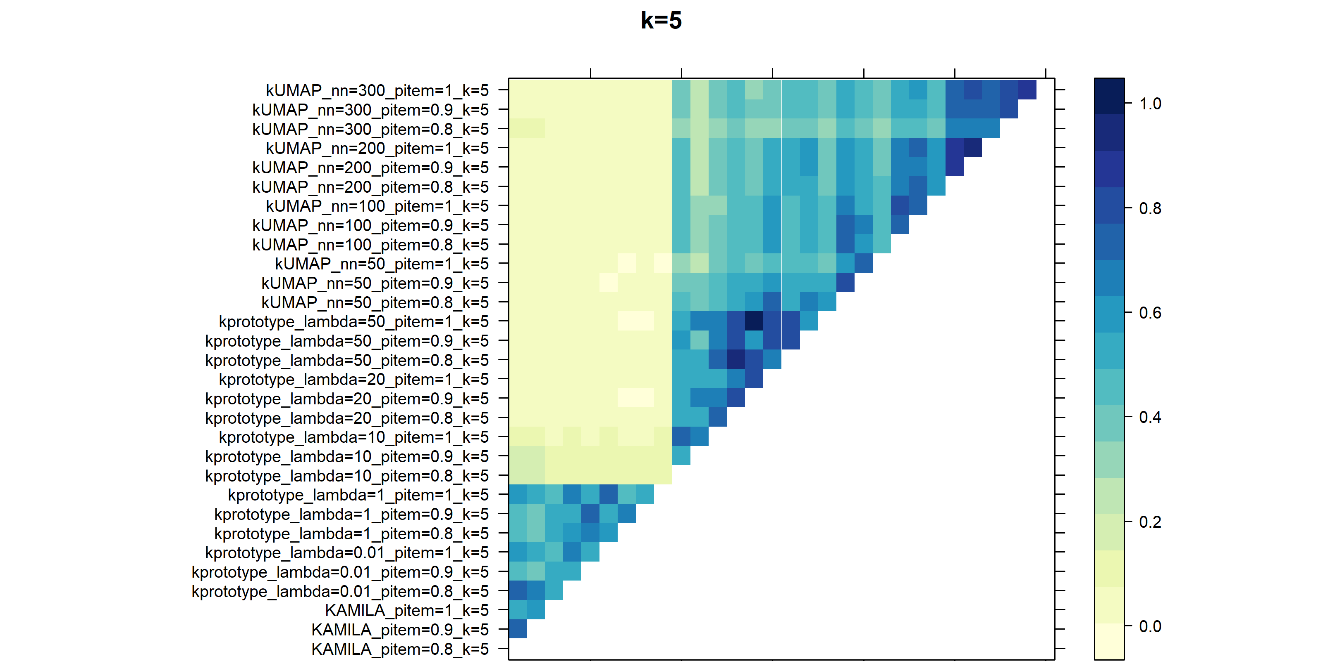
The blue color intensity is proportional to the Adjusted Rand Indexes. The higher the ARI, the deeper the blue displayed.
Aabbreviation: nn = number of neighbors, KAMILA: KAymeans for MIxed LArge data

Figure S8 Adjusted Rand Indexes between clustering methods at cluster number 6
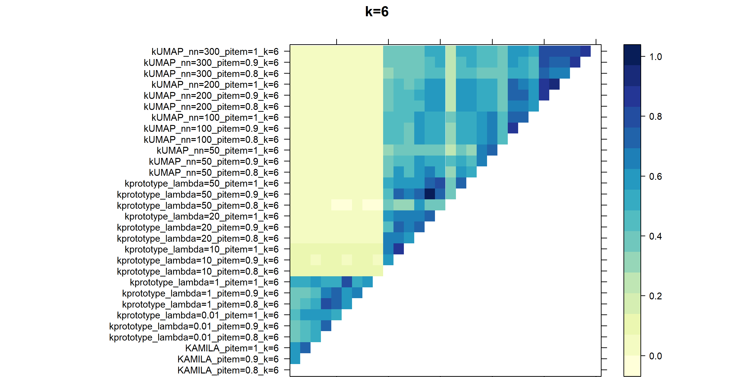
The blue color intensity is proportional to the Adjusted Rand Indexes. The higher the ARI, the deeper the blue displayed.
Abbreviation: nn = number of neighbors, KAMILA: KAymeans for MIxed LArge data

Figure S9 Adjusted Rand Indexes between clustering methods at cluster number 7
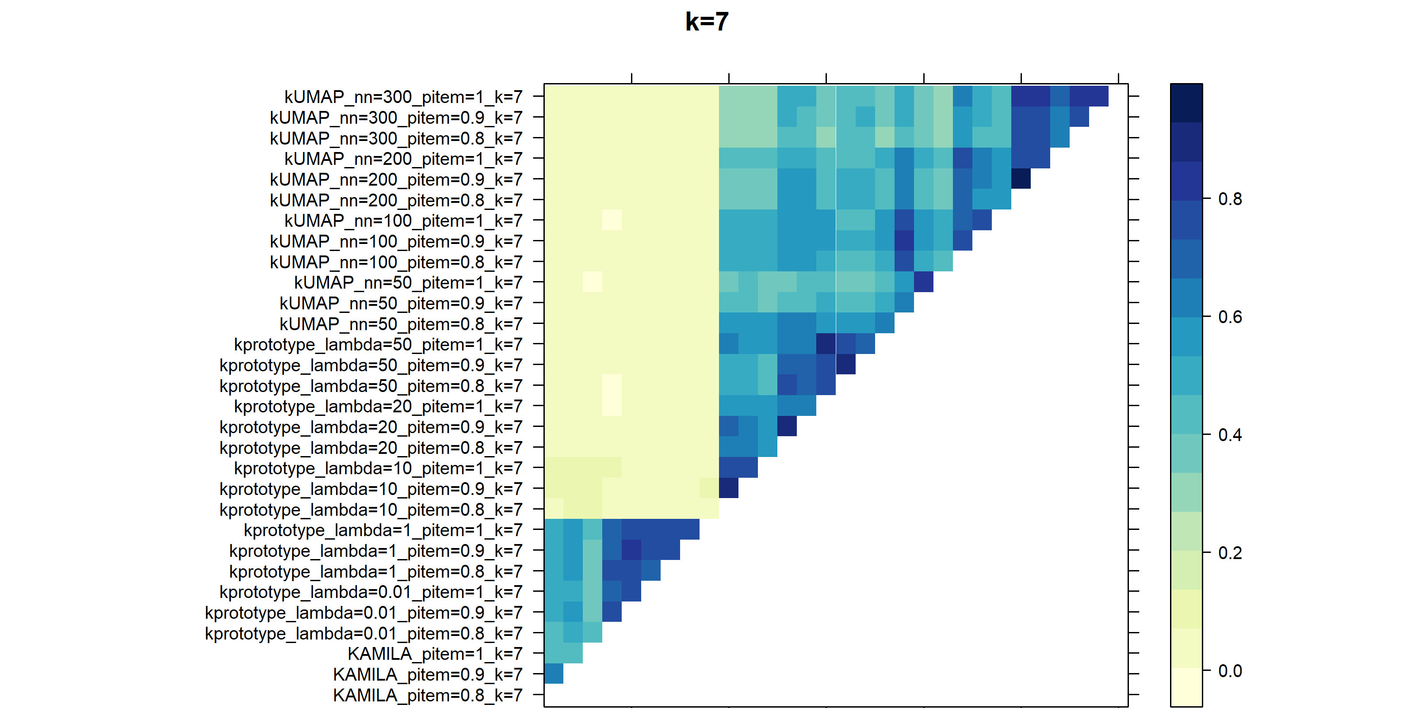
The blue color intensity is proportional to the Adjusted Rand Indexes. The higher the ARI, the deeper the blue displayed.
Abbreviation: nn = number of neighbors, KAMILA: KAymeans for MIxed LArge data

Figure S10. Consensus clustering results of k-UMAP [nn = 100]
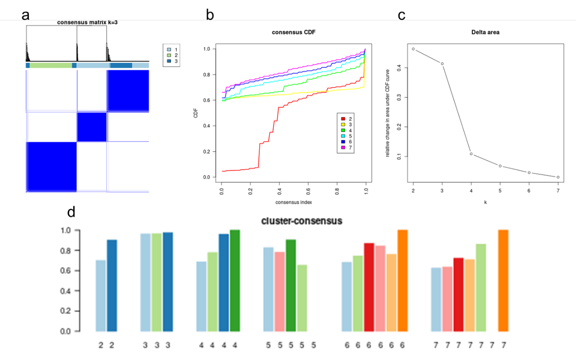

Consensus clustering results of k-UMAP [nn = 100] in derivation dataset (n = 1,756). (a) Heatmaps of the consensus matrices for k = 3. (b) Cumulative distribution function (CDF) of the consensus matrix across k=2 to k=7. (c) Relative change in the area under the CDF curve comparing k and k-1. (d) Cluster-consensus value of clusters for k=2 to k=7. This is the mean of all pairwise consensus values between a cluster's members.
Aabbreviation: nn = number of neighbors

Figure S11. Consensus clustering results of k-UMAP [nn=200]
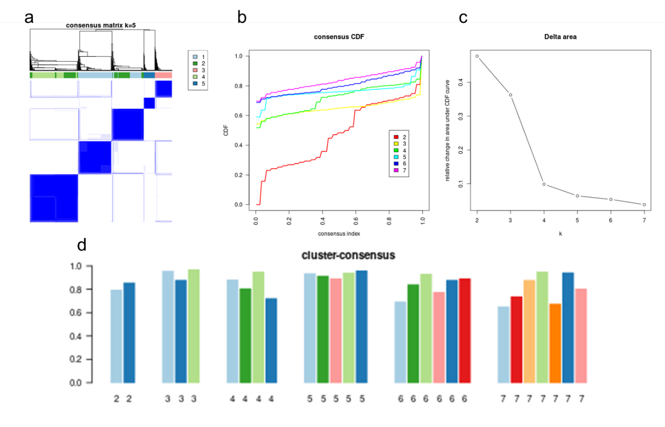

Consensus clustering results of k-UMAP [nn = 200] in derivation dataset (n = 1,756). (a) Heatmaps of the consensus matrices for k = 5. (b) Cumulative distribution function (CDF) of the consensus matrix across k=2 to k=7. (c) Relative change in the area under the CDF curve comparing k and k-1. (d) Cluster-consensus value of clusters for k=2 to k=7. This is the mean of all pairwise consensus values between a cluster's members.
Abbreviation: nn = number of neighbors

Figure S12 Consensus clustering results of KAMILA
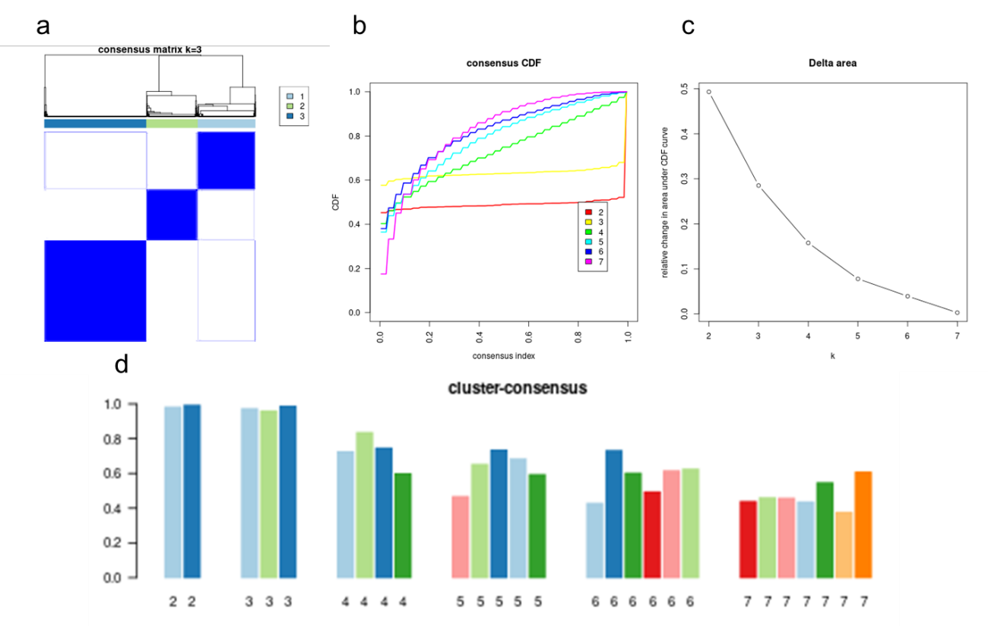

Consensus clustering results of KAMILA in derivation dataset (n = 1,756). (a) Heatmaps of the consensus matrices for k = 3. (b) Cumulative distribution function (CDF) of the consensus matrix across k=2 to k=7. (c) Relative change in the area under the CDF curve comparing k and k-1. (d) Cluster-consensus value of clusters for k=2 to k=7. This is the mean of all pairwise consensus values between a cluster's members.
Abbreviation: nn = number of neighbors, KAMILA: KAymeans for MIxed LArge data

Figure S13. Patients transition of k-UMAP [nn=100, k=3] and k-UMAP [nn=200, k=5]
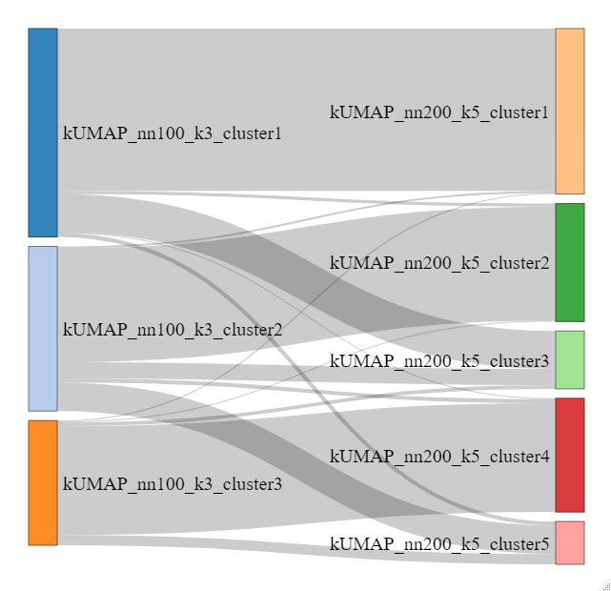

It can be seen that cluster1 in k-UMAP [nn=100, k=3] is divided into cluster1 and cluster3 in k-UMAP [nn=200, k=5], cluster2 in k-UMAP [nn=100, k=3] is mainly divided into cluster2 and cluster5 in k-UMAP [nn200, k=5], and cluster3 in k-UMAP [nn=100, k=3] is transferred to cluster4 in k-UMAP [nn=200, k=5]
Abbreviation: nn = number of neighbors, k = number of clusters

Figure S14. Consensus clustering results of k-UMAP [nn=100] in validation dataset
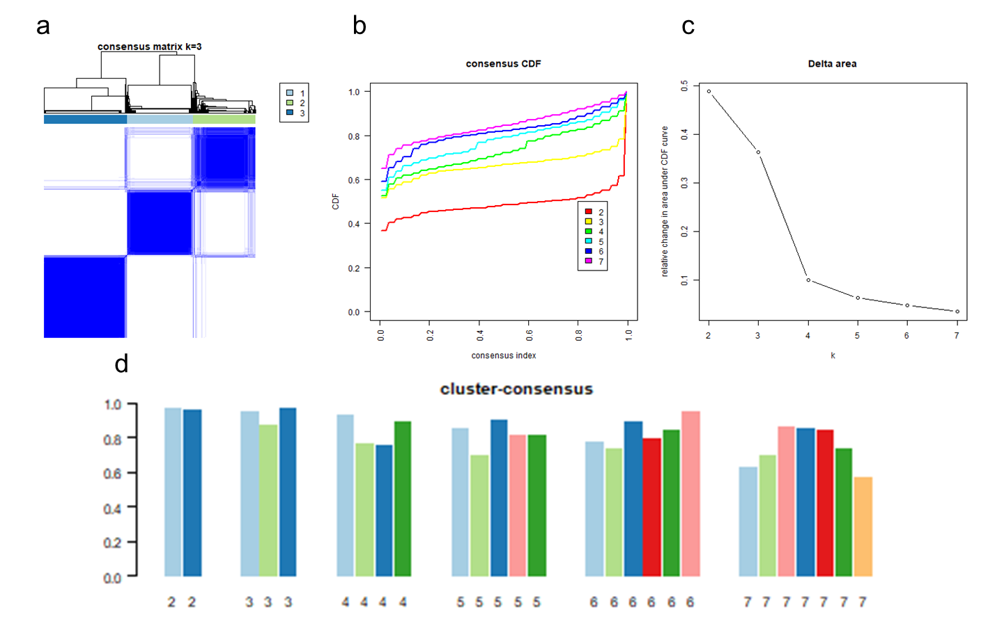

Consensus clustering results of k-UMAP [nn = 100] in validation dataset (n = 672). (a) Heatmaps of the consensus matrices for k = 3. (b) Cumulative distribution function (CDF) of the consensus matrix across k=2 to k=7. (c) Relative change in the area under the CDF curve comparing k and k-1. (d) Cluster-consensus value of clusters for k=2 to k=7. This is the mean of all pairwise consensus values between a cluster's members.
Abbreviation: nn = number of neighbors

Figure S15. UMAP plot of derivation and validation cluster for k-UMAP [nn=100, k=3]
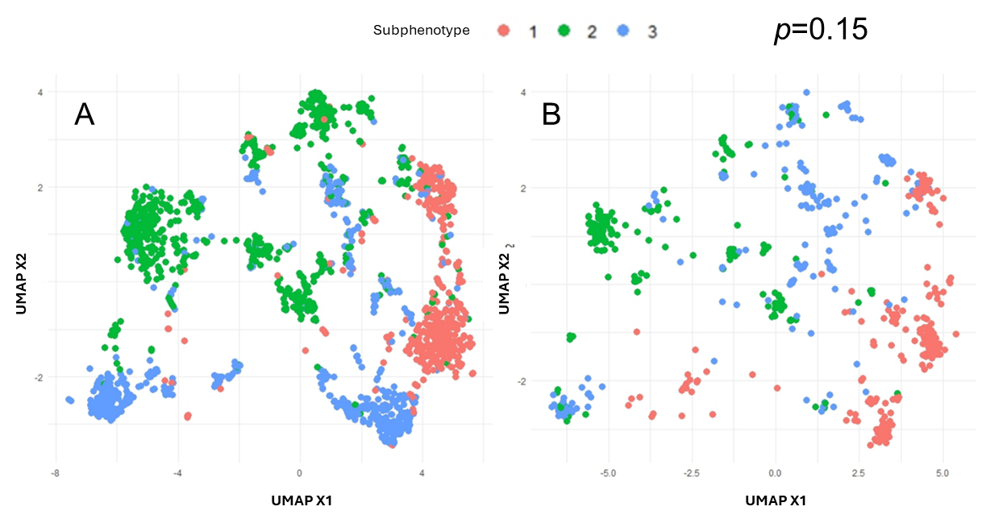

Visualization of subphenotypes using Uniform Manifold Approximation and Projection for Dimension Reduction (UMAP) in the derivation (A) and validation (B) datasets. Subphenotypes were shown in color from k-UMAP [nn=100, k=3]. The results of the comparison using nested ANOVA indicated that the two subphenotypes were similar (p=0.15).
Abbreviation: UMAP = Uniform Manifold Approximation and Projection for Dimension Reduction

Figure S16. UMAP plot of derivation and validation cluster for k-UMAP [nn=200, k=5]
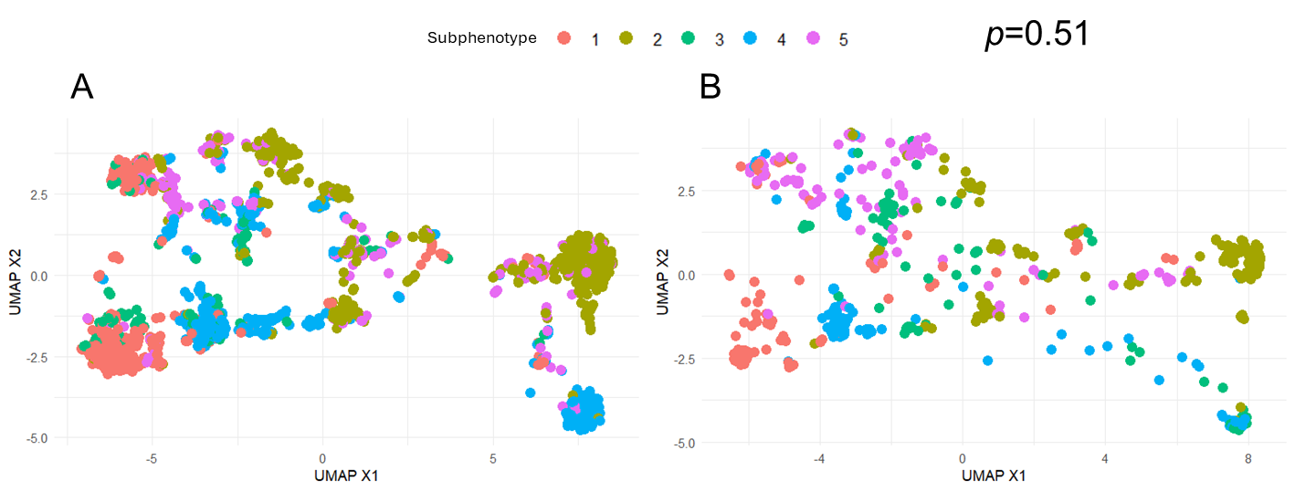

Visualization of subphenotypes using Uniform Manifold Approximation and Projection for Dimension Reduction (UMAP) in the derivation (A) and validation (B) datasets. Subphenotypes were shown in color from k-UMAP [nn=200, k=5]. The results of the comparison using nested ANOVA indicated that the two subphenotypes were similar (p=0.51).
Abbreviation: UMAP = Uniform Manifold Approximation and Projection for Dimension Reduction

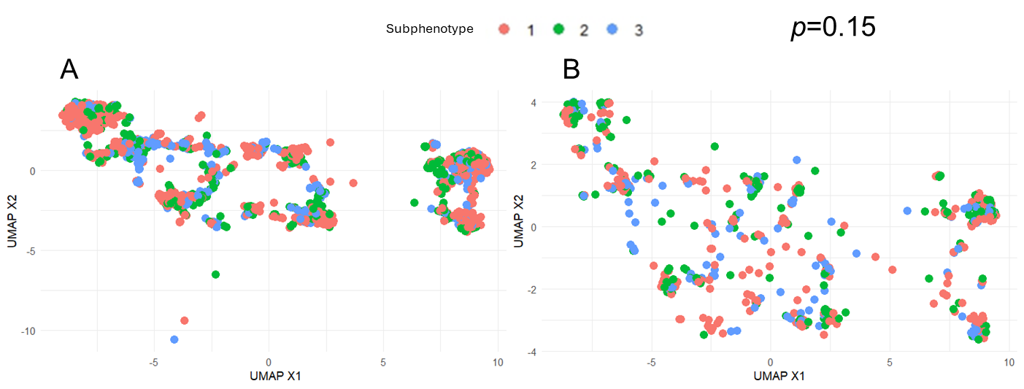
Figure S17. UMAP plot of derivation and validation cluster for KAMILA [k=3]

Visualization of subphenotypes using Uniform Manifold Approximation and Projection for Dimension Reduction (UMAP) in the derivation (A) and validation (B) datasets. Subphenotypes were shown in color from KAMILA[k=3]. The results of the comparison using nested ANOVA indicated that the two subphenotypes were similar (p=0.15).
Abbreviation: UMAP = Uniform Manifold Approximation and Projection for Dimension Reduction

Table S5. Characteristics of patients clustered using k-UMAP [nn=200, k=3].
 | ALL | Subphenotypes |  |  |  |  | P value
 | ALL | subphenotype 1 | subphenotype 2 | subphenotype 3 | subphenotype 4 | subphenotype 5
Variables | n = 1,756 | n = 407 | n = 587 | n = 126 | n = 425 | n = 211
Age, mean (SD) | 71.0 (±14.6) | 73.5 (±15.3) | 70.4 (±14.6) | 70.2 (±12.3) | 67.5 (±15.2) | 75.7 (±10.5) | < 0.001
Sex Male (%) | 61.1 | 0.7 | 99.0 | 29.4 | 64.7 | 83.9 | < 0.001
BMI, median (IQR) | 21.9 (19.1-24.7) | 21.5 (18.6-24.8) | 21.8 (19.1-24.8) | 22.0 (18.9-24.7) | 21.8 (19.2-24.4) | 22.6 (19.9-24.8) | 0.12
Admission from ER (%) | 64.2 | 91.9 | 90.3 | 50.0 | 1.9 | 71.6 | < 0.001
Past Medical history (%)
Acute myocardial infarction | 4.7 | 0.7 | 2.4 | 8.7 | 3.1 | 19.9 | < 0.001
Acute Heart Failure | 10.8 | 7.6 | 6.1 | 8.7 | 8.7 | 35.1 | < 0.001
Peripheral Arterial Disease | 3.0 | 1.7 | 1.5 | 4.8 | 1.7 | 11.4 | < 0.001
Stroke | 12.5 | 10.8 | 8.4 | 20.6 | 6.1 | 35.1 | < 0.001
Chronic Lung Disease | 5.7 | 3.9 | 7.7 | 8.7 | 4.2 | 5.2 | 0.03
Collagen Disease | 6.4 | 2.0 | 2.2 | 66.7 | 1.2 | 1.4 | < 0.001
Peptic Ulcer | 3.2 | 2.2 | 4.3 | 4.0 | 2.4 | 3.8 | 0.31
Liver Disease | 5.1 | 5.2 | 4.8 | 3.2 | 7.3 | 2.8 | 0.11
Diabetes | 25.2 | 25.3 | 23.5 | 27.8 | 16.0 | 46.5 | < 0.001
Chronic kidney disease | 8.1 | 5.4 | 4.8 | 7.9 | 4.9 | 28.9 | < 0.001
Malignancy | 13.8 | 12.0 | 14.0 | 6.4 | 21.2 | 6.2 | < 0.001
Metastatic Neoplasm | 2.2 | 0.3 | 1.7 | 0.0 | 5.9 | 1.9 | < 0.001
Medication (%)
Steroid | 12.1 | 5.7 | 5.0 | 83.3 | 9.7 | 7.1 | < 0.001
Immunosuppressant | 3.8 | 1.0 | 0.5 | 29.4 | 4.2 | 1.9 | < 0.001
Statin | 10.7 | 10.3 | 7.0 | 14.3 | 5.7 | 29.4 | < 0.001
Antiplatelet | 15.6 | 5.9 | 5.1 | 34.9 | 8.2 | 66.4 | < 0.001
Beta Blocker | 9.2 | 5.2 | 4.4 | 7.9 | 6.1 | 37.0 | < 0.001
Radiotherapy | 0.4 | 0.0 | 0.5 | 0.0 | 0.9 | 0.0 | 0.18
Vital signs, median (IQR)
Glasgow Coma Scale | 14 (10-15) | 14 (9-15) | 14 (9-15) | 14 (12-15) | 14 (10-15) | 14 (10-15) | 0.03
Respiratory rate (/min) | 25 (20-30) | 25 (21-30) | 25 (21-30) | 24 (20-30) | 24 (20-30) | 24 (20-30) | 0.03
Heart Rate (/min) | 109 (94-124) | 108 (93-124) | 111 (97-127) | 106 (93-123) | 110 (94-124) | 101 (87-119) | < 0.001
Systolic blood pressure (mmHg) | 101 (82-127) | 105 (84-130) | 103 (83-129) | 91 (79-111) | 95 (80-122) | 105 (85-138) | < 0.001
Diastolic blood pressure (mmHg) | 59 (47-74) | 60 (47-74) | 61 (48-76) | 55 (45-69) | 56 (45-73) | 60 (50-75) | 0.007
Body Temperature (℃) | 37.6 (36.7-38.7) | 37.8 (36.6-38.6) | 37.8 (36.8-39.0) | 37.4 (36.7-38.5) | 37.3 (36.6-38.4) | 37.5 (36.6-38.4) | 0.002
Blood test Data, median (IQR)
WBC (10³/µL) | 11.4 (6.0-17.8) | 11.2 (6.3-17.9) | 10.9 (5.4-17.2) | 12.4 (6.9-18.5) | 11.2 (5.1-18.3) | 12.9 (7.3-18.6) | 0.09
Hematocrit (%) | 34.0 (28.8-39.4) | 34.0 (29.1-39.1) | 36.0 (30.1-40.8) | 33.7 (28.5-37.7) | 32.0 (26.7-37.4) | 34.4 (30.4-39.2) | < 0.001
Platelets (10⁴/µL) | 14.9 (9.4-22.3) | 16.2 (9.6-23.9) | 15.7 (9.8-22.7) | 14.1 (9.7-20.4) | 13.0 (7.0-22.0) | 15.1 (11.9-20.2) | < 0.001
Creatinine (mg/dL) | 1.4 (0.9-2.5) | 1.2 (0.7-2.1) | 1.4 (0.9-2.3) | 1.3 (0.8-2.3) | 1.4 (0.8-2.5) | 2.1 (1.1-4.0) | < 0.001
Bilirubin (mg/dL) | 0.9 (0.6-1.5) | 0.8 (0.5-1.4) | 1.0 (0.6-1.7) | 0.8 (0.5-1.2) | 1.0 (0.6-1.8) | 0.8 (0.5-1.3) | < 0.001
Glucose (mg/dL) | 141 (109-191) | 143 (109-188) | 146 (116-197) | 121 (93-156) | 132 (103-174) | 159 (122-222) | < 0.001
Sodium (mEq/L) | 137 (133-140) | 137 (134-141) | 137 (133-141) | 137 (133-141) | 136 (132-139) | 136 (133-140) | < 0.001
Potassium (mEq/L) | 4.0 (3.6-4.6) | 3.9 (3.5-4.5) | 4.1 (3.7-4.6) | 4.0 (3.6-4.4) | 4.0 (3.5-4.6) | 4.3 (3.8-4.8) | < 0.001
C-reactive protein (mg/dL) | 14.8 (6.2-24.2) | 13.5 (4.6-25.0) | 14.3 (5.6-24.1) | 14.4 (5.2-24.9) | 17.5 (9.7-24.9) | 12.9 (5.5-22.4) | < 0.001
PT-INR | 1.2 (1.1-1.4) | 1.20 (1.07-1.40) | 1.20 (1.10-1.40) | 1.20 (1.06-1.40) | 1.30 (1.20-1.50) | 1.22 (1.10-1.50) | < 0.001
APTT (sec) | 35.7 (30.3-44.3) | 34.3 (29.2-42.1) | 34.3 (29.5-41.5) | 34.2 (30.9-43.5) | 40.8 (34.1-49.7) | 35.5 (30.1-43.0) | < 0.001
D-dimer (µg/mL) | 6.7 (3.0-15.7) | 6.9 (3.0-16.7) | 5.4 (2.6-13.3) | 7.3 (3.5-15.6) | 9.0 (4.1-21.4) | 5.9 (2.6-11.8) | < 0.001
Fibrinogen (mg/mL) | 439 (313-578) | 446 (325-582) | 457 (315-606) | 374 (288-518) | 436 (302-555) | 439 (330-569) | 0.02
pH | 7.39 (7.31-7.45) | 7.40 (7.32-7.46) | 7.40 (7.32-7.45) | 7.40 (7.33-7.46) | 7.38 (7.29-7.45) | 7.37 (7.28-7.44) | 0.004
PaCO2 (mmHg) | 34.0 (28.5-41.2) | 33.2 (28.0-39.5) | 34.5 (29.1-42.0) | 33.2 (29.4-41.1) | 35.0 (29.4-42.4) | 33.2 (27.6-40.0) | 0.04
PaO2 (mmHg) | 87.5 (69.8-123) | 88.6 (67.7-131.4) | 84.0 (68.0-118.0) | 84.1 (70.9-112.9) | 94.3 (74.0-136.3) | 82.0 (68.1-116.9) | 0.003
Base excess (mEq/L) | -3.2 (-7.0-0.1) | -2.9 (-6.7-0.5) | -2.6 (-6.5-0.2) | -3.5 (-6.8- 0.1) | -3.5 (-7.4- 0.1) | -4.3 (-9.3- -1.0) | 0.003
Lactate (mmol/L) | 2.9 (1.9-5.0) | 3.0 (2.0-5.0) | 3.2 (2.0-5.5) | 2.7 (1.7-4.9) | 2.7 (1.6-4.6) | 2.8 (1.7-4.7) | < 0.001
SOFA score, median (IQR) | 8 (5-11) | 8 (5-11) | 8 (5-11) | 8 (6-11) | 9 (6-12) | 8 (6-12) | 0.02
Respiration | 2 (1-3) | 2 (1-2) | 2 (1-3) | 2 (1-3) | 2 (1-2) | 2 (1-3) | 0.18
Coagulation | 1 (0-2) | 0 (0-1) | 0 (0-2) | 1 (0-2) | 1 (0-2) | 0 (0-1) | < 0.001
Liver | 0 (0-1) | 0 (0-1) | 0 (0-1) | 0 (0-1) | 0 (0-1) | 0 (0-1) | 0.001
Cardiovascular | 3 (0-4) | 1 (0-4) | 2 (0-4) | 3 (0-4) | 3 (0-4) | 3 (0-4) | 0.004
Central Nervous System | 1 (0-3) | 1 (1-3) | 1 (1-3) | 1 (0-2) | 1 (0-2) | 2 (1-3) | < 0.001
Renal | 1 (0-3) | 1 (0-3) | 1 (0-3) | 1 (0-3) | 1 (0-3) | 2 (0-3) | < 0.001
APACHE II score, median (IQR) | 22 (16-28) | 21 (16-27) | 22 (16-29) | 23 (18-29) | 22 (16-30) | 21 (16-28) | 0.09
SIRS, median (IQR) | 3 (2-4) | 3 (2-4) | 3 (2-4) | 3 (2-4) | 3 (2-3) | 3 (2-3) | 0.09
JAAM DIC score, median (IQR) | 3 (2-5) | 3 (2-5) | 3 (2-5) | 3 (2-5) | 4 (2-6) | 3 (2-4) | < 0.001
Management
Noradrenaline | 57.0 | 52.5 | 52.6 | 68.3 | 65.7 | 54.0 | < 0.001
Vasopressin | 11.9 | 11.8 | 10.8 | 15.9 | 13.2 | 10.4 | 0.44
Corticosteroids | 27.1 | 21.2 | 24.9 | 42.3 | 33.0 | 23.4 | < 0.001
Thrombomodulin | 21.1 | 17.5 | 17.9 | 29.5 | 29.4 | 14.6 | < 0.001
Antithrombin III | 19.5 | 14.9 | 14.9 | 26.2 | 30.9 | 13.7 | < 0.001
Immunoglobulin | 19.5 | 15.7 | 14.1 | 24.4 | 32.5 | 12.2 | < 0.001
PMX-DHP | 8.2 | 7.0 | 7.9 | 4.9 | 11.5 | 6.8 | 0.06
Outcomes
In-hospital death (%) | 22.1 | 18.5 | 21.1 | 24.4 | 24.6 | 24.8 | 0.19
Abbreviation: nn = number of neighbors, SD = standard deviation, IQR = interquartile range, ER = emergency room., APTT = Activated partial thromboplastin time
SOFA score = Sequential Organ Failure Assessment score, APACHE II score = Acute Physiology and Chronic Health Evaluation II score, SIRS = Systemic Inflammatory Response Syndrome, JAAM DIC score = Japanese Association for Acute Medicine Disseminated Intravascular Coagulation score. PMX-DHP = polymyxin B-immobilized fiber column hemoperfusion

Table S6. Characteristics of patients clustered using KAMILA.
 | ALL | Subphenotypes |  |  | P value
 | ALL | subphenotype 1 | subphenotype 2 | subphenotype 3 | P value
Variables | n = 1,756 | n = 858 | n = 480 | n = 418
Age, mean (SD) | 71.0 (±14.6) | 71.1 (±14.65 | 73.6 (±13.3) | 68.1 (±15.6) | < 0.001
Sex Male (%) | 61.1 | 59.9 | 64.8 | 59.3 | 0.15
BMI, median (IQR) | 21.9 (19.1-24.7) | 22.2 (19.3-25.2) | 21.2 (18.4-24.2) | 21.8 (19.1-24.4) | 0.002
Admission from ER (%) | 64.1 | 69.4 | 68.5 | 48.2 | < 0.001
Past Medical history (%)
Acute myocardial infarction | 4.7 | 4.8 | 5.6 | 3.6 | 0.36
Acute Heart Failure | 10.8 | 7.1 | 17.9 | 10.1 | < 0.001
Peripheral Arterial Disease | 3.0 | 2.3 | 4.8 | 2.4 | 0.03
Stroke | 12.5 | 13.8 | 15.0 | 6.9 | < 0.001
Chronic Lung Disease | 5.7 | 5.5 | 7.9 | 3.8 | 0.03
Collagen Disease | 6.4 | 6.2 | 5.8 | 7.7 | 0.49
Peptic Ulcer | 3.2 | 2.7 | 4.6 | 2.9 | 0.15
Liver Disease | 5.1 | 2.8 | 3.3 | 12.0 | < 0.001
Diabetes | 25.2 | 26.3 | 27.3 | 20.3 | 0.03
Chronic kidney disease | 8.1 | 4.0 | 16.3 | 7.2 | < 0.001
Malignancy | 13.8 | 12.7 | 9.8 | 20.6 | < 0.001
Metastatic Neoplasm | 2.2 | 2.1 | 1.9 | 3.1 | 0.41
Medication (%)
Steroid | 12.1 | 11.9 | 10.4 | 14.6 | 0.15
Immunosuppressant | 3.8 | 3.3 | 2.5 | 6.2 | 0.008
Statin | 10.7 | 12.1 | 10.2 | 8.2 | 0.09
Antiplatelet | 15.6 | 16.3 | 18.8 | 10.3 | 0.002
Beta Blocker | 9.2 | 7.7 | 12.9 | 7.9 | 0.004
Radiotherapy | 0.4 | 0.1 | 0.4 | 1.0 | 0.08
Vital signs, median (IQR)
Glasgow Coma Scale | 14 (10-15) | 14 (13-15) | 9 (5-13) | 14 (11-15) | < 0.001
Respiratory rate (/min) | 25 (20-30) | 25 (20-30) | 25 (20-30) | 24 (20-30) | 0.75
Heart Rate (/min) | 109 (94-124) | 108 (93-122) | 107 (90-123) | 114 (99-128) | < 0.001
Systolic blood pressure (mmHg) | 101 (82-127) | 118 (96-139) | 88 (73-110) | 88 (76-106) | < 0.001
Diastolic blood pressure (mmHg) | 59 (47-74) | 69 (56-80) | 50 (41-64) | 52 (43-62) | < 0.001
Body Temperature (℃) | 37.6 (36.7-38.7) | 37.9 (37.0-38.9) | 36.9 (36.1-38.0) | 37.6 (36.8-38.7) | < 0.001
Blood test Data, median (IQR)
WBC (10³/µL) | 11.4 (6.0-17.8) | 12.1 (6.9-17.8) | 12.2 (6.5-18.3) | 9.4 (3.6-17.0) | < 0.001
Hematocrit (%) | 34.0 (28.8-39.4) | 35.5 (30.6-40.3) | 34.1 (29.0-40.0) | 31.0 (25.4-36.4) | < 0.001
Platelets (10⁴/µL) | 14.9 (9.4-22.3) | 18.1 (12.7-25.3) | 16.7 (11.6-23.6) | 7.1 (4.0-11.1) | < 0.001
Creatinine (mg/dL) | 1.4 (0.9-2.5) | 1.0 (0.7-1.5) | 2.2 (1.4-4.0) | 1.7 (1.1-2.9) | < 0.001
Bilirubin (mg/dL) | 0.9 (0.6-1.5) | 0.8 (0.6-1.3) | 0.7 (0.4-1.1) | 1.6 (0.9-3.1) | < 0.001
Glucose (mg/dL) | 141 (109-191) | 148 (120-191) | 142 (111-215) | 117 (87-164) | < 0.001
Sodium (mEq/L) | 137 (133-140) | 137 (133-140) | 137 (133-141) | 137 (133-140) | 0.04
Potassium (mEq/L) | 4.0 (3.6-4.6) | 3.9 (3.5-4.4) | 4.5 (4.0-5.2) | 3.9 (3.4-4.4) | < 0.001
C-reactive protein (mg/dL) | 14.8 (6.2-24.2) | 14.1 (5.1-24.7) | 14.3 (5.7-23.6) | 16.2 (9.1-23.7) | 0.01
PT-INR | 1.2 (1.1-1.4) | 1.18 (1.07-1.30) | 1.26 (1.10-1.40) | 1.40 (1.25-1.79) | < 0.001
APTT (sec) | 35.7 (30.3-44.3) | 32.8 (28.6-37.9) | 36.7 (31.2-45.7) | 44.2 (36.7-56.2) | < 0.001
D-dimer (µg/mL) | 6.7 (3.0-15.7) | 4.4 (2.2-9.1) | 8.2 (4.2-18.8) | 13.3 (5.1-30.6) | < 0.001
Fibrinogen (mg/mL) | 439 (313-578) | 484 (366-630) | 414 (297-542) | 381 (259-508) | < 0.001
pH | 7.39 (7.31-7.45) | 7.43 (7.37-7.47) | 7.30 (7.16-7.38) | 7.39 (7.32-7.46) | < 0.001
PaCO2 (mmHg) | 34.0 (28.5-41.2) | 34.4 (29.6-40.1) | 36.2 (28.8-48.2) | 31.7 (26.5-37.9) | < 0.001
PaO2 (mmHg) | 87.5 (69.8-123) | 80.9 (65.8-105.0) | 96.9 (74.4-144.0) | 95.1 (74.0-139.2) | < 0.001
Base excess (mEq/L) | -3.2 (-7.0-0.1) | -0.9 (-3.7-1.5) | -7.1 (-12.5- -3.4) | -4.4 (-8.6- -1.0) | < 0.001
Lactate (mmol/L) | 2.9 (1.9-5.0) | 2.4 (1.6-3.5) | 4.1 (2.4-7.8) | 3.7 (2.2-5.8) | < 0.001
SOFA score, median (IQR) | 8 (5-11) | 6 (4-8) | 11 (9-13) | 11 (9-13) | < 0.001
Respiration | 2 (1-3) | 2 (1-2) | 2 (1-3) | 2 (1-2) | < 0.001
Coagulation | 1 (0-2) | 0 (0-1) | 0 (0-1) | 2 (1-3) | < 0.001
Liver | 0 (0-1) | 0 (0-1) | 0 (0-1) | 1 (0-2) | < 0.001
Cardiovascular | 3 (0-4) | 0 (0-3) | 3 (1-4) | 3 (1-4) | < 0.001
Central Nervous System | 1 (0-3) | 1 (0-2) | 3 (1-4) | 1 (0-2) | < 0.001
Renal | 1 (0-3) | 0 (0-2) | 2 (1-4) | 2 (1-3) | < 0.001
APACHE II score, median (IQR) | 22 (16-28) | 18 (14-22) | 29 (22-34) | 24 (18-29) | < 0.001
SIRS, median (IQR) | 3 (2-4) | 3 (2-4) | 3 (2-4) | 3 (3-4) | 0.03
JAAM DIC score, median (IQR) | 3 (2-5) | 2 (1-4) | 3 (2-5) | 5 (4-7) | < 0.001
Management (%)
Noradrenaline | 57.0 | 37.1 | 76.5 | 75.5 | < 0.001
Vasopressin | 11.9 | 5.8 | 19.2 | 16.1 | < 0.001
Corticosteroids | 27.1 | 14.8 | 40.5 | 37.5 | < 0.001
Thrombomodulin | 21.1 | 11.6 | 21.4 | 40.9 | < 0.001
Antithrombin III | 19.5 | 9.8 | 22.1 | 36.9 | < 0.001
Immunoglobulin | 19.5 | 12.8 | 21.8 | 31.0 | < 0.001
PMX-DHP | 8.2 | 4.3 | 11.5 | 12.8 | < 0.001
Outcomes
In-hospital death (%) | 22.1 | 11.3 | 31.2 | 34.2 | < 0.001
Abbreviation: nn = number of neighbors, KAMILA: KAymeans for MIxed LArge data, SD = standard deviation, IQR = interquartile range, ER = emergency room., APTT = Activated partial thromboplastin time, SOFA score = Sequential Organ Failure Assessment score, APACHE II score = Acute Physiology and Chronic Health Evaluation II score, SIRS = Systemic Inflammatory Response Syndrome, JAAM DIC score = Japanese Association for Acute Medicine Disseminated Intravascular Coagulation score. PMX-DHP = polymyxin B-immobilized fiber column hemoperfusion

Table S7. Characteristics of patients clustered using k-UMAP [nn = 100, k=3] in validation dataset
 | ALL | Subphenotypes |  |  | P-value
 | ALL | subphenotype 1 | subphenotype 2 | subphenotype 3 | P-value
Variables | n = 672 | n = 264 | n = 209 | n = 199
Age, mean (SD) | 69.6 (±15.3) | 70.9 (±16.4) | 68.7 (±15.6) | 69.0 (±13.4) | 0.04
Sex Male (%) | 59.2 | 2.7 | 99.5 | 92.0 | < 0.001
BMI, median (IQR) | 21.8 (19.1-24.5) | 21.8 (19.1-24.5) | 21.6 (18.8-25.0) | 22.0 (19.5-24.2) | 0.88
Admission from ER (%) | 65.3 | 62.5 | 87.17 | 46.2 | < 0.001
Past Medical history (%)
Acute myocardial infarction | 5.1 | 1.9 | 5.3 | 9.1 | 0.002
Acute Heart Failure | 9.2 | 6.8 | 5.7 | 16.1 | < 0.001
Peripheral Arterial Disease | 2.8 | 0.8 | 2.4 | 6.0 | 0.003
Stroke | 8.5 | 8.0 | 7.2 | 10.6 | 0.44
Chronic Lung Disease | 7.9 | 6.8 | 6.7 | 10.6 | 0.25
Collagen Disease | 7.1 | 11.0 | 1.9 | 7.5 | < 0.001
Peptic Ulcer | 4.6 | 3.4 | 6.7 | 4.0 | 0.21
Liver Disease | 7.1 | 6.1 | 8.6 | 7.0 | 0.56
Diabetes | 26.5 | 21.6 | 7.2 | 53.3 | < 0.001
Chronic kidney disease | 10.6 | 3.0 | 1.4 | 30.1 | < 0.001
Malignancy | 10.4 | 7.6 | 13.9 | 10.6 | 0.08
Metastatic Neoplasm | 3.7 | 3.0 | 4.3 | 4.0 | 0.75
Vital signs, median (IQR)
Glasgow Coma Scale | 12 (8-15) | 13 (8-15) | 12 (7-14) | 13 (8-15) | 0.27
Respiratory rate (/min) | 23 (19-29) | 22 (18-28) | 22 (18-30) | 24 (19-30) | 0.18
Heart Rate (/min) | 107 (90-125) | 108 (90-124) | 108 (90-129) | 105 (86-124) | 0.45
Systolic blood pressure (mmHg) | 101 (80-127) | 96 (79-123) | 98 (77-121) | 109 (87-137) | < 0.001
Diastolic blood pressure (mmHg) | 59 (46-73) | 57 (45-71) | 58 (45-71) | 62 (50-78) | 0.06
Body Temperature (℃) | 37.5 (36.5-38.6) | 37.5 (36.5-38.6) | 37.7 (36.6-38.6) | 37.4 (36.5-38.6) | 0.33
Blood test Data, median (IQR)
WBC (10³/µL) | 11.2 (5.916.0) | 11.2 (5.6-15.6) | 10.4 (5.7-15.8) | 11.7 (7.1-16.9) | 0.37
Hematocrit (%) | 35.0 (29.4-40.3) | 33.8 (28.7-39.0) | 38.0 (32.0-42.6) | 33.2 (28.7-38.4) | < 0.001
Platelets (10⁴/µL) | 16.8 (10.9-24.3) | 16.8 (10.5-24.0) | 17.1 (11.5-24.1) | 16.3 (9.8-25.0) | 0.66
Creatinine (mg/dL) | 1.5 (0.9-2.8) | 1.2 (0.8-2.4) | 1.4 (0.9-2.2) | 2.2 (1.3-4.7) | < 0.001
Bilirubin (mg/dL) | 0.8 (0.5-1.4) | 0.7 (0.5-1.2) | 0.9 (0.6-1.5) | 0.9 (0.5-1.5) | 0.002
Glucose (mg/dL) | 142 (107-205) | 139 (107-200) | 143 (106-199) | 154 (109-214) | 0.25
Sodium (mEq/L) | 137 (133-141) | 138 (134-141) | 138 (134-141) | 136 (132-140) | 0.02
Potassium (mEq/L) | 4.1 (3.6-4.6) | 3.9 (3.5-4.5) | 4.1 (3.7-4.6) | 4.2 (3.7-4.9) | < 0.001
C-reactive protein (mg/dL) | 12.4 (4.5-23.7) | 12.5 (4.3-23.8) | 8.9 (2.7-19.1) | 17.6 (7.4-27.3) | < 0.001
PT-INR | 1.2 (1.1-1.4) | 1.2 (1.1-1.3) | 1.2 (1.1-1.3) | 1.2 (1.1-1.5) | 0.03
D-dimer (µg/mL) | 6.7 (3.0-14.9) | 7.6 (3.1-19.8) | 7.1 (3.2-14.9) | 5.4 (2.8-10.4) | 0.02
Fibrinogen (mg/mL) | 421 (302-570) | 419 (310-556) | 381 (269-503) | 492 (322-654) | < 0.001
pH | 7.39 (7.29-7.45) | 7.41 (7.30-7.46) | 7.37 (7.25-7.44) | 7.39 (7.30-7.46) | 0.008
PaCO2 (mmHg) | 34.5 (28.8-42.6) | 33.3 (28.0-40.6) | 35.7 (30.1-43.3) | 34.0 (28.5-42.9) | 0.05
PaO2 (mmHg) | 98.0 (72.5-154.8) | 110 (74.6-179.8) | 94.3 (7.4-158.3) | 89.9 (70.7-127.3) | 0.008
Lactate (mmol/L) | 2.8 (1.6-5.1) | 2.8 (1.5-5.0) | 3.5 (1.9-5.5) | 2.4 (1.5-4.8) | 0.004
SOFA score, median (IQR) | 8 (5-11) | 8 (5-10) | 8 (6-10) | 9 (6-12) | 0.02
Respiration | 2 (1-2) | 2 (1-2) | 2 (1-3) | 2 (1-3) | 0.005
Coagulation | 0 (0-1) | 0 (0-1) | 0 (0-1) | 0 (0-2) | 0.67
Liver | 0 (0-1) | 0 (0-1) | 0 (0-1) | 0 (0-1) | 0.002
Cardiovascular | 1 (0-4) | 1 (0-4) | 1 (0-4) | 1 (0-4) | 0.38
Central Nervous System | 2 (0-3) | 1 (0-3) | 2 (1-3) | 1 (0-3) | 0.05
Renal | 1 (0-3) | 1 (0-3) | 1 (0-3) | 2 (1-4) | < 0.001
APACHE II score, median (IQR) | 21 (27-15) | 20 (14-26) | 21 (15-27) | 23 (16-29) | 0.07
SIRS, median (IQR) | 3 (2-3) | 3 (2-4) | 3 (2-3) | 3 (2-3) | 0.57
JAAM DIC score, median (IQR) | 3 (2-5) | 3 (1-5) | 3 (2-4) | 3 (2-5) | 0.25
Outcomes
In-hospital death (%) | 19.9 | 15.7 | 20.6 | 24.7 | 0.06
Abbreviation: nn = number of neighbors, SD = standard deviation, IQR = interquartile range, ER = emergency room., APTT = Activated partial thromboplastin time, SOFA score = Sequential Organ Failure Assessment score, APACHE II score = Acute Physiology and Chronic Health Evaluation II score, SIRS = Systemic Inflammatory Response Syndrome, JAAM DIC score = Japanese Association for Acute Medicine Disseminated Intravascular Coagulation score. PMX-DHP = polymyxin B-immobilized fiber column hemoperfusion

Figure S18. Odds ratios for interaction of the treatment and subphenotypes for hospital mortality in each clustering methods in septic shock patients
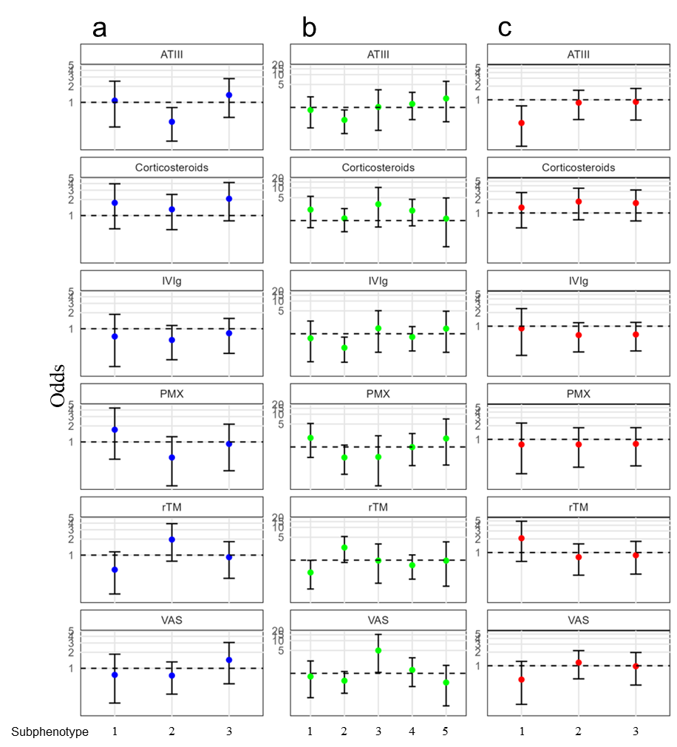

a: k-UMAP [nn=100, k=3], b: k-UMAP [nn=200, k=5], c: KAMILA [k=3]
Abbreviation: nn = number of neighbors, KAMILA: KAymeans for MIxed LArge data, ATⅢ= antithrombin III, IVIg = immunoglobulin, PMX = polymyxin B-immobilized fiber column hemoperfusion, rTM = recombinant thrombomodulin, VAS = vasopressin

Table S8. Comparisons of subphenotypes of sepsis identified in our study and that reported in the Literature
 | Number of variables | Number of subphenotypes | High mortality rate | Shock | AKI | Coagulopaty
k-UMAP [nn=100, k=3] | 52 | 3 | Subphenotype 3 | Subphenotype 2,3 |  | Subphenotype 3
k-UMAP [nn=200, k=5] | 52 | 5 | Subphenotype 3,4,5 | Subphenotype 3,4,5 | Subphenotype 5 | Subphenotype 4
KAMILA [k=3] | 52 | 3 | Subphenotype 2,3 | Subphenotype 2,3 | Subphenotype 2 | Subphenotype 3
JAMA 2019, 321:2003-2017. | 29 | 4 | Cluster4(δ) | Cluster4(δ) | Cluster2(β) | Cluster4(δ)
Crit Care. 2022 Apr  21;26:114. | 15 | 2 | Cluster2(B) | Cluster2(B) | Cluster2(B) | Cluster2(B)
Intensive Care Med 2022, 48:1582-1592. | 5 | 4 | Cluster1,4(A,D) | Cluster4(D) | - | -
Intensive Care Med 2023, 49:1349-1359. | 18 | 3 | Cluster2 | Cluster2 | Cluster2 | -
Abbreviation: nn = number of neighbors, KAMILA: KAymeans for MIxed LArge data, AKI = acute kidney injury

References
S1. Kudo D, Kushimoto S, Miyagawa N, Sato T, Hasegawa M, Ito F, et al. The impact of organ dysfunctions on mortality in patients with severe sepsis: A multicenter prospective observational study. J Crit Care. 2018;45:178-83.
S2. Abe T, Ogura H, Shiraishi A, Kushimoto S, Saitoh D, Fujishima S, et al. Characteristics, management, and in-hospital mortality among patients with severe sepsis in intensive care units in Japan: the FORECAST study. Critical Care. 2018;22:322.
S3. Abe T, Yamakawa K, Ogura H, Kushimoto S, Saitoh D, Fujishima S, et al. Epidemiology of sepsis and septic shock in intensive care units between sepsis-2 and sepsis-3 populations: sepsis prognostication in intensive care unit and emergency room (SPICE-ICU). J Intensive Care. 2020;8:44.
S4. Abe T, Umemura Y, Ogura H, Kushimoto S, Fujishima S, Saitoh D, et al. Early versus delayed vasopressor administration in patients with septic shock. Acute Med Surg. 2023;10:e852.
S5. Dellinger RP, Levy MM, Rhodes A, Annane D, Gerlach H, Opal SM, et al. Surviving sepsis campaign: international guidelines for management of severe sepsis and septic shock: 2012. Crit Care Med. 2013;41:580-637.
S6. Manu Shankar-Hari M, MSc; Gary S. Phillips, MAS; Mitchell L. Levy, MD; ChristopherW. Seymour, MD, MSc; Vincent X. Liu, MD, MSc; Clifford S. Deutschman, MD; Derek C. Angus, MD, MPh; Gordon D. Rubenfeld, MD, MSc; Mervyn Singer, MD, FRCP; for the Sepsis Definitions Task Force. Developing a NewDefinition and Assessing New Clinical Criteria for Septic Shock For the Third International Consensus Definitions for Sepsis and Septic Shock (Sepsis-3). JAMA. 2016;315:775-87.
S7. Preud'homme G, Duarte K, Dalleau K, Lacomblez C, Bresso E, Smail-Tabbone M, et al. Head-to-head comparison of clustering methods for heterogeneous data: a simulation-driven benchmark. Sci Rep. 2021;11:4202.
S8. Leland McInnes JH, James Melville. UMAP Uniform Manifold Approximation and Projection for Dimension Reduction. arXiv. 2020(1802).
S9. Allaoui M, Kherfi ML, Cheriet A. Considerably Improving Clustering Algorithms Using UMAP Dimensionality Reduction Technique: A Comparative Study. Image and Signal Processing. Lecture Notes in Computer Science2020. p. 317-25.
S10. Szepannek G. clustMixType: User-Friendly Clustering of Mixed-Type Data in R. The R Journal. 2019;10.
S11. GGeoffrey E. Hinton SR. Stochastic Neighbor Embedding. Obermayer SBaSTaK, editor. United States: MIT Press; 2002 September 26, 2003. 833-40 p.
S12. James Melville AL, Mohamed Nadhir Djekidel, Yuhan Hao, Dirk Eddelbuettel. Package ‘uwot’. 2023.
S13. PAUL R. ROSENBAUM DBR. The central role of the propensity score in observational studies for causal effects. Biometrika. 1983;70: 41–55.
S14. Austin PC. An Introduction to Propensity Score Methods for Reducing the Effects of Confounding in Observational Studies. Multivariate Behav Res. 2011;46:399-424.

