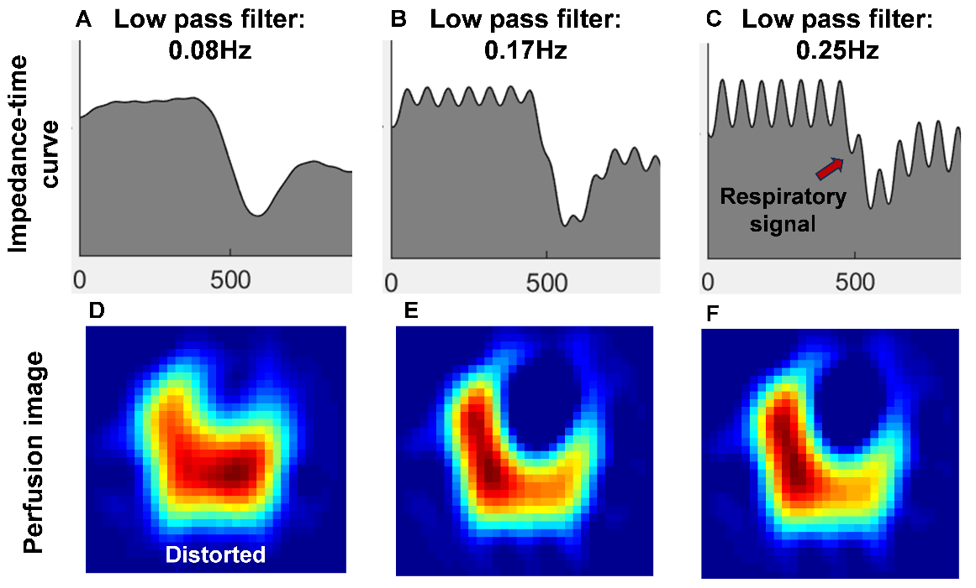
Supplementary Fig. 1. Low-pass filter frequency selection.
Impedance-time curves and lung perfusion images corresponding to different low-pass filter cut-off frequencies (0.08Hz, 0.17Hz, and 0.25Hz) are presented for a representative patient with a respiratory rate of 18 breaths/min (0.3Hz).
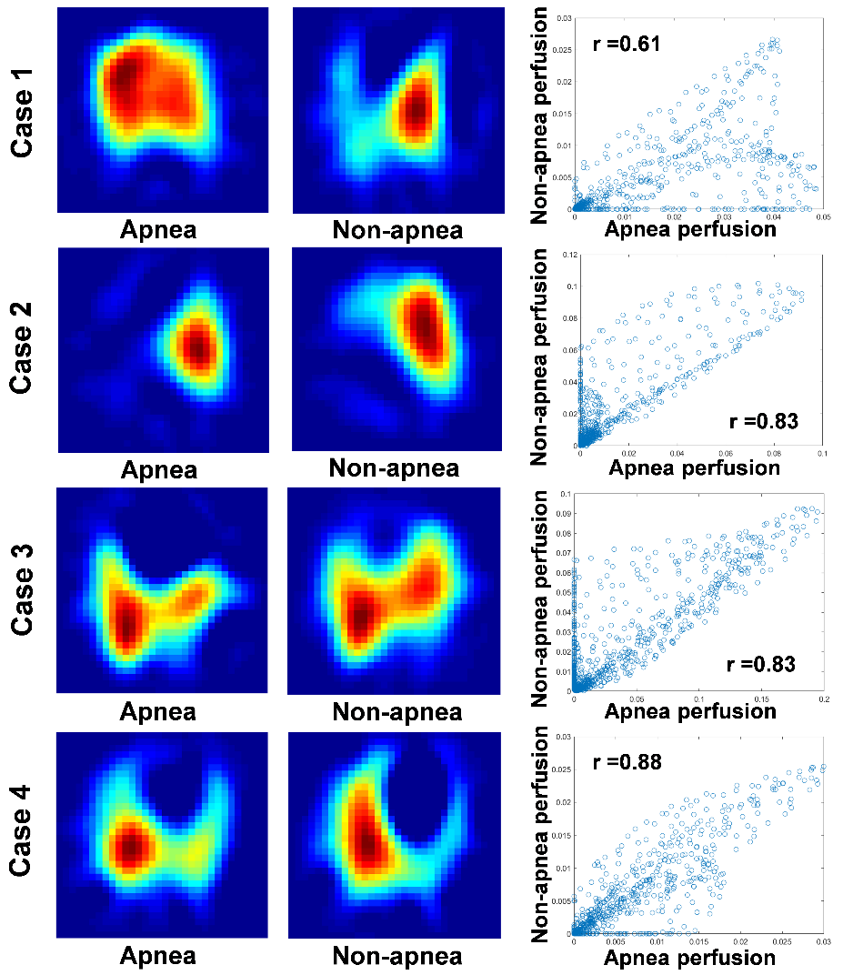
Supplementary Fig. 2. Perfusion images and pixel-wise correlation plots in low correlation cases. Each row displays apnea and non-apnea perfusion maps and their corresponding pixel-wise correlation scatter plot. In these cases, the image discrepancies were primarily attributed to inconsistent time frame selection between the two methods, which led to the inclusion of cardiac perfusion in certain images.

