Supplementary File 1

Evaluation of days alive out of hospital as an outcome after intensive care admission: a national retrospective cohort study.

- ANZICS CORE APD Definitions
Admission GCS | Last unsedated GCS recorded prior to intensive care unit (ICU) admission
Invasive ventilation | Any form of positive pressure ventilation delivered through an artificial airway such as and oral or nasal endotracheal tube or tracheostomy.
Vasopressor or inotrope use | Any inotrope or vasopressor (excluding vasodilators such as GTN or sodium nitroprusside).
Renal replacement therapy | Includes any form of renal replacement therapy. Includes patients on chronic dialysis prior to ICU admission.
Tracheostomy insertion | Tracheostomy insertion occurs after ICU admission (either in ICU or in an operating theatre). Excludes patients who have a tracheostomy in situ at the time of ICU admission.
Emergency admission | Any admission not occurring after elective surgery.
Surgical admission | Any admission after an operative procedure, where the patient is admitted from an operating theatre (or after transfer from another hospital), excluding operative procedures for trauma.
Trauma  admission | Any admission as a result of injury or illness caused by trauma
Medical admission | All other admissions (not meeting the above criteria for a surgical or trauma admission).
Mild traumatic brain injury | Admission with a traumatic brain injury, admission GCS recorded as 13-15
Moderate traumatic brain injury | Admission with a traumatic brain injury, admission GCS recorded as 9-12
Severe traumatic brain injury | Admission with a traumatic brain injury, admission GCS recorded as ≤ 8

- Figures

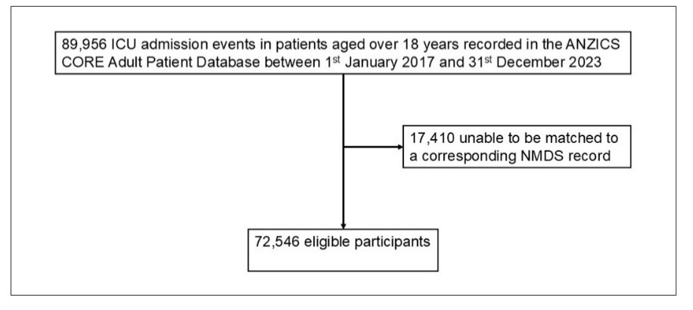
Figure S1. STROBE participant flow diagram.

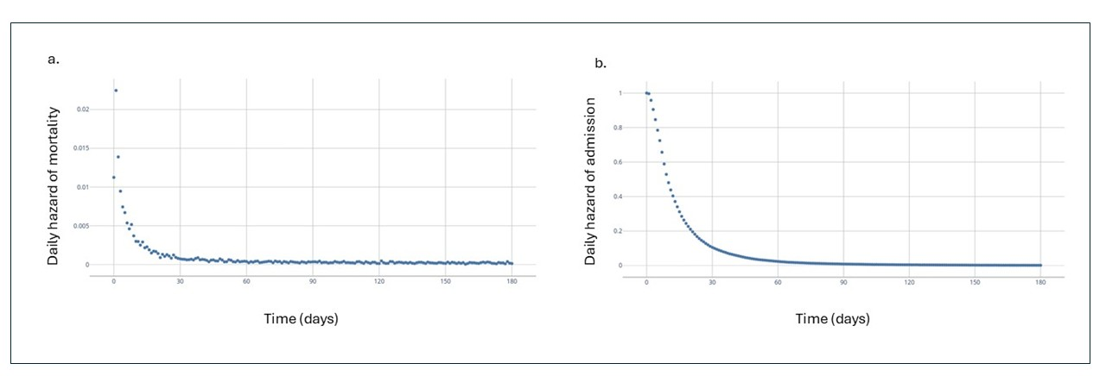
Figure S2. Daily hazards of mortality (a) and hospitalisation (b) after ICU admission.

- Tables
Table S1. Clinical and demographic description of the excluded admissions. 17,410 admissions recorded in the ANZICS CORE APD could not be matched to a corresponding NMDS record.
n of patients | n = 17,410
Age (median, IQR) | 63 (51, 73)
Sex (n, %)
Female | 6,408 (37%)
Male | 10,949 (63%)
Admission type (n, %)
Elective | 10,056 (58%)
Emergency | 7,354 (42%)
Diagnostic criteria (n, %)
Medical | 4,540 (26.1%)
Respiratory | 1,077 (6.2%)
Cardiovascular | 1,616 (9.3%)
Neurological | 383 (2.2%)
Sepsis | 714 (4.1%)
Other medical | 750 (4.3%)
Surgical | 11,952 (69%)
Trauma
All trauma | 559 (3.2%)
TBI | 147 (0.8%)
Mild (GCS 13-15) | 59 (0.3%)
Moderate (GCS 9-12) | 24 (0.1%)
Severe (GCS ≤ 8) | 56 (0.3%)
APACHE II (median, IQR) | 14 (11, 18)
Admission GCS
15 | 15,064 (87%)
13-14 | 739 (4.2%)
9-12 | 345 (2.0%)
3-8 | 870 (4.9%)
ICU treatments (n, %)
Invasive ventilation | 8,630 (50%)
Vasopressors or inotropes | 9,391 (55%)
Renal replacement therapy | 1,037 (6.1%)
Tracheostomy insertion | 503 (3.0%)
Treatment limitations | 664 (3.8%)
Length of stay (days)
ICU | 1.2 (0.9, 2.9)
Hospital | 9 (6, 16)

Table S2. Rates of missing data by variable.
Variable n = 72,546 | Missing data (n, %)
Age | 0
Sex | 0
Ethnicity | 0
Admission type | 0
Diagnostic criteria | 28 (< 0.1%)
APACHE II | 164 (0.2%)
GCS | 2,176 (3.0%)
ICU treatments
Invasive ventilation | 4,919 (6.8%)
Vasopressors or inotropes | 6,753 (9.3%)
Renal replacement therapy | 7,145 (9.8%)
Tracheostomy insertion | 7,139 (9.8%)
Treatment limitations | 852 (1.2%)
Mortality
One-month | 0
One-year | 0
Length of stay (days)
ICU | 65 (< 0.1%)
Hospital | 106 (0.1%)

Table S3. Comparison between patients with missing data and no missing data for variables where rates of missing data exceed 5%.
Variable | DAOH₉₀
Variable | Received treatment | Did not receive treatment | Unable to determine due to missing data
Invasive ventilation | 65 (5, 79) | 76 (54, 83) | 76 (55, 83)
Inotropes or vasopressors | 66 (14, 78) | 77 (57, 84) | 74 (47, 82)
Renal replacement therapy | 30 (0, 69) | 73 (44, 82) | 74 (46, 82)
Tracheostomy insertion | 24 (0, 53) | 73 (42, 82) | 74 (47, 82)

Table S4. DAOH₃₀, DAOH₉₀ and DAOH₁₈₀ by variable.
Patient characteristics |  | Number (%) | DAOH₃₀ | DAOH₉₀ | DAOH₁₈₀
Sex | Female | 29,368 (40%) | 15 (0, 23) | 73 (41, 82) | 161 (118, 171)
Sex | Male | 43,164 (59%) | 14 (0, 22) | 72 (39, 81) | 160 (117, 170)
Ethnicity | Asian | 3,501 (4.8%) | 14 (0, 22) | 72 (31, 82) | 160 (108, 171)
Ethnicity | Māori | 13,964 (19%) | 15 (0, 23) | 73 (38, 82) | 160 (112, 171)
Ethnicity | NZ European | 42,524 (57%) | 14 (0, 22) | 72 (41, 81) | 160 (119, 171)
Ethnicity | Other | 7,257 (10%) | 14 (0, 22) | 73 (42, 82) | 160 (122, 171)
Ethnicity | Pacific Islander | 5,300 (7.3%) | 15 (0, 22) | 73 (38, 82) | 160 (115, 171)
Age | 18-29 | 6,201 (8.5%) | 21 (8, 26) | 80 (63, 85) | 169 (148, 175)
Age | 30-39 | 6,040 (8.3%) | 20 (6, 25) | 78 (61, 84) | 167 (146, 174)
Age | 40-49 | 7,569 (10%) | 16 (0, 23) | 74 (48, 83) | 163 (131, 172)
Age | 50-59 | 12,557 (17%) | 15 (0, 22) | 73 (41, 81) | 161 (120, 171)
Age | 60-69 | 16,984 (23%) | 13 (0, 21) | 71 (35, 81) | 158 (109, 170)
Age | 70-79 | 16,132 (22%) | 12 (0, 21) | 69 (27, 80) | 157 (94, 169)
Age | ≥ 80 | 7,063 (9.7%) | 9 (0, 20) | 65 (9, 79) | 150 (32, 168)
APACHE II | 0-4 | 1,200 (1.7%) | 23 (17, 27) | 83 (76, 86) | 172 (164, 176)
APACHE II | 5-9 | 12,452 (17%) | 21 (13, 25) | 80 (70, 85) | 169 (157, 174)
APACHE II | 10-14 | 20,804 (29%) | 18 (6, 23) | 76 (62, 82) | 165 (147, 172)
APACHE II | 15-19 | 17,250 (24%) | 13 (0, 21) | 71 (43, 80) | 158 (121, 169)
APACHE II | 20-24 | 10,367 (14%) | 6 (0, 19) | 61 (0, 78) | 146 (29, 166)
APACHE II | 25-29 | 5,651 (7.8%) | 0 (0, 15) | 39 (0, 73) | 114 (0, 161)
APACHE II | ≥ 30 | 4,568 (6.3%) | 0 (0, 3) | 0 (0, 55) | 0 (0, 140)
Admission | Elective | 16,559 (23%) | 18 (9, 22) | 77 (66, 82) | 166 (153, 172)
Admission | Emergency | 55,978 (77%) | 13 (0, 22) | 70 (22, 81) | 157 (89, 170)
Diagnostic criteria | Medical | 36,570 (50%) | 20 (5, 25) | 78 (54, 85) | 166 (132, 174)
Diagnostic criteria | Surgical | 29,806 (41%) | 16 (3, 22) | 74 (57, 81) | 163 (142, 171)
Diagnostic criteria | All trauma | 6,142 (8.5%) | 7 (0, 20) | 65 (22, 79) | 154 (105, 169)
Diagnostic criteria | Mild TBI  (GCS 13-15) | 798 (1.1%) | 15 (0, 22) | 73.5 (55, 82) | 163 (144, 171)
Diagnostic criteria | Moderate TBI*  (GCS 9-12) | 357 (0.5%) | 9 (0, 20) | 67 (50, 80) | 157 (139, 169)
Diagnostic criteria | Severe TBI*  (GCS ≤ 8) | 1084 (1.5%) | 0 (0, 1) | 45 (0, 70) | 133 (0, 160)
Invasive ventilation | Yes | 30,431 (42%) | 8 (0, 19) | 65 (5, 79) | 154 (72, 168)
Invasive ventilation | No | 37,196 (51%) | 18 (4, 23) | 76 (54, 83) | 164 (134, 172)
Vasopressors or inotropes | Yes | 34,545 (48%) | 9 (0, 20) | 66 (14, 78) | 153 (78, 168)
Vasopressors or inotropes | No | 31,248 (43%) | 19 (5, 24) | 77 (57, 84) | 166 (140, 173)
Renal replacement therapy | Yes | 3,493 (4.8%) | 0 (0, 12) | 30 (0, 69) | 104 (0, 155)
Renal replacement therapy | No | 61,908 (85%) | 15 (0, 22) | 73 (44, 82) | 161 (123, 171)
Tracheostomy | Yes | 1,626 (2.2%) | 0 (0, 0) | 24 (0, 53) | 108 (24, 141)
Tracheostomy | No | 63,781 (88%) | 15 (0, 22) | 73 (42, 82) | 161 (120, 171)

DAOH₉₀ | ICU length of stay (days) | Hospital length of stay (days) | 1-month mortality (%) | 1-year mortality (%) | DAOH₉₀ | DAOH₁₈₀
Lower 25% | 2.3 | 10.9 | 46.4 | 58.6 | 0 | 0
Middle 50% | 1.9 | 12.1 | 0.01 | 6.6 | 71 | 159
Upper 25% | 1.0 | 4.3 | 0.00 | 2.4 | 84 | 174
Table S5. Comparison between DAOH₉₀ (grouped by quartile) and other outcome measures.
Table S6. Quantile regression estimates for the association with median DAOH_{90.} For categorical variables the difference between the groups is reported at the 50th centile. For continuous variables, the coefficient represents the change in DAOH₉₀ from an increase of one unit (i.e., age from 20 to 21 years). *TBI severity groups compared to patients without TBI.
Variable |  | Coefficient | p value
Age |  | -0.23 | < 0.001
APACHE II score |  | -1.67 | < 0.001
GCS |  | 4.33 | < 0.001
TBI severity* | Mild (GCS 13-15) | 0 | 1.000
TBI severity* | Moderate (GCS 9-12) | -6 | < 0.001
TBI severity* | Severe (GCS ≤ 8) | -28 | < 0.001
Received invasive ventilation |  | -11 | < 0.001
Received renal replacement therapy |  | -43 | < 0.001

Table S7: Time for excess hazard to reduce by 95%, t95
Group |  | t95 mortality (days) | t95 hospitalisation (days)
Study cohort |  | 18.6 | 37.3
Age | < 60 years | 16.6 | 34.8
Age | 60-69 years | 19.1 | 40.6
Age | 70-79 year | 21.3 | 39.9
Age | > 80 years | 22.3 | 36.6
APACHE II score | 0-9 | 32.1 | 24.8
APACHE II score | 10-19 | 40.6 | 37.1
APACHE II score | 20-29 | 21.7 | 49.2
APACHE II score | > 30 | 14.9 | 56.0
TBI severity | Mild | 30.4 | 36.1
TBI severity | Moderate | 24.1 | 51.3
TBI severity | Severe | 15.6 | 69.3
Invasive ventilation | Yes | 17.0 | 47.3
Invasive ventilation | No | 28.9 | 31.5
Renal replacement therapy | Yes | 21.4 | 71.0
Renal replacement therapy | No | 19.1 | 36.6
Tracheostomy | Yes | 178.1 | 119.1
Tracheostomy | No | 18.9 | 36.3

4. List of sites contributing data to the ANZICS Adult Patient Database
4.1 ICUs contributing data throughout study period (16)
Auckland City Hospital Cardiothoracic and Vascular ICU, Auckland City Hospital Department of Critical Care Medicine, Christchurch Hospital ICU, Dunedin Hospital ICU, Hawke’s Bay Hospital ICU, Hutt Hospital ICU, Middlemore Hospital ICU, Nelson Hospital ICU, Northshore Hospital ICU, Rotorua Hospital ICU, Taranaki Hospital ICU, Tauranga Hospital ICU, Timaru Hospital ICU, Waikato Hospital ICU, Wellington Hospital ICU, Whangārei Hospital ICU
4.2 ICUs contributing data during part of the study period (6)
Braemar Hospital SCU* (2021-2023), Southern Cross Hospital Hamilton* (2017), Southern Cross Hospital Wellington* (2017-2021), Southland Hospital ICU (2022-2023), Wairau Hospital ICU (2020-2023), Whakatane Hospital ICU (2019-2023)
*Denotes ICU in private healthcare facility.

