Table S1: Full Search Strategy
Database | Search term
MEDLINE
1 | "Subarachnoid Hemorrhage"[MeSH Terms] OR ("intracranial hemorrhages"[MeSH Terms:noexp] OR "Cerebral Hemorrhage"[MeSH Terms:noexp] OR "Hemorrhagic Stroke"[MeSH Terms]) OR ("Subarachnoid Hemorrhage"[Title/Abstract:~6] OR "Subarachnoid Hemorrhages"[Title/Abstract:~6] OR "Subarachnoid Haemorrhage"[Title/Abstract:~6] OR "Subarachnoid Haemorrhages"[Title/Abstract:~6] OR "Subarachnoid bleeding"[Title/Abstract:~6] OR "Subarachnoid Bleedings"[Title/Abstract:~6]) OR "cerebral aneurysm*"[Title/Abstract] OR "intracranial aneurysm*"[Title/Abstract] OR ("intracranial aneurysm"[MeSH Terms] AND "rupture, spontaneous"[MeSH Terms]) OR ("aneurysm, ruptured"[MeSH Terms:noexp] AND ("brain"[MeSH Terms] OR "Meninges"[MeSH Terms]))
2 | "ultrasonography, doppler, transcranial"[MeSH Terms]
3 | neurosono*[TW]
4 | echoencephalograph*[TW]
5 | echo-encephalograph*[TW]
6 | ultraso*[TW]
7 | sonograph*[TW]
8 | echograph*[TW]
9 | "doppler*"[TW]
10 | duplex[TW]
11 | "color flow*"[tiab] OR "colour flow*"[tiab] OR "color coded"[TW] OR "colour coded"[TW]
12 | #2 OR #3 OR #4 OR #5 OR #6 OR #7 OR #8 OR #9 OR #10 OR #11
13 | "transcranial"[TW] OR trans-cranial[TW]
14 | neurovascular[TW]
15 | #13 OR #14
16 | #12 AND #15
17 | "TCD"[tiab] OR "TCCS"[tiab]
18 | #16 OR #17
19 | #1 AND #18
CENTRAL
1 | MeSH descriptor: [Subarachnoid Hemorrhage] explode all trees
2 | (subarachnoid NEAR h?emorrhage*):ti,ab,kw
3 | (subarachnoid NEAR bleeding*):ti,ab,kw
4 | #1 #2 OR #3
5 | (cerebral aneurysm*):ti,ab,kw
6 | (intracranial aneurysm*):ti,ab,kw
7 | MeSH descriptor: [Intracranial Aneurysm] explode all trees
8 | MeSH descriptor: [Rupture, Spontaneous] explode all trees
9 | #7 AND #8
10 | MeSH descriptor: [Aneurysm, Ruptured] this term only
11 | MeSH descriptor: [Brain] explode all trees
12 | MeSH descriptor: [Meninges] explode all trees
13 | #11 or #12
14 | #10 and #13
15 | #4 or #5 or #6 or #9 or #14
16 | MeSH descriptor: [Ultrasonography, Doppler, Transcranial] explode all trees
17 | (neurosono* or echoencephalograph* or echo-encephalograph* or ultraso* or sonograph* or echograph* or doppler* or duplex):ti,ab,kw
18 | ((color or colour) NEAR/2 (flow* or coded)):ti,ab,kw
19 | #16 or #17 or #18
20 | #15 and #19
21 | #20 in Trials
Embase
1 | 'subarachnoid hemorrhage'/de
2 | subarachnoid NEAR/6 h?emorrhage*
3 | subarachnoid NEAR/6 bleeding*
4 | #1 OR #2 OR #3
5 | 'intracranial aneurysm'/exp
6 | 'rupture'/de
7 | #5 AND #6
8 | 'aneurysm rupture'/de
9 | 'brain'/exp
10 | 'meninx'/exp
11 | #9 OR #10
12 | #8 AND #11
13 | #4 OR #12
14 | 'transcranial doppler ultrasonography'/exp
15 | neurosono*:ti,ab,kw OR echoencephalograph*:ti,ab,kw OR 'echo encephalograph*':ti,ab,kw OR ultraso*:ti,ab,kw OR sonograph*:ti,ab,kw OR echograph*:ti,ab,kw OR doppler*:ti,ab,kw OR duplex:ti,ab,kw
16 | ((color OR colour) NEAR/2 (flow* OR coded)):ti,ab,kw
17 | #14 OR #15 OR #16
18 | #13 AND #17
19 | 'subarachnoid hemorrhage'/de
20 | subarachnoid NEAR/6 h?emorrhage*
21 | subarachnoid NEAR/6 bleeding*
22 | #19 OR #20 OR #21
23 | 'intracranial aneurysm'/exp
24 | 'rupture'/de
25 | #23 AND #24
26 | 'aneurysm rupture'/de
27 | 'brain'/exp
28 | 'meninx'/exp
29 | #27 OR #28
30 | #26 AND #29
31 | #22 OR #30
32 | 'transcranial doppler ultrasonography'/exp
33 | neurosono*:ti,ab,kw OR echoencephalograph*:ti,ab,kw OR 'echo encephalograph*':ti,ab,kw OR ultraso*:ti,ab,kw OR sonograph*:ti,ab,kw OR echograph*:ti,ab,kw OR doppler*:ti,ab,kw OR duplex:ti,ab,kw
34 | ((color OR colour) NEAR/2 (flow* OR coded)):ti,ab,kw
35 | #32 OR #33 OR #34
36 | #31 AND #35

Table S2: Additional study characteristics.
Study, year | Conflict of interest | Funding source | Severity of SAH |  |  |  | Index test |  | Reference  standard
Study, year | Conflict of interest | Funding source | WFNS (median) | Hunt & Hess  (median) | Fisher  (median) | mFisher  (median) | TCD by experienced technician | Reference blinded | TCD blinded
Grolimund et al, 1987 | Unknown | Unknown | Unknown | Unknown | Unknown | Unknown | Unknown | Unknown | Unknown
Lindegaard et al, 1989 | Unknown | Yes¹ | Unknown | Unknown | Unknown | Unknown | Unknown | Unknown | Unknown
Sloan et al, 1989 | Unknown | Unknown | Unknown | Unknown | Unknown | Unknown | Yes | Yes | Yes
Lewis et al, 1992 | Unknown | Unknown | Unknown | Unknown | Unknown | Unknown | Yes | Unknown | Yes
Burch et al, 1996 | Unknown | Unknown | Unknown | Unknown | Unknown | Unknown | Unknown | Yes | Yes
Proust et al, 1999 | Unknown | Unknown | Unknown | 3 | Unknown | Unknown | Yes | Yes | Yes
Vora et al, 1999 | Unknown | Unknown | 2 | Unknown | Unknown | Unknown | Unknown | Yes | Yes
Proust et al, 2002 | Unknown | Unknown | Unknown | 3 | 3 | Unknown | Unknown | Unknown | Unknown
Jabre et al, 2002 | Unknown | Unknown | Unknown | Unknown | Unknown | Unknown | Yes | Yes | Yes
Suarez et al, 2002 | Unknown | Unknown | Unknown | Unknown | 3 | Unknown | Yes | Unknown | Unknown
Mascia et al, 2003 | Yes² | Yes³ | 2.5 | Unknown | 3 | Unknown | Yes | Yes | Yes
Krejza et al, 2005 | No | Yes⁴ | 1 | Unknown | Unknown | Unknown | Yes | Yes | Yes
Naval et al, 2005 | Unknown | Unknown | Unknown | 3 | Unknown | Unknown | Yes | Unknown | Unknown
Lee et al, 2006 | Unknown | Unknown | 3 | Unknown | 3 | Unknown | Yes | Unknown | Yes
Pham et al, 2007 | Unknown | Unknown | Unknown | Unknown | 4 | Unknown | Yes | Yes | Yes
Ionita et al, 2008 | Unknown | Unknown | Unknown | Unknown | Unknown | Unknown | Yes | Unknown | Yes
Nakae et al, 2011 | No | Unknown | Unknown | Unknown | Unknown | 2.5 | Yes | Unknown | Unknown
Wang et al, 2012 | Unknown | Unknown | Unknown | Unknown | Unknown | Unknown | Yes | Unknown | Unknown
Kunze et al, 2012 | Unknown | Yes⁵ | Unknown | Unknown | Unknown | Unknown | Yes | Yes | Yes
Rajajee et al, 2012 | No | Unknown | Unknown | 2.5 | Unknown | 3 | Yes | Yes | Unknown
Sebastian et al, 2013 | Unknown | Unknown | Unknown | 2 | Unknown | Unknown | Yes | Unknown | no
Seidel et al, 2014 | Unknown | Unknown | 2.5 | 1.5 | Unknown | Unknown | Unknown | Unknown | Unknown
Malhotra et al, 2014 | Unknown | Unknown | Unknown | 3 | 3 | Unknown | Yes | Yes | Yes
Pifferi et al, 2014 | Unknown | Unknown | Unknown | Unknown | Unknown | Unknown | Unknown | Unknown | Unknown
Connolly et al, 2017 | No | Unknown | Unknown | Unknown | Unknown | Unknown | Yes | Yes | Yes
Harst et al, 2017 | Unknown | Unknown | Unknown | Unknown | Unknown | Unknown | Unknown | Unknown | Unknown
Wang et al, 2018 | No | No | Unknown | 3 | Unknown | Unknown | Unknown | Unknown | Unknown
Neulen et al, 2019 | No | Yes⁶ | Unknown | Unknown | Unknown | Unknown | Yes | Yes | Yes
Sastry et al, 2022 | No | Unknown | Unknown | Unknown | Unknown | Unknown | Unknown | Unknown | Unknown
Clare et al, 2022 | Yes⁷ | No | Unknown | 3 | Unknown | Unknown | robotic | Yes | Yes
Darsaut et al, 2022 | Unknown | Unknown | Unknown | Unknown | Unknown | Unknown | Yes | Unknown | Yes
Kim et al, 2023 | No | No | Unknown | 3 | Unknown | 3 | Unknown | Yes | Unknown
Conflict of interest and Funding source
¹ The Norwegian Council on Cardiovascular Diseases.
² Doppler equipment supplied by DWL, Elektronische Systeme, Supplingen, Germanny.
³ Foundation Baxter and Alma Ricard Chair in cerebrovascular surgery, University of Toronto.
⁴ Supported in part by the American Heart Association Established Investigator Award and NATO fellowship program.
⁵ The German Research Foundation (DFG) and the University of Wuerzburg under the "Open Access Publishing" program.
⁶ A grant of the Medical Center of the Johannes Gutenberg University Mainz (Stufe I Foerderung, grant to A.N.).
⁷ One author was the Co-Founder & Chief Scientific Officer of NovaSignal.

Table S3: Sensitivities, specificities, AUROCs, and likelihood ratios by threshold-based subgroups.
Subgroups | No. of Patients (study) | Sensitivity | Specificity | AUROC | Positive likelihood ratio | Negative likelihood ratio
MFV threshold = 120 cm/s ª | 2302 (19) | 0.75 (0.69 - 0.81) | 0.74 (0.63 - 0.83) | 0.80 (0.73 - 0.82) | 2.9 (2.1 - 4.1) | 0.34 (0.27 - 0.41)
MFV threshold > 120 cm/s ^{a, b} | 1137 (11) | 0.70 (0.56 - 0.81) | 0.81 (0.66 - 0.90) | 0.81 (0.74 - 0.83) | 3.7 (2.3 - 6.1) | 0.38 (0.27 - 0.50)
LR threshold = 3 ª | 558 (4) | 0.91 (0.85 - 0.95) | 0.83 (0.36 - 0.98) | 0.92 (0.86 - 0.95) | 5.3 (1.5 - 37.5) | 0.12 (0.08 - 0.21)
LR threshold = 6 ª | 557 (4) | 0.34 (0.21 - 0.49) | 0.97 (0.91 - 0.99) | 0.73 (0.39 - 0.96) | 11.7 (4.9 - 29.0) | 0.68 (0.54 - 0.80)
AUROC, area under the receiver operating characteristic curve; MFV, mean flow velocity; LR, Lindegaard ratio.
ª Heterogeneity (subgroup, I² %): 1, 12%;2, 25%: 3, 0%; 4, 0%.
^{b} Varied across 11 assessments (125–200 cm/s): 125 (n=1), 140 (n=2), 150 (n=4), 160 (n=1), 168 (n=1), 180 (n=1), and 200 cm/s (n=1).

Table S4: Sensitivities, specificities, AUROCs, and likelihood ratios by study-design subgroups.
Subgroups | No. of Patients (study) | Sensitivity | Specificity | AUROC | Positive likelihood ratio | Negative likelihood ratio
Prospective studies ª | 1833 (18) | 0.77 (0.71 - 0.83) | 0.76 (0.62 - 0.86) | 0.82 (0.71 - 0.84) | 3.3 (2.0 - 5.7) | 0.30 (0.22 - 0.41)
TCD frequency ^{a, b} | 2957 (27) | 0.76 (0.69 - 0.81) | 0.75 (0.66 - 0.83) | 0.81 (0.72 - 0.82) | 3.0 (2.2 - 4.3) | 0.33 (0.25 - 0.42)
TCD-reference gap ^{a, b} | 1848 (17) | 0.78 (0.72 - 0.83) | 0.73 (0.59 - 0.84) | 0.81 (0.72 - 0.83) | 2.9 (1.9 - 4.8) | 0.30 (0.22 - 0.42)
TCD experienced technician ^{a, b} | 2102 (21) | 0.76 (0.69 - 0.82) | 0.73 (0.60 - 0.83) | 0.80 (0.71 - 0.82) | 2.8 (1.9 - 4.2) | 0.33 (0.25 - 0.43)
Diagnosis with angiography ^{a, c} | 3211 (26) | 0.78 (0.71 - 0.84) | 0.81 (0.72 - 0.88) | 0.86 (0.78 - 0.87) | 4.2 (2.9 - 6.3) | 0.27 (0.21 - 0.35)
Diagnosis without angiography ^{a, c} | 372 (5) | 0.70 (0.59 - 0.80) | 0.51 (0.37 - 0.65) | 0.68 (0.52 - 0.76) | 1.4 (1.1 - 2.0) | 0.58 (0.40 - 0.82)
AUROC, area under the receiver operating characteristic curve. TCD, transcranial Doppler.
a Heterogeneity (subgroup, I2 %): Prospective studies, 32%; TCD frequency, 13%: TCD-reference interval, 18%; TCD experienced technician, 15%; Diagnosis with angiography, 14%; Diagnosis without angiography, 0%.
^{b} Only studies with available data
^{c} Studies employing a reference standard with angiography or without angiography

Figure S1: Forrest plot for sensitivity

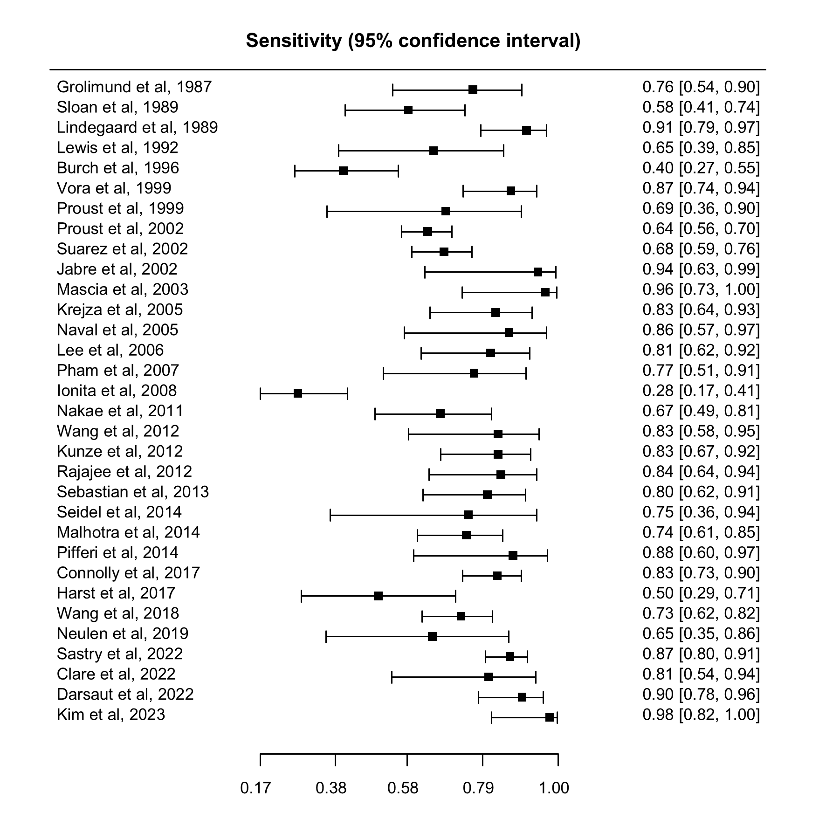

Figure S2: Forrest plot for specificity

