Supplementary Materials
ESM1. Methods
ESM2. Flow Chart
ESM3. Patients’ general characteristics and ICU events
ESM4. Forest plot of factors associated with the impairment of the physical and mental component of SF-36 in multivariable analysis
ESM5. Limitations
ESM 6. Table of Missing Data

ESM1. METHODS
Patients
We prospectively screened all consecutive adult patients admitted to our ICU with moderate to severe PC-CS from June 2014 to June 2019. PC-CS was defined as a moderate to severe low cardiac output syndrome: moderate defined by the requirement of high doses of inotropes or vasopressors with clinical or biological markers of impaired organ perfusion or severe defined by the need for a mechanical circulatory support; following cardiac surgery, whether intraoperatively, resulting in difficulty separating from cardiopulmonary bypass, or postoperatively within six hours. The first line treatment for PC-CS was inotropes (norepinephrine and dobutamine). In cases of refractory cardiogenic shock – i.e., low cardiac output syndrome despite optimized medical therapy, the implantation of a mechanical circulatory support with percutaneous VA-ECMO was performed. Our team’s protocol for ECMO implantation has been previously described.
Inclusion criteria included patients who were at least 18 years old, had been diagnosed with moderate to severe PC-CS, and were alive at the time of the study. Exclusion criteria were: long-term circulatory assistance with a Left Ventricular Assist Device (LVAD) or heart transplant, veno-venous ECMO configuration, mental or linguistic inability to understand the study; patients under guardianship or curatorship, lost to follow-up and patients who did not consent to participate in the study.
Study intervention
Between May and July 2020, patients were contacted by phone and asked to complete the SF-36 questionary to assess their quality of life at least one year after ICU discharge in accordance with the HAS recommendations.(22) Two calls were made in the absence of a response before the patient was considered lost to follow-up. Responders to the post-ICU follow-up were divided in two groups based on whether or not they had undergone VA-ECMO.
Data collection
The following data was collected in standardized forms: demographic parameters; cardiovascular history; clinical severity; surgical procedure; in-ICU organ-support therapy including VA-ECMO, mechanical ventilation and renal replacement therapy; ICU complications including pulmonary infection, neurological complications (stroke and delirium), atrial fibrillation and transfusion; vital status at ICU discharge and at last follow-up; SF-36 questionary at least one year after ICU discharge. Data were prospectively collected. Neurological complications and atrial fibrillation were retrospectively extracted from hospital records coded using the ICD-10 classification system.
Outcome measures
The primary endpoint was the SF-36 score at least one year after ICU discharge in patients with and without an history of VA-ECMO support. The SF-36 is a 36-item health status generic measure of health status. It yields an eight-scale profile of scores as well as summary physical and mental measures. The SF-36 has been useful for comparing general and specific populations, estimating the relative burden of different diseases, differentiating the health benefits of various treatments, and screening individual patients. Responses to questions within each dimension are summed and transformed to generate dimension scores ranging from 0 (“poor health”) to 100 (“good health”).
Secondary outcomes included an analysis of the 8 subcategories included in the SF-36 score (physical functioning, role-physical, bodily pain and global health for the physical component and mental health, social functioning, role-emotional, and vitality for the mental component), and factors associated with its impairment.
Statistical analysis
We followed the STROBE (Strengthening the Reporting of Observational Studies in Epidemiology) recommendations for reporting cohort studies. All consecutive adult patients who presented with PC-CS were included. Patients with refractory cardiogenic shock requiring an extracorporeal life support with extracorporeal membrane oxygenation were included in the VA-ECMO group whether patients whose shock was controlled with inotropic drugs were included in the control group. No sample size calculation was performed, as this observational study aimed to include the largest possible sample for comprehensive epidemiological analysis. Patient characteristics were expressed as numbers (percentages) for categorical variables, and median (interquartile range (IQR)) for continuous variables. Categorical variables were compared by chi-square test, whereas continuous variables were compared by Student’s or Wilcoxon’s rank-sum tests. SF-36 was analyzed as a continuous variable. To assess reliability of the eight SF-36 sub-categories, we calculated Cronbach’s alpha (α) using the alpha (raw) model.(26) Statistical significance was set at P < 0.05 for the physical and mental components of SF-36 score, whereas a Bonferroni correction was applied on each specific subcategory and P was set at 0.05 / 8 = 0.00625. Additionally, unadjusted differences in mean SF-36 physical and mental scores between groups were assessed with a two-tailed independent-samples t-test (α = 0.05). Equality of variances was checked using Levene’s test. Variables that showed a statistically significant baseline imbalance between ECMO and control patients (P < 0.10) and age were subsequently entered as covariates in the multivariable linear regression model to obtain adjusted mean differences and their 95% confidence interval. Assumptions of the Inverse Probability of Treatment Weighting (IPTW)-weighted linear model were checked: linearity and homoscedasticity, normality of residuals, independence, multicollinearity and influence. None of these diagnostics indicated violation of model assumptions; therefore, the IPTW-adjusted coefficients and confidence intervals were considered valid. Statistical significance was set at P < 0.05. A sensitivity analysis stratified patients into SAPS-II quartiles and refitted the IPTW-weighted general linear model with ECMO status and quartile as fixed factors; an ECMO × quartile interaction term tested for effect modification. Statistical analyses were performed using the statistical software SPSS 26.0 (IBM SPSS, Armonk, NY, United States).

ESM2. Flow chart
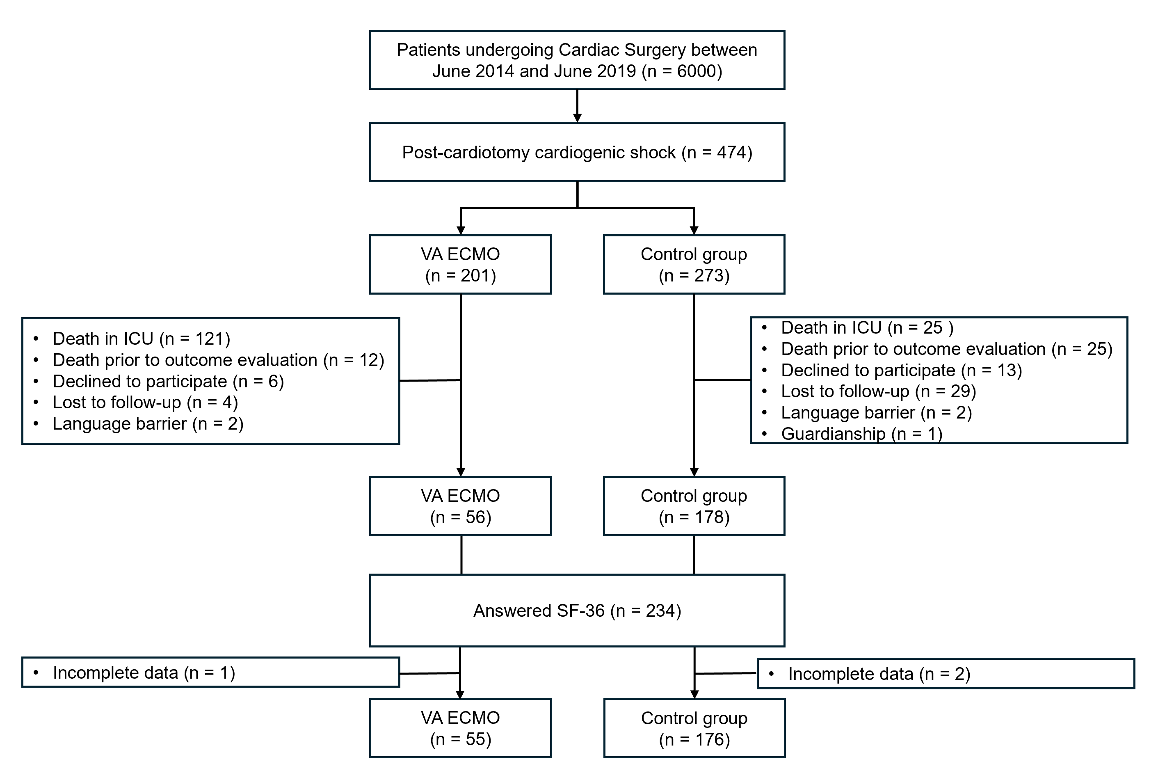
Abbreviations: ICU = Intensive Care Unit; SF-36 = Medical Outcome Study Short Form-36; VA ECMO = Veno-Arterial Extracorporeal Membrane Oxygenation.

ESM3. Patients’ general characteristics and ICU events
 | Total  (n = 231) | VA-ECMO  (n = 55) | Control  (n = 176) | Pvalue
General characteristics
Gender |  |  |  | 0.624
Male | 132 (57.1) | 33 (60.0) | 99 (56.3)
Female | 99 (42.9) | 22 (40.0) | 77 (43.7)
Age (years) | 67 [58-74] | 65 [58-73] | 68 [58-74] | 0.522
Weight (kg) | 75 [66-86] | 74 [63-82] | 76 [67-86] | 0.308
Height (cm) | 170 [160-176] | 172 [161-176] | 169 [160-176] | 0.465
BMI (kg/m²) | 26 [23 – 30] | 23 [26 – 28] | 27 [24 – 30] | 0.099
ASA |  |  |  | 0.388
1 | 1 (0.4) | 0 | 1 (0.6)
2 | 16 (6.9) | 3 (5.4) | 13 (7.4)
3 | 130 (56.3) | 27 (49.1) | 103 (58.5)
4 | 84 (36.4) | 25 (45.5) | 59 (33.5)
Euroscore II (%) | 4.1 [2.1-8.6] | 5.2 [3.0-15.3] | 4.0 [1.9-7.8] | 0.007
SAPS II | 45 [35-55] | 53 [46-64] | 42 [32-49] | <0.001
SOFA | 7 [5-9] | 10 [7-12] | 6 [5-8] | <0.001
Cardiovascular history
Hypertension | 132 (57.1) | 28 (50.9) | 106 (60.2) | 0.222
Diabetes mellitus | 54 (23.4) | 12 (21.8) | 42 (23.9) | 0.754
COPD | 24 (10.4) | 7 (12.7) | 17 (9.7) | 0.515
Lower limb arteriopathy | 21 (9.1) | 5 (9.1) | 16 (9.1) | 1.000
Pulmonary hypertension | 73 (31.6) | 16 (29.1) | 57 (32.4) | 0.185
Preoperative LVEF (%) | 50 [38-60] | 37 [27-60] | 57 [40-60] | 0.001
Surgery
Emergency | 73 (31.6) | 28 (50.9) | 45 (25.6) | <0.001
Elective | 158 (68.4) | 27 (49.1) | 131 (74.4) | <0.001
Type of surgery |  |  |  | 0.759
Coronary Artery Graft Bypass | 63 (27.3) | 16 (29.1) | 47 (26.7)
Valve surgery | 112 (48.5) | 26 (47.3) | 86 (48.9)
Multiple procedures | 30 (13.0) | 6 (10.9) | 24 (13.6)
Other | 26 (11.2) | 7 (12.7) | 19 (10.8)
VA-ECMO implantation
Intra-operative | - | 23 (41.8) | - | -
Post-operative (in ICU) | - | 31 (56.4) | - | -
Postoperative events in ICU
Length of stay in ICU (days) | 9 [6-13] | 13 [8-20] | 9 [5-12] | <0.001
Days under ECMO support | - | 7 [5-11] | - | -
Cardiac arrest | 19 (8.2) | 6 (10.9)* | 13 (7.4) | 0.407
Catecholamine support (days) | 4 [3-8] | 9 [5-13] | 4 [2-6] | <0.001
Mechanical ventilation (days) | 2 [1-6] | 6 [3-10] | 2 [1-3] | <0.001
Renal replacement therapy | 21 (9.1) | 12 (21.8) | 9 (5.1) | <0.001
Transfusion | 32 (13.9) | 13 (23.6) | 19 (10.8) | 0.014
Pulmonary infection | 76 (32.9) | 35 (63.6) | 41 (23.3) | 0.001
Atrial fibrillation | 105 (45.5) | 24 (43.6) | 81 (46.0) | 0.756
Stroke | 9 (3.9) | 3 (5.5) | 6 (3.4) | 0.494
Delirium | 31 (13.4) | 14 (25.5) | 17 (9.7) | 0.003
Delay from ICU discharge to SF-36 assessment (months) | 33 [20-60] | 54 [20-64] | 31 [20-58] | 0.093

Abbreviations: ASA = American Society of Anaesthesiologists ; BMI = Body Mass Index ; COPD= Chronic Obstructive pulmonary disease; ECMO = Extracorporeal Membrane Oxygenation ; ICU = Intensive Care Unit ; LVEF = Left Ventricular Ejection Fraction ; SAPSII = Simplified Acute Physiology Score II ; SOFA = Sequential Organ Failure Assessment. Legend: Data are expressed as numbers (percentages) for categorical variables, and median (interquartile range (IQR)) for continuous variables. Categorical variables were compared by chi-square test, whereas continuous variables were compared by Student’s or Wilcoxon’s rank-sum tests.
*VA-ECMO was implanted in 5 patients after return of spontaneous circulation, and in 1 patient during cardiopulmonary resuscitation

ESM4. Forest plot of factors associated with the impairment of the physical and mental component of SF-36 in multivariable analysis

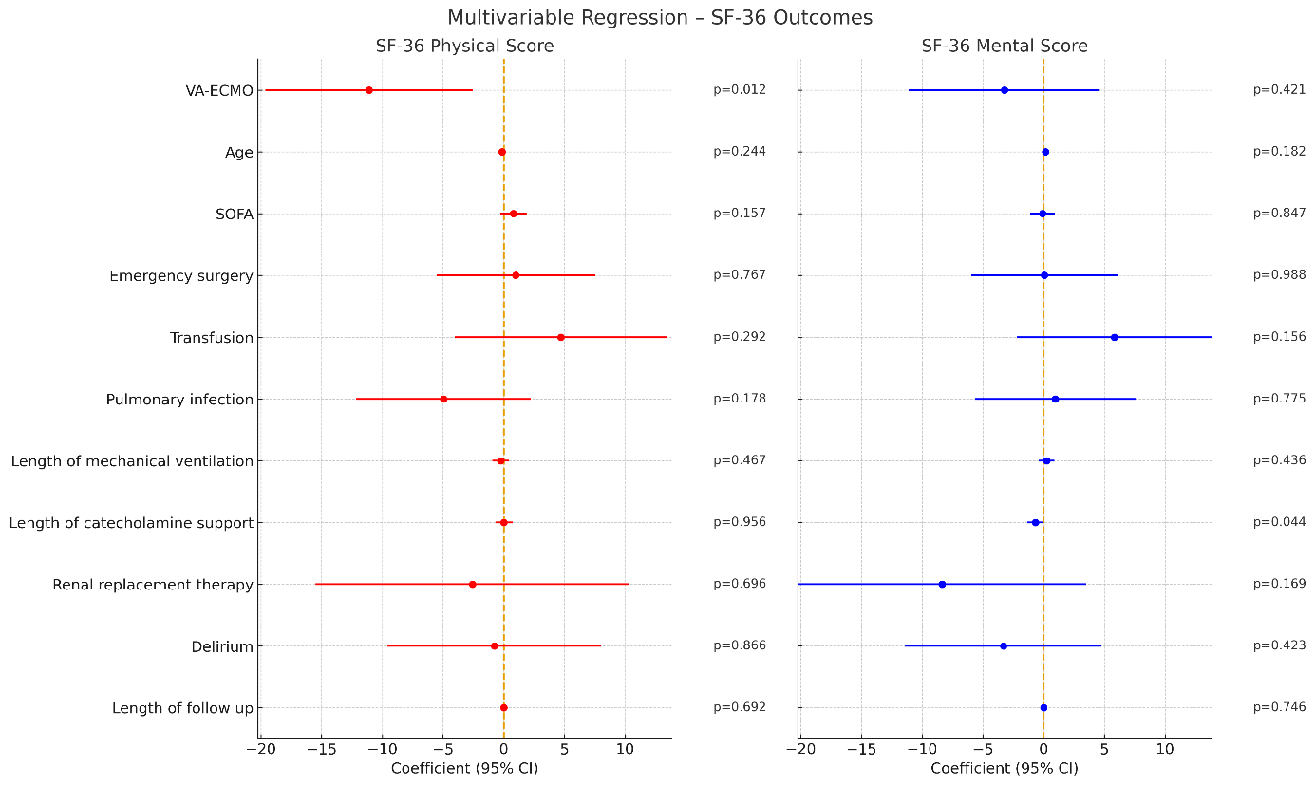

Abbreviations: CI = Confidence Interval; ECMO = Extracorporeal Membrane Oxygenation; HR = Hazard Ratio; ICU = Intensive Care Unit; SOFA = Sequential Organ Failure Assessment; SD = Standard Deviation. Legend: Analysis were performed with multiple linear regression. Statistical significance was set at P < 0.05.

ESM5. Limitations
Several sources of potential bias should be acknowledged. These include survivor bias inherent to long-term follow-up studies and indication bias for VA-ECMO. Key markers of initial shock severity, including SCAI classification, maximal vasoactive–inotropic score (VIS), and lactate levels, were not systematically recorded and could therefore not be included in the analyses. Thus, a residual confounding related to initial shock severity cannot be excluded.
In addition, postoperative and discharge left ventricular ejection fraction were not consistently available and could not be analyzed in relation to long-term quality of life. Quality of life was assessed using patient-reported outcomes only, independently of objective functional or physical performance assessments.
Moreover, a potential response bias cannot be excluded, as approximately 20% of eligible survivors did not complete the SF-36 questionnaire. Finally, follow-up duration varied from 1 to 6 years across patients, which may have influenced outcomes. However, follow-up time was not significantly associated with SF-36 scores and did not differ between groups.

ESM 6. Table of Missing Data
Variable | Valid observations (n) | Missing (n) | % Missing
Presence of VA-ECMO support | 231 | 0 | 0
Age | 231 | 0 | 0
Sex | 231 | 0 | 0
Weight | 230 | 1 | 0.4
Height | 229 | 2 | 0.9
Body Mass Index | 229 | 2 | 0.9
ASA | 231 | 0 | 0
EuroScoreII | 225 | 7 | 3.0
SAPS II | 229 | 2 | 0.9
SOFA | 229 | 2 | 0.9
Hypertension | 231 | 0 | 0
Diabetes mellitus | 231 | 0 | 0
COPD | 231 | 0 | 0
Lower limb arteriopathy | 231 | 0 | 0
Pulmonary hypertension | 197 | 34 | 14.7
Preoperative LVEF | 193 | 38 | 16.4
Length of stay in ICU | 229 | 2 | 0.9
Emergency or elective surgery | 231 | 0 | 0
Type of surgery | 231 | 0 | 0
Days under VA-ECMO support | 55/55 | 0 | 0
Timing for VA-ECMO implantation | 54/55 | 1 | 1.8
Cardiac arrest | 231 | 0 | 0
Catecholamine support (days) | 220 | 11 | 4.8
Mechanical ventilation (days) | 228 | 3 | 1.3
Renal replacement therapy | 227 | 4 | 1.7
Transfusion | 230 | 1 | 0.4
Pulmonary infection | 231 | 0 | 0
Atrial fibrillation | 231 | 0 | 0
Stroke | 231 | 0 | 0
Delirium | 231 | 0 | 0
Lenght of follow-up | 229 | 2 | 0.9
Physical function (PF) | 231 | 0 | 0
Role physical (RP) | 231 | 0 | 0
Bodily pain (BP) | 231 | 0 | 0
General Health (GH) | 231 | 0 | 0
Role emotional (RE) | 231 | 0 | 0
Mental Health (MH) | 231 | 0 | 0
Vitality (VT) | 231 | 0 | 0
Social function (SF) | 231 | 0 | 0
Physical SF-36 | 231 | 0 | 0
Mental SF-36 | 231 | 0 | 0

