Early trajectories of pulmonary hemodynamics in ARDS patients undergoing V-V ECMO: key determinants and prognostic impact

Marco Giani, Michela Bombino, Michela Ravasi, Benedetta Fumagalli, Matteo Pozzi, Nicolò Patroniti, Giacomo Grasselli, Giuseppe Foti, and Emanuele Rezoagli

Supplementary Material

Figure S1. Distribution of mPAP in the ECMO population. Histogram and boxplot illustrating the distribution of all mPAP measurements recorded during the ECMO course across the cohort (4,433 ECMO-days).
The histogram shows a right-skewed distribution with a tail of high values. The boxplot summarizes the overall distribution, including median, interquartile range, and outliers.

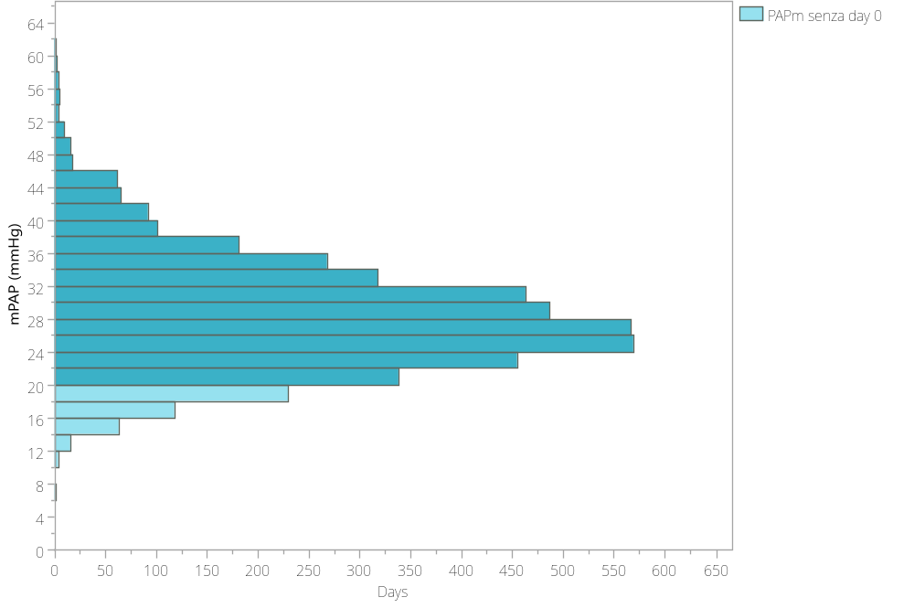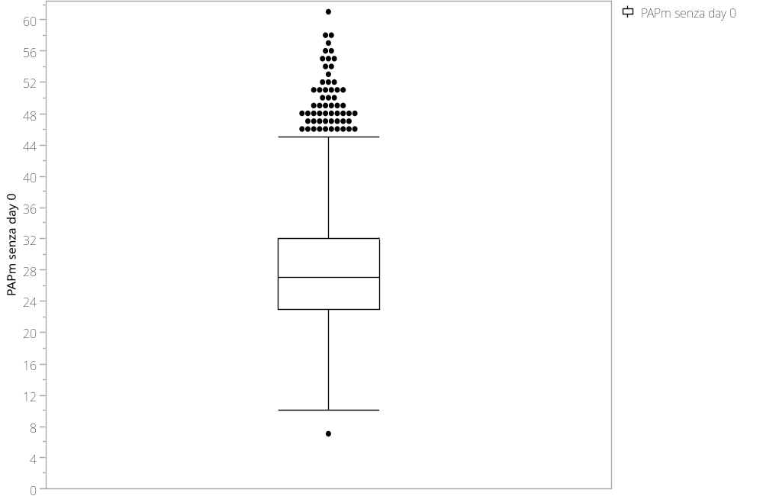

Table S1. Pulmonary vasodilator agents used for the management of pulmonary hypertension during ECMO support.
Total
(n=49)
Sildenafil | 32 (65%)
Inhaled nitric oxide (iNO) | 4 (8%)
Iloprost or Epoprostenol | 4 (8%)
Sildenafil + iNO | 3 (6%)
Sildenafil + Iloprost | 3 (6%)
Sildenafil + other drugs * | 3 (6%)
Data are presented as absolute numbers (percentage). *“Other drugs” refers to additional pulmonary vasodilators administered in combination or sequentially, including inhaled nitric oxide, iloprost, epoprostenol, and bosentan.

Table S2. Hemodynamic and respiratory parameters before and after V-V ECMO initiation in the subgroup of patients with a pulmonary artery catheter (n = 55).
 | pre-ECMO | ECMO day 1 | P value
CO, L/min | 8.3 [6.6-10.5] | 7.6 [6.4-9.0] | 0.0199
HR, bpm | 105 [96-126] | 97 [83-113] | <0.001
CVP, mmHg | 11 [9-14] | 10 [8-13] | 0.0242
MAP, mmHg | 78 [67-92] | 76 [68-87] | 0.9211
mPAP, mmHg | 31 [27-34] | 27 [23-32] | <0.001
PAOP, mmHg | 13 [12-16] | 13 [9-16] | 0.0074
Lactate, mmol/l | 1.6 [1.2-3.1] | 1.7 [1.1-2.9] | 0.7291
Qs/Qt | 0.46 [0.39-0.57] | 0.61 [0.47-0.69] | <0.001
TV, ml | 385 [320-459] | 320 [250-396] | <0.001
RR, atti/min | 30 [26-34] | 10 [10-10] | <0.001
PEEP, cmH₂O | 14 [12-16] | 15 [12-18] | 0.0629
Pplat, cmH₂O | 29 [25-30] | 26 [23-28] | <0.001
DP, cmH₂O | 14 [11-16] | 10 [8-12] | <0.001
CRS, ml/ cmH₂O | 29 [31-39] | 33 [25-47] | 0.004
PaO₂, mmHg | 73 [58-84] | 79 [70-93] | 0.001
PaCO₂, mmHg | 60 [52-70] | 50 [44-57] | <0.001
pH | 7.34 [7.29-7.37] | 7.40 [7.37-7.43] | <0.001
SatO₂, % | 93 [88-95] | 95 [93-96] | <0.001
PaO₂/FiO₂ | 76 [59-92] | 109 [91-109] | <0.001
PvCO₂, mmHg | 66 [57-75] | 52 [45-60] | <0.001
PvO₂, mmHg | 40 [33-43] | 61 [52-68] | <0.001
pHv | 7.32 [7.27-7.36] | 7.39 [7.36-7.43] | <0.001
SvO2 | 69 [59-73] | 90[86-92] | <0.001
Data are presented as median [interquartile range, 25th–75th percentile]. CO = cardiac output; HR = heart rate; CVP = central venous pressure; MAP = mean arterial pressure; mPAP = mean pulmonary artery pressure; PAOP = pulmonary artery occlusion pressure; Qs/Qt = intrapulmonary shunt fraction; TV = tidal volume; RR = respiratory rate; PEEP = positive end-expiratory pressure; Pplat = plateau pressure; DP = driving pressure; CRS = respiratory system compliance; PvO₂ = mixed venous oxygen tension; PvCO₂ = mixed venous carbon dioxide tension; pHv = mixed venous pH; SvO₂ = mixed venous oxygen saturation.

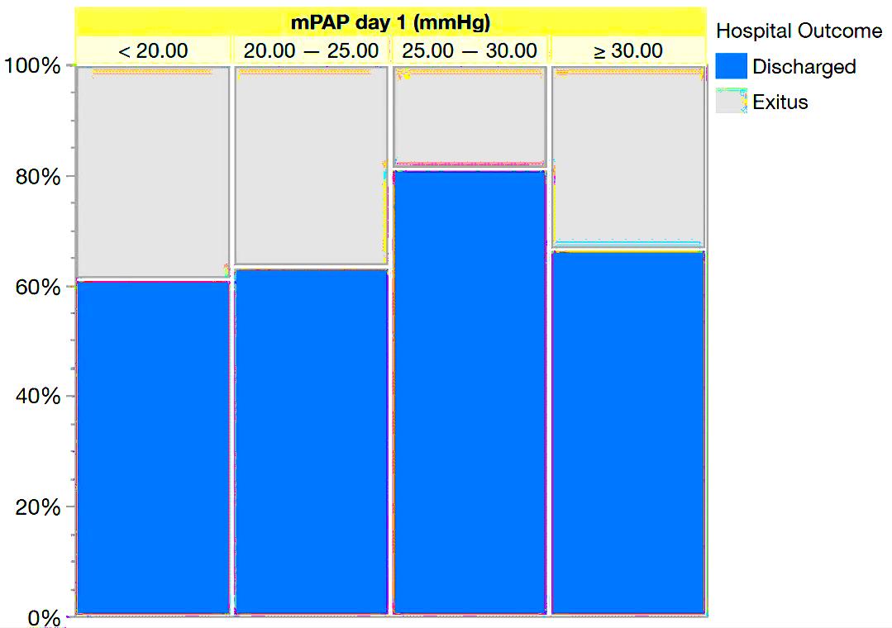
Figure S2. Stratified hospital outcomes according to early mPAP characteristics.
A

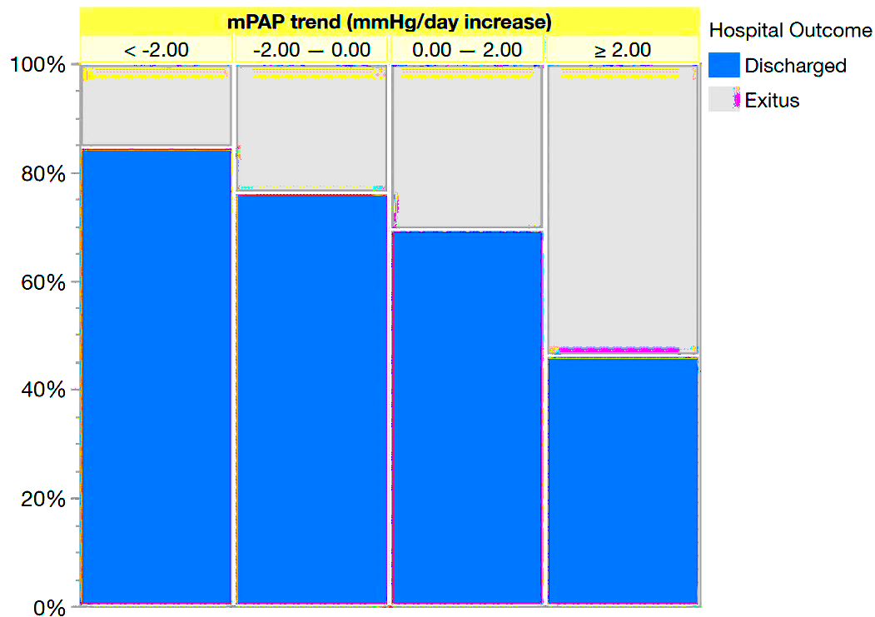
B

Panel A. Hospital mortality according to mPAP on day 1 of ECMO. Patients were stratified into four categories based on mPAP measured on the first ECMO day (<20, 20–25, 25–30, and ≥30 mmHg). The stacked bars indicate the proportion of hospital survivors and non-survivors in each category.
Panel B. Hospital mortality according to the trajectory of mean pulmonary artery pressure (mPAP) over the first five ECMO days.
Patients were grouped according to the slope of the mPAP trend calculated over the first five days of ECMO support (< –2, –2 to 0, 0 to +2, and ≥ +2 mmHg/day). Bars represent the proportion of survivors and non-survivors in each stratum.

