Supplementary Table 1. Search strategy
Database | Search Query | Results
PubMed | ("Critical Care"[Mesh] OR "Intensive Care Units"[Mesh] OR Critical Care OR ICU OR intensive care OR critically ill) AND ("Ketamine"[Mesh] OR Ketamine OR ketalar) AND ("Conscious Sedation"[Mesh] OR "Anesthesia"[Mesh] OR Sedation OR analgosedation OR anesthesia) | 258
Cochrane | (Critical Care OR ICU OR intensive care OR critically ill)  AND  (Ketamine OR ketalar)  AND  (Sedation OR analgosedation OR anesthesia) | 380
Clinical Trials Govt. | (Critical Care OR ICU OR intensive care OR critically ill)  AND  (Ketamine OR ketalar)  AND  (Sedation OR analgosedation OR anesthesia) | 222
Supplementary Table 2. GRADE Evidence Profile.

Certainty assessment |  |  |  |  |  |  |  | Summary of findings
Participants  (studies)  Follow-up | Risk of bias | Inconsistency | Indirectness | Imprecision | Publication bias | Overall certainty of evidence | Study event rates (%) |  |  | Relative effect  (95% CI) | Anticipated absolute effects
 |  |  |  |  |  |  | With control |  | With ketamine | Relative effect  (95% CI) | Risk with control | Risk difference with ketamine
IV morphine at 24 h in adults (mg)
371 (4 RCTs) | Serious^{h} | Not serious | Not serious | Not serious | Undetectedᵈ | ⨁⨁⨁◯  Moderate^{h} | - |  | - | MD −5.77 [−6.32, −5.23] | 46.0 mg | 5.77 mg lower
IV morphine at 48 h in adults (mg)
153 (2 RCTs) | Serious^{h} | Seriousᵃ | Not serious | Seriousᵇ | Undetectedᵈ | ⨁◯◯◯  Very low^{a,b,h} | - |  | - | MD −12.52 [−27.45, 2.41] | 49.8 mg | 12.52 mg lower
Pediatric IV morphine at 24 h (mg/kg)
105 (2 RCTs) | Not serious | Very seriousᵃᵉ | Not serious | Seriousᵇ | Undetectedᵈ | ⨁◯◯◯  Very low^{c} | - |  | - | MD −0.52 [−1.25, 0.20] | 1.43 mg/kg | 0.52 mg/kg lower
ICU length of stay
387 (5 RCTs) | Serious^{h} | Not serious | Not serious | Seriousᵇ | Undetectedᵈ | ⨁⨁◯◯  Low^{b,h} | - |  | - | MD −0.97 [−1.95, 0.02] | 31.0 h | 0.97 h lower
Mechanical ventilation duration
318 (4 RCTs) | Serious^{h} | Seriousᵃᶠ | Not serious | Seriousᵇ | Undetectedᵈ | ⨁◯◯◯  Very low^{a,b,h} | - |  | - | MD −0.84 [−1.93, 0.24] | 7.5 h | 0.84 h lower
Postoperative nausea and vomiting (PONV)
258 (4 RCTs) | Serious^{h} | Not serious | Not serious | Seriousᵇ | Undetectedᵈ | ⨁⨁◯◯  Low^{b,h} | 24.4% |  | 12.2% | RR 0.59 [0.36, 0.98] | 24.4% | 10% less
Psychotomimetic adverse effects
301 (3 RCTs) | Serious^{h} | Not serious | Not serious | Very seriousᵇ | Undetectedᵈ | ⨁◯◯◯  Very low^{b,h} | 2.6% |  | 4.1% | RR 1.40 [0.40, 4.92] | 2.6% | 1% more
CI: confidence interval; MD: mean difference; RR: risk ratio
Explanations
ᵃ Inconsistency: substantial heterogeneity (I² exceeding 50%).
ᵇ Imprecision: 95% CI includes no effect and/or small total N or few events.
ᵈ Publication bias: <10 studies, funnel plot not assessed; no downgrade.
ᵉ Very serious inconsistency: extremely high heterogeneity (I² ≈ 98%) with discordant effects.
ᶠ Heterogeneity unexplained and not resolved by sensitivity analyses (ventilation duration).
ᵍ Heterogeneity resolved on sensitivity excluding Abdelfattah 2024 (I² → 0%); downgrade retained due to instability/clinical diversity.
^{h} Risk of bias is necessitating downregulation

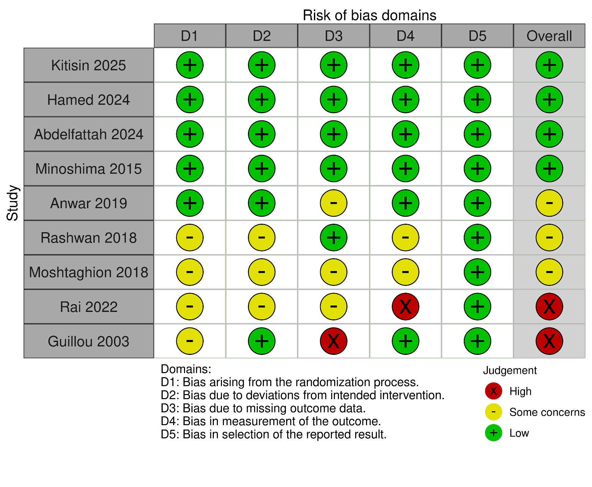
Supplementary Figure 1. Risk of bias assessment using RoB2
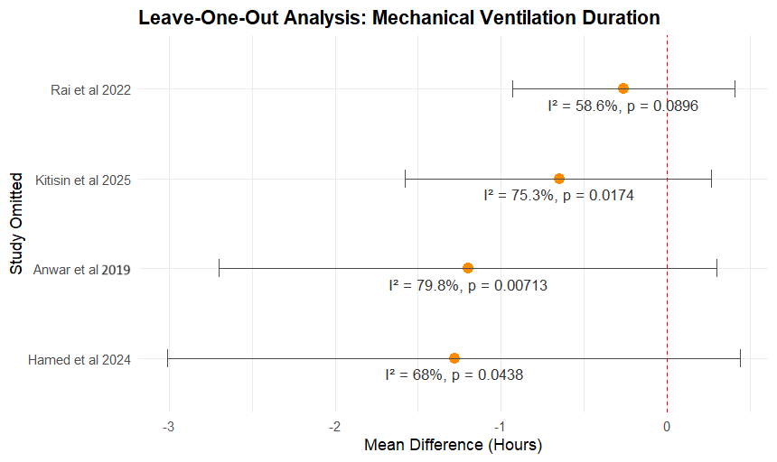

Supplementary Figure 2. Sensitivity Analysis duration of mechanical ventilation

