Supplement 2 : IRI Trajectory Analysis by Transition Timing

Methods

Transition groups
Patients were stratified by transition timing using inclusive cut-points unless otherwise specified: ≤3 d (3), >3–5 d (5), >5–7 d (7), >7–10 d (10), and never (>10 d or missing).

Trajectory aggregation
IRI values were aggregated in regular time bins to form group trajectories. For each (time bin × group) we computed the median and interquartile range (IQR).

Confirmatory analyses
AUC(0–X d): Per patient, area under IRI vs time using the trapezoidal rule. Group differences assessed via Kruskal–Wallis; pairwise contrasts via Mann–Whitney with Holm correction. Effect sizes reported as Cliff’s δ.
Slopes (0–X d): Per-patient slope of IRI vs time using ordinary least squares (or robust Theil–Sen when selected). Group differences via Kruskal–Wallis and Holm-adjusted pairwise Mann–Whitney. A within‑patient fixed‑effects common slope by group is also provided in-app.

Results

AUC(0–20 d) by group
Global test: Kruskal–Wallis across groups (n_groups=5): H = 262.775, p = 1.15e-55.

Per‑patient slopes (0–20 d) by group
Global test: Kruskal–Wallis across groups (n_groups=5): H = 917.731, p = 2.4e-197.

Interpretation
Directionality: Median AUC increases with later transition timing (3 < 5 < 7 < 10 < never), consistent with higher cumulative insulin resistance when transition is delayed/absent.
Dynamics: Per‑patient slopes are most negative for early transition groups, indicating faster resolution of insulin resistance; late/never groups are flatter or positive.
Statistical evidence: Both AUC and slope distributions differ strongly across groups (Kruskal–Wallis p-values ≪ 0.001). Pairwise contrasts identify the largest gaps between early (e.g., 3 d) and late/never groups.

Robustness & Sensitivity
Findings remain qualitatively unchanged under
- inclusive vs strict cut-points,
- time-binning choices (0.25–2 d),
- trimming of extreme IRI values,
- minimum measurement thresholds per patient, and
- robust slope estimation via Theil–Sen in place of OLS.

Supplementary Figures
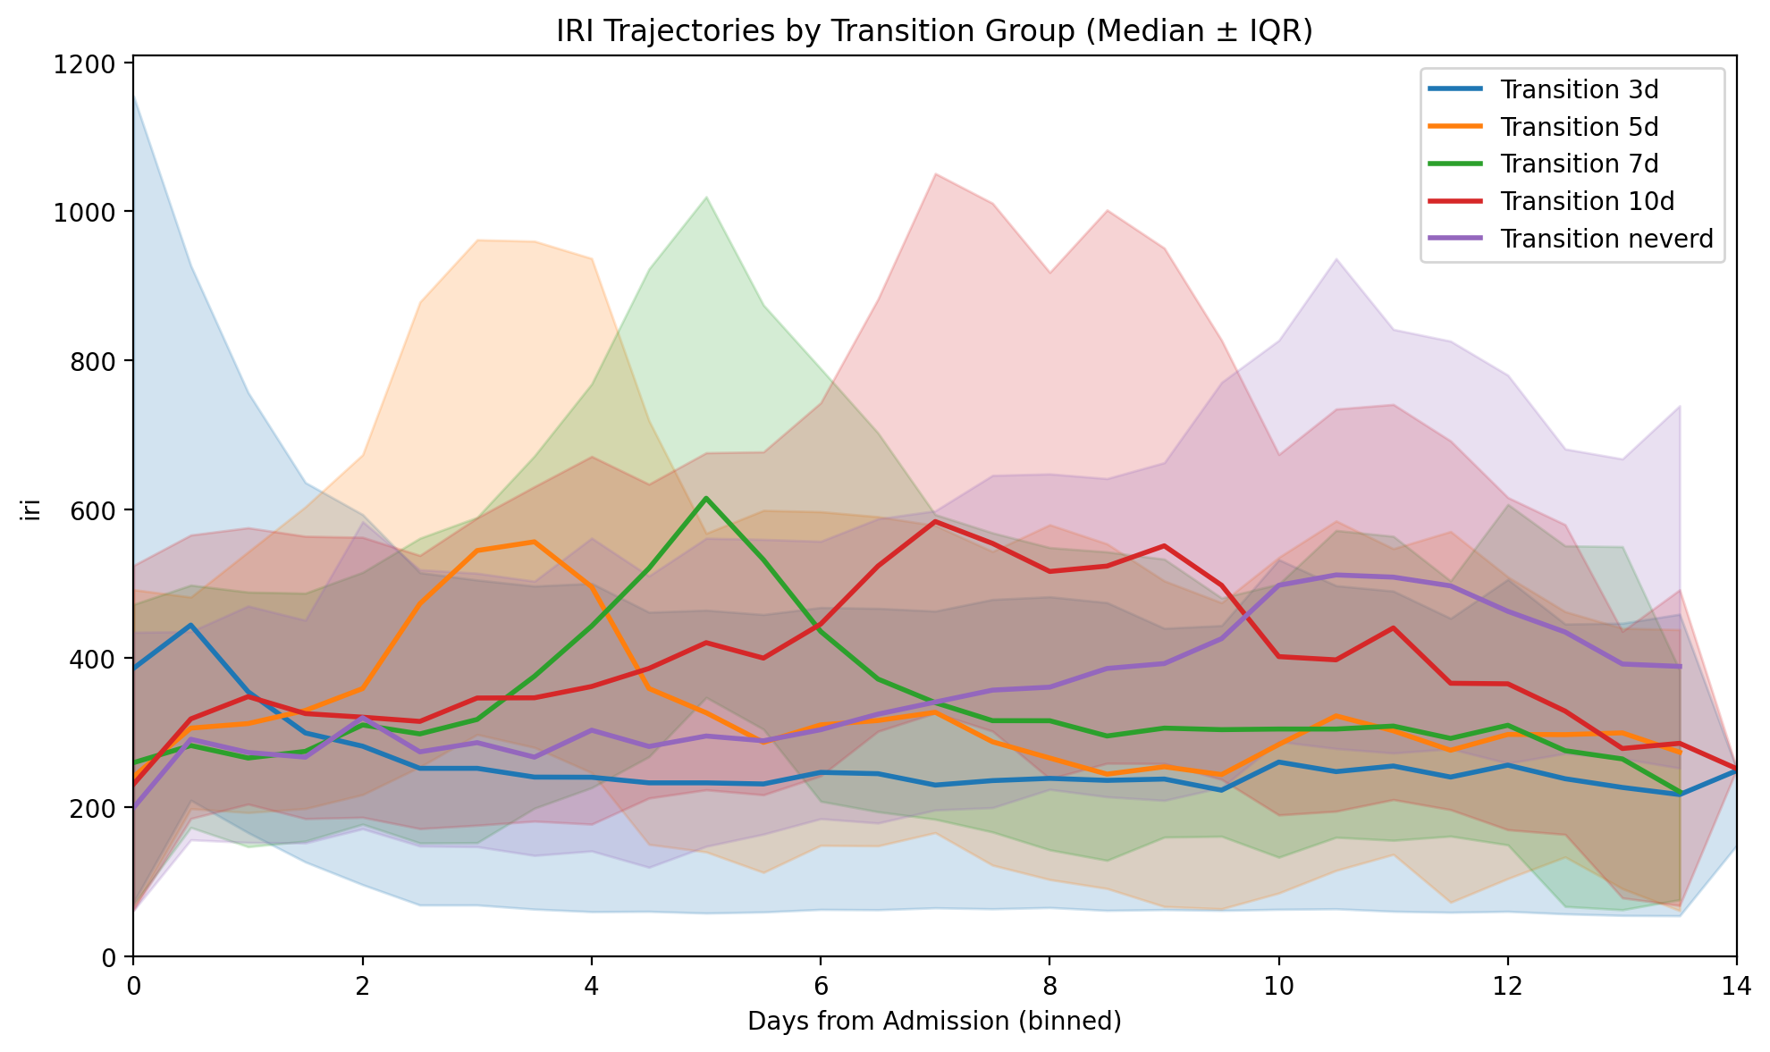
Figure S1. Insulin Resistance Index (IRI) trajectories by transition group.
Median IRI values (lines) with interquartile ranges (shaded areas) are shown from ICU admission through day 14, stratified by transition timing: Day 3 (blue), Day 5 (orange), Day 7 (green), Day 10 (red), and never transitioned (purple). Patients who transitioned earlier demonstrated higher initial IRI peaks followed by a more rapid decline, whereas those with delayed or absent transition exhibited persistently elevated or rising IRI values. This pattern supports the concept that early transition from catabolic to anabolic state is associated with faster resolution of insulin resistance.

