Data Supplement

Title: Effect of driving pressure-limiting strategies on outcomes of patients with ARDS: a meta-analysis of randomized controlled trials

Authors: Michalis Agrafiotis, Michail Georgopoulos, Evangelia Akoumianaki, Ilias I. Siempos

Supplemental Figure 1. Risk of bias assessment for each of the four randomized controlled trials included in the meta-analysis.

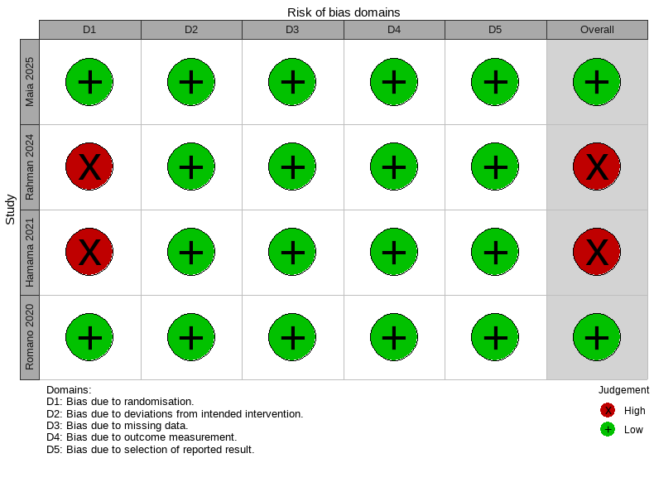

Supplemental Figure 2. Mean differences in post-randomization driving pressure between patients with acute respiratory distress syndrome undergoing driving pressure-limiting strategies on top of lung protective ventilation (“intervention” group) versus lung protective ventilation alone (“control” group) on (a) study day 1, (b) study day 2 and (c) study day 3. Pooled mean differences (MD) and 95% confidence intervals (CI) were calculated using a random-effects model.
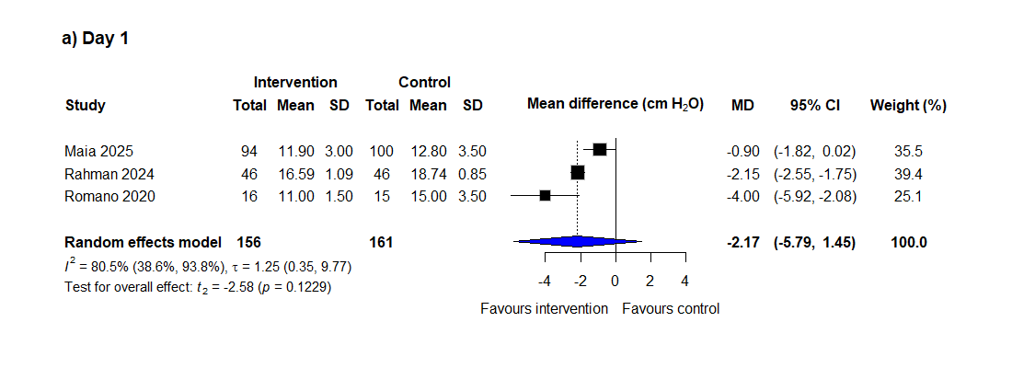
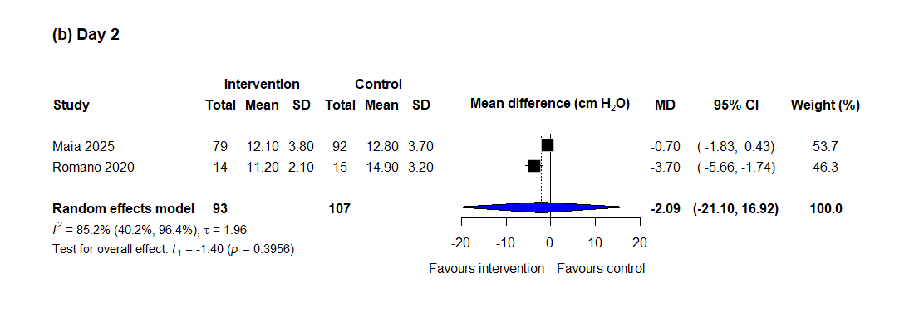
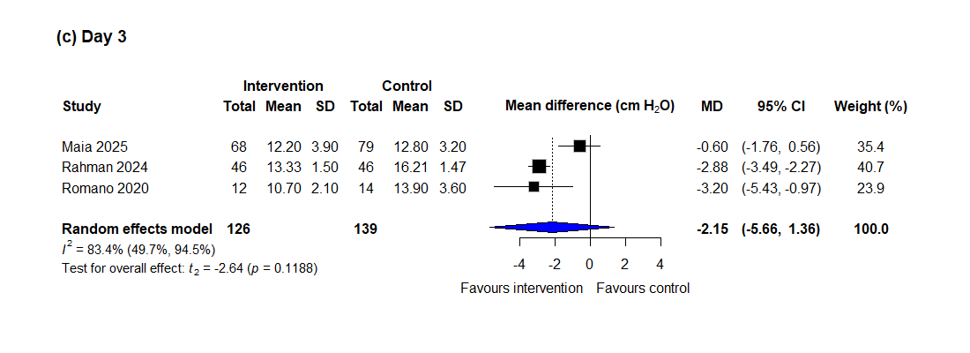

Supplemental Figure 3. Leave-one-out sensitivity analysis of all-cause mortality. Squares indicate the pooled estimate after exclusion of each study, and the diamond represents the overall pooled estimate including all studies. Pooled relative risks (RR) and 95% confidence intervals (CI) were calculated using a random-effects model.

Supplemental Figure 4. Ventilator-free days of patients with acute respiratory distress syndrome undergoing driving pressure-limiting strategies on top of lung protective ventilation (“intervention” group) versus lung protective ventilation alone (“control” group). Pooled mean difference (MD) and 95% confidence intervals (CI) were calculated using a random-effects model.
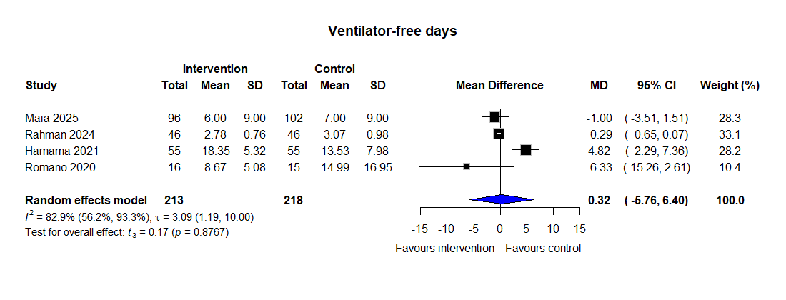

For the randomized controlled trials by Hamama et al and by Romano et al, which reported ventilator-free days data as medians with interquartile ranges, the approximations derived by Luo et al were used to estimate corresponding means and standard deviations.

Supplemental Figure 5. Leave-one-out sensitivity analysis of ventilator-free days. Squares indicate the pooled estimate after exclusion of each study, and the diamond represents the overall pooled estimate including all studies. Pooled mean difference (MD) and 95% confidence intervals (CI) were calculated using a random-effects model.
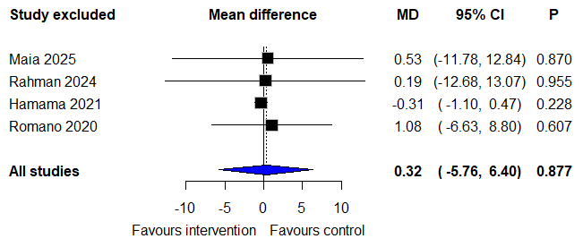

For the randomized controlled trials by Hamama et al and by Romano et al, which reported ventilator-free days data as medians with interquartile ranges, the approximations derived by Luo et al were used to estimate corresponding means and standard deviations.

Supplemental Figure 6. Leave-one-out sensitivity analysis of length of intensive care unit stay. Squares indicate the pooled estimate after exclusion of each study, and the diamond represents the overall pooled estimate including all studies. Pooled mean difference (MD) and 95% confidence intervals (CI) were calculated using a random-effects model.

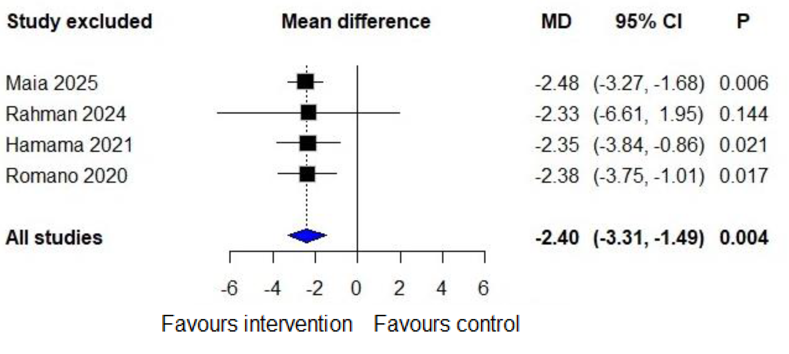
For the randomized controlled trials by Hamama et al and by Romano et al, which reported length of intensive care unit stay data as medians with interquartile ranges, the approximations derived by Luo et al were used to estimate corresponding means and standard deviations.

