Supplemental Figure 1: Patient flow diagram. cDPP3^{LOW} and cDPP3^{HIGH} subgroups refer to patients with cDPP3 ≤ 40 ng/mL and > 40 ng/mL, respectively. cDPP3: circulating dipeptidyl peptidase 3.

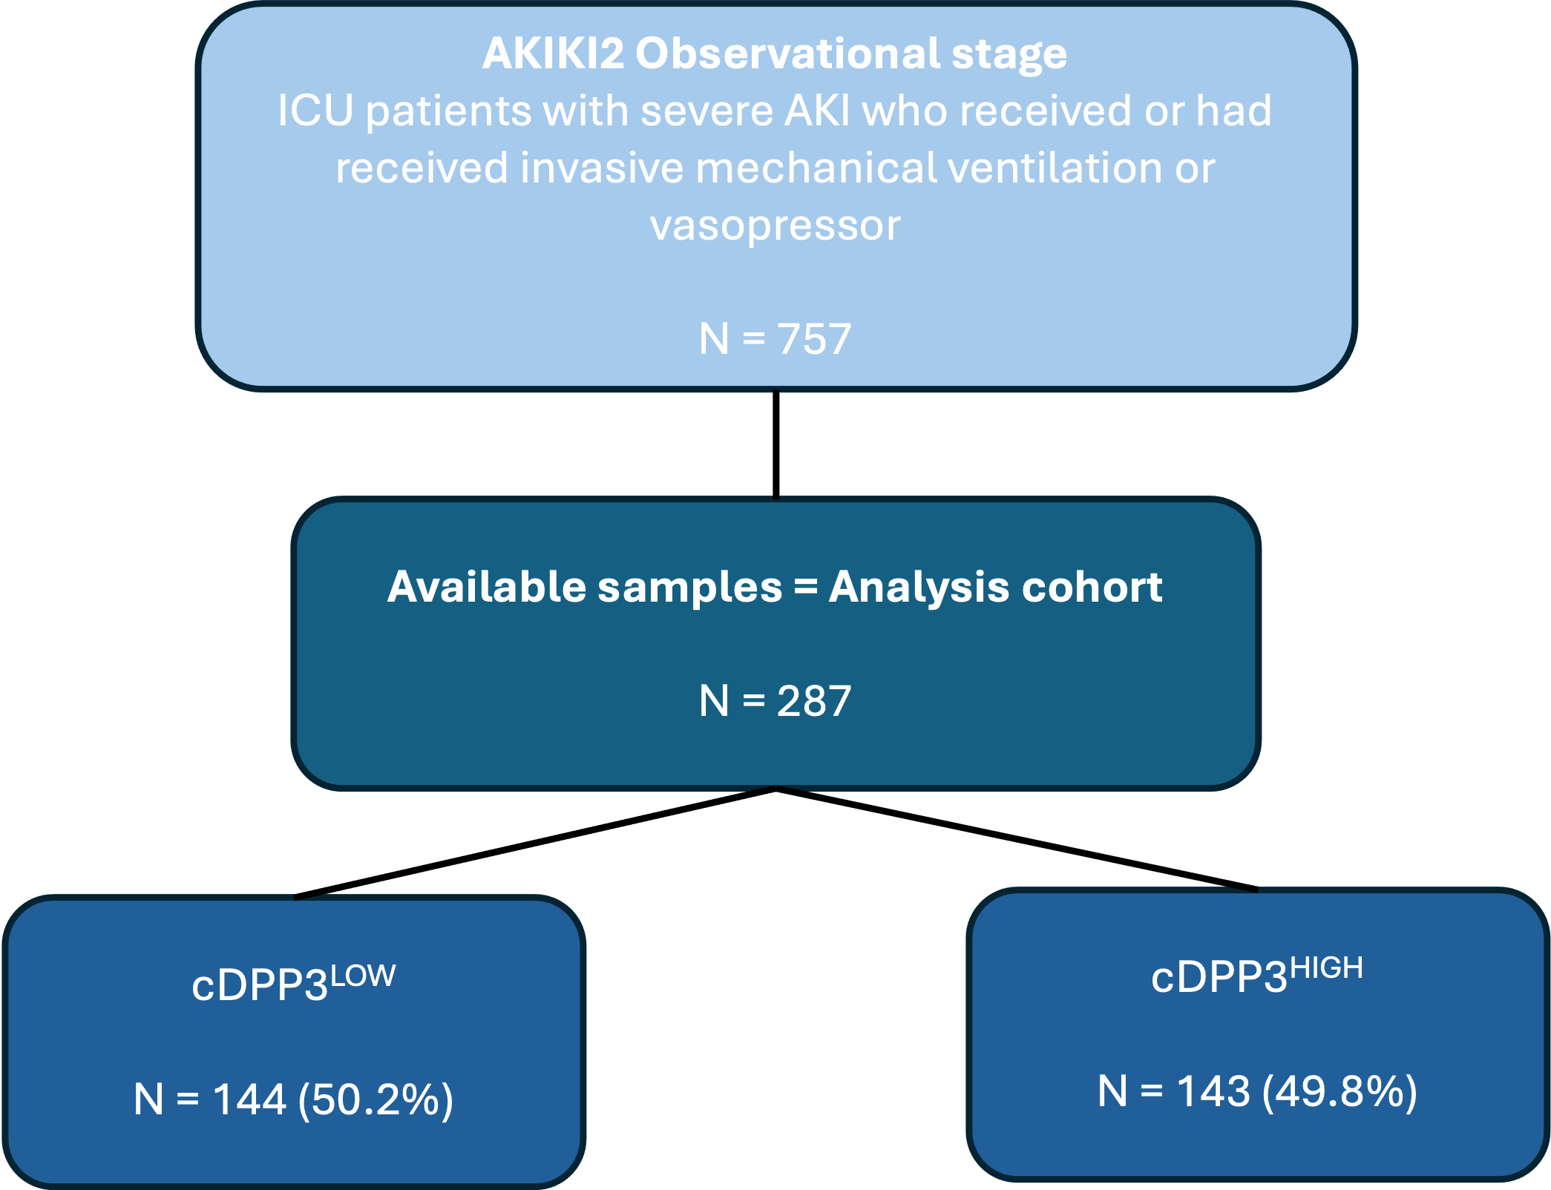

Supplemental Figure 2 : Covariate balance before and after propensity score weighting for adjusted analyses.

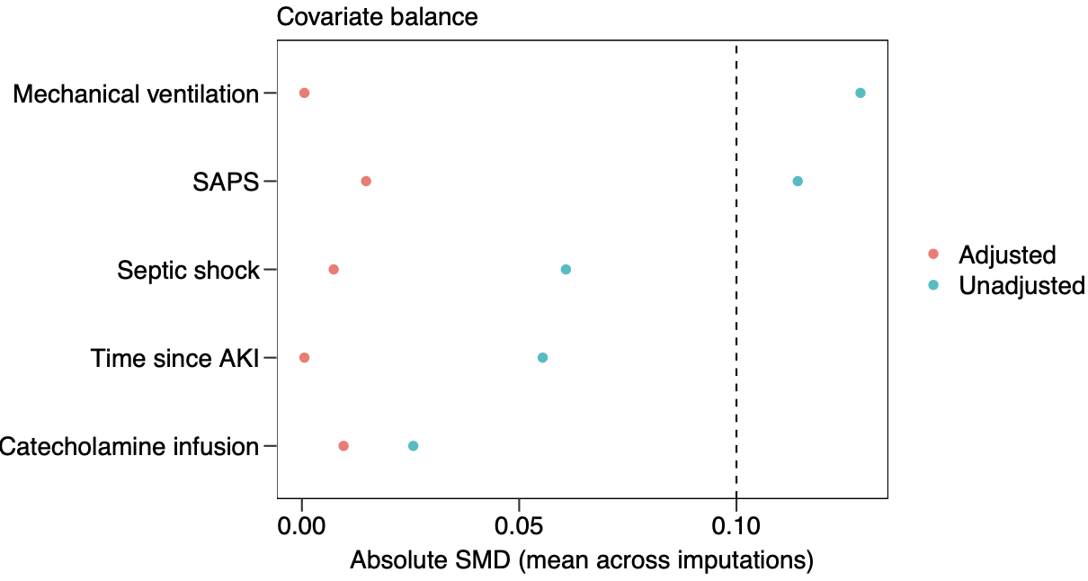

Supplemental Table 1. Organ support-free days after propensity score weighting. cDPP3^{LOW} and cDPP3^{HIGH} subgroups refer to patients with cDPP3 ≤ 40 ng/mL and > 40 ng/mL, respectively. Mean differences and p values are derived from inverse probability of treatment weighting using the propensity score. RRT: Renal replacement therapy.

Variable | cDPP3^{LOW} | cDPP3^{HIGH} | Adjusted mean difference (95% CI) |  |  |  | Adjusted p value
Ventilator-free days | 18 [0-28] | 0 [0-21] | -5.03 (-7.67, -2.42) |  |  |  | <0.001
Vasopressor-free days | 25 [24-28] | 2 [0-26] | -5.05 (-8.00, -2.14) |  |  |  | <0.001
RRT-free days | 27 [0-28] | 1 [0-28] | -5.93 (-8.97, -2.86) |  |  |  | <0.001

Supplemental Table 2. Organ support-free days in 28-day survivors. cDPP3^{LOW} and cDPP3^{HIGH} subgroups refer to patients with cDPP3 ≤ 40 ng/mL and > 40 ng/mL, respectively. RRT: Renal replacement therapy.
Variable | cDPP3^{LOW} | cDPP3^{HIGH} | Mean difference |  | p
Ventilator-free days | 26 [16-28] | 21 [5-27] | -4.37 (-7.47; -1.17) |  | 0.01
Vasopressor-free days | 26 [24-28] | 26 [22-27] | -1.60 (-3.17; -0.09) |  | 0.04
RRT-free days | 28 [27-28] | 28 [14-28] | -3.31 (-5.89; -0.79) |  | 0.01

