Frailty and its association with long-term mortality in patients with cardiogenic shock: a multicentre retrospective study
Supplementary Material

*Ryan Ruiyang Ling, *Shir Lynn Lim, David Kaye, Oliver Lim, Christopher Jer Wei Low, Graeme MacLaren, Daniel I. McIsaac, Kiran Shekar, Ryo Ueno, David Pilcher, Kollengode Ramanathan, Ashwin Subramaniam,

Corresponding author:
Shir Lynn Lim
shir.lynn.lim@nus.edu.sg

Table of contents
Supplementary Methods 3
Diagnostic codes included in analysis 3
Nutrition risk: the modified Nutrition in Critically Ill (mNUTRIC) score 3
Supplementary Results 5
Figure S1. Study inclusion flowchart 5
Table S1. Baseline characteristics of patients with a known and unknown Clinical Frailty Scale. 6
Figure S2. Distribution of clinical frailty scale status among patients included in our study 7
Figure S3. Unadjusted survival curves of patients, stratified based on Clinical Frailty Scale modelled as an ordinal variable from CFS 1 through 8 8
Figure S4. Unadjusted survival curves of patients, stratified based on Clinical Frailty Scale modelled as a categorical variable with three levels (CFS 1-3: no frailty, CFS 4-5: mild frailty, CFS 6-8: moderate to severe frailty) 9
Figure S5. Unadjusted survival curves of patients with and without frailty, stratified based on sex. 10
Figure S6. Unadjusted survival curves of patients with and without frailty, stratified based on age. 11
Figure S7. Unadjusted survival curves of patients with and without frailty, stratified based on nutrition status 12
Figure S8. Unadjusted survival curves of patients with and without frailty, stratified based on BMI categories. 13
Figure S9. Landmark survival at ICU discharge. 14
Figure S10. Survival analysis excluding patients with ICU stays <24 hours. 14

Supplementary Methods

Diagnostic codes included in analysis
In our analysis, using the APACHE III-J code for cardiogenic shock (AP-101) may inadvertently exclude patients who had cardiogenic shock, but were tagged with a different principal diagnosis. In order to broaden the potential population for inclusion in our study, we included patients with cardiogenic shock (AP-101), and patients with an acute cardiovascular diagnosis, and at least two of the three criteria: (1) mean arterial pressure <65 within 24 hours from ICU admission, (2) received vasopressors or inotropes, or (3) had a serum lactate of ≥2mmol/l. The following table summarises the diagnostic codes we defined as “acute cardiovascular diagnoses”, and how we categorised them into aetiologies of cardiogenic shock. More information can be found in the ANZICS APD data dictionary (refer to Data Availability statement in main manuscript).

Diagnostic code | Diagnosis | Category
102 | Cardiac arrest | Non-ischaemic
104 | Congestive heart failure | Non-ischaemic
106 | Rhythm disturbance | Non-ischaemic
107 | Acute myocardial infarction | Ischaemic
109 | Other cardiovascular disease | Non-ischaemic
110 | Cardiomyopathy | Non-ischaemic
111 | Unstable angina | Ischaemic
1206 | Valvular heart surgery | Post-cardiac surgical
1207 | Coronary artery bypass graft | Post-cardiac surgical
1212 | CABG with valve repair/replacement | Post-cardiac surgical

Nutrition risk: the modified Nutrition in Critically Ill (mNUTRIC) score
We used the mNUTRIC score to define nutrition risk in patients with cardiogenic shock. The following table delineates the number of points given to each variable, and the derivation of whether patients are at high nutrition risk or not.

Variable | Range | Points
Age | <50 | 0
Age | 50-<75 | 1
Age | ≥75 | 2
APACHE II score | <15 | 0
APACHE II score | 15-19 | 1
APACHE II score | 20-28 | 2
APACHE II score | ≥28 | 3
SOFA score | <6 | 0
SOFA score | 6-9 | 1
SOFA score | ≥10 | 2
Number of comorbidities | <2 | 0
Number of comorbidities | ≥2 | 1
Days from hospital to ICU admission | <1 | 0
Days from hospital to ICU admission | ≥1 | 1
A score of ≥5 suggests that the patient is at high nutrition risk.
Table adapted from Heyland et al. Crit Care 15(6):R268.

Definitions for derlirium and pressure injuries
Delirium: In the ANZICS-APD, delirium is defined as an acute or fluctuating mental state (which represents a change from the patient’s normal baseline) and is characterised by inattention with altered level of consciousness, agitation or disorganised thought processes. It should be diagnosed by standardised assessment tools such as (but not limited to) the Confusion Assessment Method for ICU (CAM-ICU). The ANZICS-APD only captures development of delirium during the ICU stay; admission for delirium or delirium after ICU discharge is not included.

Pressure injury: The ANZICS-APD uses the National Pressure Injury Advisory Panel Staging System to define pressure injuries, and only includes Stage II pressure injuries and above. These are defined below:

- Stage II (partial thickness skin loss)
- Stage III (full thickness skin loss)
- Stage IV (full thickness tissue loss)
- Unstageable/suspected deep tissue pressure injuries (where skin is breached but depth is unknown)

Only new pressure injuries which develop during ICU stay and up to 48 hours after ICU discharge are included. Stage I pressure injuries, patients admitted with a pre-existing pressure injury or in whom a pressure injury is thought to have developed prior to ICU admission and is diagnosed within 48 hours of ICU admission, and patients with skin loss due to other conditions are not included as having pressure injuries.

Supplementary Results

Figure S1. Study inclusion flowchart

Table S1. Baseline characteristics of patients with a known and unknown Clinical Frailty Scale.
Demographic variable* | Patients with unknown CFS | Patients with known CFS | p-value
Number | 31,283 (30.5%) | 71,359 (69.5%) | -
Male sex | 21,610 (69.1%) | 49,918 (70.0%) | 0.005
Indigenous status* | 1,481 (5.2%) | 3,672 (5.3%) | 0.39
Age (years) | 68.9 (59.4, 76.4) | 68.6 (59.2, 75.7) | <0.001
ICU admission source
- Emergency Department | 7,066 (22.6%) | 13,666 (19.2%) | <0.001
- General Ward | 6,571 (21.0%) | 10,086 (14.1%) | <0.001
- Other hospital | 2,015 (6.4%) | 20,873 (4.2%) | <0.001
- Other hospital ICU | 250 (0.8%) | 244 (0.3%) | <0.001
- Operating theatre | 15,339 (49.1%) | 44,984 (63.0%) | <0.001
- Direct admit | 23 (0.1%) | 111 (0.2%) | <0.001
Hospital classification
- Public Tertiary | 19,379 (61.9%) | 41,417 (58.3%) | <0.001
- Public Metropolitan | 2,595 (8.3%) | 6,483 (9.1%) | <0.001
- Public Rural/Regional | 2,070 (6.6%) | 4,159 (5.8%) | <0.001
- Private | 7,239 (23.1%) | 19,300 (27.0%) | <0.001
Documented co-morbidities
- Chronic respiratory condition | 1,355 (4.3%) | 4,131 (5.8%) | <0.001
- Chronic cardiovascular condition | 4480 (14.3%) | 12,042 (16.9%) | <0.001
- Chronic liver disease | 277 (0.9%) | 643 (0.9%) | 0.73
- Chronic renal failure | 1,167 (3.7%) | 2,892 (4.1%) | 0.030
- Metastatic cancer | 383 (1.2%) | 942 (1.3%) | 0.36
- Lymphoma | 188 (0.6%) | 449 (0.6%) | 0.60
- Leukaemia | 222 (0.7%) | 453 (0.6%) | 0.17
- Diabetes mellitus | 4,307 (13.8%) | 21,361 (29.9%) | <0.001
- Immunosuppression | 854 (2.7%) | 1,898 (2.7%) | 0.63
Miscellaneous
- Pregnant or postpartum | 57 (0.2%) | 154 (0.2%) | 0.91
- Treatment limitations at ICU admission | 2,264 (7.2%) | 5,014 (7.0%) | 0.23
- Cardiac arrest | 4,236 (13.8%) | 9,422 (13.5%) | 0.13
- ICU following rapid response team review | 4,682 (16.1%) | 8,706 (12.4%) | <0.001
- Pre-ICU hospital stay | 20.9 (4.8, 61.7) | 24.5 (7.3, 74.0) | <0.001
Acute Illness Severity scores
- APACHE-II | 19 (14, 26) | 17 (13, 22) | <0.001
- APACHE-III | 61 (48, 84) | 56 (45, 72) | <0.001
- ANZROD (%) | 20.9 [28.0] | 13.2 [23.7] | <0.001
- SOFA | 6 (4, 8) | 5 (4, 7) | <0.001
Organ supports
- Mechanical ventilation | 18,113 (57.9%) | 57,719 (80.9%) | <0.001
- Non-invasive ventilation | 2,482 (7.9%) | 8,778 (12.3%) | <0.001
- Vasopressor and inotropes | 19,561 (62.5%) | 65,212 (91.4%) | <0.001
- Renal replacement therapy | 1,257 (4.0%) | 4,497 (6.3%) | <0.001
- Extracorporeal membrane oxygenation | 193 (0.6%) | 669 (0.9%) | <0.001
- Tracheostomy | 210 (0.7%) | 703 (1.0%) | <0.001
Outcomes
- Survival months | 48.0 (22.1, 48.0) | 21.4 (6.5, 39.6) | <0.001
- ICU mortality | 5,181 (16.6%) | 7,065 (9.9%) | <0.001
- Hospital mortality | 6,342 (20.3%) | 8,842 (12.4%) | <0.001
ANZROD – Australia New Zealand Risk of Death, APACHE – Acute Physiology and Chronic Health Evaluation, CFS – clinical frailty scale, ICU – intensive care unit, SOFA – sequential organ failure assessment.
* In Australia, those identified as Aboriginal/Torres Strait Islander were coded as Indigenous.
Data are n (%), mean [standard deviation] or median (interquartile range)

Figure S2. Distribution of clinical frailty scale status among patients included in our study

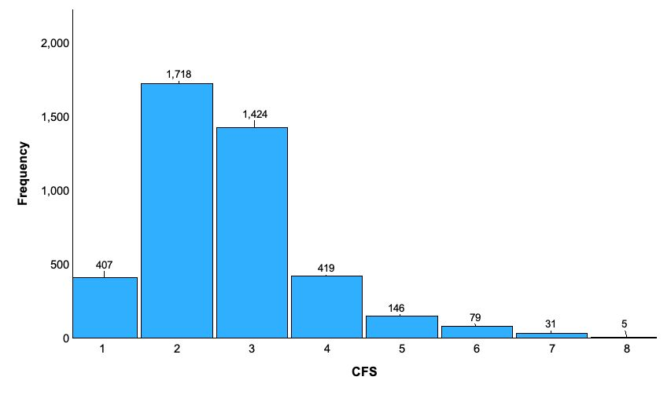

Figure S3. Unadjusted survival curves of patients, stratified based on Clinical Frailty Scale modelled as an ordinal variable from CFS 1 through 8

Figure S4. Unadjusted survival curves of patients, stratified based on Clinical Frailty Scale modelled as a categorical variable with three levels (CFS 1-3: no frailty, CFS 4-5: mild frailty, CFS 6-8: moderate to severe frailty)

Figure S5. Unadjusted survival curves of patients with and without frailty, stratified based on sex.

Figure S6. Unadjusted survival curves of patients with and without frailty, stratified based on age.

Figure S7. Unadjusted survival curves of patients with and without frailty, stratified based on nutrition status
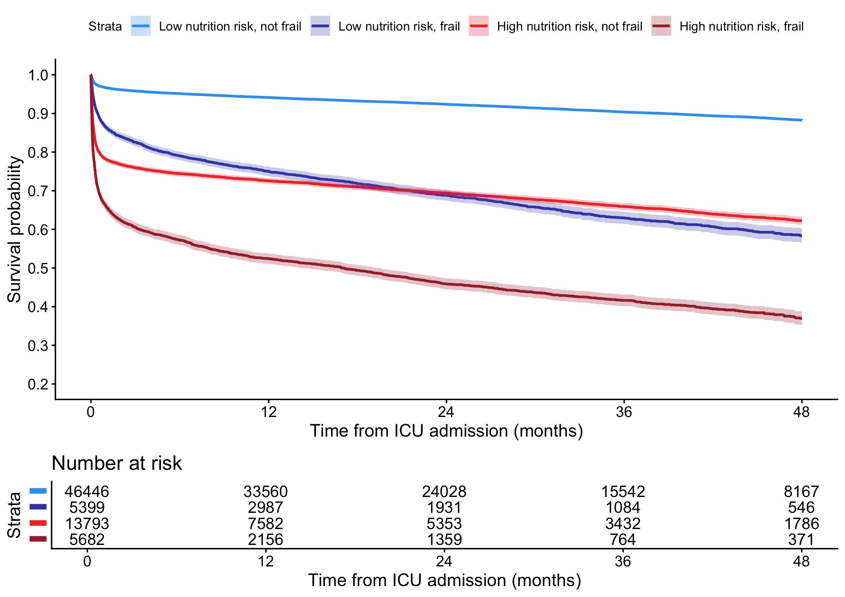

Figure S8. Unadjusted survival curves of patients with and without frailty, stratified based on BMI categories.
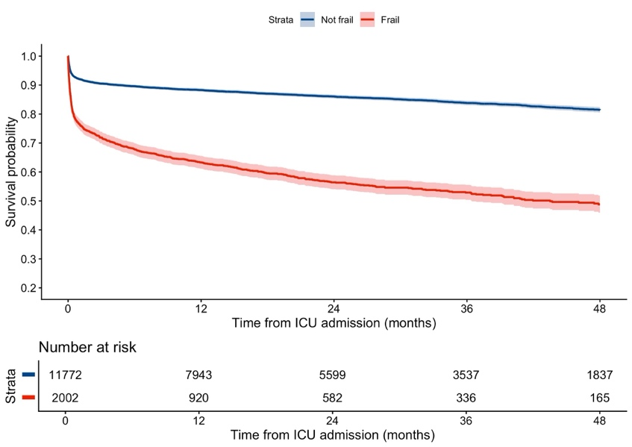
BMI <25

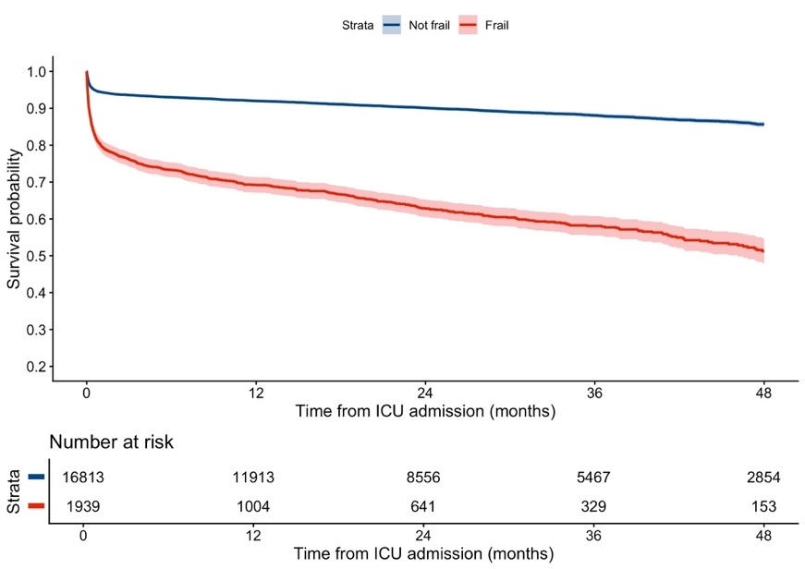
BMI 25-30

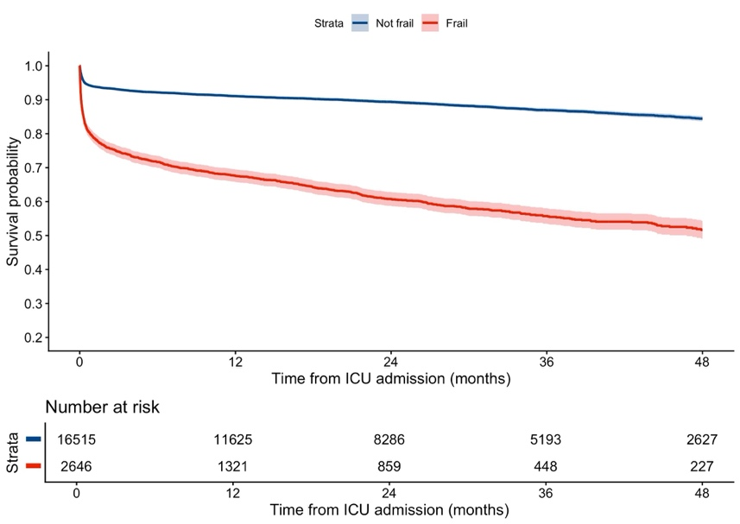
BMI <30

Figure S9. Landmark survival at ICU discharge.

Figure S10. Survival analysis excluding patients with ICU stays <24 hours.
