Tables

Table S1. Four Groups Categorized by Overlap of SOFA-1 and SOFA-2 among Patients Admitted with Suspected Infection
 | SOFA-1(-)/SOFA-2(-) | SOFA-1(+)/SOFA-2(+) | SOFA-1(-)/SOFA-2(+) | SOFA-1(+)/SOFA-2(-)
Organ dysfunction
SOFA-1 | < 2 | >= 2 | < 2 | >= 2
SOFA-2 | < 2 | >= 2 | >= 2 | < 2
Suspected infection | 1 | 1 | 1 | 1
Suspected Infection (presence of both 1 and 2):
1. Blood culture obtained (irrespective of the result), AND
2. At least 4 Qualifying Antimicrobial Days (QAD) – starting within the time period 2 calendar days before and after the collection date of a blood culture.
Even though only 2 QADs had elapsed before patient death, this scenario counts as an event since there were consecutive QADs until the day prior to death.

Table S2. Mechanical Organ Supports and Comorbidity Categorized by Overlap of SOFA-1 and SOFA-2 among ICU Admissions with Suspected Infection.
 | Overall  (n = 24,510) | SOFA-1(-)/SOFA-2(-)  (n = 2,475) | SOFA-1(+)/SOFA-2(+)  (n = 18,178) | SOFA-1(-)/SOFA-2(+)  (n = 1,346) | SOFA-1(+)/SOFA-2(-)  (n = 2,449) | P value
Mechanical organ supports
IMV, n (%) | 17,647 (72.0) | 1,101 (44.5) | 13,806 (75.9) | 814 (60.5) | 1,878 (76.7) | <0.001
HFNO, n (%) | 1,432 (5.8) | 21 (0.8) | 1,192 (6.6) | 70 (5.2) | 149 (6.1) | <0.001
NMV, n (%) | 673 (2.7) | 24 (1.0) | 562 (3.1) | 32 (2.4) | 54 (2.2) | <0.001
VV ECMO, n (%) | 90 (0.4) | 0 (0.0) | 83 (0.5) | 7 (0.5) | 0 (0.0) | <0.001
VA ECMO, n (%) | 81 (0.3) | 0 (0.0) | 80 (0.4) | 1 (0.1) | 0 (0.0) | <0.001
IABP, n (%) | 204 (0.8) | 0 (0.0) | 203 (1.1) | 1 (0.1) | 0 (0.0) | <0.001
CRRT, n (%) | 2,645 (10.8) | 8 (0.3) | 2,574 (14.2) | 47 (3.5) | 10 (0.4) | <0.001
Comorbidity
Hypertension, n (%) | 6,589 (26.9) | 399 (16.1) | 5,192 (28.6) | 319 (23.7) | 674 (27.5) | <0.001
COPD, n (%) | 651 (2.7) | 49 (2.0) | 500 (2.8) | 40 (3.0) | 60 (2.4) | <0.001
Asthma, n (%) | 186 (0.8) | 13 (0.5) | 141 (0.8) | 7 (0.5) | 25 (1.0) | 0.149
Stroke, n (%) | 1,512 (6.2) | 177 (7.2) | 1,116 (6.1) | 117 (8.7) | 96 (3.9) | <0.001
Dementia, n (%) | 40 (0.2) | 1 (0.0) | 35 (0.2) | 2 (0.1) | 2 (0.1) | 0.234
Rheumatic disease, n (%) | 608 (2.5) | 23 (0.9) | 521 (2.9) | 23 (1.7) | 40 (1.6) | <0.001
Peptic ulcer, n (%) | 249 (1.0) | 14 (0.6) | 206 (1.1) | 9 (0.7) | 19 (0.8) | 0.014
Mild liver disease, n (%) | 612 (2.5) | 17 (0.7) | 555 (3.1) | 16 (1.2) | 22 (0.9) | <0.001
Severe liver disease, n (%) | 461 (1.9) | 4 (0.2) | 438 (2.4) | 8 (0.6) | 11 (0.4) | <0.001
Diabetes mellitus, n (%) | 3,657 (14.9) | 205 (8.3) | 2,893 (15.9) | 190 (14.1) | 365 (14.9) | <0.001
Paraplegia, n (%) | 120 (0.5) | 9 (0.4) | 96 (0.5) | 7 (0.5) | 8 (0.3) | 0.44
Chronic Kidney Dysfunction, n (%) | 1,195 (4.9) | 8 (0.3) | 1,159 (6.4) | 14 (1.0) | 14 (0.6) | <0.001
Cancer, n (%) | 5,348 (21.8) | 565 (22.8) | 3,730 (20.5) | 220 (16.4) | 827 (33.8) | <0.001
HIV, n (%) | 20 (0.1) | 3 (0.1) | 13 (0.1) | 3 (0.2) | 1 (0.0) | 0.216
Myocardial infarction, n (%) | 3,118 (12.7) | 109 (4.4) | 2,593 (14.3) | 122 (9.1) | 291 (11.9) | <0.001
Heart failure, n (%) | 2,305 (9.4) | 36 (1.5) | 2,051 (11.3) | 90 (6.7) | 126 (5.1) | <0.001
Charlson scoreª, n (%) |  |  |  |  |  | <0.001
0 | 17,169 (70.0) | 2,131 (86.1) | 12,016 (66.1) | 1,020 (75.8) | 1,950 (79.6)
1 | 4,992 (20.4) | 295 (11.9) | 4,047 (22.3) | 255 (19.0) | 386 (15.8)
2 | 1,882 (7.7) | 45 (1.8) | 1,681 (9.2) | 58 (4.3) | 97 (4.0)
3 | 408 (1.7) | 3 (0.1) | 379 (2.1) | 11 (0.8) | 15 (0.6)
4 | 55 (0.2) | 1 (0.0) | 51 (0.3) | 1 (0.1) | 1 (0.0)
5 | 4 (0.0) | 0 (0.0) | 4 (0.0) | 0 (0.0) | 0 (0.0)
HFNO = High-flow nasal oxygen; IMV = Invasive mechanical ventilation; NMV = Non-invasive mechanical ventilation. VV-ECMO = veno-venous extracorporeal membrane oxygenation. VA-ECMO = veno-arterial extracorporeal membrane oxygenation. IABP = Intra-aortic balloon pump counterpulsation. CRRT = continuous renal replacement therapy. SD = standard deviation; SOFA = Sequential Organ Failure Assessment; COPD = Chronic obstructive pulmonary disease; HIV = human immunodeficiency virus.

Table S3. Patient Characteristics and Clinical Outcomes Among ICU Patients with Suspected Infection.
Variables | Overall  (n = 24,510) | Survivors  (n = 21,563) | Non-Survivors  (n = 2,947) | p value | Missing, (%)
Demographics
Age, mean ± SD | 57 ± 17 | 56 ± 17 | 61 ± 17 | <0.001 | 13.3
Female, n (%) | 9,641 (39.3) | 8,527 (39.5) | 1,114 (37.8) | <0.001 | 4.3
Severity of illness and hospital stay
SOFA-1, mean ± SD | 7 ± 5 | 7 ± 4 | 10 ± 5 | <0.001 | 0
SOFA-2, mean ± SD | 5 ± 4 | 5 ± 4 | 9 ± 5 | <0.001 | 0
ICU stay (day), mean ± SD | 9 ± 14 | 9 ± 14 | 11 ± 17 | <0.001 | 0
In-hospital stay (day), mean ± SD | 27 ± 29 | 28 ± 30 | 24 ± 39 | <0.001 | 1.2
GCS, mean ± SD | 12 ± 4 | 12 ± 4 | 9 ± 5 | <0.001 | 12.1
Ventilation duration (hour), mean ± SD | 146.4 ± 275.2 | 132.8 ± 260.3 | 228.1 ± 340.08 | <0.001 | 24.3
SpO₂/FiO₂, mean ± SD | 331 ± 407 | 346 ± 424 | 198 ± 164 | <0.001 | 27.3
PaO₂/FiO₂, mean ± SD | 264 ± 131 | 275 ± 126 | 183 ± 138 | <0.001 | 40.6
IMV, n (%) | 17,647 (71.1) | 15,225 (70.6) | 2,200 (74.7) | <0.001 | 0
HFNO, n (%) | 1,432 (5.8) | 1,237 (5.7) | 195 (6.6) | <0.001 | 1.6
NMV, n (%) | 673 (2.7) | 555 (2.6) | 118 (4.0) | <0.001 | 1.7
VV ECMO, n (%) | 90 (0.4) | 53 (0.2) | 37 (1.3) | <0.001 | 73.1
VA ECMO, n (%) | 81 (0.3) | 35 (0.2) | 46 (1.6) | <0.001 | 0
IABP, n (%) | 204 (0.8) | 153 (0.7) | 51 (1.7) | <0.001 | 0
CRRT, n (%) | 3,702 (15.1) | 2,708 (12.6) | 994 (33.7) | <0.001 | 0
WCC (*10⁹/l), mean ± SD | 12.3 ± 7.9 | 12.2 ± 7.6 | 12.8 ± 9.7 | <0.001 | 12.7
Platelet (*10⁹/l), mean ± SD | 187 ± 107 | 192 ± 107 | 155 ± 107 | <0.001 | 0.1
Fibrin (g/L), mean ± SD | 3.97 ± 2.03 | 3.95 ± 2.01 | 4.11 ± 2.17 | 0.019 | 74.3
TBIL (μmol/L), mean ± SD | 26.6 ± 48.1 | 25.8 ± 46.8 | 32.7 ± 55.9 | <0.001 | 0.2
Creatinine (μmol/L), mean ± SD | 120.9 ± 141.6 | 116.4 ± 139.1 | 154.6 ± 154.7 | <0.001 | 0.2
Infection sites
Pneumonia, n (%) | 8,685 (35.4) | 6,869 (31.9) | 1,816 (61.6) | <0.001 | 0
Gastrointestinal perforation, n (%) | 745 (3.0) | 664 (3.1) | 81 (2.7) | 0.356 | 0
Cholecystitis or cholangitis, n (%) | 606 (2.5) | 561 (2.6) | 45 (1.5) | 0.001 | 0
Gastrointestinal infection, n (%) | 1,755 (7.2) | 1,614 (7.5) | 141 (4.8) | <0.001 | 0
Cellulitis or soft tissue infection, n (%) | 523 (2.1) | 458 (2.1) | 65 (2.2) | 0.826 | 0
Neurologic infection, n (%) | 840 (3.4) | 740 (3.4) | 100 (3.4) | 0.957 | 0
Sepsis of urinary tract origin, n (%) | 650 (2.7) | 619 (2.8) | 37 (1.3) | <0.001 | 0
Diagnoses on admission to ICU
Hypertension, n (%) | 6,589 (26.9) | 5,757 (26.7) | 832 (28.2) | 0.082 | 0
COPD, n (%) | 651 (2.7) | 502 (2.3) | 149 (5.1) | <0.001 | 0
Asthma, n (%) | 186 (0.8) | 163 (0.8) | 23 (0.8) | 0.975 | 0
Stroke, n (%) | 1,512 (6.2) | 1,277 (5.9) | 235 (8.0) | <0.001 | 0
Dementia, n (%) | 40 (0.2) | 33 (0.2) | 7 (0.2) | 0.411 | 0
Rheumatic disease, n (%) | 608 (2.5) | 476 (2.2) | 132 (4.5) | <0.001 | 0
Peptic ulcer, n (%) | 249 (1.0) | 209 (1.0) | 40 (1.4) | 0.061 | 0
Mild liver disease, n (%) | 612 (2.5) | 543 (2.5) | 69 (2.3) | 0.607 | 0
Severe liver disease, n (%) | 461 (1.9) | 278 (1.3) | 183 (6.2) | <0.001 | 0
Diabetes mellitus, n (%) | 3,657 (14.9) | 3,138 (14.6) | 519 (17.6) | 0.001 | 0
Paraplegia, n (%) | 120 (0.5) | 107 (0.5) | 13 (0.4) | 0.794 | 0
Chronic Kidney Dysfunction, n (%) | 1,195 (4.9) | 779 (3.6) | 416 (14.1) | <0.001 | 0
Cancer, n (%) | 5,348 (21.8) | 4,633 (21.5) | 715 (24.3) | 0.001 | 0
HIV, n (%) | 20 (0.1) | 18 (0.1) | 2 (0.1) | 1 | 0
Myocardial infarction, n (%) | 3,118 (12.7) | 2,555 (11.8) | 563 (19.1) | <0.001 | 0
Heart failure, n (%) | 2,305 (9.4) | 1,912 (8.9) | 393 (13.3) | <0.001 | 0
Charlson score ª, n (%) |  |  |  | <0.001 | 0
0 | 17,169 (70.0) | 15,610 (72.4) | 1,559 (52.9)
1 | 4,992 (20.4) | 4,109 (19.1) | 883 (30.0)
2 | 1,882 (7.7) | 1,512 (7.0) | 370 (12.6)
3 | 408 (1.7) | 296 (1.4) | 112 (3.8)
4 | 55 (0.2) | 32 (0.1) | 23 (0.8)
5 | 4 (0.0) | 4 (0.0) | 0 (0.0)
HFNO = High-flow nasal oxygen; IMV = Invasive mechanical ventilation; NMV = Non-invasive mechanical ventilation. VV-ECMO = veno-venous extracorporeal membrane oxygenation. VA-ECMO = veno-arterial extracorporeal membrane oxygenation. IABP = Intra-aortic balloon pump counterpulsation. CRRT = continuous renal replacement therapy. SD = standard deviation; SOFA = Sequential Organ Failure Assessment; COPD = Chronic obstructive pulmonary disease; HIV = human immunodeficiency virus; GCS = Glasgow Coma Scale. ICU = Intensive care unit. TBIL = Total bilirubin. SOFA = Sequential Organ Failure Assessment; SD = standard deviation. WCC = white cell counts.

ª Charlson comorbidity was defined by ICD-10 codes (Charlson et al.)

Table S4. Patient Characteristics Stratified by SOFA Version (SOFA-1 vs SOFA-2) in ICU Patients with Suspected Infection in MIMIC-IV cohort.
 | Overall  (n = 15,563) | SOFA-1(-)/SOFA-2(-)  (n = 1232) | SOFA-1(-)/SOFA-2(+)  (n = 636) | SOFA-1(+)/SOFA-2(-)  (n = 479) | SOFA-1(+)/SOFA-2(+)  (n = 13,216) | p value | Missing (%)
Demographics
Age (year), mean ± SD | 65 ± 17 | 60 ± 18 | 63 ± 17 | 61 ± 18 | 66 ± 17 | <0.001 | 0
Severity of illness and hospital stay
SOFA-1, mean ± SD | 6 ± 4 | 1 ± 0 | 1 ± 0 | 3 ± 1 | 6 ± 3 | <0.001 | 0
SOFA-2, mean ± SD | 5 ± 4 | 1 ± 0 | 3 ± 1 | 1 ± 0 | 6 ± 3 | <0.001 | 0
ICU stay (day), mean ± SD | 7 ± 9 | 5 ± 7 | 7 ± 9 | 6 ± 7 | 7 ± 9 | <0.001 | 0
In-hospital stay (day), mean ± SD | 16 ± 16 | 12 ± 12 | 15 ± 14 | 14 ± 13 | 16 ± 16 | <0.001 | 0
In-hospital mortality, n (%) | 3,182 (20.4) | 94 (7.6) | 64 (10.1) | 40 (8.4) | 2,984 (22.6) | <0.001 | 0
GCS, mean ± SD | 13.3 ± 3.0 | 14.8 ± 0.7 | 14.7 ± 0.9 | 14.5 ± 1.0 | 13.1 ± 3.2 | <0.001 | 0.1
Ventilation duration (hour), mean ± SD | 61.07 ± 93.41 | 39.88 ± 59.18 | 49.48 ± 89.19 | 52.37 ± 81.27 | 63.60 ± 95.90 | <0.001 | 11.1
PaO₂/FiO₂, mean ± SD | 209 ± 121 | 438 ± 80 | 393 ± 139 | 339 ± 60 | 202 ± 116 | <0.001 | 55.8
SpO₂/FiO₂, mean ± SD | 244 ± 155 | 339 ± 138 | 390 ± 200 | 315 ± 165 | 237 ± 152 | <0.001 | 55.5
IMV, n (%) | 6,945 (44.6) | 295 (23.9) | 190 (29.9) | 230 (48.0) | 6,230 (47.1) | <0.001 | 11.1
HFNO, n (%) | 351 (2.3) | 60 (4.9) | 16 (2.5) | 12 (2.5) | 263 (2.0) | <0.001 | 11.1
NMV, n (%) | 213 (1.4) | 20 (1.6) | 16 (2.5) | 2 (0.4) | 175 (1.3) | <0.001 | 11.1
CRRT, n (%) | 451 (0.3) | 0 (0) | 1 (0.2) | 0 (0) | 450 (3.6) | <0.001 | 0
Vasopressor use (any), n (%) | 4,627 (29.7) | 14 (1.4) | 72 (11.3) | 65 (13.5) | 4,432 (33.5) | <0.001 | 0
Laboratory parameters
Platelet (×10⁹/L), mean ± SD | 192 ± 114 | 263 ± 113 | 254 ± 97 | 235 ± 108 | 179 ± 111 | <0.001 | 1.1
TBIL (mg/dL), mean ± SD | 2.5 ± 5.5 | 0.6 ± 0.3 | 0.6 ± 0.6 | 0.7 ± 0.6 | 2.8 ± 5.9 | <0.001 | 35.1
Creatinine (mg/dL), mean ± SD | 1.8 ± 1.8 | 0.8 ± 0.3 | 0.8 ± 0.3 | 1.0 ± 0.4 | 2.0 ± 2.0 | <0.001 | 0.9
Comorbidities (Charlson index)
Myocardial infarction, n (%) | 2,452 (15.8) | 110 (8.9) | 68 (10.7) | 60 (12.5) | 2,214 (16.8) | <0.001 | 0
Congestive heart failure, n (%) | 4,659 (29.9) | 221 (17.9) | 158 (24.8) | 93 (19.4) | 4,187 (31.7) | <0.001 | 0
Peripheral vascular disease, n (%) | 1,644 (10.6) | 75 (6.1) | 45 (7.1) | 40 (8.4) | 1,484 (11.2) | <0.001 | 0
Cerebrovascular disease, n (%) | 2,342 (15.0) | 177 (14.4) | 118 (18.6) | 83 (17.3) | 1,964 (14.9) | 0.075 | 0
Dementia, n (%) | 838 (5.4) | 24 (1.9) | 20 (3.1) | 19 (4.0) | 775 (5.9) | <0.001 | 0
Chronic pulmonary disease, n (%) | 4,186 (26.9) | 348 (28.2) | 178 (28.0) | 130 (27.1) | 3,530 (26.7) | 0.435 | 0
Rheumatologic disease, n (%) | 593 (3.8) | 53 (4.3) | 16 (2.5) | 23 (4.8) | 501 (3.8) | 0.061 | 0
Peptic ulcer disease, n (%) | 585 (3.8) | 32 (2.6) | 13 (2.0) | 14 (2.9) | 526 (4.0) | 0.001 | 0
Mild liver disease, n (%) | 2,586 (16.6) | 67 (5.4) | 37 (5.8) | 32 (6.7) | 2,450 (18.5) | <0.001 | 0
Diabetes without complications, n (%) | 3,797 (24.4) | 242 (19.6) | 154 (24.2) | 97 (20.3) | 3,304 (25.0) | <0.001 | 0
Diabetes with complications, n (%) | 1,784 (11.5) | 85 (6.9) | 42 (6.6) | 32 (6.7) | 1,625 (12.3) | <0.001 | 0
Paraplegia, n (%) | 931 (6.0) | 87 (7.1) | 71 (11.2) | 42 (8.8) | 731 (5.5) | <0.001 | 0
Renal disease, n (%) | 3,521 (22.6) | 82 (6.7) | 39 (6.1) | 34 (7.1) | 3,366 (25.5) | <0.001 | 0
Cancer, n (%) | 2,495 (16.0) | 187 (15.2) | 97 (15.3) | 69 (14.4) | 2,142 (16.2) | 0.532 | 0

HFNO = High-flow nasal oxygen; IMV = Invasive mechanical ventilation; NMV = Non-invasive mechanical ventilation. CRRT = continuous renal replacement therapy. SD = standard deviation; SOFA = Sequential Organ Failure Assessment; COPD = Chronic obstructive pulmonary disease; HIV = human immunodeficiency virus.

Table S5. Differences in Total and Organ-Specific SOFA Scores Between SOFA-1 and SOFA-2 in ICU Patients with Suspected Infection.
Variables | Total number | SOFA-2 = SOFA-1 | SOFA-2 < SOFA-1 | SOFA-2 > SOFA-1 | Difference (SD) | 95% CI
Multicenter cohort
Total score, n (%) | 24,509 | 4,674 (19.1%) | 13,940 (56.9%) | 5,895 (24.1%) | 80.9% (3.48) | -8.68, 4.96
Respiratory, n (%) | 14,280 | 7,055 (32.8%) | 10,626 (49.3%) | 3,853 (17.9%) | 67.2% (1.49) | -3.47, 2.36
Cardiovascular, n (%) | 24,173 | 12,269 (50.8%) | 10,195 (42.2%) | 1,709 (7.1%) | 49.2% (1.18) | -4.25, 2.24
Kidney, n (%) | 24,474 | 17,992 (73.5%) | 1,874 (7.7%) | 4,608 (18.8%) | 26.5% (1.01) | -1.71, 2.26
Brain, n (%) | 21,539 | 14,270 (66.3%) | 5,902 (27.4%) | 1,367 (6.3%) | 33.7% (1.19) | -2.88 1.81
Liver, n (%) | 24,466 | 22,951 (93.8%) | 1,515 (6.2%) | 0 (0%) | 6.2% (0.24) | -0.53, 0.41
Hemostasis, n (%) | 24,478 | 21,278 (86.9%) | 0 (0%) | 3,200 (13.1%) | 13.1% (0.34) | -0.53, 0.79
MIMIC-IV cohort
Total score, n (%) | 15,563 | 3,865 (24.8%) | 8,603 (55.3%) | 3,095 (19.9%) | 75.2% (1.71) | -4.17, 2.54
Respiratory, n (%) | 15,563 | 11,026 (70.8%) | 4,464 (28.7%) | 73 (0.5%) | 29.2% (0.45) | -2.16, 1.26
Cardiovascular, n (%) | 15,563 | 10,014 (66.0%) | 4,272 (28.2%) | 880 (5.8%) | 34.0% (0.91) | -2.06, 1.52
Kidney, n (%) | 15,563 | 9,113 (58.6%) | 1,427 (9.2%) | 5,023 (32.3%) | 41.4% (0.89) | -1.34, 2.14
Brain, n (%) | 15,563 | 15,265 (98.1%) | 298 (1.9%) | 0 (0%) | 1.9% (0.14) | -0.29, 0.26
Liver, n (%) | 15,563 | 14,841 (95.4%) | 722 (4.6%) | 0 (0%) | 4.6% (0.21) | -0.46, 0.34
Hemostasis, n (%) | 15,563 | 13,526 (86.9%) | 3 (0.0%) | 2,034 (13.1%) | 13.1% (0.35) | -0.54, 0.81
ICU = intensive care unit; SD = standard difference; CI = confidence interval. SOFA = Sequential Organ Failure Assessment.

Table S6. Difference of Organ Support between Multicenter cohort and MIMIC-IV.
Variables | Multicenter cohort  (n = 24,510) | MIMIC-IV  (n = 15,563)
Norepinephrine, n (%) | 14,175 (57.8%) | 3,022 (19.4%)
Vasopressin, n (%) | 753 (3.1%) | 424 (2.7%)
Phenylephrine, n (%) | 1,167 (4.8%) | 843 (3.9%)
Dopamine, n (%) | 1,214 (5.0%) | 254 (2.8%)
Epinephrine, n (%) | 569 (2.3%) | 318 (3.1%)
IABP, n (%) | 204 (0.8%) | 178 (1.1)
ECMO, n (%) | 171 (0.7%) | 73 (0%)
RVAD/LVAD, n (%) | 0 (0%) | 1 (0%)
RRT, n (%) | 3,702 (15.1%) | 451 (2.9%)

Table S7. Differences in Prevalence Between SOFA-1 and SOFA-2 in ICU Patients with Suspected Infection.
Variables | Sepsis-1  (n = 20,604) | Sepsis-2  (n = 19,540)
Age, mean ± SD | 58 ± 17 | 57 ± 17
SOFA-1, mean ± SD | 6 ± 3 | 6 ± 3
SOFA-2, mean ± SD | 7 ± 4 | 6 ± 4
ICU stay (day), mean ± SD | 9 ± 13 | 10 ± 14
In-hospital stay (day), mean ± SD | 28 ± 29 | 27 ± 29
In-hospital mortality, n (%) | 2,665 (12.9%) | 2,761 (14.1%)
ICU = intensive care unit; SD = standard difference; CI = confidence interval. SOFA = Sequential Organ Failure Assessment.

Table S8. Pooled Area Under the Receiving Operating characteristic (ROC) and Adjusted ROC for the Total SOFA-1 SOFA-2 Scores by Different Missing Approaches.
Missing approaches | SOFA version | AUC | 95% CI | Adjusted AUC* | 95% CI Adjusted
Missing as zero | SOFA 1 | 0.679 | 0.668, 0.689 | 0.747 | 0.736, 0.757
Missing as zero | SOFA 2 | 0.746 | 0.737, 0.756 | 0.797 | 0.788, 0.807
Last observation carried forward | SOFA 1 | 0.683 | 0.673, 0.693 | 0.753 | 0.743, 0.764
Last observation carried forward | SOFA 2 | 0.746 | 0.737, 0.756 | 0.797 | 0.787, 0.807
Complete case | SOFA 1 | 0.736 | 0.726, 0.747 | 0.753 | 0.743, 0.764
Complete case | SOFA 2 | 0.791 | 0.782, 0.801 | 0.797 | 0.787, 0.807
Multiple imputation | SOFA 1 | 0.756 | 0.747, 0.765 | 0.797 | 0.787, 0.807
Multiple imputation | SOFA 2 | 0.755 | 0.745, 0.764 | 0.797 | 0.788, 0.807
*Includes age, gender, chronic obstructive pulmonary disease, hypertension, and diabetes.
AUC = area under the curve. CI = confidence interval. SOFA = Sequential Organ Failure Assessment.

Table S9. Hospital Outcomes Stratified by SOFA Version (SOFA-1 vs SOFA-2) Across Subgroups of the Complete Cohort.
 | SOFA-1(-)/SOFA-2(-) | SOFA-1(+)/SOFA-2(+) | SOFA-1(-)/SOFA-2(+) | SOFA-1(+)/SOFA-2(-)
Patients required IMV (sensitivity analysis) | N = 1,118 | N = 13,806 | N = 814 | N = 1,862
In-hospital mortality, n (%) | 62 (5.6%) | 2,195 (15.9%) | 93 (11.4%) | 39 (2.1%)
Patients with hyperlacticaemia (sensitivity analysis) | N = 620 | N = 9,289 | N = 396 | N = 895
In-hospital mortality, n (%) | 14 (2.3%) | 1,663 (17.9%) | 45 (11.4%) | 23 (2.6%)
Patients with complete data for PaO₂/FiO₂ (sensitivity analysis) | N = 333 | N = 12,009 | N = 209 | N = 2,002
In-hospital mortality, n (%) | 5 (1.5%) | 1,809 (15.1%) | 10 (4.8%) | 45 (2.3%)

IMV = Invasive mechanical ventilation; SOFA = Sequential Organ Failure Assessment.

Table S10. Missing data of the primary cohort (n = 24,510).
 | Missing, n(%)
Pre-ICU
Billirubin | 11,782 (48.1%)
Creatinine | 11,782 (48.1%)
Platelet | 10,432 (42.6%)
The first 24 hours of ICU admission
Billirubin | 44 (0.2%)
Creatinine | 40 (0.2%)
Platelet | 31 (0.1%)
GCS | 2,975 (12.1%)
PaO₂/FiO₂ | 9,957 (40.6%)
SpO₂/FiO₂ | 6,685 (27.3%)
Missing data was calculated for all infection cases (n =). Amongst cases that had missing pre-ICU laboratory data of bilirubin, creatinine, and platelet, 51.9%, 51.9%, and 57.4% had at least one normal hospital laboratory result during hospital stay.
ICU, Intensive Care Unit; GCS, Glasgow Coma Scale.

Figure.

Figure S1. The Distribution and In-hospital Mortality by SOFA Scores among Patients with Suspected Infection.
The distribution and observed in-hospital mortality rates across total SOFA-1 (A) and SOFA-2 (B) scores of patients with suspected infection upon ICU admission.
ICU = Intensive care unit; IMV = Invasive mechanical ventilation; SOFA = Sequential Organ Failure Assessment.

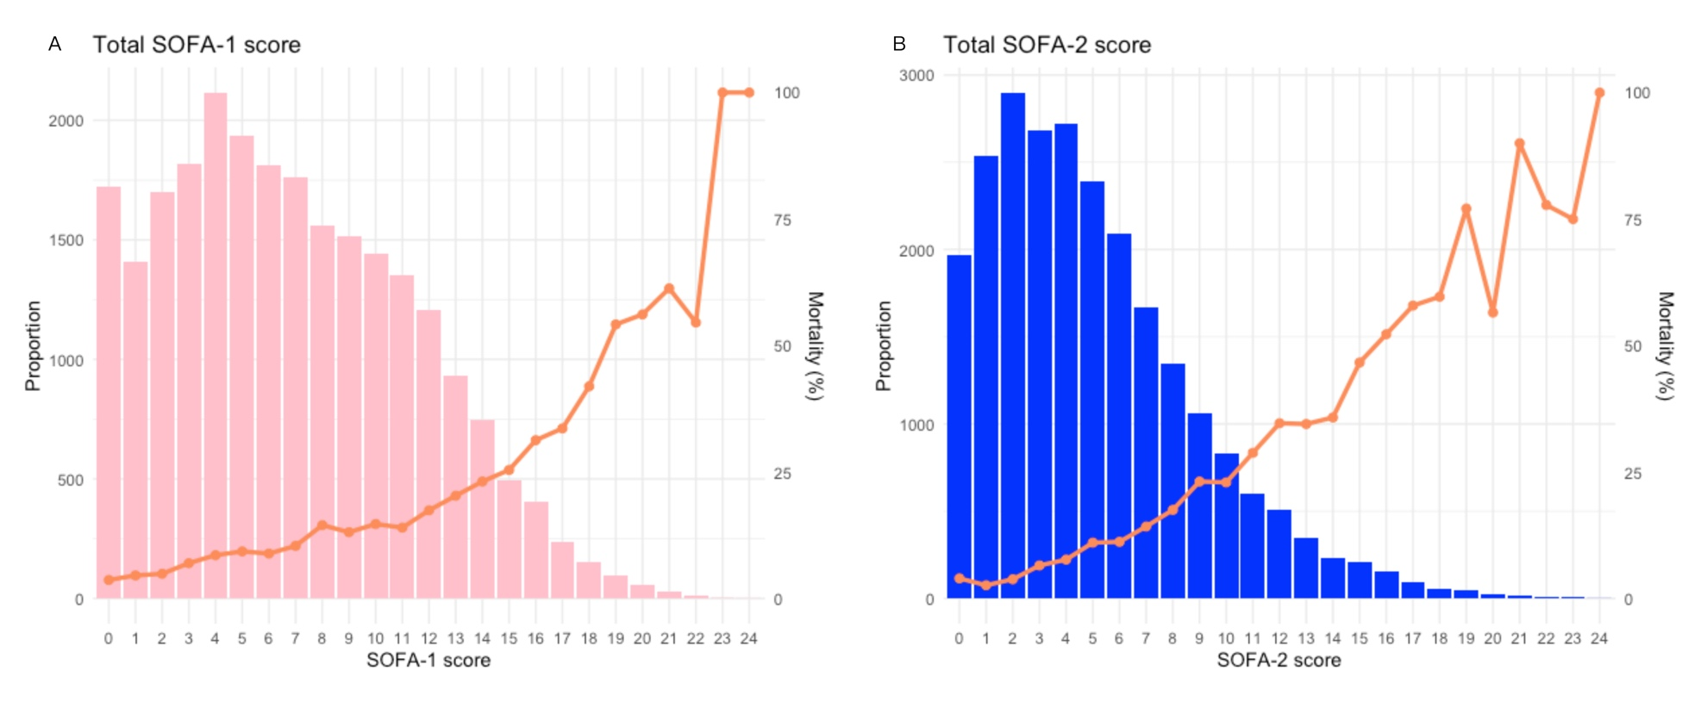

Figure S2. Distribution and Associated In-hospital Mortality by SOFA-1 versus SOFA-2 in the Kidney and Brain Domain.
A-C. Distribution of score differences between SOFA versions (SOFA-2 - SOFA-1) in the kidney domain and the corresponding in-hospital mortality across categories.
D-F. Distribution of score differences between SOFA versions (SOFA-2 - SOFA-1) in the brain domain and the corresponding in-hospital mortality across categories.
ICU = Intensive care unit; SOFA = Sequential Organ Failure Assessment.
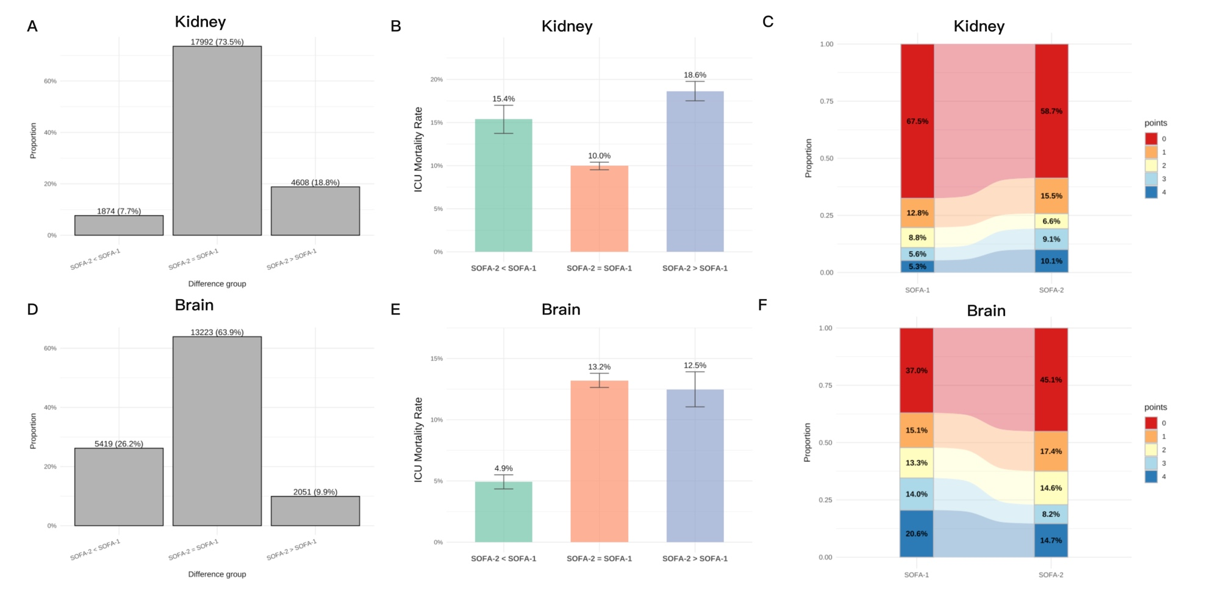

Figure S3. Distribution and Associated In-hospital Mortality of SOFA-1 versus SOFA-2 in Cardiovascular and Respiratory Domain.
A-C. Distribution of score differences between SOFA versions (SOFA-2 – SOFA-1) in the cardiovascular domain and the corresponding in-hospital mortality across categories.
D-F. Distribution of score differences between SOFA versions (SOFA-2 – SOFA-1) in the respiratory domain and the corresponding in-hospital mortality across categories.
ICU = Intensive care unit; SOFA = Sequential Organ Failure Assessment.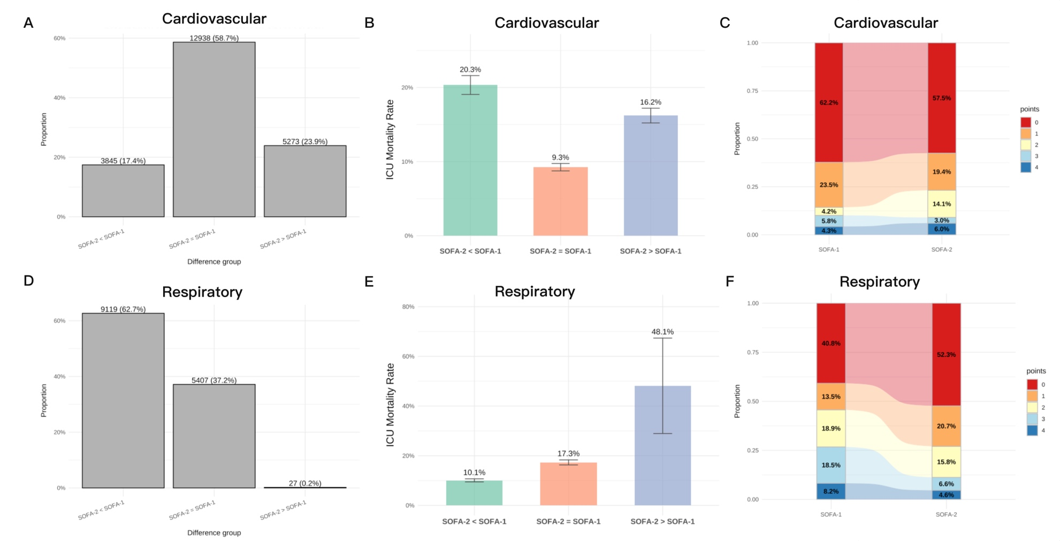

Figure S4. Distribution and Associated In-hospital Mortality of SOFA-1 versus SOFA-2 in Hemostasis and Liver Domain.
A-C. Distribution of score differences between SOFA versions (SOFA-2 – SOFA-1) in the hemostasis domain and the corresponding in-hospital mortality across categories.
D-F. Distribution of score differences between SOFA versions (SOFA-2 – SOFA-1) in the liver domain and the corresponding in-hospital mortality across categories.
ICU = Intensive care unit; SOFA = Sequential Organ Failure Assessment.

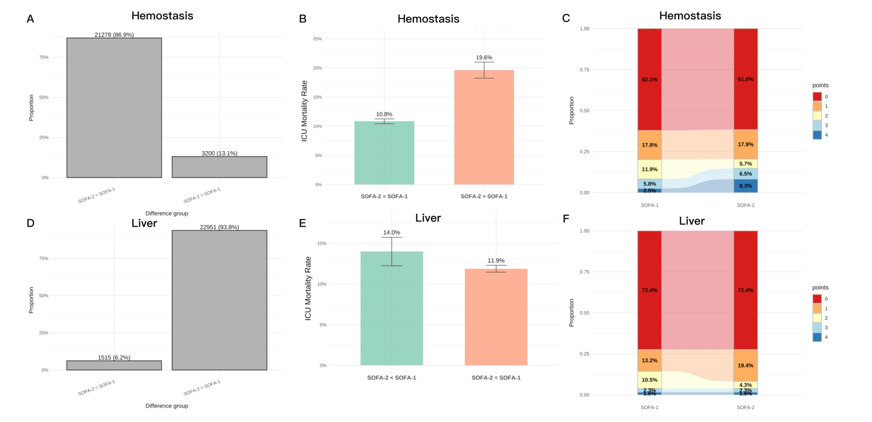

Figure S5. Discriminative Performance of Sequential Organ Failure Assessment (SOFA) Scores for In-hospital Mortality.
The area under the receiver operating characteristic curves (AUROCs) comparing the discriminative performance of the SOFA score (SOFA-1 versus SOFA-2) for predicting in-hospital mortality. The area under the ROC curve (AUC) for SOFA-1 was 0.679 (95% CI, 0.668 - 0.689), and for SOFA-2 was 0.746 (95% CI, 0.737 - 0.756).

Figure S6. Distribution and In-hospital Mortality by Total SOFA Score among Patients with Suspected Infection Required IMV.
The distribution and observed in-hospital mortality rates across total SOFA-1 (A) and SOFA-2 (B) scores of patients with suspected infection required IMV upon ICU admission.
ICU = Intensive care unit; IMV = Invasive mechanical ventilation.
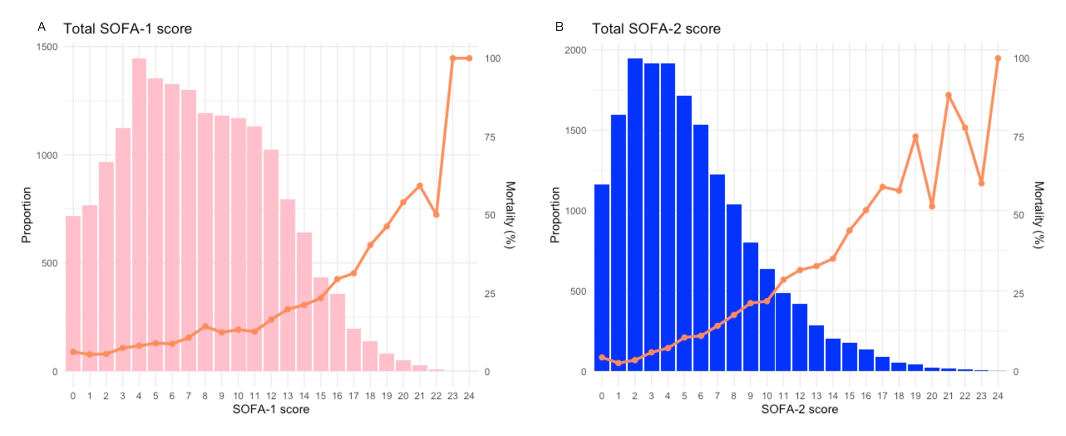

Figure S7. Survival and Hazard Analysis of SOFA Score Categories for Patients with Suspected Infection Required IMV.
A: Kaplan-Meier (KM) survival curves for in-hospital mortality. B: Forest plots illustrating the results of the cox proportional hazards model for in-hospital mortality, showing the hazard ratios (HR) and 95% confidence intervals (CI) for the SOFA score categories.
IMV = Invasive mechanical ventilation.

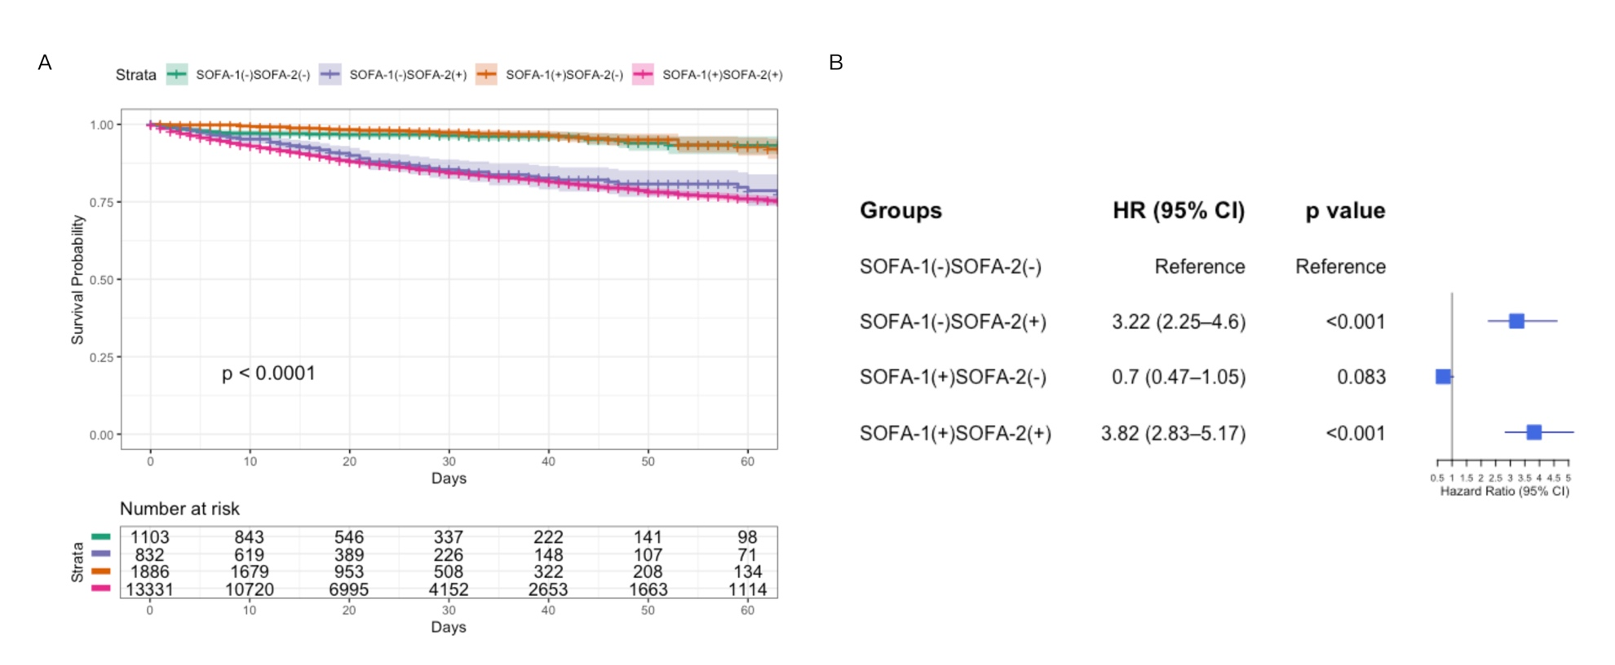

Figure S8. Discriminative performance of Sequential Organ Failure Assessment (SOFA) scores for mortality among patients with suspected infection required IMV.
The area under the receiver operating characteristic curves (AUROCs) comparing the discriminative performance of the SOFA score (SOFA-1 versus SOFA-2) for predicting in-hospital mortality. The area under the ROC curve (AUC) for SOFA-1 was 0.655 (95% CI, 0.642 - 0.667), and for SOFA-2 was 0.749 (95% CI, 0.738 - 0.760).
IMV = Invasive mechanical ventilation.

Figure S9. Survival and Hazard Analysis of SOFA Score Categories for Patients with Suspected Infection and Hyperlacticaemia.
A: Kaplan-Meier (KM) survival curves for in-hospital mortality. B: Forest plots illustrating the results of the cox proportional hazards model for in-hospital mortality, showing the hazard ratios (HR) and 95% confidence intervals (CI) for the SOFA score categories.
Hyperlacticaemia: maximum lactate concentration during the early ICU period was ≥2 mmol/L.
ICU = Intensive Care Unit; SOFA = Sequential Organ Failure Assessment.

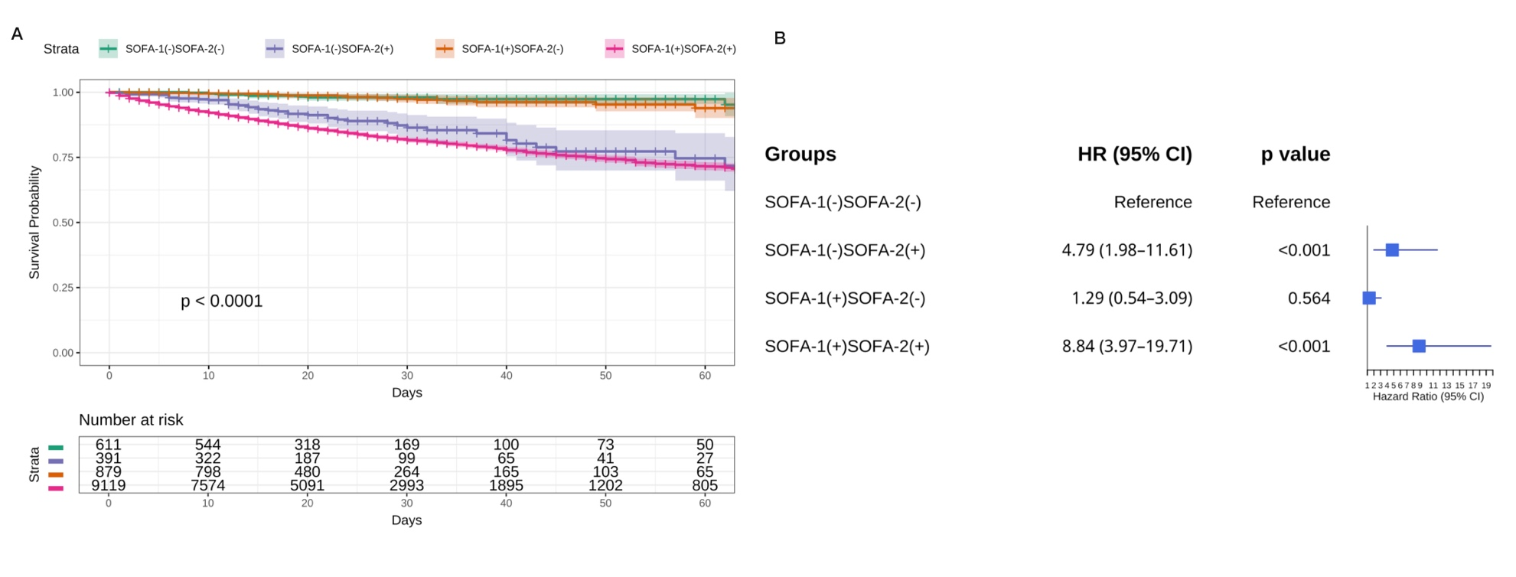

Figure S10. The distribution and ICU mortality by SOFA scores on admission among patients with suspected infection in MIMIC-IV.
The distribution and observed in-hospital mortality rates across total SOFA-1 (A) and SOFA-2 (B) scores of patients with suspected infection in MIMIC-IV upon ICU admission.

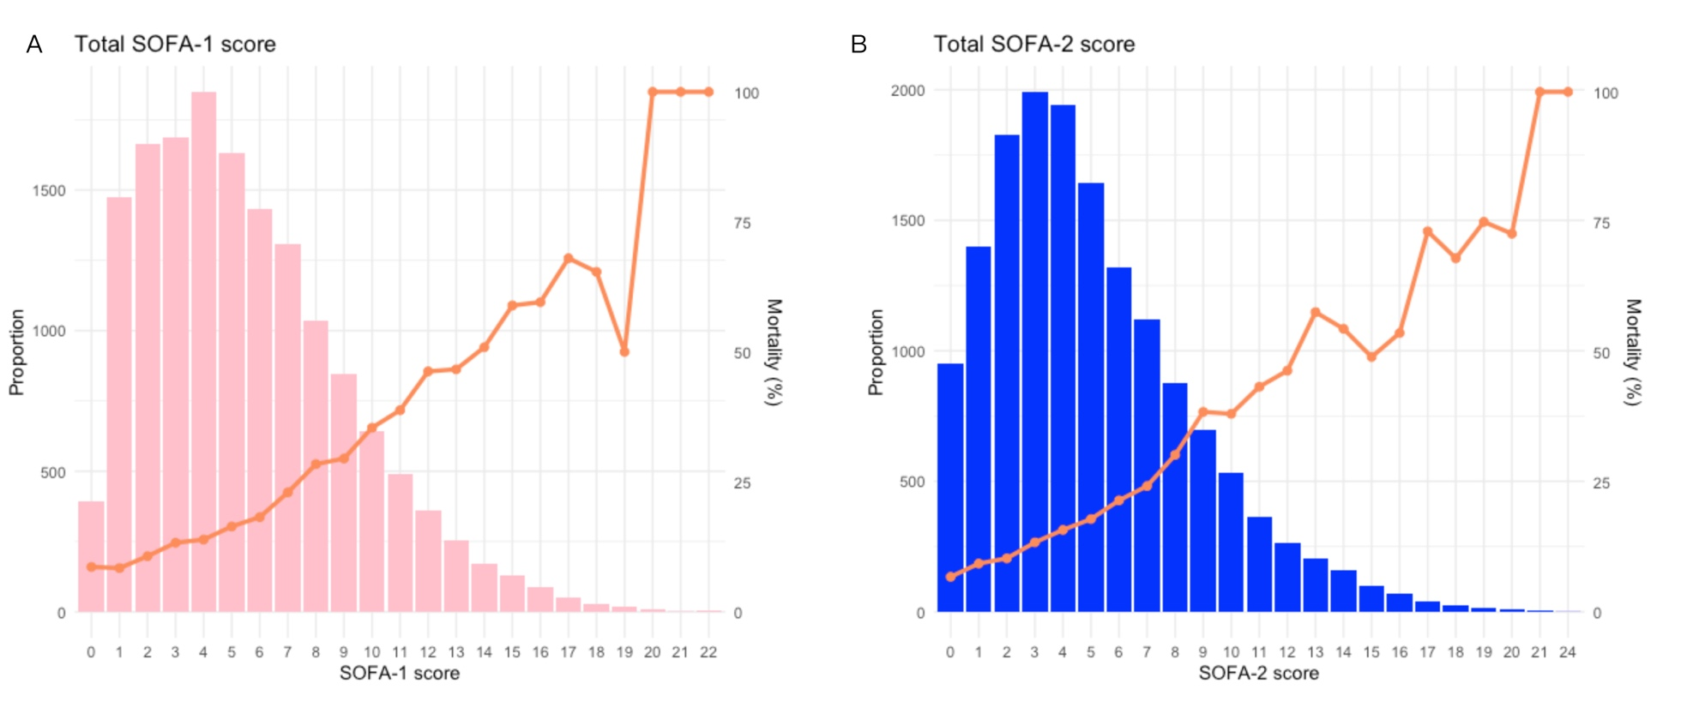

Figure S11. The difference and relationship between SOFA-1 and SOFA-2 Scores among Patients with Suspected Infection in MIMIC-IV.
- The distribution change from total SOFA-1 to SOFA-2 is shown.
B. Agreement between SOFA-1 and SOFA-2 scores and their association with in-hospital mortality.

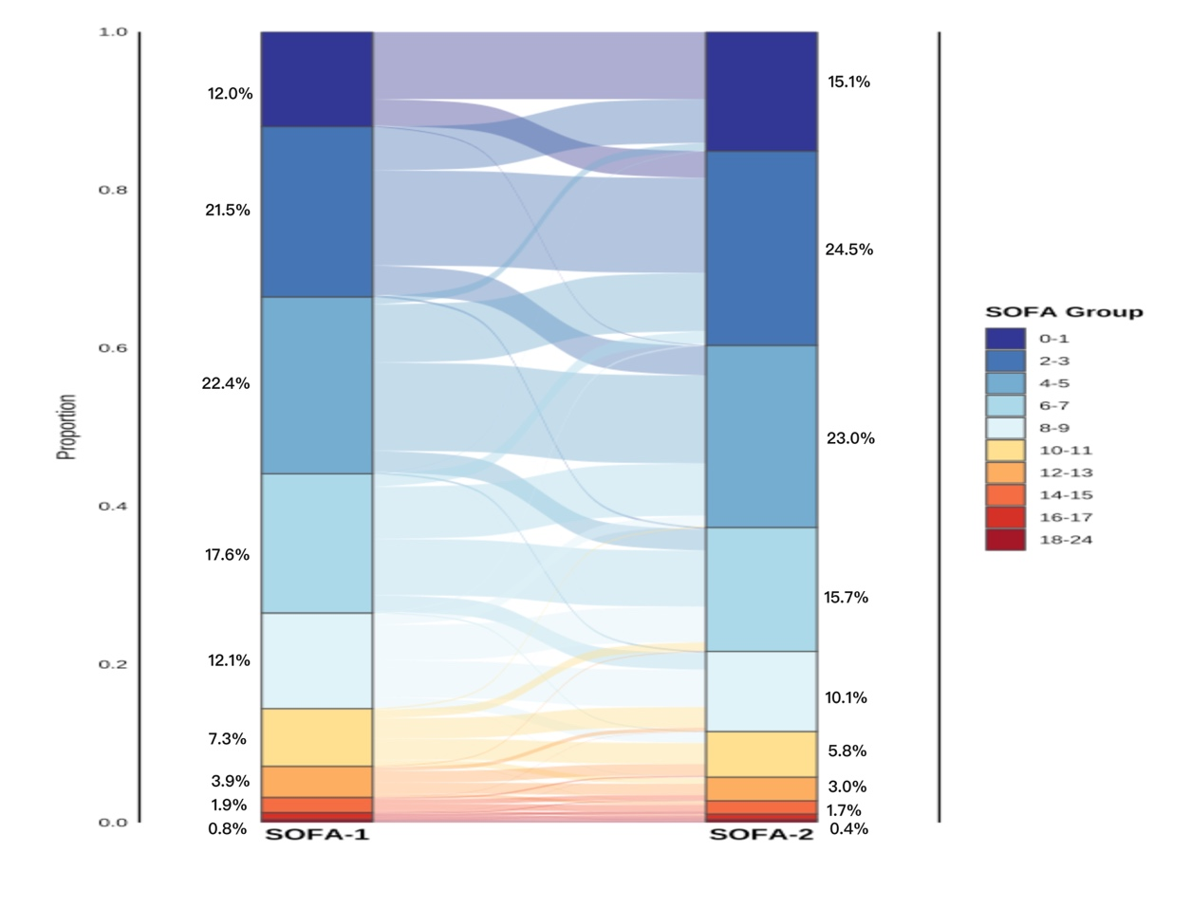

Figure S12. Survival and Hazard Analysis of SOFA Score Categories for Patients with Suspected Infection in MIMIC-IV.
A: Kaplan-Meier (KM) survival curves for in-hospital mortality. B: Forest plots illustrating the results of the cox proportional hazards model for in-hospital mortality, showing the hazard ratios (HR) and 95% confidence intervals (CI) for the SOFA score categories.

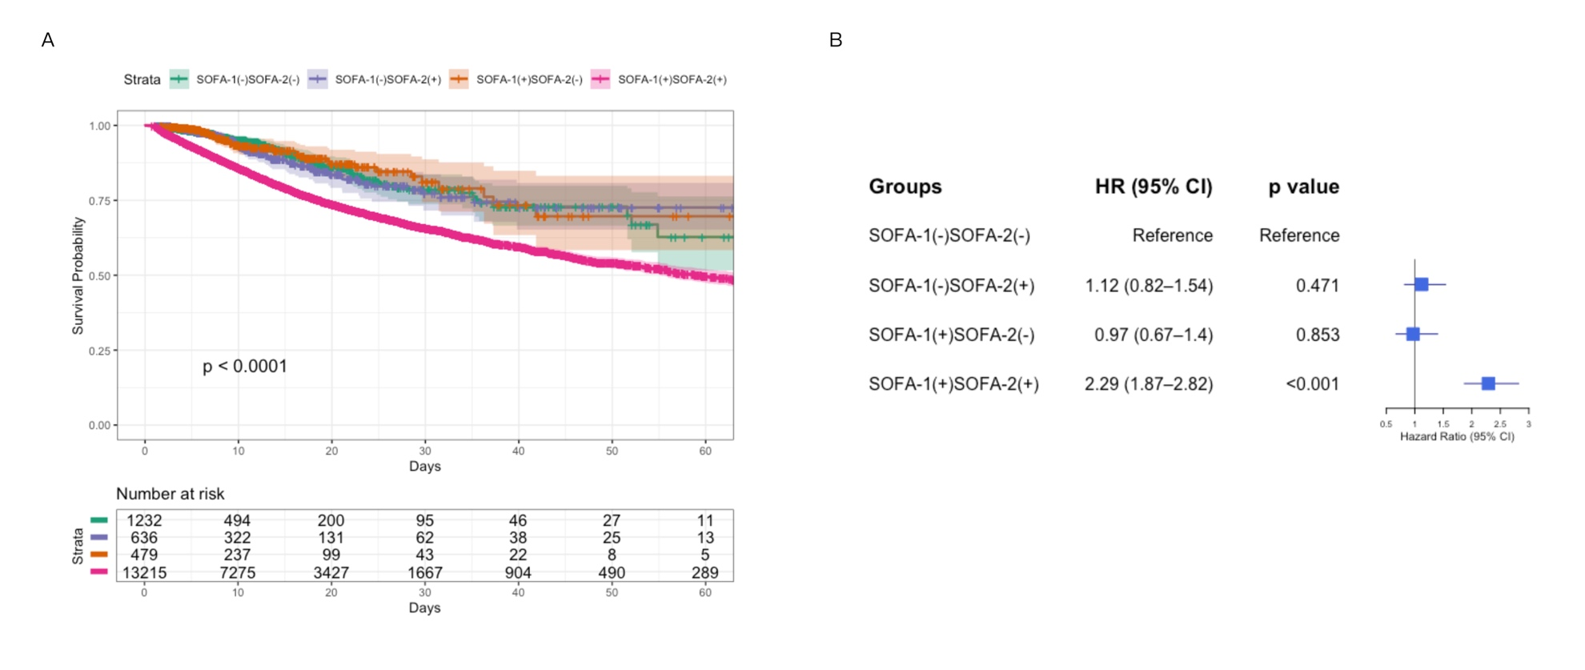

Figure S13. Discriminative performance of Sequential Organ Failure Assessment (SOFA) scores for in-hospital mortality among patients with suspected infection in MIMIC-IV.
The area under the receiver operating characteristic curves (AUROCs) comparing the discriminative performance of the SOFA score (SOFA-1 versus SOFA-2) for predicting in-hospital mortality. The area under the ROC curve (AUC) for SOFA-1 was 0.688 (95% CI, 0.678 - 0.699), and for SOFA-2 was 0.694 (95% CI, 0.683 - 0.704).

Figure S14. Distribution and Associated In-hospital Mortality by SOFA-1 versus SOFA-2 in the Hemostasis and Liver Domain in MIMIC-IV cohort.
A-C. Distribution of score differences between SOFA versions (SOFA-2 - SOFA-1) in the hemostasis domain and the corresponding in-hospital mortality across categories.
D-F. Distribution of score differences between SOFA versions (SOFA-2 - SOFA-1) in the liver domain and the corresponding in-hospital mortality across categories.
ICU = Intensive care unit; SOFA = Sequential Organ Failure Assessment.
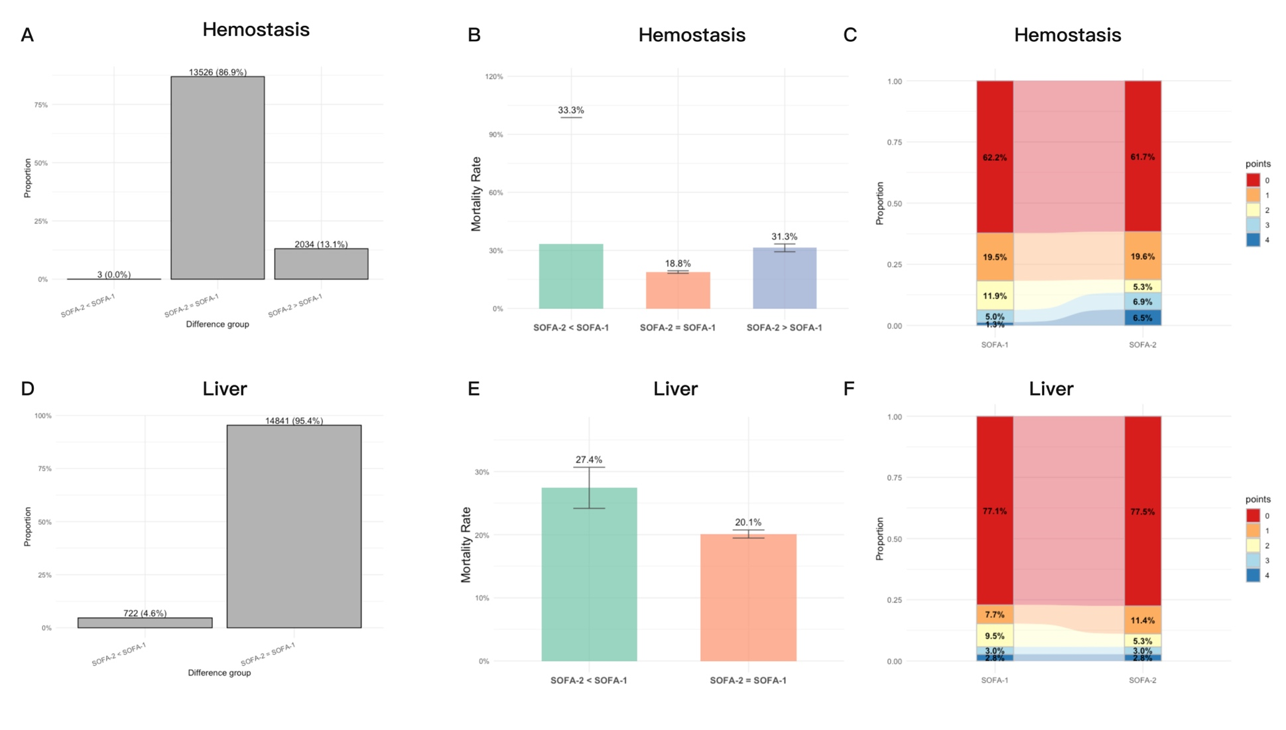

Figure S15. Distribution and Associated In-hospital Mortality by SOFA-1 versus SOFA-2 in the Cardiovascular and Respiratory Domain in MIMIC-IV cohort.
A-C. Distribution of score differences between SOFA versions (SOFA-2 - SOFA-1) in the cardiovascular domain and the corresponding in-hospital mortality across categories.
D-F. Distribution of score differences between SOFA versions (SOFA-2 - SOFA-1) in the respiratory domain and the corresponding in-hospital mortality across categories.
ICU = Intensive care unit; SOFA = Sequential Organ Failure Assessment.
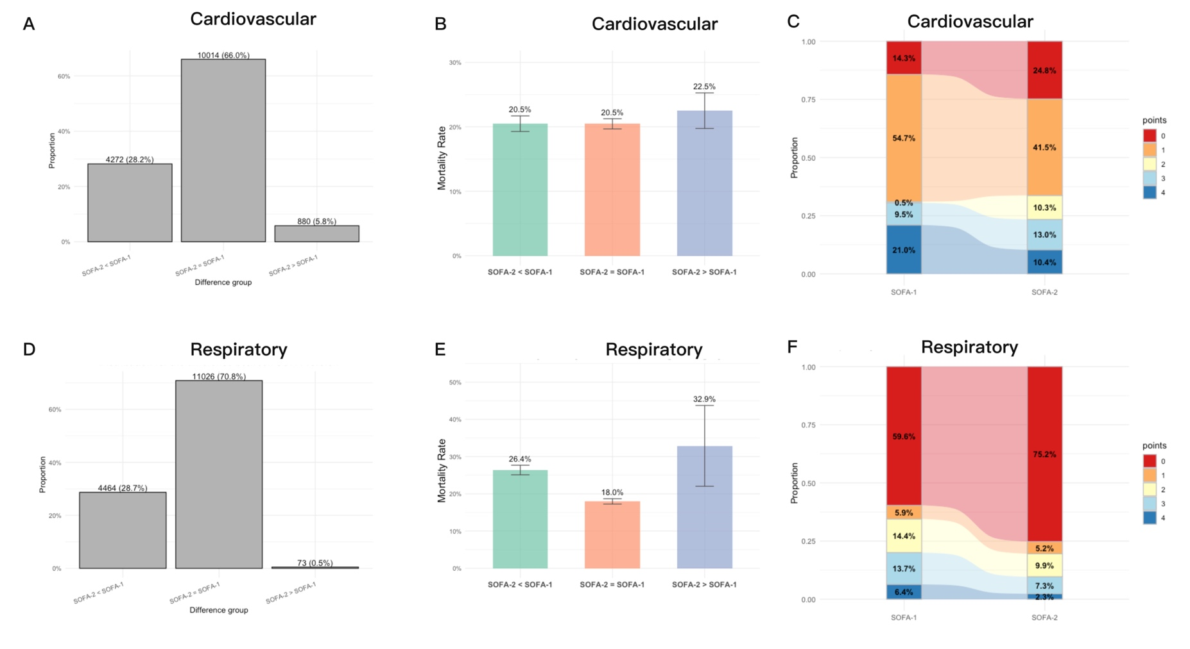

Figure S16. Distribution and Associated In-hospital Mortality by SOFA-1 versus SOFA-2 in the Kidney and Brain Domain in MIMIC-IV cohort.
A-B. Distribution of score differences between SOFA versions (SOFA-2 - SOFA-1) in the kidney domain and the corresponding in-hospital mortality across categories.
C-D. Distribution of score differences between SOFA versions (SOFA-2 - SOFA-1) in the brain domain and the corresponding in-hospital mortality across categories.
ICU = Intensive care unit; SOFA = Sequential Organ Failure Assessment.
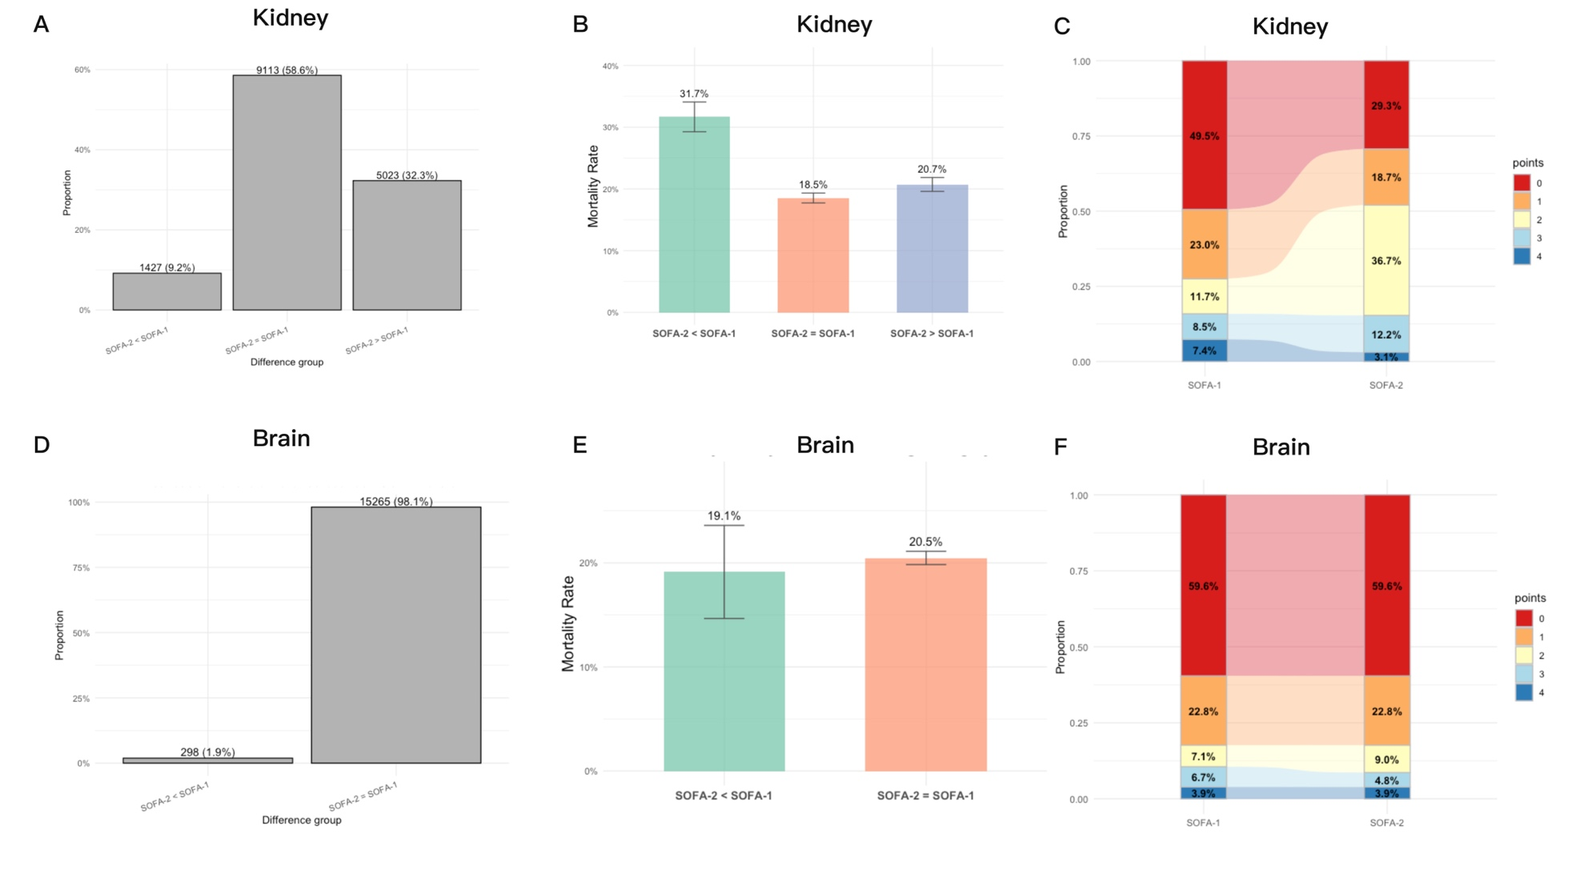

Figure S17. The cross-cohort comparison of treatment-associated score differences between primary cohort and MIMIC-IV cohort.

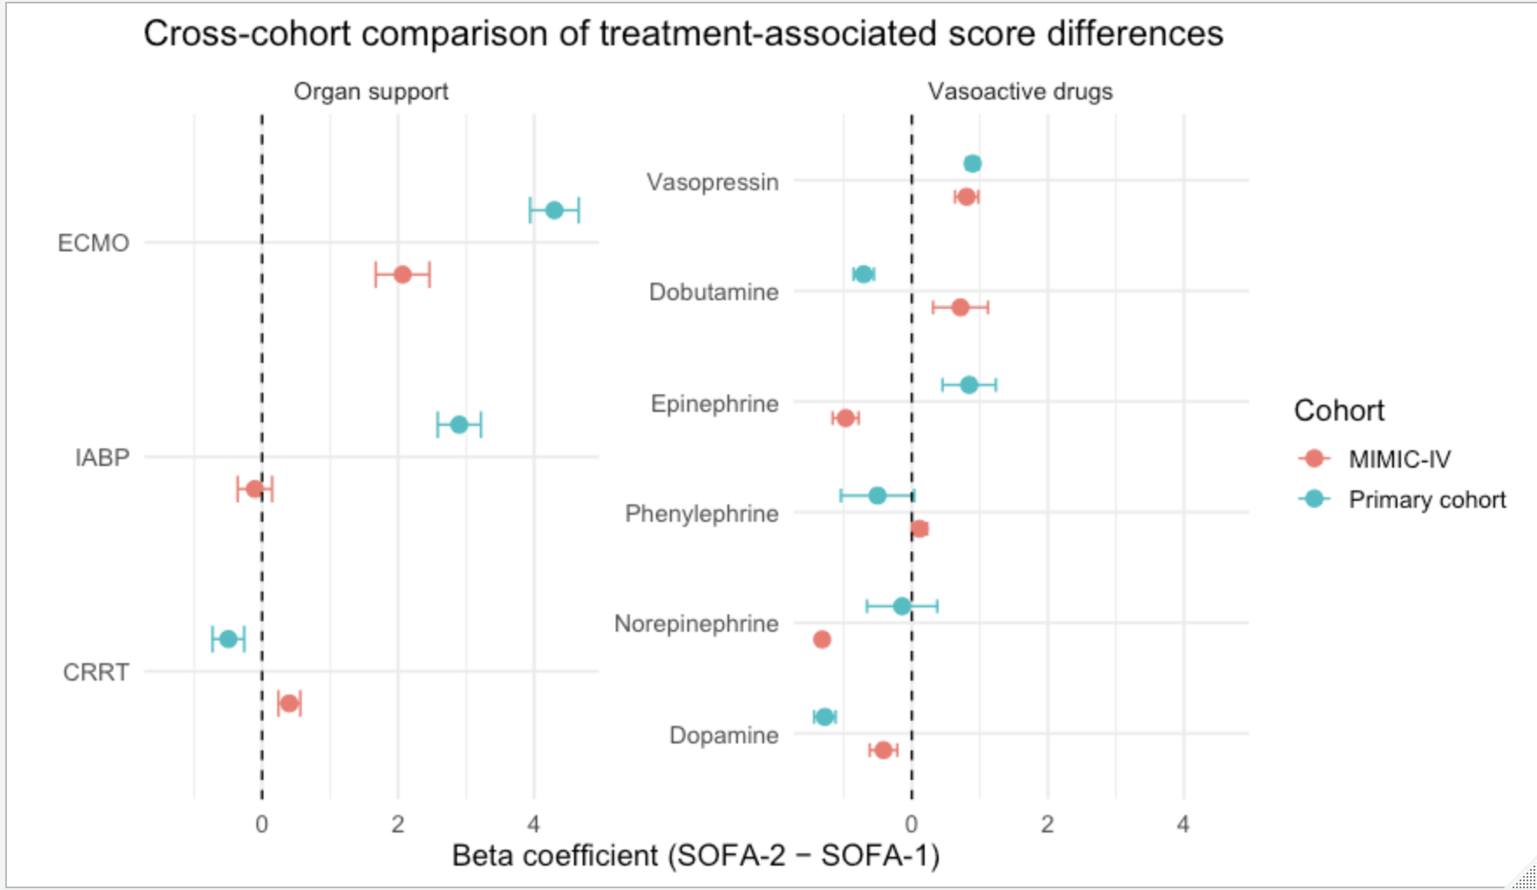

Supplemental methods

Sensitivity analysis
Sensitivity analyses were conducted to assess the robustness of the primary findings under alternative analytical assumptions and across clinically relevant subgroups.
First, to evaluate the impact of missing data handling, we applied alternative imputation strategies for variables included in the SOFA components and covariates, and reassessed the discriminative performance (AUROC) and multivariable-adjusted associations with ICU mortality.
Second, to address potential population heterogeneity and differences in illness severity, subgroup analyses were performed in clinically defined subsets of patients. These included: (1) patients requiring invasive mechanical ventilation (IMV) during ICU stay; (2) patients with hyperlactatemia, defined as a maximum serum lactate concentration ≥2 mmol/L measured from ICU admission through day 7; and (3) patients with complete PaO₂/FiO₂ ratio data available for respiratory SOFA assessment. Within each subgroup, the performance of SOFA-1 and SOFA-2 for sepsis identification was re-evaluated using the same analytical framework as in the primary analysis.
Lactate-based stratification was selected as a marker of metabolic severity because serum lactate is a well-established indicator of tissue hypoperfusion and disease severity in critically ill patients and is not incorporated into either SOFA-1 or SOFA-2, thereby minimizing the risk of circularity when comparing the two scoring systems.
Third, the robustness and generalizability of the findings were further examined through external validation using the MIMIC-IV database, with particular attention to reclassification patterns and the identification of patients at high risk of ICU mortality.

The sedation for brain scores.
According to the SOFA-2 criteria, patients receiving pharmacologic treatment for delirium were assigned at least 1 point in the neurological component, even if the recorded GCS was 15, whereas sedation for non-neurological indications was not considered evidence of neurological dysfunction.

The code for estimation the FiO₂ from O₂ delivery systems
1. Partial rebreathing masks
FiO2 = {50, if PRM = 10; 55, if PRM = 11; 60, if PRM = 12}
2. Simple masks
FiO2 = {21 + 4 × Mask, if 21 + 4×Mask ≤ 50; 35, if 21 + 4×Mask > 50}
3. Nasal cannula
FiO2 = {21 + 4 × NC, if 21 + 4×NC ≤ 40; 40, if 21 + 4×NC > 40}
4. No oxygen delivery systems: 21%

Primary code for SOFA-2 (sample from MIMIC-IV)
--SOFA 2.0
DROP MATERIALIZED VIEW IF EXISTS mimiciv_derived.sofa2_v3;
CREATE MATERIALIZED VIEW mimiciv_derived.sofa2_v3 AS
WITH co AS (
SELECT
ih.stay_id,
ie.hadm_id,
ie.intime AS icu_intime,
hr,
ih.endtime - INTERVAL '1 HOUR' AS starttime,
ih.endtime
FROM mimiciv_derived.icustay_hourly AS ih
INNER JOIN mimiciv_icu.icustays AS ie
ON ih.stay_id = ie.stay_id
),
spo2 AS (
SELECT
ce.stay_id,
DATE_TRUNC('hour', ce.charttime) AS hour_time,
MIN(ce.valuenum) AS spo2_min
FROM mimiciv_icu.chartevents ce
WHERE ce.itemid = 220277 -- SpO₂的itemid
AND ce.valuenum IS NOT NULL
GROUP BY
ce.stay_id,
DATE_TRUNC('hour', ce.charttime)
),
fio2 AS (
SELECT
vs.stay_id,
DATE_TRUNC('hour', vs.charttime) AS hour_time,
MAX(vs.fio2) AS fio2_max
FROM mimiciv_derived.ventilator_setting vs
WHERE vs.fio2 IS NOT NULL
GROUP BY
vs.stay_id,
DATE_TRUNC('hour', vs.charttime)
),
spo2_fio2_ratio AS (
SELECT
s.stay_id,
s.hour_time,
ROUND((s.spo2_min :: NUMERIC) / (f.fio2_max :: NUMERIC / 100), 2) AS spo2fio2_ratio
FROM spo2 s
LEFT JOIN fio2 f
ON s.stay_id = f.stay_id
AND s.hour_time = f.hour_time
),
pafi_spo2 AS (
SELECT
ie.stay_id,
bg.charttime,
DATE_PART('hour', bg.charttime - ie.intime) AS hr,
CASE WHEN vd.stay_id IS NULL THEN bg.pao2fio2ratio ELSE NULL END AS pao2fio2ratio_novent,
CASE WHEN vd.stay_id IS NOT NULL THEN bg.pao2fio2ratio ELSE NULL END AS pao2fio2ratio_vent,
CASE
WHEN vd.stay_id IS NULL
THEN COALESCE(bg.pao2fio2ratio, sfr.spo2fio2_ratio)
ELSE NULL
END AS combined_ratio_novent,
CASE
WHEN vd.stay_id IS NOT NULL
THEN COALESCE(bg.pao2fio2ratio, sfr.spo2fio2_ratio)
ELSE NULL
END AS combined_ratio_vent
FROM mimiciv_icu.icustays AS ie
INNER JOIN mimiciv_derived.bg AS bg ON ie.subject_id = bg.subject_id
LEFT JOIN mimiciv_derived.ventilation AS vd
ON ie.stay_id = vd.stay_id
AND bg.charttime >= vd.starttime
AND bg.charttime <= vd.endtime
AND (
vd.ventilation_status = 'InvasiveVent'
OR vd.ventilation_status = 'HFNC'
OR vd.ventilation_status = 'Tracheostomy'
OR vd.ventilation_status = 'NonInvasiveVent'
)
LEFT JOIN spo2_fio2_ratio sfr
ON ie.stay_id = sfr.stay_id
AND DATE_TRUNC('hour', bg.charttime) = sfr.hour_time
WHERE bg.specimen = 'ART.'
),
vs AS (
SELECT
co.stay_id,
co.hr,
MIN(vs.mbp) AS meanbp_min
FROM co
LEFT JOIN mimiciv_derived.vitalsign AS vs
ON co.stay_id = vs.stay_id
AND co.starttime < vs.charttime
AND co.endtime >= vs.charttime
GROUP BY
co.stay_id,
co.hr
),
sedation_delirium AS (
SELECT
co.stay_id,
co.hr,
CASE WHEN EXISTS (
SELECT 1 FROM mimiciv_icu.inputevents ie
WHERE ie.stay_id = co.stay_id
AND ie.itemid IN (221744, 221668, 221906, 221741)
AND ie.starttime < co.endtime
AND ie.endtime > co.starttime
AND COALESCE(ie.rate, 0) > 0
) THEN TRUE ELSE FALSE END AS has_sedation,
CASE WHEN EXISTS (
SELECT 1 FROM mimiciv_hosp.diagnoses_icd di
WHERE di.stay_id = co.stay_id
AND (di.icd_code LIKE 'F05%' OR di.icd_code = 'R41.82')
) OR EXISTS (
SELECT 1 FROM mimiciv_icu.chartevents ce
WHERE ce.stay_id = co.stay_id
AND ce.itemid = 223900 -- CAM-ICU评分
AND ce.charttime BETWEEN co.starttime AND co.endtime
AND ce.valuenum = 1 -- CAM-ICU阳性（谵妄）
) THEN TRUE ELSE FALSE END AS has_delirium
FROM co
)
gcs AS (
SELECT
co.stay_id,
co.hr,
MIN(gcs.gcs) AS gcs_min
FROM co
LEFT JOIN mimiciv_derived.gcs AS gcs
ON co.stay_id = gcs.stay_id
AND co.starttime < gcs.charttime
AND co.endtime >= gcs.charttime
GROUP BY
co.stay_id,
co.hr
),
bili AS (
SELECT
co.stay_id,
co.hr,
MAX(enz.bilirubin_total) AS bilirubin_max
FROM co
LEFT JOIN mimiciv_derived.enzyme AS enz
ON co.hadm_id = enz.hadm_id
AND co.starttime < enz.charttime
AND co.endtime >= enz.charttime
GROUP BY
co.stay_id,
co.hr
),
cr AS (
SELECT
co.stay_id,
co.hr,
MAX(chem.creatinine) AS creatinine_max
FROM co
LEFT JOIN mimiciv_derived.chemistry AS chem
ON co.hadm_id = chem.hadm_id
AND co.starttime < chem.charttime
AND co.endtime >= chem.charttime
GROUP BY
co.stay_id,
co.hr
),
plt AS (
SELECT
co.stay_id,
co.hr,
MIN(cbc.platelet) AS platelet_min
FROM co
LEFT JOIN mimiciv_derived.complete_blood_count AS cbc
ON co.hadm_id = cbc.hadm_id
AND co.starttime < cbc.charttime
AND co.endtime >= cbc.charttime
GROUP BY
co.stay_id,
co.hr
),
pf AS (
SELECT
co.stay_id,
co.hr,
MIN(pafi_spo2.pao2fio2ratio_novent) AS pao2fio2ratio_novent,
MIN(pafi_spo2.pao2fio2ratio_vent) AS pao2fio2ratio_vent
FROM co
LEFT JOIN pafi_spo2
ON co.stay_id = pafi_spo2.stay_id
AND co.hr = pafi_spo2.hr
AND co.starttime < pafi_spo2.charttime
AND co.endtime >= pafi_spo2.charttime
GROUP BY
co.stay_id,
co.hr
),
uo AS (
SELECT
co.stay_id,
co.hr,
MAX(uo.uo_mlkghr_6hr) AS uo_6hr,
MAX(uo.uo_mlkghr_12hr) AS uo_12hr,
MAX(uo.uo_mlkghr_24hr) AS uo_24hr,
MAX(
CASE
WHEN uo.uo_tm_24hr BETWEEN 22 AND 30
THEN CAST(uo.urineoutput_24hr AS NUMERIC) / uo.uo_tm_24hr * 24
END
) AS uo_total_24hr
FROM co
LEFT JOIN mimiciv_derived.urine_output_rate AS uo
ON co.stay_id = uo.stay_id
AND co.starttime < uo.charttime
AND co.endtime >= uo.charttime
GROUP BY
co.stay_id,
co.hr
),
rt AS (
SELECT
co.stay_id,
co.hr,
MAX(rrt.charttime) AS charttime,
CASE WHEN MAX(rrt.charttime) IS NOT NULL THEN 4 ELSE NULL END AS crrt
FROM co
LEFT JOIN mimiciv_derived.crrt AS rrt
ON co.stay_id = rrt.stay_id
AND co.starttime < rrt.charttime
AND co.endtime >= rrt.charttime
WHERE rrt.crrt_mode IS NOT NULL
GROUP BY
co.stay_id,
co.hr
),
bg AS (
SELECT
co.stay_id,
co.hr,
MIN(bg.ph) AS ph_min,
MIN(bg.bicarbonate) AS HCO3_min,
MAX(bg.potassium) AS K_max
FROM co
LEFT JOIN mimiciv_derived.bg
ON co.hadm_id = bg.hadm_id
AND co.starttime < bg.charttime
AND co.endtime >= bg.charttime
AND bg.specimen = 'ART.'
GROUP BY
co.stay_id,
co.hr
),
rt_2 AS (
SELECT
co.stay_id,
co.hr,
MAX(cr.creatinine_max) AS creatinine_max,
MAX(uo.uo_6hr) AS uo_6hr,
MIN(bg.ph_min) AS ph_min,
MIN(bg.HCO3_min) AS HCO3_min,
MAX(bg.K_max) AS K_max,
CASE
WHEN (MAX(uo.uo_6hr) < 0.3 OR MAX(cr.creatinine_max) > 1.2)
AND ((MIN(bg.ph_min) <= 7.2 AND MIN(bg.HCO3_min) <= 12) OR MAX(bg.K_max) >= 6.0)
THEN 1
WHEN COALESCE(MAX(cr.creatinine_max),MAX(uo.uo_6hr),MIN(bg.ph_min),MIN(bg.HCO3_min),MAX(bg.K_max)) IS NULL
THEN NULL
ELSE 0
END AS crrt_2
FROM co
LEFT JOIN cr ON co.stay_id = cr.stay_id AND co.hr = cr.hr
LEFT JOIN uo ON co.stay_id = uo.stay_id AND co.hr = uo.hr
LEFT JOIN bg ON co.stay_id = bg.stay_id AND co.hr = bg.hr
GROUP BY co.stay_id, co.hr
),
vaso AS (
SELECT
co.stay_id,
co.hr,
MAX(epi.vaso_rate) AS rate_epinephrine,
MAX(nor.vaso_rate) AS rate_norepinephrine,
MAX(dop.vaso_rate) AS rate_dopamine,
MAX(dob.vaso_rate) AS rate_dobutamine,
MAX(vas.vaso_rate) AS rate_vasopressin,
MAX(phe.vaso_rate) AS rate_phenylephrine,
MAX(mil.vaso_rate) AS rate_milrinone
FROM co
LEFT JOIN mimiciv_derived.epinephrine AS epi
ON co.stay_id = epi.stay_id AND epi.starttime < co.endtime AND epi.endtime > co.starttime
LEFT JOIN mimiciv_derived.norepinephrine AS nor
ON co.stay_id = nor.stay_id AND nor.starttime < co.endtime AND nor.endtime > co.starttime
LEFT JOIN mimiciv_derived.dopamine AS dop
ON co.stay_id = dop.stay_id AND dop.starttime < co.endtime AND dop.endtime > co.starttime
LEFT JOIN mimiciv_derived.dobutamine AS dob
ON co.stay_id = dob.stay_id AND dob.starttime < co.endtime AND dob.endtime > co.starttime
LEFT JOIN mimiciv_derived.vasopressin AS vas
ON co.stay_id = vas.stay_id AND vas.starttime < co.endtime AND vas.endtime > co.starttime
LEFT JOIN mimiciv_derived.phenylephrine AS phe
ON co.stay_id = phe.stay_id AND co.endtime > phe.starttime AND co.endtime <= phe.endtime
LEFT JOIN mimiciv_derived.milrinone AS mil
ON co.stay_id = mil.stay_id AND mil.starttime < co.endtime AND mil.endtime > co.starttime
WHERE
epi.stay_id IS NOT NULL
OR nor.stay_id IS NOT NULL
OR dop.stay_id IS NOT NULL
OR dob.stay_id IS NOT NULL
OR vas.stay_id IS NOT NULL
OR phe.stay_id IS NOT NULL
OR mil.stay_id IS NOT NULL
GROUP BY
co.stay_id,
co.hr
),
vaso_2 AS (
SELECT
co.stay_id,
co.hr,
co.starttime,
co.endtime,
ROUND(CAST(COALESCE(rate_norepinephrine, 0) + COALESCE(rate_epinephrine, 0) AS NUMERIC), 4) AS NE_Epi_dose,
ROUND(
CASE WHEN rate_dopamine > 0 THEN CAST(rate_dopamine AS NUMERIC) / 100 ELSE 0 END,
4
) AS dopamine_ne_equivalent,
CASE
WHEN (rate_phenylephrine IS NOT NULL AND rate_phenylephrine > 0)
OR (rate_vasopressin IS NOT NULL AND rate_vasopressin > 0)
OR (rate_dobutamine IS NOT NULL AND rate_dobutamine > 0)
OR (rate_milrinone IS NOT NULL AND rate_milrinone > 0)
THEN TRUE
ELSE FALSE
END AS is_other_vaso_used
FROM co
LEFT JOIN vaso ON co.stay_id = vaso.stay_id AND co.hr = vaso.hr
),
LVAD AS (
SELECT
co.stay_id,
co.hr,
MAX(cha.charttime) AS charttime,
CASE WHEN MAX(cha.charttime) IS NOT NULL THEN 1 ELSE NULL END AS LVAD
FROM co
LEFT JOIN mimiciv_icu.chartevents AS cha
ON co.stay_id = cha.stay_id AND co.starttime < cha.charttime AND co.endtime >= cha.charttime
WHERE cha.itemid = 220125
GROUP BY co.stay_id, co.hr
),
RVAD AS (
SELECT
co.stay_id,
co.hr,
MAX(cha.charttime) AS charttime,
CASE WHEN MAX(cha.charttime) IS NOT NULL THEN 1 ELSE NULL END AS RVAD
FROM co
LEFT JOIN mimiciv_icu.chartevents AS cha
ON co.stay_id = cha.stay_id AND co.starttime < cha.charttime AND co.endtime >= cha.charttime
WHERE cha.itemid = 220128
GROUP BY co.stay_id, co.hr
),
IABP AS (
SELECT
co.stay_id,
co.hr,
MAX(cha.charttime) AS charttime,
CASE WHEN MAX(cha.charttime) IS NOT NULL THEN 1 ELSE NULL END AS IABP
FROM co
LEFT JOIN mimiciv_icu.chartevents AS cha
ON co.stay_id = cha.stay_id AND co.starttime < cha.charttime AND co.endtime >= cha.charttime
WHERE cha.itemid = 225979
GROUP BY co.stay_id, co.hr
),
ECMO AS (
SELECT
co.stay_id,
co.hr,
MAX(cha.charttime) AS ecmo_charttime,
CASE
WHEN COUNT(cha.charttime) > 0 THEN 1
ELSE 0
END AS ECMO
FROM co
LEFT JOIN mimiciv_icu.chartevents AS cha
ON co.stay_id = cha.stay_id
AND co.starttime < cha.charttime
AND co.endtime >= cha.charttime
AND (
cha.itemid IN (224660, 229268, 225794, 225795, 225796, 225797, 225798, 225799, 225800)
OR (cha.value IS NOT NULL AND LOWER(cha.value) LIKE '%ecmo%')
)
GROUP BY
co.stay_id, co.hr
),
scorecomp AS (
SELECT
co.stay_id,
co.hr,
co.starttime,
co.endtime,
/*respiratory*/
pf.pao2fio2ratio_novent,
pf.pao2fio2ratio_vent,
/*cardiovascular*/
vaso_2.NE_Epi_dose,
vaso_2.dopamine_ne_equivalent,
vaso_2.is_other_vaso_used,
vs.meanbp_min,
/*CNS*/
gcs.gcs_min, ,
sd.has_sedation,
sd.has_delirium,
/* uo */
uo.uo_6hr,
uo.uo_12hr,
uo.uo_24hr,
uo.uo_total_24hr,
cr.creatinine_max,
rt.crrt,
rt_2.crrt_2,
/* labs */
bili.bilirubin_max,
plt.platelet_min,
/*mechanical assistant*/
LVAD.LVAD,
RVAD.RVAD,
IABP.IABP,
ECMO.ECMO
FROM co
LEFT JOIN vs ON co.stay_id = vs.stay_id AND co.hr = vs.hr
LEFT JOIN gcs ON co.stay_id = gcs.stay_id AND co.hr = gcs.hr
LEFT JOIN bili ON co.stay_id = bili.stay_id AND co.hr = bili.hr
LEFT JOIN cr ON co.stay_id = cr.stay_id AND co.hr = cr.hr
LEFT JOIN plt ON co.stay_id = plt.stay_id AND co.hr = plt.hr
LEFT JOIN pf ON co.stay_id = pf.stay_id AND co.hr = pf.hr
LEFT JOIN uo ON co.stay_id = uo.stay_id AND co.hr = uo.hr
LEFT JOIN vaso_2 ON co.stay_id = vaso_2.stay_id AND co.hr = vaso_2.hr
LEFT JOIN rt ON co.stay_id = rt.stay_id AND co.hr = rt.hr
LEFT JOIN rt_2 ON co.stay_id = rt_2.stay_id AND co.hr = rt_2.hr
LEFT JOIN LVAD ON co.stay_id = LVAD.stay_id AND co.hr = LVAD.hr
LEFT JOIN RVAD ON co.stay_id = RVAD.stay_id AND co.hr = RVAD.hr
LEFT JOIN IABP ON co.stay_id = IABP.stay_id AND co.hr = IABP.hr
LEFT JOIN ECMO ON co.stay_id = ECMO.stay_id AND co.hr = ECMO.hr
),
scorecalc AS (
SELECT
scorecomp.*,
/* Respiration */
CASE
WHEN pao2fio2ratio_vent <= 75 OR ECMO = 1 THEN 4
WHEN pao2fio2ratio_vent <= 150 THEN 3
WHEN pao2fio2ratio_novent <= 225 THEN 2
WHEN pao2fio2ratio_vent <= 225 THEN 2
WHEN pao2fio2ratio_novent <= 300 THEN 1
WHEN pao2fio2ratio_vent <= 300 THEN 1
WHEN COALESCE(pao2fio2ratio_vent, pao2fio2ratio_novent) IS NULL THEN NULL
ELSE 0
END AS respiration,
/* Coagulation */
CASE
WHEN platelet_min <= 50 OR ECMO = 1 THEN 4
WHEN platelet_min <= 80 THEN 3
WHEN platelet_min <= 100 THEN 2
WHEN platelet_min <= 150 THEN 1
WHEN platelet_min IS NULL THEN NULL
ELSE 0
END AS coagulation,
/* Liver */
CASE
WHEN bilirubin_max > 12.0 THEN 4
WHEN bilirubin_max BETWEEN 6.0 AND 12.0 THEN 3
WHEN bilirubin_max BETWEEN 3.0 AND 6.0 THEN 2
WHEN bilirubin_max BETWEEN 1.2 AND 3.0 THEN 1
WHEN bilirubin_max IS NULL THEN NULL
ELSE 0
END AS liver,
/* Cardiovascular */
CASE
WHEN NE_Epi_dose > 0.4
OR (NE_Epi_dose BETWEEN 0.2 AND 0.4 AND (dopamine_ne_equivalent > 0 OR is_other_vaso_used IS TRUE))
OR (LVAD = 1 OR RVAD = 1 OR IABP = 1)
THEN 4
WHEN (NE_Epi_dose BETWEEN 0.2 AND 0.4 AND dopamine_ne_equivalent = 0 AND is_other_vaso_used IS FALSE)
OR (NE_Epi_dose <= 0.2 AND (dopamine_ne_equivalent > 0 OR is_other_vaso_used IS TRUE))
THEN 3
WHEN meanbp_min < 70 AND NE_Epi_dose = 0 AND dopamine_ne_equivalent = 0 AND is_other_vaso_used IS FALSE
THEN 1
WHEN meanbp_min >= 70 AND NE_Epi_dose = 0 AND dopamine_ne_equivalent = 0 AND is_other_vaso_used IS FALSE
THEN 0
WHEN (NE_Epi_dose > 0 AND NE_Epi_dose <= 0.2)
OR dopamine_ne_equivalent > 0
OR is_other_vaso_used IS TRUE
THEN 2
ELSE NULL
END AS cardiovascular,
/* Neurological failure (GCS) */
CASE
WHEN has_sedation = TRUE AND has_delirium = TRUE THEN 1
WHEN gcs_min BETWEEN 13 AND 14 THEN 1
WHEN gcs_min BETWEEN 9 AND 12 THEN 2
WHEN gcs_min BETWEEN 6 AND 8 THEN 3
WHEN gcs_min < 6 THEN 4
WHEN gcs_min IS NULL THEN NULL
ELSE 0
END AS cns,
/* Renal failure - high creatinine or low urine output */
CASE
WHEN crrt = 4 OR crrt_2 = 1 THEN 4
WHEN COALESCE(uo_6hr, uo_12hr, uo_24hr, uo_total_24hr, creatinine_max) IS NULL THEN NULL
WHEN creatinine_max > 3.5 OR uo_24hr < 0.3 OR uo_total_24hr < 100 THEN 3
WHEN creatinine_max BETWEEN 2.0 AND 3.5 OR uo_12hr < 0.5 THEN 2
WHEN creatinine_max BETWEEN 1.2 AND 2.0 OR (uo_6hr < 0.5 AND uo_12hr >= 0.5) THEN 1
WHEN creatinine_max <= 1.2 THEN 0
ELSE 0
END AS renal
FROM scorecomp
),
score_final AS (
SELECT
s.*,
COALESCE(MAX(respiration) OVER w, 0) AS respiration_24hours,
COALESCE(MAX(coagulation) OVER w, 0) AS coagulation_24hours,
COALESCE(MAX(liver) OVER w, 0) AS liver_24hours,
COALESCE(MAX(cardiovascular) OVER w, 0) AS cardiovascular_24hours,
COALESCE(MAX(cns) OVER w, 0) AS cns_24hours,
COALESCE(MAX(renal) OVER w, 0) AS renal_24hours,
COALESCE(MAX(respiration) OVER w, 0) +
COALESCE(MAX(coagulation) OVER w, 0) +
COALESCE(MAX(liver) OVER w, 0) +
COALESCE(MAX(cardiovascular) OVER w, 0) +
COALESCE(MAX(cns) OVER w, 0) +
COALESCE(MAX(renal) OVER w, 0) AS sofa_24hours
FROM scorecalc AS s
WINDOW w AS (PARTITION BY stay_id ORDER BY hr NULLS FIRST ROWS BETWEEN 23 PRECEDING AND 0 FOLLOWING)
)
SELECT *
FROM score_final
WHERE hr >= 24;

