Supplementary materials
Internal Dataset Validation of RDA and PD probabilities
In this section we report on the complementary classification performance of our convolutional neural network (CCN) on the annotated patterns (SXB, NF, PDS). The model showed a good performance with a Receiver Operating Characteristic – Area Under the Curve (ROC–AUC) of 0.87 for periodic discharges (PD) detection and 0.85 for rhythmic delta activity (RDA) detection. Figure 1 shows the differences in PD and RDA probabilities across their respective annotations.

Figure 1. Internal Validation of RDA and PD probabilities after evaulation of pattern probability by our CNN model.
Abbreviations: RDA, Rhythmic Delta Activity; PD, Periodic Discharges; CNN, Convolutional Neural Network.

Behavior of the feature of interest across a sample
In this section, we show qualitative analysis of five different cases of subjects that reflect the delta feature interaction that we highlighted in Figure 4 of the main manuscript.
First, here we show three different subjects: sub-001, sub-002, and sub-003. Sub-001 had an unfavorable outcome, while sub-002 and sub-003 had a favorable outcome but with different quantitative electroencephalogram (qEEG) trajectories. Indeed, Figure 2 reports a high value of delta level across sub-001 and sub-003 with a steeper 1/f trend that can be seen in the estimated power spectral density (right panel). The frequency characteristics are clearly different for subj-002, who instead shows a less steep aperiodic trend and a peak in alpha activity. Conversely, when we look at the connectivity in delta, the picture changes as only sub-001 demonstrates a hyper-connected topology in the delta range (Figure 3).
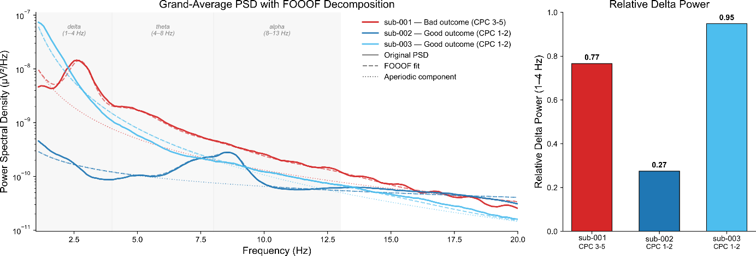
Figure 2. Distribution of power spectrum across three exemplary subjects. Left panel shows the different characteristics of the power spectrum for two good outcomes in shades of blue and poor outcome in red. Right panel shows the relative delta power across the same three subjects. Abbreviations: CPC, Cerebral Performance Category

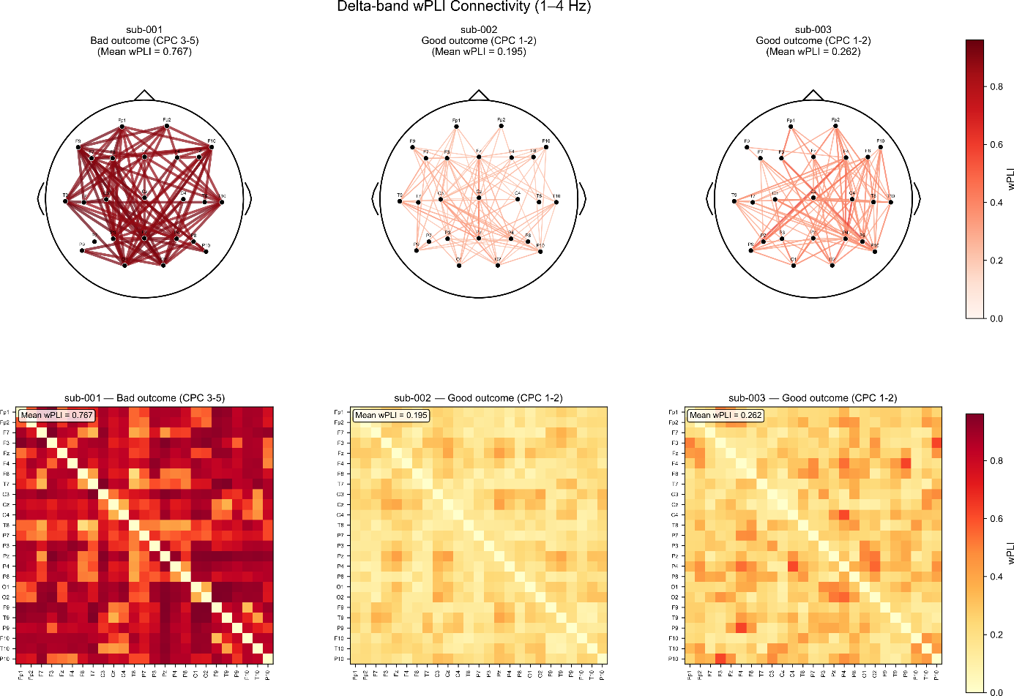
Figure 3 a. Connectivity topographies across three subjects with good outcome (on the right) and poor outcome (one the left). Upper panels: show the connections across the topography (top 100); Lower panel: Connectivity matrix for the delta power across the same ordered subjects. Abbreviations: CPC, Cerebral Performance Category
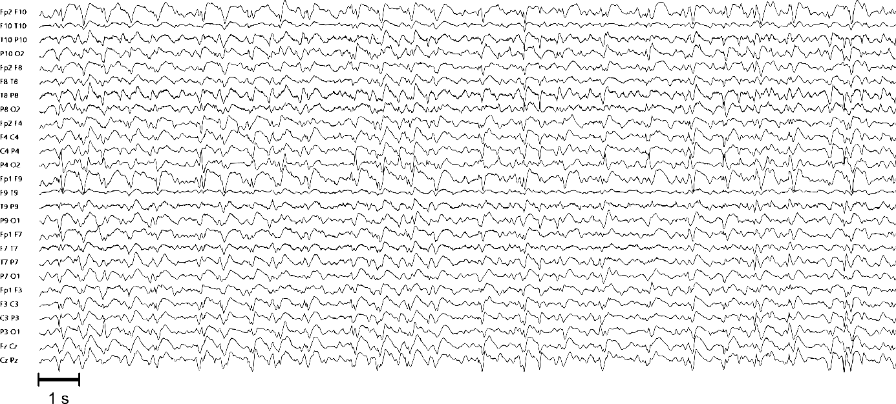
Sub-001

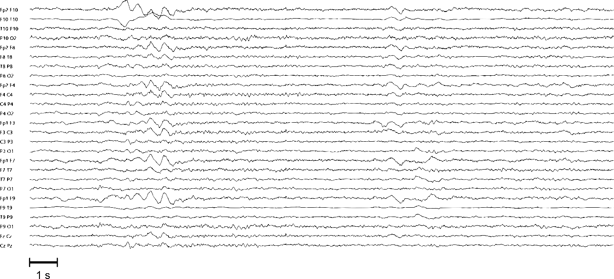
Sub-002

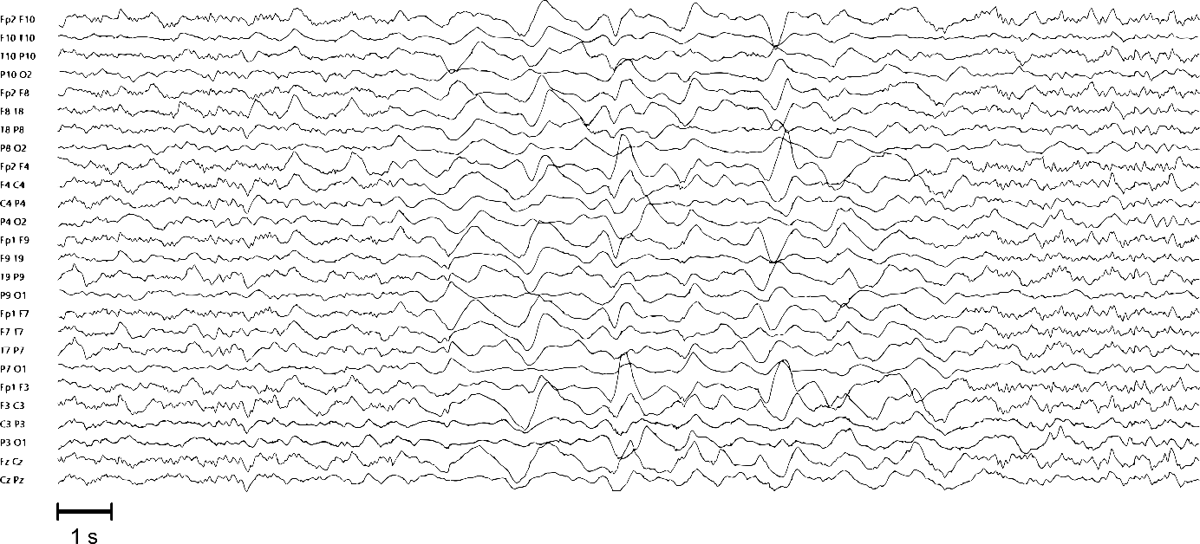
Sub-003
Figure 3.b Corresponding 20-second EEG segments from the subjects included in the connectivity analysis above. Bipolar montage; sensitivity 7 µV/mm; high-frequency filter 70 Hz; low-frequency filter 0.5 Hz; notch filter 50 Hz.
Upper panel: Subj-001 with unfavorable neurological outcome showing high delta power and high delta connectivity. EEG trace showing a theta background with GPDs+R at a frequency of 1.5 Hz. Middle panel: Subj-002 with favorable neurological outcome showing low delta power and low delta connectivity. EEG trace showing an alpha-theta background with intermittent delta slowing. Lower panel: Subj-003 with favorable neurological outcome showing high delta power but low delta connectivity. EEG trace showing an alpha background with intermittent superimposed generalized delta slowing. Abbreviations: GPDs+R: Generalized Periodic Discharges with Rhythmic modifier.

In a different scenario, it is depicted for subj-004 and subj-005 with poor and good outcomes, respectively. In this case, both the connectivity values and power in delta look similar (Figure 4), but the RDA prediction by the convolutional neural network is substantially greater for the subj-005, informing the model towards a good prognosis (Figure 5).

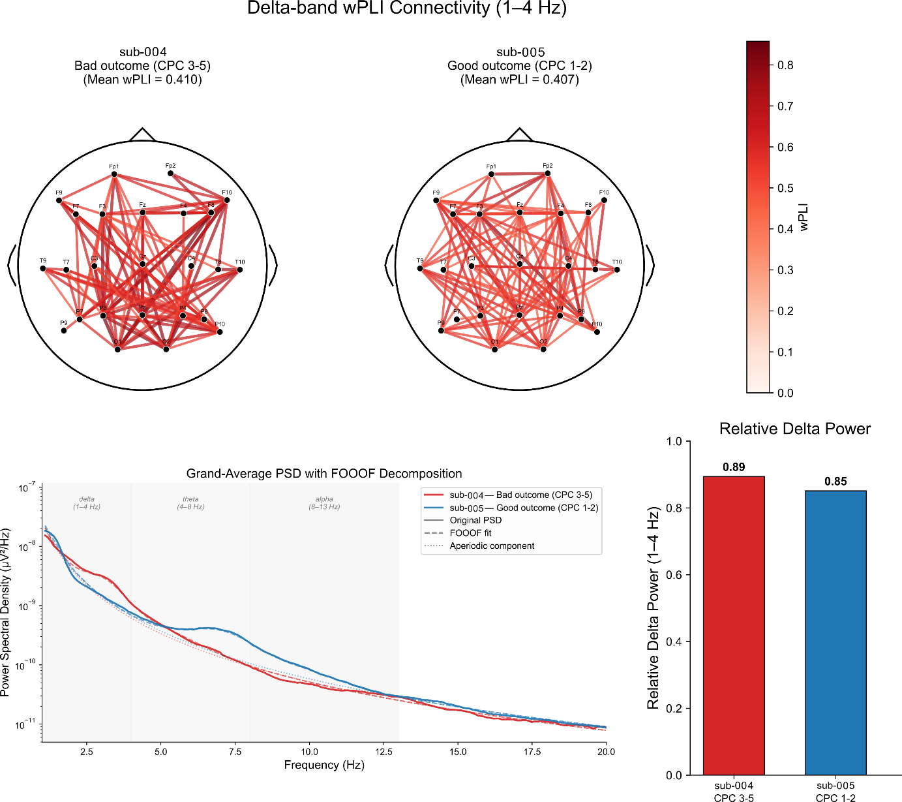
Figure 4. Upper panel: Connectivity across two subjects with good outcome (on the right) and poor outcome (one the left) show the connections across the topography (top 100); Lower panels: Distribution of power spectrum across the same two (poor outcome in red; good outcome in blue). Abbreviations: CPC, Cerebral Performance Category.
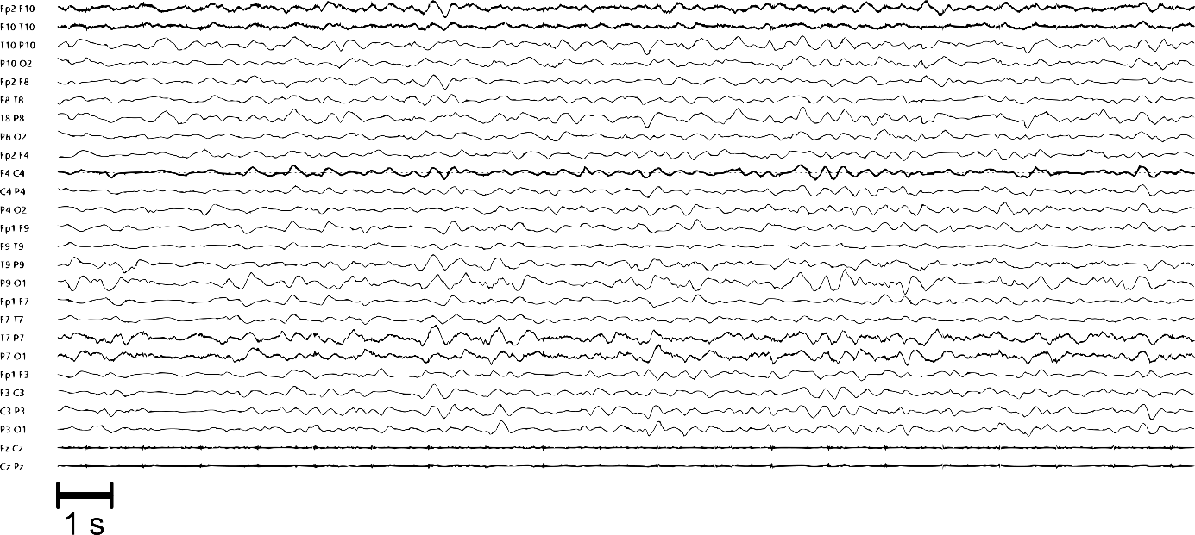
Sub-004
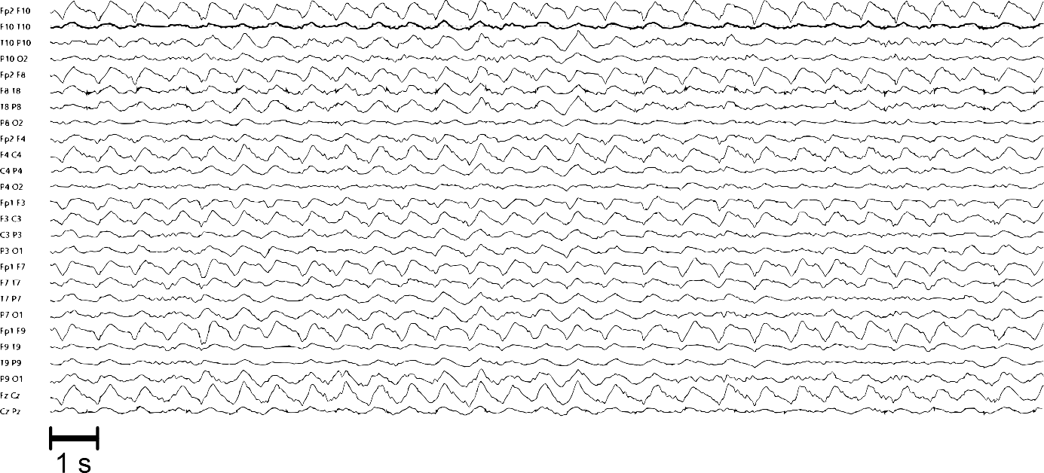
Sub-005
Figure 5. 20 seconds electroencephalogram (EEG) recording. Bipolar montage. Sensitivity: 7 µV/mm. High-frequency filter: 70 Hz. Low-frequency filter: 0.5 Hz. Notch filter: 50 Hz.
Upper panel: Subj-004 with unfavorable neurological outcome showing a low probability of RDA (Rhythmic Delta Activity) at 23% and high delta power, as detected by the). Prediction of the CNN is reported at the top of each panel. EEG trace showing a theta background with intermittent delta slowing.
Lower panel: Subj-005 with good outcome and high probability of RDA at 88% detected by the CNN. EEG trace showing a theta background with GRDA+S at a frequency of 1 Hz.
Abbreviations : CNN, convolutional neural network. GRDA+S: Generalized Rhythmic Delta Activity with superimposed sharp waves.

Finally in Figure 6, we show the individual subject SHAP values to have a better overview of the impact of the individual features on the final decision boundary (indicated as f(X) in Figure 6). On the left panel, we can see that in subj-004 the impact of connectivity measures as well as the spectral power of delta push strongly toward an unfavorable outcome. A notable contribution of PD probability is also observed, likely interacting with the delta features in shaping the decision boundary. In subj-005, a similar negative effect of the delta features is observed, but the high RDA probability provides a considerable contribution toward the good outcome. Importantly, in both cases it is possible to see that while some features contribute more than others in the definition of f(X), the final model’s predictions are based on the cumulative effect of multiple components.

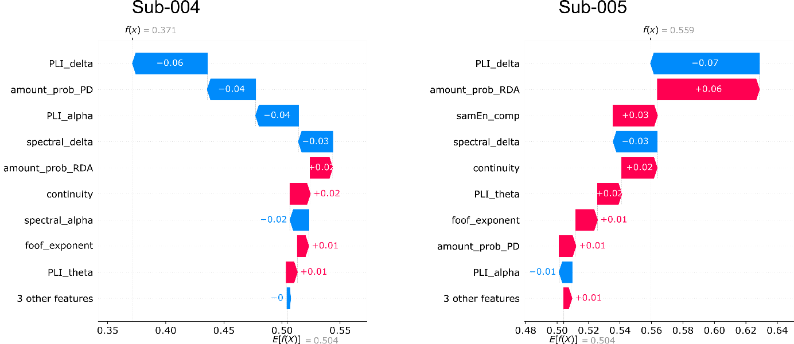
Figure 6. SHAP analysis of Subj-004 and Subj-005. X-axes show the decision function (probability of good outcome) while y-axes show the contribution of the most important features for each subject. Red bar is a positive contribution to the good outcome while blue bar is a negative one.

