Lower versus Standard Dose-Intensity Continuous Renal Replacement Therapy:
a Systematic Review and Meta-analysis
Supplementary File
Contents | Page
Table S1: Search Strategy (for Ovid MEDLINE, Ovid Embase, Cochrane library, CINAHL and Scopus) | 3
Table S2: Risk of bias assessment of the included randomized controlled trials based on ROB2 | 7
Table S3: Risk of bias assessment of the included cohort studies based on the ROBINS-I V2 tools | 8
Table S4: Outcome mapping by studies | 11
Table S5: GRADE evidence profile comparing low vs standard dose-intensity CRRT for the outcomes | 12
Figure S1: Risk of bias assessment for randomized controlled trials (A) and observational studies (B) | 16
Figure S2: ICU mortality, subgroup by study location | 17
Figure S3: ICU mortality: sensitivity analysis by leave-one-out method | 18
Figure S4: ICU mortality: sensitivity analysis by using the Hartung-Knapp-Sidik-Jonkman (HKSJ) method | 18
Figure S5: Overall 28-day mortality | 19
Figure S6: 28-day mortality: sensitivity analysis by leave-one-out method | 19
Figure S7: 28-day mortality: sensitivity analysis by using the Hartung-Knapp-Sidik-Jonkman (HKSJ) method | 19
Figure S8: 90-day mortality: sensitivity analysis by leave-one-out method | 20
Figure S9: 90-day mortality: sensitivity analysis by using the Hartung-Knapp-Sidik-Jonkman (HKSJ) method | 20
Figure S10: Overall hospital mortality | 21
Figure S11: Hospital mortality: sensitivity analysis by leave-one-out method | 21
Figure S12: Hospital mortality: sensitivity analysis by using the Hartung-Knapp-Sidik-Jonkman (HKSJ) method | 22
Figure S13: Dialysis dependence: subgroup analysis by study location | 23
Figure S14: Dialysis dependence: sensitivity analysis by leave-one-out method | 24
Figure S15: Dialysis dependence: sensitivity analysis by using the Hartung-Knapp-Sidik-Jonkman (HKSJ) method | 24
Figure S16: RRT duration by type of studies | 25
Figure S17: RRT duration: sensitivity analysis by leave-one-out method | 25
Figure S18: RRT duration: sensitivity analysis by using the Hartung-Knapp-Sidik-Jonkman (HKSJ) method | 26
Figure S19: Overall ICU length of stay | 26
Figure S20: ICU length of stay: sensitivity analysis by leave-one-out method | 27
Figure S21: ICU length of stay: sensitivity analysis by using the Hartung-Knapp-Sidik-Jonkman (HKSJ) method | 27
Figure S22: Overall hospital length of stay | 28
Figure S23: Hospital length of stay: sensitivity analysis by using the Hartung-Knapp-Sidik-Jonkman (HKSJ) method | 28
Figure S24: Mechanical ventilation duration | 29
Figure S25: Mechanical ventilation duration: sensitivity analysis by using the Hartung-Knapp-Sidik-Jonkman (HKSJ) method | 29
Figure S26: ICU mortality: subgroup analysis by lower vs higher CRRT dose-intensity | 30
Figure S27: 28-day mortality: subgroup analysis by lower vs higher CRRT dose-intensity | 30
Figure S28: RRT duration: subgroup analysis by lower vs higher CRRT dose-intensity | 30
Figure S29: ICU length of stay: subgroup analysis by lower vs higher CRRT dose-intensity | 31
Figure S30: Hospital length of stay: subgroup analysis by lower vs higher CRRT dose-intensity | 31
Figure S31: Mechanical ventilation duration: subgroup analysis by lower vs higher CRRT dose-intensity | 31
Figure S32: Hospital mortality: subgroup analysis by lower vs higher CRRT dose-intensity | 32
Figure S33: Funnel plot for ICU mortality | 33
Figure S34: Doi plot for ICU mortality | 34
Characteristics of studies | 35

Table S1: Search Strategy (for Ovid MEDLINE, Ovid Embase, Cochrane library, CINAHL and Scopus)
Database | Search Strategy
MEDLINE  Ovid MEDLINE(R) ALL 1946 to September 18, 2025 | 1. exp Continuous Renal Replacement Therapy/  2. exp *Hemofiltration/mt [Methods]  3. exp *Renal Replacement Therapy/mt [Methods]  4. ((continuous* or prolonged or sustained or extended) adj3 (dialys* or hemodialys* or haemodialys*)).tw,kf.  5. (continuous* adj3 (haemodiafiltrat* or haemo diafiltrat* or haemofiltrat* or haemo filtrat* or hemodiafiltrat* or hemo diafiltrat* or hemofiltrat* or hemo filtrat*)).mp.  6. (continuous* adj3 (kidney replacement or renal replacement or renal support*)).mp.  7. (CRRT or continuous RRT* or CKRT).tw,kf.  8. or/1-7  9. ((low* or standard or reduc* or less*) adj3 (dose* or dosing* or intensit*)).mp.  10. low effluent volume.mp.  11. "volume sparing".tw,kf.  12. or/9-11  13. 8 and 12  14. exp child/ or exp infant/ or adolescent/ or exp pediatrics/ or child, abandoned/ or exp child, exceptional/ or child, orphaned/ or child, unwanted/ or minors/ or (pediatric* or paediatric* or (child* not childbearing) or newborn* or congenital* or infan* or baby or babies or neonat* or pre-term or preterm* or premature birth* or NICU or preschool* or pre-school* or kindergarten* or kindergarden* or elementary school* or nursery school* or (day care* not adult*) or schoolchild* or toddler* or boy or boys or girl* or middle school* or pubescen* or juvenile* or teen* or youth* or high school* or adolesc* or pre-pubesc* or prepubesc*).mp. or (child* or adolesc* or pediat* or paediat*).jn.  15. animals/ not (animals/ and humans/)  16. (veterinary or rabbit or rabbits or animal or animals or mouse or mice or rodent or rodents or rat or rats or murine or hamster* or pig or pigs or piglets or swine or porcine or horse* or equine or cow or cows or cattle or bovine or goat or goats or sheep or lambs or ovine or monkey or monkeys or trout or marmoset$1 or canine or dog or dogs or feline or cat or cats or zebrafish).ti.  17. or/14-16  18. 13 not 17  19. limit 18 to (english language and yr="1995 -Current")
Embase  Ovid Embase 1974 to 2025 September 17 | 1. exp continuous renal replacement therapy/  2. exp continuous hemofiltration/  3. ((continuous* or prolonged or sustained or extended) adj3 (dialys* or hemodialys* or haemodialys*)).tw,kw.  4. (continuous* adj3 (haemodiafiltrat* or haemo diafiltrat* or haemofiltrat* or haemo filtrat* or hemodiafiltrat* or hemo diafiltrat* or hemofiltrat* or hemo filtrat*)).mp.  5. (continuous* adj3 (kidney replacement or renal replacement or renal support*)).mp.  6. (CRRT or continuous RRT* or CKRT).tw,kw.  7. or/1-6  8. ((low* or standard or reduc* or less*) adj3 (dose* or dosing* or intensit*)).mp.  9. low effluent volume.mp.  10. "volume sparing".tw,kw.  11. or/8-10  12. 7 and 11  13. juvenile/ or exp adolescent/ or exp child/ or exp postnatal development/ or (pediatric* or paediatric* or (child* not childbearing) or newborn* or congenital* or infan* or baby or babies or neonat* or pre term or preterm* or premature birth or NICU or preschool* or pre school* or kindergarten* or elementary school* or nursery school* or schoolchild* or toddler* or boy or boys or girl* or middle school* or pubescen* or juvenile* or teen* or youth* or high school* or adolesc* or prepubesc* or pre pubesc*).mp. or (child* or adolesc* or pediat* or paediat*).jn.  14. animal/ not (animal/ and human/)  15. (veterinary or rabbit or rabbits or animal or animals or mouse or mice or rodent or rodents or rat or rats or murine or hamster* or pig or pigs or piglets or swine or porcine or horse* or equine or cow or cows or cattle or bovine or goat or goats or sheep or lambs or ovine or monkey or monkeys or trout or marmoset$1 or canine or dog or dogs or feline or cat or cats or zebrafish).ti.  16. or/13-15  17. 12 not 16  18. limit 17 to (english language and yr="1995 -Current")
Cochrane Library  via Wiley | #1 [mh "Continuous Renal Replacement Therapy"]  #2 [mh Hemofiltration/mt]  #3 [mh "Renal Replacement Therapy"/mt]  #4 ((continuous* or prolonged or sustained or extended) NEAR/3 (dialys* or hemodialys* or haemodialys*))  #5 (continuous* NEAR/3 (haemodiafiltrat* or haemo diafiltrat* or haemofiltrat* or haemo filtrat* or hemodiafiltrat* or hemo diafiltrat* or hemofiltrat* or hemo filtrat*))  #6 (continuous* NEAR/3 (kidney replacement or renal replacement or renal support*))  #7 CRRT or (continuous NEXT RRT*) or CKRT  #8 ^{1-#7}  #9 ((low* or standard or reduc* or less*) NEAR/3 (dose* or dosing* or intensit*))  #10 low effluent volume  #11 volume sparing  #12 {OR #9-#11}  #13 #8 AND #12  #14 [mh "Child"] or ([mh "Congenital, Hereditary and Neonatal Diseases and Abnormalities"]) or [mh "infant"] or [mh ^"adolescent"] or [mh "pediatrics"] or [mh ^"child, abandoned"] or [mh "child, exceptional"] or [mh ^"child, orphaned"] or [mh ^"child, unwanted"] or [mh ^"minor"] or (pediatric* or paediatric* or (child* not childbearing) or newborn* or congenital* or infan* or baby or babies or neonat* or pre-term or preterm* or (premature NEXT birth) or NICU or preschool* or (pre NEXT school*) or kindergarten* or kindergarden* or (elementary NEXT school*) or (nursery NEXT school*) or ((day NEXT care*) not adult*) or schoolchild* or toddler* or boy or boys or girl* or (middle NEXT school*) or pubescen* or juvenile* or teen* or youth* or (high NEXT school*) or adolesc* or (pre NEXT pubesc*) or prepubesc*):ti,ab,kw or (child* or adolesc* or pediat* or paediat*):so  #15 [mh animals] NOT ([mh animals] AND [mh humans])  #16 (veterinary or rabbit or rabbits or animal or animals or mouse or mice or rodent or rodents or rat or rats or murine or hamster* or pig or pigs or piglets or swine or porcine or horse* or equine or cow or cows or cattle or bovine or goat or goats or sheep or lambs or ovine or monkey or monkeys or trout or marmoset* or canine or dog or dogs or feline or cat or cats or zebrafish):ti  #17 {OR #14-#16}  #18 #13 NOT #17  Publication Date Limit: 1995 - 2025  Languages: English
CINAHL | S1 (MH "Continuous Renal Replacement Therapy+")  S2 (MM "Hemofiltration+/MT")  S3 (MM "Renal Replacement Therapy+/MT")  S4 ((continuous* or prolonged or sustained or extended) N3 (dialys* or hemodialys* or haemodialys*))  S5 (continuous* N3 (haemodiafiltrat* or "haemo diafiltrat*" or haemofiltrat* or "haemo filtrat*" or hemodiafiltrat* or "hemo diafiltrat*" or hemofiltrat* or "hemo filtrat*"))  S6 (continuous* N3 ("kidney replacement" or "renal replacement" or "renal support*"))  S7 CRRT or "continuous RRT*" or CKRT  S8 S1 OR S2 OR S3 OR S4 OR S5 OR S6 OR S7  S9 ((low* or standard or reduc* or less*) N3 (dose* or dosing* or intensit*))  S10 "low effluent volume"  S11 "volume sparing"  S12 S9 OR S10 OR S11  S13 S8 AND S12  S14 ( (pediatric* OR paediatric* OR (child* NOT childbearing) OR newborn* OR congenital* OR infan* OR baby OR babies OR neonat* OR "pre-term" OR preterm OR "premature birth*" OR NICU OR preschool* OR "pre-school*" OR kindergarten* OR kindergarden* OR "elementary school*" OR "nursery school*" OR schoolchild* OR toddler* OR boy OR boys OR girl* OR "middle school*" OR pubescen* OR juvenile* OR teen* OR youth* OR "high school*" OR adolesc* OR prepubesc* OR "pre-pubesc*" OR (MH "Child+") OR (MH "Adolescence+") OR (MH "Minors (Legal)") OR "(MH "Child Abuse, Sexual") OR (MH "Child Behavior Disorders+") OR (MH "Child, Medically Fragile") OR (MH "Child Day Care") OR (MH "Child Behavior+") OR (MH "Child Mortality") OR (MH "Child Passenger Safety") OR (MH "Child Development Disorders, Pervasive+") OR (MH "Child Custody") OR (MH "Child Abuse+") OR (MH "Child Nutritional Physiology+") OR (MH "Child Behavior Checklist") ) OR SO ( child* OR pediatric* OR paediatric* OR adolescent* ) )  S15 (MH "Animals+") NOT ((MH "Animals+") AND (MH "Human"))  S16 TI ((veterinary or rabbit or rabbits or animal or animals or mouse or mice or rodent or rodents or rat or rats or murine or hamster* or pig or pigs or piglets or swine or porcine or horse* or equine or cow or cows or cattle or bovine or goat or goats or sheep or lambs or ovine or monkey or monkeys or trout or marmoset* or canine or dog or dogs or feline or cat or cats or zebrafish))  S17 S14 OR S15 OR S16  S18 S13 NOT S17  Limiters: English Language  Publication Date: 19950101-20251231
Scopus | ( TITLE-ABS-KEY ( ( ( continuous* OR prolonged OR sustained OR extended ) W/3 ( dialys* OR hemodialys* OR haemodialys* ) ) OR ( continuous* W/3 ( haemodiafiltrat* OR "haemo diafiltrat*" OR haemofiltrat* OR "haemo filtrat*" OR hemodiafiltrat* OR "hemo diafiltrat*" OR hemofiltrat* OR "hemo filtrat*" ) ) OR ( continuous* W/3 ( "kidney replacement" OR "renal replacement" OR "renal support*" ) ) OR CRRT OR "continuous RRT*" OR CKRT ) AND TITLE-ABS-KEY ( ( ( low* OR standard OR reduc* OR less* ) W/3 ( dose* OR dosing* OR intensit* ) ) OR "low effluent volume" OR "volume sparing" ) AND NOT ( TITLE-ABS-KEY ( pediatric* OR paediatric* OR ( child* AND NOT childbearing ) OR newborn* OR congenital* OR infan* OR baby OR babies OR neonat* OR "pre-term" OR preterm OR "premature birth*" OR nicu OR preschool* OR "pre-school*" OR kindergarten* OR kindergarden* OR "elementary school*" OR "nursery school*" OR schoolchild* OR toddler* OR boy OR boys OR girl* OR "middle school*" OR pubescen* OR juvenile* OR teen* OR youth* OR "high school*" OR adolesc* OR prepubesc* OR "pre-pubesc*" ) OR SRCTITLE ( child* OR pediatric* OR paediatric* OR adolescent ) OR TITLE ( ( veterinary OR rabbit OR rabbits OR animal OR animals OR mouse OR mice OR rodent OR rodents OR rat OR rats OR murine OR hamster* OR pig OR pigs OR piglets OR swine OR porcine OR horse* OR equine OR cow OR cows OR cattle OR bovine OR goat OR goats OR sheep OR lambs OR ovine OR monkey OR monkeys OR trout OR marmoset* OR canine OR dog OR dogs OR feline OR cat OR cats OR zebrafish ) ) ) )  Date: 1995 - 2025  Limited to: English

Table S2: Risk of bias assessment of the included randomized controlled trials based on ROB2
 | D1: Bias arising from the randomization process | D2: Bias due to deviations from intended intervention | D3: Bias due to missing outcome data | D4: Bias in measurement of the outcome | D5: Bias in selection of the reported results | Overall
Ronco 2000 | Some concerns  No information on allocation concealment  Modest baseline imbalance (APACHE II score) | Some concerns  Open-label trial  ITT analysis | Low risk  Outcome data available for all | Low risk  mortality | Some concerns  No prespecified protocol available | Some concerns
Bouman 2002 | Some concerns  No information on allocation concealment  Some degrees of baseline imbalances | Some concerns  Open-label trial  Different timing of CRRT initiation | Low risk  Outcome data available for nearly all | Low risk  mortality | Some concerns  No prespecified protocol available | Some concerns
Tolwani 2008 | Some concerns  Baseline imbalances | Some concerns  Open-label trial  ITT analysis | Low risk  Outcome data available for all | Low risk  mortality | Some concerns  No prespecified protocol available | Some concerns
Abbreviations: APACHE II, Acute Physiology and Chronic Health Evaluation II; D, domain; ITT, intention to treat

Table S3: Risk of bias assessment of the included cohort studies based on the ROBINS-I V2 tools
Author/  Year | D1: Bias due to confounding | D2: Bias in classification of interventions | D3: Bias in selection of participants | D4: Bias due to missing data | D5: Bias in measurement of outcomes | D6: Bias in selection of the reported results | Overall bias
Vesconi 2009 | Serious  Important confounders not fully adjusted | Low  Classification was based on treatment data | Serious  Patients with long CRRT interruptions (post-baseline technical/clinical events) were excluded from the analysis.  This could be associated with the intervention. | Moderate  ~15% missingness for intervention | Low  Mortality | Serious  No detailed SAP, Many possible analyses | Serious
Nurmohamed 2011 | Serious  Doses were strongly linked to body weight and severity; both incompletely adjusted | Low  Dose was calculated from CRRT machine settings | Low  No clear evidence of exclusion post-baseline variable measurements | Low  Nearly complete data | Low  Mortality | Serious  Backward selection and ROC-derived thresholds indicate data-driven choices | Serious
Fujii 2012 | Serious  Important confounders not fully adjusted | Low  Classification was based on treatment data | Low  No clear evidence of exclusion post-baseline variable measurements | Low  Complete data | Low  Mortality | Serious  Multiple modelling possible | Serious
Uchino 2013  Yasuda 2014 | Serious  Important confounders (between database, center etc.) not fully adjusted | Low  Classification was based on treatment data | Low  No clear evidence of exclusion post-baseline variable measurements | Low  Complete data | Low  Mortality | Serious  Multiple modelling possible | Serious
Li 2014 | Serious  Dose category is heavily structured by calendar year and machine | Low  Classification was based on treatment data | Low  No clear evidence of exclusion post-baseline variable measurements | Low  Complete data | Low  Mortality | Serious  Stepwise variable selection.  Multiple modelling possible | Serious
Mayumi 2016 | Serious  Important confounders (sepsis etc.) not fully adjusted | Low  Classification was based on treatment data | Low  No clear evidence of exclusion post-baseline variable measurements | Low  Complete data | Low  Mortality | Serious  Post-hoc  multiple modelling possible | Serious
Okamoto 2024 | Serious  Residual severity differences may bias either direction, but net effect likely inflates the apparent benefit of delivered dose ≥13 ml/kg/h | Low  Classification was based on treatment data | Low  No clear evidence of exclusion post-baseline variable measurement | Low  Complete data | Low  Mortality | Serious  Many analytic degrees of freedom | Serious
Yagi 2024 | Serious  Heavier patients (in the low-dose group) have inherently better survival | Low  Classification was based on treatment data | Low  No clear evidence of exclusion post-baseline variable measurements | Low  Complete data | Low  Mortality | Serious  Multiple potential modelling | Serious
Faria 2025 | Moderate  Unmeasured baseline factors (AKI etiology, chronic diseases, surgical vs medical etc) remain | Low  Classification was based on treatment data | Low  No clear evidence of exclusion post-baseline variable measurement | Low  Targeted CRRT>24h | Low  Mortality | Serious  Reported different modelling | Serious
Napoli 2025 | Critical  Several confounding factors, not described | Low  Classification was based on treatment data | Low  No clear evidence of exclusion post-baseline variable measurements | Moderate  Non-consenting survivors and some lost-to-follow-up may be excluded | Low  Mortality | Serious  Multiple time window possible | Critical
Abbreviations: AKI, acute kidney injury; CRRT, continuous renal replacement therapy; D, domain; ROC, receiver operating curve; SAP, statistical analysis plan

Table S4: Outcome mapping by studies
Author/year | 28-day mortality | 90-day mortality | ICU mortality | Hospital mortality | RRT duration | Dialysis dependence | AKI resolution | ICU length of stay | Hospital length of stay | Electrolytes (K, PO₄) | Changes in urea | Others
Ronco 2000ª | ✓ |  |  |  | ✓ |  | ✓
Bouman 2002^{b} | ✓ |  | ✓ | ✓ |  |  | ✓ | ✓ | ✓ |  |  | MV duration
Tolwani 2008 | ✓ |  | ✓ | ✓ | ✓ | ✓ |  | ✓ | ✓
Vesconi 2009ª |  |  | ✓ |  |  |  |  | ✓ |  |  |  | MV duration
Nurmohamed 2011 | ✓
Fujii 2012 |  |  | ✓ | ✓ | ✓ | ✓
Uchino 2013 |  |  | ✓ | ✓ | ✓ | ✓
Li 2014^{b} | ✓ | ✓ |  | ✓ | ✓ | ✓ |  | ✓ | ✓
Yasuda 2014^{d} |  |  | ✓ | ✓ | ✓ | ✓ |  |  |  |  | ✓
Mayumi 2016 |  |  | ✓ | ✓ |  |  |  |  |  |  |  | 60-day mortality
Okamoto 2024 |  | ✓ |  |  | ✓^{c} |  |  | ✓ ^{c} | ✓ ^{c}
Yagi 2024 |  |  | ✓ | ✓ |  | ✓ |  | ✓ | ✓ | ✓ | ✓ | Change in acid-base, MV duration
Faria 2025 |  | ✓ |  |  |  | ✓
Napoli 2025 |  | ✓ |  |  |  | ✓ |  |  |  | ✓
Abbreviations: AKI, acute kidney injury; ICU, intensive care unit; K, potassium; MV, mechanical ventilation; PO₄, phosphate; RRT, renal replacement therapy
ª Had 3 groups; low dose, standard dose and high dose. Therefore, only the low dose and standard dose groups were included in the primary analysis. High dose group was included in an additional subgroup analysis.
^{b} The comparator group was ≥40 mL/kg/h of delivered CRRT dose. Therefore, these studies were excluded from the main analysis but included in an additional subgroup analysis.
^{c} for dose <13.2 ml/kg/h
^{d} Used the same data as the Uchino et al. study. Therefore, this study was excluded from the analysis of ICU mortality, hospital mortality, dialysis dependence and RRT duration.

Table S5: GRADE evidence profile comparing low vs standard dose-intensity CRRT for the outcomes

Outcome | Results | - Risk of bias | - Inconsistency | - Indirectness | - Imprecision | - Reporting bias | Overall  certainty
ICU mortality | 6 studies | Serious concerns  Moderate risk of bias  (n=1; Tolwani)  Serious risk of bias (n=5; Vesconi, Fujii, Uchino, Mayumi, Yagi) | Serious concerns  Moderate heterogeneity, results significant in observational studies and studies conducted in Japan | No concerns  Studies included adults admitted to ICU for range of indications (medical and surgical) | No concerns  OIS adequate (351 events/780 people vs. 800 events/1,482 people); Narrow CI | Serious concerns  6 studies (n=2,262) reporting outcome  vs.  8 studies (n=2,663) missing outcome; moderate risk for  publication bias | Very low
28-day mortality | 3 studies | Some concerns  Low risk of bias (n=2; Ronco, Tolwani)  Serious risk of bias (n=1; Nurmohamed) | Serious concerns  Two studies which favoured standard dose and one study which favoured low dose; high heterogeneity | No concerns  Studies included adults admitted to ICU for range of indications (medical and surgical) | Very serious concerns  OIS inadequate (149 events/281 people  vs.  133 events/301 people); Wide CI which includes no effect | Serious concerns  3 studies (n=582) reporting outcome  vs.  11 studies (n=4,343)  missing outcome;  publication bias not detected | Very low
90-day mortality | 3 studies | Serious concerns  Serious risk of bias (n=2; Okamoto, Faria)  Critical risk of bias (n=1; Napoli) | Serious concerns  One study which favoured standard dose; increased mortality in very low dose (<13 ml/kg/hr); high heterogeneity | Some concerns  One study which included post open-heart surgery | Serious concerns  OIS inadequate (312 events/702 people vs. 592 events/1,193 people); CI includes no effect | Serious concerns  3 studies (n=1,895) reporting outcome  vs.  11 studies (n=3,030)  missing outcome;  publication bias not detected | Very low
Hospital mortality | 5 studies | Serious concerns  Moderate risk of bias  (n=1; Tolwani)  Serious risk of bias (n=5; Fujii, Uchino, Mayumi, Yagi) | Serious concerns  One study which favoured standard dose; results significant in studies conducted in Japan; high heterogeneity | Some concerns  One study which included post open-heart surgery | No concerns  OIS met (399 events/719 people vs. 810 events/1,280 people); CI was significant | Serious concerns  5 studies (n=1,999) reporting outcome  vs.  9 studies (n=2,926)  missing outcome;  publication bias not detected | Very low
Dialysis dependence | 6 studies | Serious concerns  Moderate risk of bias (n=1; Tolwani)  Serious risk of bias (n=4; Fujii, Uchino, Yagi, Faria)  Critical risk of bias (n=1; Napoli) | Serious concerns  Observational studies and RCTs showed discordant signals; high heterogeneity | Some concerns  One study which included post open-heart surgery | Very serious concerns  OIS inadequate (58 events/339 people vs. 65 events/475 people); Wide CI which includes no effect | Serious concerns  6 studies (n=814) reporting outcome  vs.  8 studies (n=4,111)  missing outcome;  publication bias not detected | Very low
RRT duration | 4 studies | Serious concerns  Moderate risk of bias (n=2; Ronco, Tolwani)  Serious risk of bias (n=3; Fujii, Uchino, Okamoto) | Serious concerns  One study favoured standard dose and one study favoured low dose; high heterogeneity | Some concerns  One study which included post open-heart surgery | No concerns  The pooled sample (2107 participants) exceeds the OIS; CI includes no effect but does not include MCID | Serious concerns  4 studies (n=2,107) reporting outcome  vs.  10 studies (n=2,818)  missing outcome;  publication bias not detected | Very low
ICU LOS | 3 studies | Serious concerns  Moderate risk of bias (n=1; Tolwani)  Serious risk of bias (n=2; Vesconi, Yagi) | Serious concerns  One study favoured standard dose and one study favoured low dose; high heterogeneity | Some concerns  One study which included post open-heart surgery | No concerns  The pooled sample (657 participants) is much smaller than the OIS; CI includes no effect but does not include MCID | Serious concerns  3 studies (n=657) reporting outcome  vs.  11 studies (n=4,268)  missing outcome;  publication bias not detected | Very low
Hospital LOS | 2 studies | Serious concerns  Moderate risk of bias (n=1; Tolwani)  Serious risk of bias (n=1; Yagi) | Serious concerns  One study favoured standard dose and one study favoured low dose; high heterogeneity | Some concerns  One study which included post open-heart surgery | No concerns  The pooled sample (394 participants) is much smaller than the OIS; CI includes no effect but does not include MCID | Serious concerns  2 studies (n=394) reporting outcome  vs.  12 studies (n=4,531)  missing outcome;  publication bias not detected | Very low
MV duration | 2 studies | Serious concerns  Serious risk of bias (n=2; Vesconi, Yagi) | No concerns  No significant heterogeneity; all three studies showed the same trends | No concerns  Studies included adults admitted to ICU for range of indications (medical and surgical) | No concerns  The pooled sample (457 participants) is much smaller than the OIS; CI includes no effect but does not include MCID | Serious concerns  2 studies (n=457) reporting outcome  vs.  12 studies (n=4,468)  missing outcome;  publication bias not detected | Very low
Abbreviations: CI, confidence interval; ICU, intensive care unit; LOS, length of stay; MCID, minimal clinically important difference; MV, mechanical ventilation; OIS, optimal information size; RCT, randomized controlled trial; RRT, renal replacement therapy

Figure S1: Risk of bias assessment for randomized controlled trials (A) and observational studies (B). Abbreviation: D domain
(A) Quality assessment of the included randomized controlled trials based on ROB2
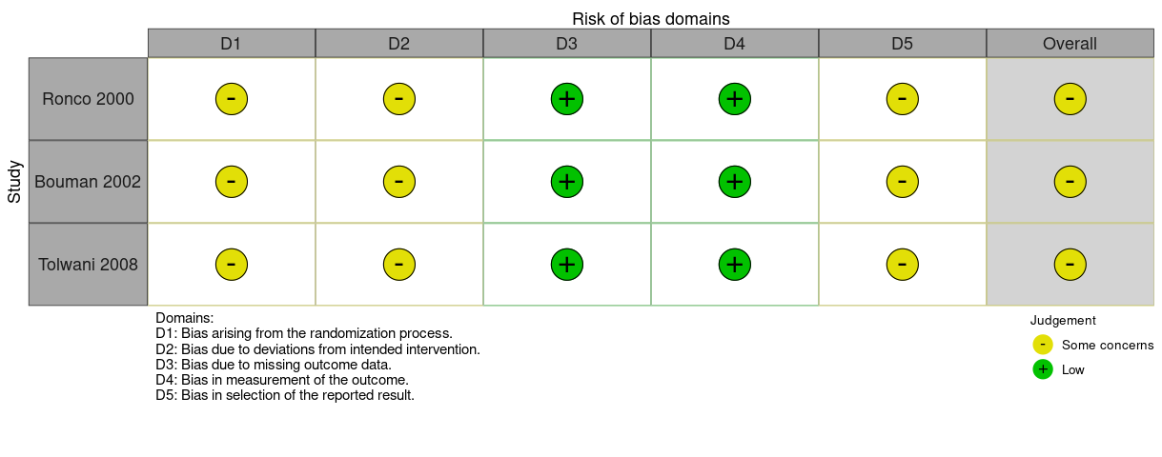
(B) Quality assessment of the included cohort study based on the ROBINS-I V2 tool
 | Risk of bias domains
 | D1 | D2 | D3 | D4 | D5 | D6 | Overall
Vesconi 2009 | Serious | Low | Serious | Moderate | Low | Serious | Serious
Nurmohamed 2011 | Serious | Low | Low | Low | Low | Serious | Serious
Fujii 2012 | Serious | Low | Low | Low | Low | Serious | Serious
Uchino 2013  Yasuda 2014 | Serious | Low | Low | Low | Low | Serious | Serious
Li 2014 | Serious | Low | Low | Low | Low | Serious | Serious
Mayumi 2016 | Serious | Low | Low | Low | Low | Serious | Serious
Okamoto 2024 | Serious | Low | Low | Low | Low | Serious | Serious
Yagi 2024 | Serious | Low | Low | Low | Low | Serious | Serious
Faria 2025 | Moderate | Low | Low | Low | Low | Serious | Serious
Napoli 2025 | Critical | Low | Low | Moderate | Low | Serious | Critical
Domains:
D1: Bias due to confounding
D2: Bias in classification of interventions
D3: Bias in selection of participants
D4: Bias due to missing data
D5: Bias in measurement of outcomes

Figure S2: ICU mortality, subgroup by study location
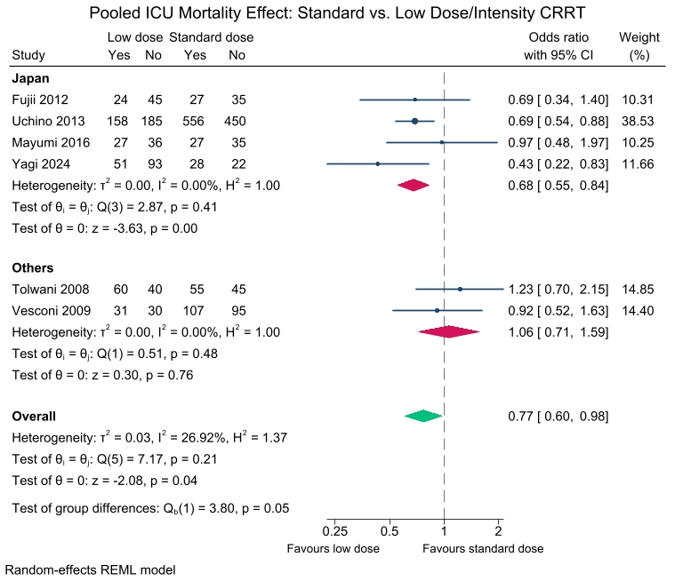
Figure S3: ICU mortality: sensitivity analysis by leave-one-out method
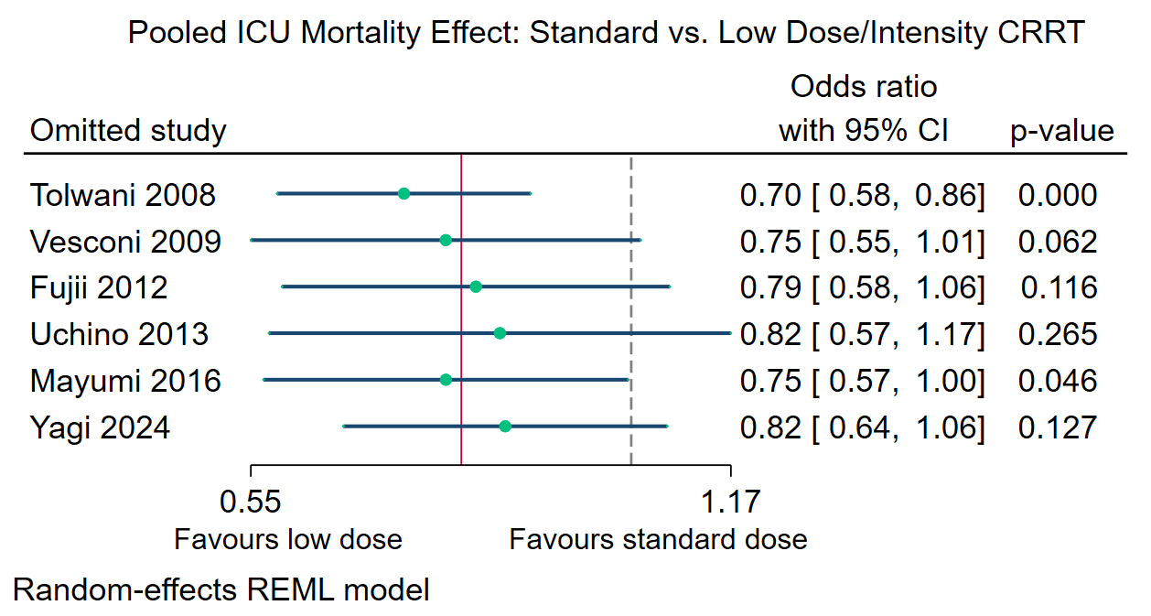

Figure S4: ICU mortality: sensitivity analysis by using the Hartung-Knapp-Sidik-Jonkman (HKSJ) method
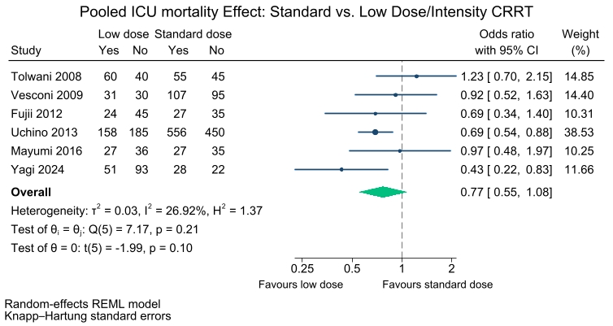

Figure S5: Overall 28-day mortality
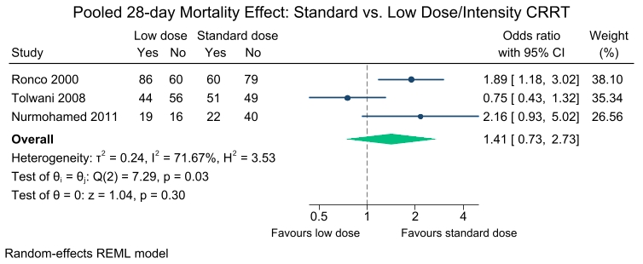
Figure S6: 28-day mortality: sensitivity analysis by leave-one-out method
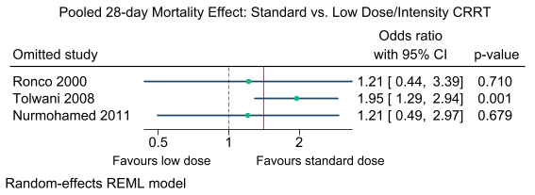
Figure S7: 28-day mortality: sensitivity analysis by using the Hartung-Knapp-Sidik-Jonkman (HKSJ) method
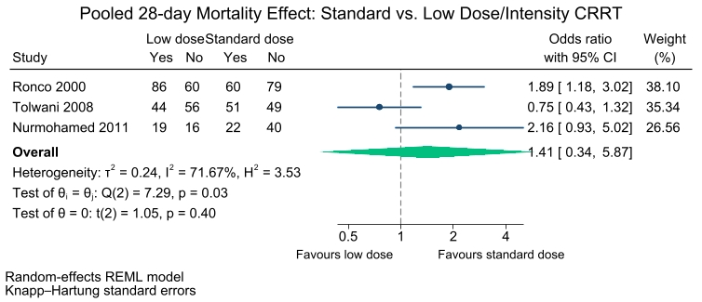

Figure S8: 90-day mortality: sensitivity analysis by leave-one-out method
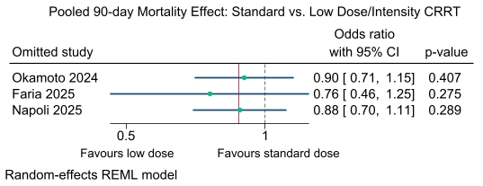

Figure S9: 90-day mortality: sensitivity analysis by using the Hartung-Knapp-Sidik-Jonkman (HKSJ) method
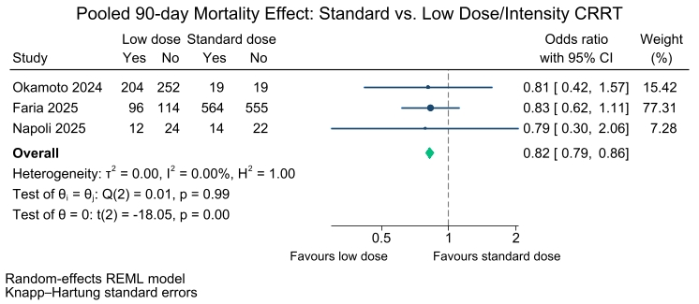

Figure S10: Overall hospital mortality
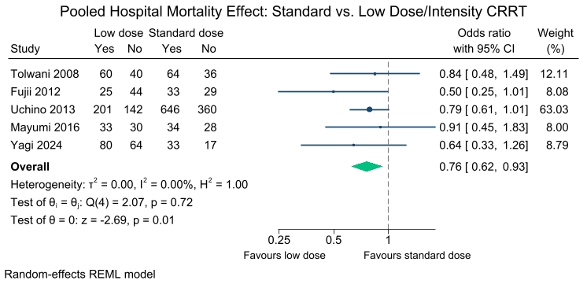

Figure S11: Hospital mortality: sensitivity analysis by leave-one-out method
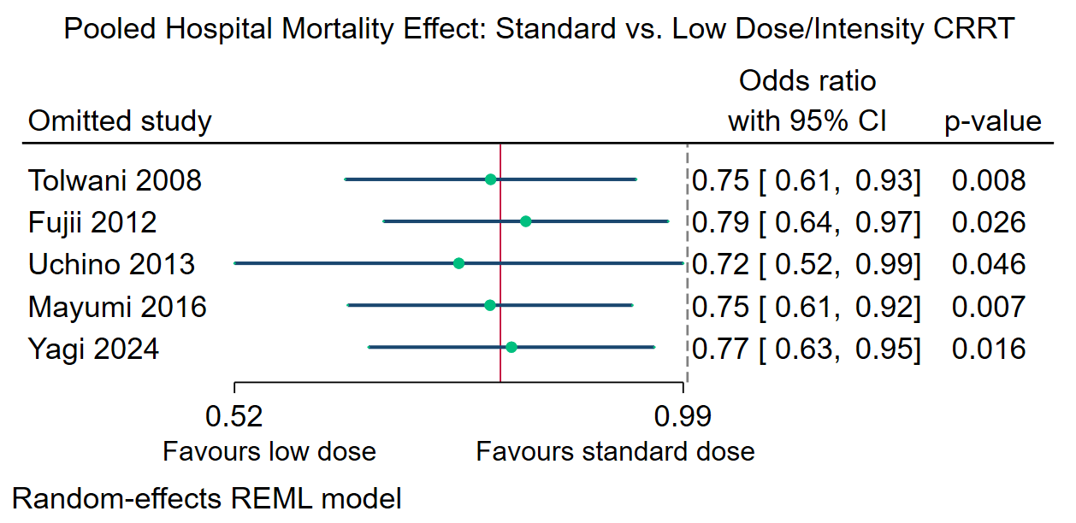
Figure S12: Hospital mortality: sensitivity analysis by using the Hartung-Knapp-Sidik-Jonkman (HKSJ) method
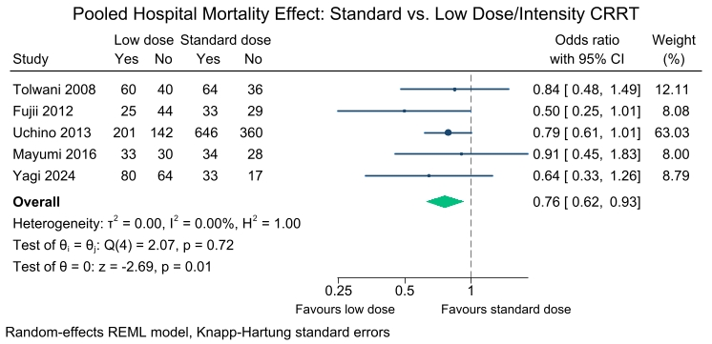

Figure S13: Dialysis dependence: subgroup analysis by study location
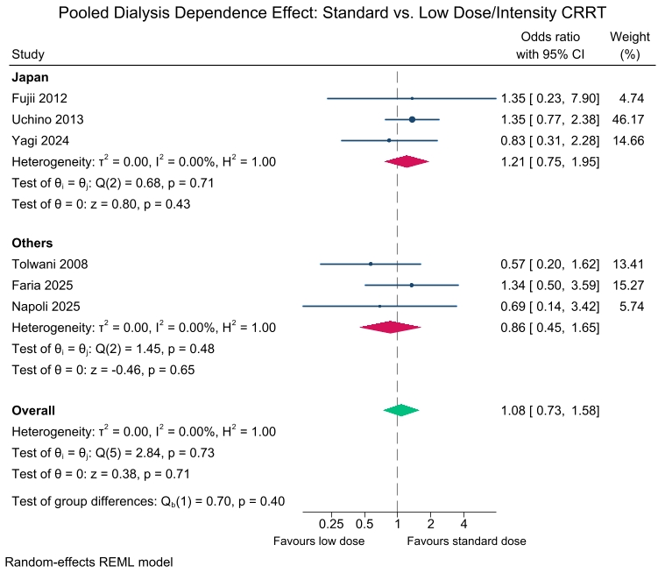

Figure S14: Dialysis dependence: sensitivity analysis by leave-one-out method
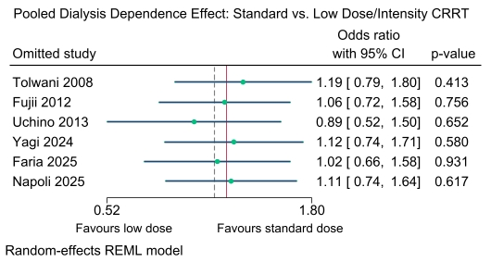

Figure S15: Dialysis dependence: sensitivity analysis by using the Hartung-Knapp-Sidik-Jonkman (HKSJ) method
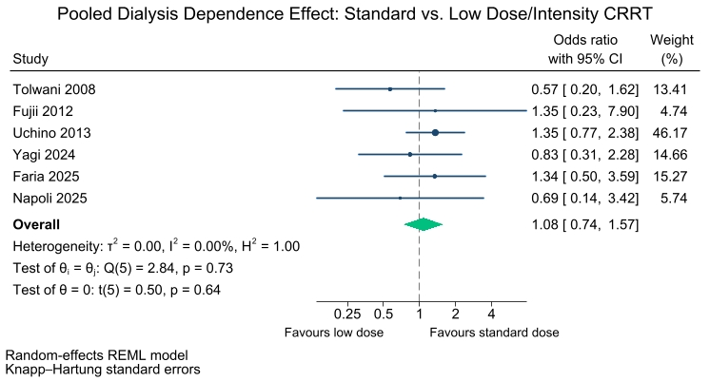

Figure S16: RRT duration by type of studies
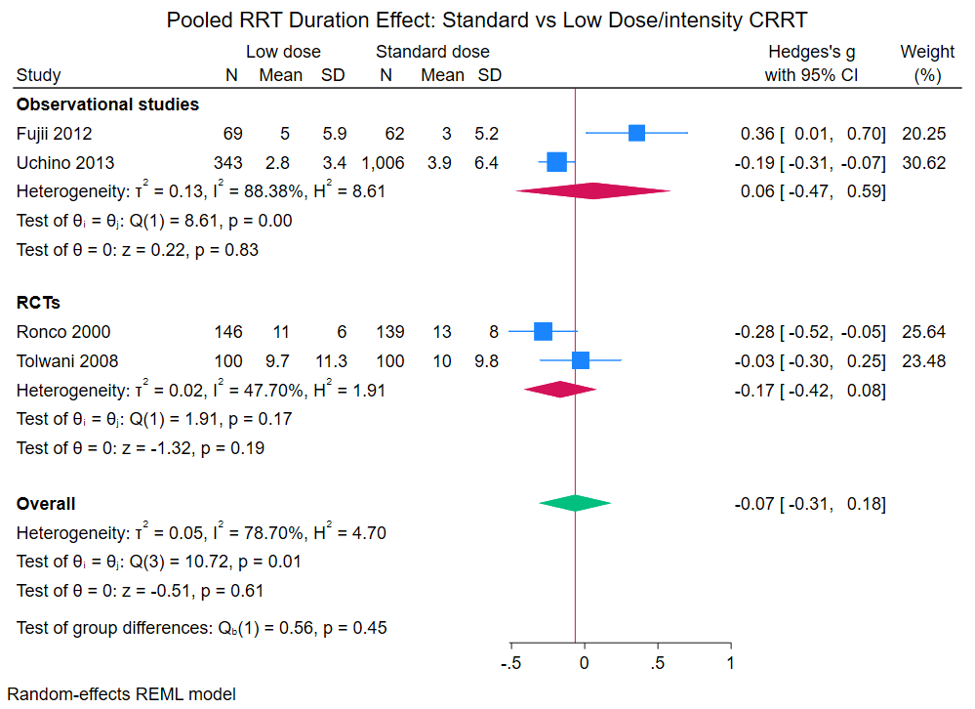

Figure S17: RRT duration: sensitivity analysis by leave-one-out method
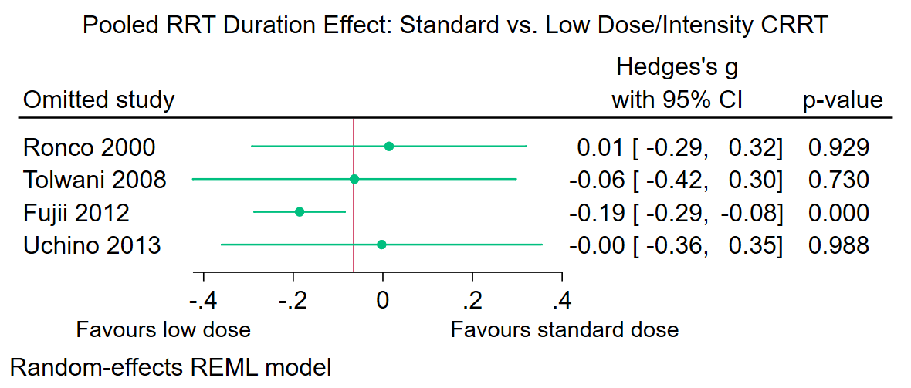

Figure S18: RRT duration: sensitivity analysis by using the Hartung-Knapp-Sidik-Jonkman (HKSJ) method
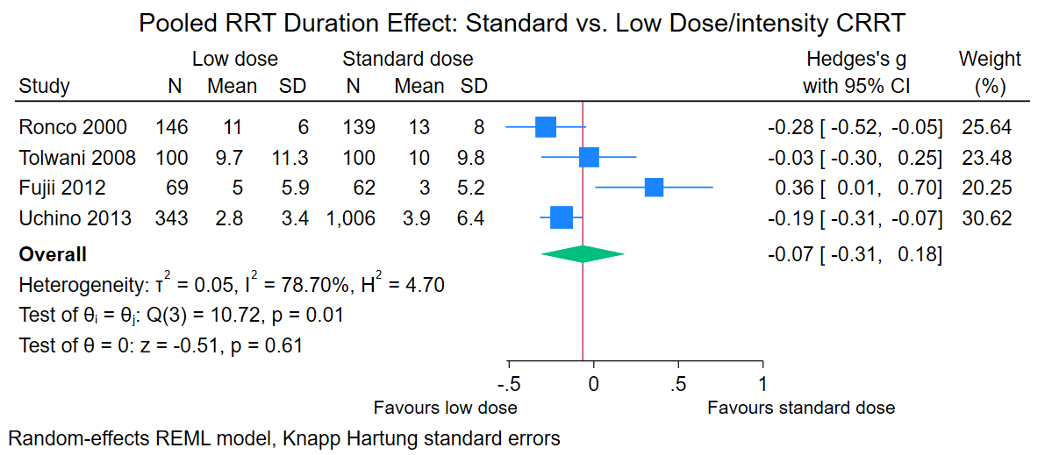

Figure S19: Overall ICU length of stay
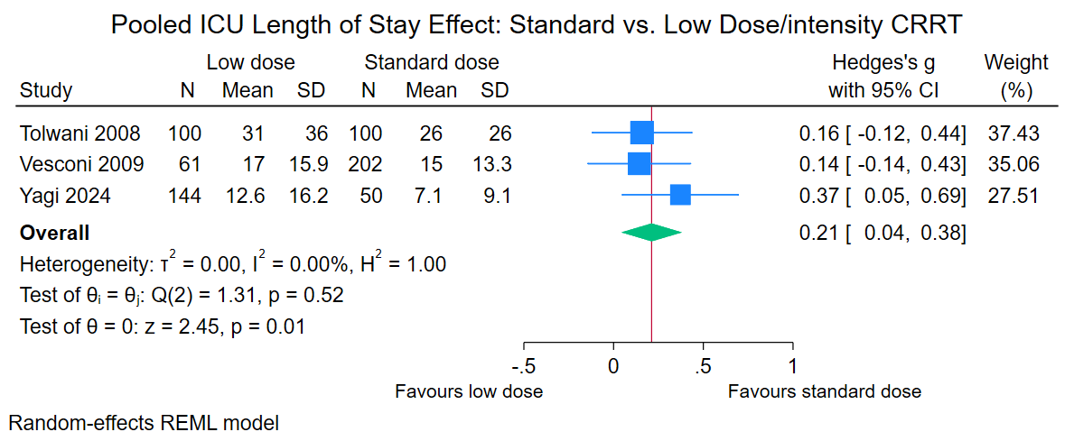

Figure S20: ICU length of stay: sensitivity analysis by leave-one-out method
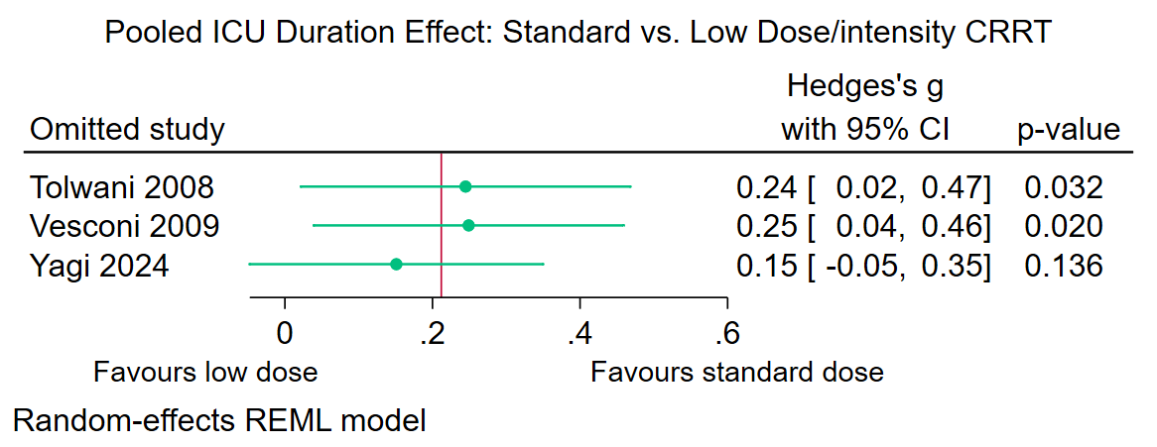

Figure S21: ICU length of stay: sensitivity analysis by using the Hartung-Knapp-Sidik-Jonkman (HKSJ) method
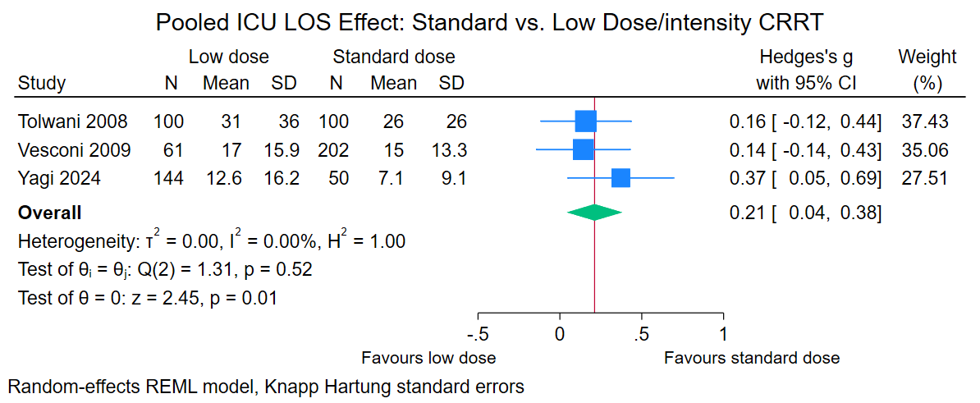

Figure S22: Overall hospital length of stay
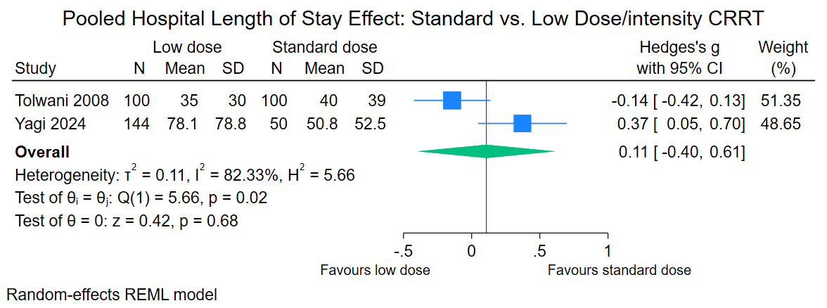

Figure S23: Hospital length of stay: sensitivity analysis by using the Hartung-Knapp-Sidik-Jonkman (HKSJ) method
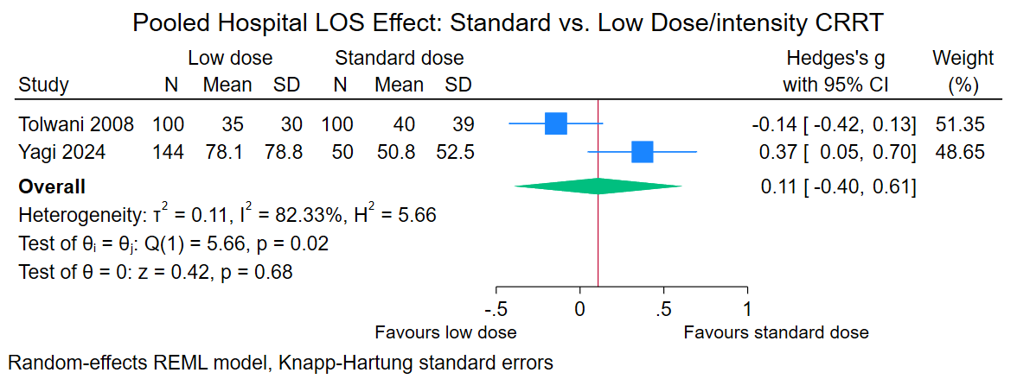

Figure S24: Mechanical ventilation duration
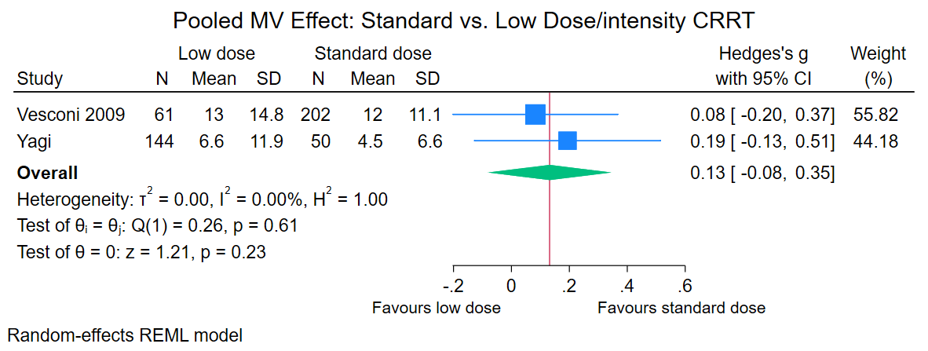

Figure S25: Mechanical ventilation duration: sensitivity analysis by using the Hartung-Knapp-Sidik-Jonkman (HKSJ) method
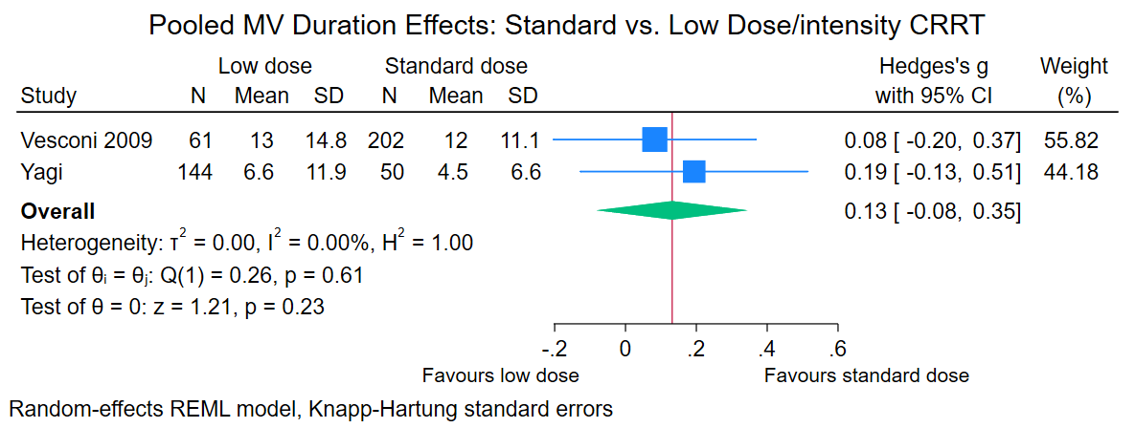

Figure S26: ICU mortality: subgroup analysis by lower vs higher CRRT dose-intensity
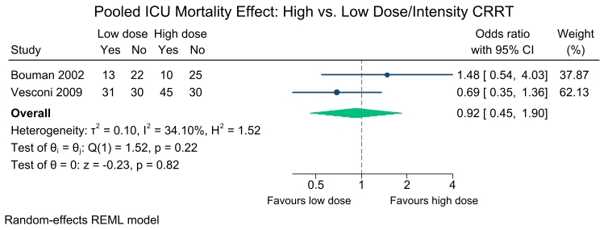
Figure S27: 28-day mortality: subgroup analysis by lower vs higher CRRT dose-intensity
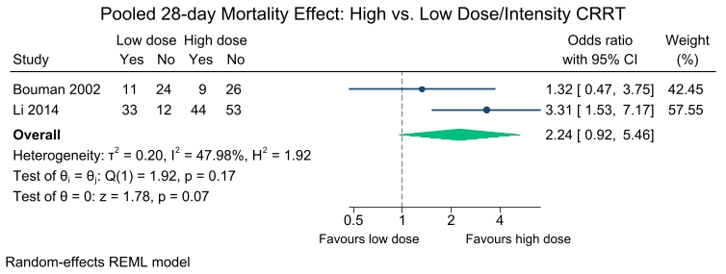

Figure S28: RRT duration: subgroup analysis by lower vs higher CRRT dose-intensity
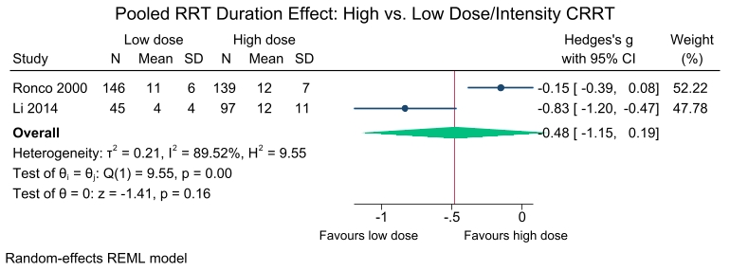

Figure S29: ICU length of stay: subgroup analysis by lower vs higher CRRT dose-intensity
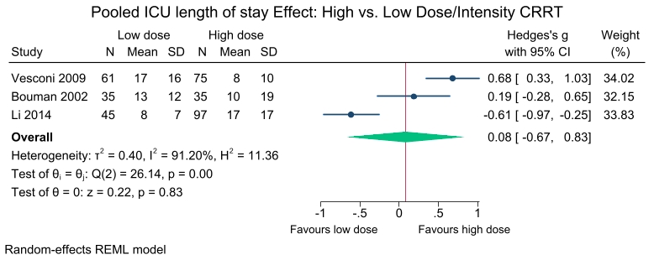
Figure S30: Hospital length of stay: subgroup analysis by lower vs higher CRRT dose-intensity
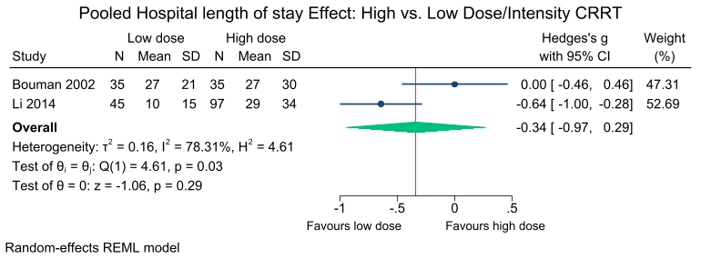

Figure S31: Mechanical ventilation duration: subgroup analysis by lower vs higher CRRT dose-intensity
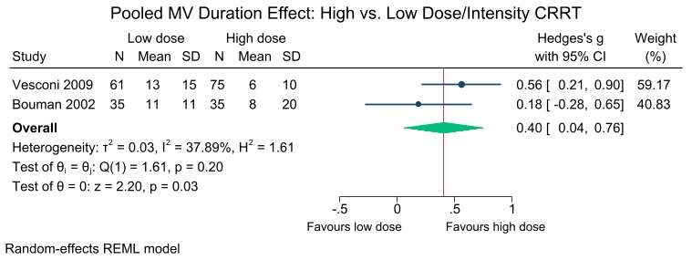

Figure S32: Hospital mortality: subgroup analysis by lower vs higher CRRT dose-intensity
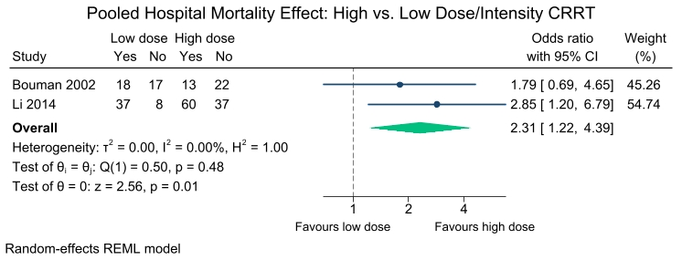

Figure S33: Funnel plot for ICU mortality
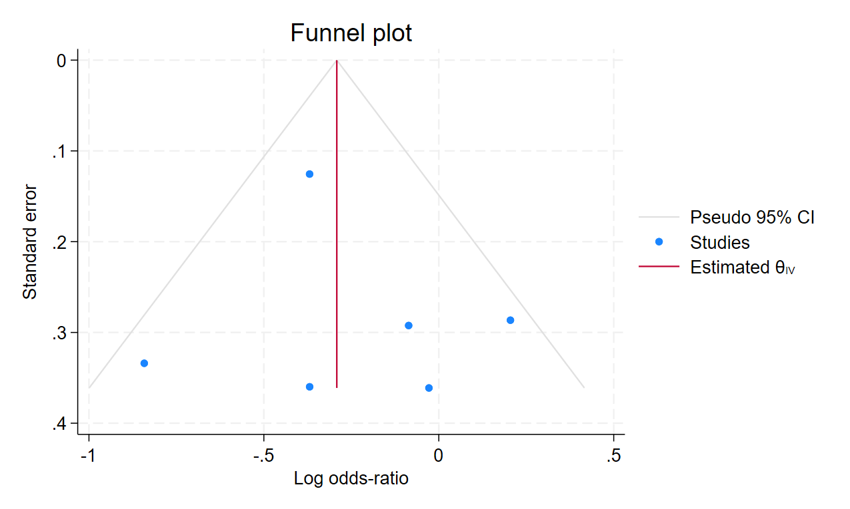

Regression-based Egger test for small-study effects
Random-effects model
Method: REML

H0: beta1 = 0; no small-study effects
beta1 = 0.32
SE of beta1 = 1.688
z = 0.19
Prob > |z| = 0.8508

Figure S34: Doi plot for ICU mortality
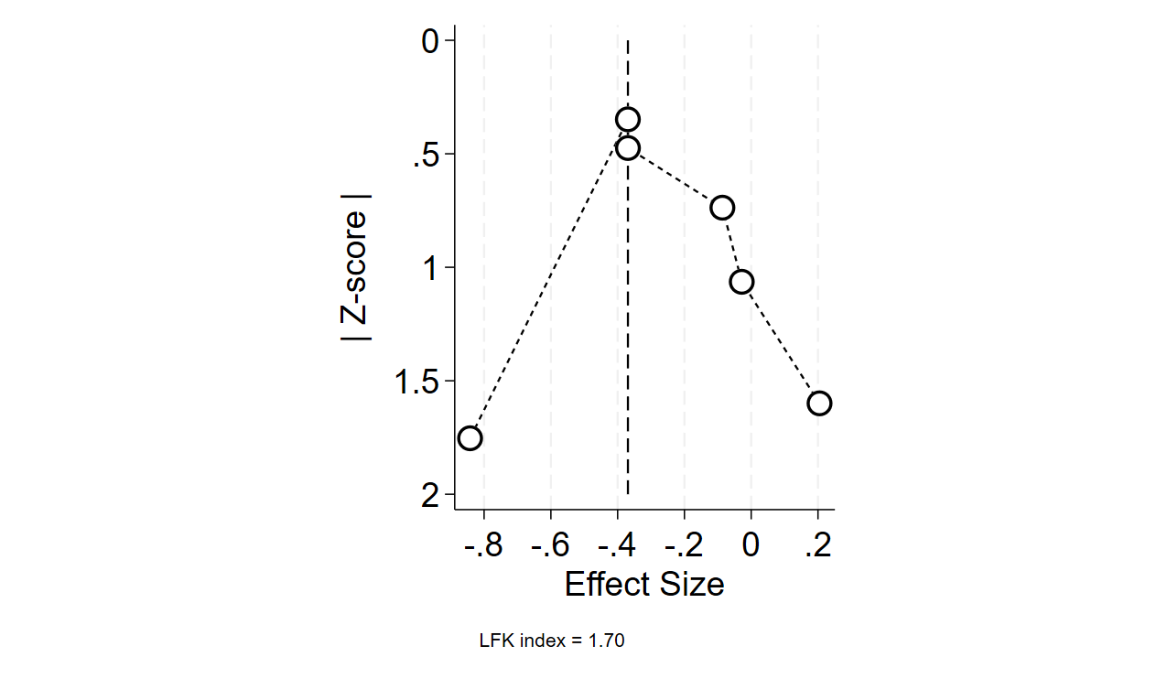

Characteristics of studies
01: Ronco 2000
Methods | - Study design: Parallel RCT  - Study duration: 1994 to September 1999  - Funding: N/A
Participants | - Setting: single centre  - Country: Italy  - Inclusion criteria: admission to the intensive-care unit and the presence of acute renal failure, defined by abnormal concentrations of serum blood urea nitrogen and creatinine, and urine output of less than 200 mL in the preceding 12 h, despite fluid resuscitation and furosemide administration  - Exclusion criteria: N/A  - Total sample size: 425  - Low dose/intensity group (146)  - Standard dose/intensity group (Group 1) (139)  - Standard dose/intensity group (Group 2) (140)  - Mean age ± SD (years): 61 ± 10  - Low dose/intensity group (61 ± 10)  - Standard dose/intensity group (Group 1) (59 ± 9)  - Standard dose/intensity group (Group 2) (63 ± 12)  - Sex (M/F): 238/187  - Low dose/intensity group (81/65)  - Standard dose/intensity group (Group 1) (77/62)  - Standard dose/intensity group (Group 2) (80/60)  - Mean weight ± SD (kg): 68 ± 9  - Low dose/intensity group (68 ± 11)  - Standard dose/intensity group (Group 1) (69 ± 8)  - Standard dose/intensity group (Group 2) (67 ± 9)  - Definition of body weight: before ICU admission  - Mean APACHE II ± SD: 23 ± 4  - Low dose/intensity group (22 ± 3)  - Standard dose/intensity group (Group 1) (24 ± 4)  - Standard dose/intensity group (Group 2) (22 ± 4)  - Sepsis 12.3%  - Low dose/intensity group (13.7%)  - Standard dose/intensity group (Group 1) (12.2%)  - Standard dose/intensity group (Group 2) (10.7%)  - Characteristics: surgical 75% Medical 13% Trauma 11.7%  - BUN at CRRT initiation (SD) (mmol/L): 18.5 ± 4.2  - Low dose/intensity group (18.2 ± 4.3)  - Standard dose/intensity group (Group 1) (17.9 ± 3.9)  - Standard dose/intensity group (Group 2) (19.3 ± 4.3)  - SCr at CRRT initiation ± SD (µmol/L): 318.2 ± 153.2  - Low dose/intensity group (309.4 ± 132.6)  - Standard dose/intensity group (Group 1) (327.1 ± 141.4)  - Standard dose/intensity group (Group 2) (318.2 ± 185.6)
Intervention | - Modality: CVVH  - Low dose/intensity group:  - prescribed dose: 20 mL/kg/h  - delivered dose: 19 mL/kg/h  - Standard dose/intensity group (Group 1):  - prescribed dose: 35 mL/kg/h  - delivered dose: 33.5 mL/kg/h  - Standard dose/intensity group (Group 2):  - prescribed dose: 45 mL/kg/h  - delivered dose: 42.5 mL/kg/h
Outcomes | - Primary outcomes  - Survival at day 15 after discontinuation of CVVH  - Secondary outcomes  - Recovery of kidney function 15 days after discontinuation of CVVH, RRT duration  - Adverse events: clinical and technical complications
Notes

02: Bouman 2002
Methods | - Study design: Parallel RCT  - Study duration: May 1998 to March 2000  - Funding: N/A
Participants | - Setting: 2 centres  - Country: The Netherlands  - Inclusion criteria: patients with circulatory and respiratory insufficiency and early AKI who need CRRT; CrCl < 20 mL/min, and oliguria < 180 mL/6 h despite fluid resuscitation; circulatory support and furosemide; early timing: < 12 h inclusion; late timing: BUN > 40 mmol/L or severe pulmonary oedema  - Exclusion criteria: preexisting renal disease with creatinine clearance of 30 mL/min according to the formula of Cockcroft and Gault; ARF caused by permanent occlusion or surgical lesion of the renal artery; ARF caused by (glomerulo)nephritis, interstitial nephritis, or vasculitis; ARF caused by postrenal obstruction; CHILD class C liver cirrhosis; AIDS with a CD4 count of <0.05 x 10^9/L; nonwitnessed arrest with Glasgow Coma Score of 5; hematologic malignancy with neutrophils of <0.05 x 10⁹/L; and no hemofiltration machine free for use at the moment of inclusion.  - Total sample size: 106  - Early low dose/intensity group (35)  - Late low dose/intensity group (36)  - Late standard dose/intensity group (35)  - Mean age ± SD (years): 68 ± 12  - Early low dose/intensity group (70 ± 10)  - Late low dose/intensity group (67 ± 13)  - Late standard dose/intensity group (68 ± 13)  - Sex (M/F): 53/53  - Early low dose/intensity group (20/15)  - Late low dose/intensity group (22/14)  - Late standard dose/intensity group (21/14)  - Mean APACHE II ± SD: 22.9 ± 7.4  - Early low dose/intensity group (21.7 ± 5.5)  - Late low dose/intensity group (23.6 ± 8.3)  - Late standard dose/intensity group (23.5 ± 8.4)  - Cardiosurgical 58.6%  - Early low dose/intensity group (74.3%)  - Late low dose/intensity group (50%)  - Late standard dose/intensity group (51.4%)  - Postop surgical/medical 41.4%  - Early low dose/intensity group (25.7%)  - Late low dose/intensity group (50%)  - Late standard dose/intensity group (48.6%)  - BUN at CRRT initiation (IQR) (mmol/L):  - Early low dose/intensity group (17.1 (14.4-23.5))  - Late low dose/intensity group (16.3 (13.7–20.6))  - Late standard dose/intensity group (37.4 (22.0–41.4))
Intervention | - Modality: CVVH  - Early + low-volume haemofiltration group  - treatment started within 12 h after time of inclusion  - prescribed dose 24 to 36 L/d  - delivered dose 20.1 (17.5–22.0)mL/kg/h  - Late + low-volume haemofiltration group  - Treatment started when the patient fulfilled the conventional criteria for RRT: urea level 40 mmol/L, potassium 6.5 mmol/L or severe pulmonary oedema  - prescribed dose 24 to 36 L/d  - delivered dose 19.0 (16.6–21.2) mL/kg/h  - Early + high volume haemofiltration group  - Treatment started within 12 h after time of inclusion  - prescribed dose 75 L/d  - delivered dose 48.2 (42.3–58.7) mL/kg/h
Outcomes | - Primary outcomes  - Mortality at day 28  - Recovery of kidney function  - Secondary outcomes  - ICU survival, hospital survival, duration of mechanical ventilation, length of ICU stay, length of hospitalisation
Notes | Control was high volume

03: Tolwani 2008
Methods | - Study design: Parallel RCT  - Study duration: August 2003 to March 2006  - Funding: a 2002 Pfizer Scholars in Clinical Epidemiology Grant and by General Clinical Research Center grant M01RR-00032 from the National Center for Research Resources.
Participants | - Setting: Single centre  - Country: USA  - Inclusion criteria: Clinical diagnosis of ARF in the ICU, defined by at least one of the following: (1) Volume overload despite diuretics, (2) oliguria (urine output <200ml/12 h) despite fluid resuscitation and diuretics, (3) anuria (urine output <50 ml/12 h), (4) azotemia (BUN ≥80 mg/dl), or (5) hyperkalemia (K ≥6.5 mmol/L) and/or an increase in serum creatinine >2.5 mg/dl from normal values or a sustained rise in serum creatinine of ≥1 mg/dl over baseline  - Exclusion criteria: ESRD, Previous IHD; >24 h of CRRT at time of enrollment, weighed >125 or <50 kg (limitations of machine)  - Total sample size: 200  - Low dose/intensity group (100) vs standard dose/intensity group (100)  - Mean age ± SD (years): 60 ± 16; low dose/intensity group (62 ± 15) vs standard dose/intensity group (58 ± 16)  - Sex (M/F): 116/84; low dose/intensity group (57/43) vs standard dose/intensity group (59/41)  - Ethnicity: White 69%, Black 30%, other 1%; low dose/intensity group (73, 27, 0) vs standard dose/intensity group (65, 33, 2)  - Mean weight ± SD (kg): 91.5 ± 18.5; low dose/intensity group (90 ± 19) vs standard dose/intensity group (93 ± 18)  - Definition of weight: actual BW on the day of CRRT initiation  - Mean APACHE II ± SD: 26 ± 7; low dose/intensity group (26 ± 7) vs standard dose/intensity group (26 ± 6)  - Sepsis (%): 54%; low dose/intensity group (54%) vs standard dose/intensity group (54%)  - BUN at CRRT initiation ± SD (mg/dL): 75.5 ± 37.5; low dose/intensity group (76 ± 38) vs standard dose/intensity group (75 ± 37)  - SCr at CRRT initiation ± SD (mg/dL): 4.3 ± 2.1; low dose/intensity group (4.3 ± 2.2) vs standard dose/intensity group (4.2 ± 2.0)
Intervention | - Modality: pre-dilution CVVHDF  - Low dose/intensity group:  - Prescribed dose (mL/kg/h): 25  - Delivered dose (mL/kg/h): 17  - Standard dose/intensity group:  - Prescribed dose (mL/kg/h): 35  - Delivered dose (mL/kg/h): 29
Outcomes | - Primary outcome  - Survival in ICU discharge or 30 days after CRRT initiation  - Secondary outcomes  - ICU survival, hospital survival, ICU kidney recovery, hospital kidney recovery, ICU length of stay, hospital length of stay
Notes

04: Vesconi 2009
Methods | - Study design: Prospective cohort study  - Study duration: June 2005 to December 2007  - Funding: Fresenius Medical Care
Participants | - Setting: Multicentre  - Country: Italy; Germany; Portugal; Spain; France; Austria; Belgium; The Netherlands  - Inclusion criteria: patients aged 12 years or older treated with RRT in the ICU  - Exclusion criteria: patients with pre-existing chronic kidney disease stage 5  - Total sample size: 338  - Low dose/intensity group (61)  - Standard dose/intensity group (Group 1) (202)  - Standard dose/intensity group (Group 2) (75)  - Mean age ± SD (years): 62.1 ± 16.9  - Low dose/intensity group (59.05 ± 19.0)  - Standard dose/intensity group (Group 1) (63.48 ± 15.9)  - Standard dose/intensity group (Group 2) (61.01 ± 17.4)  - Sex (M/F): 226/112  - Low dose/intensity group (45/16)  - Standard dose/intensity group (Group 1) (137/65)  - Standard dose/intensity group (Group 2) (44/31)  - Mean weight ± SD (kg): 79.4 ± 19.7  - Low dose/intensity group (91.66 ± 24.4)  - Standard dose/intensity group (Group 1) (79.70 ± 18.0)  - Standard dose/intensity group (Group 2) (68.81 ± 12.8)  - Definition of weight: N/A  - Mean APACHE II ± SD: 10 ± 3  - Low dose/intensity group (9 ± 4)  - Standard dose/intensity group (Group 1) (10 ± 3)  - Standard dose/intensity group (Group 2) (11 ± 4)  - Sepsis (%): 32.7%  - Low dose/intensity group (31.2%)  - Standard dose/intensity group (Group 1) (40.1%)  - Standard dose/intensity group (Group 2) (40.5%)  - SCr on ICU admission (IQR) (µmol/L):  - Low dose/intensity group: 106 (88-150)  - Standard dose/intensity group (Group 1): 97 (80-150)  - Standard dose/intensity group (Group 2): 106 (80-150)  - SCr at CRRT initiation (IQR) (µmol/L):  - Low dose/intensity group: 283 (177-389)  - Standard dose/intensity group (Group 1): 283 (194-415)  - Standard dose/intensity group (Group 2): 221 (168-327)
Intervention | - Modality: CVVH, CVVHD, CVVHDF  - Low dose/intensity group:  - Prescribed dose (mL/kg/h): ≤20  - Delivered dose (mL/kg/h): 15.4 ± 4.2  - Standard dose/intensity group (Group 1):  - Prescribed dose (mL/kg/h): 21-34  - Delivered dose (mL/kg/h): 26.9 ± 4.0  - Standard dose/intensity group (Group 2):  - Prescribed dose (mL/kg/h): ≥35  - Delivered dose (mL/kg/h): 44.8 ± 9.4
Outcomes | - Primary outcome  - ICU mortality  - Secondary outcomes  - ICU length of stay, mechanical ventilation duration
Notes

05: Nurmohamed 2011
Methods | - Study design: retrospective study  - Study duration: November 2004 to January 2006  - Funding: N/A
Participants | - Setting: single centre  - Country: The Netherlands  - Inclusion criteria: AKI treated by CVVH and sepsis  - Exclusion criteria: ESKD  - Total sample size: 97  - Low dose/intensity group (43) vs standard dose/intensity group (54)  - Mean age ± SD (years): 69 ± 24; low dose/intensity group (70 ± 19) vs standard dose/intensity group (68 ± 28)  - Sex (M/F): 63/34; low dose/intensity group (29/14) vs standard dose/intensity group (34/20)  - Mean weight ± SD (kg): 77.2 ± 16.6; low dose/intensity group (80 ± 20) vs standard dose/intensity group (75 ± 13)  - Definition of weight: N/A  - Mean BMI ± SD (kg/m²): 25.1 ± 5.0; low dose/intensity group (26.2 ± 5.3) vs standard dose/intensity group (24.2 ± 4.6)  - Mean SOFA ± SD: 11 ± 4; low dose/intensity group (12 ± 4) vs standard dose/intensity group (10 ± 4)  - Mean APACHE II ± SD: 27.2 ± 8.6; low dose/intensity group (28 ± 11) vs standard dose/intensity group (26.5 ± 6)  - Sepsis (%): 52%; low dose/intensity group (54%) vs standard dose/intensity group (50%)  - Diabetes (%): 23.7%; low dose/intensity group (21%) vs standard dose/intensity group (26%)  - Hypertension (%): 40.2%; low dose/intensity group (37%) vs standard dose/intensity group (43%)  - BUN at CRRT initiation ± SD (mmol/L): 20.3 ± 14.7; low dose/intensity group (21.8 ± 16.3) vs standard dose/intensity group (19.1 ± 13.7)  - SCr at CRRT initiation ± SD (µmol/L): 247 ± 165; low dose/intensity group (230 ± 114) vs standard dose/intensity group (261 ± 197)
Intervention | - Modality: CVVH  - Low dose/intensity group: non-survivors (<19.7 ml/kg/hr)  - Prescribed dose (mL/kg/h): 22.9 ± 5.6  - Delivered dose (mL/kg/h): 20.0 ± 6.0  - Standard dose/intensity group: survivors (≥19.7 ml/kg/hr)  - Prescribed dose (mL/kg/h): 23.8 ± 4.7  - Delivered dose (mL/kg/h): 22.7 ± 6.0
Outcomes | - Primary outcome:  - 28-day mortality  - Secondary outcomes:  - CRRT duration, hospital length of stay, number of filters changed
Notes | Comparison between survivors (standard dose/intensity) and non-survivors (low dose/intensity)

06: Fujii 2012
Methods | - Study design: retrospective study  - Study duration: January 2007 to July 2010  - Funding: N/A
Participants | - Setting: Multicentre  - Country: Japan  - Inclusion criteria: aged 15 years or older hospitalized in the ICUs treated with CRRT during their ICU stay  - Exclusion criteria: patients with pre-existing end-stage renal disease on chronic hemodialysis or those with CRRT for non-renal indications  - Total sample size: 131  - Low dose/intensity group (69) vs standard dose/intensity group (62)  - Median age (IQR) (years): 60 (49-74); low dose/intensity group (56 (43-74)) vs standard dose/intensity group (63 (53-74))  - Sex (M/F): 87/44; low dose/intensity group (52/17) vs standard dose/intensity group (35/27)  - Median weight (IQR) (kg): 60 (53-70); low dose/intensity group (69.8 (60-75.6)) vs standard dose/intensity group (55.5 (50-59.4))  - Definition of weight: N/A  - Median APACHE II (IQR): 26 (21-34.5); low dose/intensity group (26 (20.7-36.5)) vs standard dose/intensity group (25 (21-33.5))  - Sepsis (%): 55%; low dose/intensity group (59%) vs standard dose/intensity group (53%)  - BUN at CRRT initiation (IQR) (mg/dL): 39 (30-60); low dose/intensity group (40 (31-56)) vs standard dose/intensity group (36 (30-63))  - SCr at CRRT initiation (IQR) (mg/dL): 2.47 (1.44-3.65); low dose/intensity group (2.47 (1.52-4.44)) vs standard dose/intensity group (2.48 (1.21-3.33))
Intervention | - Modalities: post-dilution CVVHDF  - Low-dose group: ≤16.7 ml/kg/h  - Delivered doses (IQR) (mL/kg/h): 14.2 (13-16.6)  - Standard-dose group: >16.7 ml/kg/h  - Delivered doses (IQR) (mL/kg/h): 20 (18.1-23.0)
Outcomes | - Primary outcome:  - In-hospital mortality  - Secondary outcomes:  - ICU mortality, dialysis dependence at hospital discharge
Notes

07: Uchino 2013
Methods | - Study design: retrospective study  - Study duration: January to December 2010  - Funding: Japanese Society for Physicians and Trainees in Intensive Care Fund
Participants | - Setting: Multicentre  - Country: Japan  - Inclusion criteria: all patients older than 18 years admitted to one of the participating ICUs and treated with CRRT due to AKI according to the RIFLE criteria  - Exclusion criteria: aged less than 18 years, any RRT before ICU admission, end-stage renal failure on chronic dialysis  - Total sample size: 1349  - Low dose/intensity group (343) vs standard dose/intensity group (1006)  - Median age (IQR) (years): low dose/intensity group (69 (59-77)) vs standard dose/intensity group (66 (51-74))  - Sex (M/F): low dose/intensity group (226/117) vs standard dose/intensity group (662/344)  - Median weight (IQR) (kg): low dose/intensity group (59 (50-68)) vs standard dose/intensity group (75 (65-85))  - Definition of weight: N/A  - Sepsis (%): low dose/intensity group (48.7%) vs standard dose/intensity group (50.2%)  - SCr on ICU admission (IQR) (µmol/L): low dose/intensity group (90 (66-159)) vs standard dose/intensity group (96 (77-143))  - BUN at CRRT initiation (IQR) (mmol/L): low dose/intensity group (17 (12-26)) vs standard dose/intensity group (23 (15-34))  - SCr at CRRT initiation (IQR) (µmol/L): low dose/intensity group (240 (164-334)) vs standard dose/intensity group (292 (192-427))
Intervention | - Modalities: CVVHDF/CVVHD/CVVH  - Low-dose group: (JSEPTIC study)  - Delivered doses (IQR) (mL/kg/h): 14.3 (11.1-17.8)  - Standard-dose group: (BEST Study)  - Delivered doses (IQR) (mL/kg/h): 20.4 (15.3-27.7)
Outcomes | - Primary outcome:  - In-hospital mortality  - Secondary outcomes:  - CRRT duration, ICU mortality, dialysis dependence at hospital discharge
Notes | Comparison of data between JSEPTIC and BEST studies

08: Li 2014
Methods | - Study design: retrospective study  - Study duration: January 2003 to December 2007  - Funding: National Science Council (NSC 101-2314-B-075-038); National Science Council (NSC 102-2633-B-075-001); Taipei Veterans General Hospital (V102-B-016); Taipei Veterans General Hospital (V102-E2-002); Taipei Veterans General Hospital (V95-B1-009)
Participants | - Setting: single centre  - Country: Taiwan  - Inclusion criteria: adult patients who had developed dialysis-requiring AKI after cardiac surgery  - Exclusion criteria: patients who were hemodynamic stable or receiving chronic dialysis for end-stage kidney disease  - Total sample size: 142  - Low dose/intensity group (45) vs standard dose/intensity group (97)  - Mean age ± SD (years): 69.6 ± 12.1; low dose/intensity group (69.1 ± 14.0) vs standard dose/intensity group (69.9 ± 11.1)  - Sex (M/F): 95/47; low dose/intensity group (34/11) vs standard dose/intensity group (61/36)  - Mean weight ± SD (kg): 64.9 ± 12.7; low dose/intensity group (63.3 ± 11.3) vs standard dose/intensity group (65.6 ± 13.4)  - Definition of weight: N/A  - Mean SOFA ± SD: 16.4 ± 2.5; low dose/intensity group (16.7 ± 2.3) vs standard dose/intensity group (16.3 ± 2.6)  - Mean APACHE II ± SD: 27.9 ± 5.1; low dose/intensity group (27.5 ± 5.8) vs standard dose/intensity group (28.1 ± 4.7)  - Diabetes (%): 30.5%; low dose/intensity group (15%) vs standard dose/intensity group (46%)  - BUN on ICU admission ± SD (mmol/L): 12.1 ± 6.8; low dose/intensity group (12.7 ± 7.5) vs standard dose/intensity group (11.9 ± 6.4)  - SCr on ICU admission ± SD (µmol/L): 244.7 ± 207.4; low dose/intensity group (238.7 ± 176.8) vs standard dose/intensity group (247.5 ± 221.0)
Intervention | - Modality: predilutional hemofiltration  - Low dose/intensity group:  - Before 2005, replacement fluid 1000-1200 mL/h  - Delivered dose (mL/kg/h): 18.1 ± 3.6  - Standard dose/intensity group:  - After 2005, replacement fluid 3000 mL/h  - Delivered dose (mL/kg/h): 45.2 ± 7.9
Outcomes | - Primary outcome:  - In-hospital mortality  - Secondary outcomes:  - CRRT duration, ICU length of stay, hospital length of stay, 28-day mortality, 90-day mortality, dialysis dependence
Notes | Post open heart surgery

09: Yasuda 2014
Methods | - Study design: retrospective study  - Study duration: January to December 2010  - Funding: N/A
Participants | - Setting: Multicentre  - Country: Japan  - Inclusion criteria: all patients older than 18 years admitted to one of the participating ICUs and treated with CRRT due to AKI according to the RIFLE criteria  - Exclusion criteria: aged less than 18 years, any RRT before ICU admission, end-stage renal failure on chronic dialysis, no information on their body weight at ICU admission  - Total sample size: 316  - <10 mL/kg/h: 64  - 10-15 mL/kg/h: 138  - 15-20 mL/kg/h: 68  - >20 mL/kg/h: 46  - Median age (IQR) (years):  - <10 mL/kg/h: 67 (53, 76)  - 10-15 mL/kg/h: 69 (60, 76)  - 15-20 mL/kg/h: 71 (58, 79)  - >20 mL/kg/h: 71 (60, 77)  - Sex (M/F):  - <10 mL/kg/h: 47/17  - 10-15 mL/kg/h: 93/45  - 15-20 mL/kg/h: 45/23  - >20 mL/kg/h: 22/24  - Median weight (IQR) (kg):  - <10 mL/kg/h: 68 (60-79), 10-15 mL/kg/h: 60 (52-70), 15-20 mL/kg/h: 54 (50-61)  - >20 mL/kg/h: 50 (42, 60)  - Definition of weight: BW on ICU admission  - Sepsis (%):  - <10: 7(10.9%), 10-15: 13(9.4%), 15-20: 11(16.2%)  - >20 mL/kg/h: 6.50%  - SCr on ICU admission (IQR) (µmol/L): <10 mL/kg/h: 248 (159-378), 10-15 mL/kg/h: 242 (182-328), 15-20 mL/kg/h: 225 (163-310), >20 mL/kg/h: 254 (169-363)  - BUN at CRRT initiation (IQR) (mmol/L): <10 mL/kg/h: 18.0 (11.7-27), 10-15 mL/kg/h: 17.7 (12.1-25.8), 15-20 mL/kg/h: 17.5 (10.7-23.0), >20 mL/kg/h: 20.0 (14.3-35.3)  - SCr on at CRRT initiation (IQR) (µmol/L): <10 mL/kg/h: 248 (159-378), 10-15 mL/kg/h: 242 (182-328), 15-20 mL/kg/h: 225 (163-310), >20 mL/kg/h: 254 (169-363)
Intervention | - Modalities: CVVHDF/CVVHD/CVVH  - Low-dose group:  - Prescribed/delivered doses (IQR) (mL/kg/h):  - <10/8.7 (7.1-9.2)  - 10-15/12.6 (11.1-13.9)  - 15-20/16.6 (15.7-18.3)  - Standard-dose group: >20 mL/kg/h  - Delivered dose: 24.4 (20.9-30.9)
Outcomes | - Primary outcome:  - Urea and creatinine clearance  - Secondary outcomes:  - CRRT duration, ICU mortality, hospital mortality, dialysis dependence
Notes | Participants were the same as the Uchino et al. study. Therefore, the study was excluded from the meta-analysis.

10: Mayumi 2016
Methods | - Study design: retrospective study  - Study duration: June 2011 to April 2014  - Funding: the Tokyo Society of Medical Sciences (to K.D.). Asahi Kasei Corporation (Tokyo, Japan)
Participants | - Setting: single centre  - Country: Japan  - Inclusion criteria: aged 18 years or older and treated with CRRT during their ICU stay  - Exclusion criteria: pre-existing end-stage renal disease on chronic hemodialysis  - Total sample size: 125  - Low dose/intensity group (63) vs standard dose/intensity group (62)  - Mean age ± SD (years): 63.4 ± 14.3; low dose/intensity group (62.3 ± 13.5) vs standard dose/intensity group (64.5 ± 15.2)  - Sex (M/F): 89/36; low dose/intensity group (46/17) vs standard dose/intensity group (43/19)  - Mean weight ± SD (kg): 65.1 ± 15.3; low dose/intensity group (71.1 ± 15.5) vs standard dose/intensity group (59.0 ± 12.6)  - Definition of weight: actual BW at CRRT initiation  - Mean SOFA ± SD: 9.1 ± 4.0; low dose/intensity group (12.0 ± 3.9) vs standard dose/intensity group (9.1 ± 4.0)  - Mean APACHE II ± SD: 24.7 ± 8.2; low dose/intensity group (24.6 ± 7.8) vs standard dose/intensity group (24.8 ± 8.7)  - Sepsis (%): 44.8; low dose/intensity group (34.9%) vs standard dose/intensity group (54.8%)  - Diabetes (%): 32%; low dose/intensity group (38.1%) vs standard dose/intensity group (25.8%)  - Hypertension (%): 60%; low dose/intensity group (55.5%) vs standard dose/intensity group (64.5%)  - SCr on ICU admission ± SD (mg/dL): 1.47 ± 1.23; low dose/intensity group (1.48 ± 1.14) vs standard dose/intensity group (1.46 ± 1.33)  - BUN at CRRT initiation ± SD (mg/dL): 64.1 ± 38.8; low dose/intensity group (68.8 ± 40.4) vs standard dose/intensity group (59.3 ± 36.7)  - SCr at CRRT initiation ± SD (mg/dL): 3.36 ± 1.93; low dose/intensity group (3.68 ± 2.03) vs standard dose/intensity group (3.02 ± 1.76)
Intervention | - Low dose/intensity group: below median (≤20 mL/kg/h)  - Delivered dose: 15.4 (12.3-17.6)  - Standard dose/intensity group: above median (>20 mL/kg/h)  - Delivered dose: 27.1 (23.7-36.4)
Outcomes | - Primary outcome:  - ICU mortality  - Secondary outcomes:  - ICU mortality (sepsis patients), hospital mortality, hospital mortality (sepsis patients), 60-day mortality, 60-day mortality (sepsis patients)
Notes

11: Okamoto 2024
Methods | - Study design: retrospective study  - Study duration: January 1, 2012 and December 31, 2021  - Funding: N/A
Participants | - Setting: single centre  - Country: Japan  - Inclusion criteria: adult patients (aged ≥ 20 years) who underwent CKRT in the medical and surgical ICU at Nara Medical University Hospital  - Exclusion criteria: ESKD, died within 24 hours after ICU admission, underwent CRRT for nonrenal indications, and those who received CKRT for more than 28 days  - Total sample size: 494  - Low dose/intensity group (247) vs standard dose/intensity group (247)  - Median age (IQR) (years): 72 (62-81); low dose/intensity group (68 (58-77)) vs standard dose/intensity group (76 (67-83))  - Sex (M/F): 309/185; low dose/intensity group (185/62) vs standard dose/intensity group (124/123)  - Median weight (IQR) (kg): 56.5 (48.0-67.0); low dose/intensity group (66.0 (59.6-75.4)) vs standard dose/intensity group (48.3 (42.0-53.9))  - Definition of weight: N/A  - Median BMI (IQR) (kg/m²): 22.1 (19.5-25.2); low dose/intensity group (24.8 (22.6-27.8)) vs standard dose/intensity group (19.8 (17.5-21.6))  - Median APACHE II (IQR): 25 (19-30); low dose/intensity group (24 (19-30)) vs standard dose/intensity group (26 (20-31))  - Sepsis (%): 47.2%; low dose/intensity group (42.1%) vs standard dose/intensity group (52.2%)  - Diabetes (%): 27.3%; low dose/intensity group (30.8%) vs standard dose/intensity group (23.9%)  - Hypertension (%): 51.2%; low dose/intensity group (52.6%) vs standard dose/intensity group (49.8%)  - BUN on ICU admission (IQR) (mg/dL): 49 (30-73); low dose/intensity group 49 (29-67) vs standard dose/intensity group (51 (32-78))  - SCr on ICU admission (IQR) (mg/dL): 2.5 (1.7-3.7); low dose/intensity group (2.7 (1.9-4.0)) vs standard dose/intensity group (2.3 (1.5-3.5))
Intervention | - Modalities: CVVHDF (99.6%)  - Low dose/intensity group: below median (<13.2 mL/kg/h)  - Prescribed dose: 11.8 (10.6-12.8)  - Delivered dose: 11.3 (9.9-12.2)  - Standard dose/intensity group: above median (≥13.2 mL/kg/h)  - Prescribed dose: 16.4 (15.0-18.6)  - Delivered dose: 16.2 (14.5-18.3)
Outcomes | - Primary outcome:  - 90-day mortality  - Secondary outcomes:  - CRRT duration, ICU length of stay, hospital length of stay
Notes | 456 (92.3%) received delivered CRRT doses below 20 mL/kg/h

12: Yagi 2024
Methods | - Study design: retrospective study  - Study duration: September 2013 until December 2020  - Funding: JSPS KAKENHI Grant
Participants | - Setting: single centre  - Country: Japan  - Inclusion criteria: aged >18 years admitted to the ICU and requiring CRRT for AKI  - Exclusion criteria: -  - Total sample size: 194  - Low dose/intensity group (144) vs standard dose/intensity group (50)  - Mean age ± SD (years): 67.7 ± 13.9; low dose/intensity group (67.7 ± 13.9) vs standard dose/intensity group (67.6 ± 14)  - Sex (M/F): low dose/intensity group (103/41) vs standard dose/intensity group (30/20)  - Mean weight ± SD (kg): 56.7 ± 12.3; low dose/intensity group (56.8 ± 11.3) vs standard dose/intensity group (56.5 ± 15)  - Definition of weight: actual BW on ICU admission  - Mean BMI ± SD (kg/m2): 21.5 ± 4.1; low dose/intensity group (21.5 ± 3.8) vs standard dose/intensity group (21.5 ± 4.8)  - Mean APACHE II ± SD: 30.1 ± 8.9; low dose/intensity group (28.8 ± 8.2) vs standard dose/intensity group (33.9 ± 9.8)  - BUN at CRRT initiation ± SD (mmol/L): 26.1 ± 16.1; low dose/intensity group (25.9 ± 15.1) vs standard dose/intensity group (26.8 ± 18.7)  - SCr at CRRT initiation ± SD (µmol/L): 344.4 ± 264.6; low dose/intensity group (348.3 ± 237.3) vs standard dose/intensity group (333.2 ± 333.6)
Intervention | - Modalities: CVVHD  - Low dose/intensity group: QD 10-19.9 mL/kg/h  - Delivered dose: 13.2 ± 2.3  - Standard dose/intensity group: QD ≥20 mL/kg/h  - Delivered dose: 36.5 ± 15.3
Outcomes | - Primary outcome:  - changes in the acid-base balance (defined as pH, BE, and strong ion difference (sodium, potassium, chloride, calcium, and lactate ions)) 6 h after CRRT initiation.  - Secondary outcomes:  - ICU mortality, ICU length of stay, hospital length of stay, hospital mortality, dialysis dependence, daily urea levels, daily serum phosphate, daily serum potassium
Notes

13: Faria 2025
Methods | - Study design: retrospective study  - Study duration: 2009-2019  - Funding: Conselho Nacional de Desenvolvimento Cientifico e Tecnológico (A.B.L. grant number: 306377/2022-5) and Fundação Edson Queiroz/UNIFOR
Participants | - Setting: single centre  - Country: USA  - Inclusion criteria: adult patients who underwent CRRT for more than 24 h  - Exclusion criteria: patients with exogenous intoxication, those with CRRT duration >28 days and those with no data about the delivered CRRT dose  - Total sample size: 1329  - Low dose/intensity group (210) vs standard dose/intensity group (1119)  - Mean age ± SD (years): 62.8 ± 14.5  - Sex (M/F): 828/501  - Median BMI (IQR) (kg): 31.4 (26.9-34.1)  - Definition of weight: N/A  - Mean SOFA ± SD: N/A  - Sepsis: 71%  - Diabetes: 40.1%  - BUN at CRRT initiation (IQR) (mg/dL): 63 (42-92)  - SCr at CRRT initiation (IQR) (mg/dL): 4.0 (2.9-5.5)
Intervention | - Low dose/intensity group: <20 mL/kg/h  - Delivered dose: 17 mL/kg/h  - Standard dose/intensity group: ≥20 mL/kg/h
Outcomes | - Primary outcome:  - 90-day mortality  - Secondary outcomes:  - Dialysis dependence at 28 days after CRRT initiation
Notes

14: Napoli 2025
Methods | - Study design: retrospective study  - Study duration: N/A  - Funding: N/A
Participants | - Setting: single centre  - Country: Italy  - Inclusion criteria: AKI patients treated by CRRT-PIRRT in the last 12 months  - Exclusion criteria: AKI caused by metformin-induced lactic acidosis  - Total sample size: 72  - Low dose/intensity group (36) vs standard dose/intensity group (36)  - Mean age ± SD (years): 77± 9; low dose/intensity group (75 ± 9) vs standard dose/intensity group (78 ± 8)  - Sex (M/F): low dose/intensity group (22/14) vs standard dose/intensity group (20/16)  - Mean weight ± SD (kg): 75 ± 9; low dose/intensity group (74 ± 10) vs standard dose/intensity group (75 ± 9)  - Definition of weight: N/A  - Mean SOFA ± SD: 10 ± 3; low dose/intensity group (9 ± 3) vs standard dose/intensity group (10 ± 3)  - Sepsis: low dose/intensity group (33%) vs standard dose/intensity group (39%)  - Diabetes: low dose/intensity group (47%) vs standard dose/intensity group (28%)  - SCr at CRRT initiation ± SD (mg/dL): low dose/intensity group (5.1 ± 2.4) vs standard dose/intensity group (4.3 ± 1.6)
Intervention | - Modalities: CVVHDF/PIRRT  - Filter: AN69ST membrane  - Low dose/intensity group: prescribed dose 12.5 mL/kg/h  - Standard dose/intensity group: prescribed dose 25 mL/kg/h
Outcomes | - Primary outcome:  - 90-day mortality  - Secondary outcomes:  - Dialysis dependence  - Hypophosphataemia
Notes | -

