Additional file 7: Longitudinal distribution of total SOFA-1 and SOFA-2 scores during the first 7 days after ICU admission

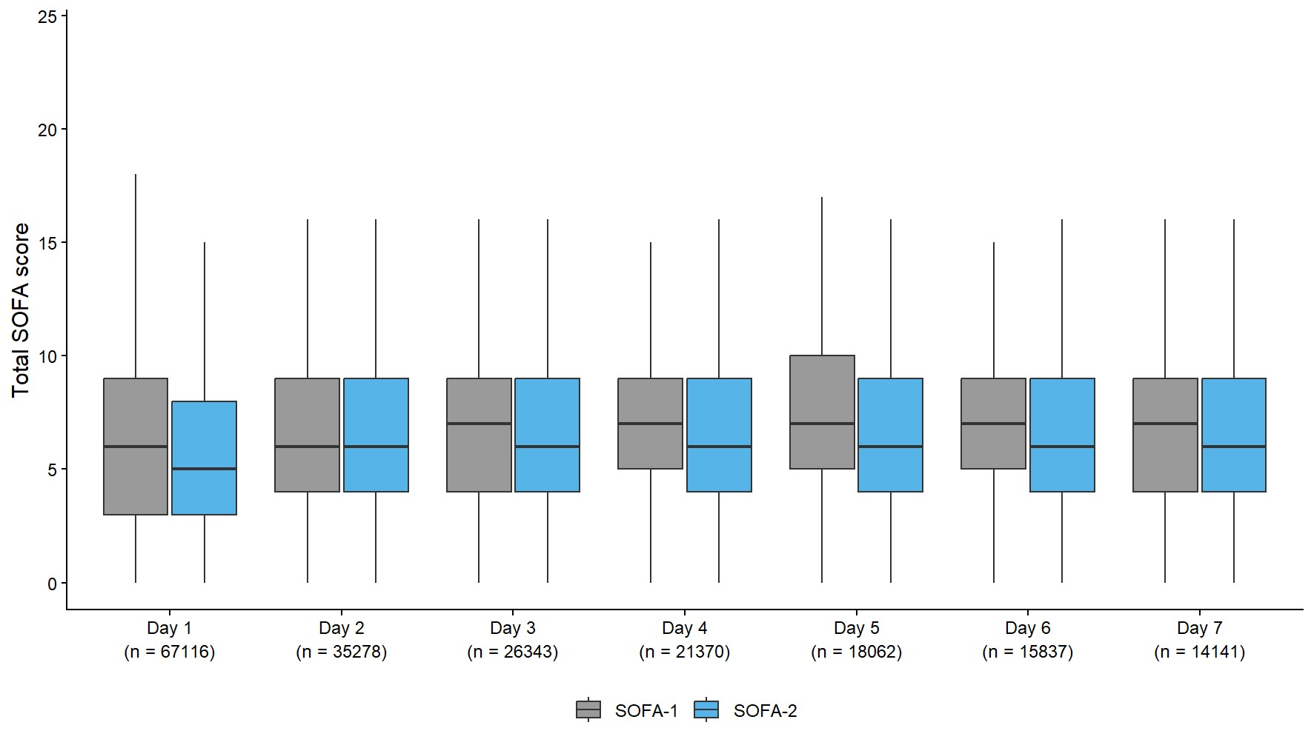

SOFA, Sequential Organ Failure Assessment

