Additional file 9: Distributional differences in SOFA-1 and SOFA-2 domain and total scores in the complete-case cohort
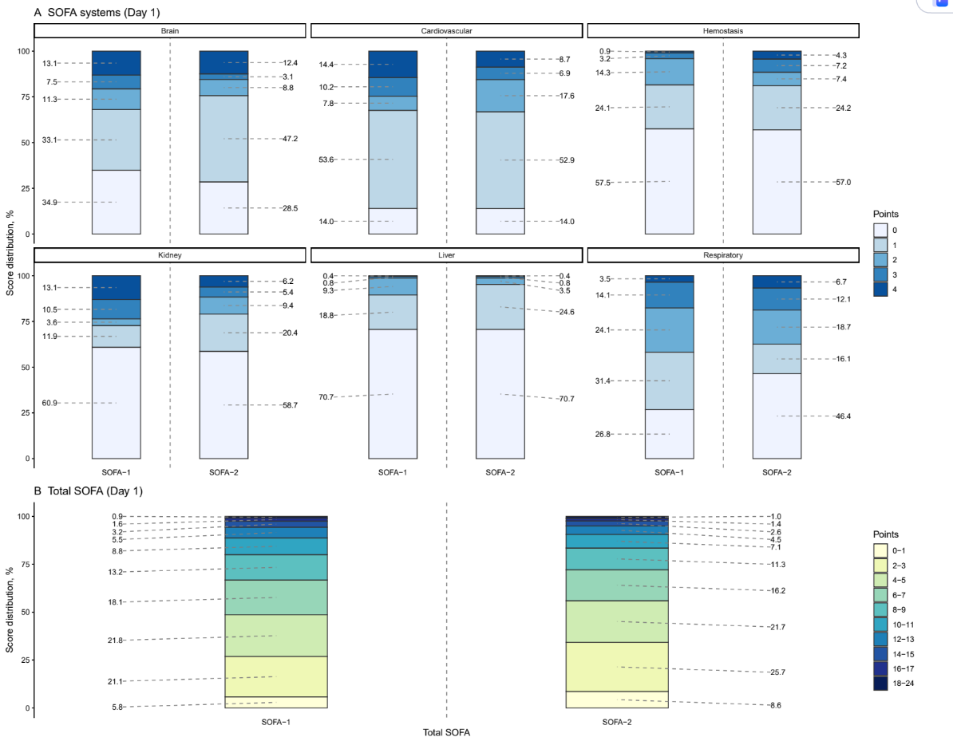
SOFA, Sequential Organ Failure Assessment

