Supplements
Correlation analyses: Plasma concentrations of sTREM-1 at V1 and V3 correlated positively (r=0.63). There was no correlation with inflammation markers like PCT and CRP at V1 (with PCT V1 r=0,23 and with CRP V1 r=0,09) and at V3 (with PCT V3 r=0,23; with CRP V3 r=0.16). Regarding organ dysfunction parameters, plasma concentrations of sTREM-1 V1 correlated weakly with the SOFA score at V1 (r=0.35) and sTREM-1 V3 correlated weakly with the SOFA score at V3 (r=0.48). Plasma concentrations of sTREM-1 at V1 correlated moderately with creatinine V1 (r=0.57) and sTREM-1 V3 correlated only slightly with creatinine at V3 (r=0.32). There was no correlation of sTREM-1 plasma concentrations with the fluid balance at V1 or V3 nor with the Horowitz index at V1 or V3. Plasma concentrations of sTREM-1 at V1 correlated weakly with thrombocytes (r=0.45), whereas there was no correlation at V3.

Suppl. Table 1.) ΔsTREM-1 values in different outcomes vs. pre-existing conditions
 |  | ΔsTREM-1 pg/ml  median (IQR) |  |  |  | p - value
Outcomes | n | yes | n | no | n
28-day mortality | 398 | -24.2 (-175-64.6) | 88 | -43.4 (-127-25.4) | 310 | 0.369
Septic Shock | 425 | -44.6 (-159-37.4) | 299 | -50.3 (-124-10.5) | 126 | 0.897
Need for RRT | 425 | -82.5 (-229-105) | 116 | -42.2 (-122-15.4) | 309 | 0.732
Need for mechanical ventilation | 425 | -38.4 (-153-40.1) | 314 | -63.9 (-139-2.68) | 111 | 0.065
SIC Score: positive | 409 | -80.7 (-250-25-4) | 65 | -43.2 (-123-31.7) | 344 | 0.139
Pre-existing conditions | n
Male | 425 | -39.6 (-126-30.1) | 288 | -60.2 (-174-31.7) | 137 | 0.359
CCI: > median | 499 | -55.1 (-175-32) | 196 | -40.1 (-122-27.4) | 229 | 0.379
Immunosuppression | 415 | -62.5 (-153-19.1) | 36 | -44.4 (-148-31.4) | 379 | 0.339
Nosocomial | 425 | -22.7 (-105-41.5) | 209 | -69.5 (-182-16.3) | 216 | <0.001
Abbreviations: CCI: Charlson Comorbidity Index; IQR: Interquartile range; RRT: renal replacement therapy; SIC Score: Sepsis Induced Coagulopathy Score; ΔsTREM-1: difference of sTREM-1 plasma concentrations from day 1 to day 3
Bold values are statistically significant for p ≤ 0.05

Suppl. Table 2.) sTREM-1 values in different outcomes vs. pre-existing conditions and comorbidities in sepsis vs. septic shock
 |  | Sepsis  sTREM-1 V1 pg/ml  median (IQR) |  |  |  | p - value |  | Septic shock  sTREM-1 V1 pg/ml  median (IQR) |  |  |  | p - value
Outcomes | n | yes | n | no | n |  | n | yes | n | no | n
28-day mortality | 141 | 359 (246-540) | 36 | 264 (179-405) | 105 | 0.033 | 359 | 516 (329-761) | 144 | 346 (242-576) | 215 | <0.001
Need for RRT | 141 | 538 (407-816) | 27 | 241 (170-381) | 114 | <0.001 | 359 | 674 (451-863) | 106 | 335 (239-502) | 253 | <0.001
Need for MV | 141 | 305(194-493) | 81 | 281 (171-469) | 60 | 0.662 | 359 | 436 (283-680) | 290 | 316 (237-469) | 69 | <0.001
SIC Score: positive | 135 | 600 (246-883) | 14 | 273 (184-407) | 121 | 0.007 | 347 | 544 (329-797) | 70 | 369 (254-617) | 277 | 0.003
Pre-existing conditions and comorbidities
Male | 141 | 305 (193-477) | 93 | 263 (176-496) | 48 | 0.797 | 359 | 391 (267-640) | 244 | 414 (287-654) | 115 | 0.379
Immunosuppression | 141 | 517(331-1248) | 8 | 274 (187-469) | 133 | 0.020 | 349 | 403 (310-642) | 37 | 407 (269-650) | 312 | 0.553
Nosocomial | 141 | 278 (191-407) | 77 | 303 (188-533) | 64 | 0.484 | 359 | 371 (257-630) | 164 | 421 (274-670) | 195 | 0.152
CCI: > median | 141 | 353 (220-538) | 65 | 246 (162-388) | 76 | 0.007 | 359 | 478 (310-691) | 169 | 364 (240-582) | 190 | <0.001
Abbreviations: CCI: Charlson Comorbidity Index; IQR: Interquartile range; MV: mechanical ventilation, RRT: renal replacement therapy; SIC Score: Sepsis Induced Coagulopathy Score
Bold values are statistically significant for p ≤ 0.05

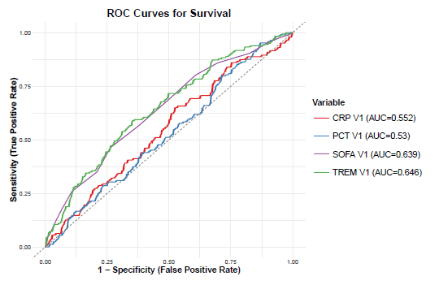
Suppl. Figure 1: AUC curves of sTREM-1, SOFA Score, CRP and PCT V1 in predicting survival day 28
Abbreviations: CRP: C-reactive protein, PCT: procalcitonin, SOFA: Sequential Organ Failure Assessment, TREM-1: Triggering receptor expressed on Myeloid Cells-1: ROC: Receiver Operating Characteristics

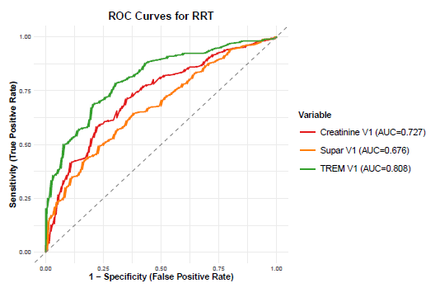
Suppl. Figure 2: AUC curves of sTREM-1, suPAR and Creatinine V1 in predicting RRT
Abbreviations: ROC: Receiver Operating Characteristics; RRT: renal replacement therapy; suPAR: Soluble form of urokinase-type plasminogen activator receptor TREM-1: Triggering receptor expressed on Myeloid Cells-1:

