Supplemental material

Page 1 Table of contents
Page 2 eTable 1 Per-protocol and sensitivity analyses
Page 3 eTable 2 End-tidal CO₂ changes after aortic occlusion
Page 4 eFigure 1 Graphical representation of change in end-tidal CO2 after aortic occlusion
Page 5 eTable 3 Adverse events and protocol deviations

eTable 1. Per-protocol and sensitivity analyses

Analysis | REBOA | Control | Adjusted RD | Unadjusted RD | P value
Per-protocol analysis (CACE) | 25/88 (28%) | 24/91 (26%) | 7 % (-17, 31) | - | 0.57
Sensitivity analysis for the primary analysis | 25/88 (28 %) | 24/91 (26 %) | 4 % (-9, 16) | 2 % (-11, 15) | 0.56
Sensitivity analysis 1 of the per-protocol analysis | 11/50 (22 %) | 6/53 (11 %) | 16 % (2, 29) | 11 % (-4, 25) | 0.02
Sensitivity analysis 2 of the per-protocol analysis | 25/69 (36 %) | 24/90 (27 %) | 11 % (-4, 24) | 10 % (-5, 24) | 0.14

eTable 1. The prespecified per-protocol analysis was performed using the complier average causal effect (CACE) method in the intention-to-treat population. Three sensitivity analysis were performed. First, a sensitivity analysis of the primary analysis adjusted for both “time to randomization” and “rhythm at randomization”. Then, two supporting as-treated per-protocol sensitivity analyses were conducted. In the first per-protocol sensitivity analysis, patients with aortic occlusion were compared with the control group, excluding patients in the control group which died or achieved sustained ROSC before the median time to perform the REBOA procedure. In the second per-protocol sensitivity analysis, patients in the intervention group in whom did not receive the intervention due to death or ROSC were included in the analysis. REBOA indicates resuscitative endovascular balloon occlusion of the aorta, RD; risk difference, CACE; complier average causal effect.

eTable 2. End-tidal CO₂ changes after aortic occlusion

Parameters | Estimate | 95% CI | P value
Fixed effects
Intercept | 3.71 | (3.14, 4.28) | 0.00
Change at 30 s | 0.04 | (-0.23, 0.30) | 0.79
Change at 60 s | 0.17 | (-0.09, 0.43) | 0.21
Change at 90 s | 0.22 | (-0.04, 0.48) | 0.11
Change at 120 s | 0.41 | (0.15, 0.67) | 0.003
Random effects |  | - | -
Patient ID (intercept) SD  Residual SD | 1.96  0.67 | - | -

eTable 2. Results from the linear mixed effect model, with end-tidal CO₂ values (kPa) as dependent variable, change at different timepoints as fixed variables and patient ID as random intercept. The random intercept induces a compound symmetry covariance structure, accounting for within-patient clustering. Imputation of missing values is done according to the statistical analysis plan [Sec. 8.2.2.2]. CI indicates confidence intervals.

eFigure 1. Graphical representation of change in end-tidal CO2 after aortic occlusion
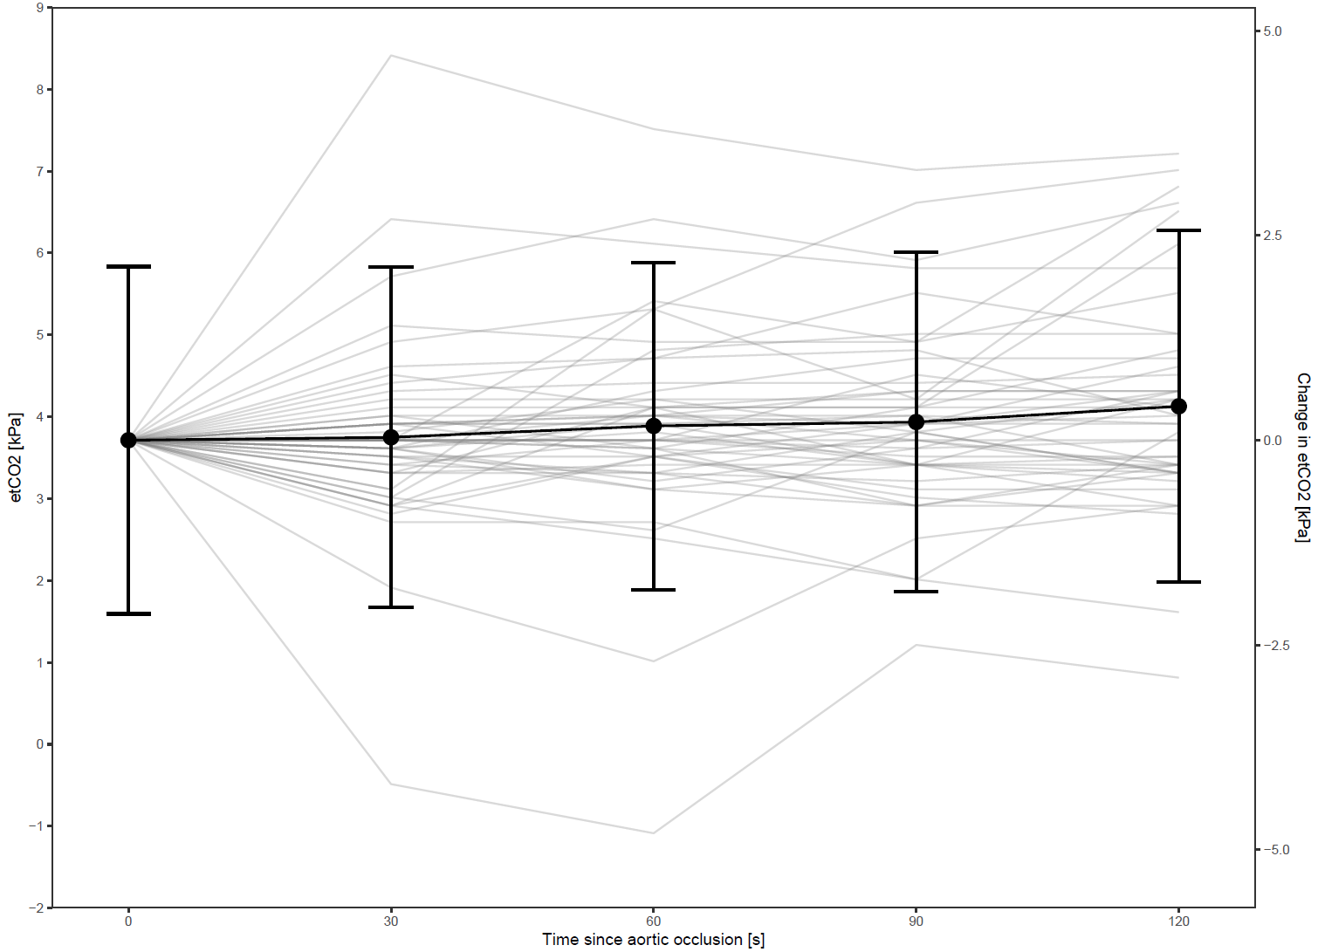

eFigure 1. Change in end-tidal CO2 after aortic occlusion, with the individual changes in background.
eTable 3. Adverse events and protocol deviations

Registered adverse events | REBOA  n=26 | Control  n=31 | Causality | Severity
Patients with adverse events registered, n | 12 | 7
Predefined complications related to REBOA
Intra-aortic thrombus | 1 |  | Probable | Severe
Balloon rupture in situ | 1 |  | Causal relationship | Mild
Predefined complications related to cardiac arrest and CPR
Sternal fracture | 2 |  | Not related | Moderate
Rib fractures | 5 | 8 | Not related | Moderate
Aspiration pneumonia | 2 | 4 | Not related | Severe
Respiratory failure | 7 | 5 | Unlikely | Life-threatening
Drifting of compression device |  | 1 | Not related | Severe
Erroneous dose of adrenaline provided |  | 1 | Not related | Severe
Cerebral infarction | 1 |  | Unlikely | Severe
Lung/bronchopleural injury |  | 2 | Not related | Severe
Predefined complications related to both cardiac arrest, CPR and REBOA
Extremity ischemia | 1 |  | Possible | Severe
Intestinal ischaemia | 1 | 1 | Possible | Life-threatening
Injury to the gastric ventricle or liver | 1 |  | Possible | Life-threatening
Cardiac events/injury | 2 | 2 | Possible | Severe
Total | 24 | 24
Not important protocol deviations | 10 | 2
Important protocol deviations
Balloon inflated in control group |  | 1
Study procedure affected subject´s safety (no pulse check after occlusion) | 1
Venous placement of REBOA | 1

eTable 3. All registered adverse events and protocol deviations. Adverse events are only registered in patients admitted to hospital. Anticipated or unanticipated serious adverse device events, in addition to other adverse events deemed serious by the study site investigator, were reported directly to the project management. Severity and relatedness of adverse events are according to “ISO 14155:2011 Clinical investigation of medical devices for human subjects — Good clinical practice“. Important protocol deviations were handled according to the study protocol and national legislation. REBOA indicates resuscitative endovascular balloon occlusion of the aorta; CPR, cardiopulmonary resuscitation.

