Additional Files

Blood Pressure Response Index Trajectories Identify Distinct Hemodynamic Phenotypes and Predict Mortality in Septic Shock: A Two-Database Retrospective Cohort Study

Supplementary Methods
Supplementary Figures S1–S9
Supplementary Tables S1–S25

Part I: Supplementary Methods
1. Sepsis-3 identification in eICU-CRD
Unlike MIMIC-IV, which provides a pre-computed Sepsis-3 table in its derived schema, eICU-CRD required a de novo implementation of the Sepsis-3 criteria.
Suspected infection was defined as the receipt of ≥ 2 administrations of intravenous antibiotics during the ICU stay, identified from the medication table using 25 drug name patterns covering major antibiotic classes (vancomycin, piperacillin-tazobactam, meropenem, imipenem-cilastatin, cefepime, ceftriaxone, ceftazidime, cefazolin, cefoxitin, ampicillin-sulbactam, levofloxacin, ciprofloxacin, moxifloxacin, metronidazole, clindamycin, linezolid, daptomycin, gentamicin, tobramycin, amikacin, aztreonam, trimethoprim-sulfamethoxazole, and colistin). This approach was adopted because eICU-CRD has limited body fluid sampling data, precluding the standard combination of antibiotics plus blood culture used in MIMIC-IV. The infection offset was defined as the time of the first antibiotic administration, and the sepsis onset time (t₀) was defined as the earlier of the infection offset and zero (ICU admission), i.e., t₀ = LEAST(infection_offset, 0).
The SOFA score was computed from all six organ-system components using the worst values within 24 hours of ICU admission. The respiratory component was derived from the PaO₂/FiO₂ ratio using paired PaO₂ and FiO₂ measurements from the lab table, requiring both values to be recorded within a 60-minute window. Where the PaO₂/FiO₂ ratio was unavailable, the respiratory SOFA subscore was set to 0 (baseline assumption). The coagulation component was derived from the minimum platelet count, and the hepatic component from the maximum total bilirubin, both from the lab table within the first 24 hours. The cardiovascular component was determined by the minimum MAP (from vitalPeriodic) and vasopressor use (from infusiondrug), following standard SOFA cardiovascular scoring thresholds (MAP < 70 mmHg, dopamine ≤ 5 / > 5 / > 15 μg/kg/min, norepinephrine/epinephrine ≤ 0.1 / > 0.1 μg/kg/min). The neurological component used the Glasgow Coma Scale (GCS) total score from the apacheapsvar table, calculated as the sum of eyes, motor, and verbal subscores (each defaulting to 1 when missing). The renal component used the maximum creatinine and 24-hour urine output. Sepsis was diagnosed when the total SOFA score was ≥ 2.
2. VIS computation methods
The Vasoactive-Inotropic Score (VIS) was computed using the modified Gaies formula with coefficients for six drugs: dopamine × 1, dobutamine × 1, epinephrine × 100, norepinephrine × 100, vasopressin (U/kg/min) × 10,000, and milrinone × 10. Phenylephrine was assigned a coefficient of zero following the original VIS definition but was tracked for descriptive purposes. Hours with VIS = 0 (vasopressor pause) were excluded from BPRI computation; windows in which all hours had VIS = 0 were assigned missing BPRI values. Overall, 83.1% of MIMIC-IV and 61.2% of eICU-CRD patients had all 12 windows valid (VIS > 0 in at least one hour per window). Missingness appeared to vary systematically: the best-prognosis class (C3 Responders) had the highest proportion with < 12 valid windows (29.2% in MIMIC-IV), likely reflecting intermittent vasopressor cessation in improving patients, while C6 (Persistently Low) had the lowest (3.9%), consistent with sustained vasopressor dependence. The LCMM framework accommodates missing observations through likelihood-based estimation without requiring complete data. Of note, the VIS formula assigns semi-arbitrary coefficients derived from pediatric cardiac surgery and assumes a linear dose–response relationship; in practice, the hemodynamic effect of vasopressors is non-linear. An alternative denominator such as norepinephrine equivalent dose (NED) might yield different results and warrants future investigation.
3. MIMIC-IV event-level computation
MIMIC-IV stores vasopressor infusions in the inputevents table as interval records with explicit start and end times, with rates pre-standardized to μg/kg/min (patient weight incorporated into the rate calculation); vasopressin rates were recorded in units/hour and standardized to U/kg/min. For each patient-hour within the 48-hour observation window, we identified all drug start/stop event boundaries falling within that hour. At each boundary time point (plus the hour start time), the instantaneous VIS was calculated by summing the weighted contributions of all concurrently active drugs (those whose infusion interval [start, end) encompassed the evaluation time). The hourly VIS maximum (VISₘₐₓ) was the highest instantaneous VIS across all evaluation points within that hour.
4. eICU-CRD LOCF-based computation
eICU-CRD records vasopressor data in the infusiondrug table as point-in-time snapshots (a single time offset per record with no explicit end time). To reconstruct continuous drug activity status, we applied a last observation carried forward (LOCF) approach with a maximum gap (MAX_GAP) of 120 minutes. For each drug at any given evaluation time t, the most recent record at or before t was identified using binary search (bisect algorithm). If the time gap between t and that record was ≤ 120 minutes and the recorded dose was > 0, the drug was considered active at the recorded dose. If the gap exceeded 120 minutes or the most recent recorded dose was zero, the drug was considered discontinued.
5. eICU-CRD dose standardization
Vasopressor records in eICU-CRD are recorded in heterogeneous units requiring per-record standardization. Rates recorded in μg/kg/min were used directly. Rates in μg/min were divided by patient body weight. Rates in mL/hr were converted using drug concentration (calculated from the recorded drug amount divided by the volume of fluid when available; otherwise, standard concentrations were applied: norepinephrine and epinephrine 16 μg/mL, dopamine 1,600 μg/mL, dobutamine 2,000 μg/mL, vasopressin 0.2 units/mL, milrinone 200 μg/mL), then divided by 60 and by body weight. Vasopressin doses were similarly standardized to U/kg/min.
6. Weight handling differences
In MIMIC-IV, infusion rates in the inputevents table are pre-normalized to weight-based units (μg/kg/min); no further weight adjustment is required. In eICU-CRD, infusion rates vary across institutions and may be weight-based or absolute. Patient weight was obtained from the infusiondrug table’s patientweight field, with fallback to the patient table’s admissionweight. No default weight (e.g., 70 kg) was imputed. Records requiring weight-based conversion with missing weight were excluded from VIS computation.
7. Latent class mixed model specification and selection
BPRI trajectories were modeled using latent class mixed models (LCMM). Class labels (C1–C6) were assigned by the LCMM algorithm and are arbitrary; we retained them for consistency with the original model output and assigned descriptive names (e.g., Responders, Non-Responders) based on trajectory shape and clinical characteristics. LCMM was implemented via the hlme() function in the R lcmm package. The outcome variable was log-transformed window BPRI: log(BPRI_min + 0.1). The fixed-effects trajectory was specified as a quadratic polynomial in time (window index 1–12). Class-specific trajectory shapes were estimated by allowing each latent class its own intercept, linear slope, and quadratic curvature via the mixture specification. Individual-level heterogeneity was captured by a random intercept; the within-class residual variance was constrained to be homogeneous across classes (nwg = FALSE).
The quadratic specification was chosen because with 12 time points spanning 48 hours, a quadratic function provides sufficient flexibility to capture the clinically relevant patterns (monotonic rise, decline, plateau, and U-shaped recovery) while avoiding overfitting. Permitting class-specific quadratic coefficients means that the six classes collectively represent six distinct quadratic shapes, which proved sufficient to capture the observed heterogeneity. The random-intercept-only structure was adopted for computational tractability.
For model selection, ng = 2 through 10 latent classes were scanned with 10 random starting values per class number. Each random start was initialized using random perturbation of the ng = 1 baseline model parameters (B = random(m1)), with a maximum of 500 iterations. The BIC decreased monotonically from ng = 2 (152,000) to ng = 10 (117,182). The 6-class solution was selected using a composite criterion combining BIC minimization with two practical constraints: minimum class proportion ≥ 5% and minimum MPCMP ≥ 0.70. Models with ng ≥ 7 failed the minimum class proportion threshold (ng = 7: 4.9%, ng = 8: 3.7%).
8. Multiple imputation technical details
Multiple imputation by chained equations (MICE) was performed using miceforest version 6.0.5, which employs LightGBM gradient-boosted decision trees as the imputation algorithm. Ten imputed datasets (m = 10) were generated, each with 10 iterations. To manage memory requirements (~3 GB peak usage), imputation was performed in batches of 2 datasets per ImputationKernel instance (5 batches total), with garbage collection between batches.
Variables with > 40% missing data in either database were excluded (95 variables total, including troponin, brain natriuretic peptide, C-reactive protein, D-dimer, fibrinogen, and base excess). Remaining continuous variables were winsorized at P1/P99 per database. Categorical variables (race, trajectory class) were one-hot encoded prior to imputation and decoded afterward.
Outcome variables (ICU mortality and in-hospital mortality, both with 0% missing) were included as predictors in the imputation model to preserve outcome–covariate associations, but were not themselves imputed. Three post-imputation variables (48-hour maximum SOFA, APS score, and overall minimum BPRI) were merged into the imputed datasets after imputation. The final imputed datasets contained 98 variables for MIMIC-IV (4,389 × 98) and 96 for eICU-CRD (1,240 × 96), with zero missing values.
9. Restricted mean survival time pseudo-value regression
The restricted mean survival time (RMST) represents the area under the survival curve up to a pre-specified restriction time τ, providing a clinically interpretable measure of average survival time that does not require the proportional hazards assumption. RMST differences between trajectory classes and the C3 reference were estimated at τ = 14 days for ICU mortality and τ = 30 days for in-hospital mortality, with sensitivity analyses at τ = 7 and 14 days, respectively.
For unadjusted analysis (M1), per-class RMST was estimated from Kaplan–Meier survival curves using numerical integration, with variance derived from the Greenwood estimator.
For covariate-adjusted analyses (M2 and M3), we employed the jackknife pseudo-value approach. For each patient i in a dataset of n patients, the pseudo-value was computed as θ̂ᵢ = n × RMST(all) − (n − 1) × RMST(all except i). These pseudo-values were used as the dependent variable in ordinary least squares regression with trajectory class dummies and covariates from M2 or M3. Pseudo-values were computed once per combination of database, outcome, and restriction time, and cached for reuse across covariate sets. All results were pooled across 10 imputed datasets using Rubin’s rules.
10. Pre-vasopressor fluid balance computation
Pre-vasopressor fluid balance was defined as the net fluid balance from ICU admission to the time of first vasopressor administration (tᵥ). In MIMIC-IV, fluid intake was computed from the inputevents table by summing crystalloid, colloid, and bolus fluid volumes administered between ICU admission and tᵥ. Fluid output was computed from the outputevents table over the same interval. Net fluid balance was calculated as total intake minus total output. In eICU-CRD, fluid intake and output were obtained from the intakeOutput table by summing intaketotal and outputtotal, respectively. Patients with no intake or output records in this window were assigned a fluid balance of zero.
11. Treatment intensity classification
A composite treatment intensity classification was constructed from three binary variables: mechanical ventilation (MV), corticosteroid use, and continuous renal replacement therapy (CRRT). Four levels were defined: Low intensity (no MV, no CRRT, with or without corticosteroids); Moderate intensity (MV alone or CRRT alone, with or without corticosteroids); High intensity (concurrent MV and CRRT without corticosteroids); Maximal intensity (concurrent MV, corticosteroids, and CRRT).
12. Software and package versions
Data extraction and management: Python 3.12 with pandas 2.x, NumPy, SQLAlchemy, and psycopg2, querying PostgreSQL 17.2 databases hosting MIMIC-IV v3.1 and eICU-CRD v2.0. Trajectory modeling: R 4.4.2 with the lcmm package (version 2.1.0). Statistical analysis: Python with lifelines (Kaplan–Meier and Cox regression), statsmodels (logistic regression, pseudo-value regression), scikit-learn (AUC computation), and scipy (statistical tests). Multiple imputation: miceforest version 6.0.5 (LightGBM-based).

13. VIS-only and NED-based BPRI sensitivity analyses
To assess whether vasopressor intensity alone (without MAP) produces comparable trajectory phenotypes (SA-4), we applied the same LCMM framework to log-transformed VIS trajectories: log(VIS_max + 0.1), using the identical model specification (class-specific quadratic polynomial, random intercept, ng = 2–6). VIS-only LCMM converged only at ng = 2 (BIC = 160,769, requiring class-specific residual variance [nwg = TRUE], conv = 2) and failed at ng ≥ 3 despite extensive optimization (10 random starts × maxiter = 500, gridsearch with 20 repetitions, multiple variance specifications). The convergence difficulty reflects the highly skewed distribution of VIS values, which lack the stabilizing effect of the MAP numerator. In the original BPRI formulation, MAP (typically titrated to 65–75 mmHg) normalizes the denominator, producing a ratio with sufficient dynamic range for class separation.
To evaluate sensitivity to the vasopressor intensity metric (SA-5), we replaced VIS with norepinephrine equivalent dose (NED) as the denominator. NED was computed as: norepinephrine × 1 + epinephrine × 1 + dopamine × 0.01 + phenylephrine × 0.1 + vasopressin (units/min) × 2.5. Dobutamine and milrinone (inotropes) were excluded. NED-based BPRI (MAP/NED) was log-transformed and modeled identically. LCMM failed to converge at any ng ≥ 2 (0/10 starts × maxiter = 500, all specifications). The likely explanation is that NED values (median ≈ 0.1–0.5 μg/kg/min) are approximately 100-fold smaller than VIS values (median ≈ 18), producing MAP/NED ratios concentrated in the hundreds (median = 475) with compressed log-scale variance (SD = 0.89 vs. BPRI SD = 1.68). This compressed dynamic range provides insufficient variability for latent class separation. The VIS formula’s larger coefficients (×100 for catecholamines, ×10000 for vasopressin) scale the denominator to a range comparable to MAP, In the present data, the VIS-based formulation yielded greater dynamic range and more stable class separation than the tested NED-based alternative.
14. Early classification and simplified classification alternatives
To assess the earliest time at which reliable trajectory classification is achievable (SA-6), we extracted summary features from the first 4 (16 hours), 6 (24 hours), and 8 (32 hours) windows: window-level mean, minimum, and maximum BPRI, plus the linear slope of BPRI over time. A Random Forest classifier (100 trees, 5-fold cross-validation) was trained to predict the full 48-hour LCMM class assignment. Classification was evaluated at three levels of granularity: 6-class (original), 3-group (Responders [C3/C4], Intermediate [C5], Non-Responders [C1/C2/C6]), and binary (Responders vs. Non-Responders, excluding C5). To compare simplified classification alternatives (SA-7), we evaluated: (a) binary threshold classification using maximum BPRI across all 12 windows at thresholds of 5, 10, and 15; (b) 3-group trajectory-based classification; and (c) binary trajectory-based classification (C3/C4 vs. rest). Discrimination was assessed using logistic regression AUC for ICU mortality prediction.
15. Additional sensitivity analyses (SA-7 through SA-11)
Lactate over-adjustment (SA-8): M2 and M3 logistic regression models were re-fitted after removing lactate_max. Delayed-onset exclusion (SA-10): patients with tv − t₀ > 72 hours were excluded and M3 re-fitted. Likelihood ratio tests (SA-11): nested models (null, binary, 3-group, 6-class) compared via LR = 2×(LL_full − LL_reduced) ~ χ²(df). All analyses used 10 MICE-imputed datasets with Rubin’s rules pooling.

Part II: Supplementary Figures
Fig. S1 Missing rate bar chart for retained variables.

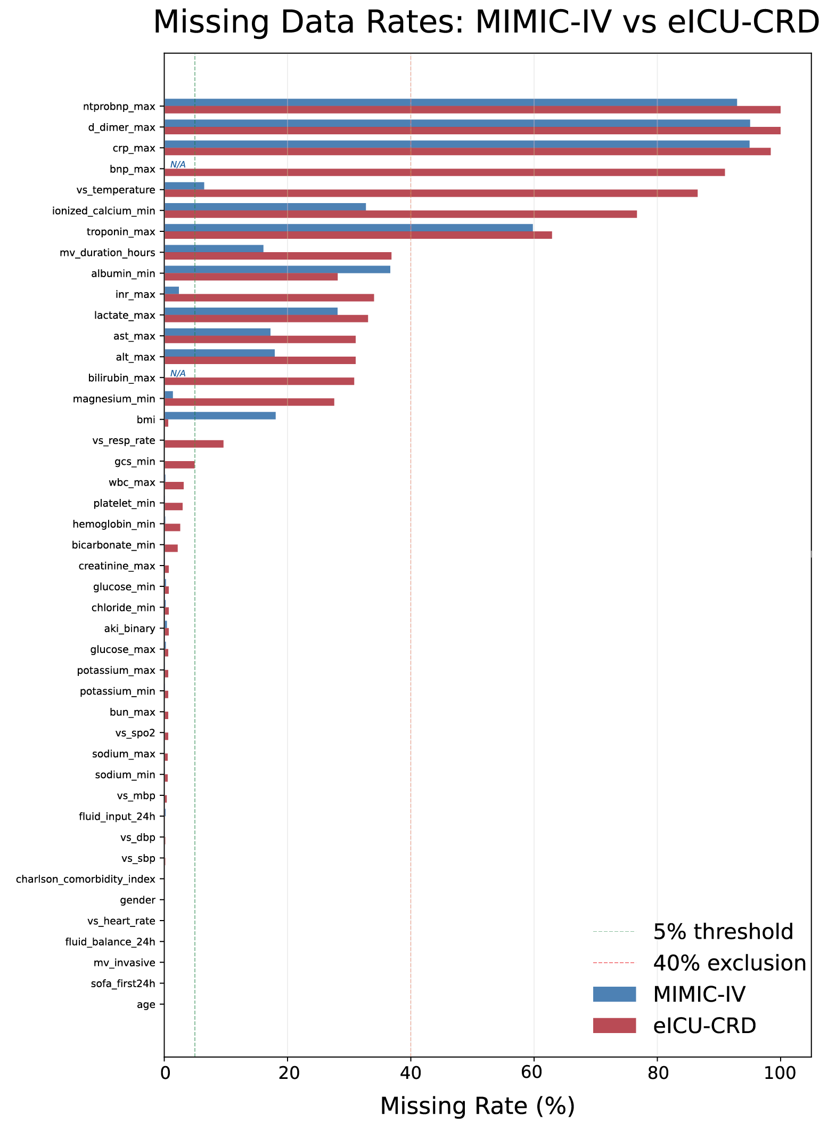
Fig. S2 External validation of BPRI trajectory phenotypes via parameter transport to eICU-CRD.
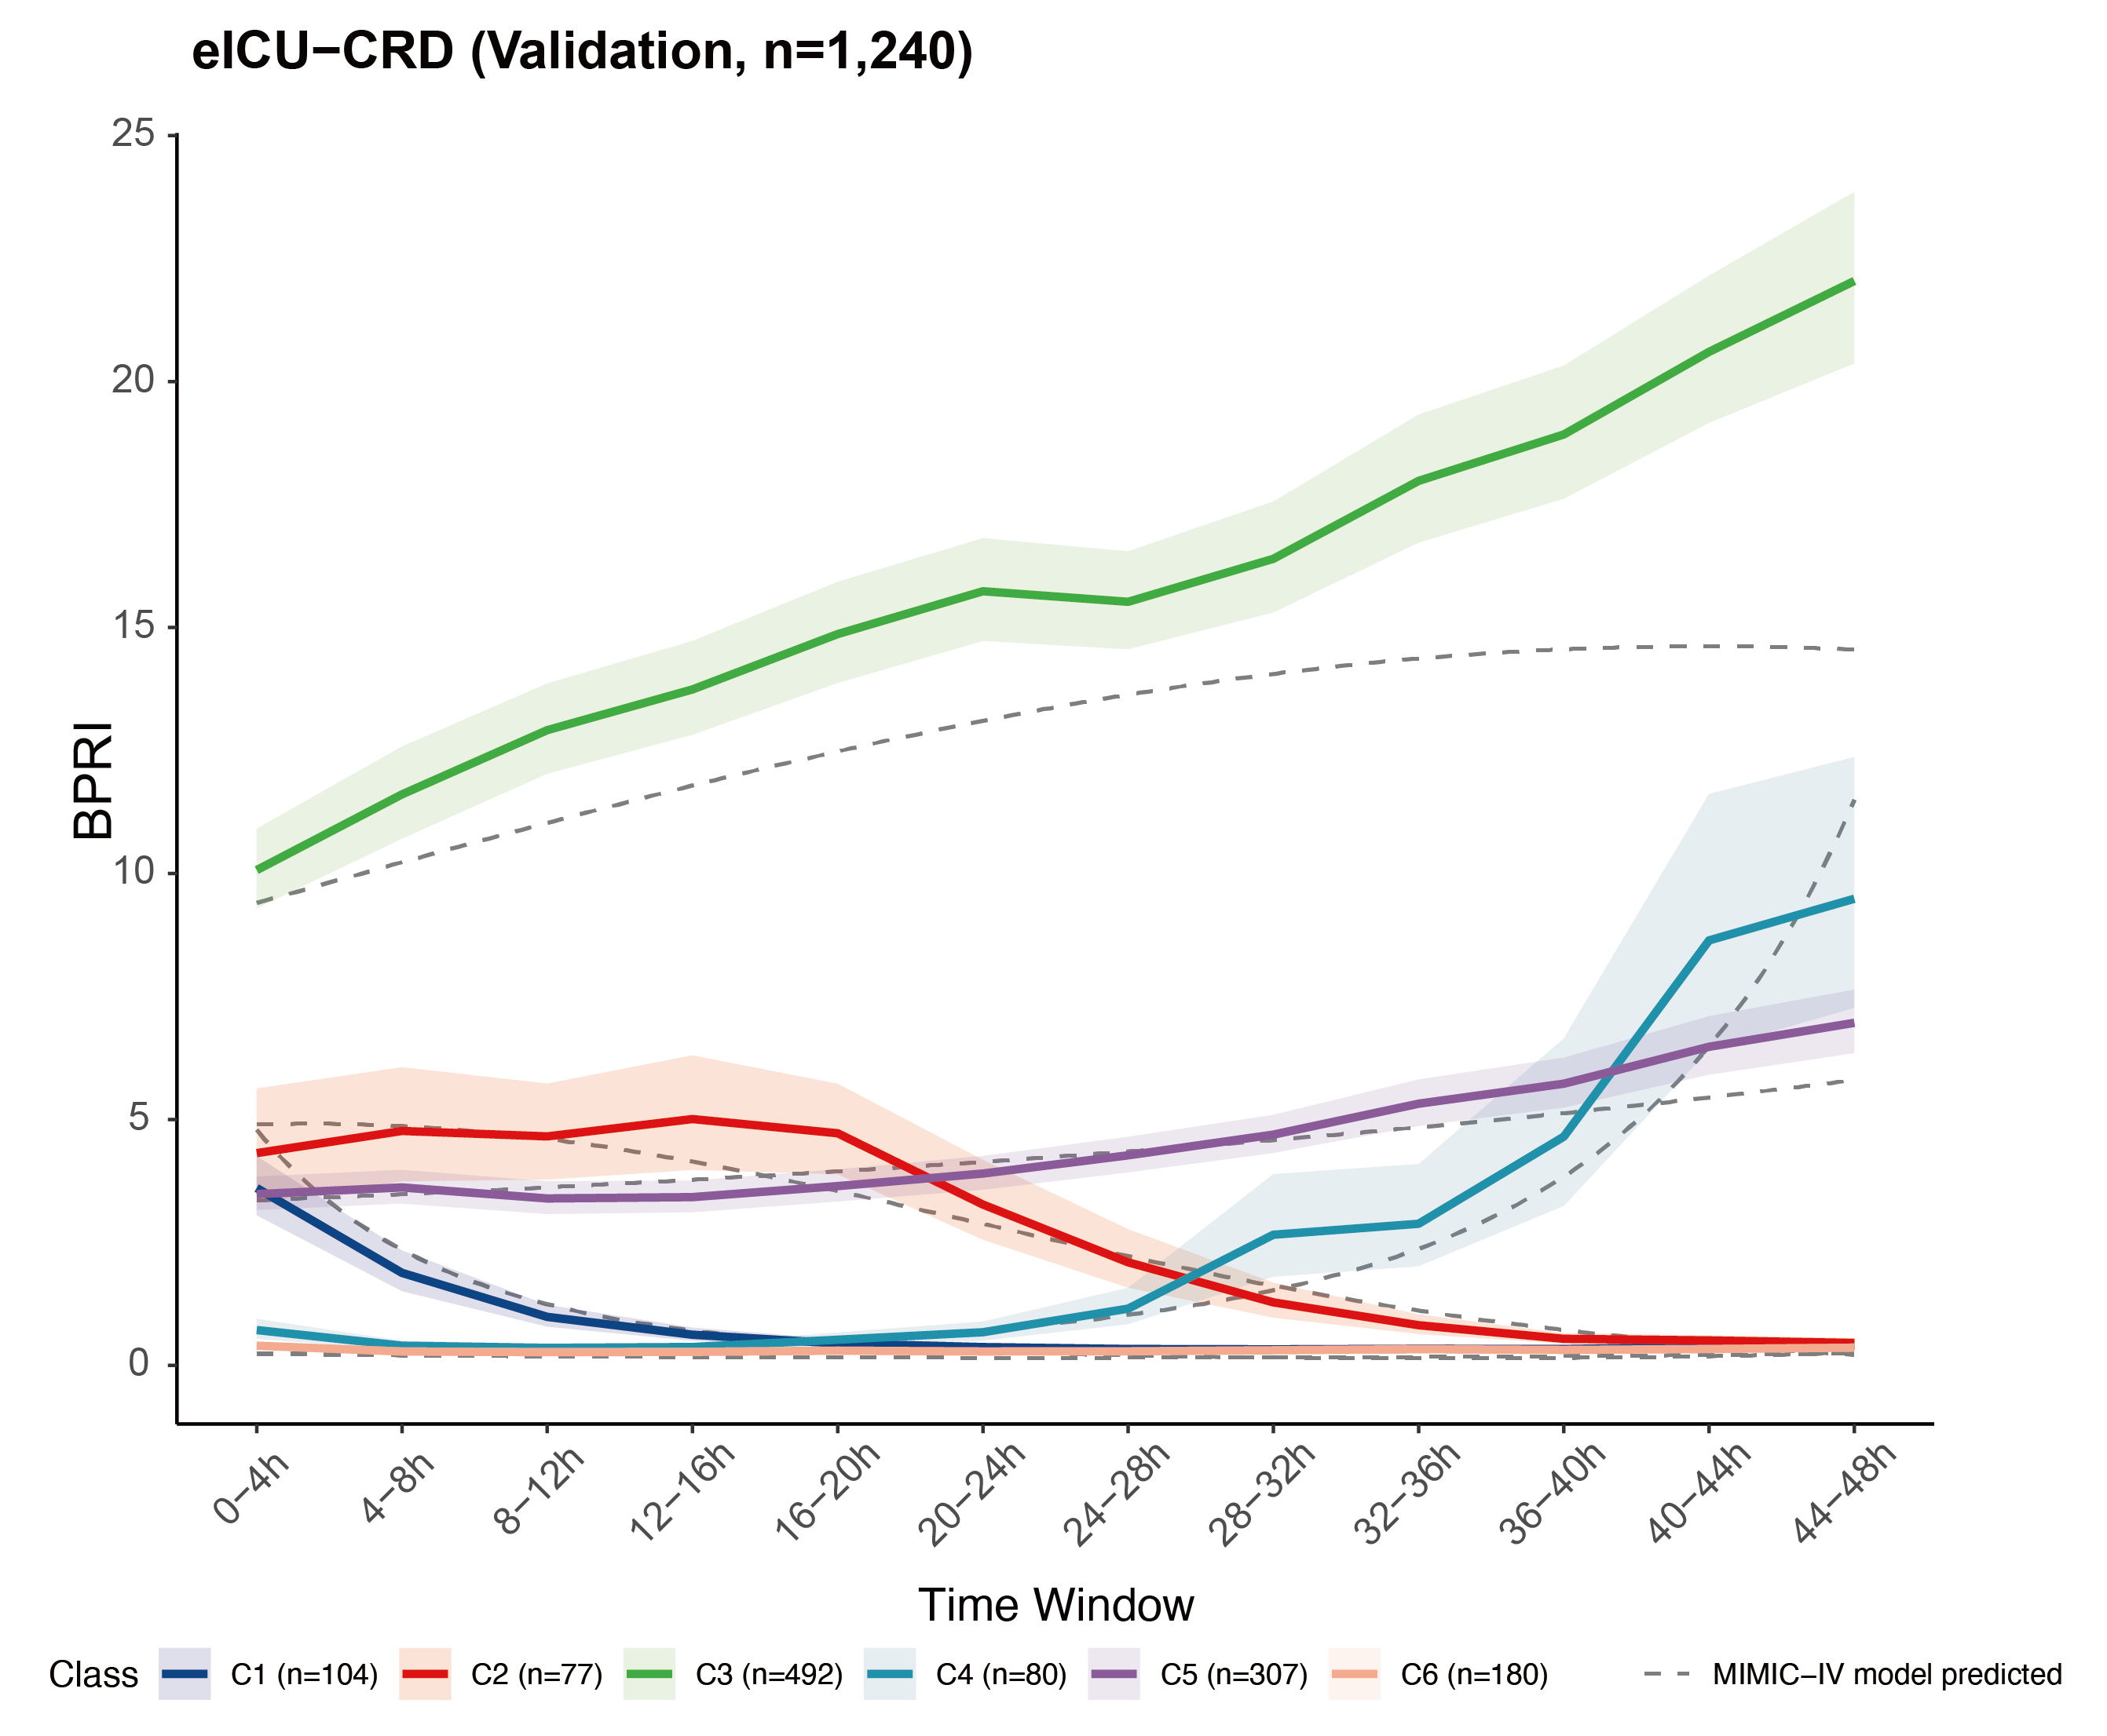
Fig. S3 Outcome comparison by BPRI trajectory class in MIMIC-IV.
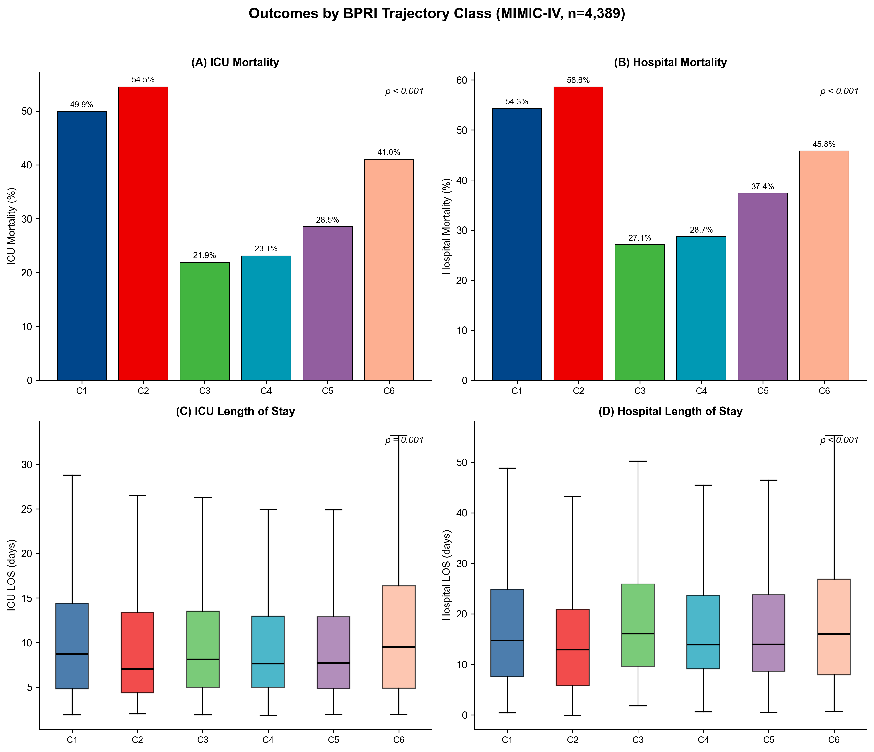

Fig. S4 Restricted mean survival time (RMST) analysis forest plots.
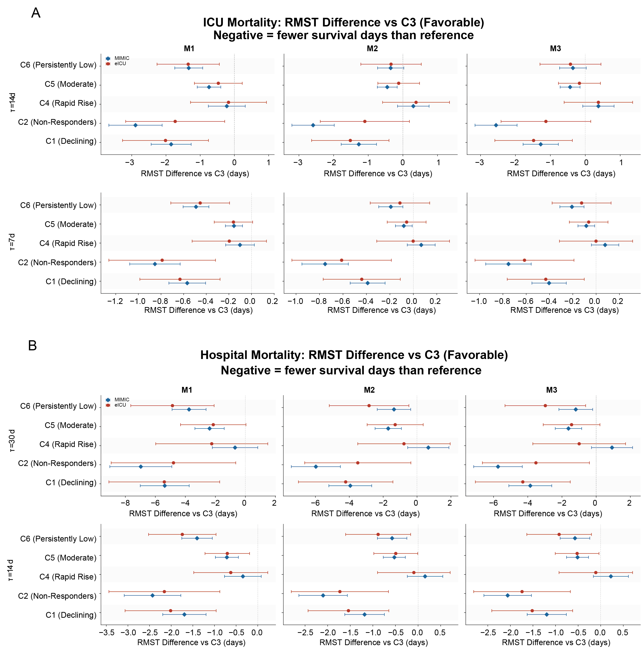
Fig. S5 Incremental predictive value of BPRI trajectory classification beyond severity scores.
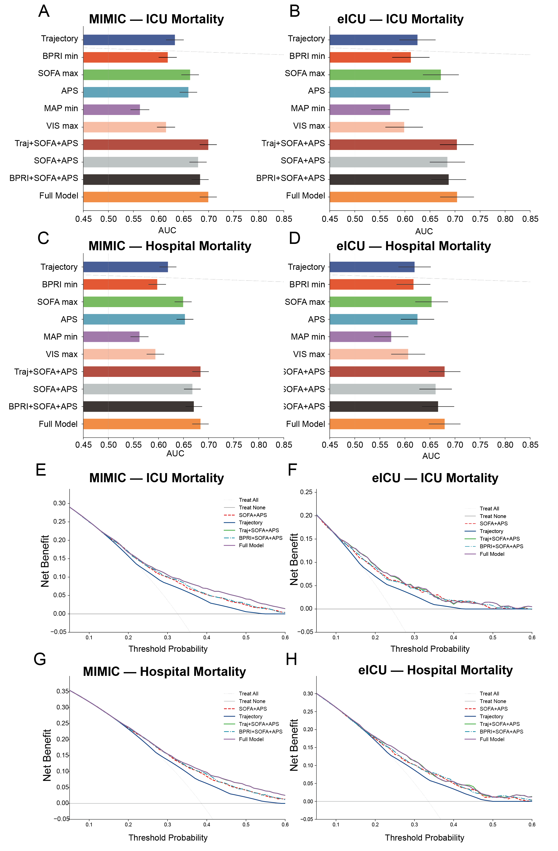

Fig. S6 Calibration plots for incremental prediction models.
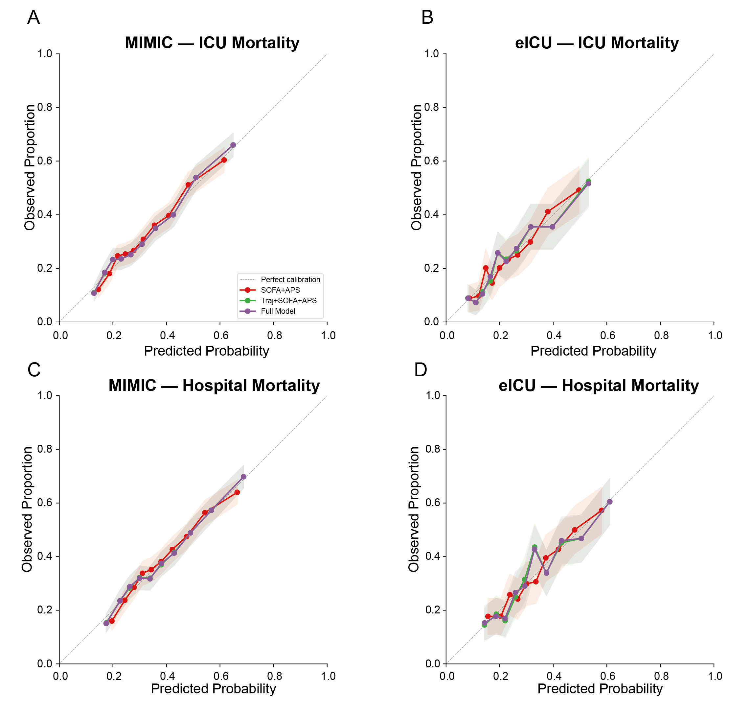

Fig. S7 Sensitivity analysis: window minimum versus mean BPRI aggregation. a–b, MIMIC-IV trajectory comparison and concordance heatmap. c–d, eICU-CRD results. e–f, Mean BPRI BIC and trajectories.

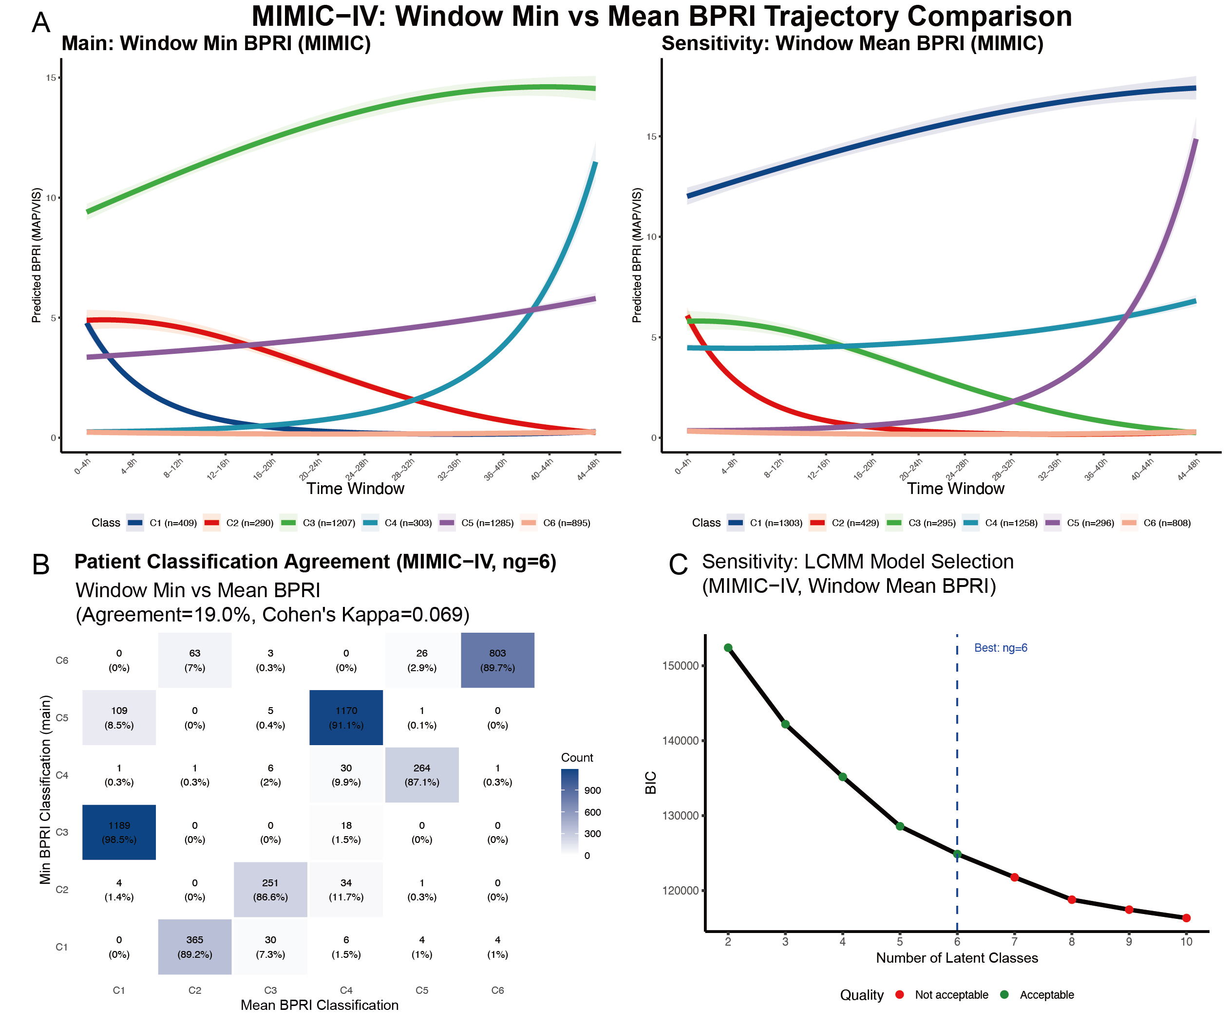

Fig S8 Sensitivity analysis: classification concordance heatmap between original and expanded LCMM models. 6 × 6 heatmap showing patient reclassification between the original (≥ 44 hours) and expanded (≥ 24 hours) 6-class LCMM models in MIMIC-IV. Cell values represent patient counts; optimal 1:1 class mapping (bold diagonal) yields 75.7% overall concordance. Extreme phenotypes show the highest stability: C6 (100%), C1 (89.7%), C4 (86.8%).
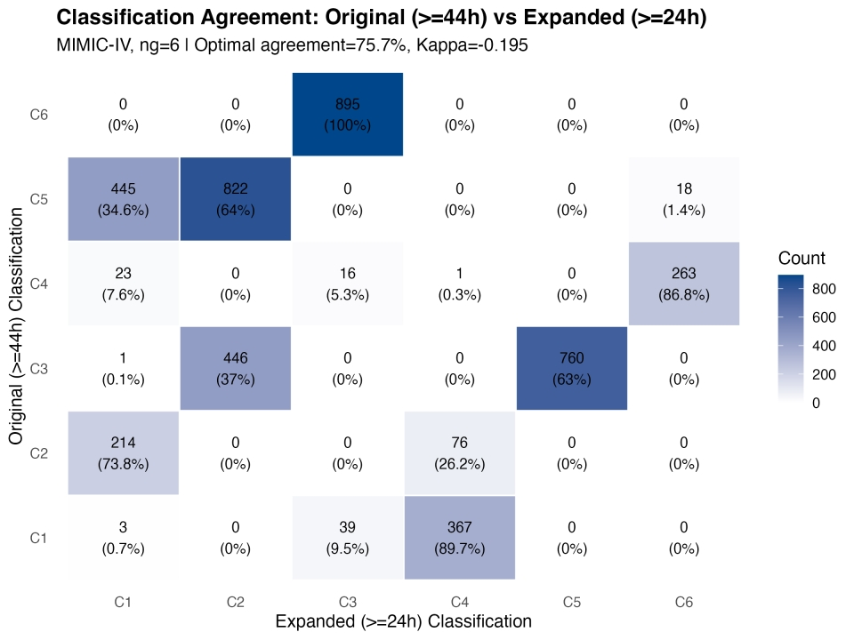

Fig. S9 Sensitivity analysis: BPRI trajectory comparison under relaxed vasopressor duration threshold (≥ 24 hours). a, MIMIC-IV trajectory comparison between the original cohort (≥ 44 hours, n = 4,389) and the expanded cohort (≥ 24 hours, n = 6,801). b, eICU-CRD trajectory comparison between the original cohort (n = 1,240) and the expanded cohort (n = 2,356). Trajectory shapes are preserved with consistent class ordering in both databases.

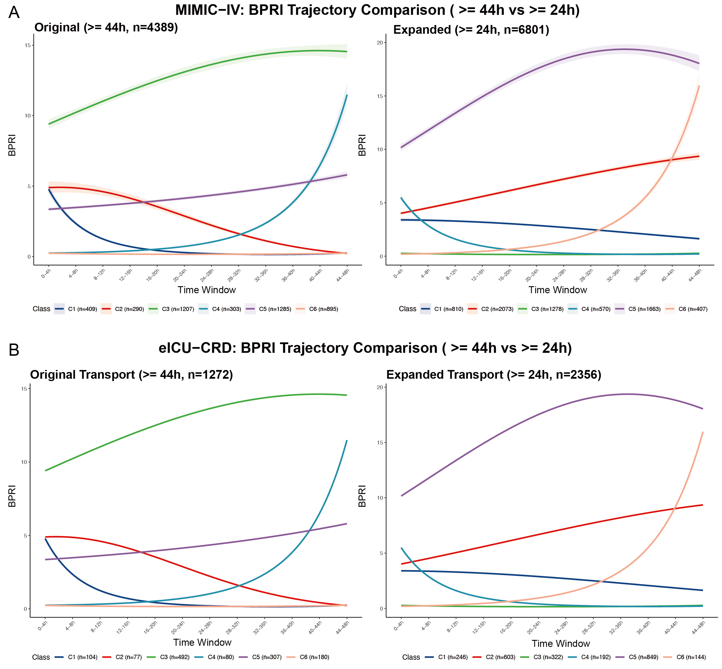

Part III: Supplementary Tables
Table S1. eICU-CRD antibiotic drug name patterns for suspected infection identification. Intravenous antibiotic drug name patterns (SQL LIKE matching) used to define suspected infection (≥ 2 administrations) in the eICU-CRD cohort. Patterns were applied to the infusiondrug.drugname field.
# | Drug Name Pattern | Antibiotic Class
1 | vancomycin | Glycopeptide
2 | piperacillin | Beta-lactam / BLI
3 | tazobactam | Beta-lactam / BLI
4 | meropenem | Carbapenem
5 | cefepime | Cephalosporin (4th gen)
6 | ceftriaxone | Cephalosporin (3rd gen)
7 | levofloxacin | Fluoroquinolone
8 | ciprofloxacin | Fluoroquinolone
9 | ampicillin | Penicillin
10 | azithromycin | Macrolide
11 | metronidazole | Nitroimidazole
12 | flagyl | Nitroimidazole (brand)
13 | linezolid | Oxazolidinone
14 | daptomycin | Lipopeptide
15 | ceftazidime | Cephalosporin (3rd gen)
16 | cefazolin | Cephalosporin (1st gen)
17 | gentamicin | Aminoglycoside
18 | tobramycin | Aminoglycoside
19 | trimethoprim | Folate inhibitor
20 | aztreonam | Monobactam
21 | ertapenem | Carbapenem
22 | imipenem | Carbapenem
23 | clindamycin | Lincosamide
24 | amikacin | Aminoglycoside
25 | cefoxitin | Cephalosporin (2nd gen)

Table S2. Multiple imputation distribution comparison (summary).
Database | Variable | Type | Pre_N | Pre_Missing% | Pre_Mean_or_Median | Pre_SD_or_IQR | Post_Missing% | Post_Mean_or_Median | Post_SD_or_IQR | N_Imputed
eICU | pf_ratio_min | Continuous | 824 | 33.5% | 145.00 | [89.15, 230.00] | 0.0% | 190.84 | [110.76, 285.97] | 416
MIMIC | lactate_max | Continuous | 3155 | 28.1% | 3.00 | [1.80, 5.60] | 0.0% | 2.71 | [1.60, 5.01] | 1234
eICU | alt_max | Continuous | 855 | 31.0% | 37.00 | [20.00, 107.50] | 0.0% | 39.30 | [20.25, 126.08] | 385
MIMIC | pf_ratio_min | Continuous | 3015 | 31.3% | 150.00 | [94.90, 228.00] | 0.0% | 158.82 | [100.81, 237.82] | 1374
eICU | ast_max | Continuous | 855 | 31.0% | 63.00 | [32.00, 200.00] | 0.0% | 66.70 | [32.45, 229.85] | 385
eICU | magnesium_min | Continuous | 898 | 27.6% | 1.80 | [1.60, 2.10] | 0.0% | 1.88 | [1.60, 2.10] | 342
MIMIC | lactate_first | Continuous | 4016 | 8.5% | 2.30 | [1.50, 3.80] | 0.0% | 2.20 | [1.40, 3.70] | 373
MIMIC | alt_max | Continuous | 3602 | 17.9% | 37.00 | [19.00, 101.00] | 0.0% | 35.40 | [19.00, 98.70] | 787
eICU | albumin_min | Continuous | 891 | 28.1% | 2.40 | [2.00, 2.90] | 0.0% | 2.50 | [2.10, 2.90] | 349
MIMIC | fluid_output_24h | Continuous | 4241 | 3.4% | 1685.00 | [850.00, 2915.00] | 0.0% | 1624.20 | [779.70, 2833.60] | 148

Pre- and post-imputation distributions were comparable for all variables (maximum shift in median < 31.6%). The table above shows the 10 variables with the largest differences. Full distribution comparison for all 88 imputed variables is available on request.
Table S3. Baseline characteristics stratified by BPRI trajectory class (C1–C6). Extended version of Table 1 stratified by the six trajectory classes within each database. Continuous variables: median (IQR); categorical: n (%). P-values from Kruskal–Wallis test (continuous) or chi-square test (categorical).
Cohort | Variable | Missing | Overall | C1 | C2 | C3 | C4 | C5 | C6 | p-value
MIMIC-IV | Demographics
MIMIC-IV | Age, years |  | 65.0 [54.0, 75.0] | 64.0 [54.0, 75.0] | 66.0 [55.0, 75.0] | 64.0 [54.5, 75.0] | 66.0 [54.0, 74.5] | 66.0 [55.0, 77.0] | 64.0 [53.5, 73.0] | 0.003
MIMIC-IV | Male sex, n (%) |  | 2584 (58.9) | 220 (53.8) | 161 (55.5) | 717 (59.4) | 188 (62.0) | 754 (58.7) | 544 (60.8) | 0.132
MIMIC-IV | BMI, kg/m² | 793 (18.1%) | 27.8 [23.8, 33.3] | 28.1 [23.4, 33.6] | 27.6 [23.6, 33.1] | 28.5 [24.5, 34.6] | 27.1 [23.8, 31.8] | 26.9 [23.3, 31.9] | 28.2 [24.1, 33.2] | 0.001
MIMIC-IV | Weight, kg |  | 80.0 [66.8, 96.6] | 78.2 [63.3, 98.3] | 81.0 [66.0, 92.8] | 81.6 [69.2, 99.1] | 77.5 [67.1, 92.6] | 76.6 [64.2, 93.7] | 80.2 [68.0, 97.3] | 0.001
MIMIC-IV | Vital Signs (first 24h)
MIMIC-IV | Heart rate, bpm |  | 88.6 [77.4, 101.9] | 94.1 [82.5, 105.9] | 89.1 [78.2, 100.4] | 83.7 [73.2, 95.7] | 89.0 [78.6, 102.3] | 86.9 [75.9, 98.9] | 97.4 [83.4, 110.2] | 0.001
MIMIC-IV | Systolic BP, mmHg | 2 (0.0%) | 106 [100, 113] | 105 [99, 112] | 106 [99, 114] | 108 [101, 115] | 107 [101, 114] | 105 [100, 112] | 104 [98, 111] | 0.001
MIMIC-IV | Diastolic BP, mmHg | 2 (0.0%) | 58.3 [52.8, 64.1] | 58.2 [52.5, 64.2] | 57.4 [52.2, 64.4] | 59.7 [53.9, 65.8] | 58.8 [52.6, 64.1] | 57.5 [52.3, 63.1] | 58.0 [52.4, 63.4] | 0.001
MIMIC-IV | Mean arterial pressure, mmHg |  | 72.5 [67.6, 78.1] | 71.9 [67.1, 77.5] | 72.1 [66.9, 78.0] | 73.7 [68.7, 79.6] | 74.2 [69.2, 79.6] | 71.8 [66.7, 77.4] | 72.1 [67.3, 77.1] | 0.001
MIMIC-IV | Temperature, °C | 284 (6.5%) | 36.8 [36.5, 37.3] | 36.9 [36.5, 37.3] | 36.8 [36.5, 37.2] | 36.8 [36.5, 37.2] | 36.9 [36.6, 37.3] | 36.8 [36.6, 37.3] | 36.9 [36.5, 37.3] | 0.083
MIMIC-IV | Respiratory rate, /min |  | 20.7 [17.9, 23.9] | 21.4 [18.5, 24.1] | 20.8 [17.9, 23.8] | 19.8 [17.5, 22.9] | 21.0 [18.4, 23.8] | 20.3 [17.7, 23.6] | 22.1 [18.9, 25.4] | 0.001
MIMIC-IV | SpO2, % | 1 (0.0%) | 97.1 [95.6, 98.5] | 96.9 [95.2, 98.2] | 97.1 [95.6, 98.6] | 97.1 [95.7, 98.5] | 97.3 [96.0, 98.6] | 97.4 [96.0, 98.8] | 96.8 [95.0, 98.2] | 0.001
MIMIC-IV | Severity Scores
MIMIC-IV | SOFA score (first 24h) |  | 9.0 [7.0, 12.0] | 10.0 [8.0, 13.0] | 10.0 [7.0, 12.0] | 8.0 [6.0, 10.0] | 10.0 [7.0, 12.0] | 9.0 [7.0, 11.0] | 11.0 [9.0, 14.0] | 0.001
MIMIC-IV | SOFA max (t0 to tv+48h) |  | 10.0 [8.0, 13.0] | 12.0 [10.0, 15.0] | 12.0 [9.0, 14.0] | 9.0 [7.0, 11.0] | 11.0 [9.0, 13.0] | 10.0 [8.0, 12.0] | 12.0 [10.0, 15.0] | 0.001
MIMIC-IV | Respiratory | 1034 (23.6%) | 3.0 [2.0, 4.0] | 3.0 [2.0, 4.0] | 3.0 [2.0, 4.0] | 3.0 [2.0, 4.0] | 3.0 [2.0, 4.0] | 3.0 [2.0, 4.0] | 3.0 [3.0, 4.0] | 0.001
MIMIC-IV | Coagulation | 6 (0.1%) | 0.0 [0.0, 2.0] | 0.0 [0.0, 2.0] | 1.0 [0.0, 2.0] | 0.0 [0.0, 1.0] | 0.0 [0.0, 2.0] | 0.0 [0.0, 1.0] | 1.0 [0.0, 2.0] | 0.001
MIMIC-IV | Liver | 789 (18.0%) | 0.0 [0.0, 2.0] | 1.0 [0.0, 2.0] | 0.0 [0.0, 2.0] | 0.0 [0.0, 1.0] | 0.0 [0.0, 2.0] | 0.0 [0.0, 2.0] | 1.0 [0.0, 2.0] | 0.001
MIMIC-IV | Cardiovascular |  | 4.0 [3.0, 4.0] | 4.0 [3.0, 4.0] | 4.0 [3.0, 4.0] | 3.0 [2.0, 4.0] | 4.0 [4.0, 4.0] | 4.0 [4.0, 4.0] | 4.0 [4.0, 4.0] | 0.001
MIMIC-IV | CNS |  | 0.0 [0.0, 1.0] | 0.0 [0.0, 1.0] | 0.0 [0.0, 1.0] | 0.0 [0.0, 1.0] | 0.0 [0.0, 1.0] | 0.0 [0.0, 1.0] | 0.0 [0.0, 1.0] | 0.036
MIMIC-IV | Renal |  | 1.0 [0.0, 3.0] | 2.0 [1.0, 3.0] | 2.0 [1.0, 3.0] | 1.0 [0.0, 2.0] | 1.0 [0.0, 3.0] | 1.0 [0.0, 3.0] | 2.0 [1.0, 3.0] | 0.001
MIMIC-IV | APS score (APSIII / APACHE IV APS) |  | 63.0 [49.0, 80.0] | 72.0 [55.0, 87.0] | 67.0 [53.0, 82.0] | 54.0 [43.0, 68.0] | 64.0 [50.5, 81.0] | 61.0 [49.0, 76.0] | 75.0 [58.0, 93.0] | 0.001
MIMIC-IV | GCS (minimum) |  | 15.0 [14.0, 15.0] | 15.0 [13.0, 15.0] | 15.0 [14.0, 15.0] | 15.0 [14.0, 15.0] | 15.0 [14.0, 15.0] | 15.0 [13.0, 15.0] | 15.0 [14.0, 15.0] | 0.029
MIMIC-IV | Charlson Comorbidity Index |  | 6.0 [4.0, 8.0] | 6.0 [4.0, 8.0] | 6.0 [4.0, 8.0] | 6.0 [4.0, 8.0] | 5.0 [4.0, 8.0] | 6.0 [4.0, 8.0] | 5.0 [4.0, 8.0] | 0.113
MIMIC-IV | Laboratory Values (first 24h)
MIMIC-IV | WBC, x10⁹/L (max) | 8 (0.2%) | 16.0 [11.0, 22.4] | 17.2 [12.1, 24.7] | 16.0 [11.0, 21.7] | 13.7 [9.4, 18.8] | 17.6 [12.7, 25.1] | 15.9 [11.1, 21.1] | 18.5 [12.5, 26.4] | 0.001
MIMIC-IV | Hemoglobin, g/dL (min) | 7 (0.2%) | 9.2 [7.8, 10.9] | 9.0 [7.6, 10.7] | 9.2 [7.9, 10.7] | 9.4 [7.9, 11.2] | 8.9 [7.8, 10.6] | 9.3 [7.9, 11.0] | 8.9 [7.5, 10.6] | 0.001
MIMIC-IV | Platelets, x10⁹/L (min) | 6 (0.1%) | 155 [98, 226] | 154 [87, 229] | 145 [88, 205] | 169 [111, 237] | 150 [92, 210] | 164 [105, 236] | 128 [76, 196] | 0.001
MIMIC-IV | Creatinine, mg/dL (max) | 5 (0.1%) | 1.7 [1.1, 2.9] | 1.8 [1.1, 3.1] | 1.8 [1.2, 3.0] | 1.4 [0.9, 2.6] | 1.7 [1.1, 2.7] | 1.7 [1.1, 3.0] | 2.1 [1.3, 3.2] | 0.001
MIMIC-IV | BUN, mg/dL (max) | 4 (0.1%) | 32.0 [21.0, 53.0] | 33.0 [20.0, 54.0] | 34.0 [22.0, 57.0] | 30.0 [19.0, 52.0] | 31.0 [20.0, 49.0] | 34.0 [21.0, 54.0] | 33.0 [23.0, 53.0] | 0.005
MIMIC-IV | ALT, U/L (max) | 787 (17.9%) | 37.0 [19.0, 101.0] | 37.0 [21.0, 98.0] | 41.0 [22.0, 111.0] | 33.0 [18.0, 78.0] | 39.0 [19.0, 120.0] | 33.0 [19.0, 91.0] | 44.0 [21.0, 151.0] | 0.001
MIMIC-IV | AST, U/L (max) | 756 (17.2%) | 68.0 [33.0, 188.0] | 76.0 [39.0, 241.0] | 80.5 [39.0, 199.2] | 52.0 [28.0, 127.0] | 80.0 [37.5, 238.5] | 61.0 [32.0, 163.0] | 95.0 [42.0, 312.0] | 0.001
MIMIC-IV | Albumin, g/dL (min) | 1609 (36.7%) | 2.8 [2.3, 3.3] | 2.8 [2.2, 3.2] | 2.8 [2.3, 3.3] | 3.0 [2.6, 3.5] | 2.7 [2.3, 3.3] | 2.9 [2.4, 3.4] | 2.6 [2.2, 3.1] | 0.001
MIMIC-IV | Lactate, mmol/L (max) | 1234 (28.1%) | 3.0 [1.8, 5.6] | 3.6 [2.3, 6.3] | 2.6 [1.6, 5.0] | 2.1 [1.4, 3.8] | 3.9 [2.5, 6.2] | 2.5 [1.6, 4.2] | 5.0 [2.7, 8.1] | 0.001
MIMIC-IV | Lactate, mmol/L (first) | 373 (8.5%) | 2.3 [1.5, 3.8] | 2.5 [1.6, 4.2] | 2.2 [1.5, 3.8] | 1.8 [1.2, 2.7] | 2.8 [1.8, 4.6] | 2.1 [1.4, 3.3] | 3.1 [1.9, 5.5] | 0.001
MIMIC-IV | Glucose, mg/dL (max) | 11 (0.3%) | 166 [130, 231] | 168 [134, 236] | 163 [129, 236] | 154 [125, 212] | 187 [142, 255] | 164 [129, 228] | 182 [139, 261] | 0.001
MIMIC-IV | Sodium, mEq/L (max) | 4 (0.1%) | 140 [136, 143] | 139 [136, 143] | 139 [137, 142] | 140 [136, 143] | 139 [136, 143] | 139 [136, 143] | 140 [136, 143] | 0.157
MIMIC-IV | Potassium, mEq/L (max) | 5 (0.1%) | 4.7 [4.2, 5.3] | 4.7 [4.2, 5.4] | 4.7 [4.3, 5.3] | 4.6 [4.2, 5.2] | 4.7 [4.3, 5.3] | 4.6 [4.2, 5.2] | 4.8 [4.3, 5.4] | 0.001
MIMIC-IV | Chloride, mEq/L (min) | 10 (0.2%) | 101 [96, 105] | 100 [96, 105] | 101 [97, 105] | 101 [95, 105] | 101 [96, 105] | 101 [96, 105] | 101 [95, 105] | 0.479
MIMIC-IV | Bicarbonate, mEq/L (min) | 4 (0.1%) | 19.0 [15.7, 22.0] | 18.0 [14.0, 21.0] | 19.0 [15.0, 22.0] | 21.0 [18.0, 24.0] | 17.0 [14.0, 21.0] | 19.0 [16.0, 22.0] | 17.0 [12.0, 20.0] | 0.001
MIMIC-IV | Anion gap, mEq/L (max) | 7 (0.2%) | 18.0 [15.0, 22.0] | 19.0 [16.0, 23.0] | 18.0 [15.0, 22.0] | 16.0 [14.0, 20.0] | 18.0 [15.2, 23.0] | 18.0 [15.0, 22.0] | 20.0 [16.0, 24.0] | 0.001
MIMIC-IV | INR (max) | 104 (2.4%) | 1.5 [1.3, 2.1] | 1.7 [1.4, 2.3] | 1.6 [1.3, 2.1] | 1.4 [1.2, 1.8] | 1.6 [1.3, 2.1] | 1.5 [1.3, 2.0] | 1.7 [1.4, 2.3] | 0.001
MIMIC-IV | pH (min) | 937 (21.3%) | 7.3 [7.2, 7.3] | 7.2 [7.2, 7.3] | 7.3 [7.2, 7.3] | 7.3 [7.2, 7.4] | 7.2 [7.2, 7.3] | 7.3 [7.2, 7.4] | 7.2 [7.1, 7.3] | 0.001
MIMIC-IV | PaCO2, mmHg (max) | 942 (21.5%) | 46.0 [39.0, 55.0] | 46.0 [39.0, 54.2] | 46.0 [38.0, 55.0] | 45.0 [39.0, 54.0] | 46.0 [40.0, 54.0] | 45.0 [38.0, 54.0] | 48.0 [40.0, 57.0] | 0.003
MIMIC-IV | P/F ratio (min) | 1374 (31.3%) | 150 [95, 228] | 145 [88, 225] | 151 [104, 227] | 156 [107, 230] | 146 [93, 210] | 165 [100, 258] | 131 [81, 204] | 0.001
MIMIC-IV | Comorbidities
MIMIC-IV | Hypertension |  | 2760 (62.9) | 237 (57.9) | 190 (65.5) | 775 (64.2) | 196 (64.7) | 822 (64.0) | 540 (60.3) | 0.087
MIMIC-IV | Coronary artery disease |  | 1853 (42.2) | 156 (38.1) | 136 (46.9) | 537 (44.5) | 143 (47.2) | 524 (40.8) | 357 (39.9) | 0.015
MIMIC-IV | Congestive heart failure |  | 1973 (45.0) | 147 (35.9) | 130 (44.8) | 620 (51.4) | 139 (45.9) | 567 (44.1) | 370 (41.3) | 0.001
MIMIC-IV | Cerebrovascular disease |  | 569 (13.0) | 68 (16.6) | 31 (10.7) | 140 (11.6) | 40 (13.2) | 176 (13.7) | 114 (12.7) | 0.115
MIMIC-IV | Chronic pulmonary disease |  | 1253 (28.5) | 101 (24.7) | 89 (30.7) | 366 (30.3) | 75 (24.8) | 371 (28.9) | 251 (28.0) | 0.167
MIMIC-IV | Diabetes (without complications) |  | 1130 (25.7) | 91 (22.2) | 76 (26.2) | 345 (28.6) | 80 (26.4) | 321 (25.0) | 217 (24.2) | 0.100
MIMIC-IV | Diabetes (with complications) |  | 624 (14.2) | 48 (11.7) | 49 (16.9) | 209 (17.3) | 47 (15.5) | 167 (13.0) | 104 (11.6) | 0.001
MIMIC-IV | Chronic kidney disease |  | 1397 (31.8) | 116 (28.4) | 97 (33.4) | 422 (35.0) | 94 (31.0) | 426 (33.2) | 242 (27.0) | 0.002
MIMIC-IV | Mild liver disease |  | 1007 (22.9) | 123 (30.1) | 74 (25.5) | 223 (18.5) | 60 (19.8) | 288 (22.4) | 239 (26.7) | 0.001
MIMIC-IV | Severe liver disease |  | 535 (12.2) | 72 (17.6) | 42 (14.5) | 121 (10.0) | 30 (9.9) | 154 (12.0) | 116 (13.0) | 0.001
MIMIC-IV | Malignant cancer (solid) |  | 569 (13.0) | 64 (15.6) | 36 (12.4) | 122 (10.1) | 43 (14.2) | 167 (13.0) | 137 (15.3) | 0.006
MIMIC-IV | Metastatic solid tumor |  | 263 (6.0) | 28 (6.8) | 12 (4.1) | 43 (3.6) | 20 (6.6) | 91 (7.1) | 69 (7.7) | 0.001
MIMIC-IV | Myocardial infarction |  | 1067 (24.3) | 92 (22.5) | 79 (27.2) | 306 (25.4) | 80 (26.4) | 308 (24.0) | 202 (22.6) | 0.407
MIMIC-IV | Peripheral vascular disease |  | 665 (15.2) | 58 (14.2) | 46 (15.9) | 177 (14.7) | 44 (14.5) | 214 (16.7) | 126 (14.1) | 0.580
MIMIC-IV | Immunosuppression |  | 160 (3.6) | 12 (2.9) | 9 (3.1) | 58 (4.8) | 8 (2.6) | 46 (3.6) | 27 (3.0) | 0.196
MIMIC-IV | Infection
MIMIC-IV | Pulmonary infection |  | 1626 (37.0) | 159 (38.9) | 114 (39.3) | 475 (39.4) | 93 (30.7) | 462 (36.0) | 323 (36.1) | 0.069
MIMIC-IV | Abdominal infection |  | 746 (17.0) | 93 (22.7) | 43 (14.8) | 141 (11.7) | 51 (16.8) | 225 (17.5) | 193 (21.6) | 0.001
MIMIC-IV | Urinary infection |  | 847 (19.3) | 67 (16.4) | 56 (19.3) | 270 (22.4) | 51 (16.8) | 255 (19.8) | 148 (16.5) | 0.009
MIMIC-IV | Bloodstream infection |  | 2600 (59.2) | 279 (68.2) | 183 (63.1) | 590 (48.9) | 172 (56.8) | 747 (58.1) | 629 (70.3) | 0.001
MIMIC-IV | Blood culture positive |  | 766 (17.5) | 84 (20.5) | 55 (19.0) | 206 (17.1) | 36 (11.9) | 219 (17.0) | 166 (18.5) | 0.057
MIMIC-IV | Time to antibiotics, hours | 110 (2.5%) | 2.0 [0.0, 6.0] | 2.0 [0.0, 7.0] | 2.0 [0.0, 10.0] | 2.0 [0.0, 8.0] | 1.0 [0.0, 4.0] | 2.0 [0.0, 7.0] | 1.0 [0.0, 4.0] | 0.001
MIMIC-IV | Treatment & Interventions
MIMIC-IV | ICU to vasopressor, hours | 4 (0.1%) | 4.9 [1.9, 16.2] | 5.4 [1.9, 20.0] | 4.9 [1.8, 17.7] | 7.3 [2.6, 25.2] | 3.6 [1.5, 8.1] | 4.6 [1.8, 14.1] | 3.8 [1.7, 9.0] | 0.001
MIMIC-IV | Corticosteroid use |  | 1252 (28.5) | 137 (33.5) | 95 (32.8) | 245 (20.3) | 95 (31.4) | 311 (24.2) | 369 (41.2) | 0.001
MIMIC-IV | RBC transfusion |  | 738 (16.8) | 106 (25.9) | 59 (20.3) | 116 (9.6) | 53 (17.5) | 174 (13.5) | 230 (25.7) | 0.001
MIMIC-IV | Mechanical ventilation |  | 3685 (84.0) | 370 (90.5) | 254 (87.6) | 925 (76.6) | 271 (89.4) | 1027 (79.9) | 838 (93.6) | 0.001
MIMIC-IV | CRRT |  | 1173 (26.7) | 155 (37.9) | 102 (35.2) | 223 (18.5) | 79 (26.1) | 260 (20.2) | 354 (39.6) | 0.001
MIMIC-IV | AKI (any stage) | 19 (0.4%) | 3202 (73.0) | 325 (79.5) | 247 (85.2) | 809 (67.0) | 215 (71.0) | 870 (67.7) | 736 (82.2) | 0.001
MIMIC-IV | Fluid Balance (first 24h)
MIMIC-IV | Fluid input (0-6h), mL | 9 (0.2%) | 824 [155, 1780] | 999 [200, 2093] | 694 [105, 1500] | 500 [52, 1144] | 1070 [246, 2256] | 813 [192, 1707] | 1308 [373, 2452] | 0.001
MIMIC-IV | Fluid input (0-24h), mL | 9 (0.2%) | 2579 [964, 4842] | 3270 [1344, 6006] | 2195 [783, 4450] | 1587 [506, 3428] | 3138 [1604, 5177] | 2476 [969, 4516] | 4097 [2055, 6747] | 0.001
MIMIC-IV | Fluid output (0-24h), mL | 148 (3.4%) | 1685 [850, 2915] | 1482 [787, 2835] | 1568 [718, 2715] | 1852 [1054, 3142] | 1862 [918, 2835] | 1560 [850, 2790] | 1638 [705, 2790] | 0.001
MIMIC-IV | Fluid balance (0-24h), mL |  | 787 [-823, 2932] | 1446 [-367, 4119] | 690 [-901, 2547] | -41.0 [-1605.6, 1582.6] | 1047 [-324, 3351] | 751 [-641, 2682] | 2105 [109, 4875] | 0.001
MIMIC-IV | BPRI (Observation Period)
MIMIC-IV | BPRI minimum (across all windows) |  | 1.1 [0.1, 3.6] | 0.1 [0.1, 0.2] | 0.2 [0.1, 0.2] | 5.7 [3.8, 8.3] | 0.1 [0.1, 0.2] | 2.0 [1.3, 2.9] | 0.1 [0.1, 0.1] | 0.001
MIMIC-IV | Outcomes
MIMIC-IV | ICU mortality |  | 1429 (32.6) | 204 (49.9) | 158 (54.5) | 264 (21.9) | 70 (23.1) | 366 (28.5) | 367 (41.0) | 0.001
MIMIC-IV | In-hospital mortality |  | 1696 (38.6) | 222 (54.3) | 170 (58.6) | 327 (27.1) | 87 (28.7) | 480 (37.4) | 410 (45.8) | 0.001
MIMIC-IV | ICU length of stay, days |  | 8.1 [4.9, 13.9] | 8.7 [4.8, 14.4] | 7.0 [4.4, 13.4] | 8.1 [5.0, 13.5] | 7.6 [5.0, 13.0] | 7.7 [4.8, 12.9] | 9.5 [4.9, 16.4] | 0.001
MIMIC-IV | Hospital length of stay, days |  | 14.9 [8.6, 24.9] | 14.7 [7.6, 24.8] | 12.9 [5.8, 20.9] | 16.1 [9.6, 25.9] | 13.9 [9.1, 23.7] | 14.0 [8.6, 23.8] | 16.0 [7.9, 26.9] | 0.001
eICU-CRD | Demographics
eICU-CRD | Age, years |  | 67.0 [57.8, 76.0] | 64.0 [57.0, 73.2] | 66.0 [58.0, 75.0] | 67.0 [57.8, 75.0] | 67.5 [58.8, 75.2] | 69.0 [59.5, 79.0] | 64.0 [56.0, 73.0] | 0.010
eICU-CRD | Male sex, n (%) |  | 686 (55.3) | 60 (57.7) | 37 (48.1) | 279 (56.7) | 53 (66.2) | 152 (49.5) | 105 (58.3) | 0.052
eICU-CRD | BMI, kg/m² | 8 (0.6%) | 28.2 [24.0, 33.2] | 27.5 [23.8, 31.0] | 27.5 [24.1, 32.4] | 28.8 [24.7, 33.9] | 27.3 [23.7, 31.7] | 27.4 [22.9, 32.0] | 29.0 [23.9, 35.1] | 0.017
eICU-CRD | Weight, kg | 1 (0.1%) | 80.2 [68.0, 98.0] | 78.6 [65.3, 94.1] | 81.5 [68.2, 95.1] | 82.4 [69.2, 100.3] | 79.1 [68.2, 96.8] | 75.6 [64.3, 90.8] | 83.5 [68.1, 104.1] | 0.001
eICU-CRD | Vital Signs (first 24h)
eICU-CRD | Heart rate, bpm |  | 90.7 [79.3, 104.0] | 99.8 [90.2, 113.3] | 91.5 [76.4, 108.6] | 86.1 [75.5, 96.4] | 91.8 [79.3, 110.6] | 92.4 [82.5, 104.3] | 97.0 [86.6, 112.7] | 0.001
eICU-CRD | Systolic BP, mmHg | 2 (0.2%) | 106 [99, 114] | 103 [96, 111] | 104 [97, 111] | 109 [101, 117] | 106 [99, 111] | 105 [98, 113] | 104 [97, 113] | 0.001
eICU-CRD | Diastolic BP, mmHg | 2 (0.2%) | 55.0 [50.0, 61.0] | 52.9 [48.4, 59.0] | 53.3 [48.6, 58.5] | 56.1 [51.3, 61.7] | 55.0 [50.1, 61.4] | 54.8 [49.1, 60.9] | 54.9 [50.0, 60.2] | 0.004
eICU-CRD | Mean arterial pressure, mmHg | 5 (0.4%) | 71.3 [66.3, 76.3] | 68.2 [64.7, 73.1] | 67.6 [63.1, 74.3] | 72.0 [67.7, 76.9] | 70.2 [66.2, 77.2] | 70.9 [65.7, 76.2] | 71.4 [66.3, 76.2] | 0.001
eICU-CRD | Temperature, °C | 1073 (86.5%) | 37.0 [36.5, 37.4] | 37.3 [35.3, 39.0] | 37.1 [36.8, 37.4] | 37.0 [36.5, 37.3] | 37.0 [36.8, 37.8] | 37.1 [36.4, 37.4] | 36.9 [36.5, 37.2] | 0.921
eICU-CRD | Respiratory rate, /min | 119 (9.6%) | 20.2 [16.9, 24.0] | 22.3 [19.1, 26.9] | 20.6 [17.5, 23.9] | 19.2 [16.2, 22.6] | 19.2 [16.2, 23.9] | 20.1 [17.0, 24.3] | 22.6 [18.3, 25.3] | 0.001
eICU-CRD | SpO2, % | 8 (0.6%) | 97.3 [95.6, 98.6] | 96.4 [95.0, 98.5] | 97.1 [95.1, 98.6] | 97.5 [96.0, 98.8] | 97.1 [95.8, 98.4] | 97.4 [95.9, 98.7] | 96.3 [94.2, 98.3] | 0.001
eICU-CRD | Severity Scores
eICU-CRD | SOFA score (first 24h) |  | 10.0 [8.0, 13.0] | 11.0 [9.0, 14.0] | 11.0 [8.0, 14.0] | 10.0 [7.0, 12.0] | 11.0 [10.0, 13.2] | 10.0 [8.0, 12.0] | 12.0 [10.0, 14.0] | 0.001
eICU-CRD | SOFA max (t0 to tv+48h) |  | 11.0 [9.0, 13.0] | 13.0 [10.0, 14.0] | 11.0 [9.0, 14.0] | 10.0 [8.0, 12.0] | 12.0 [9.8, 14.0] | 11.0 [8.0, 13.0] | 13.0 [11.0, 15.0] | 0.001
eICU-CRD | Respiratory | 405 (32.7%) | 3.0 [2.0, 4.0] | 3.0 [2.0, 4.0] | 3.0 [2.0, 4.0] | 3.0 [2.0, 3.0] | 3.0 [3.0, 4.0] | 3.0 [2.0, 4.0] | 3.0 [2.0, 4.0] | 0.001
eICU-CRD | Coagulation | 37 (3.0%) | 0.0 [0.0, 2.0] | 0.0 [0.0, 2.0] | 0.0 [0.0, 2.0] | 1.0 [0.0, 2.0] | 0.0 [0.0, 1.0] | 0.0 [0.0, 1.0] | 1.0 [0.0, 2.0] | 0.002
eICU-CRD | Liver | 382 (30.8%) | 0.0 [0.0, 1.8] | 1.0 [0.0, 2.0] | 0.0 [0.0, 2.0] | 0.0 [0.0, 1.0] | 0.0 [0.0, 1.0] | 0.0 [0.0, 1.0] | 0.0 [0.0, 2.0] | 0.002
eICU-CRD | Cardiovascular |  | 4.0 [4.0, 4.0] | 4.0 [4.0, 4.0] | 4.0 [4.0, 4.0] | 4.0 [4.0, 4.0] | 4.0 [4.0, 4.0] | 4.0 [4.0, 4.0] | 4.0 [4.0, 4.0] | 0.001
eICU-CRD | CNS | 8 (0.6%) | 2.0 [1.0, 3.0] | 2.0 [1.0, 3.0] | 3.0 [1.0, 3.0] | 2.0 [1.0, 3.0] | 3.0 [2.0, 4.0] | 2.0 [1.0, 3.0] | 3.0 [1.0, 4.0] | 0.003
eICU-CRD | Renal | 9 (0.7%) | 1.0 [0.0, 2.0] | 2.0 [1.0, 2.0] | 1.0 [0.0, 2.0] | 1.0 [0.0, 2.0] | 1.0 [0.8, 2.0] | 1.0 [0.0, 2.0] | 2.0 [1.0, 2.0] | 0.001
eICU-CRD | APS score (APSIII / APACHE IV APS) | 101 (8.1%) | 72.0 [54.0, 95.0] | 81.0 [65.5, 99.5] | 76.0 [60.0, 98.0] | 63.0 [47.0, 82.5] | 80.0 [66.5, 107.8] | 70.0 [54.0, 89.0] | 89.5 [67.0, 110.2] | 0.001
eICU-CRD | GCS (minimum) | 61 (4.9%) | 10.0 [7.0, 14.0] | 10.0 [7.0, 14.5] | 9.5 [6.0, 13.8] | 11.0 [7.0, 14.0] | 9.0 [6.0, 12.0] | 10.0 [7.0, 14.0] | 10.0 [3.0, 14.0] | 0.012
eICU-CRD | Charlson Comorbidity Index | 1 (0.1%) | 2.0 [1.0, 3.0] | 2.0 [1.0, 4.0] | 1.0 [0.0, 4.0] | 2.0 [1.0, 3.0] | 2.0 [0.0, 3.0] | 2.0 [1.0, 3.0] | 2.0 [0.0, 3.2] | 0.974
eICU-CRD | Laboratory Values (first 24h)
eICU-CRD | WBC, x10⁹/L (max) | 39 (3.1%) | 15.5 [10.1, 22.7] | 18.2 [8.8, 24.7] | 17.2 [12.2, 26.6] | 13.9 [9.5, 19.6] | 16.3 [11.0, 22.7] | 17.2 [11.6, 23.2] | 17.2 [8.2, 26.2] | 0.001
eICU-CRD | Hemoglobin, g/dL (min) | 32 (2.6%) | 9.7 [8.1, 11.3] | 9.7 [8.0, 11.5] | 9.4 [8.0, 10.9] | 9.8 [8.3, 11.4] | 9.8 [7.8, 11.6] | 9.8 [8.1, 11.3] | 9.6 [8.1, 10.9] | 0.883
eICU-CRD | Platelets, x10⁹/L (min) | 37 (3.0%) | 153 [96, 222] | 158 [79, 229] | 160 [93, 228] | 149 [97, 218] | 154 [105, 228] | 170 [109, 238] | 134 [74, 196] | 0.004
eICU-CRD | Creatinine, mg/dL (max) | 9 (0.7%) | 1.8 [1.1, 2.9] | 2.0 [1.3, 3.3] | 1.9 [1.0, 3.0] | 1.5 [0.9, 2.5] | 1.8 [1.3, 2.8] | 1.7 [1.0, 2.9] | 2.3 [1.6, 3.3] | 0.001
eICU-CRD | BUN, mg/dL (max) | 8 (0.6%) | 33.0 [21.0, 51.2] | 42.5 [25.0, 61.2] | 34.0 [22.0, 54.0] | 31.0 [18.0, 45.0] | 34.5 [22.0, 52.0] | 31.0 [20.0, 49.0] | 40.0 [28.0, 58.0] | 0.001
eICU-CRD | ALT, U/L (max) | 385 (31.0%) | 37.0 [20.0, 107.5] | 32.0 [19.5, 79.5] | 33.5 [21.5, 128.8] | 34.0 [19.0, 96.0] | 43.5 [20.2, 109.8] | 32.0 [18.0, 71.8] | 57.0 [24.0, 154.0] | 0.012
eICU-CRD | AST, U/L (max) | 385 (31.0%) | 63.0 [32.0, 200.0] | 65.0 [36.0, 157.0] | 77.0 [35.0, 272.0] | 55.0 [28.0, 159.0] | 85.0 [35.2, 208.2] | 57.5 [30.0, 171.0] | 91.0 [43.0, 301.0] | 0.007
eICU-CRD | Albumin, g/dL (min) | 349 (28.1%) | 2.4 [2.0, 2.9] | 2.2 [1.9, 2.6] | 2.3 [1.9, 2.6] | 2.5 [2.1, 2.9] | 2.5 [1.9, 2.8] | 2.5 [2.1, 3.0] | 2.3 [2.0, 2.7] | 0.001
eICU-CRD | Lactate, mmol/L (max) | 410 (33.1%) | 3.0 [1.7, 5.3] | 3.5 [2.1, 5.8] | 2.8 [1.8, 5.8] | 2.2 [1.4, 3.6] | 3.7 [1.9, 5.3] | 2.8 [1.6, 4.8] | 5.2 [3.3, 9.4] | 0.001
eICU-CRD | Lactate, mmol/L (first) | 410 (33.1%) | 2.6 [1.6, 4.8] | 2.5 [1.9, 5.0] | 2.5 [1.6, 4.5] | 2.0 [1.3, 3.3] | 3.2 [1.4, 5.1] | 2.4 [1.5, 4.4] | 4.4 [2.7, 8.1] | 0.001
eICU-CRD | Glucose, mg/dL (max) | 8 (0.6%) | 159 [121, 212] | 158 [110, 214] | 149 [117, 223] | 146 [115, 186] | 191 [138, 239] | 162 [124, 214] | 187 [146, 242] | 0.001
eICU-CRD | Sodium, mEq/L (max) | 7 (0.6%) | 140 [136, 144] | 138 [136, 144] | 139 [135, 145] | 140 [137, 143] | 141 [135, 144] | 140 [136, 143] | 141 [138, 146] | 0.004
eICU-CRD | Potassium, mEq/L (max) | 8 (0.6%) | 4.4 [3.9, 4.9] | 4.4 [3.9, 5.2] | 4.2 [3.8, 4.8] | 4.3 [3.9, 4.8] | 4.5 [3.9, 5.1] | 4.5 [4.0, 4.9] | 4.5 [4.0, 4.9] | 0.050
eICU-CRD | Chloride, mEq/L (min) | 9 (0.7%) | 105 [99, 109] | 103 [98, 108] | 104 [100, 110] | 105 [100, 109] | 105 [100, 108] | 104 [99, 108] | 105 [99, 109] | 0.201
eICU-CRD | Bicarbonate, mEq/L (min) | 27 (2.2%) | 18.8 [15.0, 22.0] | 16.0 [13.0, 18.0] | 19.0 [14.8, 21.0] | 20.2 [17.5, 23.6] | 16.9 [14.0, 20.0] | 19.0 [15.8, 22.0] | 15.5 [12.0, 18.8] | 0.001
eICU-CRD | Anion gap, mEq/L (max) | 326 (26.3%) | 12.8 [10.0, 16.0] | 14.0 [12.0, 18.0] | 14.0 [10.0, 17.2] | 11.0 [9.0, 14.0] | 13.0 [10.0, 17.0] | 13.8 [10.0, 17.2] | 15.0 [11.0, 19.0] | 0.001
eICU-CRD | INR (max) | 422 (34.0%) | 1.6 [1.3, 2.1] | 1.7 [1.4, 2.1] | 1.6 [1.4, 2.2] | 1.5 [1.3, 2.0] | 1.5 [1.3, 1.9] | 1.5 [1.3, 1.9] | 1.9 [1.5, 2.7] | 0.001
eICU-CRD | pH (min) | 299 (24.1%) | 7.3 [7.2, 7.4] | 7.2 [7.1, 7.3] | 7.3 [7.2, 7.3] | 7.3 [7.3, 7.4] | 7.3 [7.1, 7.3] | 7.3 [7.2, 7.4] | 7.2 [7.1, 7.3] | 0.001
eICU-CRD | PaCO2, mmHg (max) | 264 (21.3%) | 42.1 [36.0, 50.0] | 42.8 [33.1, 52.0] | 42.0 [35.0, 49.7] | 42.0 [36.7, 47.8] | 39.2 [35.0, 52.5] | 42.0 [34.5, 49.5] | 43.9 [39.0, 54.0] | 0.133
eICU-CRD | P/F ratio (min) | 416 (33.5%) | 145 [89, 230] | 140 [82, 235] | 137 [89, 227] | 166 [107, 254] | 137 [90, 192] | 146 [89, 229] | 106 [73, 206] | 0.001
eICU-CRD | Comorbidities
eICU-CRD | Hypertension |  | 572 (46.1) | 34 (32.7) | 34 (44.2) | 219 (44.5) | 42 (52.5) | 157 (51.1) | 86 (47.8) | 0.025
eICU-CRD | Coronary artery disease |  | 129 (10.4) | 10 (9.6) | 5 (6.5) | 57 (11.6) | 7 (8.8) | 36 (11.7) | 14 (7.8) | 0.519
eICU-CRD | Congestive heart failure |  | 258 (20.8) | 13 (12.5) | 11 (14.3) | 109 (22.2) | 18 (22.5) | 75 (24.4) | 32 (17.8) | 0.063
eICU-CRD | Cerebrovascular disease |  | 178 (14.4) | 12 (11.5) | 11 (14.3) | 70 (14.2) | 8 (10.0) | 50 (16.3) | 27 (15.0) | 0.715
eICU-CRD | Chronic pulmonary disease |  | 162 (13.1) | 13 (12.5) | 5 (6.5) | 62 (12.6) | 4 (5.0) | 54 (17.6) | 24 (13.3) | 0.022
eICU-CRD | Diabetes (without complications) |  | 439 (35.4) | 27 (26.0) | 23 (29.9) | 184 (37.4) | 31 (38.8) | 104 (33.9) | 70 (38.9) | 0.180
eICU-CRD | Diabetes (with complications) |  | 0 (0.0) | 0 (0.0) | 0 (0.0) | 0 (0.0) | 0 (0.0) | 0 (0.0) | 0 (0.0) | —
eICU-CRD | Chronic kidney disease |  | 253 (20.4) | 18 (17.3) | 17 (22.1) | 98 (19.9) | 14 (17.5) | 66 (21.5) | 40 (22.2) | 0.873
eICU-CRD | Mild liver disease |  | 96 (7.7) | 16 (15.4) | 9 (11.7) | 36 (7.3) | 4 (5.0) | 15 (4.9) | 16 (8.9) | 0.010
eICU-CRD | Severe liver disease |  | 96 (7.7) | 16 (15.4) | 9 (11.7) | 36 (7.3) | 4 (5.0) | 15 (4.9) | 16 (8.9) | 0.010
eICU-CRD | Malignant cancer (solid) |  | 187 (15.1) | 21 (20.2) | 14 (18.2) | 74 (15.0) | 12 (15.0) | 41 (13.4) | 25 (13.9) | 0.606
eICU-CRD | Metastatic solid tumor |  | 0 (0.0) | 0 (0.0) | 0 (0.0) | 0 (0.0) | 0 (0.0) | 0 (0.0) | 0 (0.0) | —
eICU-CRD | Myocardial infarction |  | 117 (9.4) | 6 (5.8) | 5 (6.5) | 61 (12.4) | 9 (11.2) | 21 (6.8) | 15 (8.3) | 0.063
eICU-CRD | Peripheral vascular disease |  | 53 (4.3) | 3 (2.9) | 4 (5.2) | 25 (5.1) | 3 (3.8) | 14 (4.6) | 4 (2.2) | 0.638
eICU-CRD | Immunosuppression |  | 44 (3.5) | 4 (3.8) | 3 (3.9) | 19 (3.9) | 2 (2.5) | 8 (2.6) | 8 (4.4) | 0.892
eICU-CRD | Infection
eICU-CRD | Pulmonary infection |  | 290 (23.4) | 20 (19.2) | 20 (26.0) | 109 (22.2) | 16 (20.0) | 76 (24.8) | 49 (27.2) | 0.547
eICU-CRD | Abdominal infection |  | 56 (4.5) | 11 (10.6) | 3 (3.9) | 14 (2.8) | 6 (7.5) | 11 (3.6) | 11 (6.1) | 0.009
eICU-CRD | Urinary infection |  | 95 (7.7) | 6 (5.8) | 6 (7.8) | 32 (6.5) | 8 (10.0) | 29 (9.4) | 14 (7.8) | 0.629
eICU-CRD | Bloodstream infection |  | 25 (2.0) | 2 (1.9) | 3 (3.9) | 12 (2.4) | 0 (0.0) | 2 (0.7) | 6 (3.3) | 0.159
eICU-CRD | Blood culture positive |  | 0 (0.0) | 0 (0.0) | 0 (0.0) | 0 (0.0) | 0 (0.0) | 0 (0.0) | 0 (0.0) | —
eICU-CRD | Time to antibiotics, hours | 20 (1.6%) | 0.0 [0.0, 4.4] | 0.0 [0.0, 5.0] | 0.0 [0.0, 11.3] | 0.0 [0.0, 2.9] | 0.0 [0.0, 5.1] | 0.0 [0.0, 5.9] | 0.0 [0.0, 4.5] | 0.108
eICU-CRD | Treatment & Interventions
eICU-CRD | ICU to vasopressor, hours |  | 1.9 [0.6, 7.6] | 1.9 [0.6, 8.3] | 1.2 [0.6, 6.3] | 2.4 [0.7, 9.5] | 0.9 [0.3, 3.9] | 1.8 [0.6, 7.2] | 1.7 [0.6, 7.6] | 0.004
eICU-CRD | Corticosteroid use |  | 339 (27.3) | 30 (28.8) | 17 (22.1) | 126 (25.6) | 25 (31.2) | 72 (23.5) | 69 (38.3) | 0.007
eICU-CRD | RBC transfusion |  | 125 (10.1) | 11 (10.6) | 4 (5.2) | 36 (7.3) | 9 (11.2) | 28 (9.1) | 37 (20.6) | 0.001
eICU-CRD | Mechanical ventilation |  | 934 (75.3) | 94 (90.4) | 57 (74.0) | 354 (72.0) | 64 (80.0) | 210 (68.4) | 155 (86.1) | 0.001
eICU-CRD | CRRT |  | 171 (13.8) | 29 (27.9) | 20 (26.0) | 41 (8.3) | 9 (11.2) | 22 (7.2) | 50 (27.8) | 0.001
eICU-CRD | AKI (any stage) | 9 (0.7%) | 737 (59.4) | 74 (71.2) | 51 (66.2) | 248 (50.4) | 46 (57.5) | 179 (58.3) | 139 (77.2) | 0.001
eICU-CRD | Fluid Balance (first 24h)
eICU-CRD | Fluid input (0-6h), mL | 3 (0.2%) | 931 [0, 3685] | 565 [0, 3168] | 455 [0, 2590] | 1165 [10, 3721] | 1520 [0, 5231] | 306 [0, 3272] | 695 [0, 4538] | 0.002
eICU-CRD | Fluid input (0-24h), mL | 1 (0.1%) | 5850 [1037, 12507] | 4728 [481, 9326] | 4050 [585, 10304] | 6236 [1592, 12444] | 8605 [1957, 19055] | 5027 [451, 11853] | 6396 [376, 14550] | 0.070
eICU-CRD | Fluid output (0-24h), mL | 2 (0.2%) | 2412 [914, 5400] | 1938 [524, 3830] | 1835 [927, 3825] | 2968 [1050, 6098] | 2450 [1331, 5192] | 2500 [863, 5444] | 1850 [788, 4710] | 0.009
eICU-CRD | Fluid balance (0-24h), mL |  | 2129 [-677, 7548] | 2106 [-559, 6638] | 1323 [-975, 6603] | 2034 [-486, 6778] | 3676 [-480, 12926] | 1522 [-802, 7877] | 2631 [-850, 10146] | 0.170
eICU-CRD | BPRI (Observation Period)
eICU-CRD | BPRI minimum (across all windows) |  | 1.9 [0.3, 5.1] | 0.2 [0.1, 0.3] | 0.3 [0.2, 0.5] | 6.2 [4.1, 10.0] | 0.2 [0.1, 0.4] | 2.0 [1.2, 3.1] | 0.2 [0.1, 0.3] | 0.001
eICU-CRD | Outcomes
eICU-CRD | ICU mortality |  | 300 (24.2) | 44 (42.3) | 26 (33.8) | 81 (16.5) | 16 (20.0) | 70 (22.8) | 63 (35.0) | 0.001
eICU-CRD | In-hospital mortality |  | 416 (33.5) | 52 (50.0) | 33 (42.9) | 116 (23.6) | 26 (32.5) | 104 (33.9) | 85 (47.2) | 0.001
eICU-CRD | ICU length of stay, days |  | 6.6 [4.1, 10.8] | 7.0 [4.2, 10.8] | 7.0 [3.4, 11.4] | 5.9 [4.1, 9.9] | 6.0 [3.8, 10.7] | 7.0 [4.5, 10.9] | 7.6 [4.1, 12.4] | 0.124
eICU-CRD | Hospital length of stay, days |  | 11.8 [7.4, 17.8] | 11.3 [5.8, 17.9] | 11.9 [5.4, 16.5] | 11.7 [8.0, 17.7] | 11.1 [8.1, 16.8] | 12.2 [7.8, 18.0] | 11.6 [5.9, 19.4] | 0.602
Missing indicates the number (%) of missing values (when applicable). P-values are formatted to three decimals; values <0.001 are displayed as ＜0.001
Table S4. Complete LCMM model selection results for MIMIC-IV.
ng | BIC | loglik | n_converged | min_class_n | min_class_pct | avg_MPCMP | min_MPCMP | APPA | entropy | acceptable | elapsed_min | delta_BIC
1 | 196006.260 | -97986.350 | 1.000 | 4389 | 100 | 1.000 | 1.000 | 1.000 | 1.000 | TRUE | 0.000
2 | 152000.200 | -75966.550 | 10 | 1619 | 36.900 | 0.994 | 0.992 | 0.994 | 0.980 | TRUE | 0.900 | -44006.060
3 | 142201.700 | -71050.530 | 10 | 1290 | 29.400 | 0.974 | 0.961 | 0.974 | 0.944 | TRUE | 2.400 | -9798.500
4 | 135321.350 | -67593.580 | 10 | 412 | 9.400 | 0.973 | 0.959 | 0.973 | 0.953 | TRUE | 8.100 | -6880.350
5 | 128782.080 | -64307.170 | 10 | 304 | 6.900 | 0.967 | 0.956 | 0.967 | 0.952 | TRUE | 13.500 | -6539.270
6 | 125279.510 | -62539.110 | 9.000 | 290 | 6.600 | 0.964 | 0.945 | 0.965 | 0.954 | TRUE | 58.100 | -3502.570
7 | 122470.210 | -61117.690 | 9.000 | 214 | 4.900 | 0.956 | 0.931 | 0.953 | 0.942 | FALSE | 84.800 | -2809.300
8 | 119492.520 | -59612.070 | 8.000 | 164 | 3.700 | 0.960 | 0.935 | 0.955 | 0.948 | FALSE | 185.700 | -2977.690
9 | 118480.200 | -59089.140 | 8.000 | 160 | 3.600 | 0.943 | 0.892 | 0.933 | 0.928 | FALSE | 274.700 | -1012.320
10 | 117181.500 | -58423.010 | 6.000 | 160 | 3.600 | 0.941 | 0.894 | 0.931 | 0.929 | FALSE | 648 | -1298.700

Table S5. Classification quality comparison between MIMIC-IV (development) and eICU-CRD (parameter transport validation).
Metric | MIMIC-IV (Development) | eICU-CRD (Transport)
N patients | 4,389 | 1,240
APPA | 0.965 | 0.960
Entropy | 0.954 | 0.947
Min MPCMP | 0.945 | 0.941
Min class (%) | 6.600 | 6.200
BIC | 125,280 | 37,017

Table S6. Class distribution and ICU mortality and hospital mortality by trajectory class.
Class | MIMIC n (%) | MIMIC ICU Mort (%) | MIMIC Hosp Mort (%) | eICU n (%) | eICU ICU Mort (%) | eICU Hosp Mort (%)
C1 | 409 (9.3) | 49.900 | 54.300 | 104 (8.4) | 42.300 | 50
C2 | 290 (6.6) | 54.500 | 58.600 | 77 (6.2) | 33.800 | 42.900
C3 | 1207 (27.5) | 21.900 | 27.100 | 492 (39.7) | 16.500 | 23.600
C4 | 303 (6.9) | 23.100 | 28.700 | 80 (6.5) | 20 | 32.500
C5 | 1285 (29.3) | 28.500 | 37.400 | 307 (24.8) | 22.800 | 33.900
C6 | 895 (20.4) | 41 | 45.800 | 180 (14.5) | 35 | 47.200

Table S7. Proportional hazards (PH) assumption test for trajectory-class indicators in Cox models.
Cohort | Outcome | Variable | test_statistic | p | -log2(p)
MIMIC | ICU mortality | class_C1 | 9.193 | 0.002 | 8.685
MIMIC | ICU mortality | class_C2 | 30.153 | ＜0.001 | 24.578
MIMIC | ICU mortality | class_C4 | 0.008 | 0.928 | 0.108
MIMIC | ICU mortality | class_C5 | 1.485 | 0.223 | 2.165
MIMIC | ICU mortality | class_C6 | 11.774 | ＜0.001 | 10.702
eICU | ICU mortality | class_C1 | 0.005 | 0.941 | 0.087
eICU | ICU mortality | class_C2 | 6.527 | 0.011 | 6.557
eICU | ICU mortality | class_C4 | 0.021 | 0.884 | 0.179
eICU | ICU mortality | class_C5 | 0.120 | 0.729 | 0.457
eICU | ICU mortality | class_C6 | 0.208 | 0.649 | 0.624

Table S8. Incremental predictive value of BPRI trajectory classification beyond conventional severity scores.
Database | Outcome | Model | AUC | AUC 95% CI | C-statistic | C-stat 95% CI
MIMIC | ICU Mortality | S1_Trajectory | 0.633 | (0.6155-0.6500) | 0.613 | (0.5944-0.6307)
MIMIC | ICU Mortality | S2_BPRI_min | 0.619 | (0.6008-0.6361) | 0.605 | (0.5863-0.6227)
MIMIC | ICU Mortality | S3_SOFA_max | 0.663 | (0.6459-0.6802) | 0.604 | (0.5863-0.6226)
MIMIC | ICU Mortality | S4_APS | 0.660 | (0.6427-0.6767) | 0.629 | (0.6107-0.6468)
MIMIC | ICU Mortality | S5_MAP_min | 0.563 | (0.5445-0.5812) | 0.586 | (0.5682-0.6047)
MIMIC | ICU Mortality | S6_VIS_max | 0.615 | (0.5973-0.6326) | 0.599 | (0.5806-0.6170)
MIMIC | ICU Mortality | Comb1_Traj+SOFA+APS | 0.699 | (0.6827-0.7159) | 0.654 | (0.6363-0.6718)
MIMIC | ICU Mortality | Comb2_SOFA+APS | 0.679 | (0.6621-0.6957) | 0.629 | (0.6113-0.6473)
MIMIC | ICU Mortality | Comb3_BPRI+SOFA+APS | 0.683 | (0.6661-0.6997) | 0.637 | (0.6192-0.6551)
MIMIC | ICU Mortality | Comb4_Traj+SOFA+APS+BPRI | 0.699 | (0.6827-0.7160) | 0.654 | (0.6364-0.6719)
MIMIC | Hospital Mortality | S1_Trajectory | 0.619 | (0.6022-0.6353) | 0.598 | (0.5802-0.6150)
MIMIC | Hospital Mortality | S2_BPRI_min | 0.597 | (0.5803-0.6144) | 0.587 | (0.5695-0.6044)
MIMIC | Hospital Mortality | S3_SOFA_max | 0.649 | (0.6326-0.6658) | 0.595 | (0.5779-0.6127)
MIMIC | Hospital Mortality | S4_APS | 0.653 | (0.6362-0.6691) | 0.614 | (0.5970-0.6316)
MIMIC | Hospital Mortality | S5_MAP_min | 0.562 | (0.5445-0.5796) | 0.567 | (0.5496-0.5847)
MIMIC | Hospital Mortality | S6_VIS_max | 0.594 | (0.5767-0.6109) | 0.583 | (0.5652-0.6001)
MIMIC | Hospital Mortality | Comb1_Traj+SOFA+APS | 0.684 | (0.6676-0.6998) | 0.636 | (0.6192-0.6534)
MIMIC | Hospital Mortality | Comb2_SOFA+APS | 0.667 | (0.6513-0.6838) | 0.617 | (0.5993-0.6338)
MIMIC | Hospital Mortality | Comb3_BPRI+SOFA+APS | 0.670 | (0.6541-0.6866) | 0.623 | (0.6055-0.6400)
MIMIC | Hospital Mortality | Comb4_Traj+SOFA+APS+BPRI | 0.684 | (0.6676-0.6998) | 0.636 | (0.6191-0.6533)
eICU | ICU Mortality | S1_Trajectory | 0.625 | (0.5893-0.6607) | 0.614 | (0.5760-0.6515)
eICU | ICU Mortality | S2_BPRI_min | 0.612 | (0.5749-0.6486) | 0.616 | (0.5780-0.6535)
eICU | ICU Mortality | S3_SOFA_max | 0.672 | (0.6362-0.7071) | 0.639 | (0.6019-0.6768)
eICU | ICU Mortality | S4_APS | 0.651 | (0.6150-0.6861) | 0.631 | (0.5930-0.6682)
eICU | ICU Mortality | S5_MAP_min | 0.571 | (0.5330-0.6081) | 0.610 | (0.5725-0.6481)
eICU | ICU Mortality | S6_VIS_max | 0.598 | (0.5614-0.6355) | 0.599 | (0.5613-0.6371)
eICU | ICU Mortality | Comb1_Traj+SOFA+APS | 0.704 | (0.6703-0.7370) | 0.672 | (0.6349-0.7086)
eICU | ICU Mortality | Comb2_SOFA+APS | 0.685 | (0.6500-0.7194) | 0.655 | (0.6178-0.6921)
eICU | ICU Mortality | Comb3_BPRI+SOFA+APS | 0.687 | (0.6529-0.7216) | 0.661 | (0.6235-0.6977)
eICU | ICU Mortality | Comb4_Traj+SOFA+APS+BPRI | 0.704 | (0.6707-0.7374) | 0.671 | (0.6346-0.7083)
eICU | Hospital Mortality | S1_Trajectory | 0.619 | (0.5873-0.6512) | 0.609 | (0.5752-0.6429)
eICU | Hospital Mortality | S2_BPRI_min | 0.617 | (0.5837-0.6504) | 0.617 | (0.5831-0.6506)
eICU | Hospital Mortality | S3_SOFA_max | 0.653 | (0.6210-0.6855) | 0.623 | (0.5894-0.6567)
eICU | Hospital Mortality | S4_APS | 0.625 | (0.5922-0.6579) | 0.612 | (0.5782-0.6459)
eICU | Hospital Mortality | S5_MAP_min | 0.573 | (0.5386-0.6065) | 0.589 | (0.5546-0.6227)
eICU | Hospital Mortality | S6_VIS_max | 0.607 | (0.5731-0.6399) | 0.604 | (0.5704-0.6382)
eICU | Hospital Mortality | Comb1_Traj+SOFA+APS | 0.679 | (0.6479-0.7103) | 0.652 | (0.6191-0.6855)
eICU | Hospital Mortality | Comb2_SOFA+APS | 0.661 | (0.6292-0.6933) | 0.635 | (0.6011-0.6681)
eICU | Hospital Mortality | Comb3_BPRI+SOFA+APS | 0.666 | (0.6343-0.6980) | 0.644 | (0.6102-0.6769)
eICU | Hospital Mortality | Comb4_Traj+SOFA+APS+BPRI | 0.679 | (0.6481-0.7104) | 0.652 | (0.6188-0.6852)
AUC with 95% CI, C-statistic, and DeLong test results for single-predictor and combination models. Continuous NRI, IDI, and likelihood ratio test statistics for pairwise model comparisons. Results pooled across 10 imputed datasets using Rubin’s rules.

Table S9. DeLong’s test for pairwise comparisons of AUCs between prediction models.
Database | Outcome | Model A | Model B | Delta-AUC (A-B) | 95% CI | P-value (DeLong)
MIMIC | ICU Mortality | S1_Trajectory | S2_BPRI_min | 0.014 | (+0.0016 to +0.0269) | 0.027
MIMIC | ICU Mortality | S1_Trajectory | S3_SOFA_max | -0.030 | (-0.0506 to -0.0100) | 0.003
MIMIC | ICU Mortality | S1_Trajectory | S4_APS | -0.027 | (-0.0484 to -0.0056) | 0.014
MIMIC | ICU Mortality | S1_Trajectory | S5_MAP_min | 0.070 | (+0.0466 to +0.0931) | <0.001
MIMIC | ICU Mortality | S1_Trajectory | S6_VIS_max | 0.018 | (+0.0048 to +0.0306) | 0.007
MIMIC | ICU Mortality | Comb2_SOFA+APS | Comb1_Traj+SOFA+APS | -0.020 | (-0.0287 to -0.0120) | <0.001
MIMIC | ICU Mortality | Comb2_SOFA+APS | Comb3_BPRI+SOFA+APS | -0.004 | (-0.0074 to -0.0006) | 0.022
MIMIC | ICU Mortality | Comb2_SOFA+APS | Comb4_Traj+SOFA+APS+BPRI | -0.020 | (-0.0288 to -0.0121) | <0.001
MIMIC | ICU Mortality | Comb3_BPRI+SOFA+APS | Comb1_Traj+SOFA+APS | -0.016 | (-0.0239 to -0.0089) | <0.001
MIMIC | ICU Mortality | Comb1_Traj+SOFA+APS | Comb4_Traj+SOFA+APS+BPRI | -0.000 | (-0.0001 to +0.0000) | 0.247
MIMIC | Hospital Mortality | S1_Trajectory | S2_BPRI_min | 0.021 | (+0.0092 to +0.0335) | <0.001
MIMIC | Hospital Mortality | S1_Trajectory | S3_SOFA_max | -0.030 | (-0.0500 to -0.0108) | 0.002
MIMIC | Hospital Mortality | S1_Trajectory | S4_APS | -0.034 | (-0.0545 to -0.0134) | 0.001
MIMIC | Hospital Mortality | S1_Trajectory | S5_MAP_min | 0.057 | (+0.0344 to +0.0791) | <0.001
MIMIC | Hospital Mortality | S1_Trajectory | S6_VIS_max | 0.025 | (+0.0125 to +0.0374) | <0.001
MIMIC | Hospital Mortality | Comb2_SOFA+APS | Comb1_Traj+SOFA+APS | -0.016 | (-0.0240 to -0.0084) | <0.001
MIMIC | Hospital Mortality | Comb2_SOFA+APS | Comb3_BPRI+SOFA+APS | -0.003 | (-0.0060 to +0.0003) | 0.073
MIMIC | Hospital Mortality | Comb2_SOFA+APS | Comb4_Traj+SOFA+APS+BPRI | -0.016 | (-0.0240 to -0.0084) | <0.001
MIMIC | Hospital Mortality | Comb3_BPRI+SOFA+APS | Comb1_Traj+SOFA+APS | -0.013 | (-0.0204 to -0.0063) | <0.001
MIMIC | Hospital Mortality | Comb1_Traj+SOFA+APS | Comb4_Traj+SOFA+APS+BPRI | 0.000 | (-0.0001 to +0.0001) | 0.681
eICU | ICU Mortality | S1_Trajectory | S2_BPRI_min | 0.013 | (-0.0091 to +0.0356) | 0.246
eICU | ICU Mortality | S1_Trajectory | S3_SOFA_max | -0.047 | (-0.0915 to -0.0019) | 0.041
eICU | ICU Mortality | S1_Trajectory | S4_APS | -0.026 | (-0.0715 to +0.0204) | 0.276
eICU | ICU Mortality | S1_Trajectory | S5_MAP_min | 0.054 | (+0.0083 to +0.1006) | 0.021
eICU | ICU Mortality | S1_Trajectory | S6_VIS_max | 0.026 | (+0.0036 to +0.0495) | 0.023
eICU | ICU Mortality | Comb2_SOFA+APS | Comb1_Traj+SOFA+APS | -0.019 | (-0.0356 to -0.0023) | 0.025
eICU | ICU Mortality | Comb2_SOFA+APS | Comb3_BPRI+SOFA+APS | -0.003 | (-0.0095 to +0.0043) | 0.464
eICU | ICU Mortality | Comb2_SOFA+APS | Comb4_Traj+SOFA+APS+BPRI | -0.019 | (-0.0360 to -0.0027) | 0.023
eICU | ICU Mortality | Comb3_BPRI+SOFA+APS | Comb1_Traj+SOFA+APS | -0.016 | (-0.0308 to -0.0020) | 0.026
eICU | ICU Mortality | Comb1_Traj+SOFA+APS | Comb4_Traj+SOFA+APS+BPRI | -0.000 | (-0.0019 to +0.0012) | 0.647
eICU | Hospital Mortality | S1_Trajectory | S2_BPRI_min | 0.002 | (-0.0185 to +0.0229) | 0.838
eICU | Hospital Mortality | S1_Trajectory | S3_SOFA_max | -0.034 | (-0.0741 to +0.0060) | 0.096
eICU | Hospital Mortality | S1_Trajectory | S4_APS | -0.006 | (-0.0467 to +0.0350) | 0.779
eICU | Hospital Mortality | S1_Trajectory | S5_MAP_min | 0.047 | (+0.0048 to +0.0885) | 0.029
eICU | Hospital Mortality | S1_Trajectory | S6_VIS_max | 0.013 | (-0.0086 to +0.0341) | 0.243
eICU | Hospital Mortality | Comb2_SOFA+APS | Comb1_Traj+SOFA+APS | -0.018 | (-0.0344 to -0.0013) | 0.034
eICU | Hospital Mortality | Comb2_SOFA+APS | Comb3_BPRI+SOFA+APS | -0.005 | (-0.0131 to +0.0033) | 0.244
eICU | Hospital Mortality | Comb2_SOFA+APS | Comb4_Traj+SOFA+APS+BPRI | -0.018 | (-0.0347 to -0.0014) | 0.034
eICU | Hospital Mortality | Comb3_BPRI+SOFA+APS | Comb1_Traj+SOFA+APS | -0.013 | (-0.0263 to +0.0004) | 0.057
eICU | Hospital Mortality | Comb1_Traj+SOFA+APS | Comb4_Traj+SOFA+APS+BPRI | -0.000 | (-0.0022 to +0.0018) | 0.862

Table S10. Net reclassification improvement (NRI) and integrated discrimination improvement (IDI) for enhanced models versus base models.
Database | Outcome | Comparison | Base Model | Enhanced Model | NRI | NRI 95% CI | NRI P-value | NRI Events | NRI Non-Events | IDI | IDI 95% CI | IDI P-value
MIMIC | ICU Mortality | Traj added to SOFA+APS | Comb2_SOFA+APS | Comb1_Traj+SOFA+APS | 0.313 | (0.2525 to 0.3740) | <0.001 | -0.125 | 0.439 | 0.025 | (0.0201 to 0.0302) | <0.001
MIMIC | ICU Mortality | BPRI_min added to SOFA+APS | Comb2_SOFA+APS | Comb3_BPRI+SOFA+APS | 0.155 | (0.0948 to 0.2143) | <0.001 | 0.367 | -0.213 | 0.003 | (0.0016 to 0.0045) | <0.001
MIMIC | ICU Mortality | Full model vs SOFA+APS | Comb2_SOFA+APS | Comb4_Traj+SOFA+APS+BPRI | 0.313 | (0.2525 to 0.3740) | <0.001 | -0.125 | 0.439 | 0.025 | (0.0201 to 0.0302) | <0.001
MIMIC | ICU Mortality | Traj vs BPRI_min (with SOFA+APS) | Comb3_BPRI+SOFA+APS | Comb1_Traj+SOFA+APS | 0.186 | (0.1255 to 0.2465) | <0.001 | -0.211 | 0.397 | 0.022 | (0.0175 to 0.0267) | <0.001
MIMIC | ICU Mortality | BPRI_min added to Traj+SOFA+APS | Comb1_Traj+SOFA+APS | Comb4_Traj+SOFA+APS+BPRI | -0.204 | (-0.2673 to -0.1418) | <0.001 | -0.013 | -0.191 | -0.000 | (-0.0000 to 0.0000) | 0.651
MIMIC | Hospital Mortality | Traj added to SOFA+APS | Comb2_SOFA+APS | Comb1_Traj+SOFA+APS | 0.106 | (0.0457 to 0.1669) | <0.001 | -0.005 | 0.111 | 0.019 | (0.0153 to 0.0237) | <0.001
MIMIC | Hospital Mortality | BPRI_min added to SOFA+APS | Comb2_SOFA+APS | Comb3_BPRI+SOFA+APS | 0.102 | (0.0440 to 0.1602) | <0.001 | 0.329 | -0.227 | 0.003 | (0.0011 to 0.0039) | <0.001
MIMIC | Hospital Mortality | Full model vs SOFA+APS | Comb2_SOFA+APS | Comb4_Traj+SOFA+APS+BPRI | 0.107 | (0.0468 to 0.1680) | <0.001 | -0.006 | 0.113 | 0.019 | (0.0153 to 0.0237) | <0.001
MIMIC | Hospital Mortality | Traj vs BPRI_min (with SOFA+APS) | Comb3_BPRI+SOFA+APS | Comb1_Traj+SOFA+APS | 0.096 | (0.0381 to 0.1545) | 0.001 | -0.246 | 0.343 | 0.017 | (0.0131 to 0.0209) | <0.001
MIMIC | Hospital Mortality | BPRI_min added to Traj+SOFA+APS | Comb1_Traj+SOFA+APS | Comb4_Traj+SOFA+APS+BPRI | -0.207 | (-0.2675 to -0.1468) | <0.001 | -0.019 | -0.188 | -0.000 | (-0.0000 to 0.0000) | 0.647
eICU | ICU Mortality | Traj added to SOFA+APS | Comb2_SOFA+APS | Comb1_Traj+SOFA+APS | 0.251 | (0.1218 to 0.3794) | <0.001 | 0.140 | 0.111 | 0.017 | (0.0082 to 0.0250) | <0.001
eICU | ICU Mortality | BPRI_min added to SOFA+APS | Comb2_SOFA+APS | Comb3_BPRI+SOFA+APS | 0.198 | (0.0797 to 0.3163) | 0.001 | 0.453 | -0.255 | 0.002 | (-0.0008 to 0.0048) | 0.164
eICU | ICU Mortality | Full model vs SOFA+APS | Comb2_SOFA+APS | Comb4_Traj+SOFA+APS+BPRI | 0.220 | (0.0912 to 0.3493) | <0.001 | 0.127 | 0.094 | 0.017 | (0.0083 to 0.0252) | <0.001
eICU | ICU Mortality | Traj vs BPRI_min (with SOFA+APS) | Comb3_BPRI+SOFA+APS | Comb1_Traj+SOFA+APS | 0.289 | (0.1610 to 0.4180) | <0.001 | 0.153 | 0.136 | 0.015 | (0.0071 to 0.0221) | <0.001
eICU | ICU Mortality | BPRI_min added to Traj+SOFA+APS | Comb1_Traj+SOFA+APS | Comb4_Traj+SOFA+APS+BPRI | 0.031 | (-0.0968 to 0.1592) | 0.633 | -0.167 | 0.198 | 0.000 | (-0.0005 to 0.0008) | 0.627
eICU | Hospital Mortality | Traj added to SOFA+APS | Comb2_SOFA+APS | Comb1_Traj+SOFA+APS | 0.323 | (0.2076 to 0.4379) | <0.001 | 0.260 | 0.063 | 0.018 | (0.0098 to 0.0251) | <0.001
eICU | Hospital Mortality | BPRI_min added to SOFA+APS | Comb2_SOFA+APS | Comb3_BPRI+SOFA+APS | 0.229 | (0.1205 to 0.3366) | <0.001 | 0.462 | -0.233 | 0.004 | (0.0007 to 0.0075) | 0.017
eICU | Hospital Mortality | Full model vs SOFA+APS | Comb2_SOFA+APS | Comb4_Traj+SOFA+APS+BPRI | 0.323 | (0.2076 to 0.4377) | <0.001 | 0.264 | 0.058 | 0.018 | (0.0100 to 0.0253) | <0.001
eICU | Hospital Mortality | Traj vs BPRI_min (with SOFA+APS) | Comb3_BPRI+SOFA+APS | Comb1_Traj+SOFA+APS | 0.255 | (0.1397 to 0.3697) | <0.001 | 0.269 | -0.015 | 0.013 | (0.0070 to 0.0196) | <0.001
eICU | Hospital Mortality | BPRI_min added to Traj+SOFA+APS | Comb1_Traj+SOFA+APS | Comb4_Traj+SOFA+APS+BPRI | 0.060 | (-0.0564 to 0.1758) | 0.314 | -0.149 | 0.209 | 0.000 | (-0.0007 to 0.0010) | 0.687

Table S11. Distribution of treatment intensity levels within each trajectory class and ICU mortality by treatment intensity level
Cohort | Class/ ICU Mortality | Low | Moderate | High | Maximal | N
MIMIC-IV | C1 | 36 (8.802%) | 221 (54.034%) | 80 (19.560%) | 72 (17.604%) | 409
MIMIC-IV | C2 | 27 (9.310%) | 170 (58.621%) | 46 (15.862%) | 47 (16.207%) | 290
MIMIC-IV | C3 | 246 (20.381%) | 774 (64.126%) | 120 (9.942%) | 67 (5.551%) | 1207
MIMIC-IV | C4 | 26 (8.581%) | 204 (67.327%) | 41 (13.531%) | 32 (10.561%) | 303
MIMIC-IV | C5 | 223 (17.354%) | 837 (65.136%) | 141 (10.973%) | 84 (6.537%) | 1285
MIMIC-IV | C6 | 45 (5.028%) | 508 (56.760%) | 159 (17.765%) | 183 (20.447%) | 895
MIMIC-IV | Overall | 603 (13.739%) | 2714 (61.836%) | 587 (13.374%) | 485 (11.050%) | 4389
MIMIC-IV | ICU Mortality | 91/603  15.091% | 776/2714  28.592% | 277/587  47.189% | 285/485  58.763%
eICU-CRD | C1 | 8 (7.692%) | 69 (66.346%) | 21 (20.192%) | 6 (5.769%) | 104
eICU-CRD | C2 | 18 (23.377%) | 41 (53.247%) | 13 (16.883%) | 5 (6.494%) | 77
eICU-CRD | C3 | 134 (27.236%) | 321 (65.244%) | 23 (4.675%) | 14 (2.846%) | 492
eICU-CRD | C4 | 16 (20.000%) | 55 (68.750%) | 5 (6.250%) | 4 (5.000%) | 80
eICU-CRD | C5 | 94 (30.619%) | 194 (63.192%) | 12 (3.909%) | 7 (2.280%) | 307
eICU-CRD | C6 | 22 (12.222%) | 111 (61.667%) | 23 (12.778%) | 24 (13.333%) | 180
eICU-CRD | Overall | 292 (23.548%) | 791 (63.790%) | 97 (7.823%) | 60 (4.839%) | 1240
eICU-CRD | ICU Mortality | 38/292  (13.014%) | 193/791  (24.399%) | 44/97  (45.361%) | 25/60  (41.667%)
Percentage of patients in each treatment intensity level (Low, Moderate, High, Maximal) within each trajectory class, and ICU mortality by intensity level, for both MIMIC-IV and eICU-CRD. Treatment intensity is a composite of mechanical ventilation (MV), corticosteroid use, and continuous renal replacement therapy (CRRT): Low = no MV, no CRRT; Moderate = MV only or CRRT only; High = MV + CRRT; Maximal = MV + steroid + CRRT.

Table S12. Classification concordance: window minimum vs. mean BPRI.
Min \ Mean | C1 | C2 | C3 | C4 | C5 | C6 | Best Match | Match Rate
C1 | 0 | 365 | 30 | 6 | 4 | 4 | C2 | 89.242%
C2 | 4 | 0 | 251 | 34 | 1 | 0 | C3 | 86.552%
C3 | 1189 | 0 | 0 | 18 | 0 | 0 | C1 | 98.509%
C4 | 1 | 1 | 6 | 30 | 264 | 1 | C5 | 87.129%
C5 | 109 | 0 | 5 | 1170 | 1 | 0 | C4 | 91.051%
C6 | 0 | 63 | 3 | 0 | 26 | 803 | C6 | 89.721%
Overall |  |  |  |  |  |  | 4042/4389 | 92.094%

Table S13. Sensitivity analysis: relaxed vasopressor duration threshold (≥ 24 hours)—classification concordance, model quality, and prognostic gradient comparison.
Metric | Original_44h | Expanded_24h
N_patients | 4389 | 6801
BIC | 125279.508 | 176964.532
APPA | 0.965 | 0.947
min_MPCMP | 0.945 | 0.922
Entropy | 0.954 | 0.929
min_class_n | 290 | 407
min_class_pct | 6.600 | 6.000
n_converged | 9.000 | 11

Table S14. Classification concordance between original (≥ 44 hours) and expanded (≥ 24 hours) LCMM models. Optimal 1:1 class mapping.
Original_Class | Mapped_Expanded_Class | Match_N | Total_N | Match_Pct
C1 | C4 | 367 | 409 | 89.700
C2 | C1 | 214 | 290 | 73.800
C3 | C5 | 760 | 1207 | 63
C4 | C6 | 263 | 303 | 86.800
C5 | C2 | 822 | 1285 | 64
C6 | C3 | 895 | 895 | 100
TOTAL |  | 3321 | 4389 | 75.700

Table S15. Prognostic gradient comparison between original (≥ 44 hours) and expanded (≥ 24 hours) cohorts.
Class | Orig_N | Orig_ICU_Mort | Orig_Hosp_Mort | Expanded_N | Expanded_ICU_Mort | Expanded_Hosp_Mort
C1 | 409 | 49.900 | 54.300 | 570 | 53 | 57.500
C2 | 290 | 54.500 | 58.600 | 810 | 42.700 | 48.800
C3 | 1207 | 21.900 | 27.100 | 1663 | 15.500 | 20.700
C4 | 303 | 23.100 | 28.700 | 407 | 19.900 | 26.300
C5 | 1285 | 28.500 | 37.400 | 2073 | 20.400 | 28.200
C6 | 895 | 41 | 45.800 | 1278 | 46.600 | 50.500

Table S16. Descriptive comparison of main cohort (≥44 hours) vs excluded short-vasopressor population (<44 hours)
Cohort | Variable | Main (>=44h) | Excluded (<44h) | p-value | SMD
MIMIC-IV | MIMIC-IV (N) | 4389 | 7634
MIMIC-IV | Male sex | 2584 (58.9%) | 4383 (57.4%) | — | 0.030
MIMIC-IV | Age, years | 65.0 [54.0-75.0] | 67.0 [56.0-77.0] | ＜0.001 | 0.124
MIMIC-IV | Weight, kg | 80.0 [66.8-96.6] | 78.2 [65.7-93.0] | ＜0.001 | 0.087
MIMIC-IV | SOFA score (first 24h) | 11.0 [9.0-14.0] | 8.0 [6.0-11.0] | ＜0.001 | 0.792
MIMIC-IV | Charlson Comorbidity Index | 6.0 [4.0-8.0] | 5.0 [4.0-8.0] | ＜0.001 | 0.077
MIMIC-IV | Lactate max, mmol/L | 2.7 [1.7-4.8] | 2.5 [1.6-4.2] | ＜0.001 | 0.072
MIMIC-IV | Creatinine max, mg/dL | 1.5 [1.0-2.6] | 1.3 [0.9-2.1] | ＜0.001 | 0.162
MIMIC-IV | BUN max, mg/dL | 30.0 [19.0-50.0] | 26.0 [17.0-43.0] | ＜0.001 | 0.164
MIMIC-IV | WBC max, 10^9/L | 14.0 [9.4-20.2] | 14.1 [9.6-19.9] | 0.990 | 0.008
MIMIC-IV | Platelet min, 10^9/L | 171.0 [107.0-244.0] | 169.0 [114.0-241.0] | 0.454 | 0.001
MIMIC-IV | Hemoglobin min, g/dL | 9.7 [8.2-11.5] | 9.8 [8.2-11.3] | 0.947 | 0.013
MIMIC-IV | INR max | 1.5 [1.2-2.0] | 1.4 [1.2-1.8] | ＜0.001 | 0.058
MIMIC-IV | Bilirubin max, mg/dL | 0.9 [0.5-2.2] | 0.7 [0.4-1.7] | ＜0.001 | 0.109
MIMIC-IV | Albumin min, g/dL | 32.0 [18.0-80.0] | 31.0 [17.0-75.0] | 0.155 | 0.045
eICU-CRD | eICU-CRD (N) | 1272 | 3092
eICU-CRD | Male sex | 702 (55.2%) | 1725 (55.8%) | — | 0.012
eICU-CRD | Age, years | 67.0 [57.0-76.0] | 68.0 [57.0-78.0] | 0.010 | 0.074
eICU-CRD | Weight, kg | 80.0 [67.7-97.9] | 80.9 [67.9-97.3] | 0.741 | 0.025
eICU-CRD | SOFA score (first 24h) | 10.0 [8.0-12.0] | 9.0 [7.0-11.0] | ＜0.001 | 0.308
eICU-CRD | Lactate max, mmol/L | 3.4 [1.9-6.1] | 3.0 [1.8-5.6] | 0.002 | 0.059
eICU-CRD | Creatinine max, mg/dL | 1.6 [1.0-2.8] | 1.4 [1.0-2.4] | ＜0.001 | 0.129
eICU-CRD | BUN max, mg/dL | 31.0 [20.0-50.0] | 28.0 [18.0-46.0] | ＜0.001 | 0.137
eICU-CRD | WBC max, 10^9/L | 14.5 [9.6-21.2] | 14.7 [10.0-20.8] | 0.772 | 0.010
eICU-CRD | Platelet min, 10^9/L | 178.0 [111.0-248.8] | 175.0 [118.0-252.0] | 0.640 | 0.011
eICU-CRD | Hemoglobin min, g/dL | 10.2 [8.4-12.1] | 10.4 [8.7-12.2] | 0.077 | 0.054
eICU-CRD | INR max | 1.4 [1.2-1.9] | 1.4 [1.2-1.8] | 0.003 | 0.082
eICU-CRD | Bilirubin max, mg/dL | 0.8 [0.5-1.6] | 0.7 [0.4-1.2] | ＜0.001 | 0.215
eICU-CRD | Albumin min, g/dL | 2.6 [2.1-3.1] | 2.8 [2.2-3.3] | ＜0.001 | 0.212
eICU-CRD | pH min | 7.3 [7.2-7.4] | 7.3 [7.2-7.4] | 0.398 | 0.042
eICU-CRD | Sodium, mmol/L | 138.0 [135.0-143.0] | 139.0 [136.0-143.0] | 0.009 | 0.081
eICU-CRD | Potassium, mmol/L | 4.4 [3.9-5.0] | 4.4 [3.9-5.1] | 0.532 | 0.052
eICU-CRD | Bicarbonate min, mmol/L | 19.0 [15.9-23.0] | 20.3 [16.9-23.3] | ＜0.001 | 0.103
eICU-CRD | Last vasopressor hour | 47.0 [47.0-47.0] | 17.0 [7.0-29.0] | ＜0.001 | 3.076
eICU-CRD | First vasopressor hour | 0.0 [0.0-0.0] | 0.0 [0.0-0.0] | 0.116 | 0.028
eICU-CRD | Total vasopressor hours | 45.0 [30.0-48.0] | 12.0 [6.0-22.0] | ＜0.001 | 2.185
eICU-CRD | Median VIS max | 10.0 [4.6-55.3] | 5.9 [2.8-18.0] | ＜0.001 | 0.100
eICU-CRD | Valid BPRI windows (of 12) | 12.0 [10.0-12.0] | 12.0 [12.0-12.0] | ＜0.001 | 0.840
eICU-CRD | ICU LOS, days | 6.6 [4.1-10.9] | 2.8 [1.5-5.6] | ＜0.001 | 0.669
eICU-CRD | Hospital LOS, days | 11.8 [7.5-17.9] | 7.4 [4.3-12.6] | ＜0.001 | 0.436
eICU-CRD | ICU mortality | 312 (24.5%) | 596 (19.3%) | — | 0.127
eICU-CRD | In-hospital mortality | 430 (33.8%) | 754 (24.4%) | — | 0.209
eICU-CRD | Myocardial infarction | 333 (26.2%) | 796 (25.7%) | — | 0.010
eICU-CRD | Congestive heart failure | 260 (20.4%) | 532 (17.2%) | — | 0.083
eICU-CRD | Peripheral vascular disease | 53 (4.2%) | 169 (5.5%) | — | 0.061
eICU-CRD | Cerebrovascular disease | 127 (10.0%) | 274 (8.9%) | — | 0.038
eICU-CRD | Chronic pulmonary disease | 261 (20.5%) | 743 (24.0%) | — | 0.084
eICU-CRD | Diabetes without complications | 447 (35.1%) | 1067 (34.5%) | — | 0.013
eICU-CRD | Diabetes with complications | 0 (0.0%) | 0 (0.0%) | — | 0.000
eICU-CRD | Renal disease | 258 (20.3%) | 502 (16.2%) | — | 0.105
Continuous variables are presented as median [IQR] and compared using Wilcoxon rank-sum tests. Categorical variables are presented as n (%) and compared using chi-squared tests. SMD = standardized mean difference. P-values are shown to three decimals; values <0.001 are displayed as ＜0.001.
Table S17. Vasopressor type usage by BPRI trajectory class.
 | Drug | Overall | C1 Declining  (n=409) |  | C2 Non-Resp  (n=290) | C3 Responder  (n=1207) | C4 Rapid Rise  (n=303) | C5 Stable-Rise  (n=1285) | C6 Persist Low  (n=895)
MIMIC-IV | Norepinephrine | 4143 (94.4) |  | 405 (99.0) | 288 (99.3) | 1030 (85.3) | 299 (98.7) | 1255 (97.7) | 866 (96.8)
MIMIC-IV | Vasopressin | 2356 (53.7) |  | 408 (99.8) | 258 (89.0) | 167 (13.8) | 291 (96.0) | 337 (26.2) | 895 (100.0)
MIMIC-IV | Phenylephrine | 1583 (36.1) |  | 183 (44.7) | 112 (38.6) | 305 (25.3) | 116 (38.3) | 411 (32.0) | 456 (50.9)
MIMIC-IV | Epinephrine | 870 (19.8) |  | 96 (23.5) | 55 (19.0) | 175 (14.5) | 94 (31.0) | 143 (11.1) | 307 (34.3)
MIMIC-IV | Dopamine | 539 (12.3) |  | 47 (11.5) | 44 (15.2) | 171 (14.2) | 32 (10.6) | 168 (13.1) | 77 (8.6)
MIMIC-IV | Dobutamine | 485 (11.1) |  | 53 (13.0) | 42 (14.5) | 136 (11.3) | 47 (15.5) | 120 (9.3) | 87 (9.7)
MIMIC-IV | Milrinone | 443 (10.1) |  | 39 (9.5) | 23 (7.9) | 167 (13.8) | 41 (13.5) | 73 (5.7) | 100 (11.2)
eICU-CRD | Norepinephrine | 1123 (90.6) |  | 102 (98.1) | 75 (97.4) | 403 (81.9) | 78 (97.5) | 294 (95.8) | 171 (95.0)
eICU-CRD | Vasopressin | 526 (42.4) |  | 99 (95.2) | 65 (84.4) | 53 (10.8) | 65 (81.2) | 67 (21.8) | 177 (98.3)
eICU-CRD | Phenylephrine | 297 (24.0) |  | 41 (39.4) | 28 (36.4) | 75 (15.2) | 19 (23.8) | 49 (16.0) | 85 (47.2)
eICU-CRD | Epinephrine | 201 (16.2) |  | 15 (14.4) | 13 (16.9) | 60 (12.2) | 20 (25.0) | 45 (14.7) | 48 (26.7)
eICU-CRD | Dopamine | 221 (17.8) |  | 14 (13.5) | 9 (11.7) | 105 (21.3) | 17 (21.2) | 54 (17.6) | 22 (12.2)
eICU-CRD | Dobutamine | 127 (10.2) |  | 4 (3.8) | 7 (9.1) | 42 (8.5) | 8 (10.0) | 45 (14.7) | 21 (11.7)
eICU-CRD | Milrinone | 146 (11.8) |  | 5 (4.8) | 9 (11.7) | 76 (15.4) | 6 (7.5) | 35 (11.4) | 15 (8.3)
Number and percentage of patients receiving each vasopressor agent during the 48-hour observation period, stratified by trajectory class. Values are n (%). Vasopressin use was near-universal in unfavorable trajectory classes (C1, C6) and rare in the best-prognosis class (C3), compatible with contemporary practice patterns in patients requiring higher vasopressor intensity.
Table S18. Sensitivity analysis: VIS-only and NED-based BPRI trajectory LCMM convergence results.
ng | BPRI (main)  BIC | BPRI  Conv | VIS-only  BIC | VIS  Conv | NED-BPRI  BIC | NED  Conv
2 | 152,000 | 10/10 | 160,769 | 5/5* | — | 0/10
3 | 142,202 | 10/10 | — | 0/10 | — | 0/10
4 | 135,321 | 10/10 | — | 0/10 | — | 0/10
5 | 128,782 | 10/10 | — | 0/10 | — | 0/10
6 | 125,280 | 9/10 | — | 0/10 | — | 0/10
* VIS-only ng = 2 converged only with class-specific residual variance (nwg = TRUE, conv = 2 [near-convergence]). — = did not converge. BPRI BIC values from main analysis Table S4. NED = norepinephrine equivalent dose.
Table S19. Sensitivity analysis: early classification performance.
Time | Database | 6-class  Accuracy | 3-group  Accuracy | Binary  AUC | Mortality  AUC
16h (T1–T4) | MIMIC-IV | 0.699 | 0.705 | 0.863 | 0.556
24h (T1–T6) | MIMIC-IV | 0.772 | 0.782 | 0.914 | 0.582
32h (T1–T8) | MIMIC-IV | 0.841 | 0.856 | 0.957 | 0.613
16h (T1–T4) | eICU-CRD | 0.692 | — | — | 0.567
24h (T1–T6) | eICU-CRD | 0.769 | — | — | 0.578
48h (full) | Both | 1.000 (ref) | 1.000 (ref) | 1.000 (ref) | 0.633
5-fold cross-validated accuracy at 16, 24, and 32 hours using Random Forest with early BPRI features (mean, minimum, maximum, slope). Binary AUC = discrimination of favorable (C3/C4) vs. unfavorable (C1/C2/C6) phenotypes.
Table S20. Sensitivity analysis: simplified classification alternatives for ICU mortality prediction. AUC via logistic regression.
Classification | N groups | MIMIC AUC | eICU AUC | Note
6-class LCMM trajectory | 6 | 0.633 | 0.625 | Main analysis
3-group (Resp/Inter/NonResp) | 3 | 0.624 | 0.619 | C3,C4 / C5 / C1,C2,C6
Binary trajectory (C3,C4 vs rest) | 2 | 0.582 | 0.591 | Trajectory-based
BPRI ＜15 | 2 | 0.578 | 0.582 | Static threshold
BPRI ＜10 | 2 | 0.586 | 0.587 | Static threshold
BPRI ＜5 | 2 | 0.586 | 0.574 | Static threshold

Table S21. Sensitivity analysis: effect of removing lactate from M3 logistic regression on trajectory class ORs for ICU mortality. Δ% = (OR_no_lactate − OR_with_lactate) / OR_with_lactate × 100.
Database | Class | M3+lactate  OR (95% CI) | M3−lactate  OR (95% CI) | Δ% | Sig  changed?
MIMIC-IV | C1 | 2.68 (2.08–3.46) | 2.79 (2.16–3.59) | +3.9% | No
 | C2 | 3.67 (2.76–4.86) | 3.73 (2.81–4.94) | +1.7% | No
 | C4 | 0.76 (0.55–1.04) | 0.81 (0.59–1.11) | +7.2% | No
 | C5 | 1.27 (1.04–1.54) | 1.28 (1.06–1.55) | +1.1% | No
 | C6 | 1.51 (1.22–1.88) | 1.70 (1.38–2.10) | +12.5% | No
eICU-CRD | C1 | 2.65 (1.62–4.35) | 2.76 (1.69–4.52) | +4.1% | No
 | C2 | 1.90 (1.08–3.36) | 1.96 (1.12–3.44) | +3.3% | No
 | C4 | 0.89 (0.47–1.66) | 0.93 (0.50–1.73) | +4.9% | No
 | C5 | 1.27 (0.87–1.85) | 1.31 (0.90–1.92) | +3.6% | No
 | C6 | 1.50 (0.96–2.34) | 1.77 (1.16–2.72) | +18.3% | Yes*
* eICU C6: non-significant with lactate (p=0.065) → significant without (p=0.008).
Table S22. Sensitivity analysis: effect of excluding patients with vasopressor initiation > 72 hours after sepsis onset. M3 logistic OR for ICU mortality.
Database | Class | Full cohort  OR (95% CI) | Excl >72h  OR (95% CI) | Δ% | N excluded
MIMIC-IV | C1 | 2.68 (2.08–3.46) | 2.63 (2.02–3.42) | −1.8% | 200 (4.6%)
 | C2 | 3.67 (2.76–4.86) | 3.67 (2.74–4.90) | 0.0%
 | C4 | 0.76 (0.55–1.04) | 0.79 (0.57–1.09) | +4.5%
 | C5 | 1.27 (1.04–1.54) | 1.25 (1.03–1.53) | −1.2%
 | C6 | 1.51 (1.22–1.88) | 1.49 (1.19–1.87) | −1.4%
eICU-CRD | C1 | 2.65 (1.62–4.35) | 3.03 (1.80–5.10) | +14.2% | 95 (7.5%)
 | C2 | 1.90 (1.08–3.36) | 2.37 (1.31–4.28) | +24.5%
 | C4 | 0.89 (0.47–1.66) | 0.82 (0.41–1.67) | −7.1%
 | C5 | 1.27 (0.87–1.85) | 1.62 (1.08–2.42) | +27.5%
 | C6 | 1.50 (0.96–2.34) | 1.71 (1.06–2.76) | +14.2%
Table S23. Likelihood ratio tests comparing nested classification models for ICU mortality.
Database | Comparison | LR | df | p-value
MIMIC-IV | 6-class vs Null | 229.7 | 5 | < 0.001 | ***
 | 3-group vs Null | 209.6 | 2 | < 0.001 | ***
 | Binary vs Null | 118.6 | 1 | < 0.001 | ***
 | 6-class vs 3-group | 20.1 | 3 | 1.7×10⁻⁴ | ***
 | 6-class vs Binary | 111.1 | 4 | < 0.001 | ***
 | 3-group vs Binary | 91.1 | 1 | < 0.001 | ***
eICU-CRD | 6-class vs Null | 49.1 | 5 | < 0.001 | ***
 | 3-group vs Null | 46.6 | 2 | < 0.001 | ***
 | Binary vs Null | 30.9 | 1 | < 0.001 | ***
 | 6-class vs 3-group | 2.5 | 3 | 0.479 | ns
 | 6-class vs Binary | 18.2 | 4 | 0.001 | **
 | 3-group vs Binary | 15.7 | 1 | < 0.001 | ***
AIC/BIC: MIMIC 6-class AIC=5321 (best), BIC=5360; 3-group AIC=5335, BIC=5355 (best). eICU 3-group AIC=1332 (best), BIC=1347 (best); 6-class AIC=1335, BIC=1366.

Table S24. MNAR sensitivity: classification quality comparison (original full cohort vs. ≥ 10 valid windows subset)
Metric | Original (n = 4,389) | Refit ≥ 10 windows
N patients | 4,389 | 4,091
Optimal ng | 6 | 6
BIC | 125,280 | 118,961
APPA | 0.965 | 0.966
Minimum MPCMP | 0.945 | 0.949
Entropy | 0.954 | 0.957
Minimum class (%) | 6.6 | 6.6
Overall concordance (%) | — | 99.2
Cohen’s κ | — | 0.990
Adjusted Rand index | — | 0.987

Table S25. Per-class prognostic gradient and concordance (original vs. refit, ≥ 10 valid windows subset)
Trajectory class | Original n | Original  ICU mort (%) | Original  Hosp mort (%) | Refit n | Refit  ICU mort (%) | Refit  Hosp mort (%) | Concordance (%)
C1 (Declining) | 397 | 49.4 | 53.9 | 390 | 49 | 53.3 | 97
C2 (Non-Responder) | 262 | 54.6 | 59.5 | 272 | 54 | 59.2 | 98.1
C3 (Responder) | 1051 | 21.6 | 26.5 | 1053 | 21.6 | 26.5 | 99.9
C4 (Rapid Riser) | 286 | 22.7 | 28.7 | 284 | 22.5 | 28.5 | 99.3
C5 (Stable-Rising) | 1204 | 28.1 | 37.3 | 1206 | 28.3 | 37.5 | 99.5
C6 (Persistently Low) | 891 | 41.1 | 45.8 | 886 | 41.2 | 45.9 | 99.4

