Supplemental Material to

High vasopressor doses are associated with decreased tissue oxygenation in critically ill patients
Patrick Rehn¹, Katharina Hölzl¹, Silvia Seidlitz², Ayca von Garrel¹, Tobias Hölle¹, Maik von der Forst¹, Alexander Studier-Fischer^{2,3}, Mascha Fiedler-Kalenka¹, Dania Fischer¹, Felix CF Schmitt¹, Christoph Lichtenstern¹, Markus Alexander Weigand¹, Lena Maier-Hein², Maximilian Dietrich¹, Stephan Katzenschlager^{1,#}

¹ Department of Anesthesiology, Heidelberg University Hospital, Im Neuenheimer Feld 420, 69120 Heidelberg, Germany.
² Division of Intelligent Medical Systems (IMSY), German Cancer Research Center (DKFZ), Im Neuenheimer Feld 280, 69120 Heidelberg, Germany
³ Department of General, Visceral, and Transplantation Surgery, Heidelberg University Hospital, Im Neuenheimer Feld 420, 69120 Heidelberg, Germany
⁴ Department of Urology and Urosurgery, Medical Faculty of the University of Heidelberg, University Medical Center Mannheim, Theodor-Kutzer-Ufer 1-3, 68167 Mannheim, Germany.

#Corresponding author:
Dr. med. Dr. med. univ. Stephan Katzenschlager
Stephan.Katzenschlager@med.uni-heidelberg.de
Department of Anesthesiology, Heidelberg University Hospital
Im Neuenheimer Feld 420
69120 Heidelberg, Germany

Table of Contents
Supplemental Figure 1: Distribution of residuals. 3
Supplemental Figure 2: Scatterplot of Residuals vs. Predicted Values 4
Supplemental Figure 3: Scatter Plot of Cook's Distance 5
Supplement Figure 4: 30-Day Mortality across NEE groups 6
Supplement Figure 5: StO₂ trajectories from shock onset to reversal stratified by 30-day mortality 7
Supplemental Table 1: Baseline Characteristics of excluded patients 8
Supplemental Table 2: Hyperspectral Imaging data, lactate, and creatinine levels according to NEE-quartiles. 9
Supplemental Table 3: Sensitivity analyses assessing non-linearity of the association between NEE and StO₂ 10
Supplemental Table 4: Comparison of Standard Errors HC3 and OLS for Linear Regression 11
Supplemental Table 5: Non-Sepsis Subgroup 12

Supplemental Figure 1: Distribution of residuals.
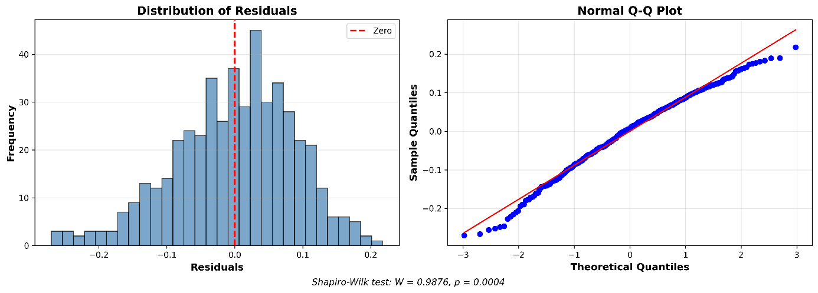

Supplemental Figure 2: Scatterplot of Residuals vs. Predicted Values
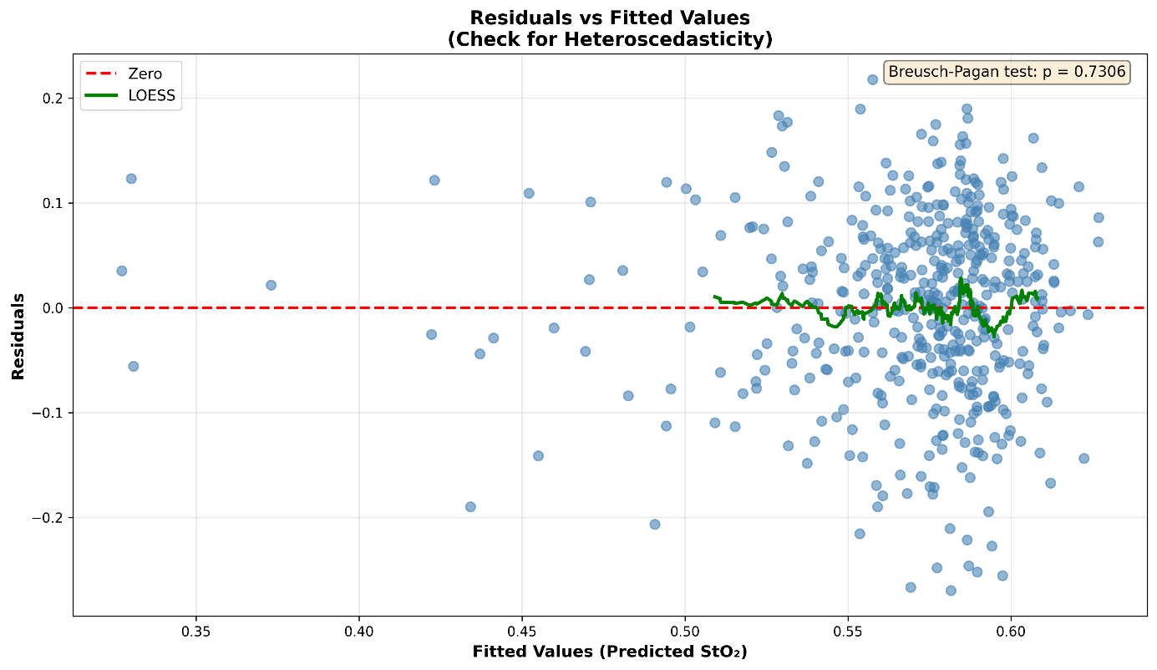

Supplemental Figure 3: Scatter Plot of Cook's Distance
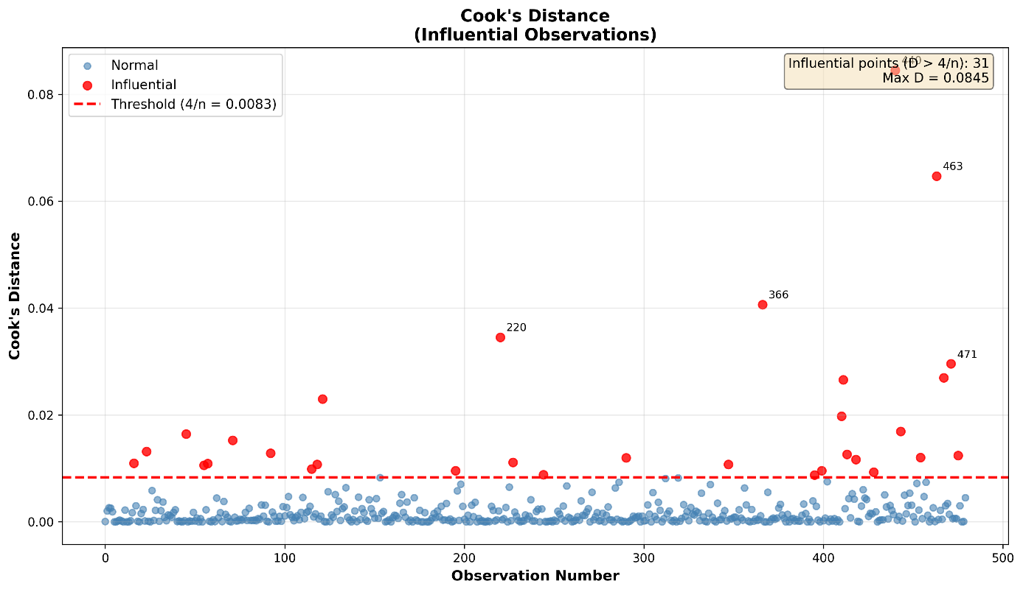

Supplement Figure 4: 30-Day Mortality across NEE groups
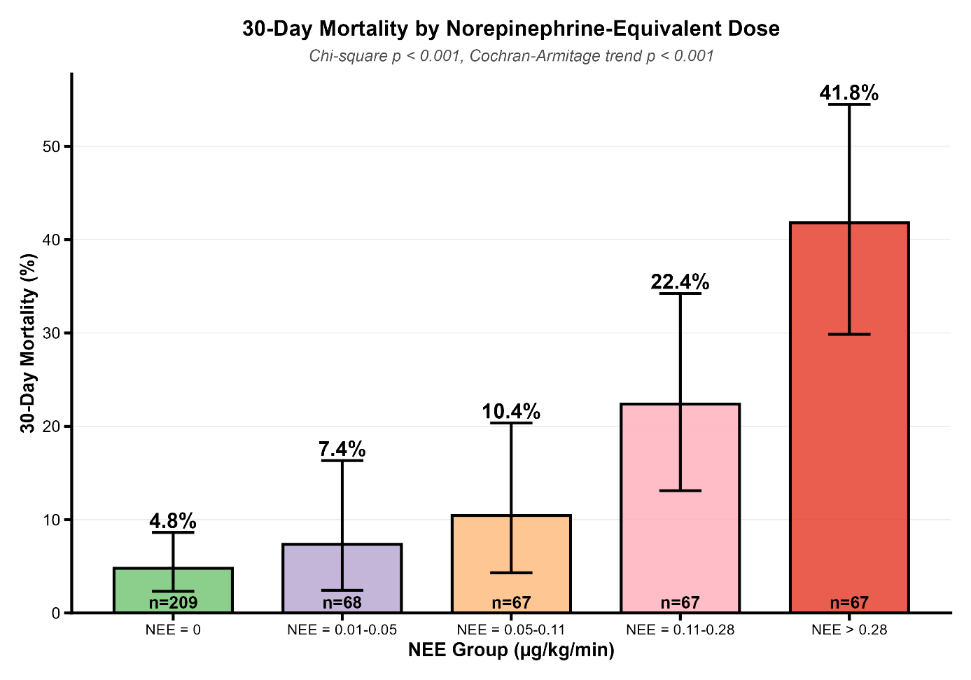
The percentage on top of the error bar represents the mortality rate.

Supplement Figure 5: StO₂ trajectories from shock onset to reversal stratified by 30-day mortality
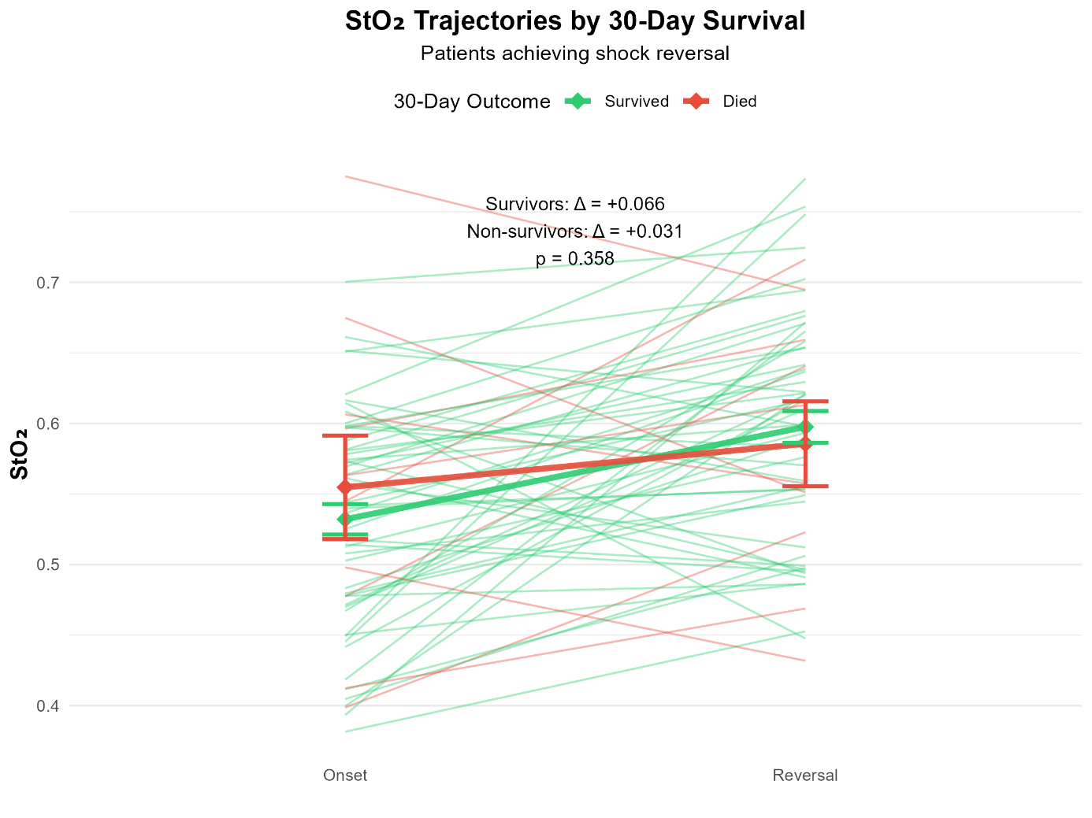
Individual patient trajectories (thin lines) and mean values with standard error (bold lines with error bars) are shown for survivors (green) and non-survivors (red). Survivors demonstrated greater StO₂ improvement (+6.6%) compared to non-survivors (+3.1%), though this difference did not reach statistical significance (p = 0.358, n = 61 patients with complete mortality data).

Supplemental Table 1: Baseline Characteristics of excluded patients
Variable | Excluded Patients (n=6)
Age, years, mean ± SD | 67.7 ± 10.8
Weight, mean ± SD [kg] | N.A.
Female sex, n (%) | 0 (0)
APACHE II score, mean ± SD | 38.3 ± 5.9
SOFA score, mean ± SD | 9.6 ± 4.0
Preexisting cardiovascular disease, n (%) | 2 (33)
CKD, n (%) | 1 (17)
Acute kidney injury, n (%) | 2 (33)
RRT, n (%) | 2 (33)
Malignant disease, n (%) | 1 (17)
Ventilated at baseline, n (%) | 6 (100)
Fluid Balance Day 1, mean ± SD [ml] | 2389.6 ± 2873.0
Sepsis present, n (%) | 3 (50)
Septic shock, n (%) | 1 (17)
Unclear Sepsis Status, n (%) | 2 (33)
Sepsis focus (among sepsis patients)
Abdominal, n (%) | 1 (33)
Pulmonal, n (%) | 0 (33)
UTI, n (%) | 1 (33)
Soft tissue/skin, n (%) | 0 (0)
Multiple foci, n (%) | 0 (0)
Other/unknown, n (%) | 1 (33)
Values given as mean and standard deviation or absolute and relative frequencies. APACHE: Acute Physiology And Chronic Health Evaluation-Score, SOFA: Sequential Organ Failure Assessment Score, CKD: Chronic Kidney Failure, RRT: Renal Replacement Therapy, UTI: Urinary Tract Infection.

Supplemental Table 2: Hyperspectral Imaging data, lactate, and creatinine levels according to NEE-quartiles.
Variable | NEE = 0  (n=221) | NEE 0.01- 0.05  (n=71) | NEE 0.05-0.11  (n=70) | NEE 0.11-0.28  (n=70) | NEE >0.28  (n=70) | p-value  (ANOVA)
StO₂, mean ± SD | 0.59 ± 0.09 | 0.59 ± 0.09 | 0.57 ± 0.08 | 0.55 ± 0.10 | 0.51 ± 0.10 | <0.001
NIR, mean ± SD | 0.48 ± 0.08 | 0.48 ± 0.08 | 0.48 ± 0.07 | 0.47 ± 0.07 | 0.45 ± 0.08 | 0.030
TWI, mean ± SD | 0.67 ± 0.07 | 0.68 ± 0.06 | 0.70 ± 0.07 | 0.72 ± 0.06 | 0.72 ± 0.07 | <0.001
THI, mean ± SD | 0.25 ± 0.10 | 0.24 ± 0.12 | 0.23 ± 0.10 | 0.28 ± 0.13 | 0.29 ± 0.11 | 0.002
Lactate [mmol/L], mean ± SD | 1.51 ± 1.0 | 1.56 ± 1.11 | 1.65 ± 0.98 | 2.56 ± 2.59 | 4.57 ± 5.00 | <0.001
Creatinine [mg/dL], mean ± SD | 1.37 ± 1.42 | 1.27 ± 0.96 | 1.31 ± 1.12 | 1.71 ± 0.96 | 2.01 ± 1.07 | <0.001
StO₂: tissue oxygen saturation, NIR: near-infrared index, TWI: tissue water index, THI: tissue hemoglobin index. NEE: Norepinephrine Equivalent (µg/kg/min).

Supplemental Table 3: Sensitivity analyses assessing non-linearity of the association between NEE and StO₂
Model | Key parameter | Estimate | 95% CI | p-value | Model comparison vs linear | AIC
Primary linear model | NEE | -0.093 | -0.150 to -0.036 | 0.001 | Reference | -954.6
Quadratic model | NEE² | -0.043 | -0.154 to 0.068 | 0.450 | p = 0.450 | -953.2
Restricted cubic spline | Overall NEE effect | — | — | 0.012 | — | —
Restricted cubic spline | Non-linear component | — | — | 0.693 | — | —
Natural spline model | Overall spline terms | — | — | — | p = 0.477 | -951.2
AIC: Akaike’s information criterion; CI = Confidence interval; NEE = Norepinephrine-equivalent dose

Supplemental Table 4: Comparison of Standard Errors HC3 and OLS for Linear Regression
Predictor | OLS | HC3
Age (years) | 0.0003 | 0.0003
MAP (mmHg) | 0.0003 | 0.0003
Lactate (mmol/L) | 0.0003 | 0.0002
SOFA | 0.0012 | 0.0012
NEE | 0.0288 | 0.0320
OLS: Oridnary Least Squares, HC3: Heteroskedasticity-consistent standard errors

Supplemental Table 5: Non-Sepsis Subgroup
Parameter | NEE = 0 (n = 207) | NEE 0.01 –0.03 (n = 43) | NEE 0.03 –0.07 (n = 42) | NEE 0.07 – 0.16 (n = 42) | NEE > 0.16 (n = 42) | p-value (ANOVA)
StO₂, mean ±SD | 0.588 ± 0.093 | 0.597 ± 0.09 | 0.580 ± 0.09 | 0.556 ± 0.09 | 0.537 ± 0.09 | 0.006
NIR, mean ±SD | 0.474 ± 0.08 | 0.491 ± 0.06 | 0.492 ± 0.06 | 0.484 ± 0.06 | 0.455 ± 0.07 | 0.099
TWI, mean ±SD | 0.670 ± 0.07 | 0.678 ± 0.05 | 0.685 ± 0.07 | 0.690 ± 0.07 | 0.720 ± 0.06 | <0.001
THI, mean ±SD | 0.245 ± 0.10 | 0.222 ± 0.10 | 0.221 ± 0.09 | 0.220 ± 0.10 | 0.272 ± 0.11 | 0.059
Significant post-hoc Tukey test for StO₂: NEE=0 vs Q4 (p=0.011), Q1 vs Q4 (p=0.024). Significant post-hoc comparisons for TWI: NEE=0 vs Q4 (p<0.001), Q1 vs Q4 (p=0.035). ). StO₂ = tissue oxygen saturation, NIR = near-infrared index, TWI = tissue water index, THI = tissue hemoglobin index. NEE = norepinephrine-equivalent dose (µg/kg/min).

