Supplementary Material
Pre SBT Post SBT

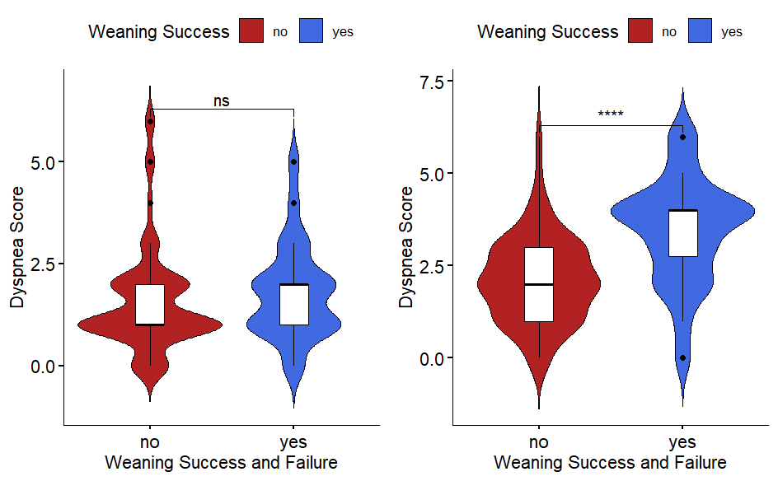
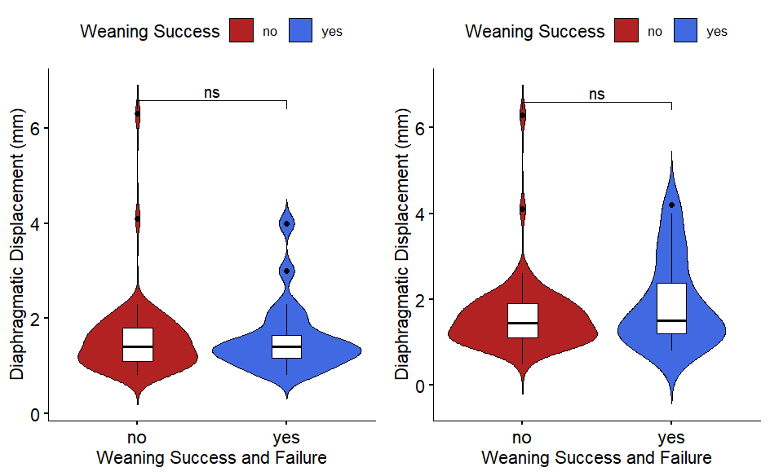

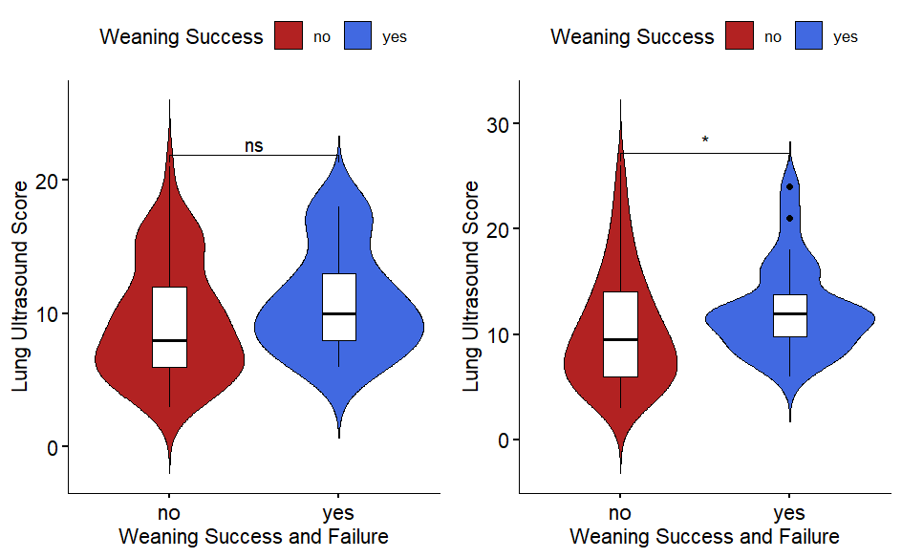

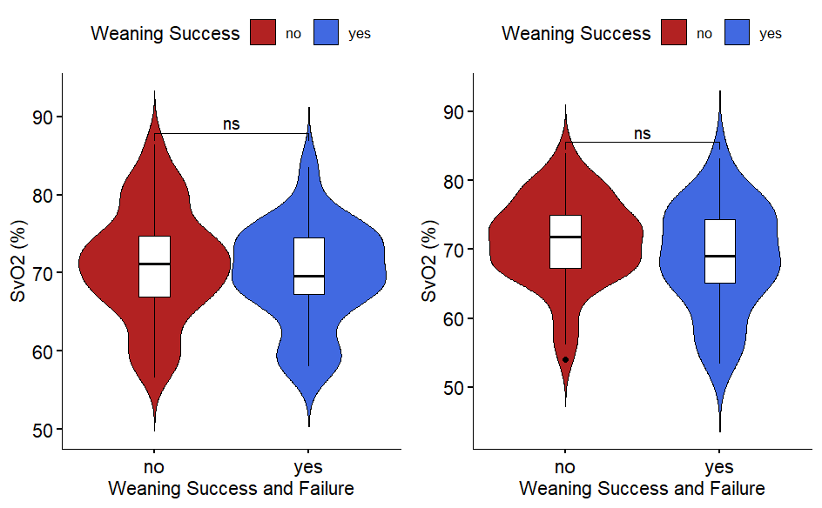

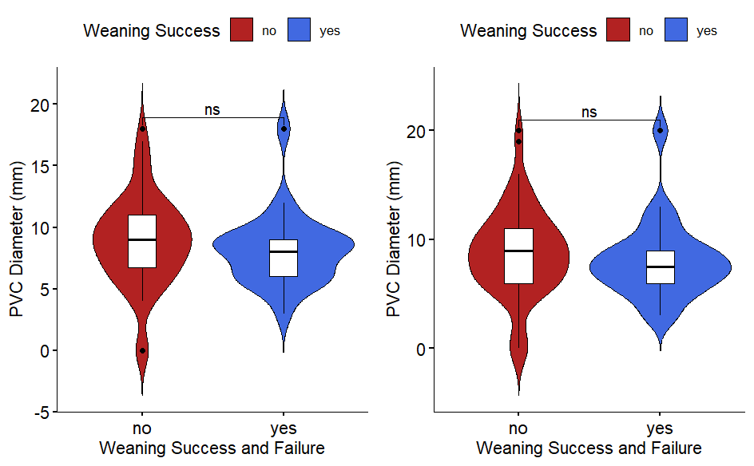

Figure S1. Violin plots of individual variables before and after SBT in the weaning success and weaning failure groups.

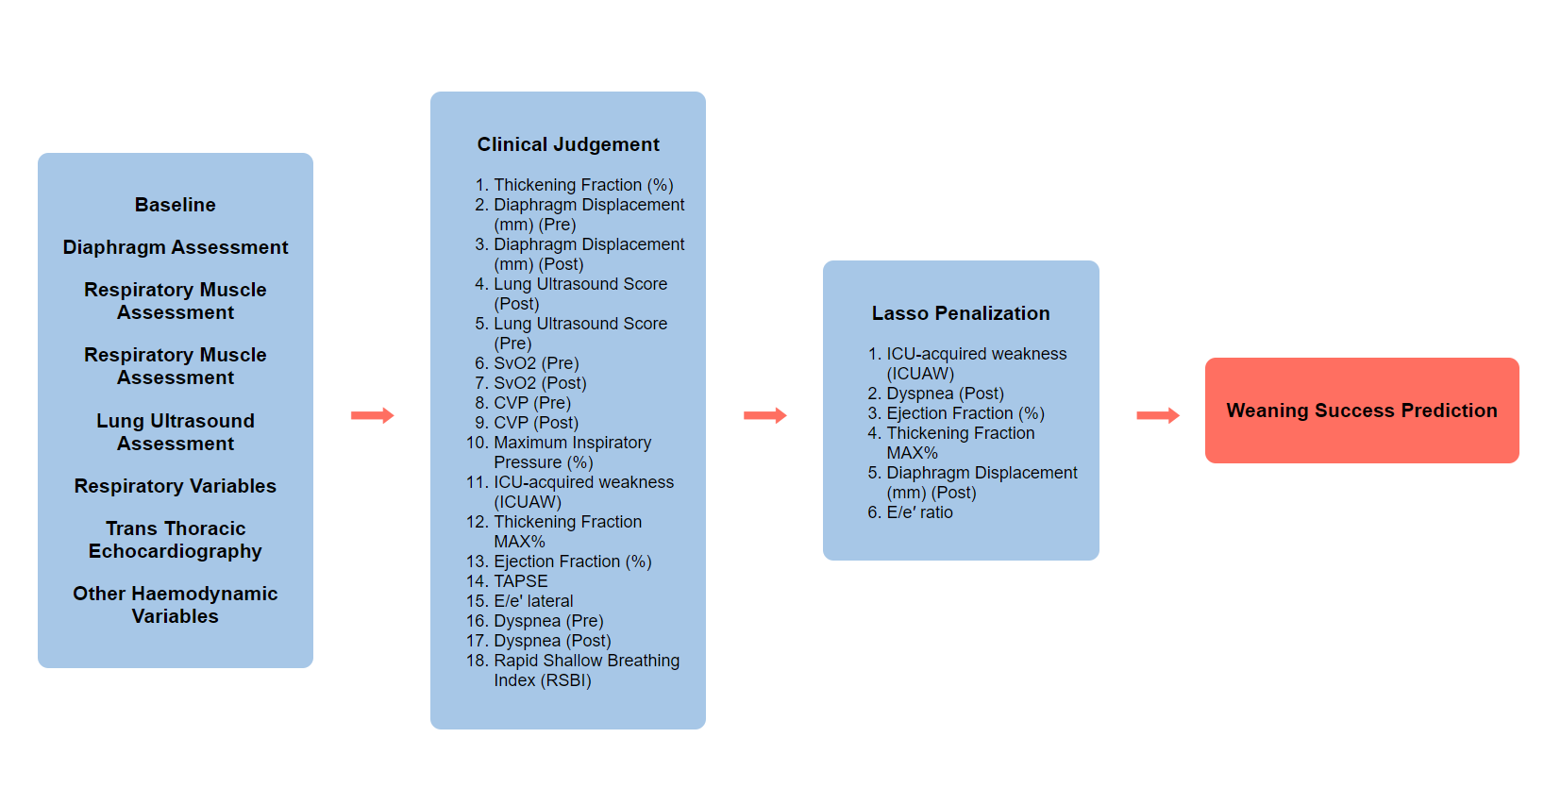

Figure S2: Variable selection Flowchart depicting the development of the weaning success predictive tool using clinical and statistical approaches. The process begins with baseline patient data, including diaphragm assessment, respiratory muscle assessment, lung ultrasound, and other

