Figure S3: Bedside Web-Based Tool for Weaning Outcome Prediction
A web-based bedside tool was developed to translate the final predictive model into a clinically usable format and to support real-time decision-making during the weaning process. The application was implemented using the Shiny framework in R and is intended as a proof of concept to demonstrate the feasibility of integrating statistical learning models into routine clinical workflows.
The interface allows clinicians to input patient-specific variables identified in the final penalized logistic regression model. These include diaphragm thickening fraction (TF), diaphragmatic displacement after the spontaneous breathing trial (SBT), left ventricular ejection fraction, E/e′ ratio, and self-reported dyspnea following SBT. ICU-acquired weakness (ICUAW) is incorporated as a binary variable, consistent with the model specification, and reflects the underlying clinical construct derived from handgrip strength.
The output is presented both as a numerical estimate and as a graphical representation contrasting the probabilities of success and failure, thereby improving interpretability and facilitating bedside use.
https://biostatlab.shinyapps.io/bs_tool_weanus/
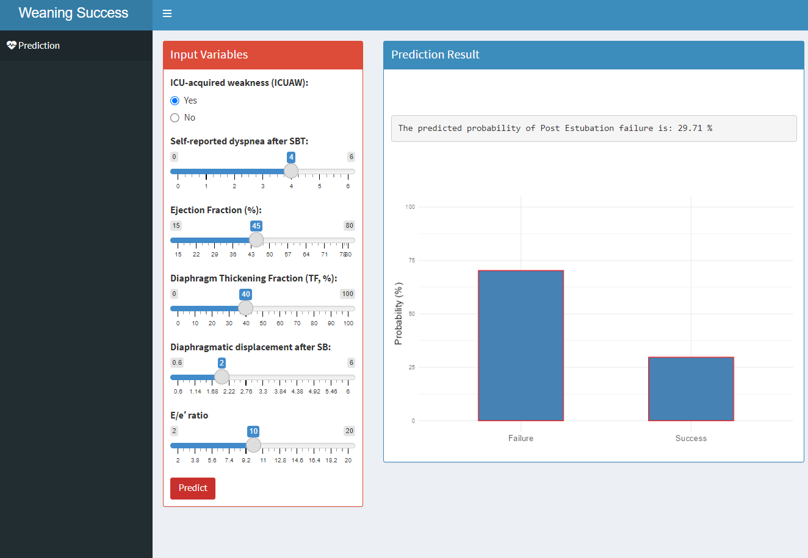
It is important to emphasize that this bedside tool is currently a proof of concept and has not undergone formal external validation. Therefore, its use should be considered exploratory, and predictions should not be interpreted as definitive clinical recommendations. Further work is required to validate the model in independent populations, assess calibration and clinical utility, and evaluate its impact on decision-making and patient outcomes before routine clinical implementation.

