Supplementary Material

Manuscript:
Timing matters: Sex differences in treatment limitation decisions in intensive care

Characteristic | Men  (n= 395,440) | Women  (n=259,220) | SMD
Timing of limitations
No limitations | 337,532 (85.4%) | 212,205 (81.9%) | 0.094
At ICU admission | 34,031 (8.6%) | 31,129 (12.0%) | -0.112
During ICU stay | 21,698 (5.5%) | 14,365 (5.5%) | -0.002
At ICU discharge | 2,179 (0.6%) | 1,521 (0.6%) | -0.005

A.

B.
Characteristic | Men  (n= 57,908) | Women  (n=47,015) | SMD
Degree of limitations
Patient’s wish | 2,140 (3.7%) | 1,813 (3.9%) | -0.008
Health advocate’s wish | 42,070 (72.6%) | 35,916 (76.4%) | -0.085
Medical decision | 13,698 (23.7%) | 9,286 (19.8%) | 0.095
Reason for limitations
Time-limited | 27,259 (47.1%) | 25,340 (53.9%) | -0.137
Content-limited | 7,415 (12.8%) | 5,476 (11.6%) | 0.035
Palliation / withdrawal | 23,234 (40.1%) | 16,199 (34.5%) | 0.117

Supplementary Table 1. Timing and characteristics of treatment limitations decisions according to sex. A. Timing of treatment limitations in the overall ICU population. Percentages are calculated within the overall ICU population. B. Degree and reason for treatment limitations among patients with documented limitation. Proportions are calculated within the subgroup of patients with documented treatment limitation and therefore describe decision characteristics rather than the probability of treatment limitations. Values are presented as counts and proportions. ICU, intensive care unit: SMD, standardized mean difference.

 | Treatment limitations present at ICU admission |  | Treatment limitations occurring during ICU stay or at ICU discharge
 | Adjusted OR [95% CI] | p-value | Adjusted OR [95% CI] | p-value
Female sex vs male sex | 1.25 [1.23, 1.27] | <0.001 | 1.10 [1.08, 1.13] | <0.001
Age (years)* | 2.23 [2.20, 2.25] | <0.001 | 1.35 [1.33, 1.36] | <0.001
SAPS II score* | 1.31 [1.30, 1.31] | <0.001 | 1.85 [1.84, 1.86] | <0.001
Primary diagnoses
Cardiovascular diagnosis | 1.00 (Reference) |  | 1.00 (Reference)
Neurological diagnoses | 1.98 [1.93, 2.04] | <0.001 | 1.85 [1.79, 1.92] | <0.001
Respiratory/ENT diagnoses | 2.36 [2.30, 2.43] | <0.001 | 2.02 [1.95, 2.09] | <0.001
Gastrointestinal diagnoses | 1.63 [1.58, 1.68] | <0.001 | 1.14 [1.10, 1.19] | <0.001
Metabolic/endocrine diagnoses | 1.39 [1.33, 1.46] | <0.001 | 0.61 [0.57, 0.66] | <0.001
Trauma | 1.86 [1.79, 1.93] | <0.001 | 1.48 [1.40, 1.56] | <0.001
Urogenital diagnoses | 1.41 [1.33, 1.50] | <0.001 | 0.66 [0.59, 0.73] | <0.001
Sepsis/septic shock | 2.00 [1.93, 2.08] | <0.001 | 1.48 [1.42, 1.55] | <0.001
Other ICU diagnoses | 1.57 [1.50, 1.63] | <0.001 | 0.93 [0.87, 0.99] | 0.016
Admission type
Emergency vs elective | 1.96 [1.91, 2.01] | <0.001 | 2.24 [2.16, 2.33] | <0.001
In-hospital origin of the patient
Emergency | 1.00 (Reference) |  | 1.00 (Reference)
Operating room/post-interventional | 0.59 [0.58, 0.61] | <0.001 | 0.72 [0.69, 0.74] | <0.001
Other ICU | 1.10 [1.04, 1.16] | 0.002 | 1.62 [1.53, 1.73] | <0.001
Intermediate care unit/recovery area | 0.85 [0.81, 0.89] | <0.001 | 1.16 [1.10, 1.23] | <0.001
Ward | 1.17 [1.15, 1.20] | <0.001 | 1.24 [1.20, 1.28] | <0.001
Other | 0.78 [0.74, 0.83] | <0.001 | 0.98 [0.92, 1.04] | 0.569
Type of ICU
Mixed or other ICU | 1.00 (Reference) |  | 1.00 (Reference)
Medical ICU | 2.25 [2.17, 2.34] | <0.001 | 0.89 [0.84, 0.93] | <0.001
Surgical ICU | 0.93 [0.89, 0.97] | 0.001 | 0.90 [0.86, 0.95] | <0.001
Hospital category
Regional hospital/no category | 1.00 (Reference) |  | 1.00 (Reference)
University hospital | 0.60 [0.58, 0.62] | <0.001 | 1.17 [1.13, 1.20] | <0.001
Large/cantonal hospital | 0.84 [0.82, 0.86] | <0.001 | 1.53 [1.48, 1.57] | <0.001
Pre-hospital patient origin
Other | 1.00 (Reference) |  | 1.00 (Reference)
Home | 0.81 [0.79, 0.84] | <0.001 | 0.98 [0.95, 1.02] | 0.345
Transfer from other hospital | 0.87 [0.84, 0.91] | <0.001 | 1.27 [1.21, 1.33] | <0.001
Nursing facility | 2.44 [2.27, 2.62] | <0.001 | 1.52 [1.36, 1.70] | <0.001
Number of observations | 614897 |  | 589500
BIC | 322269.85 |  | 213169.92

Supplementary Table 2. Multivariable models including patient origin prior to hospital admission.
Multivariable logistic regression analyses assessing the association between sex and treatment limitation decisions, additionally adjusted for patient origin (home, nursing facility, or transfer) as a proxy for baseline functional status. Models are shown for treatment limitation at ICU admission (left) and treatment limitation during ICU stay (right). Results are presented as adjusted ORs with 95% CIs. Abbreviations: BIC, Bayesian Information Criterion; CI, confidence interval ; ENT, ear-nose-throat; ICU, intensive care unit; OR, odds ratio; SAPS II, Simplified Acute Physiology Score II. *Adjusted ORs are reported per 10-unit increase for age and SAP II score.

Primary diagnosis category | Female vs male: Adjusted OR [95% CI]
Trauma | 1.45 [1.36, 1.56]
Cardiovascular diagnoses | 1.40 [1.35, 1.46]
Respiratory and ENT diagnoses | 1.25 [1.20, 1.31]
Gastrointestinal diagnoses | 1.21 [1.15, 1.27]
Neurological diagnoses | 1.18 [1.13, 1.23]
Urogenital | 1.18 [1.05, 1.34]
Other ICU diseases | 1.17 [1.09, 1.26]
Sepsis/Septic shock | 1.16 [1.09, 1.24]
Metabolic/endocrine diagnoses | 1.05 [0.96, 1.14]

Supplementary Table 3. Sex-by-diagnosis interaction for treatment limitation at ICU admission. Adjusted odds ratios (OR) and 95% confidence intervals (CI) from a logistic regression model assessing treatment limitation at ICU admission compared with no limitation (n = 614,897). The model includes an interaction term between sex and primary diagnosis category to evaluate effect modification. All models were adjusted for age (per 10 years), SAPS II score (per 10 points), admission type, in-hospital origin, ICU type, and hospital category. Abbreviations: CI, confidence interval; ENT, ear, nose and throat; ICU, intensive care unit; OR, odds ratio; SAPS II, Simplified Acute Physiology Score II.

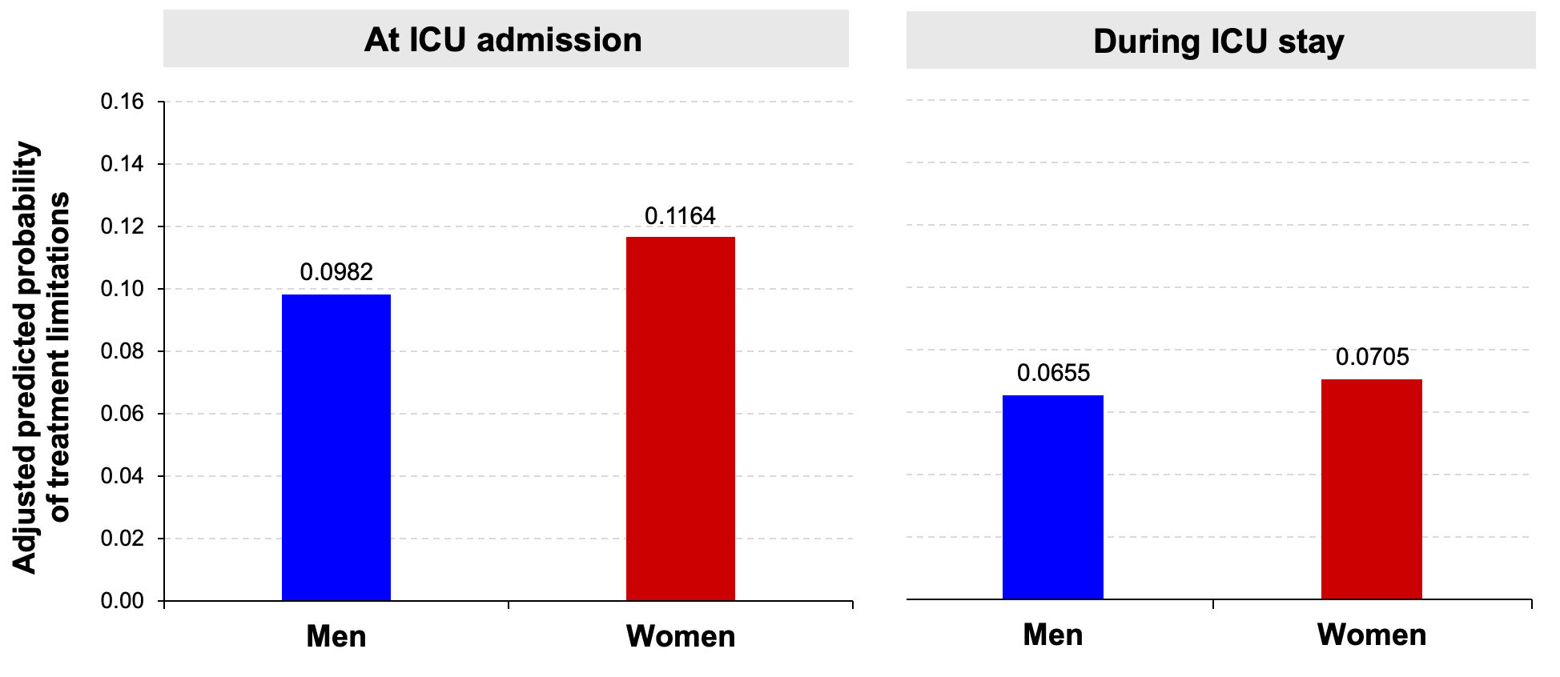
Supplementary Figure 1. Adjusted predicted probability of treatment limitation by sex and decision stage. Predicted probabilities derived from multivariable models standardized to the covariate distribution of the study population.

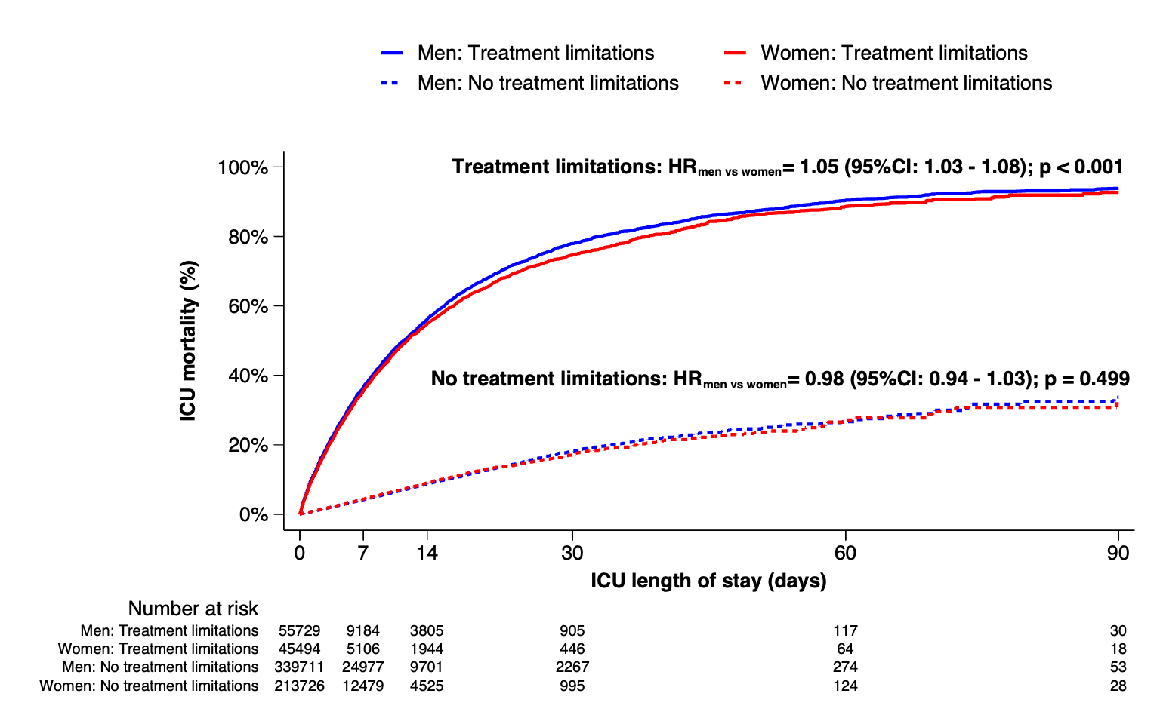
Supplementary Figure 2. ICU mortality according to treatment limitation status. Kaplan–Meier estimates of ICU mortality in patients with and without documented treatment limitations, shown separately for women and men. Curves represent unadjusted cumulative mortality over ICU length of stay and describe outcome according to limitation status rather than a causal effect of treatment limitations. Abbreviations: CI, confidence interval; ICU, intensive care unit; HR, hazard ratio
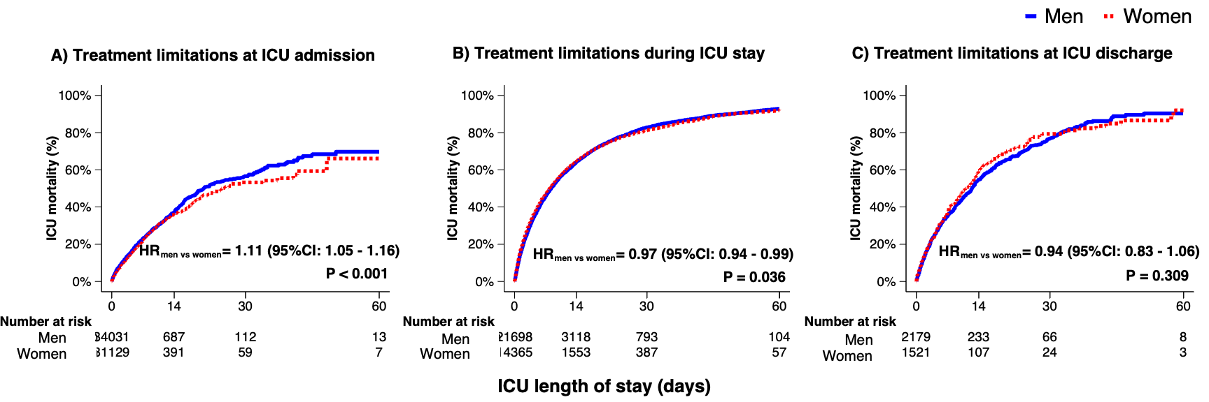
Supplementary Figure 3. ICU mortality according to timing of treatment limitation and sex. Kaplan–Meier estimates of ICU mortality stratified by sex within timing categories of treatment limitation. (A) limitation present at ICU admission, (B) limitation occurring during the ICU stay, and (C) limitation documented at ICU discharge. Curves represent unadjusted comparisons between women and men within each stratum; hazard ratios correspond to unadjusted Cox models. Percentages indicate cumulative mortality over ICU length of stay. Abbreviations: CI, confidence interval; ICU, intensive care unit; HR, hazard ratio.

