Supplementary Material 1
Effect of the orexin receptor antagonist, suvorexant, on sleep architecture in the early postoperative period following cardiac surgery: a randomized controlled trial

Karuna Wongtangman^{1,2*}, Siddhartha reddy Janga^{3*}, Omid Azimaraghi^{1*}, Rafi Khandaker¹, Tanvi Khera³, Jonathan Leff¹, Stephen J Forest⁴, Aiman Suleiman¹, Christopher Tam¹, Stephen Spindel⁴, Pamela N DeYoung⁵, The ICU Sedation collaborators#, Atul Malhotra⁵, Balachundhar Subramaniam³, Matthias Eikermann^{1,6}
Collaborators#: Christian Mpody¹, John Lipiz¹, Jamil Borgi⁴, Robert E Michler⁴, Daniel J Goldstein⁴, Joseph J Derose⁴, Michael Kiyatkin¹, Daniel Rueddel Thomas¹, Tim Brandenburger⁷, Michael Chang¹, Constance Rippel¹, Fabian Kuhn⁸, Dorothee Stratz⁸, Sujatha Ramachandran¹, Jan N Schwarz¹, Lorenz Droege¹, Daniel O Thomas-Rueddel¹, Noah Hopstein¹, Pooja Kumar⁹, Tina Ramishvili¹, Shiyon Mathew¹⁰, Marjan Rahmanian ¹¹, Evgenii Surnin¹, Nonthida Rojanapithayakorn^{1,2}, William J. Sauer¹

¹ Department of Anesthesiology, Montefiore Medical Center and Albert Einstein College of Medicine, Bronx, NY, USA
² Department of Anesthesiology, Faculty of Medicine, Siriraj Hospital, Mahidol University, Bangkok, Thailand.
³ Department of Anesthesia, Critical Care, and Pain Medicine, Beth Israel Deaconess Medical Center, Harvard Medical School, Boston, MA
⁴ Department of Cardiothoracic and Vascular Surgery, Montefiore Medical Center and Albert Einstein College of Medicine, Bronx, New York.
⁵ Division of Pulmonary, Critical Care, Sleep Medicine, and Physiology, University of California San Diego, La Jolla, CA, United States.
⁶ Klinik für Anästhesiologie und Intensivmedizin, Universität Duisburg-Essen, Essen, Germany
⁷ Zentrum fuer Anesthesiologie, Heinrich- Heine Universitaet, Duesseldorf, Germany
⁸ Universitaetsspital Zuerich, Institute for Anesthesiology and Perioperative Medicine, Zuerich, Switzerland.
⁹ Pharmacy, Montefiore Medical Center and Albert Einstein College of Medicine, Bronx, New York.
¹⁰ Department of nursing, Montefiore Medical Center, Bronx, New York.
¹¹ Division of Critical Care Medicine, Montefiore Medical Center, Bronx, New York
*Equal contribution

Corresponding authors:
Balachundhar Subramaniam, MD, Department of Anesthesia, Critical Care, and Pain Medicine, Beth Israel Deaconess Medical Center, Harvard Medical School, Boston, MA., bsubrama@bidmc.harvard.edu
Matthias Eikermann, MD, Department of Anesthesiology, Montefiore Medical Center, Albert Einstein College of Medicine
111 East 210th St, Bronx, NY 10467, USA, meikermann@montefiore.org,
In order to respect space limitations in the main manuscript, we present additional information on methods and results in this Supplementary Appendix.
Table of Contents
S1 Study design and setting 3
S2 Study participants 3
S3 Study intervention 4
S4 Study outcomes 5
S4.1 EEG spectrograms 5
S4.2 RCSQ 5
S5 Actiwatch Pilot Data 6
S6 Supplementary Table 7
STable 1: Safety endpoint 7
STable 2: Subjective sleep quality of the first night after extubation 7
S7 Supplementary Figures 8
SFigure 1. Multitaper EEG spectrograms of a postoperative cardiac ICU patient during the first night of monitoring 8
SFigure2 Sample hypnograms of patients receiving A-suvorexant and B-placebo 9
SFigure3 Association of actigraphy and EEG-based sleep scoring 10
S8 Reference: 11

S1 Study design and setting
This multicenter, randomized, double-blind, placebo-controlled clinical trial was conducted at two tertiary referral hospitals in the United States: Montefiore Medical Center (Bronx, NY) and Beth Israel Deaconess Medical Center (Boston, MA). The study protocol was developed by the study investigators and approved by the local institutional review boards at both Albert Einstein College of Medicine/Montefiore Health System (protocol number 2021-13369) and Beth Israel Deaconess Medical Center (protocol number 2019-P0000759). This study was conducted under IND 113,330 filed with the U.S. Food and Drug Administration. The study protocol has been previously published (1). The trial was registered prior to patient enrollment at clinicaltrials.gov (NCT04092894, Principal investigator: Matthias Eikermann, Date of registration: 09/17/2019, Study Start (Actual) 2020-02-28).
The study was conducted in two cardiothoracic ICUs: a 20-bed cardiac ICU at Beth Israel Deaconess Medical Center and a 14-bed cardiac ICU at Montefiore Medical Center. The ICU rooms in which first-night sleep recordings were obtained were single-patient rooms. All EEG sleep recordings for the primary analysis were performed in these ICU rooms during the first postoperative night after extubation. Delirium assessments and subjective sleep questionnaires were also performed in the ICU while patients remained there; if patients were subsequently transferred out of the ICU, these follow-up assessments were continued in the cardiac step-down units, where patients were typically cared for in two-bed rooms. EEG sleep recordings, however, were limited to the first postoperative night in the ICU. The recordings were obtained under usual care conditions, including routine nocturnal nursing assessments and other clinical interventions, which were not standardized across rooms or centers.

S2 Study participants
Participants (age ≥ 60 years) admitted to the ICU after coronary artery bypass graft surgery with or without aortic and/ or mitral valve replacement between February 2020 and February 2025 were eligible for enrollment.
The exclusion criteria were the following
- Severe cardio-vascular disorders (ejection fraction <30%)
- Renal insufficiency (creatinine clearance <30 mL/min or dialysis dependence)
- Liver failure (Child- Pugh score >6)
- Coma (Richmond Agitation Sedation Scale (RASS) <−1)
- Signs and symptoms of delirium and agitation at time of enrolment (confusion assessment method (CAM- ICU positive)
- Psychiatric or neurological diseases (including chronic benzodiazepine use, bipolar disorder, psychotic disorder, post- traumatic stress disorder, the requirement of prophylactic psychiatric medication, evidence of acute depression on screening visit)
- Pre- existing cognitive impairment
- Alzheimer disease
- Parkinson’s disease
- Medications for cognitive decline
- History of recent seizures (within 1 year prior to visit)
- Alcoholism or documented history of alcohol abuse
- Narcolepsy
- Severe sleep apnea requiring home continuous positive airway pressure (CPAP) treatment
- Morbid obesity (body mass index (BMI) >40)
- Known hypersensitivity to study medications
- English language limitations
After enrollment the night before surgery, 11 patients were excluded prior to randomization due to postoperative pulmonary complications (n=7), patient withdrawal (n=3), and massive intraoperative hemorrhage (n=1). 100 patients were randomized; 47 patients in each group received study medication for at least one night.
Post-randomization losses of the primary outcome fell into 2 broad categories.
Primary exclusion (no medication received): Six randomized patients did not receive the study medication for the following reasons: three patients declined the medication after surgery; the primary surgeon requested withholding the medication for one patient; and two patients had fluctuating RASS scores of −1 to −2 after extubation, leading to a decision not to administer the medication after discussion with the principal investigator.
Secondary exclusion (medication received): Sixteen additional randomized patients were excluded from the primary analysis due to loss of analyzable EEG data for the following reasons: technical acquisition failure, unreadable, corrupted, or non-convertible EDF files, or premature electrode removal resulting in insufficient overnight data for valid sleep-stage scoring. However, under the intention-to-treat principle, data from 83 patients were available for the RCSQ analysis, and all randomized patients were included in the delirium analysis.

S3 Study intervention
Patient eligibility was assessed and informed consent was obtained, preoperatively. After postoperative extubation, patients were randomly assigned into a 1:1 ratio to receive either suvorexant 20 mg or placebo. This process was performed by an investigator who did not have other roles in patient enrollment or management. All other investigators, patients, attending physicians, and the nurses were blinded to the study assignment. At each center the study drug (suvorexant 20 mg or placebo) was prepared by pharmacists, who were not involved in this study. Study drugs were packaged in identically shaped containers labeled with sequential numbers according to the randomization table order.
The study medication was administered orally between 9-10 PM after extubation until seven consecutive doses or until any of the following occurred: hospital discharge, ICU discharge if signs of airway obstruction were observed during sleep in the ICU, or inhibitors of CYP3A were co-administered. Rescue medications were the following: low-dose melatonin and a low-dose benzodiazepine for sleeplessness, haloperidol for agitation, and oxycodone for pain control.

S4 Study outcomes

S4.1 EEG spectrograms
Continuous overnight EEG recordings were obtained from patients in the intensive care unit (ICU) using the SedLine® Brain Function Monitor (Masimo Corp., Irvine, CA). The monitor provides a four-channel frontal montage (Fp1, Fp2, F7, F8) referenced to a midline electrode, sampled at 250 Hz. Data were exported in European Data Format (EDF) files for offline analysis. Each file contained a full night (typically 6–10 hours) of continuous EEG data along with metadata on channel configuration and impedance. The measurements were started before the initiation of study medication and continuously recorded until 6:00. The onset of sleep was defined as REM or non- REM stages 1, 2, 3 on the EEG as the first 30 seconds epoch after lights off. Wakefulness was defined as an awake period of 30 s or longer.
Spectrogram Computation and Visualization
EDF files were imported into MATLAB (MathWorks, Natick, MA) using custom-built scripts. After exporting the full EEG recording from Polyman, the EDF file was loaded into MATLAB, where the script extracted the EEG channel by vertically concatenating the EDF data segments and defined multitaper parameters (sampling rate, frequency range, and Slepian tapers). Time–frequency analysis was then performed using Chronux’s mtspecgramc function, which computes multitaper spectral estimates across short sliding windows. The resulting matrices of spectral power were converted to decibels and visualized using MATLAB’s imagesc function, with time on the x-axis, frequency on the y-axis, and color representing power. Standardized color limits, logarithmic scaling, and saved figure outputs were incorporated directly in the code to ensure consistent visualization.
This multitaper approach provides improved spectral concentration and reduced variance retaining physiologic activity and allowing clear visualization of delta, theta, alpha, and beta rhythms. The resulting spectrograms depict overnight neurophysiologic dynamics, including transitions between behavioral states, emergence of slow-wave, and suppression patterns associated with sedation or environmental disturbances, and follows established methods for analyzing sleep architecture (2, 3).

S4.2 RCSQ
The Richards- Campbell Sleep Questionnaire (RCSQ) was used assessing subjective sleep quality based on a five- item, Visual Analogue Scale (each ranging from 0 (worst value) to 100 (best value)). The questionnaire evaluates perceptions of depth of sleep, sleep onset latency, number of awakenings, time spent awake and overall sleep quality(4). Patients were asked to complete a sleep questionnaire every morning. RCSQ questionnaire results were available in 83 patients for a median (IQR) of 4 (2, 5) nights/ patients. Total RCSQ was calculated as a mean of 5 components. Mean (IQR) total RCSQ during the first night assessment was 34.7 (24.1, 45.4) in the suvorexant group and 33.3 (22.7, 43.8) in control group (p=0.85). A repeated measures mixed linear model for repeated measurements were used to test for differences in the mean RCSQ for each night.

S5 Actiwatch Pilot Data
We used an actigraph wrist- watch (Actiwatch, Phillips, NV, USA) to measure movements during the EEG monitoring in 6 patients in the pilot study. The data indicates that actigraphy cannot be used in the ICU for sleep scoring after cardiac surgery. Post-operative patients frequently remain immobile despite being awake due to pain, sedation, delirium risk, or restricted mobility, and the device cannot differentiate between voluntary movements and passive movements caused by bedside nursing care or repositioning (SFigure 2). The presence of arterial lines, and limitations related to radial artery harvesting during surgery further reduce wearable feasibility and contribute to signal misclassification. Collectively, these factors highlight that wrist actigraphy cannot be used for accurate sleep scoring in critically ill post-operative patients.

S6 Supplementary Table

STable 1: Safety endpoint
Adverse event | Suvorexant group  (n=49) | Placebo group  (n=51) | p-value
Somnolence | 1 (2%) | 1 (2%) | 0.98
Fatigue | 1 (2%) | 0 (0%) | 0.31
Abnormal thought/ hallucination | 2 (4%) | 0 (0%) | 014

STable 2: Subjective sleep quality of the first night after extubation
 | Suvorexant group, n=41  Median (IQR) | Controlled group, n=42  Median (IQR) | p-value
Total RCSQ* | 34.7 (24.1, 45.4) | 33.3 (22.7, 43.8) | 0.85
Subcomponent of RCSQ
Sleep depth  Sleep latency  Awakenings  Returning to sleep  Sleep quality | 32.7 (21.8, 43.5)  37.2 (26.0, 48.3)  34.1 (23.5, 44.8)  36.9 (25.6, 48.2)  32.8 (21.4, 44.3) | 31.4 (20.6, 42.1)  33.9 (22.9, 44.9)  31.4 (20.9, 41.9)  35.5 (24.4, 46.6)  34.3 (23.0, 45.6) | 0.56  0.89  0.59  0.63  0.81
* The mean of the five subcomponents
RCSQ; Richards- Campbell Sleep Questionnaire, IQR; interquartile range

S7 Supplementary Figures

SFigure 1. Multitaper EEG spectrograms of a postoperative cardiac ICU patient during the first night of monitoring
Spectrogram from a predominantly sleeping patient shows attenuated high-frequency beta (13–30 Hz) activity with enhanced low-frequency delta (0.5–4 Hz) and theta (4–8 Hz) power, consistent with consolidated non-REM sleep epochs (sleep efficiency 72.2 %, WASO 122.8 min, TST 423 min (N1 17.6 %, N2 77.5 %, N3 0%, REM 4.8%).
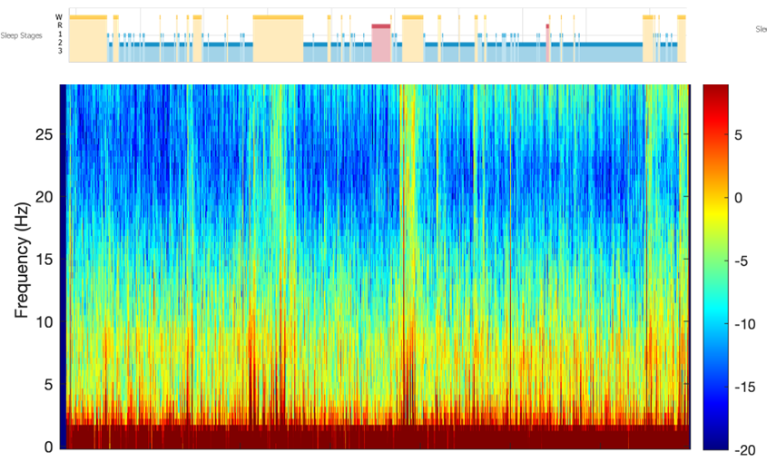

SFigure2 Sample hypnograms of patients receiving A-suvorexant and B-placebo
Both patients slept for 65% of total monitoring period, predominantly in stage 2 NREM sleep (light blue). Slow wave sleep (stage 3 NREM - dark blue) was observed in patient who received suvorexant (A) but not in the patient who received placebo (B).

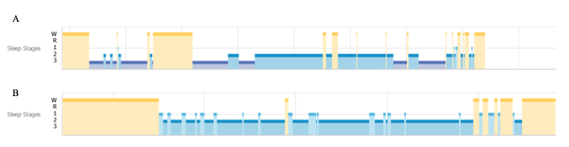

SFigure3 Association of actigraphy and EEG-based sleep scoring
Scatter plot demonstrating the relationship between wrist actigraphy activity counts and EEG defined sleep stages (N1, N2, N3, REM, and Wake) in postcardiac surgery patients undergoing simultaneous polysomnographic and actigraphic monitoring on POD0. The Y axis shows activity counts from the actiwatch accelerometer, (30-second epoch) reflecting movement intensity, and the X axis indicates the corresponding EEG sleep stage classification. The activity level was zero in 80.9% (5331/6592) of epochs.
Activity levels were lowest during REM sleep, consistent with physiologic motor suppression in these stages, and progressively higher across lighter non-REM stages (N1, N2), peaking during wakefulness. The distribution shows the expected inverse relationship between sleep depth and motor activity (coefficient -1.09, 95% confidence interval -1.51 to -0.66, p<0.001). However, there is considerable overlap between low-activity wake epochs and lighter sleep stages. This overlap illustrates a known limitation of actigraphy, particularly in postoperative patients who may remain immobile while awake due to pain, sedation, or restricted movement. Conversely, sporadic bursts of activity during N2 or N3 likely reflect arousals, postoperative restlessness, or nursing-related disturbances.
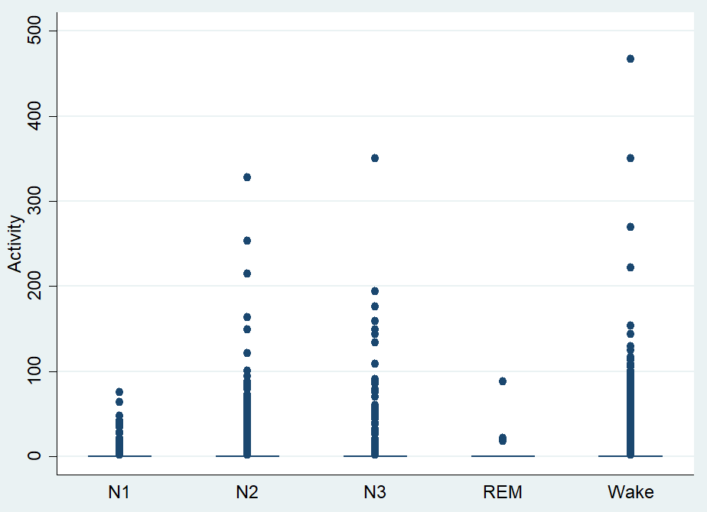

S8 Reference:
1. Azimaraghi O, Hammer M, Santer P, Platzbecker K, Althoff FC, Patrocinio M, et al. Study protocol for a randomised controlled trial evaluating the effects of the orexin receptor antagonist suvorexant on sleep architecture and delirium in the intensive care unit. BMJ Open 2020;10:e038474.
2. Prerau MJ, Brown RE, Bianchi MT, Ellenbogen JM, Purdon PL. Sleep neurophysiological dynamics through the lens of multitaper spectral analysis. Physiology 2017;32:60–92.
3. Purdon PL, Sampson A, Pavone KJ, Brown EN. Clinical Electroencephalography for Anesthesiologists: Part I: Background and Basic Signatures. Anesthesiology 2015;123:937–960.
4. Bourne RS, Minelli C, Mills GH, Kandler R. Clinical review: Sleep measurement in critical care patients: Research and clinical implications. Crit Care 2007;
5. Elliott R, Axelin A, Richards KC, Vahlberg T, Ritmala-Castren M. Sensitivity and specificity of proposed Richards-Campbell Sleep Questionnaire cut-off scores for good quality sleep during an ICU stay. J Clin Nurs 2023;32:2700–2708.

