Supplementary Appendix
Supplement to: Efficacy of Higher-Dose versus Lower-Dose Corticosteroids in Community-Acquired Pneumonia: A Systematic Review and Network Meta-Analysis

CONTENTS
eMethods 1. Protocol and Reporting 1
eMethods 2. Search Strategy 2
eMethods 3. Eligibility Criteria and Exclusion Criteria 5
eMethods 4. Definition of Outcomes 6
eMethods 5. Dose Standardization and Node Classification 9
eMethods 6. Network Meta-analysis Model and Assumptions 13
eMethods 7. Sensitivity Analyses, Subgroup Analyses, and Meta-regression 15
eMethods 8. GRADE Certainty of Evidence Assessment and Outcome-Specific Thresholds 19
eTable 1. Corticosteroid Dosage Regimens Across Studies with Dexamethasone Equivalency 23
eTable 2. Classification of Initial and Extended Mortality Outcomes Across Included Trials 31
eTable 3. Study-Level Data Extraction Sheet for Continuous Data 35
eTable 4. Study-Level Data Extraction Sheet for Binary Data 38
eTable 5. Risk of Bias Assessment for Included Trials (RoB 2) 45
eTable 6. Summary of Findings and CINEMA Confidence Assessment 53
eTable 7. Distribution of Potential Effect Modifiers by Treatment Node 65
eTable 8. Assessment of Potential Confounding Variables Across the Treatment Network 68
eTable 9. Baseline Clinical and Methodological Characteristics Across Treatment Nodes 71
eTable 10. Sensitivity Analysis for All-Cause Mortality (Short-Term) (All Population) 79
eTable 11. Sensitivity Analysis for All-Cause Mortality (Short-Term) (Severe Population) 82
eTable 12. Sensitivity Analysis for All-Cause Mortality (Short-Term) (Non-Severe Population) 85
eTable 13. Summary of HKSJ Sensitivity Analysis Results 88
eTable 14. Dose–response Meta-regression 91
eTable 15. Baujat Analysis 92
eTable 16. TSA Summary 93
eFigure 1. Distribution of Daily Dexamethasone-Equivalent Dose by Year of Publication and Trial Sample Size, With Prespecified Dose Thresholds 103
eFigure 2. P-Score Ranking Plots Across Outcomes for (A) Short-term all-cause mortality, (B) Long-term all-cause mortality, (C) Days off the ventilator, (D) Duration of mechanical ventilation, (E) Gastrointestinal bleeding, (F) Hyperglycemia, (G) ICU length of stay, (H) Invasive mechanical ventilation, (I) Length of stay, (J) Neuropsychiatric adverse reactions, (K) Secondary infections, (L) Serious adverse events and (M) Time to clinical stability. 104
eFigure 3. Leave-One-Out Sensitivity Analyses for All-Cause Mortality (Short-Term) (Overall, Severe CAP, and Non-severe CAP) 111
eFigure 4. Linear and Non-Linear Dose–Response Meta-regression for Short-Term All-Cause Mortality by Severity Strata 113
eFigure 5. Baujat Plots for Influence and Contribution to Heterogeneity in Short-Term All-Cause Mortality (Overall, Severe CAP, and Non-severe CAP) 116
eFigure 6. Trial Sequential Analysis for Short-Term All-Cause Mortality at the Prespecified Threshold (7.5 mg/d Dexamethasone-Equivalent) 117
eFigure 7. Contour-enhanced funnel plots 118

eMethods 1. Protocol and Reporting

1. Trial registration
The protocol for this systematic review and network meta-analysis was registered with the International Prospective Register of Systematic Reviews (PROSPERO) (CRD420261297943) on January 31, 2026.

2. Reporting guideline
This report was prepared in accordance with the PRISMA 2020 statement and the PRISMA extension for network meta-analyses (PRISMA-NMA). Each of the two checklists is provided as a separate document.
PRISMA 2020 statement
Page MJ, McKenzie JE, Bossuyt PM, Boutron I, Hoffmann TC, Mulrow CD, et al. The PRISMA 2020 statement: an updated guideline for reporting systematic reviews. BMJ 2021;372:n71. doi: 10.1136/bmj.n71.
PRISMA-NMA
Hutton B, Salanti G, Caldwell DM, Chaimani A, Schmid CH, Cameron C, Ioannidis JP, Straus S, Thorlund K, Jansen JP, Mulrow C, Catalá-López F, Gøtzsche PC, Dickersin K, Boutron I, Altman DG, Moher D. The PRISMA Extension Statement for Reporting of Systematic Reviews Incorporating Network Meta-analyses of Health Care Interventions: Checklist and Explanations. Ann Intern Med. 2015;162(11):777-784. doi: 10.7326/M14-2385

eMethods 2. Search Strategy
PubMed
 | "Pneumonia"[MeSH Terms] OR "community-acquired pneumonia"[Title/Abstract] OR "community-acquired pneumonia"[Title/Abstract] OR "CAP"[Title/Abstract] OR "pneumococcal pneumonia"[Title/Abstract] | 477,499
 | "Adrenal Cortex Hormones"[MeSH Terms] OR "Glucocorticoids"[MeSH Terms] OR "corticosteroid*"[Title/Abstract] OR "glucocorticoid*"[Title/Abstract] OR "steroid*"[Title/Abstract] OR "hydrocortisone"[Title/Abstract] OR "prednisone"[Title/Abstract] OR "prednisolone"[Title/Abstract] OR "methylprednisolone"[Title/Abstract] OR "dexamethasone"[Title/Abstract] OR "fludrocortisone"[Title/Abstract] | 773,802
 | "randomized controlled trial"[Publication Type] OR "controlled clinical trial"[Publication Type] OR "randomized"[Title/Abstract] OR "randomised"[Title/Abstract] OR "randomly"[Title/Abstract] OR "placebo"[Title/Abstract] OR "trial"[Title/Abstract] OR "groups"[Title/Abstract] | 4,459,291
 | #1 AND #2 AND #3 | 2,299
Cochrane
 | MeSH descriptor: [Pneumonia] explode all trees | 14,380
 | (community-acquired pneumonia):ti,ab,kw | 2,099
 | (community acquired pneumonia):ti,ab,kw | 2,133
 | (CAP):ti,ab,kw | 6,736
 | (pneumococcal pneumonia):ti,ab,kw | 631
 | #1 OR #2 OR #3 OR #4 OR #5 | 21,563
 | MeSH descriptor: [Adrenal Cortex Hormones] explode all trees | 19,341
 | MeSH descriptor: [Glucocorticoids] explode all trees | 6,054
 | (corticosteroid*):ti,ab,kw | 29,056
 | (glucocorticoid*):ti,ab,kw | 11,863
 | (steroid*):ti,ab,kw | 39,684
 | (hydrocortisone):ti,ab,kw | 10,746
 | (prednisone):ti,ab,kw | 11,669
 | (prednisolone):ti,ab,kw | 8,548
 | (methylprednisolone):ti,ab,kw | 6,410
 | (dexamethasone):ti,ab,kw | 18,298
 | (fludrocortisone):ti,ab,kw | 312
 | #7 OR #8 OR #9 OR #10 OR #11 OR #12 OR #13 OR #14 OR #15 OR #16 OR #17 | 106,663
 | (random*):ti,ab,kw | 1,480,601
 | (placebo*):ti,ab,kw | 419,866
 | (trial):ti,ab,kw | 1,198,944
 | (groups):ti,ab,kw | 691,861
 | #19 OR #20 OR #21 OR #22 | 1,791,178
 | #6 AND #18 AND #23 | 988
Embase
 | 'pneumonia'/exp OR 'community acquired pneumonia':ab,ti OR 'community-acquired pneumonia':ab,ti OR cap:ab,ti OR 'pneumococcal pneumonia':ab,ti | 555,954
 | 'corticosteroid'/exp OR 'glucocorticoid'/exp OR corticosteroid*:ab,ti OR glucocorticoid*:ab,ti OR steroid*:ab,ti OR hydrocortisone:ab,ti OR prednisone:ab,ti OR prednisolone:ab,ti OR methylprednisolone:ab,ti OR dexamethasone:ab,ti OR fludrocortisone:ab,ti | 1,716,292
 | 'randomized controlled trial'/de OR 'controlled clinical trial'/de OR 'randomization'/de OR random*:ab,ti OR placebo*:ab,ti OR trial:ab,ti | 3,624,418
 | #1 AND #2 AND #3 | 9,546

eMethods 3. Eligibility Criteria and Exclusion Criteria
Domain | Inclusion Criteria | Exclusion Criteria
Study design | Randomized controlled trials (RCTs) | Observational studies, non-randomized studies
Population | Adults (≥18 years) hospitalized with community-acquired pneumonia (CAP), confirmed or clinically suspected. | Studies primarily assessing viral pneumonias (e.g., COVID-19, influenza, SARS) to maintain etiological homogeneity.
Intervention | Systemic corticosteroids of any type, dose, duration, or route of administration. | Inhaled corticosteroids only.
Comparator | Placebo or usual care | No comparator group, or active interventions without a placebo/usual care control arm.
Primary outcome | Provided extractable data for all-cause mortality or at least one of the predefined secondary endpoints. | No extractable data available for any of the predefined network meta-analysis outcomes.
Mixed populations | Trials enrolling broader critical illness populations (e.g., sepsis, septic shock, ARDS) were eligible only if CAP-specific subgroup outcome data were explicitly reported or extractable. | Mixed critical illness populations where CAP-specific data could not be isolated.
Language / publication status | No restrictions | —

eMethods 4. Definition of Outcomes

1. All causes mortality (short term)
All-cause mortality (short term) was defined as the longest reported mortality assessment up to 60 days after randomization.
Eligible time points included in-hospital mortality (or mortality at discharge) and fixed-time mortality assessments within 60 days (eg, 28 days, 30 days, or 60 days), when reported.
When more than 1 mortality time point within 60 days was reported within the same trial, the latest time point was selected.
Selection hierarchy (when multiple mortality time points within 60 days were available): 60-day mortality → 30-day mortality → 28-day mortality → in-hospital (or discharge) mortality.
For a small number of trials for which population-stratified mortality data (eg, CAP subgroup data) were available only from secondary sources (eg, previously published meta-analyses), we extracted the latest retrievable mortality time point within 60 days for the short-term mortality outcome.
If no mortality time point at or before 60 days was retrievable for a given trial/subgroup, that trial/subgroup did not contribute to the short-term mortality outcome.
2. All causes mortality (long term)
All-cause mortality (long term) was defined as the longest reported mortality follow-up time point beyond 60 days after randomization. For trials reporting more than 1 follow-up time point beyond 60 days, the longest reported follow-up was selected (eg, 90, 180 days, depending on availability). Eligibility rule for long-term mortality extraction: a trial contributed to the long-term mortality outcome only if it reported mortality at ≥1 follow-up time point beyond 60 days after randomization. If a trial reported both ≤60-day and >60-day mortality, it could contribute to both the short-term and long-term mortality outcomes, using the selection rules above.

3. Invasive mechanical ventilation
Invasive mechanical ventilation (IMV) was defined as the initiation of invasive mechanical ventilation after randomization among participants not receiving IMV at baseline. When trials reported multiple ventilation-related endpoints, we preferentially extracted the endpoint that explicitly referred to invasive mechanical ventilation or endotracheal intubation. If only “mechanical ventilation” was reported without specifying invasiveness, we extracted it only when the clinical context indicated invasive ventilation.

4. Duration of mechanical ventilation
Duration of mechanical ventilation was defined as the total time receiving invasive mechanical ventilation, extracted in days. If reported in hours, values were converted to days. If multiple definitions were presented (eg, duration among ventilated patients vs all randomized), we extracted the definition most clearly referring to ventilated patients and consistent across trials.

5. Days off the ventilator
Days off the ventilator was defined as the number of days within a fixed observation window during which the patient was alive and free of invasive mechanical ventilation, as defined by trial authors.

6. Length of stay
Hospital length of stay was defined as the total duration of hospitalization (days), as reported by trial authors. When both “time from randomization to discharge” and “time from admission to discharge” were reported, we preferentially extracted the measure most consistently reported across trials.

7. ICU length of stay
ICU length of stay was defined as the total duration of ICU hospitalization (days), as reported by trial authors. If ICU length of stay was reported only among ICU-admitted participants, we extracted that measure and noted the denominator definition.

8. Time to clinical stability
Time to clinical stability was defined as the time (days) from randomization to achievement of clinical stability, as defined by trial authors (eg, stable vital signs, ability to maintain oral intake, and/or improvement in mental status). When multiple clinical stability definitions were presented within a trial, we extracted the primary definition used in the trial report.

9. Secondary infections
Secondary infections were defined as new infections occurring after randomization (eg, nosocomial infections, secondary bacterial/fungal infections), as defined by trial authors. When trials reported multiple infection endpoints, we extracted the broadest definition corresponding to “secondary” or “nosocomial” infection (excluding baseline infection at enrollment).

10. Serious adverse events
Serious adverse events (SAEs) were defined according to trial authors’ definitions (eg, regulatory definitions or protocol prespecification). If a trial reported both overall adverse events and SAEs, we extracted SAEs.

11. Hyperglycemia
Hyperglycemia was defined as hyperglycemia as reported by trial authors. When both laboratory-only hyperglycemia and treatment-requiring hyperglycemia were available, we preferentially extracted the treatment-requiring definition (eg, requiring insulin or other glucose-lowering therapy) to improve clinical comparability.

12. Gastrointestinal bleeding
Gastrointestinal bleeding was defined as any gastrointestinal bleeding event reported after randomization, as defined by trial authors (eg, clinically overt bleeding, bleeding requiring transfusion, or endoscopic confirmation). If multiple bleeding severities were reported, we extracted the broadest clinically relevant definition.

13. Neuropsychiatric adverse reactions
Neuropsychiatric adverse reactions were defined as neuropsychiatric events reported after randomization (eg, delirium, agitation, psychosis, mood disturbance), as defined by trial authors. When delirium was reported separately from other neuropsychiatric events, we extracted delirium if it was the prespecified or most frequently reported endpoint; otherwise, we extracted the composite neuropsychiatric endpoint.

eMethods 5. Dose Standardization and Node Classification

1. Dose standardization to dexamethasone-equivalent dose
To harmonize corticosteroid exposure across trials using different agents, all systemic corticosteroid regimens were converted to a dexamethasone-equivalent (Dex-eq) daily dose (mg/day). The following equivalence conversions were applied:
Steroid | Equivalent Dexamethasone (Dex) Dose
Hydrocortisone | 1 mg dexamethasone = 26.7 mg hydrocortisone
Methylprednisolone | 1 mg dexamethasone = 5.3 mg methylprednisolone
Prednisolone | 1 mg dexamethasone = 5.3 mg prednisolone
Prednisone | 1 mg dexamethasone = 6.7 mg prednisone
Dexamethasone | 1 mg dexamethasone = 1 mg dexamethasone
Accordingly, daily doses were converted using these multipliers:
- Hydrocortisone → Dex-eq (mg) = hydrocortisone (mg) ÷ 26.7
- Methylprednisolone → Dex-eq (mg) = methylprednisolone (mg) ÷ 5.3
- Prednisolone → Dex-eq (mg) = prednisolone (mg) ÷ 5.3
- Prednisone → Dex-eq (mg) = prednisone (mg) ÷ 6.7
- Dexamethasone → Dex-eq (mg) = dexamethasone (mg)
All conversions were performed at the trial-arm level using the intended regimen reported in the publication (or supplementary materials).

2. Calculation of daily dose across dosing formats
For each trial arm, the Dex-eq daily dose was derived from the reported regimen using prespecified rules:
- Intermittent dosing (e.g., q6h/q8h/q12h):
The total amount administered over 24 hours was summed to obtain mg/day, then converted to Dex-eq.
- Continuous infusion:
The infusion rate was converted to a 24-hour total (mg/day), then converted to Dex-eq.
- Loading dose plus maintenance dosing:
When a loading dose was used, we calculated (a) the total dose delivered in the first 24 hours and (b) the maintenance daily dose thereafter (if explicitly reported). For node classification, we used the maintenance daily dose when it was clearly specified and represented the predominant exposure over the treatment course; otherwise, we used the first-24-hour total dose. The rule applied was documented during extraction.
- Tapering regimens:
When dosing tapered, we extracted the full schedule and calculated both the initial daily Dex-eq dose and the mean daily Dex-eq dose over the planned course (total planned dose divided by planned duration). For node classification, the initial daily dose was used as the primary indicator of regimen intensity because it reflects early exposure in the acute inflammatory phase. If the taper schedule was incompletely reported, classification was based on the most clearly stated daily dose, and the limitation was recorded.
- Ambiguous or complex regimens:
When trial reporting was insufficient for an unambiguous calculation (e.g., unclear timing windows, mixed schedules, or incomplete dosing details), two reviewers independently derived the dose using the prespecified rules. Discrepancies were resolved through consensus discussion, with all assumptions and decisions logged. Where uncertainty remained, we preferentially used the explicit intended daily regimen described by trial authors and evaluated the impact of potential misclassification through threshold sensitivity analyses.

3. Node definition and high- vs low-dose threshold
We defined the threshold for distinguishing dosing strategies at 7.5 mg/day dexamethasone equivalents based on biological plausibility and consistency with contemporary high-quality evidence. A daily dose of 7.5 mg dexamethasone is pharmacologically equivalent to 200 mg of hydrocortisone. We selected this specific cut-off point for two primary reasons:
A daily regimen of 200 mg hydrocortisone represents the standard “stress-dose” intervention in modern critical care, including the 2024 SCCM/ESICM CIRCI Guidelines (1) and the 2021 Surviving Sepsis Campaign Guidelines (SSCG) (2). In parallel, recent dose-response meta-analyses in severe CAP demonstrate that the corticosteroid-associated survival benefit peaks at daily doses corresponding to approximately 6 mg of dexamethasone (3). By anchoring our threshold at 7.5 mg dexamethasone-equivalent (slightly above the peak efficacy threshold), our network explicitly captures the core dosing strategy employed in recent pivotal trials. This allows us to rigorously test whether de-escalation below this standard immunomodulatory intensity compromises clinical efficacy.
The 200 mg/day hydrocortisone regimen represents the standard intervention in recent pivotal randomized controlled trials for severe CAP, including CAPE COD (4) and REMAP-CAP (5). By setting the threshold at 7.5 mg, our analysis explicitly captures the dosing strategy employed in these defining studies as the reference standard for efficacy comparison.
Therefore, this threshold serves as the pivotal point to evaluate whether doses meeting or exceeding this standard (≥7.5 mg/day) provide different outcomes compared to lower sub-standard doses.
References
1. Chaudhuri D, Nei AM, Rochwerg B, Balk RA, Asehnoune K, Cadena R, et al. 2024 Focused Update: Guidelines on Use of Corticosteroids in Sepsis, Acute Respiratory Distress Syndrome, and Community-Acquired Pneumonia. Crit Care Med. 2024;52(5):e219-e33.
2. Evans L, Rhodes A, Alhazzani W, Antonelli M, Coopersmith CM, French C, et al. Surviving Sepsis Campaign: International Guidelines for Management of Sepsis and Septic Shock 2021. Critical care medicine. 2021;49(11):e1063-e143.
3. Pitre T, Abdali D, Chaudhuri D, Pastores SM, Nei AM, Annane D, et al. Corticosteroids in Community-Acquired Bacterial Pneumonia: a Systematic Review, Pairwise and Dose-Response Meta-Analysis. J Gen Intern Med. 2023;38(11):2593-606.
4. Dequin PF, Meziani F, Quenot JP, Kamel T, Ricard JD, Badie J, et al. Hydrocortisone in Severe Community-Acquired Pneumonia. N Engl J Med. 2023;388(21):1931-41.
5. Angus DC. Effect of hydrocortisone on mortality in patients with severe community-acquired pneumonia: The REMAP-CAP Corticosteroid Domain Randomized Clinical Trial. Intensive Care Med. 2025;51(4):665-80.

4. Prespecified threshold sensitivity analyses
To assess robustness of node assignment and conclusions to the choice of dose threshold, we prespecified sensitivity analyses using alternative thresholds:
- ±10% of the primary threshold: 6.75 mg/day and 8.25 mg/day Dex-eq
- ±20% of the primary threshold: 6.0 mg/day and 9.0 mg/day Dex-eq
For each alternative threshold, trial arms were reclassified into high- vs low-dose nodes and the network meta-analysis was repeated. These analyses were intended to evaluate whether conclusions were sensitive to modest, clinically plausible threshold shifts, particularly when multiple regimens clustered near the primary cut point and to quantify any resulting changes in effect estimates and certainty of evidence.

eMethods 6. Network Meta-analysis Model and Assumptions
We performed a frequentist network meta-analysis using the netmeta package in R. All outcomes were analyzed using random-effects models to account for potential clinical and methodological heterogeneity across studies. Between-study heterogeneity (τ²) was primarily estimated using the restricted maximum likelihood (REML) method; when REML failed to converge for specific outcomes, the DerSimonian–Laird estimator was applied as an alternative to ensure model stability. The comparison between high-dose and low-dose corticosteroids was informed entirely by indirect evidence via the common comparator and was interpreted accordingly. Sensitivity analysis using the HKSJ method was performed only for the direct comparisons between high-dose corticosteroids versus placebo and low-dose corticosteroids versus placebo, as the HKSJ method cannot be applied to indirect comparisons. Treatment effects were expressed as risk ratios (RRs) for dichotomous outcomes and mean differences (MDs) for continuous outcomes, with corresponding 95% confidence intervals. For dichotomous outcomes involving zero events, a standard continuity correction of 0.5 was added to all cells of the 2×2 table for studies with zero events in only one intervention arm (single-zero studies). Studies with zero events in both arms (double-zero studies) were excluded from the estimation of relative effects, as they do not provide estimable information on treatment differences. Placebo or standard care was specified as the reference group.
Corticosteroid dose categories (high dose vs low dose) were not predefined in the original trials but were assigned post hoc by the investigators after harmonizing daily equivalent doses using a prespecified threshold. Accordingly, no dose-related restrictions were applied during study selection.
The resulting network had a shared-comparator structure, consisting solely of direct comparisons between high-dose corticosteroids versus placebo and low-dose corticosteroids versus placebo. No trials directly compared high-dose and low-dose corticosteroids, and no closed loops were present in the network. In principle, assessment of consistency between direct and indirect evidence is recommended in network meta-analysis. However, due to the absence of closed loops and the lack of treatment comparisons informed by both direct and indirect evidence, formal statistical inconsistency assessments (e.g., design-by-treatment interaction models or node-splitting approaches) were not feasible and were therefore not performed. The comparison between high-dose and low-dose corticosteroids was informed entirely by indirect evidence via the common comparator and was interpreted accordingly.
Treatment ranking was conducted using P-scores derived from the random-effects network meta-analysis model. P-scores range from 0 to 1, with higher values indicating a greater probability that a treatment is more effective relative to others in the network. Rankings were interpreted as supportive information alongside effect estimates and their uncertainty.

eMethods 7. Sensitivity Analyses, Subgroup Analyses, and Meta-regression

1. Severity-stratified analyses
In addition to the overall network meta-analysis, we performed prespecified severity-stratified analyses for severe and non-severe community-acquired pneumonia (CAP). Severity strata were assigned using trial-level eligibility criteria and/or baseline severity information reported by trial authors (eg, ICU enrollment, validated severity scores, or explicit “severe CAP” definitions). When trials reported results separately by severity subgroup, subgroup-specific estimates were extracted and analyzed within the corresponding stratum.

2. Sensitivity analyses
To evaluate robustness of findings, we conducted the following sensitivity analyses:
- Fixed-effect vs random-effects models:
Primary analyses used random-effects models. Sensitivity analyses were repeated using fixed-effect models to assess dependence of estimates on between-study heterogeneity assumptions.
- Excluding trials at high risk of bias:
Analyses were repeated after excluding trials judged to be at high risk of bias by the Cochrane RoB 2 tool (overall judgment), to assess whether results were driven by methodologically weaker studies.
- Excluding small and/or early trials:
To explore the influence of potential small-study effects and early-era trial conduct, we repeated analyses after excluding (a) small trials (using a prespecified sample-size threshold) and/or (b) early trials (using a prespecified publication-year cut point).
- Leave-one-out analysis:
We performed leave-one-out analyses by sequentially omitting each study and re-estimating treatment effects to identify influential trials.
- Threshold sensitivity analyses:
To evaluate sensitivity to the high- vs low-dose cut point, we repeated the network meta-analysis after reclassifying trial arms under alternative thresholds (±10% and ±20% of the primary 7.5 mg/day dexamethasone-equivalent threshold).
- Restriction to trials explicitly enrolling patients with CAP
To assess robustness to population indirectness and improve clinical transitivity, we performed an additional sensitivity analysis restricted to trials in which CAP was the explicit enrollment criterion (eg, CAP, hospitalized CAP, severe CAP, or pathogen-defined CAP such as pneumococcal pneumonia). Trials enrolling broader critically ill populations, such as sepsis, septic shock, or acute respiratory distress syndrome, without CAP as an inclusion criterion were excluded. This analysis was not prespecified in the PROSPERO registration and should be interpreted as supportive evidence.
- Restriction to trials not enrolling patients with CAP
We also performed a complementary sensitivity analysis restricted to trials enrolling broader critically ill populations, such as sepsis, septic shock, or acute respiratory distress syndrome, in which CAP-specific subgroup data were available. This analysis was intended to examine whether indirect evidence derived from non-CAP enrollment frameworks yielded findings consistent with those observed in trials explicitly enrolling patients with CAP. Because these trials were not designed primarily as CAP trials, this analysis was considered supportive and interpreted cautiously.
- Restriction to double-blind trials
To address potential performance and ascertainment biases introduced by a lack of blinding, we conducted an additional sensitivity analysis restricted strictly to double-blind randomized controlled trials (excluding open-label and single-blind trials). This analysis was performed post-hoc in response to peer review, was not prespecified in the PROSPERO registration, and should be interpreted as supportive evidence.

3. Exploratory analyses prompted by threshold sensitivity findings
After observing that modest threshold shifts could reassign multiple regimens clustered near the cut point, we conducted additional exploratory analyses to further characterize dose-related patterns and the stability of conclusions. These analyses were not prespecified in the PROSPERO registration and are presented as supportive, hypothesis-generating evidence.
- Dose–response meta-regression
We examined whether treatment effects varied with corticosteroid intensity using a dose–response meta-regression framework. The exposure variable was the continuous dexamethasone-equivalent daily dose (mg/day) for each active treatment arm. For binary outcomes, we modeled the log risk ratio as a function of dose using a random-effects meta-regression (common residual heterogeneity). We initially evaluated potential non-linear relationships using restricted cubic splines (RCS) with three knots. However, a priori, we established that in accordance with the principle of parsimony, the simpler linear model would be retained as the primary analytical approach if the non-linear terms lacked statistical significance or if severe data clustering mathematically precluded stable model convergence.
Dose–response inference is inherently constrained by the distribution of the available data. Specifically, severe clustering of dose distributions (i.e., multiple heavily weighted trials using identical regimens, such as exactly 6.0 or 7.5 mg/day) limited the continuous dose range coverage and restricted the degrees of freedom required to reliably define spline knots. Furthermore, there is potential for residual confounding by trial-level features correlated with dose (e.g., severity mix, co-interventions, era of care). Therefore, the dose-response meta-regression results, particularly the reliance on linear approximations, were interpreted cautiously and used primarily to contextualize the node-based network analyses.
- Trial sequential analysis (TSA)
Trial Sequential Analysis (TSA) was performed using risk ratio (RR) as the effect measure with a two-sided testing framework. The overall type I error was set at α = 0.05, and statistical power was set at 80% (β = 0.20). To calculate the Required Information Size (RIS), we prespecified a clinically meaningful relative risk reduction (RRR) of 20%, corresponding to an anticipated RR of 0.80. The control event rate (pC) was estimated from the pooled control groups across all included studies (total control events divided by total control participants).
Heterogeneity adjustment was performed using the D² method to obtain a diversity-adjusted information size. Sequential monitoring boundaries were constructed using an O’Brien–Fleming–type α-spending function (esOF). TSA outputs included the cumulative Z-curve, the estimated RIS, and the corresponding upper and lower trial sequential monitoring boundaries.
Evidence sufficiency was evaluated at three levels. First, we assessed whether the accrued information size (AIS)—defined as the cumulative number of participants in both intervention and control groups—reached or exceeded the RIS (AIS ≥ RIS). Second, conventional statistical significance was determined by whether the absolute value of the cumulative random-effects Z-statistic was ≥ 1.96 (two-sided α = 0.05). Third, we examined whether the cumulative Z-curve crossed the trial sequential monitoring boundary at the AIS closest to the final information size; crossing the boundary (|Z| ≥ boundary value) was interpreted as firm evidence after adjusting for random errors due to repetitive testing.
If the RIS generated by the RTSA procedure was unavailable (e.g., NA or implausibly small), a fallback sample size was calculated using a binomial approximation formula based on the prespecified RRR of 20%, with an additional adjustment for 20% diversity (diversity = 0.20) to ensure interpretability. Final TSA results were summarized in tabular form, including the number of studies (k), AIS, pC, RIS, final cumulative Z-value, and indicators of whether the RIS was reached and whether the TSA boundary was crossed for each threshold × population(severity) × dose subgroup combination.
The Required Information Size (RIS) was adjusted for heterogeneity using the diversity index (D²), estimated automatically by the RTSA package for each comparison (calculated as Diversity-adjusted RIS = Unadjusted RIS / [1 – D²]). A conservative fallback diversity index of 20% was prespecified only for rare instances where the algorithm could not automatically estimate D².

eMethods 8. GRADE Certainty of Evidence Assessment and Outcome-Specific Thresholds
The certainty of evidence for network meta-analysis (NMA) estimates was evaluated using the Confidence in Network Meta-Analysis (CINeMA) framework and its web application (http://cinema.ispm.unibe.ch/). CINeMA adapts the Grading of Recommendations Assessment, Development and Evaluation (GRADE) approach specifically for the complexities of NMA across six domains: within-study bias, reporting bias, indirectness, imprecision, heterogeneity, and incoherence. The certainty of evidence for each comparison was ultimately rated as high, moderate, low, or very low.
1. Within-study bias
Risk of bias evaluations for individual studies were derived using the Cochrane RoB 2.0 tool. We integrated study-level risk of bias into the network estimates using the Average (weighted average) method based on the contribution matrix, which calculates the proportional contribution of each direct comparison to the final network estimates.
2. Reporting bias
Reporting bias was assessed at the direct-comparison level. Formal asymmetry testing was restricted to binary direct comparisons with at least 10 informative studies, for which Harbord’s test was used as the only formal regression-based test. Continuous outcomes and binary comparisons with fewer than 10 informative studies were not formally tested and were assessed qualitatively within the CINeMA reporting-bias domain. Funnel-plot asymmetry was interpreted as potential small-study effects rather than proof of publication bias.
For the indirect comparison between higher-dose and lower-dose corticosteroids, reporting-bias concerns were therefore informed by both contributing direct comparisons—higher dose versus placebo or usual care and lower dose versus placebo or usual care. Some concerns were assigned when small-study effects were detected in an influential contributing comparison, particularly higher dose versus control. Transitivity was not used to determine reporting bias.
3. Indirectness and transitivity
Study-level indirectness was assessed according to the applicability of each study population to the target population of hospitalized adults with community-acquired pneumonia. Trials enrolling broader populations with sepsis, septic shock, or acute respiratory distress syndrome and contributing only CAP-specific subgroup data were judged to have some concerns regarding indirectness in the overall CAP analysis because of limited population representativeness. Their indirectness judgments were reconsidered in the severe-CAP analysis according to the degree of alignment with the prespecified severe clinical phenotype.
Potential intransitivity was additionally evaluated by comparing the distribution of prespecified effect modifiers across treatment nodes, including disease spectrum and severity, ICU enrollment, baseline invasive mechanical ventilation, shock, age, inflammatory burden, publication year, trial size, planned treatment duration, and blinding. Study-level indirectness judgments were summarized for each network estimate using the contribution matrix and the Average contribution method.
The higher-dose node included a greater proportion of critically ill populations than the lower-dose node, particularly with respect to ICU enrollment, baseline invasive mechanical ventilation, and shock. These imbalances resulted in some concerns regarding indirectness and potential intransitivity for the indirect higher-dose versus lower-dose comparisons. The absence of a direct higher-dose versus lower-dose trial was not, by itself, treated as population indirectness; however, the validity of this entirely indirect comparison depends on the transitivity assumption.
4. Imprecision
Imprecision was evaluated by comparing the 95% confidence intervals (CIs) of the relative risks (RRs) against a pre-specified clinical equivalence margin. We defined the clinical equivalence margin for mortality and other binary outcomes as an RR between 0.80 and 1.25. Downgrading occurred if the 95% CI crossed the line of no effect (RR = 1) and extended beyond either the lower (0.80) or upper (1.25) equivalence thresholds. When the 95% CI remained entirely on one side of the null effect, uncertainty was interpreted as relating to the magnitude rather than the direction of effect, and this alone was not considered sufficient for downgrading. Imprecision was judged primarily on the basis of 95% confidence intervals around the NMA estimates in relation to the pre-specified equivalence margin, whereas prediction intervals were considered under the heterogeneity domain to avoid double counting.
5. Heterogeneity
Heterogeneity was assessed by comparing the 95% prediction intervals (PIs) against the aforementioned clinical equivalence margin (0.80 to 1.25). To ensure methodological robustness and consistency with our primary analysis, we utilized the PIs derived from the restricted maximum likelihood (REML) estimator rather than the default odds ratio-based metrics generated by the CINeMA web application.
6. Incoherence
The treatment network had a star-shaped, shared-comparator structure and contained no closed loops. No treatment comparison was informed by both direct and indirect evidence. Consequently, local incoherence assessment using node-splitting or separate indirect-from-direct evidence methods and global assessment using the design-by-treatment interaction model were not estimable and were not performed.
The incoherence domain was therefore recorded as “Not assessable” for all comparisons rather than “No concerns.” This designation should not be interpreted as evidence that the network was coherent. A transparent manual judgment was applied because statistical incoherence could not be evaluated in this network structure. No additional downgrade was applied solely because an incoherence statistic was unavailable. Instead, concerns regarding clinical non-exchangeability were evaluated under indirectness and transitivity, statistical uncertainty under imprecision, and small-study or selective-reporting effects under reporting bias, while avoiding double counting of related concerns.
7. Overall confidence ratings
Overall confidence ratings were derived by considering the six CINeMA domains jointly rather than by mechanically summing all domain-level concerns. Related concerns were not counted more than once. For the overall short-term mortality comparison between higher-dose and lower-dose corticosteroids, confidence was rated as low because of concerns regarding indirectness and potential intransitivity and reporting bias related to small-study effects in the contributing higher-dose versus control evidence. Incoherence was not statistically assessable and was not interpreted as demonstrating either the presence or absence of disagreement between direct and indirect evidence.

eTable 1. Corticosteroid Dosage Regimens Across Studies with Dexamethasone Equivalency
Study | Drug | Dosage  Regimen | Equivalent  Dose | Standardization  Methodology
Angus 2025 | Hydrocortisone | 7-day course of intravenous hydrocortisone (50 mg every 6 h) | 7.50 | Daily dose (200.0 mg) x 0.0375.
Annane 2006 | Hydrocortisone | 7-day course of intravenous hydrocortisone (50 mg every 6 h) and oral fludrocortisone (50 mg once daily) | 7.50 | Daily dose (200.0 mg) x 0.0375.
Blum 2015 | Prednisone | Prednisone 50 mg daily for 7 days | 7.50 | Daily dose (50.0 mg) x 0.15.
Confalonieri 2005 | Hydrocortisone | 7-day course of intravenous hydrocortisone (200 mg bolus followed by 10 mg/h) | 10.07 | (200 mg bolus + 10 mg/h x 24 h x 7 days) / 7 days x 0.0375.
Dequin 2023 | Hydrocortisone | Receive intravenous hydrocortisone (200 mgdaily for either 4 or 7 days as determined by clinical improvement, followed bytapering for a total of 8 or 14 days) | 5.15 | Cumulative dose (1100 mg HC) averaged over 8 days x 0.0375.
El-Ghamrawy 2006 | Hydrocortisone | An initial IV bolus of 200 mg hydrocortisone, followed by a continuous IV infusion at 10 mg/h for 7 days. | 10.07 | (200 mg bolus + 10 mg/h x 24 h x 7 days) / 7 days x 0.0375.
Fernández-Serrano 2011 | Methylprednisolone | All patients received combined intravenous antibiotic therapy consisting of ceftriaxone (1 g/day for 9 days) and levofloxacin (500 mg/day), with the latter switched from intravenous to oral administration after 5 days for a duration of at least 20 days. Regarding corticosteroid therapy, an intravenous bolus of 200 mg methylprednisolone was administered 30 minutes prior to antibiotic initiation, followed by a 9-day tapering intravenous maintenance regimen: 20 mg every 6 hours for the first 3 days, 20 mg every 12 hours for the next 3 days, and 20 mg daily for the final 3 days. Additionally, omeprazole was administered to minimize corticosteroid side effects, and insulin was used as necessary for blood glucose control. | 12.91 | (200 mg bolus + staged maintenance) / 9 days x 0.1875.
Gordon 2016 | Hydrocortisone | Upon reaching the maximum infusion rate of study drug 1, patients were administered study drug 2 (50 mg hydrocortisone phosphate or placebo) via intravenous bolus. The regimen followed a tapering schedule: every 6 hours for 5 days, followed by every 12 hours for 3 days, and finally once daily for 3 days. Furthermore, if shock resolved, the drug could be weaned more rapidly. | 4.60 | (200 mg x 5d + 100 mg x 3d + 50 mg x 3d) / 11 days x 0.0375.
Heming 2024 | Hydrocortisone | A 7-day course of therapy: intravenous hydrocortisone 50 mg every 6 hours, combined with fludrocortisone 50 μg administered once daily via nasogastric tube. | 7.50 | Daily dose (200.0 mg) x 0.0375.
Keh 2016 | Hydrocortisone | Hydrocortisone (200 mg) was administered as a continuous intravenous infusion for 5 days, followed by dose tapering until day 11 (total cumulative dose 1350 mg over 11 days) | 4.60 | (1350 mg / 11 days) × 0.0375
Li 2016 | Methylprednisolone | 7-day course of intravenous methylprednisolone (80 mg daily) | 14.99 | Daily dose (80.0 mg) x 0.1875.
Lloyd 2019 | Prednisone | Care bundle interventions included: (1) routine corticosteroid prescription (50 mg of prednisolone acetate or equivalent for 7 days); (2) switch from parenteral to oral antibiotics according to predefined rules; (3) early mobilization (sit out of bed >20 minutes on the day of admission and progressive mobilization daily); and (4) targeted nutritional therapy based on routine malnutrition screening. | 7.50 | Daily dose (50.0 mg) x 0.15.
Lucinde 2025 | Glucocorticoid | Practical glucocorticoid therapy | 6.36 | Weighted average based on usage of 5 steroids, x 0.15.
Marik 1993 | Hydrocortisone | Single dose of intravenous hydrocortisone (10 mg/kg) administered 30 minutes before antibiotics | 26.24 | (10 mg/kg x 70 kg) / 1 day x 0.0375.
Mchardy and Schonell 1972 | Prednisone | Hus the patients were divided into the following groups:1, ampicillin 1 gdaily; 2, ampicillin 1 g daily plus prednisolone20mg daily; 3, ampicillin 2 g daily; and, 4, ampicillin 2 gdaily plus prednisolone 20mg daily. | 3.00 | Daily dose (20.0 mg) x 0.15.
Meduri 1998 | Methylprednisolone | Controlled treatment with methylprednisolone (initial 2 mg/kg/d, 32 days) was administered. Non-responders at day 10 (LIS improvement < 1 point) underwent a blind crossover rescue protocol. | 16.09 | (2747.5 mg / 32 days) × 0.1875.
Meduri 2007 | Methylprednisolone | Controlled treatment with methylprednisolone (1 mg/kg/d, up to 28 days) | 8.84 | (1321.25 mg / 28 days) × 0.1875.
Meduri 2022 | Methylprednisolone | 20-day tapering course of study drug: Intravenous loading dose of 40 mg (day 0), followed by continuous infusion of 40 mg/day (days 1–7), 20 mg/day (days 8–14), 12 mg/day (days 15–17), and 4 mg/day (days 18–20). Administration switched from continuous infusion to twice-daily (IV or enteral) after ICU discharge. | 4.76 | (40 mg loading + staged maintenance) / 20 days x 0.1875.
Meijvis 2011 | Dexamethasone | Following antibiotic administration, controlled treatment with dexamethasone (5 mg IV bolus + 5 mg/d for 3 days) or placebo was initiated within 12 hours of admission. | 5.00 | (5 mg bolus + 5 mg/d x 3 days) / 4 days.
Mikami 2007 | Prednisone | 40 mg of prednisolone intravenously for 3 days | 6.00 | Daily dose (40.0 mg) x 0.15.
Nafae 2013 | Hydrocortisone | The hydrocortisone group received a 200 mg IV loading bolus, followed by a continuous infusion at 10 mg/h (240 mg/d) for 7 days. | 10.07 | (200 mg bolus + 10 mg/h x 24 h x 7 days) / 7 days x 0.0375.
Rezk 2013 | Methylprednisolone | 1 mg/kg loading dose followed by 1 mg/kg/d (days 1–14), then tapered stepwise (0.5, 0.25, 0.125 mg/kg/d) through day 28. Early extubation triggered an immediate advance to the tapering phase (day 15). | 9.31 | Cumulative dose (1 mg/kg initial) over 28 days / 28d x 0.1875.
Sabry 2011 | Hydrocortisone | Maximal conventional therapy plus intravenous hydrocortisone (200 mg loading dose over 30 min, followed by continuous infusion at 300 mg/d [12.5 mg/h]) for 7 days. | 12.32 | (200 mg bolus + 12.5 mg/h x 24 h x 7 days) / 7 days x 0.0375.
Snijders 2010 | Prednisone | 40 mg of prednisolone once daily or placebo for a total of 7 days | 6.00 | Daily dose (40.0 mg) x 0.15.
Steinberg 2006 | Methylprednisolone | Methylprednisolone (dosed by predicted body weight) was administered as a 2 mg/kg bolus, followed by 0.5 mg/kg q6h for 14 days and 0.5 mg/kg q12h for 7 days. Tapering (2 or 4 days) was determined by respiratory status or adverse events. | 23.11 | Cumulative dose (2 mg/kg bolus + phases) / 21d x 0.1875.
Tongyoo 2016 | Hydrocortisone | Patients with severe sepsis recruited within 12 hours of ARDS diagnosis were randomized to receive hydrocortisone 50 mg q6h (200 mg/d) or placebo. | 7.50 | Daily dose (200.0 mg) x 0.0375.
Torres 2015 | Methylprednisolone | Intravenous methylprednisolone bolus administered at 0.5 mg/kg q12h for 5 days. | 13.12 | (1.0 mg/kg x 70 kg) / 1 day x 0.1875.
Venkatesh 2018 | Hydrocortisone | Patients with septic shock undergoing mechanical ventilation received hydrocortisone (200 mg/d) or placebo for 7 days. | 7.50 | Daily dose (200.0 mg) x 0.0375.
Villar 2020 | Dexamethasone | Intravenous dexamethasone was administered at 20 mg/d for 5 days, followed by 10 mg/d for 5 days. | 14.99 | (20 mg x 5 days + 10 mg x 5 days) / 10 days.
Wafy 2021 | Prednisone | Steroid therapy was administered at a prednisone-equivalent dose of 40 mg/day for 7 days. | 6.00 | Daily dose (40.0 mg) x 0.15.
Wagner 1956 | Hydrocortisone | Oral hydrocortisone was tapered over 5 days, reducing the dose from 200 mg/d to 20 mg/d. | 4.12 | Cumulative dose (550 mg HC) averaged over 5 days x 0.0375.
Wittermans 2021 | Dexamethasone | Oral dexamethasone (6mg once daily) for 4 days。 | 6.00 | Daily dose (6.0 mg) directly recorded.

eTable 2. Classification of Initial and Extended Mortality Outcomes Across Included Trials
A) All-cause mortality (short-term)
Study | Time horizon | Outcome data source
Angus 2025 | 30-day all-cause mortality | Trial report (primary publication/supplement)
Annane 2006 | 28-day all-cause mortality | Secondary source (Pitre 2025)
Blum 2015 | 30-day all-cause mortality | Trial report (primary publication/supplement)
Confalonieri 2005 | 30-day all-cause mortality | Trial report (primary publication/supplement)
Dequin 2023 | 28-day all-cause mortality | Trial report (primary publication/supplement)
El-Ghamrawy 2006 | In-hospital mortality | Secondary source (Pitre 2025)
Fernández-Serrano 2011 | In-hospital mortality | Trial report (primary publication/supplement)
Li 2016 | 28-day all-cause mortality | Trial report (primary publication/supplement)
Gordon 2016 | 28-day all-cause mortality | Secondary source (Pitre 2025)
Heming 2024 | 28-day all-cause mortality | Secondary source (Pitre 2025)
Keh 2016 | 28-day all-cause mortality | Secondary source (Pitre 2025)
Lloyd 2019 | 30-day all-cause mortality | Trial report (primary publication/supplement)
Lucinde 2025 | 30-day all-cause mortality | Trial report (primary publication/supplement)
Marik 1993 | In-hospital mortality | Trial report (primary publication/supplement)
McHardy and Schonell 1972 | In-hospital mortality | Trial report (primary publication/supplement)
Meduri 1998 | In-hospital mortality | Secondary source (Pitre 2025)
Meduri 2007 | In-hospital mortality | Secondary source (Pitre 2025)
Meduri 2022 | 30-day all-cause mortality | Trial report (primary publication/supplement)
Meijvis 2011 | 30-day all-cause mortality | Secondary source (Pitre 2025)
Mikami 2007 | In-hospital mortality | Trial report (primary publication/supplement)
Nafae 2013 | In-hospital mortality | Trial report (primary publication/supplement)
Rezk 2013 | In-hospital mortality | Secondary source (Pitre 2025)
Sabry 2011 | In-hospital mortality | Trial report (primary publication/supplement)
Snijders 2010 | 30-day all-cause mortality | Trial report (primary publication/supplement)
Steinberg 2006 | 60-day all-cause mortality* | Secondary source (Pitre 2025)
Tongyoo 2016 | 28-day all-cause mortality | Secondary source (Pitre 2025)
Torres 2015 | In-hospital mortality | Trial report (primary publication/supplement)
Venkatesh 2018 | 28-day all-cause mortality | Secondary source (Pitre 2025)
Villar 2020 | In-hospital mortality | Secondary source (Pitre 2025)
Wafy 2021 | In-hospital mortality | Trial report (primary publication/supplement)
Wagner 1956 | In-hospital mortality | Trial report (primary publication/supplement)
Wittermans 2021 | 30-day all-cause mortality | Trial report (primary publication/supplement)
B) All-cause mortality (long-term)
Study | Time horizon | Outcome data source
Angus 2025 | 90-day all-cause mortality | Trial report (primary publication/supplement)
Dequin 2023 | 90-day all-cause mortality | Trial report (primary publication/supplement)
Heming 2024 | 180-day all-cause mortality | Secondary source (Pitre 2025)
Keh 2016 | 180-day all-cause mortality | Secondary source (Pitre 2025)
Lloyd 2019 | 90-day all-cause mortality | Trial report (primary publication/supplement)
Meduri 2022 | 180-day all-cause mortality | Trial report (primary publication/supplement)
Steinberg 2006 | 180-day all-cause mortality | Secondary source (Pitre 2025)
Tongyoo 2016 | 60-day all-cause mortality | Secondary source (Pitre 2025)
Venkatesh 2018 | 90-day all-cause mortality | Secondary source (Pitre 2025)
Villar 2020 | 60-day all-cause mortality | Secondary source (Pitre 2025)
Notes: “Trial report” indicates that the time horizon and event data were extracted directly from the trial publication and/or its supplementary materials. “Secondary source (Pitre 2025)” indicates that the required time point and/or CAP-subgroup outcome data were not available in the trial report and were obtained from: Pitre T, Pauley E, Chaudhuri D, et al. Intensive Care Med. 2025;51(5):917–929. When secondary-source data were used, this was recorded trial-by-trial and considered in risk-of-bias interpretation and sensitivity analyses. When CAP-subgroup outcomes were not available in the trial report, we used Pitre et al. (2025), which obtained CAP-specific subgroup data through contact with original trial investigators. * For this trial, 60-day all-cause mortality was utilized as the 'short-term' endpoint. Unlike acute CAP trials, Steinberg 2006 specifically enrolled patients with persistent ARDS 7 to 28 days after disease onset. Consequently, the original trial pre-defined 60-day mortality as its primary endpoint. Based on the data extracted from our secondary source (Pitre 2025), this 60-day primary outcome represents the most appropriate and standardized short-term metric for this specific delayed-intervention cohort.

eTable 3. Study-Level Data Extraction Sheet for Continuous Data
Study | Treatment Drug | Outcome | Experimental |  |  | Control
Study | Treatment Drug | Outcome | N | Mean | SD | N | Mean | SD
Angus 2025 | Hydrocortisone | Days off the ventilator | 338 | 26.00 | 8.150 | 116 | 28 | 6.85
Angus 2025 | Hydrocortisone | Duration of mechanical ventilation | 337 | 2.00 | 8.890 | 116 | 1.5 | 8.15
Blum 2015 | Prednisone | ICU length of stay | 392 | 3.00 | 1.600 | 393 | 5.3 | 8.7
Blum 2015 | Prednisone | Length of stay | 392 | 7.40 | 5.000 | 393 | 8.8 | 4.8
Blum 2015 | Prednisone | Time to clinical stability | 392 | 3.00 | 0.667 | 393 | 4.4 | 0.741
Confalonieri 2005 | Hydrocortisone | Days off the ventilator | 23 | 4.00 | 4.440 | 23 | 0 | 5.18
Confalonieri 2005 | Hydrocortisone | Duration of mechanical ventilation | 23 | 4.00 | 2.710 | 23 | 10 | 4.38
Confalonieri 2005 | Hydrocortisone | ICU length of stay | 23 | 15.70 | 22.800 | 23 | 22 | 33
Confalonieri 2005 | Hydrocortisone | Length of stay | 23 | 25.30 | 33.800 | 23 | 32 | 54.2
Dequin 2023 | Hydrocortisone | Days off the ventilator | 400 | 28.00 | 3.700 | 395 | 28 | 8.89
Dequin 2023 | Hydrocortisone | ICU length of stay | 400 | 5.00 | 4.440 | 395 | 6 | 5.19
El-Ghamrawy 2006 | Hydrocortisone | ICU length of stay | 17 | 12.30 | 3.100 | 17 | 17.7 | 4.2
El-Ghamrawy 2006 | Hydrocortisone | Length of stay | 17 | 16.40 | 3.900 | 17 | 23.1 | 6.3
Fernández-Serrano 2011 | Methylprednisolone | ICU length of stay | 4 | 7.00 | 3.500 | 5 | 13.8 | 18.4
Fernández-Serrano 2011 | Methylprednisolone | Length of stay | 23 | 10.70 | 3.100 | 22 | 13 | 7.1
Li 2016 | Methylprednisolone | Duration of mechanical ventilation | 18 | 13.39 | 2.620 | 19 | 16.16 | 5.85
Li 2016 | Methylprednisolone | Length of stay | 29 | 28.50 | 8.610 | 29 | 36.21 | 15.26
Gordon 2016 | Hydrocortisone | ICU length of stay | 56 | 8.00 | 9.070 | 48 | 6.5 | 10
Gordon 2016 | Hydrocortisone | Length of stay | 56 | 16.50 | 20.370 | 48 | 19 | 23.7
Heming 2024 | Hydrocortisone | Days off the ventilator | 278 | 46 | 38 | 274 | 38 | 38
Lloyd 2019 | Prednisone | Length of stay | 346 | 3.00 | 2.070 | 364 | 3 | 2
Marik 1993 | Hydrocortisone | ICU length of stay | 14 | 4.30 | 3.800 | 16 | 4.6 | 5.9
Meduri 2007 | Methylprednisolone | Duration of mechanical ventilation | 63 | 5.00 | 8.000 | 28 | 9.5 | 8
Meduri 2022 | Methylprednisolone | Days off the ventilator | 297 | 23.00 | 10.370 | 287 | 21 | 19.25
Meduri 2022 | Methylprednisolone | Duration of mechanical ventilation | 243 | 4.00 | 5.190 | 243 | 7 | 19.26
Meduri 2022 | Methylprednisolone | ICU length of stay | 287 | 6.00 | 8.140 | 297 | 7 | 5.92
Meduri 2022 | Methylprednisolone | Length of stay | 297 | 3.00 | 3.700 | 287 | 4 | 3.7
Meijvis 2011 | Dexamethasone | ICU length of stay | 7 | 21.50 | 12.200 | 10 | 18 | 16.1
Meijvis 2011 | Dexamethasone | Length of stay | 151 | 6.80 | 3.000 | 153 | 8.1 | 4.6
Mikami 2007 | Prednisone | Length of stay | 15 | 11.30 | 16.000 | 16 | 15.5 | 10.7
Nafae 2013 | Hydrocortisone | Duration of mechanical ventilation | 60 | 1.20 | 3.750 | 20 | 4.3 | 7.83
Nafae 2013 | Hydrocortisone | ICU length of stay | 60 | 3.10 | 4.900 | 20 | 6.3 | 8.2
Nafae 2013 | Hydrocortisone | Length of stay | 60 | 9.30 | 2.400 | 20 | 16.5 | 2.2
Rezk 2013 | Methylprednisolone | Days off the ventilator | 89 | 11.20 | 9.400 | 91 | 6.8 | 8.5
Snijders 2010 | Prednisone | Length of stay | 104 | 10.00 | 12.000 | 109 | 10.6 | 12.8
Tongyoo 2016 | Hydrocortisone | Duration of mechanical ventilation | 98 | 11.80 | 7.800 | 99 | 13.9 | 9
Torres 2015 | Methylprednisolone | ICU length of stay | 42 | 5.30 | 3.800 | 46 | 6 | 3.1
Torres 2015 | Methylprednisolone | Length of stay | 61 | 10.80 | 4.900 | 59 | 11.2 | 5.3
Villar 2020 | Dexamethasone | Days off the ventilator | 139 | 12.30 | 9.900 | 138 | 7.5 | 9
Villar 2020 | Dexamethasone | Duration of mechanical ventilation | 139 | 14.20 | 13.200 | 138 | 19.5 | 13.2
Wafy 2021 | Prednisone | Duration of mechanical ventilation | 25 | 8.54 | 2.980 | 25 | 9.01 | 2.96
Wafy 2021 | Prednisone | ICU length of stay | 25 | 9.09 | 2.970 | 25 | 10.95 | 2.45
Wafy 2021 | Prednisone | Length of stay | 25 | 13.45 | 4.340 | 25 | 14.5 | 3.93
Wafy 2021 | Prednisone | Time to clinical stability | 25 | 4.35 | 1.240 | 25 | 6.54 | 1.99
Wittermans 2021 | Dexamethasone | Length of stay | 203 | 4.50 | 5.000 | 198 | 5 | 5

eTable 4. Study-Level Data Extraction Sheet for Binary Data
Study | Treatment | Outcome | Experimental |  | Control
Study | Treatment | Outcome | No. of Events | Sample Size | No. of Events | Sample Size
Angus 2025 | Hydrocortisone | All causes mortality (long term) | 61 | 339 | 12 | 116
Angus 2025 | Hydrocortisone | All causes mortality (short term) | 45 | 337 | 9 | 116
Angus 2025 | Hydrocortisone | Invasive mechanical ventilation | 41 | 200 | 15 | 72
Angus 2025 | Hydrocortisone | Serious adverse events | 3 | 337 | 1 | 116
Annane 2006 | Hydrocortisone | All causes mortality (short term) | 49 | 85 | 62 | 92
Annane 2006 | Hydrocortisone | Gastrointestinal bleeding | 5 | 85 | 2 | 92
Annane 2006 | Hydrocortisone | Hyperglycemia | 5 | 85 | 2 | 92
Annane 2006 | Hydrocortisone | Neuropsychiatric adverse reactions | 0 | 85 | 1 | 92
Blum 2015 | Prednisone | All causes mortality (short term) | 16 | 392 | 13 | 393
Blum 2015 | Prednisone | Gastrointestinal bleeding | 3 | 392 | 4 | 393
Blum 2015 | Prednisone | Hyperglycemia | 3 | 392 | 4 | 393
Blum 2015 | Prednisone | Invasive mechanical ventilation | 1 | 392 | 6 | 393
Blum 2015 | Prednisone | Neuropsychiatric adverse reactions | 5 | 392 | 2 | 393
Blum 2015 | Prednisone | Secondary infections | 1 | 392 | 6 | 393
Confalonieri 2005 | Hydrocortisone | All causes mortality (short term) | 0 | 23 | 7 | 22
Confalonieri 2005 | Hydrocortisone | Gastrointestinal bleeding | 1 | 23 | 1 | 23
Confalonieri 2005 | Hydrocortisone | Hyperglycemia | 1 | 23 | 1 | 23
Confalonieri 2005 | Hydrocortisone | Invasive mechanical ventilation | 6 | 23 | 15 | 23
Confalonieri 2005 | Hydrocortisone | Neuropsychiatric adverse reactions | 0 | 23 | 3 | 23
Confalonieri 2005 | Hydrocortisone | Serious adverse events | 6 | 23 | 18 | 23
Confalonieri 2005 | Hydrocortisone | Secondary infections | 0 | 23 | 4 | 23
Dequin 2023 | Hydrocortisone | All causes mortality (long term) | 36 | 388 | 57 | 389
Dequin 2023 | Hydrocortisone | All causes mortality (short term) | 25 | 400 | 47 | 395
Dequin 2023 | Hydrocortisone | Gastrointestinal bleeding | 9 | 400 | 13 | 395
Dequin 2023 | Hydrocortisone | Hyperglycemia | 9 | 400 | 13 | 395
Dequin 2023 | Hydrocortisone | Invasive mechanical ventilation | 40 | 222 | 65 | 220
Dequin 2023 | Hydrocortisone | Serious adverse events | 70 | 400 | 99 | 395
Dequin 2023 | Hydrocortisone | Secondary infections | 39 | 400 | 44 | 395
El-Ghamrawy 2006 | Hydrocortisone | All causes mortality (short term) | 3 | 17 | 6 | 17
El-Ghamrawy 2006 | Hydrocortisone | Gastrointestinal bleeding | 2 | 17 | 1 | 17
El-Ghamrawy 2006 | Hydrocortisone | Hyperglycemia | 2 | 17 | 1 | 17
El-Ghamrawy 2006 | Hydrocortisone | Secondary infections | 2 | 17 | 1 | 17
Fernández-Serrano 2011 | Methylprednisolone | All causes mortality (short term) | 1 | 23 | 1 | 22
Fernández-Serrano 2011 | Methylprednisolone | Gastrointestinal bleeding | 1 | 23 | 0 | 22
Fernández-Serrano 2011 | Methylprednisolone | Hyperglycemia | 1 | 23 | 0 | 22
Fernández-Serrano 2011 | Methylprednisolone | Invasive mechanical ventilation | 1 | 23 | 5 | 22
Li 2016 | Methylprednisolone | All causes mortality (short term) | 6 | 29 | 6 | 29
Li 2016 | Methylprednisolone | Gastrointestinal bleeding | 1 | 29 | 0 | 29
Li 2016 | Methylprednisolone | Hyperglycemia | 2 | 29 | 3 | 29
Li 2016 | Methylprednisolone | Secondary infections | 15 | 29 | 16 | 29
Gordon 2016 | Hydrocortisone | All causes mortality (short term) | 18 | 56 | 13 | 48
Gordon 2016 | Hydrocortisone | Serious adverse events | 4 | 56 | 6 | 48
Heming 2024 | Hydrocortisone | All causes mortality (long term) | 117 | 281 | 152 | 278
Heming 2024 | Hydrocortisone | All causes mortality (short term) | 85 | 283 | 115 | 279
Heming 2024 | Hydrocortisone | Gastrointestinal bleeding | 12 | 283 | 20 | 279
Heming 2024 | Hydrocortisone | Hyperglycemia | 12 | 283 | 20 | 279
Heming 2024 | Hydrocortisone | Neuropsychiatric adverse reactions | 78 | 283 | 58 | 279
Heming 2024 | Hydrocortisone | Serious adverse events | 54 | 283 | 54 | 279
Heming 2024 | Hydrocortisone | Secondary infections | 101 | 283 | 94 | 279
Keh 2016 | Hydrocortisone | All causes mortality (long term) | 2 | 23 | 2 | 28
Keh 2016 | Hydrocortisone | All causes mortality (short term) | 1 | 23 | 2 | 28
Lloyd 2019# | Prednisone | All causes mortality (long term) | 63 | 364 | 57 | 377
Lloyd 2019# | Prednisone | All causes mortality (short term) | 40 | 364 | 39 | 377
Lloyd 2019# | Prednisone | Gastrointestinal bleeding | 8 | 364 | 3 | 377
Lloyd 2019# | Prednisone | Hyperglycemia | 26 | 66 | 13 | 70
Lloyd 2019# | Prednisone | Invasive mechanical ventilation | 4 | 364 | 3 | 377
Lucinde 2025 | Glucocorticoid | All causes mortality (short term) | 246 | 1089 | 284 | 1091
Lucinde 2025 | Glucocorticoid | Hyperglycemia | 35 | 1089 | 3 | 1091
Lucinde 2025 | Glucocorticoid | Serious adverse events | 44 | 1089 | 48 | 1091
Marik 1993 | Hydrocortisone | All causes mortality (short term) | 1 | 14 | 3 | 16
Marik 1993 | Hydrocortisone | Invasive mechanical ventilation | 2 | 14 | 4 | 16
McHardy and Schonell 1972 | Prednisone | All causes mortality (short term) | 3 | 40 | 9 | 86
Meduri 1998 | Methylprednisolone | All causes mortality (short term) | 2 | 16 | 5 | 8
Meduri 2007 | Methylprednisolone | All causes mortality (short term) | 15 | 63 | 12 | 28
Meduri 2022 | Methylprednisolone | All causes mortality (long term) | 59 | 279 | 65 | 274
Meduri 2022 | Methylprednisolone | All causes mortality (short term) | 39 | 286 | 47 | 287
Meduri 2022 | Methylprednisolone | Gastrointestinal bleeding | 3 | 297 | 1 | 287
Meduri 2022 | Methylprednisolone | Hyperglycemia | 46 | 297 | 33 | 287
Meduri 2022 | Methylprednisolone | Neuropsychiatric adverse reactions | 4 | 297 | 3 | 287
Meduri 2022 | Methylprednisolone | Serious adverse events | 167 | 297 | 162 | 287
Meduri 2022 | Methylprednisolone | Secondary infections | 27 | 297 | 38 | 287
Meijvis 2011 | Dexamethasone | All causes mortality (short term) | 9 | 151 | 11 | 153
Meijvis 2011 | Dexamethasone | Secondary infections | 7 | 151 | 5 | 153
Mikami 2007 | Prednisone | Secondary infections | 0 | 15 | 0 | 16
Mikami 2007 | Prednisone | All causes mortality (short term) | 1 | 16 | 0 | 15
Nafae 2013 | Hydrocortisone | All causes mortality (short term) | 4 | 60 | 6 | 20
Nafae 2013 | Hydrocortisone | Gastrointestinal bleeding | 1 | 60 | 1 | 20
Nafae 2013 | Hydrocortisone | Hyperglycemia | 1 | 60 | 1 | 20
Nafae 2013 | Hydrocortisone | Invasive mechanical ventilation | 8 | 60 | 5 | 20
Rezk 2013 | Methylprednisolone | Secondary infections | 0 | 18 | 3 | 9
Rezk 2013 | Methylprednisolone | All causes mortality (short term) | 0 | 18 | 3 | 9
Sabry 2011 | Hydrocortisone | All causes mortality (short term) | 2 | 40 | 6 | 40
Sabry 2011 | Hydrocortisone | Gastrointestinal bleeding | 2 | 40 | 2 | 40
Sabry 2011 | Hydrocortisone | Hyperglycemia | 2 | 40 | 2 | 40
Snijders 2010 | Prednisone | Secondary infections | 10 | 104 | 4 | 109
Snijders 2010 | Prednisone | All causes mortality (short term) | 1 | 61 | 1 | 59
Snijders 2010 | Prednisone | Invasive mechanical ventilation | 3 | 104 | 4 | 109
Snijders 2010 | Prednisone | Neuropsychiatric adverse reactions | 4 | 105 | 3 | 109
Snijders* 2010 | Prednisone | All causes mortality (short term) | 5 | 48 | 5 | 45
Steinberg 2006 | Methylprednisolone | All causes mortality (long term) | 28 | 89 | 29 | 91
Steinberg 2006 | Methylprednisolone | All causes mortality (short term) | 26 | 89 | 26 | 91
Tongyoo 2016 | Hydrocortisone | Secondary infections | 17 | 98 | 19 | 99
Tongyoo 2016 | Hydrocortisone | All causes mortality (long term) | 34 | 98 | 40 | 90
Tongyoo 2016 | Hydrocortisone | All causes mortality (short term) | 22 | 98 | 27 | 99
Tongyoo 2016 | Hydrocortisone | Gastrointestinal bleeding | 3 | 98 | 4 | 99
Tongyoo 2016 | Hydrocortisone | Hyperglycemia | 3 | 98 | 4 | 99
Torres 2015 | Methylprednisolone | Secondary infections | 1 | 61 | 0 | 59
Torres 2015 | Methylprednisolone | All causes mortality (short term) | 6 | 61 | 9 | 59
Torres 2015 | Methylprednisolone | Gastrointestinal bleeding | 11 | 61 | 7 | 59
Torres 2015 | Methylprednisolone | Hyperglycemia | 0 | 61 | 1 | 59
Torres 2015 | Methylprednisolone | Invasive mechanical ventilation | 5 | 61 | 9 | 59
Torres 2015 | Methylprednisolone | Neuropsychiatric adverse reactions | 1 | 61 | 0 | 59
Venkatesh 2018 | Hydrocortisone | All causes mortality (long term) | 120 | 415 | 121 | 414
Venkatesh 2018 | Hydrocortisone | All causes mortality (short term) | 99 | 419 | 108 | 421
Villar 2020 | Dexamethasone | Secondary infections | 33 | 139 | 35 | 138
Villar 2020 | Dexamethasone | All causes mortality (long term) | 13 | 75 | 23 | 72
Villar 2020 | Dexamethasone | All causes mortality (short term) | 13 | 75 | 19 | 72
Wafy 2021 | Prednisone | All causes mortality (short term) | 13 | 25 | 15 | 25
Wafy 2021 | Prednisone | Invasive mechanical ventilation | 12 | 25 | 13 | 25
Wagner 1956 | Hydrocortisone | All causes mortality (short term) | 1 | 52 | 1 | 61
Wittermans 2021 | Dexamethasone | All causes mortality (short term) | 1 | 126 | 2 | 119
Wittermans 2021 | Dexamethasone | Neuropsychiatric adverse reactions | 10 | 203 | 7 | 205
Wittermans* 2021 | Dexamethasone | All causes mortality (short term) | 3 | 77 | 5 | 79
Notes: *only severe group; #For cluster-randomized trials, the number of events and sample sizes were adjusted using an estimated intraclass correlation coefficient (ICC) to account for the design effect.

eTable 5. Risk of Bias Assessment for Included Trials (RoB 2)
Study | D1 | D2 | D3 | D4 | D5 | Reason for "High Risk" or "Some Concerns"
Angus 2025 | Low | Some concerns | Low | Low | Low | D2: A data-transfer error distorted the response-adaptive randomization ratios, resulting in disproportionate allocation of more severely ill patients to the intervention arm; additionally, the open-label design was accompanied by substantial unintended corticosteroid use in the control group (~23%).
Annane 2006 | High | Some concerns | Low | Low | High | D1: This was explicitly reported as a post hoc subgroup analysis of a completed randomized trial; restricting analyses to the ARDS subgroup may have undermined the balance achieved by the original randomization.  D2: As a retrospective post hoc analysis, treatment deviations and non-random factors influencing entry into the subgroup cannot be fully excluded.  D5: Post hoc analyses are inherently exploratory; endpoint selection and subgroup definitions (e.g., “nonresponders” based on cortisol response) carry a high risk of selective reporting.
Blum 2015 | Low | Low | Low | Low | Low | None.
Confalonieri 2005 | Low | Low | Some concerns | Some concerns | Low | D3: The trial had a very small sample size and was stopped early for apparent benefit, which increases the risk of overestimating treatment effects.  D4: Primary outcomes (PaO₂/FiO₂ improvement and MODS score) may be susceptible to subjective influences; despite claims of blinding, early termination and an extreme mortality contrast (0% vs 30%) raise concerns about the integrity of blinding.
Dequin 2023 | Low | Low | Low | Low | Low | None.
El-Ghamrawy 2006 | Some concerns | Some concerns | Low | Low | Some concerns | D1: Allocation concealment was not adequately described, and reporting of randomization procedures was often limited in studies from this period.  D2: It is unclear whether lack of blinding led to performance bias (treatment deviations or compensatory co-interventions).  D5: No prospective trial registration was reported, precluding verification against a prespecified protocol/analysis plan.
Fernández-Serrano 2011 | Some concerns | Low | Low | Low | Some concerns | D1: The methods did not specify the random sequence generation process or how allocation concealment was implemented.  D5: Registration was retrospective (≈3 years after study completion) and lacked a detailed statistical analysis plan, leaving residual concern for selective outcome reporting and analytic flexibility.
Li 2016 | Some concerns | High | Some concerns | Some concerns | Some concerns | D1: Allocation concealment was not described.  D2: No blinding was reported; clinicians and participants were aware of treatment assignment.  D3: Although final results were presented, the absence of a CONSORT flow diagram and unclear reporting of attrition/exclusions raise concern for selection/attrition bias.  D4: Given the open-label design and partly subjective outcomes (e.g., symptom improvement and complication assessment), outcome assessment may be prone to measurement/detection bias.  D5: No trial registration number or prespecified protocol was reported.
Gordon 2016 | Low | Low | Low | Low | Low | None.
Heming 2024 | Low | Low | Low | Low | Low | None.
Keh 2016 | Low | Low | Low | Low | Low | None.
Lloyd 2019 | Low | Some concerns | Low | Low | Low | D2: Despite ITT analysis, the intervention was recommended rather than mandated, leading to substantial non-adherence (≈24% of the intervention arm did not receive initial steroids) and notable steroid use in controls (≈25.3%).
Lucinde 2025 | Low | Low | Low | Low | Low | None.
Marik 1993 | Some concerns | Some concerns | Low | Some concerns | Low | D1: The report did not clearly describe random sequence generation or allocation concealment.  D2: Although described as double-blind, the very small ICU sample (n=20) means minor co-intervention imbalances could have disproportionate effects, and adherence details were limited.  D4: Beyond mortality, key outcomes included “clinical improvement” and physiological changes; limited information on maintenance of blinding for subjective assessments leaves residual concern for measurement bias.
McHardy and Schonell 1972 | High | High | Low | Low | Some concerns | D1: Key randomization details (sequence generation, use of opaque sequential envelopes) were not reported; moreover, prednisolone was added only in a subset within an antibiotic dose-comparison design, raising substantial concern about failure of random allocation.  D2: Blinding procedures were not reported. Given the era of the study, it is likely open-label, raising substantial concern for performance bias..  D5: No prespecified protocol/registration was available (typical for the era), and multiple comparisons increase the possibility of selective reporting of statistically significant findings.
Meduri 1998 | High | High | Low | Low | Low | D1: Unequal allocation in a small trial increases the likelihood of baseline imbalance, and allocation concealment was insufficiently described.  D2: A “blind crossover” mechanism allowed switching at day 10 for non-improvement; 4/8 controls crossed over to steroids, substantially contaminating the randomized contrast.
Meduri 2007 | Some concerns | Low | Low | Low | Low | D1: Unequal allocation with a limited sample size raises concern for baseline imbalance.
Meduri 2022 | Low | Low | Low | Low | Low | None.
Meijvis 2011 | Low | Low | Low | Low | Low | None.
Mikami 2007 | Some concerns | High | Low | High | Some concerns | D1: Randomization was mentioned, but allocation concealment procedures were not reported.  D2: The trial was open-label, and treating physicians were aware of assignment, increasing risk of performance bias.  D4: Key outcomes (e.g., antibiotic discontinuation and discharge timing) are highly clinician-dependent and were assessed without blinding, increasing risk of detection bias.  D5: Absence of a prospectively registered protocol limits assessment of selective outcome reporting.
Nafae 2013 | Some concerns | High | Low | High | Some concerns | D1: Random sequence generation and allocation concealment were not described.  D2: Single-blind design. It is unclear if personnel were blinded, leaving a potential risk of performance bias.  D4: The study was single-blind. The primary endpoint relies on clinician judgment, which is vulnerable to detection bias if the assessors (clinicians) were not blinded to the treatment assignment.  D5: Prospective trial registration could not be verified.
Rezk 2013 | High | Some concerns | Some concerns | Some concerns | Some concerns | D1: Random sequence generation and allocation concealment were not described.  D2: No blinding procedures were reported.  D3: Attrition/exclusions were not clearly reported, precluding assessment of missing data bias.  D4: Outcomes such as “clinical improvement” and length of stay are susceptible to assessor influence, and blinded outcome assessment was not described.  D5: Prospective trial registration could not be verified.
Sabry 2011 | Some concerns | Low | Low | Low | Some concerns | D1: Allocation concealment methods were insufficiently detailed.  D5: Prospective trial registration could not be verified.
Snijders 2010 | Low | Low | Low | Low | Low | None.
Steinberg 2006 | Low | Low | Low | Low | Low | None.
Tongyoo 2016 | Low | Low | Low | Low | Low | None.
Torres 2015 | Low | Low | Low | Low | Low | None.
Venkatesh 2018 | Low | Low | Low | Low | Low | None.
Villar 2020 | Low | Low | Low | Low | Low | None.
Wafy 2021 | Some concerns | Some concerns | Low | Some concerns | Some concerns | D1: Random sequence generation and allocation concealment were not reported.  D2: Blinding procedures were not described.  D4: Some outcomes (e.g., clinical stability) are partly subjective, and lack of information on blinded assessment raises concern for detection bias.  D5: Prospective trial registration could not be verified.
Wagner 1956 | Some concerns | Some concerns | Low | Some concerns | Some concerns | D1: Only the last 28 cases were described as randomized; allocation methods for the earlier cohort were unclear and concealment was not reported.  D2: Although a placebo was later introduced, the authors acknowledged that treatment assignment could be inferred clinically, risking unblinding.  D4: Subjective outcome assessment may have been influenced by compromised blinding and partial awareness of group assignment.  D5: Trial registration was not available in 1956; exclusion of 12 bacteriologically unconfirmed cases may have affected completeness and introduced reporting concerns.
Wittermans 2021 | Low | Low | Low | Low | Low | None.
Notes: Risk of bias was assessed using the Cochrane Risk of Bias 2 (RoB 2) tool. Overall risk-of-bias judgments follow RoB 2 guidance (low risk, some concerns, high risk). Abbreviations: RoB 2, Risk of Bias 2.

eTable 6. Summary of Findings and CINEMA Confidence Assessment
- Short-term all-cause mortality
Comparison | Number of studies | Within-study bias | Reporting bias | Indirectness | Imprecision | Heterogeneity | Incoherence | Confidence rating | Reason(s) for downgrading
1.Overall
High vs Placebo | 21 | Some concerns | Major concerns | Some concerns | No concerns | No concerns | No concerns | Low | Within-study bias; reporting bias/small-study effects; indirectness
Low vs Placebo | 11 | No concerns | Some concerns | No concerns | No concerns | No concerns | No concerns | Moderate | No statistical evidence of funnel-plot asymmetry was detected by Harbord’s test, but dissemination bias could not be definitively excluded; therefore, the confidence rating was conservatively downgraded from high to moderate.
High vs Low | 0 | No concerns | Some concerns | Some concerns | No concerns | No concerns | No concerns | Low | Reporting bias/small-study effects; indirectness
2.Severe
High vs Placebo | 19 | Some concerns | Major concerns | No concerns | Some concerns | No concerns | No concerns | Low | Within-study bias; reporting bias/small-study effects; imprecision
Low vs Placebo | 6 | No concerns | Low risk | No concerns | Some concerns | No concerns | No concerns | Moderate | Imprecision
High vs Low | 0 | No concerns | Some concerns | Some concerns | Major concerns | No concerns | No concerns | Low | Reporting bias/small-study effects; imprecision
3.Non-severe
High vs Placebo | 2 | Some concerns | No concerns | No concerns | Major concerns | No concerns | No concerns | Low | Within-study bias; Imprecision
Low vs Placebo | 7 | No concerns | No concerns | No concerns | Some concerns | No concerns | No concerns | Moderate | Imprecision
High vs Low | 0 | No concerns | No concerns | Some concerns | Some concerns | No concerns | No concerns | Moderate | Imprecision
(B) Long term all-cause mortality
Comparison | Number of studies | Within-study bias | Reporting bias | Indirectness | Imprecision | Heterogeneity | Incoherence | Confidence rating | Reason(s) for downgrading
1.Overall
High vs Placebo | 8 | No concerns | Low risk | Some concerns | Some concerns | No concerns | No concerns | Moderate | Indirectness;  Imprecision;
Low vs Placebo | 2 | No concerns | Low risk | No concerns | Some concerns | No concerns | No concerns | Moderate | Imprecision;
High vs Low | 0 | No concerns | Low risk | Some concerns | Some concerns | No concerns | No concerns | Moderate | Imprecision;
2.Severe
High vs Placebo | 7 | No concerns | Low risk | No concerns | Some concerns | No concerns | No concerns | Moderate | Imprecision
Low vs Placebo | 2 | No concerns | Low risk | No concerns | Some concerns | No concerns | No concerns | Moderate | Imprecision
High vs Low | 0 | No concerns | Low risk | Some concerns | Major concerns | No concerns | No concerns | Low | Imprecision
(C) Days off the ventilator
Comparison | Number of studies | Within-study bias | Reporting bias | Indirectness | Imprecision | Heterogeneity | Incoherence | Confidence rating | Reason(s) for downgrading
1.Overall
High vs Placebo | 5 | Some concerns | Low risk | Some concerns | Some concerns | Major concerns | No concerns | Very low | Within-study bias; Indirectness; Imprecision; Heterogeneity
Low vs Placebo | 2 | No concerns | Low risk | No concerns | Major concerns | No concerns | No concerns | Moderate | Imprecision
High vs Low | 0 | No concerns | Low risk | Some concerns | Major concerns | No concerns | No concerns | Low | Indirectness; Imprecision
2.Severe
High vs Placebo | 5 | Some concerns | Low risk | No concerns | No concerns | Major concerns | No concerns | Low | Within-study bias; Heterogeneity
Low vs Placebo | 2 | No concerns | Low risk | No concerns | Major concerns | No concerns | No concerns | Moderate | Imprecision
High vs Low | 0 | No concerns | Low risk | Some concerns | Major concerns | No concerns | No concerns | Low | Indirectness; Imprecision
(D) Duration of mechanical ventilation
Comparison | Number of studies | Within-study bias | Reporting bias | Indirectness | Imprecision | Heterogeneity | Incoherence | Confidence rating | Reason(s) for downgrading
1.Overall
High vs Placebo | 7 | Some concerns | Low risk | No concerns | No concerns | Some concerns | No concerns | Moderate | Within-study bias; Heterogeneity
Low vs Placebo | 2 | No concerns | Low risk | No concerns | Some concerns | No concerns | No concerns | Moderate | Imprecision
High vs Low | 0 | Some concerns | Low risk | Some concerns | Some concerns | No concerns | No concerns | Low | Within-study bias; Indirectness; Imprecision
2.Severe
High vs Placebo | 7 | Some concerns | Low risk | No concerns | No concerns | Some concerns | No concerns | Moderate | Within-study bias; Heterogeneity
Low vs Placebo | 2 | No concerns | Low risk | No concerns | Some concerns | No concerns | No concerns | Moderate | Imprecision
High vs Low | 0 | Some concerns | Low risk | Some concerns | Some concerns | No concerns | No concerns | Low | Within-study bias; Indirectness; Imprecision
(E) Gastrointestinal bleeding
Comparison | Number of studies | Within-study bias | Reporting bias | Indirectness | Imprecision | Heterogeneity | Incoherence | Confidence rating | Reason(s) for downgrading
1.Overall
High vs Placebo | 12 | No concerns | Low risk | No concerns | Some concerns | No concerns | No concerns | Moderate | Imprecision
Low vs Placebo | 2 | No concerns | Low risk | No concerns | Some concerns | No concerns | No concerns | Moderate | Imprecision
High vs Low | 0 | No concerns | Low risk | Some concerns | Some concerns | No concerns | No concerns | Moderate | Indirectness; Imprecision
2.Severe
High vs Placebo | 10 | No concerns | Low risk | No concerns | Some concerns | No concerns | No concerns | Moderate | Imprecision
Low vs Placebo | 2 | No concerns | Low risk | No concerns | Some concerns | No concerns | No concerns | Moderate | Imprecision
High vs Low | 0 | No concerns | Low risk | Some concerns | Some concerns | No concerns | No concerns | Moderate | Indirectness; Imprecision
(F) Hyperglycemia
Comparison | Number of studies | Within-study bias | Reporting bias | Indirectness | Imprecision | Heterogeneity | Incoherence | Confidence rating | Reason(s) for downgrading
1.Overall
High vs Placebo | 12 | Some concerns | Low risk | No concerns | Some concerns | No concerns | No concerns | Moderate | Within-study bias; Imprecision
Low vs Placebo | 3 | No concerns | Low risk | No concerns | Some concerns | No concerns | No concerns | Moderate | Imprecision
High vs Low | 0 | No concerns | Low risk | Some concerns | Some concerns | No concerns | No concerns | Moderate | Indirectness; Imprecision
2.Severe
High vs Placebo | 10 | Some concerns | Low risk | No concerns | Some concerns | No concerns | No concerns | Moderate | Within-study bias; Imprecision
Low vs Placebo | 2 | No concerns | Low risk | No concerns | Some concerns | No concerns | No concerns | Moderate | Imprecision
High vs Low | 0 | No concerns | Low risk | Some concerns | Some concerns | No concerns | No concerns | Moderate | Indirectness; Imprecision
3.Non-severe
High vs Placebo | 2 | Some concerns | Low risk | No concerns | Some concerns | Some concerns | No concerns | Low | Within-study bias; Imprecision; Heterogeneity
Low vs Placebo | 1 | No concerns | Low risk | No concerns | No concerns | Major concerns | No concerns | Moderate | Heterogeneity
High vs Low | 0 | No concerns | Low risk | Some concerns | Some concerns | Some concerns | No concerns | Low | Indirectness; Imprecision; Heterogeneity
(G) ICU length of stay
Comparison | Number of studies | Within-study bias | Reporting bias | Indirectness | Imprecision | Heterogeneity | Incoherence | Confidence rating | Reason(s) for downgrading
1.Overall
High vs Placebo | 7 | Some concerns | Low risk | No concerns | No concerns | Some concerns | No concerns | Moderate | Within-study bias; Heterogeneity
Low vs Placebo | 5 | No concerns | Low risk | No concerns | No concerns | Some concerns | No concerns | Moderate | -
High vs Low | 0 | No concerns | Low risk | Some concerns | Some concerns | No concerns | No concerns | Moderate | Indirectness; Imprecision
2.Severe
High vs Placebo | 7 | Some concerns | Low risk | No concerns | No concerns | Some concerns | No concerns | Moderate | Within-study bias; Heterogeneity
Low vs Placebo | 5 | No concerns | Low risk | No concerns | No concerns | Some concerns | No concerns | Moderate | -
High vs Low | 0 | No concerns | Low risk | Some concerns | Some concerns | No concerns | No concerns | Moderate | Indirectness; Imprecision
(H) Invasive mechanical ventilation
Comparison | Number of studies | Within-study bias | Reporting bias | Indirectness | Imprecision | Heterogeneity | Incoherence | Confidence rating | Reason(s) for downgrading
1.Overall
High vs Placebo | 8 | Some concerns | Low risk | No concerns | No concerns | Some concerns | No concerns | Moderate | Within-study bias; Heterogeneity
Low vs Placebo | 3 | No concerns | Low risk | No concerns | No concerns | Some concerns | No concerns | Moderate | Heterogeneity
High vs Low | 0 | Some concerns | Low risk | Some concerns | Some concerns | No concerns | No concerns | Low | Within-study bias; Indirectness; Imprecision
2.Severe
High vs Placebo | 6 | Some concerns | Low risk | No concerns | No concerns | Some concerns | No concerns | Moderate | Within-study bias; Heterogeneity
Low vs Placebo | 2 | No concerns | Low risk | No concerns | Some concerns | No concerns | No concerns | Moderate | Imprecision
High vs Low | 0 | Some concerns | Low risk | Some concerns | Major concerns | No concerns | No concerns | Low | Within-study bias; Indirectness; Imprecision
3.Non-severe
High vs Placebo | 2 | Some concerns | Low risk | No concerns | Major concerns | Some concerns | No concerns | Very low | Within-study bias; Imprecision; Heterogeneity
Low vs Placebo | 1 | No concerns | Low risk | No concerns | Major concerns | Major concerns | No concerns | Very low | Imprecision; Heterogeneity
High vs Low | 0 | No concerns | Low risk | Some concerns | Major concerns | Major concerns | No concerns | Very low | Indirectness; Imprecision; Heterogeneity
(I) Length of stay
Comparison | Number of studies | Within-study bias | Reporting bias | Indirectness | Imprecision | Heterogeneity | Incoherence | Confidence rating | Reason(s) for downgrading
1.Overall
High vs Placebo | 8 | Some concerns | Some concerns | No concerns | No concerns | Some concerns | No concerns | Low | Within-study bias; Heterogeneity; Reporting bias
Low vs Placebo | 7 | No concerns | Some concerns | No concerns | No concerns | Some concerns | No concerns | Low | Heterogeneity; Reporting bias
High vs Low | 0 | Some concerns | Some concerns | Some concerns | Some concerns | Major concerns | No concerns | Very low | Within-study bias; Imprecision; Heterogeneity; Reporting bias
2.Severe
High vs Placebo | 6 | Some concerns | Low risk | No concerns | No concerns | Major concerns | No concerns | Low | Within-study bias; Heterogeneity
Low vs Placebo | 3 | No concerns | Low risk | No concerns | Major concerns | No concerns | No concerns | Moderate | Imprecision
High vs Low | 0 | Some concerns | Low risk | Some concerns | Major concerns | Major concerns | No concerns | Very low | Within-study bias; Indirectness; Imprecision; Heterogeneity
3.Non-severe
High vs Placebo | 2 | No concerns | Low risk | No concerns | No concerns | Some concerns | No concerns | Moderate | Heterogeneity
Low vs Placebo | 4 | No concerns | Low risk | No concerns | No concerns | Some concerns | No concerns | Moderate | Heterogeneity
High vs Low | 0 | No concerns | Low risk | Some concerns | No concerns | Some concerns | No concerns | Moderate | Indirectness; Heterogeneity
(J) Neuropsychiatric adverse reactions
Comparison | Number of studies | Within-study bias | Reporting bias | Indirectness | Imprecision | Heterogeneity | Incoherence | Confidence rating | Reason(s) for downgrading
1.Overall
High vs Placebo | 5 | No concerns | Low risk | Some concerns | Some concerns | No concerns | No concerns | Moderate | Indirectness; Imprecision
Low vs Placebo | 3 | No concerns | Low risk | No concerns | Major concerns | No concerns | No concerns | Moderate | Imprecision
High vs Low | 0 | No concerns | Low risk | Some concerns | Major concerns | No concerns | No concerns | Low | Indirectness; Imprecision
2.Severe
High vs Placebo | 4 | No concerns | Low risk | No concerns | Some concerns | No concerns | No concerns | Moderate | Imprecision
Low vs Placebo | 1 | No concerns | Low risk | No concerns | Major concerns | No concerns | No concerns | Moderate | Imprecision
High vs Low | 0 | No concerns | Low risk | Some concerns | Major concerns | No concerns | No concerns | Low | Indirectness; Imprecision
3.Non-severe
High vs Placebo | 1 | No concerns | Low risk | No concerns | Major concerns | No concerns | No concerns | Moderate | Imprecision
Low vs Placebo | 2 | No concerns | Low risk | No concerns | Major concerns | No concerns | No concerns | Moderate | Imprecision
High vs Low | 0 | No concerns | Low risk | Some concerns | Major concerns | No concerns | No concerns | Low | Indirectness; Imprecision
(K) Secondary infections
Comparison | Number of studies | Within-study bias | Reporting bias | Indirectness | Imprecision | Heterogeneity | Incoherence | Confidence rating | Reason(s) for downgrading
1.Overall
High vs Placebo | 9 | Some concerns | Low risk | Some concerns | Some concerns | No concerns | No concerns | Low | Within-study bias; Indirectness; Imprecision
Low vs Placebo | 5 | No concerns | Low risk | No concerns | Some concerns | No concerns | No concerns | Moderate | Imprecision
High vs Low | 0 | No concerns | Low risk | Some concerns | Major concerns | No concerns | No concerns | Moderate | Indirectness; Imprecision
2.Severe
High vs Placebo | 8 | Some concerns | Low risk | No concerns | No concerns | Some concerns | No concerns | Moderate | Within-study bia; Heterogeneity
Low vs Placebo | 2 | No concerns | Low risk | No concerns | Some concerns | No concerns | No concerns | Moderate | Imprecision
High vs Low | 0 | No concerns | Low risk | Some concerns | Some concerns | No concerns | No concerns | Moderate | Indirectness; Imprecision
3.Non-severe
High vs Placebo | 1 | No concerns | Low risk | No concerns | Major concerns | No concerns | No concerns | Moderate | Imprecision
Low vs Placebo | 3 | No concerns | Low risk | No concerns | Some concerns | Some concerns | No concerns | Moderate | Imprecision; Heterogeneity
High vs Low | 0 | No concerns | Low risk | Some concerns | No concerns | Major concerns | No concerns | Low | Indirectness; Heterogeneity
(L) Serious adverse events
Comparison | Number of studies | Within-study bias | Reporting bias | Indirectness | Imprecision | Heterogeneity | Incoherence | Confidence rating | Reason(s) for downgrading
1.Overall
High vs Placebo | 3 | No concerns | Low risk | Some concerns | Some concerns | Some concerns | No concerns | Low | Indirectness; Imprecision; Heterogeneity
Low vs Placebo | 4 | No concerns | Low risk | No concerns | Some concerns | Some concerns | No concerns | Moderate | Imprecision; Heterogeneity
High vs Low | 0 | No concerns | Low risk | Some concerns | Major concerns | No concerns | No concerns | Low | Indirectness; Imprecision
2.Severe
High vs Placebo | 3 | No concerns | Low risk | No concerns | Some concerns | Some concerns | No concerns | Moderate | Imprecision; Heterogeneity
Low vs Placebo | 3 | No concerns | Low risk | No concerns | Some concerns | Some concerns | No concerns | Moderate | Imprecision; Heterogeneity
High vs Low | 0 | No concerns | Low risk | Some concerns | Major concerns | No concerns | No concerns | Low | Indirectness; Imprecision

eTable 7. Distribution of Potential Effect Modifiers by Treatment Node
Characteristic / effect modifier | Placebo | Lower-dose corticosteroids | Higher-dose corticosteroids | Exchangeability interpretation
Number of trial arms (k) | 32 | 12 | 20 | Network remains connected through placebo / standard care.
Total participants (N) | 4746 | 2455 | 2545 | Participant numbers support estimation across all three nodes, with the placebo node serving as the common comparator.
CAP-dominant population, k/total (%) | 20/32 (62.5%) | 10/12 (83.3%) | 10/20 (50.0%) | Lower-dose trials were more CAP-dominant; this supports overlap with placebo but highlights population differences versus higher-dose trials.
ARDS / septic shock / critical illness, k/total (%) | 12/32 (37.5%) | 2/12 (16.7%) | 10/20 (50.0%) | Higher-dose trials included more critical-illness populations; severity is the main transitivity caution.
Double-blind design, k/total (%) | 21/32 (65.6%) | 7/12 (58.3%) | 14/20 (70.0%) | Updated values show moderate trial-design balance; no node is exclusively blinded or unblinded.
Planned corticosteroid duration, days; median (n reported) | NA | 7 (n=11) | 7 (n=20) | Duration differs partly because placebo arms do not receive active corticosteroid regimens; active nodes are broadly comparable in typical planned duration, except prolonged ARDS regimens.
Age, years; median of reported values (n reported) | 62.5 (n=27) | 64.8 (n=10) | 62.0 (n=17) | Age distributions are broadly comparable across nodes.
Male sex, %; median of reported proportions (n reported) | 61.8% (n=27) | 56% (n=11) | 59.2% (n=16) | Sex distribution is broadly comparable across nodes.
ICU admission required, k/total (%) | 20/32 (62.5%) | 5/12 (41.7%) | 15/20 (75.0%) | Higher-dose trials more frequently required ICU admission; this is a severity-related caution.
Baseline invasive mechanical ventilation, %; median (n reported) | 79.8% (n=16) | 33% (n=5) | 96% (n=11) | Higher-dose trials had higher baseline invasive ventilation; this is an important potential effect modifier.
Baseline shock, %; median (n reported) | 37.5% (n=15) | 10.5% (n=4) | 48.4% (n=11) | Higher-dose and placebo arms had higher shock prevalence than lower-dose arms; this supports caution in indirect comparisons.
APACHE II score; median of reported values (n reported) | 18.2 (n=5) | 21.4 (n=1) | 18.1 (n=4) | Reporting was sparse, especially in the lower-dose node; interpretation should be cautious.
PSI class IV-V, %; median (n reported) | 52% (n=9) | 56.5% (n=6) | 65% (n=3) | Available CAP severity measures show partial overlap but incomplete reporting.
Baseline CRP, mg/L; median of reported values (n reported) | 216.7 (n=13) | 211 (n=5) | 245.3 (n=8) | Inflammatory burden overlaps across nodes but is incompletely reported.

eTable 8. Assessment of Potential Confounding Variables Across the Treatment Network
Domain / potential effect modifier | Observed pattern in updated dataset | Why it matters | Assessment | Interpretation for exchangeability
Network connectedness | Placebo / standard care connects both active-dose nodes; no lower-dose versus higher-dose direct trial is available. | Indirect comparison requires a connected network and a clinically credible common comparator. | Acceptable | The network supports indirect comparison through the common comparator, but direct dose-to-dose evidence is absent.
Disease spectrum | CAP-dominant trials: placebo 20/32 (62.5%), lower-dose 10/12 (83.3%), higher-dose 10/20 (50.0%). Critical-illness trials: placebo 12/32 (37.5%), lower-dose 2/12 (16.7%), higher-dose 10/20 (50.0%). | Disease category and illness severity may modify corticosteroid treatment effects. | Caution | Exchangeability is clinically plausible but not unconditional; severity imbalance must be acknowledged.
ICU-level enrollment | ICU admission required: placebo 20/32 (62.5%), lower-dose 5/12 (41.7%), higher-dose 15/20 (75.0%). | ICU admission captures higher baseline severity and different co-interventions. | Caution | Higher-dose trials were more ICU-oriented than lower-dose trials.
Mechanical ventilation | Median baseline invasive ventilation: placebo 79.8% (n=16), lower-dose 33% (n=5), higher-dose 96% (n=11). | Mechanical ventilation may strongly modify prognosis and treatment effect. | Important caution | The higher-dose node was enriched for mechanically ventilated patients.
Shock at baseline | Median baseline shock: placebo 37.5% (n=15), lower-dose 10.5% (n=4), higher-dose 48.4% (n=11). | Shock status may influence corticosteroid responsiveness and outcome risk. | Important caution | The lower-dose node had lower reported shock prevalence.
Blinding / trial design | Double-blind design after update: placebo 21/32 (65.6%), lower-dose 7/12 (58.3%), higher-dose 14/20 (70.0%). | Systematic differences in trial design can threaten comparability. | Acceptable | The updated blinding proportions remain broadly comparable and do not drive the main transitivity concern.
Age and sex | Median age: placebo 62.5 (n=27), lower-dose 64.8 (n=10), higher-dose 62.0 (n=17). Median male sex: placebo 61.8% (n=27), lower-dose 56% (n=11), higher-dose 59.2% (n=16). | Major demographic imbalance could confound indirect comparisons. | Acceptable | Demographic characteristics do not show a major imbalance across nodes.
Inflammatory burden | Median CRP: placebo 216.7 (n=13), lower-dose 211 (n=5), higher-dose 245.3 (n=8). | Inflammatory phenotype may modify corticosteroid benefit. | Caution | CRP values overlap but missingness limits inference.
Overall conclusion | The updated double-blind field changes only trial-design proportions. Severity-related imbalance remains the dominant issue. | Overall transitivity depends mainly on overlap of effect modifiers, not on one design-field update alone. | Acceptable with severity-related caution | The network remains suitable for indirect comparison, provided severity-related limitations are explicitly reported.

eTable 9. Baseline Clinical and Methodological Characteristics Across Treatment Nodes
Study ID | Node code | Broad population category | N | Double-blind design | Age value used (years) | Male sex (%) | Planned corticosteroid duration (days) | ICU admission required | Baseline invasive ventilation (%) | Baseline shock (%) | APACHE II value used | PSI class IV-V (%) | Baseline CRP (mg/L)
Angus 2025 | Placebo | CAP-dominant | 116 | No | 58 | 56 | NA | Yes | 37.9 | 49.2 | 18 | NA | NA
Angus 2025 | High | CAP-dominant | 339 | No | 63 | 63.1 | 7 | Yes | 41 | 48.4 | 19 | NA | NA
Annane 2006 | Placebo | ARDS / septic shock | 92 | Yes | NA | NA | NA | Yes | NA | 100 | NA | NA | NA
Annane 2006 | High | ARDS / septic shock | 85 | Yes | NA | NA | 7 | Yes | NA | 100 | NA | NA | NA
Blum 2015 | Placebo | CAP-dominant | 393 | Yes | 73 | 63 | NA | No | NA | NA | NA | 47 | 164
Blum 2015 | High | CAP-dominant | 392 | Yes | 74 | 61 | 7 | No | NA | NA | NA | 52 | 159
Confalonieri 2005 | Placebo | CAP-dominant | 23 | Yes | 66.6 | 65.2 | NA | Yes | 82.6 | 4 | 18.2 | NA | 290
Confalonieri 2005 | High | CAP-dominant | 23 | Yes | 60.4 | 73.9 | 7 | Yes | 65.2 | 9 | 17.2 | NA | 550
Dequin 2023 | Placebo | CAP-dominant | 395 | Yes | 67 | 68.6 | NA | Yes | 21.5 | NA | NA | 83.1 | 238
Dequin 2023 | Low | CAP-dominant | 400 | Yes | 67 | 70.2 | NA | Yes | 23 | NA | NA | 83.6 | 263
El-Ghamrawy 2006 | Placebo | CAP-dominant | 17 | No | 61.8 | 61.8 | NA | Yes | NA | NA | NA | NA | NA
El-Ghamrawy 2006 | High | CAP-dominant | 17 | No | 61.8 | 61.8 | 7 | Yes | NA | NA | NA | NA | NA
Fernández-Serrano 2011 | Placebo | CAP-dominant | 22 | Yes | 61 | 63.6 | NA | No | 0 | 0 | NA | 54 | NA
Fernández-Serrano 2011 | High | CAP-dominant | 23 | Yes | 66 | 69.6 | 9 | No | 0 | 0 | NA | 65 | NA
Gordon 2016 | Placebo | ARDS / septic shock | 48 | Yes | 65 | 61.54 | NA | Yes | 76.92 | 100 | NA | NA | NA
Gordon 2016 | Low | ARDS / septic shock | 56 | Yes | 65 | 61.54 | 5 | Yes | 76.92 | 100 | NA | NA | NA
Heming 2024 | Placebo | ARDS / septic shock | 279 | Yes | 65 | 69 | NA | Yes | 96 | 100 | NA | NA | NA
Heming 2024 | High | ARDS / septic shock | 283 | Yes | 64 | 71 | 7 | Yes | 96 | 100 | NA | NA | NA
Keh 2016 | Placebo | ARDS / septic shock | 28 | Yes | NA | NA | NA | Yes | NA | NA | NA | NA | NA
Keh 2016 | Low | ARDS / septic shock | 23 | Yes | NA | NA | 11 | Yes | NA | NA | NA | NA | NA
Li 2016 | Placebo | ARDS / septic shock | 29 | No | 59.32 | 55.17 | NA | Yes | NA | 100 | NA | NA | NA
Li 2016 | High | ARDS / septic shock | 29 | No | 62.31 | 51.72 | 7 | Yes | NA | 100 | NA | NA | NA
Lloyd 2019 | Placebo | CAP-dominant | 415 | Yes | 75.8 | 56.6 | NA | No | NA | NA | NA | NA | 84
Lloyd 2019 | High | CAP-dominant | 401 | Yes | 76.4 | 57.4 | 7 | No | NA | NA | NA | NA | 92.5
Lucinde 2025 | Placebo | CAP-dominant | 1091 | No | 53 | 54.4 | NA | No | NA | NA | NA | NA | NA
Lucinde 2025 | Low | CAP-dominant | 1089 | No | 52 | 53.1 | 10 | No | NA | NA | NA | NA | NA
Marik 1993 | Placebo | CAP-dominant | 16 | Yes | 40.6 | NA | NA | Yes | NA | NA | 14.2 | NA | NA
Marik 1993 | High | CAP-dominant | 14 | Yes | 31.7 | NA | 1 | Yes | NA | NA | 11.2 | NA | NA
McHardy and Schonell 1972 | Placebo | CAP-dominant | 86 | No | 59.4 | 50 | NA | No | NA | NA | NA | NA | NA
McHardy and Schonell 1972 | Low | CAP-dominant | 40 | No | 62.3 | 35 | 7 | No | NA | NA | NA | NA | NA
Meduri 1998 | Placebo | ARDS / septic shock | 8 | Yes | 51 | 50 | NA | Yes | 100 | 37.5 | NA | NA | NA
Meduri 1998 | High | ARDS / septic shock | 16 | Yes | 47 | 31.25 | 32 | Yes | 100 | 62.5 | NA | NA | NA
Meduri 2007 | Placebo | ARDS / septic shock | 28 | Yes | 53.2 | 46.4 | NA | Yes | 100 | 46.4 | NA | NA | 264
Meduri 2007 | High | ARDS / septic shock | 63 | Yes | 50.1 | 54 | 28 | Yes | 100 | 23.8 | NA | NA | 250
Meduri 2022 | Placebo | CAP-dominant | 287 | Yes | 68.6 | 95 | NA | Yes | 33 | 11 | NA | 84 | NA
Meduri 2022 | Low | CAP-dominant | 297 | Yes | 69 | 97 | 20 | Yes | 33 | 15 | NA | 81 | NA
Meijvis 2011 | Placebo | CAP-dominant | 153 | Yes | 62.8 | 57 | NA | No | NA | NA | NA | 52 | 224.5
Meijvis 2011 | Low | CAP-dominant | 151 | Yes | 64.5 | 56 | 4 | No | NA | NA | NA | 53 | 209.6
Mikami 2007 | Placebo | CAP-dominant | 16 | No | 68.4 | 75 | NA | No | 0 | 0 | NA | 50 | 192
Mikami 2007 | Low | CAP-dominant | 15 | No | 75.9 | 73.3 | 3 | No | 0 | 0 | NA | 60 | 204
Nafae 2013 | Placebo | CAP-dominant | 20 | No | 45.8 | 65 | NA | No | NA | NA | NA | NA | 95.4
Nafae 2013 | High | CAP-dominant | 60 | No | 50.1 | 53.3 | 7 | No | NA | NA | NA | NA | 91.3
Rezk 2013 | Placebo | ARDS / septic shock | 9 | No | 50.44 | 77.8 | NA | Yes | 100 | NA | NA | NA | 216.67
Rezk 2013 | High | ARDS / septic shock | 18 | No | 42.67 | 88.9 | 28 | Yes | 100 | NA | NA | NA | 240.67
Sabry 2011 | Placebo | CAP-dominant | 40 | Yes | 62.5 | 70 | NA | Yes | 85 | 10 | NA | NA | 587
Sabry 2011 | High | CAP-dominant | 40 | Yes | 61.95 | 75 | 7 | Yes | 65 | 20 | NA | NA | 550
Snijders 2010 | Placebo | CAP-dominant | 109 | Yes | 64 | 63.3 | NA | No | NA | NA | NA | 41.3 | 214.5
Snijders 2010 | Low | CAP-dominant | 104 | Yes | 63 | 52.9 | 7 | No | NA | NA | NA | 46.2 | 258.5
Steinberg 2006 | Placebo | ARDS / septic shock | 91 | Yes | 49.2 | 58 | NA | Yes | 100 | NA | NA | NA | NA
Steinberg 2006 | High | ARDS / septic shock | 89 | Yes | 49 | 40 | 21 | Yes | 100 | NA | NA | NA | NA
Tongyoo 2016 | Placebo | ARDS / septic shock | 99 | Yes | 64.4 | 51.2 | NA | Yes | 100 | 76.8 | 21.9 | NA | NA
Tongyoo 2016 | High | ARDS / septic shock | 98 | Yes | 64.4 | 51.2 | 28 | Yes | 100 | 79.6 | 21.7 | NA | NA
Torres 2015 | Placebo | CAP-dominant | 59 | Yes | 66.1 | 66.1 | NA | No | 17 | 31 | NA | 76.3 | 244
Torres 2015 | High | CAP-dominant | 61 | Yes | 64.5 | 57.4 | 5 | No | 8 | 17 | NA | 70.5 | 273
Venkatesh 2018 | Placebo | ARDS / septic shock | 421 | Yes | NA | NA | NA | Yes | NA | NA | NA | NA | NA
Venkatesh 2018 | High | ARDS / septic shock | 419 | Yes | NA | NA | 7 | Yes | NA | NA | NA | NA | NA
Villar 2020 | Placebo | ARDS / septic shock | 72 | No | NA | NA | NA | Yes | NA | NA | NA | NA | NA
Villar 2020 | High | ARDS / septic shock | 75 | No | NA | NA | 10 | Yes | NA | NA | NA | NA | NA
Wafy 2021 | Placebo | CAP-dominant | 25 | No | 58.8 | 44 | NA | Yes | 52 | NA | 23.92 | NA | NA
Wafy 2021 | Low | CAP-dominant | 25 | No | 55 | 46 | 7 | Yes | 48 | NA | 21.36 | NA | NA
Wagner 1956 | Placebo | CAP-dominant | 61 | No | NA | 79 | NA | No | NA | 0 | NA | NA | NA
Wagner 1956 | Low | CAP-dominant | 52 | No | NA | 54 | 5 | No | NA | 6 | NA | NA | NA
Wittermans 2021 | Placebo | CAP-dominant | 198 | Yes | 67 | 60.6 | NA | No | NA | NA | NA | 37.9 | 198
Wittermans 2021 | Low | CAP-dominant | 203 | Yes | 68 | 57.1 | 4 | No | NA | NA | NA | 37.9 | 211

eTable 10. Sensitivity Analysis for All-Cause Mortality (Short-Term) (All Population)
Scenario | Number of Studies | Heterogeneity (I²) | Treatment Comparison | Risk Ratio (95% CI) | P-value
Scenario 1: Baseline (7.5 mg) | 32 | I² = 17.6% | High Dose vs Placebo | 0.83 [0.74, 0.92] | 0.001
 |  |  | Low Dose vs Placebo | 0.84 [0.75, 0.95] | 0.006
 |  |  | High Dose vs Low Dose | 0.98 [0.83, 1.16] | 0.825
Scenario 2: Fixed-Effects Model | 32 | I² = 17.6% | High Dose vs Placebo | 0.83 [0.74, 0.92] | 0.001
 |  |  | Low Dose vs Placebo | 0.84 [0.75, 0.95] | 0.006
 |  |  | High Dose vs Low Dose | 0.98 [0.83, 1.16] | 0.825
Scenario 3: Low Risk of Bias Only | 14 | I² = 0.0% | High Dose vs Placebo | 0.84 [0.71, 0.99] | 0.037
 |  |  | Low Dose vs Placebo | 0.83 [0.70, 0.97] | 0.021
 |  |  | High Dose vs Low Dose | 1.01 [0.80, 1.28] | 0.904
Scenario 4: Sample Size ≥ 100 | 19 | I² = 0.0% | High Dose vs Placebo | 0.87 [0.78, 0.99] | 0.029
 |  |  | Low Dose vs Placebo | 0.83 [0.72, 0.96] | 0.012
 |  |  | High Dose vs Low Dose | 1.05 [0.87, 1.27] | 0.595
Scenario 5a: Threshold 6.0 mg (-20%) | 32 | I² = 16.7% | High Dose vs Placebo | 0.84 [0.77, 0.92] | <0.001
 |  |  | Low Dose vs Placebo | 0.77 [0.60, 0.99] | 0.039
 |  |  | High Dose vs Low Dose | 1.09 [0.84, 1.42] | 0.513
Scenario 5b: Threshold 6.75 mg (-10%) | 32 | I² = 17.6% | High Dose vs Placebo | 0.83 [0.74, 0.92] | 0.001
 |  |  | Low Dose vs Placebo | 0.84 [0.75, 0.95] | 0.006
 |  |  | High Dose vs Low Dose | 0.98 [0.83, 1.16] | 0.825
Scenario 5c: Threshold 8.25 mg (+10%) | 32 | I² = 5.9% | High Dose vs Placebo | 0.64 [0.49, 0.83] | 0.001
 |  |  | Low Dose vs Placebo | 0.86 [0.79, 0.93] | <0.001
 |  |  | High Dose vs Low Dose | 0.74 [0.57, 0.97] | 0.032
Scenario 5d: Threshold 9.0 mg (+20%) | 32 | I² = 10.5% | High Dose vs Placebo | 0.66 [0.49, 0.87] | 0.004
 |  |  | Low Dose vs Placebo | 0.85 [0.78, 0.93] | <0.001
 |  |  | High Dose vs Low Dose | 0.77 [0.57, 1.04] | 0.087
Scenario 6: Exclude Pre-2000 Studies | 28 | I² = 18.3% | High Dose vs Placebo | 0.84 [0.75, 0.93] | 0.001
 |  |  | Low Dose vs Placebo | 0.84 [0.75, 0.95] | 0.006
 |  |  | High Dose vs Low Dose | 0.99 [0.84, 1.17] | 0.917
Scenario 7: Pure CAP only | 20 | I² = 20.8% | High Dose vs Placebo | 0.88 [0.68, 1.13] | 0.323
 |  |  | Low Dose vs Placebo | 0.81 [0.68, 0.96] | 0.018
 |  |  | High Dose vs Low Dose | 1.09 [0.80, 1.48] | 0.591
Scenario 8: CAP-anchored | 22 | I² = 17.9% | High Dose vs Placebo | 0.82 [0.67, 1.00] | 0.046
 |  |  | Low Dose vs Placebo | 0.80 [0.67, 0.97] | 0.021
 |  |  | High Dose vs Low Dose | 1.02 [0.78, 1.33] | 0.893
Scenario 9：Non-pure CAP (complicated by severe systemic hyperinflammation or sepsis) | 12 | I² = 19.8% | High Dose vs Placebo | 0.81 [0.72, 0.92] | 0.001
 |  |  | Low Dose vs Placebo | 1.05 [0.62, 1.78] | 0.859
 |  |  | High Dose vs Low Dose | 0.77 [0.45, 1.33] | 0.350
Scenario 10：Exclude Lloyd 2019 | 31 | I² = 16.9% | High Dose vs Placebo | 0.81 [0.73, 0.91] | <0.001
 |  |  | Low Dose vs Placebo | 0.84 [0.75, 0.95] | 0.006
 |  |  | High Dose vs Low Dose | 0.96 [0.82, 1.14] | 0.665
Scenario 11：Double-blind Only | 21 | I² = 11.9% | High Dose vs Placebo | 0.83 [0.74, 0.93] | 0.002
 |  |  | Low Dose vs Placebo | 0.77 [0.60, 0.98] | 0.035
 |  |  | High Dose vs Low Dose | 1.08 [0.82, 1.42] | 0.572

eTable 11. Sensitivity Analysis for All-Cause Mortality (Short-Term) (Severe Population)
Scenario | Number of Studies | Heterogeneity (I²) | Treatment Comparison | Risk Ratio (95% CI) | P-value
Scenario 1: Baseline (7.5 mg) | 25 | I² = 28.4% | High Dose vs Placebo | 0.79 [0.70, 0.91] | 0.001
 |  |  | Low Dose vs Placebo | 0.79 [0.62, 1.00] | 0.051
 |  |  | High Dose vs Low Dose | 1.01 [0.77, 1.33] | 0.948
Scenario 2: Fixed-Effects Model | 25 | I² = 28.4% | High Dose vs Placebo | 0.80 [0.72, 0.90] | <0.001
 |  |  | Low Dose vs Placebo | 0.79 [0.63, 0.99] | 0.038
 |  |  | High Dose vs Low Dose | 1.02 [0.79, 1.32] | 0.872
Scenario 3: Low Risk Bias Only | 11 | I² = 0.0% | High Dose vs Placebo | 0.82 [0.68, 0.99] | 0.043
 |  |  | Low Dose vs Placebo | 0.77 [0.58, 1.02] | 0.066
 |  |  | High Dose vs Low Dose | 1.07 [0.76, 1.50] | 0.704
Scenario 4: Sample Size ≥ 100 | 12 | I² = 21.6% | High Dose vs Placebo | 0.85 [0.75, 0.97] | 0.018
 |  |  | Low Dose vs Placebo | 0.76 [0.58, 1.00] | 0.051
 |  |  | High Dose vs Low Dose | 1.12 [0.83, 1.52] | 0.467
Scenario 5a: Threshold 6.0 mg (-20%) | 25 | I² = 28.1% | High Dose vs Placebo | 0.80 [0.71, 0.90] | <0.001
 |  |  | Low Dose vs Placebo | 0.77 [0.58, 1.01] | 0.060
 |  |  | High Dose vs Low Dose | 1.05 [0.77, 1.42] | 0.774
Scenario 5b: Threshold 6.75 mg (-10%) | 25 | I² = 28.4% | High Dose vs Placebo | 0.79 [0.70, 0.91] | 0.001
 |  |  | Low Dose vs Placebo | 0.79 [0.62, 1.00] | 0.051
 |  |  | High Dose vs Low Dose | 1.01 [0.77, 1.33] | 0.948
Scenario 5c: Threshold 8.25 mg (+10%) | 25 | I² = 19.6% | High Dose vs Placebo | 0.62 [0.48, 0.82] | 0.001
 |  |  | Low Dose vs Placebo | 0.84 [0.73, 0.96] | 0.010
 |  |  | High Dose vs Low Dose | 0.74 [0.55, 1.01] | 0.056
Scenario 5d: Threshold 9.0 mg (+20%) | 25 | I² = 23.3% | High Dose vs Placebo | 0.64 [0.47, 0.86] | 0.003
 |  |  | Low Dose vs Placebo | 0.82 [0.72, 0.94] | 0.005
 |  |  | High Dose vs Low Dose | 0.77 [0.56, 1.07] | 0.126
Scenario 6: Exclude Pre-2000 Studies | 23 | I² = 24.5% | High Dose vs Placebo | 0.81 [0.71, 0.92] | 0.001
 |  |  | Low Dose vs Placebo | 0.79 [0.62, 0.99] | 0.045
 |  |  | High Dose vs Low Dose | 1.03 [0.79, 1.34] | 0.838
Scenario 7: Pure CAP only | 14 | I² = 33.5% | High Dose vs Placebo | 0.67 [0.44, 1.03] | 0.067
 |  |  | Low Dose vs Placebo | 0.73 [0.49, 1.10] | 0.138
 |  |  | High Dose vs Low Dose | 0.91 [0.50, 1.65] | 0.757
Scenario 8: CAP-anchored | 16 | I² = 24.0% | High Dose vs Placebo | 0.74 [0.58, 0.95] | 0.018
 |  |  | Low Dose vs Placebo | 0.73 [0.55, 0.98] | 0.038
 |  |  | High Dose vs Low Dose | 1.01 [0.69, 1.48] | 0.955
Scenario 9：Non-pure CAP (complicated by severe systemic hyperinflammation or sepsis) | 11 | I² = 25.3% | High Dose vs Placebo | 0.81 [0.72, 0.92] | 0.001
 |  |  | Low Dose vs Placebo | 1.14 [0.64, 2.04] | 0.662
 |  |  | High Dose vs Low Dose | 0.71 [0.39, 1.29] | 0.262
Scenario 10：Double-blind Only | 18 | I² = 13.8% | High Dose vs Placebo | 0.80 [0.71, 0.91] | 0.001
 |  |  | Low Dose vs Placebo | 0.77 [0.59, 1.00] | 0.047
 |  |  | High Dose vs Low Dose | 1.05 [0.78, 1.40] | 0.762

eTable 12. Sensitivity Analysis for All-Cause Mortality (Short-Term) (Non-Severe Population)
Scenario | Number of Studies | Heterogeneity (I²) | Treatment Comparison | Risk Ratio (95% CI) | P-value
Scenario 1: Baseline (7.5 mg) | 9 | I² = 0.0% | High Dose vs Placebo | 1.10 [0.77, 1.58] | 0.594
 |  |  | Low Dose vs Placebo | 0.87 [0.75, 1.00] | 0.051
 |  |  | High Dose vs Low Dose | 1.27 [0.86, 1.88] | 0.221
Scenario 2: Fixed-Effects Model | 9 | I² = 0.0% | High Dose vs Placebo | 1.10 [0.77, 1.58] | 0.594
 |  |  | Low Dose vs Placebo | 0.87 [0.75, 1.00] | 0.051
 |  |  | High Dose vs Low Dose | 1.27 [0.86, 1.88] | 0.221
Scenario 3: Low Risk Bias Only | 5 | I² = 0.0% | High Dose vs Placebo | 1.23 [0.60, 2.53] | 0.566
 |  |  | Low Dose vs Placebo | 0.86 [0.75, 1.00] | 0.051
 |  |  | High Dose vs Low Dose | 1.43 [0.69, 2.97] | 0.342
Scenario 4: Sample Size ≥ 100 | 8 | I² = 0.0% | High Dose vs Placebo | 1.10 [0.77, 1.58] | 0.594
 |  |  | Low Dose vs Placebo | 0.86 [0.75, 1.00] | 0.047
 |  |  | High Dose vs Low Dose | 1.28 [0.87, 1.88] | 0.217
Scenario 5a: Threshold 6.0 mg (-20%) | 9 | I² = 0.0% | High Dose vs Placebo | 0.90 [0.78, 1.03] | 0.127
 |  |  | Low Dose vs Placebo | 0.81 [0.41, 1.60] | 0.547
 |  |  | High Dose vs Low Dose | 1.11 [0.55, 2.22] | 0.772
Scenario 5b: Threshold 6.75 mg (-10%) | 9 | I² = 0.0% | High Dose vs Placebo | 1.10 [0.77, 1.58] | 0.594
 |  |  | Low Dose vs Placebo | 0.87 [0.75, 1.00] | 0.051
 |  |  | High Dose vs Low Dose | 1.27 [0.86, 1.88] | 0.221
Scenario 6: Exclude Pre-2000 Studies | 7 | I² = 0.0% | High Dose vs Placebo | 1.10 [0.77, 1.58] | 0.594
 |  |  | Low Dose vs Placebo | 0.87 [0.75, 1.00] | 0.055
 |  |  | High Dose vs Low Dose | 1.27 [0.86, 1.88] | 0.225
Scenario 7: Pure CAP only | 8 | I² = 0.0% | High Dose vs Placebo | 1.10 [0.77, 1.58] | 0.594
 |  |  | Low Dose vs Placebo | 0.87 [0.75, 1.00] | 0.056
 |  |  | High Dose vs Low Dose | 1.27 [0.86, 1.88] | 0.227
Scenario 8: CAP-anchored | 8 | I² = 0.0% | High Dose vs Placebo | 1.10 [0.77, 1.58] | 0.594
 |  |  | Low Dose vs Placebo | 0.87 [0.75, 1.00] | 0.056
 |  |  | High Dose vs Low Dose | 1.27 [0.86, 1.88] | 0.227
Scenario 9：Exclude Lloyd 2019 | 8 | I² = 0.0% | High Dose vs Placebo | 1.23 [0.60, 2.53] | 0.566
 |  |  | Low Dose vs Placebo | 0.87 [0.75, 1.00] | 0.051
 |  |  | High Dose vs Low Dose | 1.43 [0.69, 2.97] | 0.343
Scenario 10：Double-blind Only | 5 | I² = 0.0% | High Dose vs Placebo | 1.10 [0.77, 1.58] | 0.594
 |  |  | Low Dose vs Placebo | 0.79 [0.37, 1.71] | 0.552
 |  |  | High Dose vs Low Dose | 1.39 [0.60, 3.26] | 0.444

eTable 13. Summary of HKSJ Sensitivity Analysis Results
Outcome | Comparison | No. of Studies (k) | RR/MD [95% CI] | P value
All-cause mortality (short-term)
Overall | High vs Placebo | 20 | RR = 0.83 [0.71 - 0.96] | 0.015
 | Low vs Placebo | 12 | RR = 0.84 [0.76 - 0.94] | 0.004
Severe | High vs Placebo | 18 | RR = 0.80 [0.68 - 0.94] | 0.010
 | Low vs Placebo | 7 | RR = 0.79 [0.60 - 1.03] | 0.076
Non-Severe | Low vs Placebo | 7 | RR = 0.87 [0.81 - 0.93] | 0.003
All-cause mortality (long-term)
Overall | High vs Placebo | 7 | RR = 0.92 [0.70 - 1.21] | 0.480
 | Low vs Placebo | 3 | RR = 0.78 [0.45 - 1.36] | 0.194
Severe | High vs Placebo | 6 | RR = 0.88 [0.65 - 1.21] | 0.360
 | Low vs Placebo | 3 | RR = 0.78 [0.45 - 1.36] | 0.194
Invasive mechanical ventilation
Overall | High vs Placebo | 8 | RR = 0.60 [0.37 - 0.96] | 0.037
 | Low vs Placebo | 3 | RR = 0.71 [0.39 - 1.26] | 0.124
Severe | High vs Placebo | 6 | RR = 0.59 [0.36 - 0.97] | 0.041
Serious adverse events
Overall | High vs Placebo | 3 | RR = 0.65 [0.13 - 3.29] | 0.371
 | Low vs Placebo | 4 | RR = 0.86 [0.63 - 1.18] | 0.232
Severe | High vs Placebo | 3 | RR = 0.65 [0.13 - 3.29] | 0.371
 | Low vs Placebo | 3 | RR = 0.83 [0.46 - 1.51] | 0.314
Duration of mechanical ventilation
Overall | High vs Placebo | 7 | MD = -3.20 [-5.36 - -1.04] | 0.011
Severe | High vs Placebo | 7 | MD = -3.20 [-5.36 - -1.04] | 0.011
Days off the ventilator
Overall | High vs Placebo | 5 | MD = 3.35 [-1.08 - 7.79] | 0.104
Severe | High vs Placebo | 5 | MD = 3.35 [-1.08 - 7.79] | 0.104
ICU length of stay
Overall | High vs Placebo | 7 | MD = -2.40 [-4.25 - -0.55] | 0.019
 | Low vs Placebo | 5 | MD = -1.05 [-1.75 - -0.35] | 0.014
Severe | High vs Placebo | 6 | MD = -2.53 [-5.07 - 0.02] | 0.051
 | Low vs Placebo | 4 | MD = -1.06 [-1.92 - -0.19] | 0.030
Length of stay
Overall | High vs Placebo | 8 | MD = -3.29 [-6.04 - -0.54] | 0.026
 | Low vs Placebo | 7 | MD = -0.98 [-1.29 - -0.67] | <0.001
Severe | High vs Placebo | 6 | MD = -4.60 [-8.03 - -1.17] | 0.018
 | Low vs Placebo | 3 | MD = -1.01 [-1.32 - -0.70] | 0.005
Non-Severe | Low vs Placebo | 4 | MD = -0.94 [-1.79 - -0.09] | 0.039
Neuropsychiatric adverse reactions
Overall | High vs Placebo | 5 | RR = 1.32 [0.89 - 1.95] | 0.123
 | Low vs Placebo | 3 | RR = 1.39 [1.21 - 1.60] | 0.009
Severe | High vs Placebo | 4 | RR = 1.16 [0.41 - 3.30] | 0.676
Secondary infections
Overall | High vs Placebo | 9 | RR = 0.98 [0.79 - 1.23] | 0.858
 | Low vs Placebo | 5 | RR = 0.97 [0.44 - 2.12] | 0.900
Severe | High vs Placebo | 8 | RR = 0.99 [0.81 - 1.22] | 0.949
Non-Severe | Low vs Placebo | 3 | RR = 1.93 [0.04 - 95.02] | 0.279
Abbreviation: RR: Risk Ratio; MD: Mean Difference; 95% CI: 95% Confidence Interval; HKSJ: Hartung-Knapp-Sidik-Jonkman method, a more robust approach for random-effects meta-analysis.
Notes: Values are reported only for comparisons with ≥3 studies; HKSJ sensitivity analysis was performed using the Hartung-Knapp-Sidik-Jonkman method.

eTable 14. Dose–response Meta-regression
Subgroup | Linear Coefficient (Beta) | SE | P Value | RCS Overall P | RCS Non-Linearity P | RCS Knots | Final Dose-Response Relationship
Overall | -0.004 | 0.012 | 0.757 | 0.718 | 0.452 | 4.76, 7.5, 14.99 | No significant linear or non-linear dose-response relationship
Severe | -0.002 | 0.013 | 0.904 | 0.385 | 0.173 | 6, 8.84, 14.99 | No significant linear or non-linear dose-response relationship
Non-Severe | 0.118 | 0.114 | 0.301 | NA | NA | NA | RCS not feasible; no significant linear dose-response relationship
Abbreviations: RCS, restricted cubic splines; SE, standard error.
Notes: Because the P-values for non-linearity were > .05 in the overall and severe cohorts, no significant non-linear relationship was established. For the non-severe subgroup, massive clustering of dose data points around discrete thresholds mathematically precluded stable spline fitting. Therefore, in accordance with the principle of parsimony, the linear meta-regression model was retained as the most robust analytical approach.

eTable 15. Baujat Analysis
Study | Group | Contribution to Heterogeneity | Influence on Pooled Result
Angus 2025 | Overall | 4.32 | 0.06
Confalonieri 2005 | Overall | 3.22 | 0.00
Dequin 2023 | Overall | 3.78 | 0.12
Heming 2024 | Overall | 1.35 | 0.20
Lucinde 2025 | Overall | 0.29 | 0.12
Meduri 1998 | Overall | 3.97 | 0.01
Nafae 2013 | Overall | 4.99 | 0.02
Venkatesh 2018 | Overall | 0.69 | 0.09
Angus 2025 | Severe | 4.77 | 0.09
Annane 2006 | Severe | 0.3 | 0.14
Confalonieri 2005 | Severe | 3.11 | 0.01
Dequin 2023 | Severe | 2.95 | 0.21
Heming 2024 | Severe | 0.5 | 0.17
Meduri 1998 | Severe | 3.71 | 0.03
Nafae 2013 | Severe | 4.63 | 0.06
Venkatesh 2018 | Severe | 1.22 | 0.25
Blum 2015 | Non-severe | 0.77 | 0.03
Lloyd 2019 | Non-severe | 0.65 | 0.07
Lucinde 2025 | Non-severe | 0.17 | 0.74

eTable 16. TSA Summary
Population | Threshold (mg/d) | P for Interaction | Dose Group | k (Total N) | RR (95% CI) | P value | Final Z | RIS | Reached RIS
Non-severe | 6 | 0.765 | High (≥6 mg/d) | 6 (4102) | 0.90 [0.78, 1.04] | 0.163 | -1.432 | 3645 | Yes
Non-severe | 6 | 0.765 | Low (<6 mg/d) | 3 (543) | 0.81 [0.41, 1.60] | 0.547 | -0.605 | 9456 | No
Non-severe | 6.75 | 0.221 | High (≥6.75 mg/d) | 2 (1526) | 1.10 [0.77, 1.58] | 0.594 | 0.546 | 9825 | No
Non-severe | 6.75 | 0.221 | Low (<6.75 mg/d) | 7 (3119) | 0.87 [0.75, 1.00] | 0.051 | -1.957 | 2998 | Yes
Non-severe | 7.5 | 0.221 | High (≥7.5 mg/d) | 2 (1526) | 1.10 [0.77, 1.58] | 0.594 | 0.546 | 9825 | No
Non-severe | 7.5 | 0.221 | Low (<7.5 mg/d) | 7 (3119) | 0.87 [0.75, 1.00] | 0.051 | -1.957 | 2998 | Yes
Non-severe | 8.25 | NA | High (≥8.25 mg/d) | 0 (0) | NA | NA | NA | NA
Non-severe | 8.25 | NA | Low (<8.25 mg/d) | 9 (4645) | 0.90 [0.78, 1.02] | 0.106 | -1.535 | 3984 | Yes
Non-severe | 9 | NA | High (≥9 mg/d) | 0 (0) | NA | NA | NA | NA
Non-severe | 9 | NA | Low (<9 mg/d) | 9 (4645) | 0.90 [0.78, 1.02] | 0.106 | -1.535 | 3984 | Yes
Overall | 6 | 0.617 | High (≥6 mg/d) | 25 (7467) | 0.84 [0.78, 0.92] | <0.001 | -2.540 | 2535 | Yes
Overall | 6 | 0.617 | Low (<6 mg/d) | 7 (2066) | 0.78 [0.57, 1.06] | 0.113 | -2.269 | 5114 | No
Overall | 6.75 | 0.738 | High (≥6.75 mg/d) | 20 (4716) | 0.83 [0.74, 0.92] | <0.001 | -2.248 | 2604 | Yes
Overall | 6.75 | 0.738 | Low (<6.75 mg/d) | 12 (4817) | 0.85 [0.75, 0.96] | 0.009 | -2.681 | 3235 | Yes
Overall | 7.5 | 0.738 | High (≥7.5 mg/d) | 20 (4716) | 0.83 [0.74, 0.92] | <0.001 | -2.248 | 2604 | Yes
Overall | 7.5 | 0.738 | Low (<7.5 mg/d) | 12 (4817) | 0.85 [0.75, 0.96] | 0.009 | -2.681 | 3235 | Yes
Overall | 8.25 | 0.019 | High (≥8.25 mg/d) | 13 (961) | 0.56 [0.39, 0.79] | 0.001 | -3.294 | 2171 | No
Overall | 8.25 | 0.019 | Low (<8.25 mg/d) | 19 (8572) | 0.86 [0.79, 0.94] | <0.001 | -3.135 | 3001 | Yes
Overall | 9 | 0.032 | High (≥9 mg/d) | 12 (870) | 0.53 [0.35, 0.81] | 0.003 | NA | NA | NA
Overall | 9 | 0.032 | Low (<9 mg/d) | 20 (8663) | 0.85 [0.79, 0.93] | <0.001 | -3.332 | 2972 | Yes
Severe | 6 | 0.862 | High (≥6 mg/d) | 21 (3489) | 0.81 [0.72, 0.90] | <0.001 | -2.846 | 1832 | Yes
Severe | 6 | 0.862 | Low (<6 mg/d) | 4 (1523) | 0.78 [0.51, 1.17] | 0.225 | -1.414 | 4277 | No
Severe | 6.75 | 0.943 | High (≥6.75 mg/d) | 18 (3190) | 0.80 [0.71, 0.90] | <0.001 | -2.557 | 1730 | Yes
Severe | 6.75 | 0.943 | Low (<6.75 mg/d) | 7 (1822) | 0.79 [0.61, 1.03] | 0.080 | -2.341 | 4146 | No
Severe | 7.5 | 0.943 | High (≥7.5 mg/d) | 18 (3190) | 0.80 [0.71, 0.90] | <0.001 | -2.557 | 1730 | Yes
Severe | 7.5 | 0.943 | Low (<7.5 mg/d) | 7 (1822) | 0.79 [0.61, 1.03] | 0.080 | -2.341 | 4146 | No
Severe | 8.25 | 0.033 | High (≥8.25 mg/d) | 13 (961) | 0.56 [0.39, 0.79] | 0.001 | -3.294 | 2171 | No
Severe | 8.25 | 0.033 | Low (<8.25 mg/d) | 12 (4051) | 0.83 [0.74, 0.93] | 0.002 | -2.940 | 2336 | Yes
Severe | 9 | 0.051 | High (≥9 mg/d) | 12 (870) | 0.53 [0.35, 0.81] | 0.003 | NA | NA | NA
Severe | 9 | 0.051 | Low (<9 mg/d) | 13 (4142) | 0.82 [0.74, 0.92] | <0.001 | -3.080 | 2302 | Yes
Abbreviations: RR, risk ratio; CI, confidence interval; TSA, trial sequential analysis; k, number of studies; RIS, required information size; NA, not applicable.
Notes: Bold values indicate statistically significant results (P < 0.05) or successfully achieving the required information size in TSA. P for Interaction evaluates the statistical difference in treatment efficacy between the high-dose and low-dose groups at a specific threshold. NA indicates that the analysis could not be performed or parameters could not be calculated due to an insufficient number of studies (k < 2). Specifically, in the Non-Severe subgroup at the 8.25 and 9.0 mg/d thresholds, no studies (k = 0) met the criteria for the high-dose group, precluding the calculation of meta-analysis and TSA parameters. Furthermore, results for thresholds 6.75 and 7.5 mg/d, as well as 8.25 and 9.0 mg/d, were merged for conciseness as they yielded identical study categorizations and outcomes.
eTable 17. Harbord-only reporting-bias audit for direct comparisons
Part A. Binary outcomes
Outcome | Population | Comparison | Informative studies (k) | Formal-test eligibility | RR | 95% CI | I² (%) | τ² | Harbord P | Statistical reporting-bias note
All-cause mortality (long-term) | Overall | Higher-dose vs placebo/usual care | 7 | No (<10 informative studies) | 0.92 | 0.76 to 1.11 | 59.2 | 0.0327 | — | Formal Harbord test not performed (<10 informative studies); assess reporting bias qualitatively.
All-cause mortality (long-term) | Overall | Lower-dose vs placebo/usual care | 3 | No (<10 informative studies) | 0.78 | 0.57 to 1.07 | 0.1 | 0.0211 | — | Formal Harbord test not performed (<10 informative studies); assess reporting bias qualitatively.
All-cause mortality (short-term) | Overall | Higher-dose vs placebo/usual care | 20 | Yes | 0.83 | 0.74 to 0.92 | 36.1 | 0.0019 | 0.013 | Harbord asymmetry signal; possible small-study effects; consider a reporting-bias concern after qualitative review.
All-cause mortality (short-term) | Overall | Lower-dose vs placebo/usual care | 12 | Yes | 0.84 | 0.75 to 0.95 | 0.0 | 0.0000 | 0.815 | No statistical evidence of funnel-plot asymmetry by Harbord test; reporting bias is not excluded.
All-cause mortality (short-term) | Severe CAP | Higher-dose vs placebo/usual care | 18 | Yes | 0.80 | 0.71 to 0.90 | 36.8 | 0.0034 | 0.013 | Harbord asymmetry signal; possible small-study effects; consider a reporting-bias concern after qualitative review.
All-cause mortality (short-term) | Severe CAP | Lower-dose vs placebo/usual care | 7 | No (<10 informative studies) | 0.79 | 0.61 to 1.03 | 0.0 | 0.0206 | — | Formal Harbord test not performed (<10 informative studies); assess reporting bias qualitatively.
All-cause mortality (short-term) | Non-severe CAP | Higher-dose vs placebo/usual care | 2 | No (<10 informative studies) | 1.10 | 0.77 to 1.58 | 0.0 | 0.0000 | — | Formal Harbord test not performed (<10 informative studies); assess reporting bias qualitatively.
All-cause mortality (short-term) | Non-severe CAP | Lower-dose vs placebo/usual care | 7 | No (<10 informative studies) | 0.87 | 0.75 to 1.00 | 0.0 | 0.0000 | — | Formal Harbord test not performed (<10 informative studies); assess reporting bias qualitatively.
Gastrointestinal bleeding | Overall | Higher-dose vs placebo/usual care | 12 | Yes | 1.13 | 0.70 to 1.80 | 0.0 | 0.0963 | 0.220 | No statistical evidence of funnel-plot asymmetry by Harbord test; reporting bias is not excluded.
Gastrointestinal bleeding | Overall | Lower-dose vs placebo/usual care | 2 | No (<10 informative studies) | 0.95 | 0.29 to 3.10 | 27.7 | 0.2888 | — | Formal Harbord test not performed (<10 informative studies); assess reporting bias qualitatively.
Hyperglycemia | Overall | Higher-dose vs placebo/usual care | 12 | Yes | 1.15 | 0.79 to 1.67 | 7.8 | 0.0128 | 0.668 | No statistical evidence of funnel-plot asymmetry by Harbord test; reporting bias is not excluded.
Hyperglycemia | Overall | Lower-dose vs placebo/usual care | 3 | No (<10 informative studies) | 2.08 | 0.42 to 10.32 | 86.9 | 1.8109 | — | Formal Harbord test not performed (<10 informative studies); assess reporting bias qualitatively.
Invasive mechanical ventilation | Overall | Higher-dose vs placebo/usual care | 8 | No (<10 informative studies) | 0.60 | 0.39 to 0.92 | 14.8 | 0.0821 | — | Formal Harbord test not performed (<10 informative studies); assess reporting bias qualitatively.
Invasive mechanical ventilation | Overall | Lower-dose vs placebo/usual care | 3 | No (<10 informative studies) | 0.71 | 0.50 to 1.00 | 0.0 | 0.0184 | — | Formal Harbord test not performed (<10 informative studies); assess reporting bias qualitatively.
Neuropsychiatric adverse reactions | Overall | Higher-dose vs placebo/usual care | 5 | No (<10 informative studies) | 1.32 | 0.99 to 1.76 | 0.0 | 0.0000 | — | Formal Harbord test not performed (<10 informative studies); assess reporting bias qualitatively.
Neuropsychiatric adverse reactions | Overall | Lower-dose vs placebo/usual care | 3 | No (<10 informative studies) | 1.39 | 0.69 to 2.81 | 0.0 | 0.0000 | — | Formal Harbord test not performed (<10 informative studies); assess reporting bias qualitatively.
Secondary infections | Overall | Higher-dose vs placebo/usual care | 9 | No (<10 informative studies) | 0.98 | 0.83 to 1.17 | 15.7 | 0.0000 | — | Formal Harbord test not performed (<10 informative studies); assess reporting bias qualitatively.
Secondary infections | Overall | Lower-dose vs placebo/usual care | 4 | No (<10 informative studies) | 0.97 | 0.63 to 1.49 | 44.2 | 0.0776 | — | Formal Harbord test not performed (<10 informative studies); assess reporting bias qualitatively.
Serious adverse events | Overall | Higher-dose vs placebo/usual care | 3 | No (<10 informative studies) | 0.65 | 0.28 to 1.53 | 72.1 | 0.3578 | — | Formal Harbord test not performed (<10 informative studies); assess reporting bias qualitatively.
Serious adverse events | Overall | Lower-dose vs placebo/usual care | 4 | No (<10 informative studies) | 0.86 | 0.69 to 1.08 | 47.6 | 0.0246 | — | Formal Harbord test not performed (<10 informative studies); assess reporting bias qualitatively.

Part B. Continuous outcomes
Outcome | Population | Comparison | Informative studies (k) | Formal-test eligibility | MD | 95% CI | I² (%) | τ² | Harbord P | Statistical reporting-bias note
Days off the ventilator | Overall | Higher-dose vs placebo/usual care | 5 | No (continuous outcome) | 3.35 | 0.18 to 6.53 | 90.2 | 10.5950 | — | No formal Harbord test: Harbord is for binary outcomes; assess reporting bias qualitatively.
Days off the ventilator | Overall | Lower-dose vs placebo/usual care | 2 | No (continuous outcome) | 0.65 | -1.19 to 2.48 | 52.8 | 1.0562 | — | No formal Harbord test: Harbord is for binary outcomes; assess reporting bias qualitatively.
Duration of mechanical ventilation | Overall | Higher-dose vs placebo/usual care | 7 | No (continuous outcome) | -3.20 | -5.05 to -1.34 | 77.0 | 4.2969 | — | No formal Harbord test: Harbord is for binary outcomes; assess reporting bias qualitatively.
Duration of mechanical ventilation | Overall | Lower-dose vs placebo/usual care | 2 | No (continuous outcome) | -1.55 | -4.00 to 0.90 | 63.4 | 2.0289 | — | No formal Harbord test: Harbord is for binary outcomes; assess reporting bias qualitatively.
ICU length of stay | Overall | Higher-dose vs placebo/usual care | 7 | No (continuous outcome) | -2.40 | -4.10 to -0.71 | 51.7 | 2.4127 | — | No formal Harbord test: Harbord is for binary outcomes; assess reporting bias qualitatively.
ICU length of stay | Overall | Lower-dose vs placebo/usual care | 5 | No (continuous outcome) | -1.05 | -1.58 to -0.51 | 0.0 | 0.0000 | — | No formal Harbord test: Harbord is for binary outcomes; assess reporting bias qualitatively.
Length of stay | Overall | Higher-dose vs placebo/usual care | 8 | No (continuous outcome) | -3.29 | -5.75 to -0.83 | 95.8 | 9.2910 | — | No formal Harbord test: Harbord is for binary outcomes; assess reporting bias qualitatively.
Length of stay | Overall | Lower-dose vs placebo/usual care | 7 | No (continuous outcome) | -0.98 | -1.41 to -0.55 | 0.0 | 0.0000 | — | No formal Harbord test: Harbord is for binary outcomes; assess reporting bias qualitatively.
Time to clinical stability | Overall | Higher-dose vs placebo/usual care | NA | No (<2 direct studies) | — | — | — | — | — | No formal assessment: fewer than 2 direct studies were available.
Time to clinical stability | Overall | Lower-dose vs placebo/usual care | NA | No (<2 direct studies) | — | — | — | — | — | No formal assessment: fewer than 2 direct studies were available.
Abbreviations: CI, confidence interval; ICU, intensive care unit; MD, mean difference; RR, risk ratio.
Notes: Formal asymmetry testing was restricted to binary direct comparisons with at least 10 informative studies. Harbord test was the only formal small-study-effect test used in this revision, with a prespecified significance threshold of P < 0.1. Continuous outcomes were not formally tested with Harbord regression and were retained for qualitative reporting-bias assessment only. No High-dose versus Lower-dose asymmetry test was performed because that comparison was indirect in the network. Statistical testing informs, but does not replace, the final CINeMA reporting-bias judgment.

eFigure 1. Distribution of Daily Dexamethasone-Equivalent Dose by Year of Publication and Trial Sample Size, With Prespecified Dose Thresholds
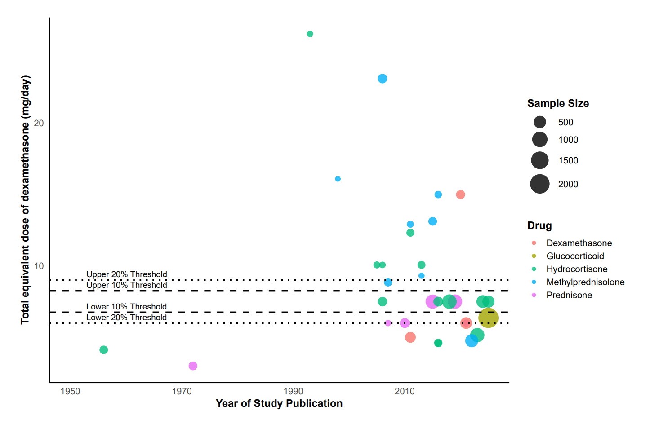
Notes: Daily doses were converted to dexamethasone-equivalent dose (mg/d) using prespecified conversion factors. Reference lines indicate the prespecified high- vs low-dose threshold and the alternative thresholds used in sensitivity analyses.

eFigure 2. P-Score Ranking Plots Across Outcomes for (A) Short-term all-cause mortality, (B) Long-term all-cause mortality, (C) Days off the ventilator, (D) Duration of mechanical ventilation, (E) Gastrointestinal bleeding, (F) Hyperglycemia, (G) ICU length of stay, (H) Invasive mechanical ventilation, (I) Length of stay, (J) Neuropsychiatric adverse reactions, (K) Secondary infections, (L) Serious adverse events and (M) Time to clinical stability.
- All causes mortality (short term)
Overall | Severe | Non-severe
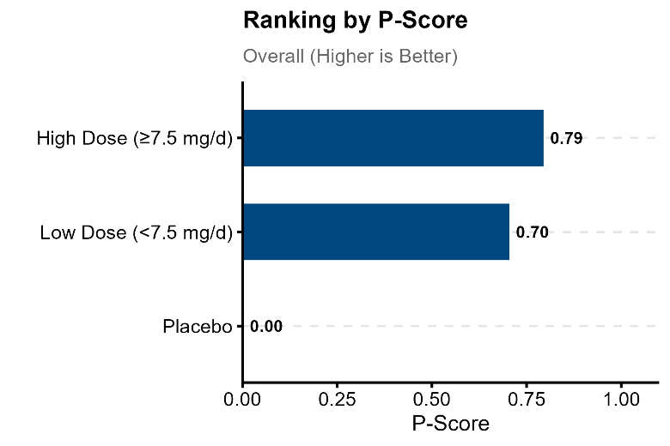 | 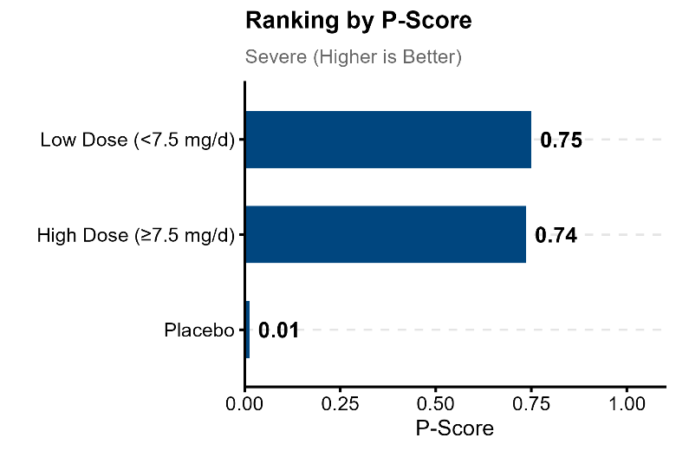 | 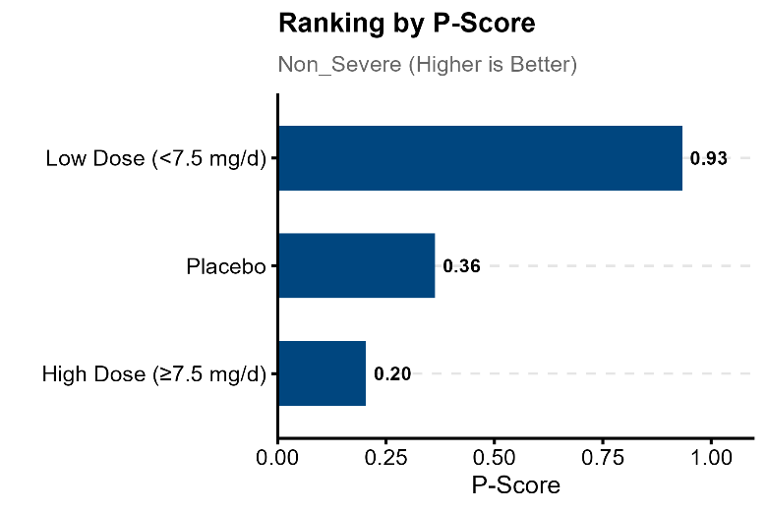
- All causes mortality (long term)
Overall | Severe | Non-severe
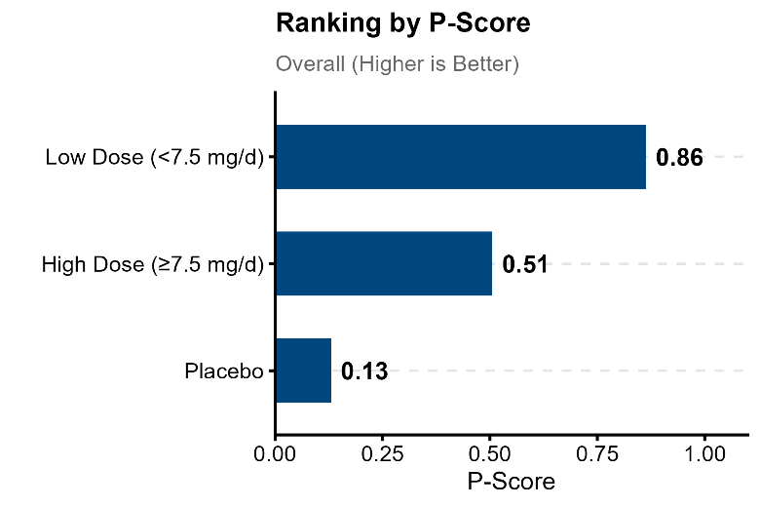 | 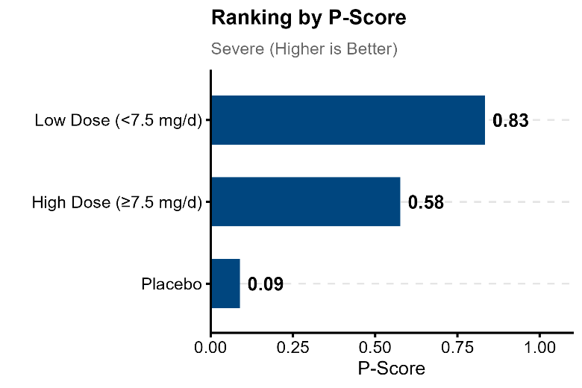 | 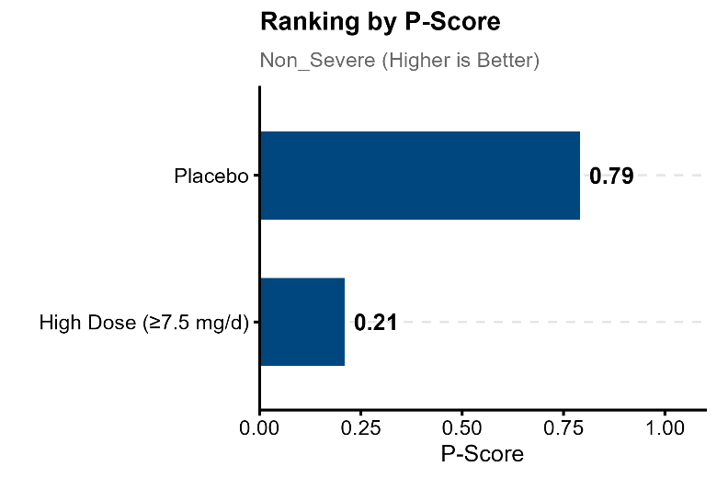
- Days off the ventilator
Overall | Severe
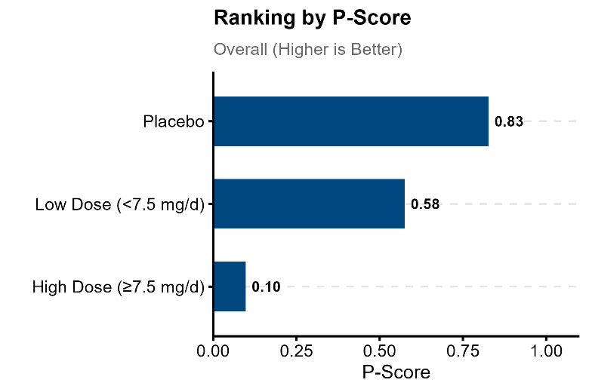 | 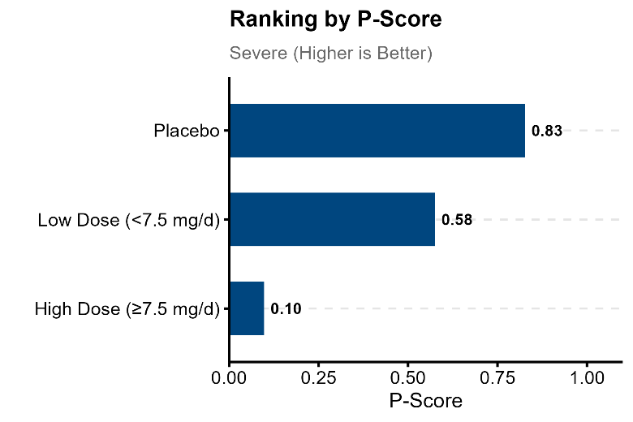
- Duration of mechanical ventilation
Overall | Severe | Non-severe
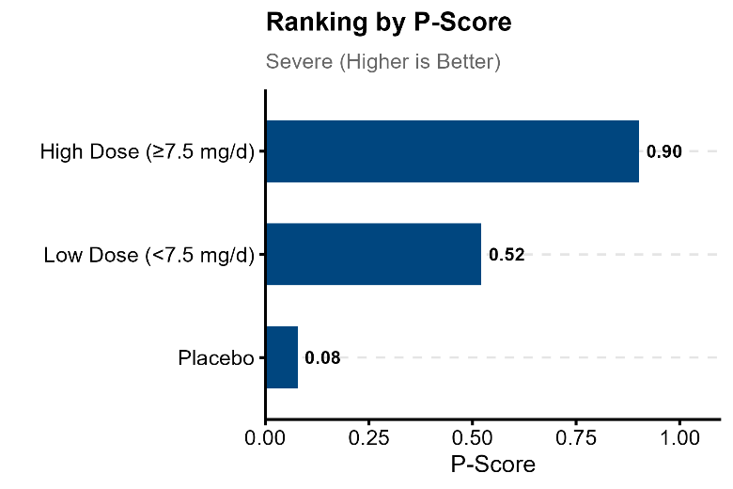 | 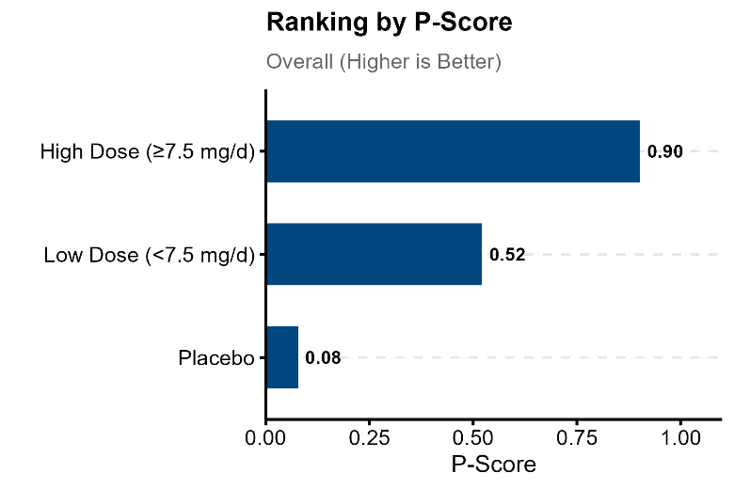 | 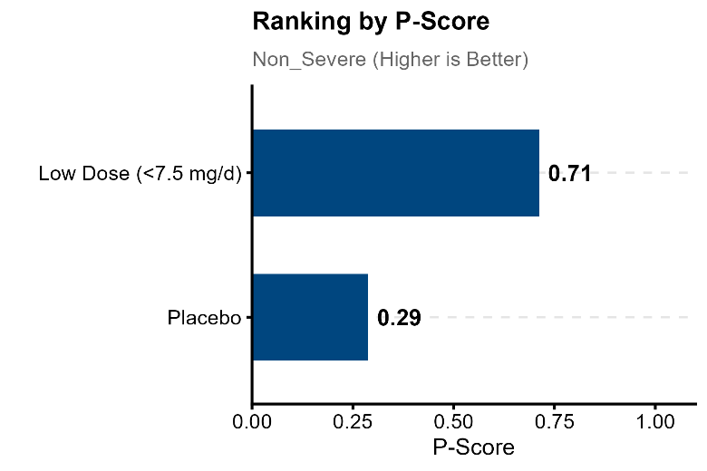
- Gastrointestinal bleeding
Overall | Severe | Non-severe
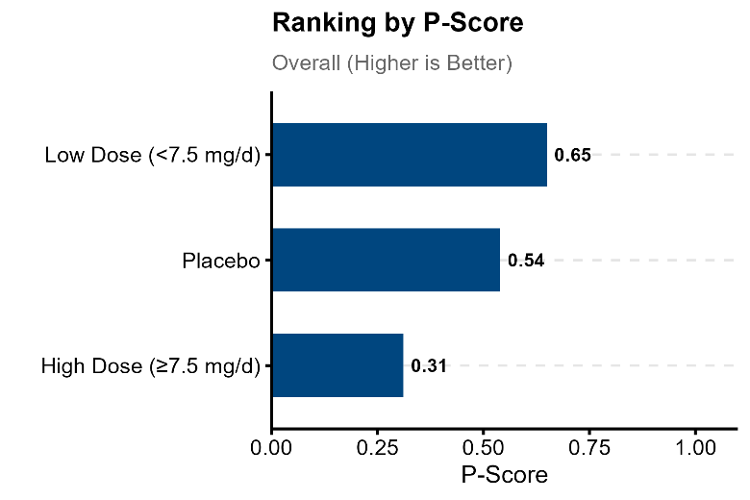 | 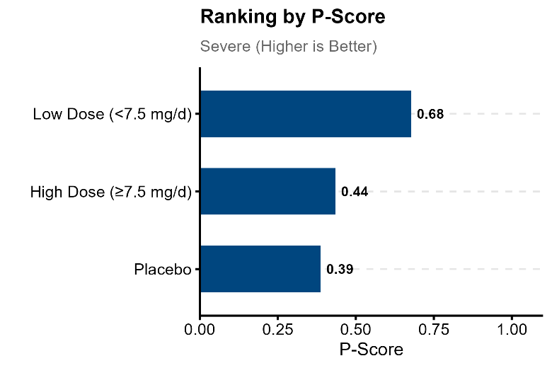 | 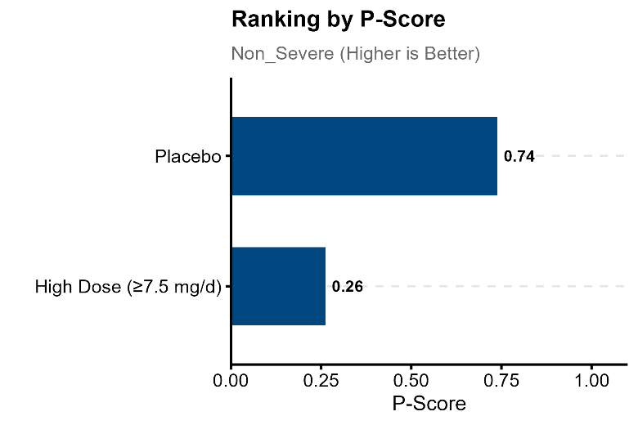
- Hyperglycemia
Overall | Severe | Non-severe
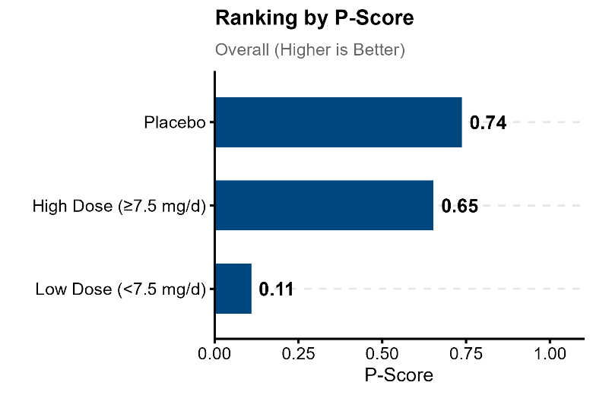 | 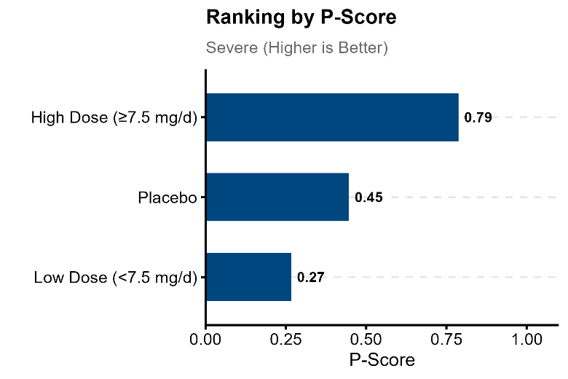 | 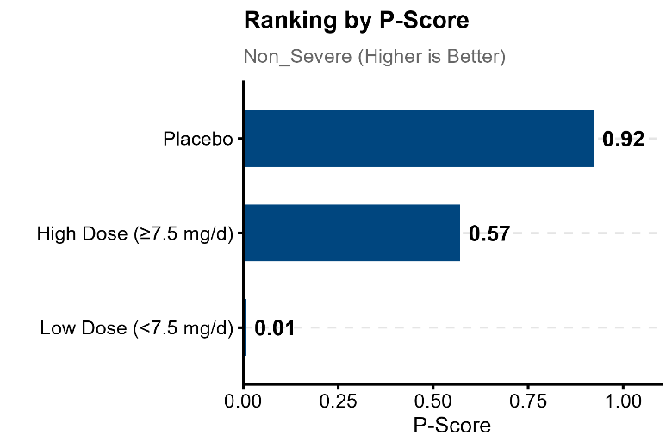
- ICU length of stay
Overall | Severe | Non-severe
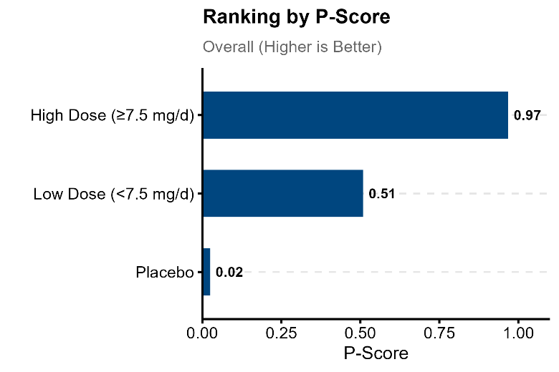 | 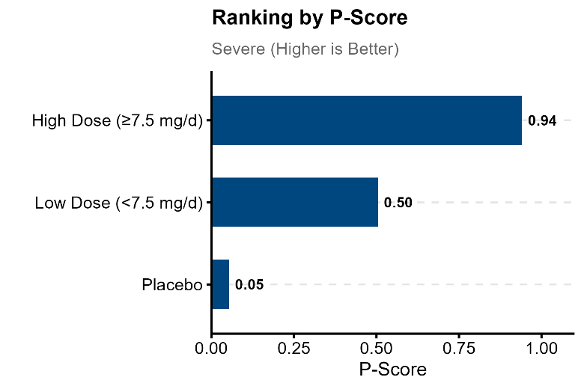 | 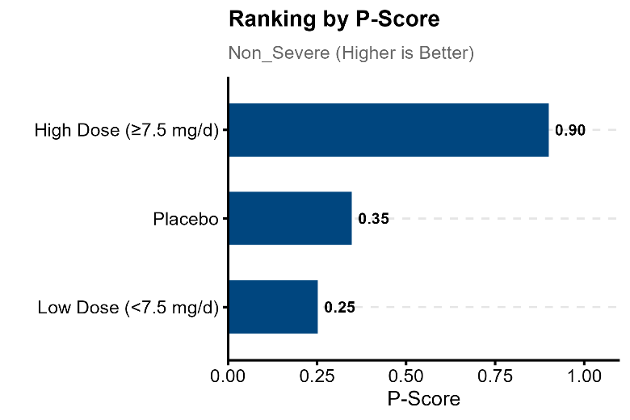
- Invasive mechanical ventilation
Overall | Severe | Non-severe
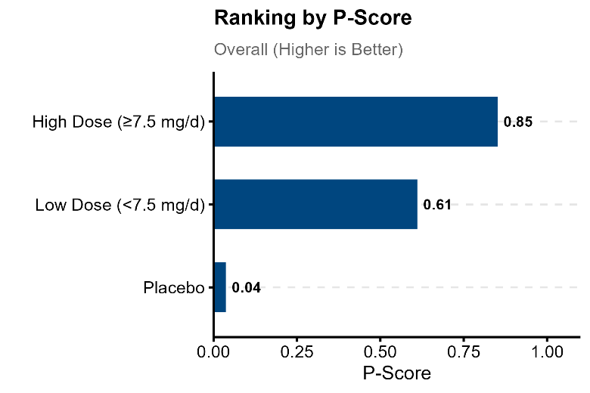 | 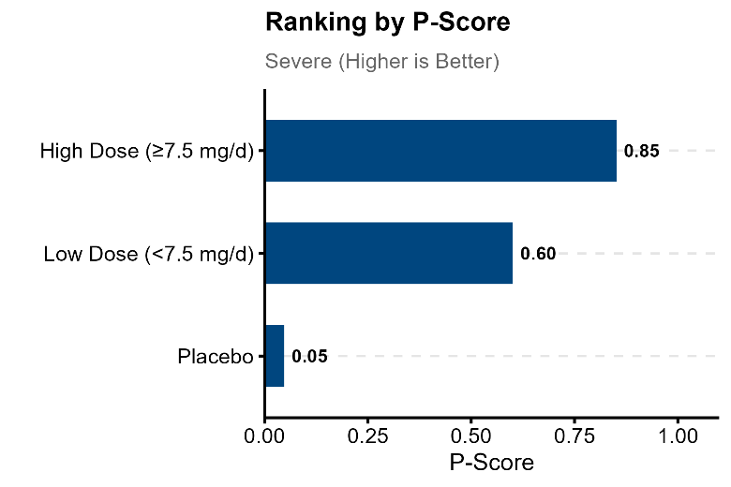 | 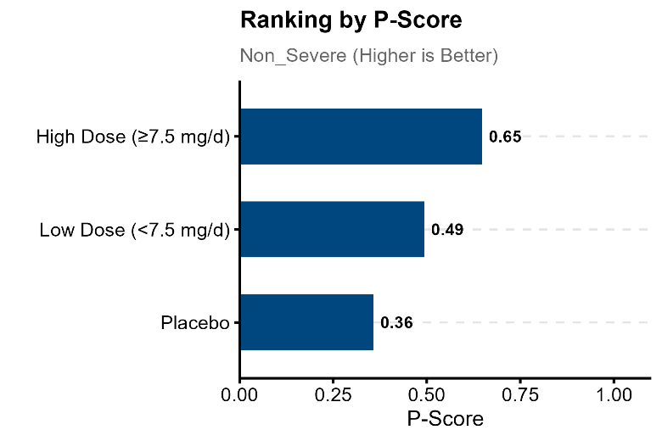
- Length of stay
Overall | Severe | Non-severe
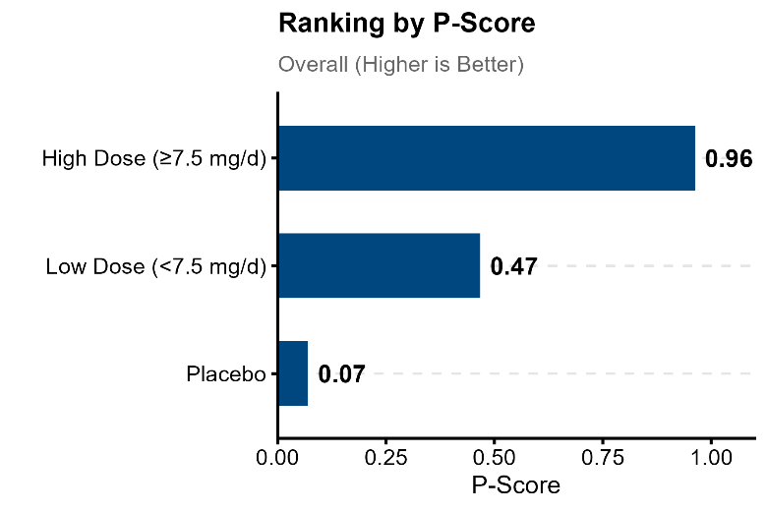 | 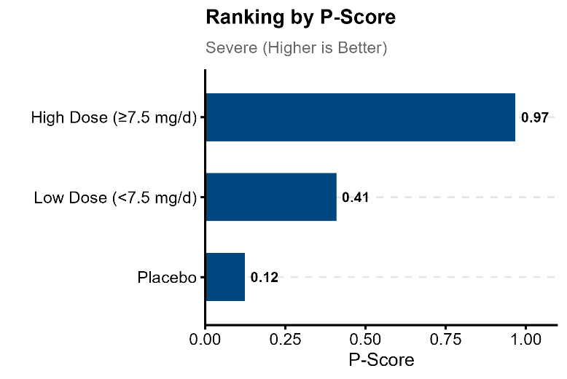 | 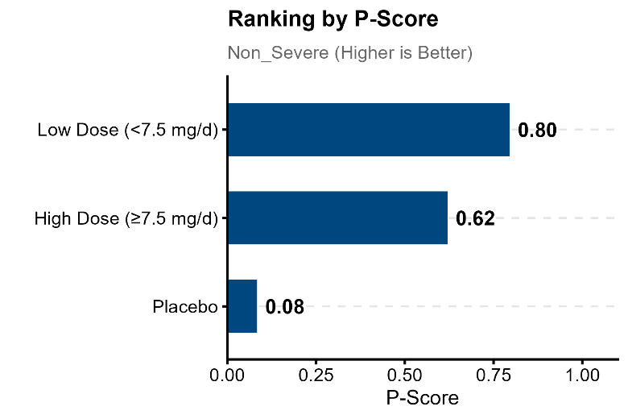
- Neuropsychiatric adverse reactions
Overall | Severe | Non-severe
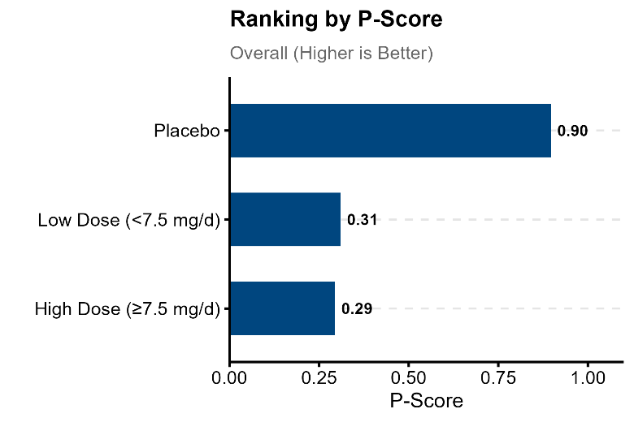 | 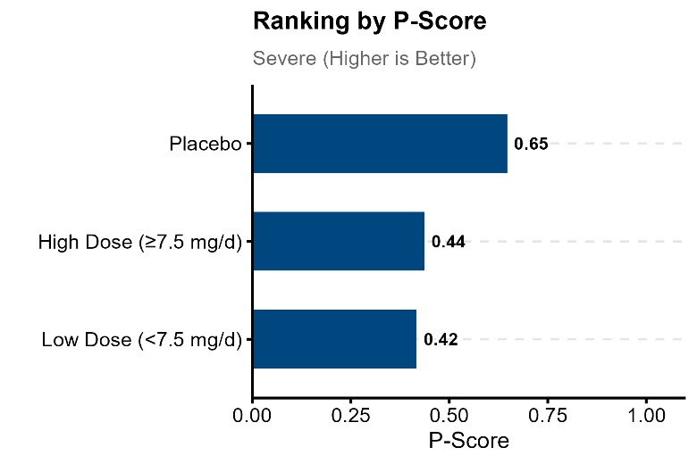 | 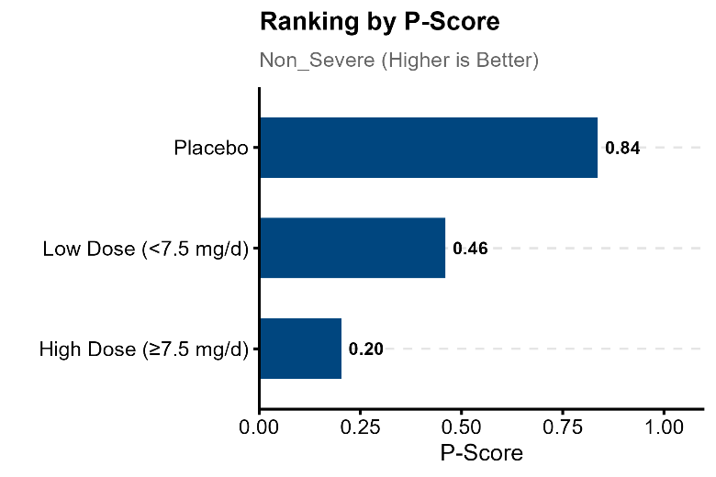
- Secondary infections
Overall | Severe | Non-severe
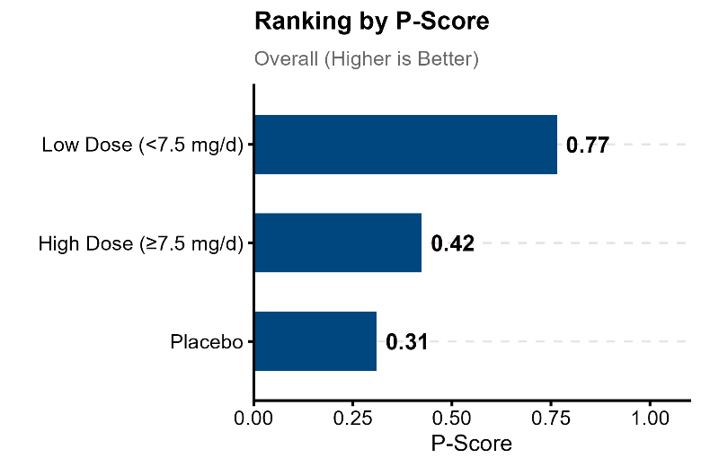 | 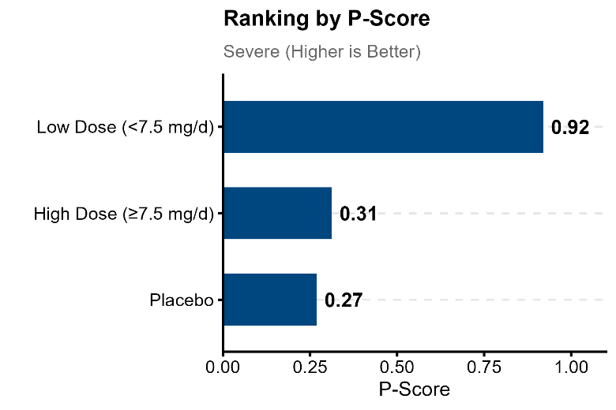 | 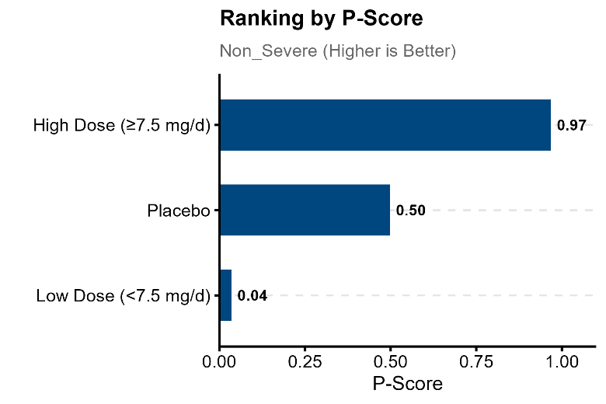
- Serious adverse events
Overall | Severe | Non-severe
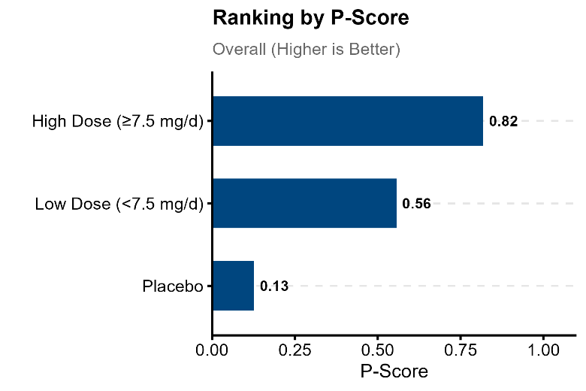 | 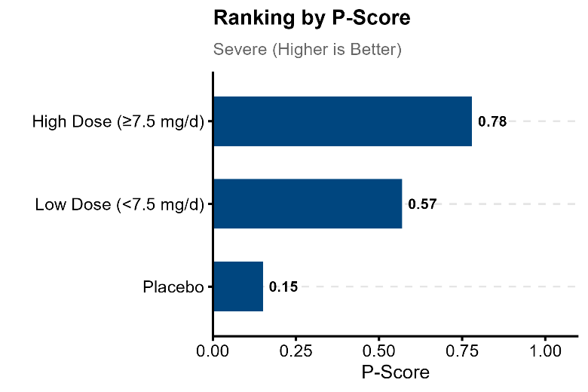 | 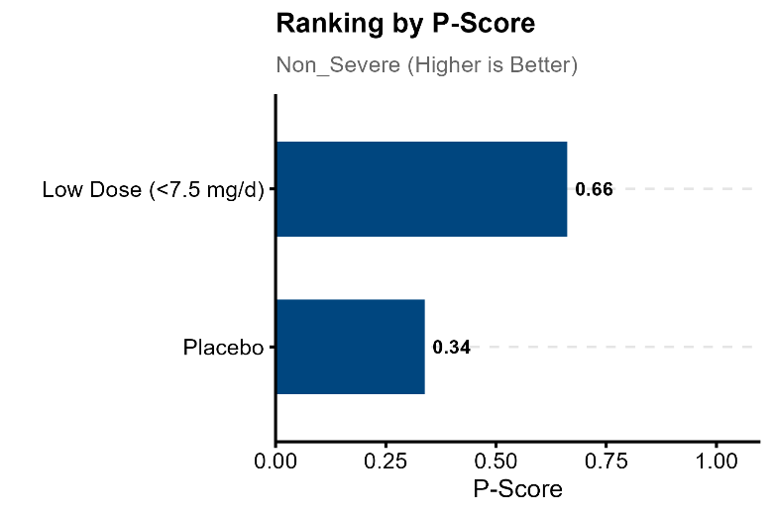
- Time to clinical stability
Overall | Severe | Non-severe
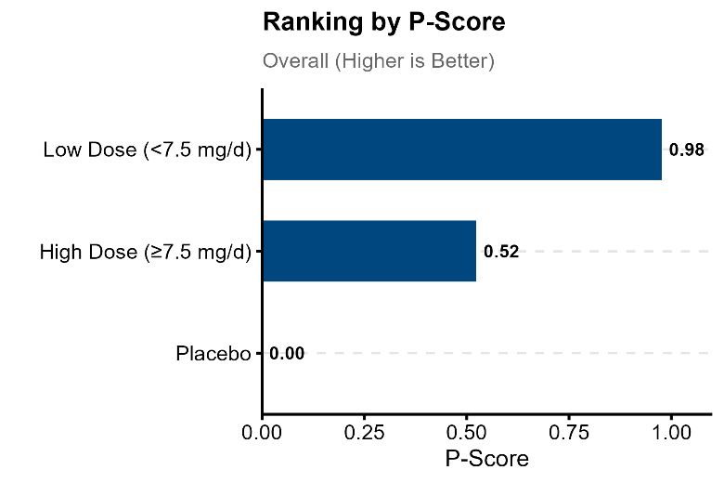 | 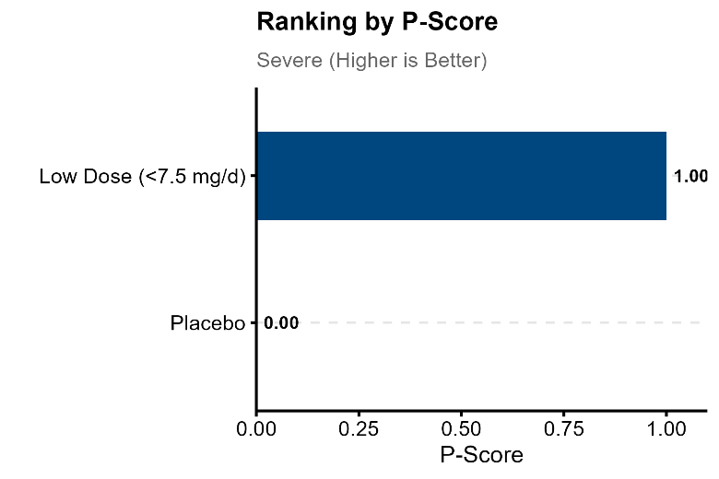 | 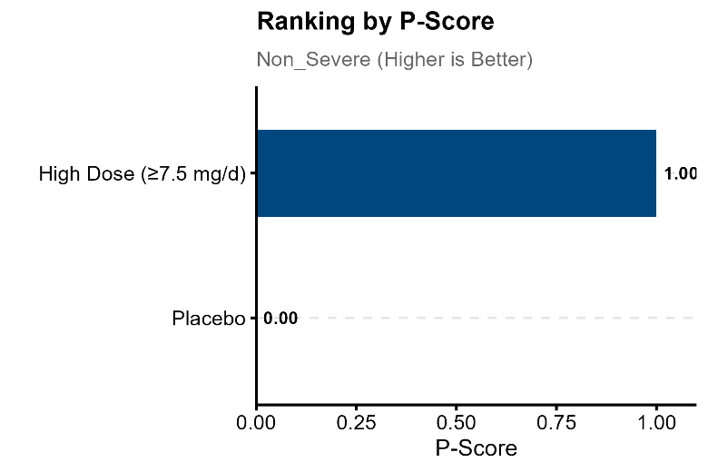

eFigure 3. Leave-One-Out Sensitivity Analyses for All-Cause Mortality (Short-Term) (Overall, Severe CAP, and Non-severe CAP)
A) Overall
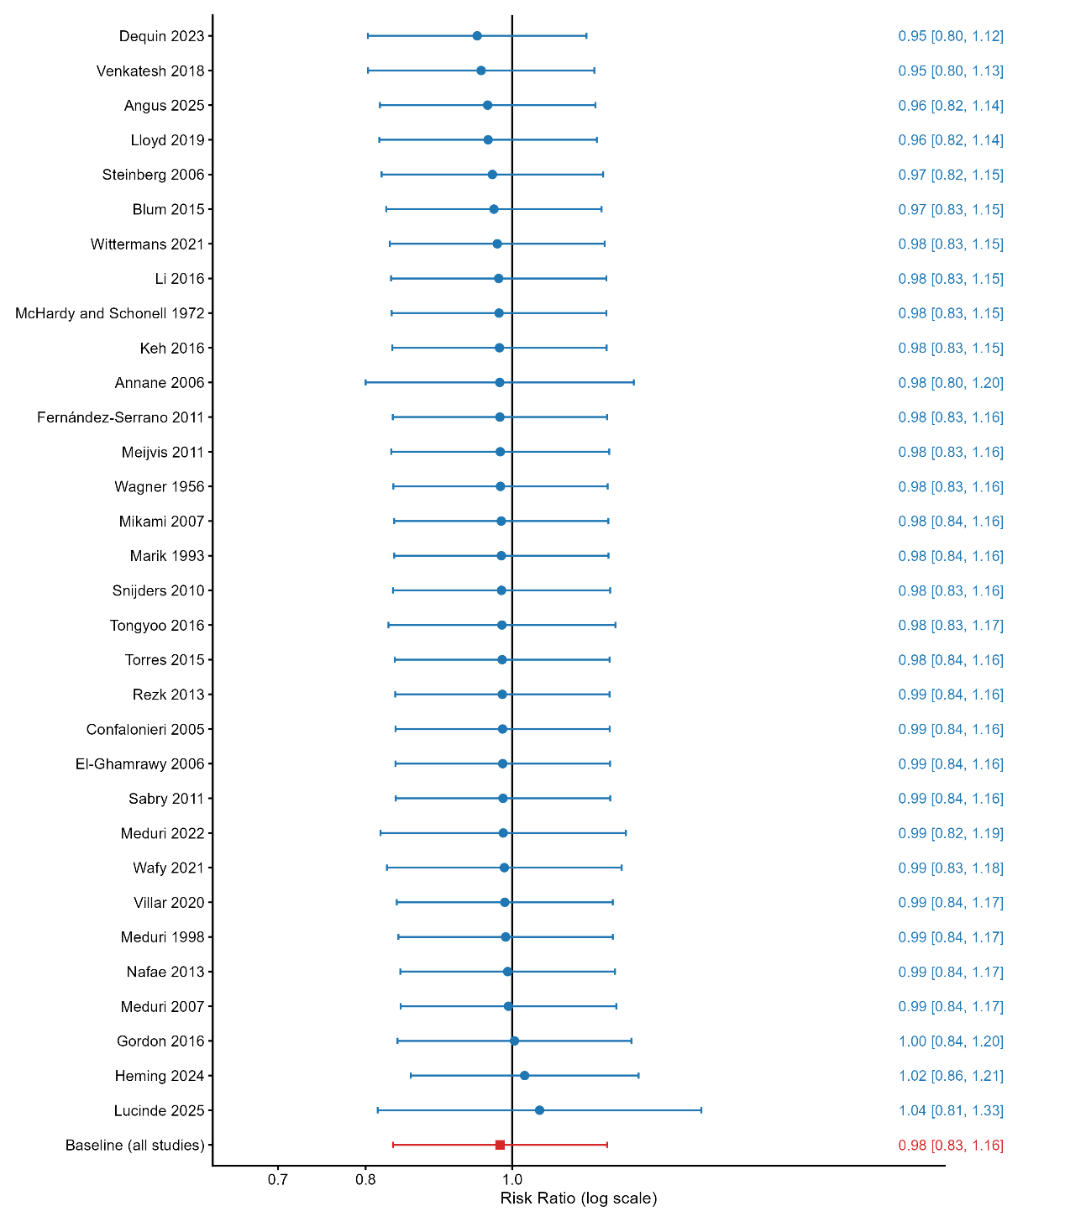

B) Severe
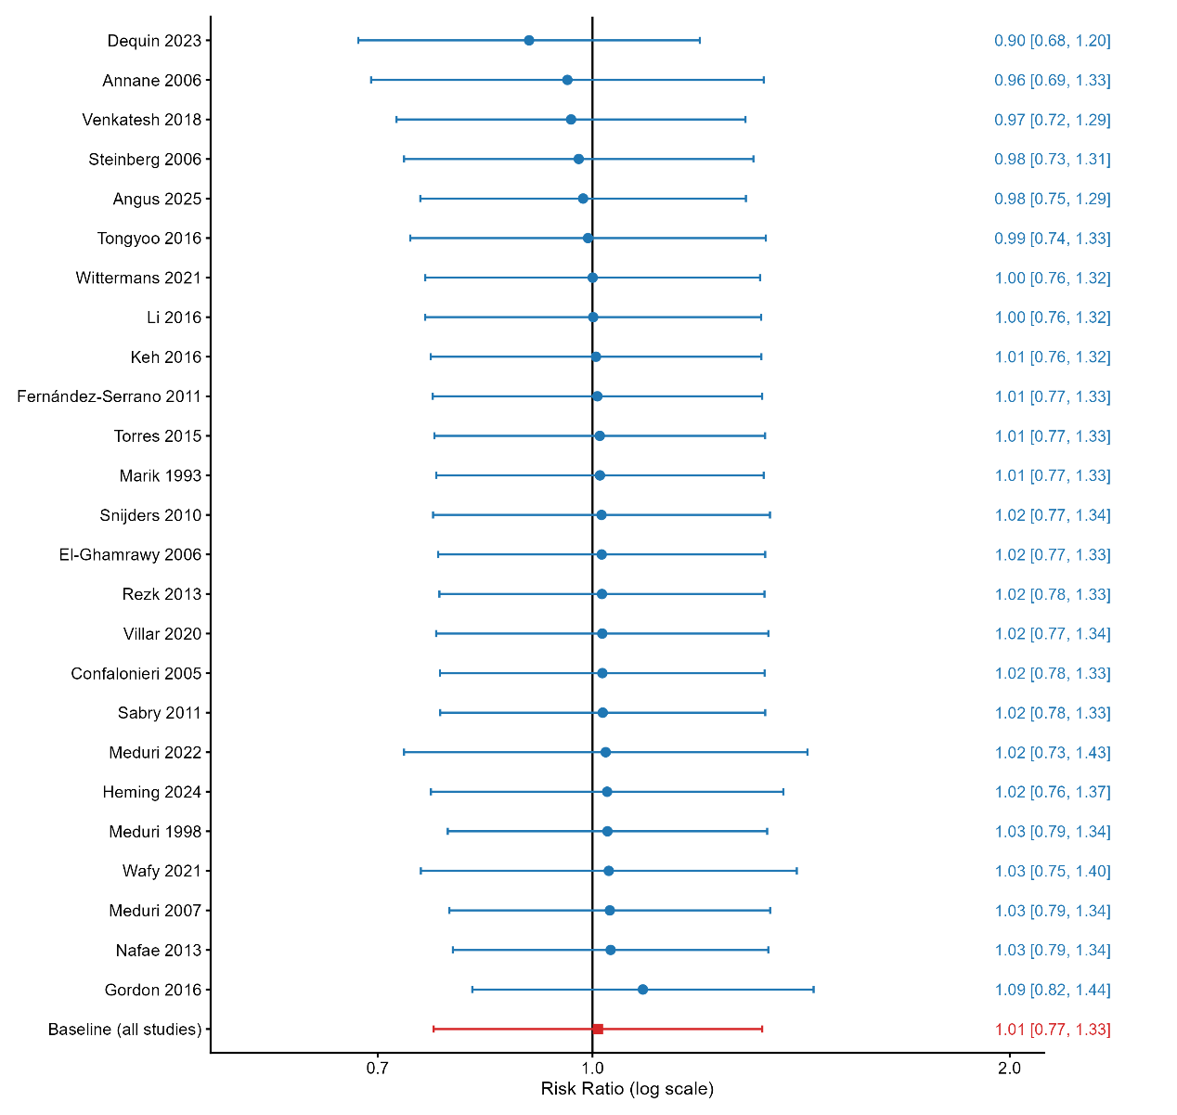
C) Non-severe
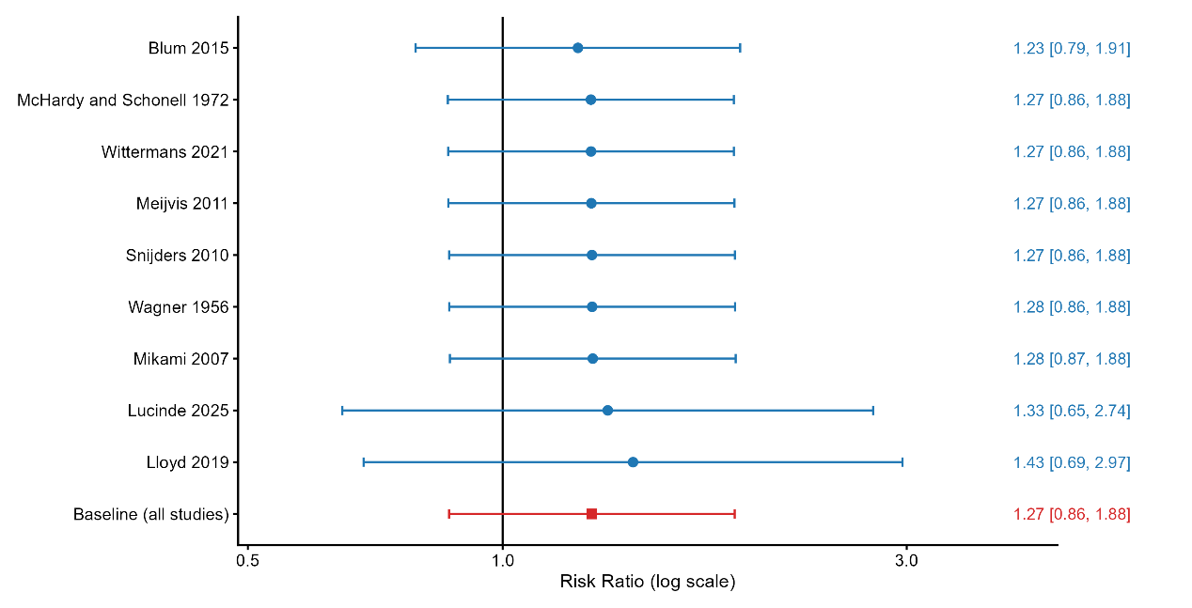

eFigure 4. Linear and Non-Linear Dose–Response Meta-regression for Short-Term All-Cause Mortality by Severity Strata

A) Overall

Linear

Non-Linear

B) Severe

Linear

Non-Linear

C) Non-severe

Linear
Notes: For panels A and B, both the primary linear continuous models (left, blue lines) and the exploratory non-linear models using restricted cubic splines with 3 knots (right, orange lines) are presented. The shaded areas represent the 95% confidence intervals (CIs). The wide, diverging CIs in the spline models, combined with non-significant testing for non-linearity (P = 0.452 for overall; P = 0.173 for severe), visually and statistically confirm the absence of a complex non-linear dose-response gradient. Consequently, the linear model was retained as the most parsimonious fit. For panel C (non-severe subgroup), only the linear meta-regression is presented.

eFigure 5. Baujat Plots for Influence and Contribution to Heterogeneity in Short-Term All-Cause Mortality (Overall, Severe CAP, and Non-severe CAP)

A) Overall

B) Severe

C) Non-severe
Notes: Baujat plots identify studies contributing most to heterogeneity and influence on the pooled estimate within each stratum.
Abbreviations: CAP, community-acquired pneumonia.

eFigure 6. Trial Sequential Analysis for Short-Term All-Cause Mortality at the Prespecified Threshold (7.5 mg/d Dexamethasone-Equivalent)
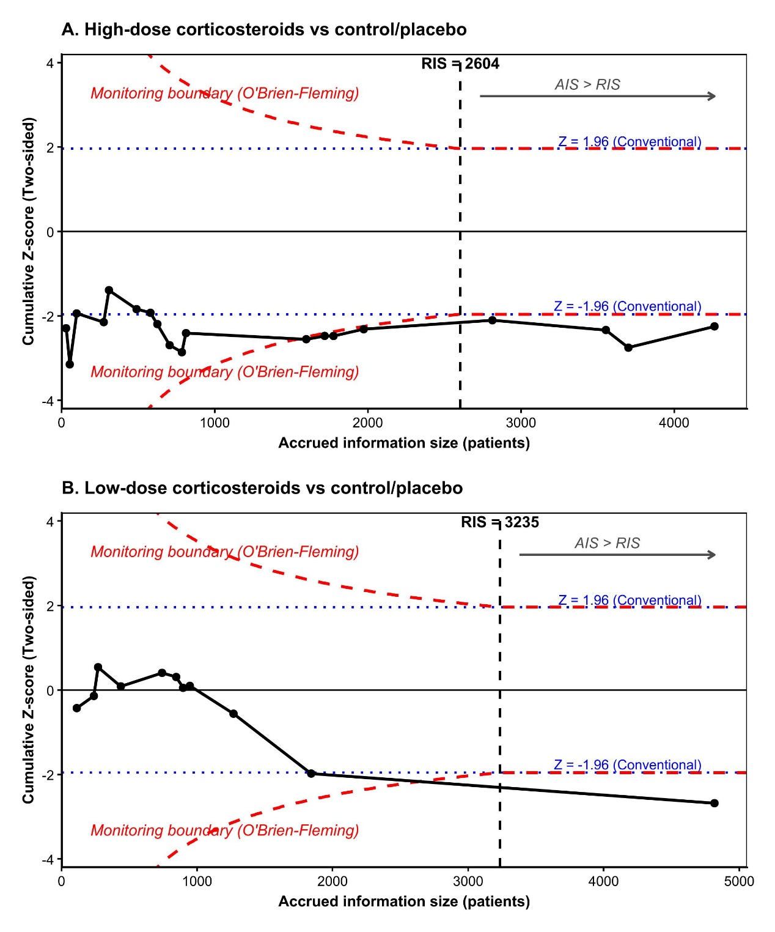
Notes: The cumulative Z-curve is displayed against O’Brien–Fleming–type trial sequential monitoring boundaries and the diversity-adjusted required information size (RIS).
Abbreviations: RIS, required information size; TSA, trial sequential analysis.

eFigure 7. Contour-enhanced funnel plots

A) All causes mortality (short term)

Overall

Severe

B) Gastrointestinal bleeding

Overall

C) Hyperglycemia

Overall

