Supplemental Material

Sodium Bicarbonate Therapy in Severe Metabolic Acidemia:
An Individual Patient Data Meta-Analysis of the BICAR-ICU and BICAR-ICU2 Trials

Maxime Fosset #, Joris Pensier #, Matthieu Jabaudon, Laurent Bitker, Audrey De Jong, Gerald Chanques, Helena Huguet, Nicolas Molinari, Samir Jaber, and Boris Jung

Supplemental Material S1. Instrument to assess the Credibility of Effect Modification Analyses (ICEMAN) in a meta-analysis of randomized controlled trials

Supplemental Figure S2. Time course of arterial pH by treatment group, overall and by baseline acidemia depth

Supplemental Figure S3. Time course of serum bicarbonate by treatment group, overall and by baseline acidemia depth.

Supplemental Figure S4. Time course of serum sodium by treatment group, overall and by baseline acidemia depth.

Instrument to assess the Credibility of Effect Modification Analyses (ICEMAN)

in a meta-analysis of randomized controlled trials :

Version 1.1

CREDIBILITY ASSESSMENT
Essential preliminary considerations to define the possible effect modification of interest
State a single candidate effect modifier (e.g., age or comorbidity): pH (≤7.10 vs > 7.10)
Was the effect modifier measured before or at randomization? [ X ] yes, continue [ ] no, stop here and refer to manual for further instructions
State a single outcome and time-point (e.g., mortality at 1 year follow-up): 90-day mortality
State a single effect measure (e.g., relative risk or risk difference): Relative risk
1: Is the analysis of effect modification based on comparison within rather than between trials?
[ ] Completely between | [ ] Mostly between or unclear | [ ] Mostly within | [ X ] Completely within
Subgroup analysis or meta-regression comparing overall effects of each individual trial. This is typical for aggregate data meta-analysis. | Subgroup analysis or meta-regression with most information coming from overall effects, but some trials providing within-trial subgroup information | Most trials providing within-trial subgroup information; or individual participant data analysis that combines within and between trial information | All trials providing within-trial subgroup information or individual participant data; and the analysis separates within from between trial information, e.g., meta-analysis of interactions
Comment: individual patient data meta-analysis
2: For within-trial comparisons, is the effect modification similar from trial to trial? [ ] Not applicable: no or one within-RCT comparison
[ ] Definitely not similar | [ ] Probably not similar or unclear | [ ] Mostly similar | [ X ] Definitely similar
Effect modification reported for two or more trials and clearly different directions | Effect modification not reported for individual trials or too imprecise to tell | Effect modification reported for two or more trials, mostly similar in direction, but considerable differences in magnitude | Effect modification reported for two or more trials, similar in direction, only some differences in magnitude
Comment: similar effects across both trials
3: For between-trial comparisons, is the number of trials large? [ X ] Not applicable: no between RCT comparison
[ ] Very small | [ ] Rather small or unclear | [ ] Rather large | [ ] Large
1 or 2 or in smallest subgroup; 5 or less in continuous meta-regression | 3-4 in smallest subgroup; 6-10 in continuous meta-regression | 5-9 in smallest subgroup; 11 to 15 in continuous meta-regression | 10 or more in smallest subgroup; more than 15 in continuous meta-regression
Comment:
4: Was the direction of effect modification correctly hypothesized a priori?
[ ] Definitely no | [ ] Probably no or unclear | [ ] Probably yes | [ X ] Definitely yes
Clearly post-hoc or results inconsistent with hypothesized direction or biologically very implausible | Vague hypothesis or hypothesized direction unclear | No prior protocol available but unequivocal statement of a priori hypothesis with correct direction of effect modification | Prior protocol available and includes correct specification of direction of effect modification, e.g., based on a biologic rationale
Comment: hypothesis defined a priori according to the existing litterature
5: Does a test for interaction suggest that chance is an unlikely explanation of the apparent effect modification? (consider irrespective of number of effect modifiers)
[ ] Chance a very likely explanation | [ ] Chance a likely explanation or unclear | [ X ] Chance may not explain | [ ] Chance an unlikely explanation
Interaction or meta-regression p-value >0.05 | Interaction or meta-regression p-value ≤0.05 and >0.01, or no test of interaction reported and not computable | Interaction or meta-regression p-value ≤0.01 and >0.005 | Interaction or meta-regression p-value ≤0.005
Comment: p-for-interaction = 0.006
6: Did the authors test only a small number of effect modifiers or consider the number in their statistical analysis?
[ ] Definitely no | [ ] Probably no or unclear | [ ] Probably yes | [ X ] Definitely yes
Explicitly exploratory analysis or large number of effect modifiers tested (e.g., greater than 10) and multiplicity not considered in analysis | No mention of number or 4-10 effect modifiers tested and number not considered in analysis | No protocol available but unequivocal statement of 3 or fewer effect modifiers tested | Protocol available and 3 or fewer effect modifiers tested or number considered in analysis
Comment:
7: Did the authors use a random effects model?
[ ] Definitely no | [ ] Probably no or unclear | [ ] Probably yes | [ X ] Definitely yes
Fixed (or common) effect or fixed effects model explicitly stated | Probably fixed effect(s) model | Probably random (or mixed) effects | Random (or mixed) effects explicitly stated
Comment: mixed effects modeling
8: If the effect modifier is a continuous variable, were arbitrary cut points avoided? [ ] not applicable: not continuous
[ ] Definitely no | [ ] Probably no or unclear | [ X ] Probably yes | [ ] Definitely yes
Analysis based on exploratory cut point(s), e.g., picking cut point associated with highest interaction p-value | Analysis based on cut point(s) of unclear origin | Analysis based on pre-specified cut point(s), e.g., suggested by prior RCT | Analysis based on the full continuum, e.g., assuming a linear or logarithmic relationship
Comment: main analysis based on a pre-specified cut-off, but p-for-interaction < 0.001 if considered as a continuous variable
9 Optional: Are there any additional considerations that may increase or decrease credibility? (manual section 3.9) [ X ] not applicable
 | [ ] Yes, probably decrease | [ ] Yes, probably increase
Comment:
10: How would you rate the overall credibility of the proposed effect modification?
The overall rating should be driven by the items that decrease credibility. The following provides a sensible strategy:
- All responses definitely or probably decrease credibility or unclear very low
- Two or more responses definitely decrease credibility maximum usually low even if all other responses satisfy credibility criteria
- One response definitely decreases credibility maximum usually moderate even if all other responses satisfy credibility criteria
- Two responses probably decrease credibility maximum usually moderate even if all other responses satisfy credibility criteria
- No response options definitely or probably decrease credibility high very likely
 | Very low credibility | Low credibility | Moderate credibility | High credibility
 | Minimal to no support for effect modification;  Use overall effect for each subgroup | Some but insufficient support for effect modification;  Use overall effect for each subgroup but note remaining uncertainty | Likely effect modification;  Use separate effects for each subgroup but note remaining uncertainty | Very likely effect modification;  Use separate effects for each subgroup
Comment:

Supplemental Figure S2. Time course of arterial pH by treatment group, overall and by baseline acidemia depth.

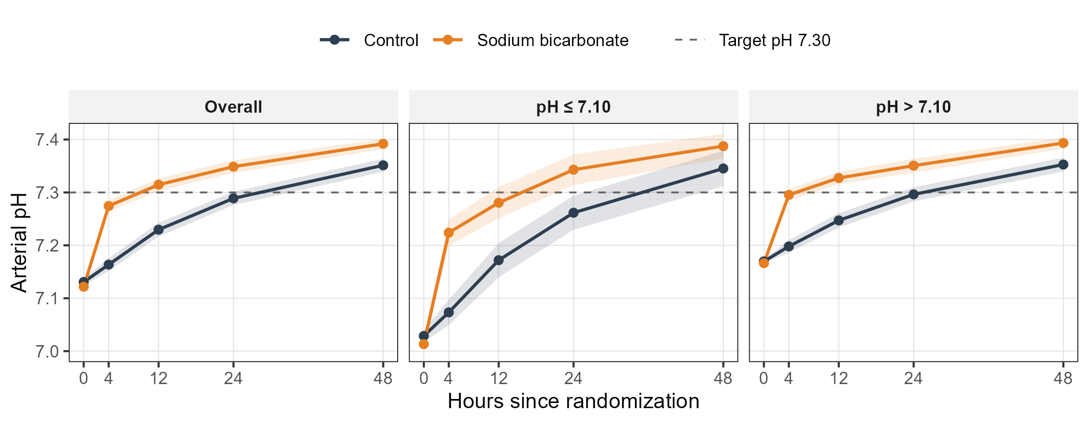

Arterial pH from randomization through 48 hours in the sodium bicarbonate group (orange) and the control group (dark blue). Points show the mean at each nominal time point (0, 4, 12, 24, and 48 hours after randomization) and shaded bands the 95% confidence interval. Panels present the overall population and the two prespecified acidemia-depth strata (baseline pH ≤ 7.10 and pH > 7.10). The dashed horizontal line indicates the protocol-specified target (pH 7.30). Data are pooled individual-patient data from the BICAR-ICU and BICAR-ICU2 trials (intention-to-treat population, N = 1,016). CI, confidence interval.

Supplemental Figure S3. Time course of serum bicarbonate by treatment group, overall and by baseline acidemia depth.

Serum bicarbonate concentration (mmol/L) from randomization through 48 hours in the sodium bicarbonate group (orange) and the control group (dark blue). Points show the mean at each nominal time point (0, 4, 12, 24, and 48 hours after randomization) and shaded bands the 95% confidence interval. Panels present the overall population and the two prespecified acidemia-depth strata (baseline pH ≤ 7.10 and pH > 7.10). Data are pooled individual-patient data from the BICAR-ICU and BICAR-ICU2 trials (intention-to-treat population, N = 1,016). CI, confidence interval.

Supplemental Figure S4. Time course of serum sodium by treatment group, overall and by baseline acidemia depth.

Serum sodium concentration (mmol/L) from randomization through 48 hours in the sodium bicarbonate group (orange) and the control group (dark blue). Points show the mean at each nominal time point (0, 4, 12, 24, and 48 hours after randomization) and shaded bands the 95% confidence interval. Panels present the overall population and the two prespecified acidemia-depth strata (baseline pH ≤ 7.10 and pH > 7.10). The dashed horizontal line indicates the threshold of serum sodium level of 150 mmol/L. Data are pooled individual-patient data from the BICAR-ICU and BICAR-ICU2 trials (intention-to-treat population, N = 1,016). CI, confidence interval.

