SUPPLEMENTAL MATERIAL
Left ventricular unloading during VA-ECMO for refractory cardiogenic shock:
a target trial emulation multicenter analysis

Corresponding author:
Alain COMBES, MD, PhD
Service de Médecine Intensive Réanimation
Sorbonne Université, Hôpital de la Pitié–Salpêtrière, AP-HP
47, bd de l’Hôpital, 75651 Paris Cedex 13, France.
Tel: +33 (0)142162937; Fax: +33 (0)1 42163817; e-mail: alain.combes@aphp.fr

Table S1. Baseline characteristics of patients according to investigation center
 | Investigation center
 | Hamburg  N = 121 | Paris  N = 143 | Total  N = 264
Type of MCS
ECMO alone | 73 (60.3%) | 65 (45.5%) | 138 (52.3%)
ECMO and IABP | 0 (0%) | 84 (58.74%) | 84 (31.58%)
ECMO and Impella | 54 (43.9%) | 1 (0.7%) | 55 (20.68%)
Demographics
Age, years | 58.4 (14.2) | 50 (12.9) | 53.8 (14.1)
Men | 89 (73.6%) | 110 (76.9%) | 199 (75.5%)
BMI, kg/m² | 26.7 (4.6) | 26.7 (5.85) | 26.7 (5.3)
Comorbidities
Atrial Fibrillation | 28 (23.1%) | 18 (12.6%) | 46 (17.5%)
Diabetes mellitus | 21 (17.4%) | 34 (23.8%) | 55 (20.8%)
Hypertension | 53 (44.2%) | 23 (16.1%) | 76 (28.9%)
Peripheral arterial disease | 9 (7.4%) | 1 (0.7%) | 10 (3.8%)
Chronic cardiomyopathy | 36.3 (38.2%) | 87 (60.8%) | 131 (49.6%)
Ischemic | 17 (14.0%) | 27 (18.8%) | 44 (16.7%)
Valvular | 9 (7.4%) | 8 (5.6%) | 17 (6.4%)
Other | 18 (14.9%) | 52 (36.4%) | 70 (26.5%)
Cardiogenic Shock Data
Cause of cardiogenic shock
Acute myocardial infarction | 60 (49.6%) | 52 (36.4%) | 112 (42.4%)
LAD occlusion | 39 (60%) | 35 (66.04%) | 74 (62.71%)
Attempted PCI | 59 (90.77%) | 49 (92.45%) | 108 (91.53%)
Successful PCI | 56 (88.89%) | 35 (81.4%) | 91 (85.85%)
Idiopathic dilated cardiomyopathy | 6 (5.0%) | 34 (23.8%) | 40 (15.2%)
Post-heart surgery | 8 (6.6%) | 11 (7.7%) | 19 (7.2%)
Myocarditis | 0 (0%) | 12 (8.4%) | 12 (4.5%)
Other | 47 (38.8%) | 34 (23.8%) | 81 (30.7%)
State of cardiogenic shock
Low-output Cardiogenic shock | 112 (92.6%) | 143 (100%) | 255 (96.6%)
High-output Cardiogenic shock | 9 (7.4%) | 0 (0%) | 9 (3.4%)
SCAI classification
C | 14 (11.6%) | 0 (0%) | 14 (5.2%)
D | 46 (38.0%) | 131 (91.6%) | 177 (67.0%)
E | 61 (50.4%) | 12 (8.4%) | 73 (27.7%)
SOFA score | NA [NA ; NA] | 11 [8 ; 14] | 11 [8 ; 14]
SAVE score | -9 [-12 ; -6] | -8 [-11 ; -5] | -9 [-11 ; -5]
SAPS II score | 74 [54 ; 83] | 53 [36 ; 68] | 62 [41.25 ; 77]
On MV Pre ECMO | 99 (81.8%) | 35 (24.5%) | 134 (50.8%)
ECMO Retrieval | 17 (14.0%) | 45 (31.5%) | 62 (23.5%)
Pre ECMO cardiac arrest | 89 (73.6%) | 43 (30.1%) | 132 (50.0%)
No-flow, min | 0 [0 ; 0] | 0 [0 ; 0] | 0 [0 ; 0]
Low-flow, min | 44.5 [20 ; 60] | 15 [10 ; 25] | 29.5 [15 ; 50]
Shockable rhythm | 36 (46.8%) | 25 (62.5%) | 61 (52.1%)
ECMO under CPR | 54 (60.7%) | 11 (25.6%) | 65 (49.2%)
Pre ECMO biology
pH | 7.17 [7.01 ; 7.27] | 7.29 [7.21 ; 7.38] | 7.25 [7.12 ; 7.33]
Lactate, mmol/L | 9.2 [5.5 ; 13.75] | 4.6 [2.8 ; 8.2] | 6.7 [3.6 ; 11.1]
Troponin, ng/L | 22263 [986 ; 162645] | 480 [85 ; 4355] | 1656 [226 ; 21666]
ASAT, UI | 290 [72 ; 968] | 183.5 [54.75 ; 584.25] | 201 [60 ; 630]
Creatinine, μmol/L | 127.6 [101 ; 176] | 125.5 [92 ; 171] | 126.72 [94 ; 174]
Prothrombin activity, % | NA [NA ; NA] | 62 [49 ; 72.75] | 62 [49 ; 72.75]
aPTT, sec | 88 [40.5 ; 160] | 48 [39.25 ; 67] | 52 [40 ; 107]
PaO2/FiO2 | 288 [146 ; 426] | 390 [224 ; 549] | 342 [162 ; 496]
Pre ECMO hemodynamics
SAP (mmHg) | 89 [70 ; 100] | 95 [85 ; 107] | 94 [84 ; 107]
DAP (mmHg) | 51 [44 ; 60] | 65 [58 ; 73] | 63 [53 ; 73]
Mean arterial pressure (mmHg) | 61 [51 ; 77] | 75 [68 ; 83] | 73 [65 ; 82]
HR (bpm) | 110 [79 ; 120] | 112 [92 ; 125] | 111 [90 ; 124]
Vasopressor use | 116 (95.87%) | 138 (96.5%) | 254 (96.21%)
Vasoactive inotropic score | NA [NA ; NA] | 88 [32 ; 146] | 88 [32 ; 146]
Epinephrine use | 42 (34.7%) | 9 (6.2%) | 51 (19.3%)
Norepinephrine use | 113 (93.3%) | 115 (80.4%) | 228 (86.3%)
Dobutamine use | 21 (17.3%) | 116 (81.1%) | 137 (51.9%)
Pre ECMO Echo Data
LVEF, % | 10 [5 ; 15] | 15 [10 ; 20] | 10 [5 ; 20]
Aortic VTI, cm | NA [NA ; NA] | 7 [6 ; 10] | 7 [6 ; 10]
Grade > II mitral regurgitation | 15 (12.61%) | 30 (21.13%) | 45 (17.24%)
Values are expressed as n (%), median [IQR] or mean (±sd).
Abbreviations: MCS mechanical circulatory support, ECMO Extracorporeal membrane oxygenation, BMI body mass index, LAD left anterior descending artery, PCI percutaneous coronary intervention, MV mechanical ventilation, CPR cardiopulmonary resuscitation, SAP systolic arterial pressure, DAP diastolic arterial pressure, MAP mean arterial pressure, HR heart rate, LVEF left ventricular ejection fraction, VTI velocity-time integral, IABP intra-aortic balloon pump.
Table S2. Patient characteristics and survival before and after propensity score weighting – ATE weights, complete cases analysis.
 | Unweighted sample |  | Weighted sample
Variable | ECMO  N = 130 | ECMO and Unload  N = 123 | ECMO  N = 269 | ECMO and Unload  N = 247
Age | 52.49 (15.17) | 55.02 (12.92) | 55.84 (14.30) | 56.94 (13.73)
Male | 88 (67.7%) | 103 (83.7%) | 208 (77.6%) | 174 (70.5%)
BMI, kg/m² | 27.11 (5.41) | 26.45 (5.34) | 27.17 (5.29) | 26.57 (5.07)
Atrial Fibrillation | 24 (18.5%) | 20 (16.3%) | 60 (22.2%) | 66 (26.7%)
Diabetes | 31 (23.8%) | 21 (17.1%) | 50 (18.5%) | 73 (29.4%)
Hypertension | 44 (33.8%) | 29 (23.6%) | 71 (26.5%) | 87 (35.3%)
Peripheral Arterial Disease | 6 (4.6%) | 3 (2.4%) | 8 (3.1%) | 8 (3.2%)
Ischemic Cardiomyopathy | 26 (20.0%) | 18 (14.6%) | 44 (16.3%) | 61 (24.8%)
Valvular Cardiomyopathy | 10 (7.7%) | 7 (5.7%) | 16 (6.1%) | 16 (6.5%)
Other chronic cardiomyopathy | 39 (30.0%) | 29 (23.6%) | 68 (25.4%) | 65 (26.5%)
Cause of cardiogenic shock
Acute myocardial infarction | 41 (31.5%) | 65 (52.8%) | 120 (44.8%) | 102 (41.1%)
Idiopathic Dilated cardiomyopathy | 12 (9.2%) | 27 (22.0%) | 42 (15.5%) | 41 (16.4%)
Myocarditis | 8 (6.2%) | 4 (3.3%) | 11 (4.2%) | 9 (3.8%)
Other | 59 (45.4%) | 19 (15.4%) | 79 (29.3%) | 81 (32.7%)
Post-cardiotomy | 10 (7.7%) | 8 (6.5%) | 17 (6.2%) | 15 (6.0%)
State of cardiogenic shock
Low-output Cardiogenic shock | 123 (94.6%) | 123 (100.0%) | 262 (97.4%) | 247 (100.0%)
High-output cardiogenic shock | 7 (5.4%) | 0 (0.0%) | 7 (2.6%) | 0 (0.0%)
SCAI Score
C | 6 (4.6%) | 7 (5.7%) | 10 (3.6%) | 13 (5.2%)
D | 87 (66.9%) | 87 (70.7%) | 189 (70.5%) | 157 (63.4%)
E | 37 (28.5%) | 29 (23.6%) | 70 (25.9%) | 78 (31.4%)
SAVE Score | -8.55 (4.90) | -8.20 (4.60) | -8.48 (4.72) | -8.47 (4.32)
SAPS II Score | 63.27 (21.59) | 55.32 (19.87) | 58.08 (21.51) | 59.41 (20.72)
Pre-ECMO IMV | 74 (56.9%) | 52 (42.3%) | 117 (43.6%) | 124 (49.9%)
Pre-ECMO GCS | 5.57 (4.79) | 6.89 (5.40) | 6.98 (5.28) | 6.35 (5.21)
Pre-ECMO Cardiac Arrest | 72 (55.4%) | 52 (42.3%) | 127 (47.5%) | 129 (52.0%)
Pre-ECMO AMI | 50 (38.5%) | 62 (50.4%) | 129 (48.2%) | 99 (39.9%)
Lactate mmol/L | 8.34 (5.76) | 7.18 (4.78) | 7.93 (5.13) | 7.09 (4.53)
Vasopressor use | 128 (98.5%) | 115 (93.5%) | 257 (95.7%) | 237 (95.9%)
LVEF, % | 17.91 (13.98) | 12.11 (8.25) | 14.66 (11.74) | 16.27 (12.07)
60 days survival status
Alive | 64 (46.4%) | 59 (46.8%) | 130 (48.6%) | 129 (52.2%)
Dead | 74 (53.6%) | 67 (53.2%) | 138 (51.4%) | 118 (47.8%)
Values are expressed as n (%) or median [IQR]. Abbreviations: IMV invasive mechanical ventilation, GCS Glasgow coma scale, AMI acute myocardial infarction.

 | Unweighted sample |  | Weighted sample
Variable | ECMO  N = 130 | ECMO and Unload  N = 123 | ECMO  N = 43 | ECMO and Unload  N = 43
Age | 52.49 (15.17) | 55.02 (12.92) | 54.27 (14.27) | 54.27 (12.42)
Male | 88 (67.7%) | 103 (83.7%) | 33 (75.9%) | 33 (75.9%)
BMI, kg/m² | 27.11 (5.41) | 26.45 (5.34) | 26.99 (5.65) | 26.99 (5.50)
Atrial Fibrillation | 24 (18.5%) | 20 (16.3%) | 9 (20.0%) | 9 (20.0%)
Diabetes | 31 (23.8%) | 21 (17.1%) | 10 (22.1%) | 10 (22.1%)
Hypertension | 44 (33.8%) | 29 (23.6%) | 13 (30.1%) | 13 (30.1%)
Peripheral Arterial Disease | 6 (4.6%) | 3 (2.4%) | 2 (3.5%) | 2 (3.5%)
Ischemic Cardiomyopathy | 26 (20.0%) | 18 (14.6%) | 8 (17.7%) | 8 (17.7%)
Valvular Cardiomyopathy | 10 (7.7%) | 7 (5.7%) | 3 (8.1%) | 3 (8.1%)
Other chronic cardiomyopathy | 39 (30.0%) | 29 (23.6%) | 12 (28.5%) | 12 (28.5%)
Cause of cardiogenic shock
Acute myocardial infarction | 41 (31.5%) | 65 (52.8%) | 19 (43.5%) | 19 (43.5%)
Idiopathic Dilated cardiomyopathy | 12 (9.2%) | 27 (22.0%) | 7 (16.7%) | 7 (16.7%)
Myocarditis | 8 (6.2%) | 4 (3.3%) | 2 (5.1%) | 2 (5.1%)
Other | 59 (45.4%) | 19 (15.4%) | 12 (27.1%) | 12 (27.1%)
Post-cardiotomy | 10 (7.7%) | 8 (6.5%) | 3 (7.5%) | 3 (7.5%)
State of cardiogenic shock
Low-output Cardiogenic shock | 123 (94.6%) | 123 (100.0%) | 43 (100.0%) | 43 (100.0%)
High-output cardiogenic shock | 7 (5.4%) | 0 (0.0%) | 0 (0.0%) | 0 (0.0%)
SCAI Score
C | 6 (4.6%) | 7 (5.7%) | 2 (5.0%) | 2 (5.0%)
D | 87 (66.9%) | 87 (70.7%) | 30 (69.1%) | 30 (69.1%)
E | 37 (28.5%) | 29 (23.6%) | 11 (25.9%) | 11 (25.9%)
SAVE Score | -8.55 (4.90) | -8.20 (4.60) | -8.34 (5.02) | -8.34 (4.56)
SAPS II Score | 63.27 (21.59) | 55.32 (19.87) | 57.75 (21.91) | 57.75 (20.28)
Pre-ECMO IMV | 74 (56.9%) | 52 (42.3%) | 20 (47.3%) | 20 (47.3%)
Pre-ECMO GCS | 5.57 (4.79) | 6.89 (5.40) | 6.61 (5.27) | 6.61 (5.34)
Pre-ECMO Cardiac Arrest | 72 (55.4%) | 52 (42.3%) | 21 (48.7%) | 21 (48.7%)
Pre-ECMO AMI | 50 (38.5%) | 62 (50.4%) | 19 (43.5%) | 19 (43.5%)
Lactate mmol/L | 8.34 (5.76) | 7.18 (4.78) | 7.41 (5.12) | 7.41 (4.71)
Vasopressor use | 128 (98.5%) | 115 (93.5%) | 42 (96.9%) | 42 (96.9%)
LVEF, % | 17.91 (13.98) | 12.11 (8.25) | 13.65 (9.53) | 13.65 (9.87)
60 days survival status
Alive | 64 (46.4%) | 59 (46.8%) | 22 (50.1%) | 21 (48.7%)
Dead | 74 (53.6%) | 67 (53.2%) | 21 (49.9%) | 22 (51.3%)
Table S3. Patient characteristics and survival before and after propensity score weighting – ATO weights, complete cases analysis.
Values are expressed as n (%) or median [IQR]. Abbreviations: IMV invasive mechanical ventilation, GCS Glasgow coma scale, AMI acute myocardial infarction.
Table S4. Patient outcomes during ICU stay according to their MCS strategy and unloading device*
 | All  (n=264) | ECMO*  (n=138) | ECMO + IABP (n=78) | ECMO + Impella (n=48)
Device related sepsis | 43 (16.3%) | 15 (10.8%) | 24 (30.7%) | 4 (8.3%)
ECMO site infection | 42 (15.9%) | 15 (10.9%) | 24 (30.8%) | 3 (6.3%)
IABP site infection | 0 (0%) | 0 (0%) | 0 (0%) | 0 (0%)
Impella site infection | 1 (1.4%) | 0 (0%) | 0 (0%) | 1 (1.8%)
Hemolysis | 79 (30.0%) | 39 (28.5%) | 11 (14.1%) | 29 (60.4%)
Leg ischemia | 42 (15.9%) | 25 (18.1%) | 9 (11.5%) | 8 (16.7%)
Ischemic Stroke | 25 (9.5%) | 11 (8.0%) | 5 (6.4%) | 9 (18.8%)
Haemorrhagic Stroke | 11 (4.2%) | 4 (2.9%) | 1 (1.3%) | 6 (12.5%)
Thrombocytopenia | 102 (38.6%) | 49 (35.5%) | 32 (41.0%) | 21 (43.8%)
Moderate Bleeding | 38 (14.4%) | 18 (13.0%) | 7 (9.0%) | 13 (27.1%)
Severe Bleeding | 81 (30.7%) | 35 (25.4%) | 27 (34.6%) | 19 (39.6%)
Renal Remplacement Therapy | 127 (48.1%) | 62 (44.9%) | 35 (44.9%) | 30 (62.5%)
Pulmonary Edema on ECMO | 115 (43.7%) | 49 (35.8%) | 39 (50.0%) | 27 (56.3%)
Ventilator Associated Pneumonia | 126 (47.7%) | 67 (48.6%) | 35 (44.9%) | 24 (50.0%)
Atrial Septostomy | 0 (0%) | 0 (0%) | 0 (0%) | 0 (0%)
IABP to Impella | 5 (1.9%) | 1 (0.7%) | 4 (5.1%) | 0 (0.0%)
LVAD/BiVAD | 13 (4.9%) | 5 (3.6%) | 4 (5.1%) | 4 (8.3%)
Heart transplant | 33 (12.5%) | 13 (9.4%) | 20 (25.6%) | 0 (0.0%)
Mechanical ventilation duration, days | 6 [2 ; 15] | 6 [2 ; 15] | 8 [3 ; 20] | 6 [3 ; 12]
ECMO successful weaning | 109 (41%) | 49 (39%) | 44 (52%) | 16 (29%)
Time on ECMO, days | 6 [3 ; 10] | 5 [3 ; 9] | 7 [5 ; 15] | 4 [3 ; 8]
Time on IABP, days | 4 [0 ; 8] | 0 [0 ; 0] | 6 [4 ; 12] | 6 [6 ; 6]
Time on Impella, days | 5 [3 ; 11] | 0 [0 ; 0] | 11 [7 ; 12] | 5 [3 ; 11]
ICU stay, days | 13 [6 ; 28] | 12 [5 ; 21.5] | 20 [10 ; 37.5] | 8 [4 ; 22.5]
Hospitalization stay, days | 19 [9 ; 41] | 15 [6 ; 34] | 31.5 [15 ; 49] | 12 [4 ; 31.]
60 days survival status^{1,2}
Alive | 123 (46.6%) | 57 (41.3) | 48 (61.5%) | 18 (37.5%)
Alive with MCS | 11 (4.2%) | 6 (4.3%) | 3 (3.8%) | 2 (7.27%)
Alive with transplant | 27 (10.2%) | 11 (8.0%) | 16 (20.5%) | 0 (0%)
Alive without MCS or transplant | 85 (32.2%) | 47 (34.1%) | 25 (32.1%) | 13 (27.1%)
Dead | 141 (53.4%) | 74 (53.6%) | 36 (46.1%) | 33 (68.8)
Values are expressed as n (%) or median [IQR].
* Patients who received Unloading device > 24h (N = 13) after ECMO initiation were considered in the ECMO alone group (6 patients received IABP > 24h after ECMO insertion and 7 patients received Impella > 24h after ECMO insertion).
¹ After ECMO initiation.² Two patients in the ECMO alone group were lost to follow up.
Abbreviations: MCS mechanical circulatory support, ECMO Extracorporeal membrane oxygenation, IABP intra-aortic balloon pump, LVAD left ventricular assist device, BiVAD biventricular assist device, ICU intensive care unit

Fig S1. Standardized differences in baseline patient characteristics before and after propensity score weighting - ATE weights
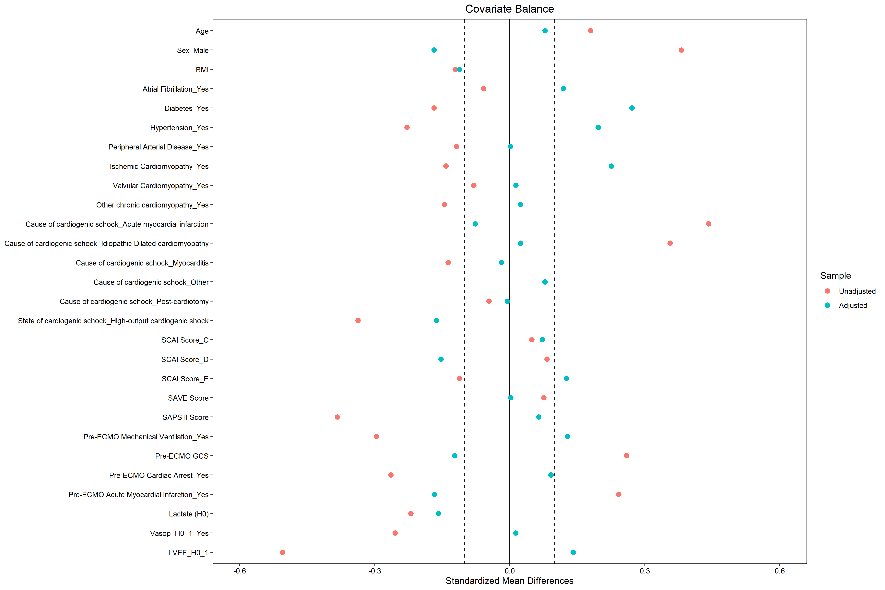

Fig S2. Kaplan-Meyer 60 days survival curves after weighting on propensity score - ATE weigths

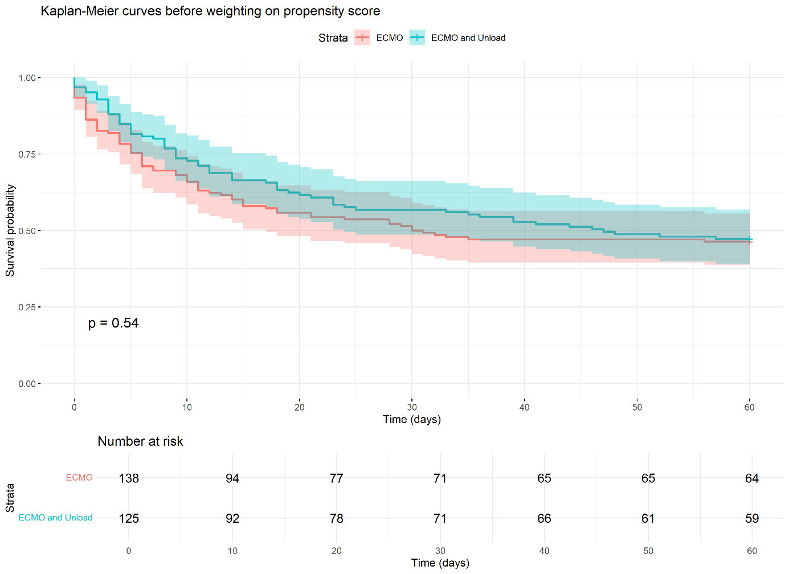

Fig S3. Standardized differences in baseline patient characteristics before and after propensity score weighting - ATO weights

