Supplementary Materials
Early Albumin Use and Mortality in Critically Ill Children With Severe Hypoalbuminemia: A Target Trial Emulation Study
Contents
SF 1. Kaplan-Meier Survival Curves for Sensitivity Analysis 1 (Albumin <35 g/L, ≤24h)
SF 2. Kaplan-Meier Survival Curves for Sensitivity Analysis 2 (Albumin <30 g/L, ≤48h)
SF 3. Diagnosis Distribution in the Non-Shock Albumin-Treated Subgroup
ST 1. Specification and Emulation of the Target Trial
ST 2. Baseline Characteristics Before and After PSM (Albumin <30 g/L, ≤48h)
ST 3. Baseline Characteristics Before and After PSM (Albumin <35 g/L, ≤24h)
ST 4. Dose-Response Analysis of Post-Treatment Albumin Change (ΔAlb) and Mortality
ST 5. Patterns of Missing Data for Baseline Covariates (Pre-imputation)
ST 6. Clinical characteristics of patients who died within 24 hours of ICU admission in the albumin <30 g/L cohort (N=50)
ST 7. Admission diagnoses in the non-shock albumin-treated subgroup (albumin <30 g/L, no vasoactive agents, N=252)
ST 8. Disease severity comparison between patients who died within 24 hours and the main

SF 1. Kaplan-Meier Survival Curves for Sensitivity Analysis 1 (Albumin <35 g/L, <24h Treatment Window)
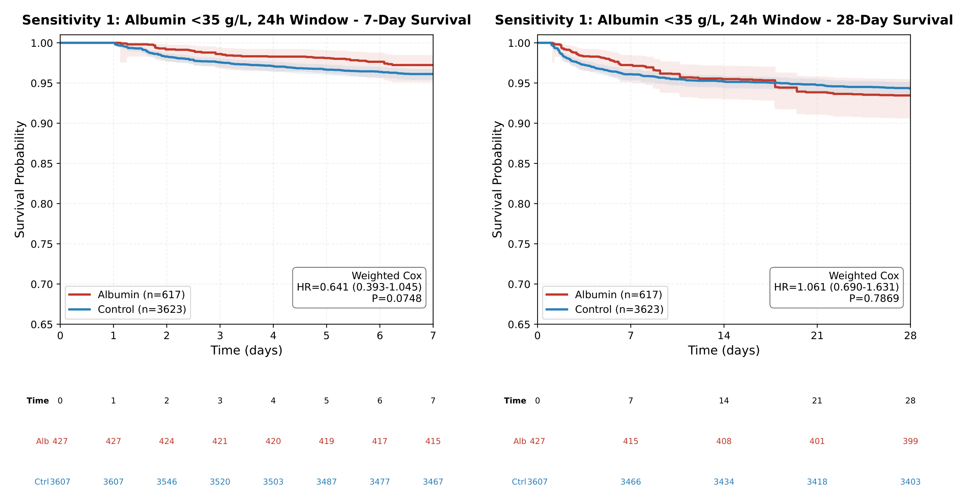
This analysis relaxed the hypoalbuminemia threshold to below 35 g/L while maintaining the 24-hour treatment window (N = 4,240). Panel a shows 7-day survival: the weighted HR was 0.64 (95% CI, 0.39–1.05; P = 0.075), indicating that the mortality reduction observed in the primary analysis was substantially attenuated when the albumin threshold was liberalized. Panel b shows 28-day survival: the HR was 1.06 (95% CI, 0.69–1.63; P = 0.787), showing no association between early albumin therapy and 28-day mortality. Numbers at risk below each panel indicate counts of children remaining in the albumin and control groups at each time point. Hazard ratios were estimated using IPTW-weighted Cox proportional hazards models with robust sandwich variance estimators.

SF 2. Kaplan-Meier Survival Curves for Sensitivity Analysis 2 (Albumin <30 g/L, <48h Treatment Window)
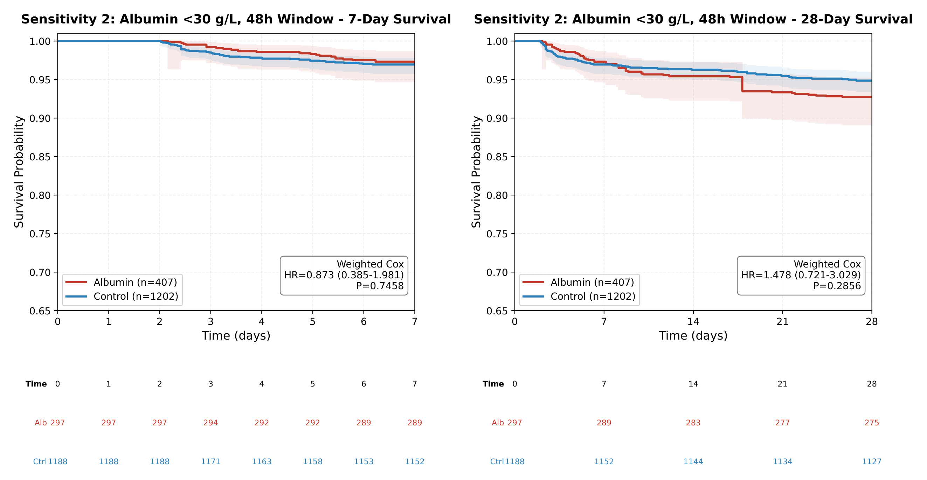
This analysis extended the treatment window from 24 to 48 hours while maintaining the albumin below 30 g/L inclusion criterion (N = 1,609). Panel a shows 7-day survival: the weighted HR was 0.87 (95% CI, 0.39–1.98; P = 0.746). Panel b shows 28-day survival: the point estimate was directionally reversed (HR, 1.48; 95% CI, 0.72–3.03; P = 0.286), though the confidence interval remained wide and crossed the null. Together with the primary and first sensitivity analyses, this attenuation pattern suggests any survival benefit is primarily confined to early intervention within a narrow clinical window of severe hypoalbuminemia. HRs from IPTW-weighted Cox models with robust standard errors.

SF 3. Diagnosis Distribution in the Non-Shock Albumin-Treated Subgroup
Primary admission diagnosis categories of 252 patients with albumin <30 g/L who did not receive vasoactive agents and were treated with albumin within 24 hours. Categories are ordered clockwise from largest to smallest proportion.
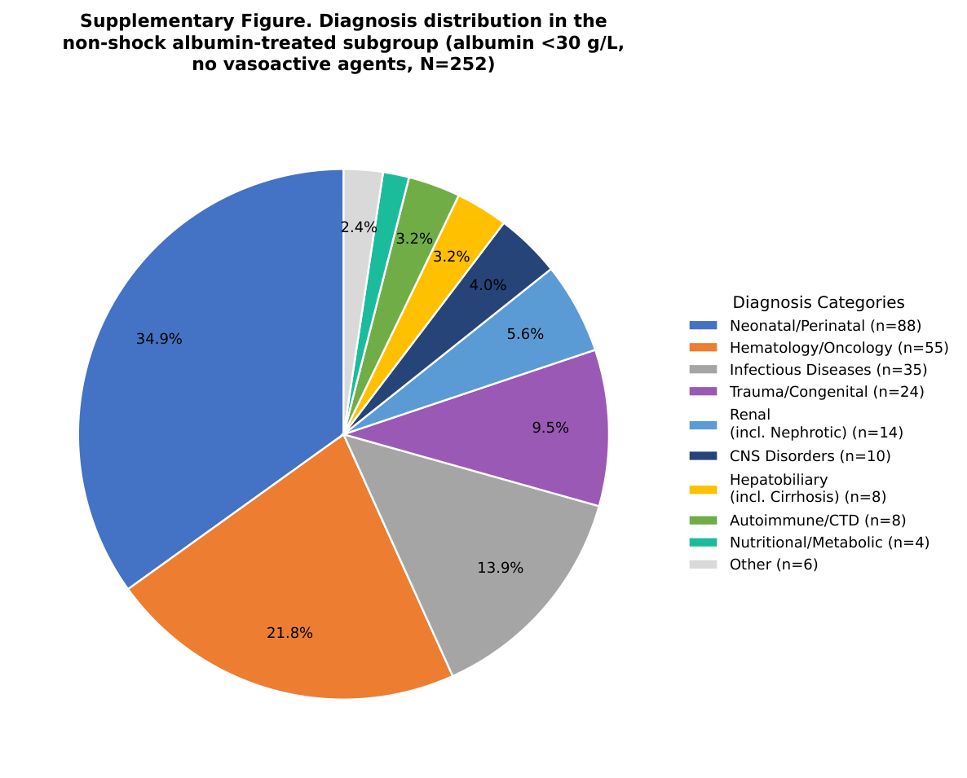
Abbreviations: CNS, central nervous system; CTD, connective tissue disease.

ST 1. Specification and Emulation of the Target Trial
Component | Target Trial Specification | Emulation Using PIC Database
Eligibility  criteria | Children < 18 years with first serum albumin < 30 g/L detected within 24 h of ICU admission. Exclude: albumin therapy before time zero; completely missing baseline labs; no follow-up after time zero; unable to determine treatment/death timing; death within 24-h treatment assignment window. | Same as target trial. Data source: PIC database (2010–2019), a single-center pediatric-specific ICU database .
Time zero | Moment when serum albumin < 30 g/L is first detected. Aligns time zero with clinical indication for potential albumin therapy rather than ICU admission. | Same as target trial. Albumin values extracted from PIC laboratory records; time zero = timestamp of first albumin < 30 g/L.
Treatment  strategies | Strategy 1: At least 1 dose of human albumin preparation within 24 h after time zero.  Strategy 2: No albumin therapy during the same 24-h window.  Both strategies allow all other treatments at clinicians’ discretion. | Same as target trial. Albumin administration identified from PIC medication records. Control group = children with no albumin record within 24 h after time zero.
Assignment  procedure | Random assignment at time zero. | Approximated by propensity score–based stabilized inverse probability of treatment weighting (IPTW) conditional on 19 prespecified baseline covariates. Weights truncated at 1st and 99th percentiles. Covariate balance assessed by standardized mean differences (SMD < 0.1).
Follow-up | From time zero until death, discharge, loss to follow-up, or administrative censoring at 28 days. | Same as target trial. Death and discharge dates extracted from PIC records. No loss to follow-up in this inpatient database.
Outcomes | Primary: 7-day and 28-day all-cause mortality.  Secondary: incident sepsis (newly diagnosed after time zero); ICU length of stay. | Same as target trial. Deaths ascertained from in-hospital death records. Sepsis identified from ICD diagnostic codes. ICU length of stay calculated from admission/discharge timestamps; restricted to ICU survivors.
Causal  contrast | Intention-to-treat–style effect of initiating an early albumin strategy vs. no albumin strategy, among children who survive the 24-h treatment assignment window. | Per-protocol emulation using baseline covariates. Causal estimand: average treatment effect in the treated-like population after IPTW weighting.
Analysis  plan | IPTW-weighted Cox proportional hazards models with doubly robust adjustment (additionally adjusting for covariates with SMD > 0.1 after IPTW). Robust sandwich variance. E-value sensitivity analysis for unmeasured confounding. Prespecified subgroup and sensitivity analyses. | Same as target trial. Propensity scores estimated by logistic regression including all 19 covariates. DR adjustment = IPTW-weighted Cox + outcome model covariates. Schoenfeld residuals for proportional hazards assumption. All analyses in Python 3.10.
DR, doubly robust; ICD, International Classification of Diseases; IPTW, inverse probability of treatment weighting; PIC, Pediatric Intensive Care; PSM, propensity score matching; SMD, standardized mean difference; TTE, target trial emulation.

ST 2. Baseline characteristics of ICU patients with severe hypoalbuminemia (ALB <30 g/L, and ＜48h) before and after propensity score matching
 |  |  | Before PSM |  |  | After PSM
Variable |  | Albumin (N=407) |  | Control (N=1202) | SMD | Albumin | Control | SMD
Age (months) |  | 4.7 (0.3-39.1) |  | 0.6 (0.0-7.0) | 0.346 | 4.7 (0.3-39.1) | 2.7 (0.3-33.0) | 0.034
Age group (%) |  |  |  |  | 0.679 |  |  | 0.165*
Infants (< 1Y) |  | 59.0% |  | 79.5% |  | 59.0% | 63.9%
Children (1-13Y) |  | 39.1% |  | 19.1% |  | 39.1% | 33.3%
Adolescents (>13Y) |  | 2.0% |  | 1.4% |  | 2.0% | 2.7%
Gender (%) |  |  |  |  | 0.060 |  |  | 0.035
Male |  | 56.8% |  | 59.7% |  | 56.8% | 58.5%
Famel |  | 43.2% |  | 40.3% |  | 43.2% | 41.5%
ICU type (%) |  |  |  |  | 1.048 |  |  | 0.423*
NICU (%) |  | 34.9% |  | 61.0% |  | 34.9% | 41.0%
SICU (%) |  | 18.7% |  | 17.4% |  | 18.7% | 25.1%
Geeral ICU (%) |  | 33.4% |  | 5.9% |  | 33.4% | 19.7%
PICU (%) |  | 9.1% |  | 13.7% |  | 9.1% | 13.1%
CICU (%) |  | 3.9% |  | 2.0% |  | 3.9% | 1.1%
Admission infection (%) |  |  |  |  | 0.022 |  |  | 0.006
YES |  | 16.7% |  | 15.9% |  | 16.7% | 16.9%
NO |  | 83.3% |  | 84.1% |  | 83.4% | 83.1%
Laboratory |  | Albumin |  | Control | SMD | Albumin | Control | SMD
CRP (mg/L) |  | 34.4 (12.0-60.7) |  | 28.6 (7.0-41.0) | 0.137 | 34.4 (12.0-60.7) | 33.0 (13.9-46.0) | 0.041
WBC (10^9/L) |  | 8.5 (4.6-14.7) |  | 10.6 (6.6-16.5) | -0.169 | 8.5 (4.6-14.7) | 9.6 (6.4-15.1) | 0.068
Lactate (mmol/L) |  | 2.6 (1.6-4.1) |  | 2.5 (1.7-3.8) | 0.032 | 2.6 (1.6-4.1) | 2.2 (1.6-3.7) | 0.057
Creatinine (μmol/L) |  | 53.0 (36.0-80.0) |  | 66.2 (41.0-90.0) | -0.116 | 53.0 (36.0-80.0) | 54.0 (34.0-77.5) | 0.108*
AST (U/L) |  | 72.0 (32.0-213.1) |  | 70.0 (35.0-186.0) | 0.1 | 72.0 (32.0-213.1) | 86.0 (38.0-199.4) | 0.080
Tbl (μmol/L) |  | 30.7 (8.3-67.6) |  | 43.1 (14.2-84.0) | -0.118 | 30.7 (8.3-67.6) | 34.0 (9.1-69.0) | 0.026
Plt (×10⁹/L) |  | 191.0 (73.5-296.5) |  | 222.0 (131.0-297.8) | -0.147 | 191.0 (73.5-296.5) | 249.0 (127.5-336.0) | 0.250*
Alb (g/L) |  | 26.2 (23.3-28.2) |  | 27.6 (25.2-28.9) | -0.374 | 26.2 (23.3-28.2) | 27.5 (24.3-28.9) | 0.162*
pH |  | 7.4 (7.3-7.4) |  | 7.4 (7.3-7.4) | 0.065 | 7.4 (7.3-7.4) | 7.4 (7.3-7.4) | 0.019
BE (mmol/L) |  | -3.7 (-6.9--0.7) |  | -3.8 (-6.3--1.3) | -0.035 | -3.7 (-6.9--0.7) | -3.8 (-6.4--1.0) | 0.058
Na (mmol/L) |  | 135.0 (131.0-138.0) |  | 135.0 (132.0-138.0) | -0.078 | 135.0 (131.0-138.0) | 136.0 (132.0-138.0) | 0.118*
K (mmol/L) |  | 3.7 (3.3-4.2) |  | 3.9 (3.5-4.4) | -0.24 | 3.7 (3.3-4.2) | 3.7 (3.3-4.1) | 0.022
Glu (mmol/L) |  | 6.2 (4.9-8.4) |  | 6.0 (4.4-7.8) | 0.134 | 6.2 (4.9-8.4) | 6.5 (4.8-8.3) | 0.056
Drug therapy |  | Albumin |  | Control | SMD | Albumin | Control | SMD
Vasoactive drugs (%) |  |  |  |  | 0.631 |  |  | 0.133*
YES |  | 31.7% |  | 7.7% |  | 31.7% | 25.7%
NO |  | 68.3% |  | 92.3% |  | 68.3% | 74.3%
Antibiotics (%) |  |  |  |  | 1.239 |  |  | 0.221*
YES |  | 69.0% |  | 16.9% |  | 69.0% | 58.5%
NO |  | 31.0% |  | 83.1% |  | 31.0% | 41.5%
Corticosteroids (%) |  |  |  |  | 0.757 |  |  | 0.436*
YES |  | 27.8% |  | 2.4% |  | 27.8% | 10.9%
NO |  | 72.2% |  | 97.6% |  | 72.2% | 90.1%
Sodium bicarbonate (%) |  |  |  |  | 1.527 |  |  | 0.299*
YES |  | 77.4% |  | 16.8% |  | 77.4% | 63.9%
NO |  | 22.6% |  | 83.2% |  | 22.6% | 36.1%
Diuretics (%) |  |  |  |  | 0.896 |  |  | 0.447*
YES |  | 37.6% |  | 4.3% |  | 37.6% | 18.0%
NO |  | 62.4% |  | 95.7% |  | 62.4% | 82.0%
Pre-surgery (%) |  |  |  |  | 0.034 |  |  | 0.157*
YES |  | 18.2% |  | 16.9% |  | 18.2% | 24.6%
NO |  | 81.8% |  | 83.1% |  | 81.8% | 75.4%
Outcomes |  | Albumin |  | Control | P | Albumin | Control | P
7days-death |  | 21/407 (5.2%) |  | 40/1202 (3.3%) | 0.1279 | 21/407 (5.2%) | 4/183 (2.2%) | 0.1505
28days-death |  | 40/407 (9.8%) |  | 67/1202 (5.6%) | 0.0042 | 40/407 (9.8%) | 6/183 (3.3%) | 0.0099
New-onset sepsis |  | 33/407 (8.1%) |  | 64/1202 (5.3%) | 0.055 | 33/407 (8.1%) | 12/183 (6.6%) | 0.625
LOS |  | 10.0 (3.7-30.9) |  | 11.2 (2.0-36.8) | 0.8981 | 10.0 (3.7-30.9) | 4.1 (1.0-14.1) | ＜0.001
Continuous variables are presented as quartiles (Q1–Q3). Categorical variables are presented as percentages (%). SMD: Standardized Mean Difference. P-values for results: chi-square test/Fisher’s exact test (categorical variables) or Wilcoxon signed-rank test (continuous variables). LOS is presented as median duration (Q1–Q3). *Covariates that remained unmatched after PSM will be included in subsequent double-robust modeling.

ST 3. Baseline characteristics of ICU patients with severe hypoalbuminemia (ALB <35 g/L, and ＜24h) before and after propensity score matching

 |  |  | Before PSM |  |  | After PSM
Variable |  | Albumin (N=617) |  | Control (N=3623) | SMD | Albumin | Control | SMD
Age (months) |  | 7.4 (0.6-45.4) |  | 1.5 (0.1-13.1) | 0.374 | 7.4 (0.6-45.4) | 3.8 (0.4-27.5) | 0.156
Age group (%) |  |  |  |  | 0.588 |  |  | 0.215*
Infants (< 1Y) |  | 55.3% |  | 74.1% |  | 55.3% | 62.8%
Children (1-13Y) |  | 41.8% |  | 24.6% |  | 41.8% | 35.4%
Adolescents (>13Y) |  | 2.9% |  | 1.4% |  | 2.9% | 1.8%
Gender (%) |  |  |  |  | 0.001 |  |  | 0.027
Male |  | 59.0% |  | 59.1% |  | 59.0% | 60.3%
Famel |  | 41.0% |  | 39.9% |  | 43.2% | 41.5%
ICU type (%) |  |  |  |  | 0.829 |  |  | 0.210*
NICU (%) |  | 28.8% |  | 48.8% |  | 28.8% | 36.2%
SICU (%) |  | 23.5% |  | 22.4% |  | 23.5% | 23.6%
Geeral ICU (%) |  | 29.8% |  | 8.1% |  | 29.8% | 23.9%
PICU (%) |  | 8.4% |  | 13.1% |  | 8.4% | 7.5%
CICU (%) |  | 9.4% |  | 7.5% |  | 9.4% | 8.8%
Admission infection (%) |  |  |  |  | 0.006 |  |  | 0.035
YES |  | 15.1% |  | 15.3% |  | 15.1% | 6.3%
NO |  | 84.9% |  | 84.7% |  | 84.9% | 93.7%
Laboratory |  | Albumin |  | Control | SMD | Albumin | Control | SMD
CRP (mg/L) |  | 34.0 (11.8-55.0) |  | 23.2 (7.0-37.2) | 0.265 | 34.0 (11.8-55.0) | 31.8 (11.9-45.6) | 0.046
WBC (10^9/L) |  | 9.2 (5.5-14.8) |  | 10.1 (6.5-15.5) | 0.089 | 9.2 (5.5-14.8) | 9.4 (6.0-14.3) | 0.018
Lactate (mmol/L) |  | 2.6 (1.7-4.2) |  | 2.4 (1.6-3.7) | 0.177 | 2.6 (1.7-4.2) | 2.4 (1.6-3.9) | 0.130*
Creatinine (μmol/L) |  | 48.0 (34.0-79.0) |  | 58.7 (36.0-87.0) | 0.069 | 48.0 (34.0-79.0) | 48.0 (34.0-84.0) | 0.013
AST (U/L) |  | 67.0 (32.0-188.8) |  | 63.0 (34.0-168.7) | 0.079 | 67.0 (32.0-188.8) | 76.0 (35.0-188.8) | 0.098
Tbl (μmol/L) |  | 23.4 (7.4-64.0) |  | 35.0 (10.0-77.0) | 0.097 | 23.4 (7.4-64.0) | 29.0 (9.7-69.9) | 0.047
Plt (×10⁹/L) |  | 197.0 (95.0-306.0) |  | 248.0 (164.0-329.0) | 0.251 | 197.0 (95.0-306.0) | 232.5 (130.0-323.8) | 0.113*
Alb (g/L) |  | 28.7 (25.3-31.9) |  | 31.3 (28.7-33.4) | 0.613 | 28.7 (25.3-31.9) | 30.4 (27.0-32.9) | 0.238*
pH |  | 7.4 (7.3-7.4) |  | 7.4 (7.3-7.4) | 0.093 | 7.4 (7.3-7.4) | 7.4 (7.3-7.4) | 0.054
BE (mmol/L) |  | -3.7 (-6.8--1.2) |  | -3.4 (-5.8--0.9) | 0.155 | -3.7 (-6.8--1.2) | -3.8 (-6.3--1.1) | 0.104*
Na (mmol/L) |  | 136.0 (132.0-139.0) |  | 136.0 (133.0-139.0) | 0.059 | 136.0 (132.0-139.0) | 136.0 (133.0-139.0) | 0.072
K (mmol/L) |  | 3.7 (3.3-4.2) |  | 3.9 (3.4-4.3) | 0.153 | 3.7 (3.3-4.2) | 3.7 (3.4-4.2) | 0.034
Glu (mmol/L) |  | 6.5 (5.1-9.2) |  | 6.2 (4.8-8.2) | 0.205 | 6.5 (5.1-9.2) | 6.6 (5.2-8.4) | 0.089
Drug therapy |  | Albumin |  | Control | SMD | Albumin | Control | SMD
Vasoactive drugs (%) |  |  |  |  | 0.609 |  |  | 0.053
YES |  | 40.5% |  | 14.5% |  | 40.5% | 37.9%
NO |  | 39.5% |  | 85.5% |  | 59.5% | 62.1%
Antibiotics (%) |  |  |  |  | 1.056 |  |  | 0.085
YES |  | 71.5% |  | 24.8% |  | 71.5% | 67.6%
NO |  | 28.5% |  | 75.2% |  | 28.5% | 32.4%
Corticosteroids (%) |  |  |  |  | 0.683 |  |  | 0.267*
YES |  | 31.1% |  | 6.0% |  | 31.1% | 19.6%
NO |  | 68.9% |  | 94.0% |  | 68.9 | 80.4%
Sodium bicarbonate (%) |  |  |  |  | 1.202 |  |  | 0.027
YES |  | 75.5% |  | 24.0% |  | 75.5% | 74.4%
NO |  | 24.5% |  | 76.0% |  | 24.5% | 25.6%
Diuretics (%) |  |  |  |  | 0.837 |  |  | 0.265*
YES |  | 40.4% |  | 7.4% |  | 40.4% | 27.9%
NO |  | 59.6% |  | 92.6% |  | 59.6% | 72.1%
Pre-surgery (%) |  |  |  |  | 0.081 |  |  | 0.037
YES |  | 19.1% |  | 16.0% |  | 19.1% | 20.6%
NO |  | 81.8% |  | 83.1% |  | 80.9% | 79.4%
Outcomes |  | Albumin |  | Control | P | Albumin | Control | P
7days-death |  | 37/617 (6.0%) |  | 126/3623 (3.5%) | 0.004 | 37/617 (6.0%) | 21/398 (5.3%) | 0.7307
28days-death |  | 65/617 (10.5%) |  | 191/3623 (5.3%) | ＜0.001 | 65/617 (10.5%) | 28/398 (7.0%) | 0.0758
New-onset sepsis |  | 36/617 (5.8%) |  | 137/3623 (3.8%) | 0.023 | 36/617 (5.8%) | 21/398 (5.3%) | 0.8122
LOS |  | 7.9 (2.9-24.9) |  | 5.9 (1.1-21.7) | 0.008 | 7.9 (2.9-24.9) | 3.0 (1.0-12.8) | ＜0.001
Continuous variables are presented as quartiles (Q1–Q3). Categorical variables are presented as percentages (%). SMD: Standardized Mean Difference. P-values for results: chi-square test/Fisher’s exact test (categorical variables) or Wilcoxon signed-rank test (continuous variables). LOS is presented as median duration (Q1–Q3). *Covariates that remained unmatched after PSM will be included in subsequent double-robust modeling.

ST 4. Dose-Response Analysis of Post-Treatment Albumin Change (ΔAlb) and Mortality
 | ΔAlb >0 (n=57) | ΔAlb ≤0 (n=83) | P
Death 7d | 0 | 11 | Fisher P=0.003
Death 28d | 3 | 15 | Fisher P=0.109
ΔAlb per 1g/L | HR | 5%-95%CI
Death 7d | 0.702 | 0.653-0.754 | <0.001
Death 28d | 0.851 | 0.600-1.208 | 0.367
RCS | P for Overall | P for Non-linear
Death 7d | P=0.012 | P=0.003
Death 28d | P=0.071 | P<0.001
Data were analyzed in patients with a post-treatment albumin measurement within 48 hours who survived to the measurement time (N = 140). Categorical analysis compared patients with ΔAlb >0 versus ≤0 using Fisher's exact test. Continuous analysis per 1 g/L increase in ΔAlb was performed using IPTW-weighted Cox proportional hazards models with robust standard errors. Restricted cubic spline (RCS) was used to evaluate linearity; P for overall tests the joint significance of all spline terms; P for non-linear tests the deviation from linearity. Abbreviations: ΔAlb, change in albumin; IPTW, inverse probability of treatment weighting; RCS, restricted cubic spline.

ST 5. Patterns of Missing Data for Baseline Covariates (Pre-imputation)
Characteristic | Overall  (N = 1649) | Albumin group  (n = 374) | Control group  (n = 1275)
Age, No. (%) | 0 (0.0) | 0 (0.0) | 0 (0.0)
Gender, No. (%) | 0 (0.0) | 0 (0.0) | 0 (0.0)
ICU type, No. (%) | 0 (0.0) | 0 (0.0) | 0 (0.0)
Infection at admission, No. (%) | 0 (0.0) | 0 (0.0) | 0 (0.0)
C-reactive protein, No. (%) | 392 (23.8) | 92 (24.6) | 300 (23.5)
White blood cell, No. (%) | 54 (3.3) | 7 (1.9) | 47 (3.7)
Lactate, No. (%) | 52 (3.2) | 10 (2.7) | 42 (3.3)
Creatinine, No. (%) | 282 (17.1) | 23 (6.1) | 259 (20.3)
Aspartate aminotransferase, No. (%) | 394 (23.9) | 49 (13.1) | 345 (27.1)
Total bilirubin, No. (%) | 157 (9.5) | 34 (9.1) | 123 (9.6)
Platelet count, No. (%) | 74 (4.5) | 11 (2.9) | 63 (4.9)
Serum albumin, No. (%) | 0 (0.0) | 0 (0.0) | 0 (0.0)
Arterial blood pH, No. (%) | 49 (3.0) | 6 (1.6) | 43 (3.4)
Base excess, No. (%) | 37 (2.2) | 6 (1.6) | 31 (2.4)
Serum sodium, No. (%) | 63 (3.8) | 13 (3.5) | 50 (3.9)
Serum potassium, No. (%) | 50 (3.0) | 9 (2.4) | 41 (3.2)
Blood glucose, No. (%) | 66 (4.0) | 11 (2.9) | 55 (4.3)
Vasoactive drug use, No. (%) | 0 (0.0) | 0 (0.0) | 0 (0.0)
Antibiotic use, No. (%) | 0 (0.0) | 0 (0.0) | 0 (0.0)
Corticosteroid use, No. (%) | 0 (0.0) | 0 (0.0) | 0 (0.0)
Bicarbonate use, No. (%) | 0 (0.0) | 0 (0.0) | 0 (0.0)
Diuretic use, No. (%) | 0 (0.0) | 0 (0.0) | 0 (0.0)
Pre-ICU surgery, No. (%) | 0 (0.0) | 0 (0.0) | 0 (0.0)
Abbreviations: NICU, neonatal intensive care unit; SICU, surgical ICU; PICU, pediatric ICU; CICU, cardiac ICU.Data are presented as No. (%). Missing laboratory values were handled using PMM Multiple Interpolation within the propensity score mode. Extreme outliers (creatinine >500 μmol/L, n=20; lactate >20 mmol/L, n=13) were set to missing and subsequently imputed.

Supplementary Table 6. Clinical characteristics of patients who died within 24 hours of ICU admission in the albumin <30 g/L cohort (N=50)
Cases 1–10 received albumin within 24 hours; Cases 11–50 did not. Abbreviations: NICU, neonatal ICU; PICU, pediatric ICU; SICU, surgical ICU; CICU, cardiac ICU; MODS, multiple organ dysfunction syndrome.
Time to albumin and time to death are calculated from ICU admission. Lactate values were missing for 14 of 50 patients (indicated by —). Cases 1–10 received albumin and are highlighted in light blue.
Case | Group | Age  (mo) | Sex | Albumin  (g/L) | Lactate  (mmol/L) | Primary diagnosis | ICU  type | Vaso-  active | Albumin  dose (g) | Time to  albumin (h) | Time to  death (h)
1 | Albumin | 2 | M | 27.3 | — | Sepsis | General ICU | Y | 20 | 11.7 | 23.3
2 | Albumin | 65 | F | 24.1 | 9.7 | Leukemia | General ICU | Y | 10 | 1.7 | 18.1
3 | Albumin | 126 | M | 25.7 | 5.5 | EBV infection | General ICU | Y | 10 | 7.2 | 8.7
4 | Albumin | 1 | F | 28.2 | — | Cardiac arrest (resuscitated) | PICU | Y | 10 | 0.4 | 6.4
5 | Albumin | 34 | M | 25.7 | 16.0 | Cardiac arrest (resuscitated) | PICU | N | 10 | 0.5 | 3.7
6 | Albumin | 4 | M | 27.4 | 17.0 | Brain tumor | SICU | Y | 10 | 0.6 | 15.2
7 | Albumin | 0 | M | 28.5 | — | Prematurity | CICU | Y | 15 | 0.5 | 23.0
8 | Albumin | 1 | M | 8.2 | 4.9 | Nephrotic nephritis | General ICU | Y | 5 | 4.3 | 23.6
9 | Albumin | 21 | F | 27.0 | 20.0 | Pneumonia | PICU | Y | 20 | 4.7 | 6.4
10 | Albumin | 12 | F | 28.3 | 17.0 | Pneumonia | PICU | Y | 10 | 1.6 | 15.1
11 | No albumin | 50 | M | 22.8 | — | Acute lymphoblastic leukemia | General ICU | Y | — | — | 7.4
12 | No albumin | 33 | F | 28.9 | 13.2 | Drowning | General ICU | Y | — | — | 17.2
13 | No albumin | 16 | M | 25.6 | 19.0 | Drowning | General ICU | Y | — | — | 11.3
14 | No albumin | 5 | F | 12.4 | 14.4 | Generalized edema | General ICU | Y | — | — | 9.4
15 | No albumin | 38 | M | 28.6 | 1.9 | Drowning | General ICU | Y | — | — | 14.1
16 | No albumin | 1 | M | 11.6 | — | Necrotizing enterocolitis | NICU | N | — | — | 7.8
17 | No albumin | 0 | M | 12.2 | — | Intestinal obstruction | NICU | N | — | — | 18.5
18 | No albumin | 0 | M | 26.8 | 12.1 | Prematurity | NICU | N | — | — | 4.4
19 | No albumin | 0 | M | 28.8 | 16.0 | Intestinal obstruction | NICU | N | — | — | 7.8
20 | No albumin | 0 | M | 14.6 | — | Cardiac arrest (resuscitated) | NICU | N | — | — | 13.4
21 | No albumin | 0 | M | 25.1 | — | Neonatal asphyxia | NICU | N | — | — | 22.5
22 | No albumin | 0 | M | 27.8 | 16.0 | Neonatal asphyxia | NICU | N | — | — | 20.9
23 | No albumin | 0 | M | 29.5 | 18.0 | Congenital heart disease | NICU | N | — | — | 20.6
24 | No albumin | 0 | F | 14.6 | — | Neonatal sepsis | NICU | N | — | — | 8.0
25 | No albumin | 0 | F | 19.6 | — | Shock | NICU | N | — | — | 21.9
26 | No albumin | 46 | M | 17.2 | 20.0 | Shock | SICU | N | — | — | 22.3
27 | No albumin | 13 | M | 29.6 | — | Fever of unknown origin | PICU | N | — | — | 4.3
28 | No albumin | 8 | M | 28.8 | 19.0 | Congestive heart failure | PICU | N | — | — | 21.8
29 | No albumin | 0 | F | 23.5 | 1.0 | Necrotizing enterocolitis | NICU | N | — | — | 7.3
30 | No albumin | 0 | M | 29.3 | 8.6 | Congenital heart disease | CICU | N | — | — | 0.0
31 | No albumin | 0 | F | 26.8 | 2.5 | Pelvic mass | NICU | N | — | — | 22.4
32 | No albumin | 0 | F | 22.1 | 19.0 | Neonatal pneumonia | NICU | N | — | — | 3.6
33 | No albumin | 0 | M | 14.8 | — | Necrotizing enterocolitis | NICU | N | — | — | 4.1
34 | No albumin | 0 | F | 20.3 | 14.3 | Prematurity | NICU | N | — | — | 13.8
35 | No albumin | 0 | M | 19.6 | — | Prematurity | NICU | Y | — | — | 3.8
36 | No albumin | 9 | M | 25.4 | 13.9 | Cardiac arrest (resuscitated) | PICU | Y | — | — | 5.9
37 | No albumin | 0 | M | 29.5 | 18.0 | Congenital heart disease | NICU | Y | — | — | 20.0
38 | No albumin | 79 | F | 22.1 | 11.4 | Gastrointestinal bleeding | PICU | N | — | — | 12.6
39 | No albumin | 74 | M | 26.4 | 18.0 | Anemia | General ICU | Y | — | — | 4.2
40 | No albumin | 41 | M | 23.1 | 20.0 | Cardiac arrest (resuscitated) | General ICU | Y | — | — | 21.5
41 | No albumin | 38 | F | 17.1 | 14.1 | Hemophagocytic lymphohistiocytosis | General ICU | Y | — | — | 20.7
42 | No albumin | 6 | F | 28.3 | 13.9 | Pneumonia | General ICU | Y | — | — | 22.1
43 | No albumin | 112 | F | 26.2 | 9.2 | Leukemia | General ICU | Y | — | — | 19.0
44 | No albumin | 6 | M | 18.1 | 10.1 | Acute enteritis | PICU | N | — | — | 14.1
45 | No albumin | 16 | F | 29.3 | 1.6 | Enteritis | PICU | N | — | — | 14.6
46 | No albumin | 0 | F | 28.6 | 12.0 | Neonatal respiratory distress syndrome | CICU | N | — | — | 14.5
47 | No albumin | 0 | M | 6.0 | — | Infectious MODS | NICU | Y | — | — | 6.8
48 | No albumin | 14 | F | 15.0 | 2.5 | Skull fracture | SICU | Y | — | — | 11.7
49 | No albumin | 2 | M | 5.1 | 9.4 | Diarrhea | PICU | Y | — | — | 8.2
50 | No albumin | 1 | M | 6.5 | 10.9 | Necrotizing enterocolitis | NICU | Y | — | — | 22.5

Supplementary Table 7. Admission diagnoses in the non-shock albumin-treated subgroup (albumin <30 g/L, no vasoactive agents, N=252)
Diagnoses are grouped by category and ranked within each category by descending frequency. Percentages are calculated within the subgroup (N=252). Abbreviations: CNS, central nervous system; CTD, connective tissue disease.
Category | Primary Admission Diagnosis | N | %
Neonatal/Perinatal | Prematurity | 58 | 23.0
 | Neonatal respiratory distress syndrome | 8 | 3.2
 | Necrotizing enterocolitis | 5 | 2.0
 | Neonatal asphyxia | 3 | 1.2
 | Congenital esophageal atresia | 3 | 1.2
 | Neonatal sepsis | 2 | 0.8
 | Neonatal vomiting | 1 | 0.4
 | Neonatal respiratory distress | 1 | 0.4
 | Congenital umbilical hernia | 1 | 0.4
 | Esophageal atresia with tracheoesophageal fistula | 1 | 0.4
 | Congenital heart disease | 1 | 0.4
 | Ventricular septal defect | 1 | 0.4
 | Neonatal abdominal distension | 1 | 0.4
 | Very low birth weight infant | 1 | 0.4
 | Neonatal pneumonia | 1 | 0.4
Hematology/Oncology | Leukemia | 12 | 4.8
 | Pelvic mass | 6 | 2.4
 | Hemophagocytic lymphohistiocytosis | 5 | 2.0
 | Pancytopenia | 4 | 1.6
 | Facial malignant lymphoma | 2 | 0.8
 | Anemia | 2 | 0.8
 | Acute lymphoblastic leukemia | 2 | 0.8
 | Malignant lymphoma | 2 | 0.8
 | Kasabach-Merritt syndrome | 2 | 0.8
 | Adrenal malignancy | 2 | 0.8
 | Cervical swelling/mass | 1 | 0.4
 | Aplastic anemia | 1 | 0.4
 | Burkitt lymphoma | 1 | 0.4
 | Acute myelomonocytic leukemia with eosinophilia (M4Eo) | 1 | 0.4
 | Adrenal tumor | 1 | 0.4
 | Lymphangioma | 1 | 0.4
 | Abdominal distension | 1 | 0.4
 | Sacrococcygeal mass | 1 | 0.4
 | Intracranial space-occupying lesion | 1 | 0.4
 | Abdominal mass | 1 | 0.4
 | Subcutaneous nodule | 1 | 0.4
 | Rhabdomyosarcoma | 1 | 0.4
 | Retroperitoneal tumor | 1 | 0.4
 | Lung mass | 1 | 0.4
 | Hemophagocytic syndrome | 1 | 0.4
 | Hepatoblastoma | 1 | 0.4
Infectious Diseases | Pneumonia | 14 | 5.6
 | Sepsis | 10 | 4.0
 | Enteritis | 2 | 0.8
 | Acute purulent meningitis | 2 | 0.8
 | Infectious mononucleosis | 1 | 0.4
 | Meningoencephalitis | 1 | 0.4
 | Acute suppurative appendicitis | 1 | 0.4
 | Skin abscess | 1 | 0.4
 | Infectious bursitis of thigh | 1 | 0.4
 | Brain abscess | 1 | 0.4
 | Influenza | 1 | 0.4
Trauma/Congenital Anomalies | Pulmonary disease (specified) | 3 | 1.2
 | Gastrointestinal bleeding | 2 | 0.8
 | Intestinal obstruction | 2 | 0.8
 | Head trauma | 2 | 0.8
 | Non-traumatic intracranial hemorrhage | 1 | 0.4
 | Intestinal duplication | 1 | 0.4
 | Duodenal obstruction | 1 | 0.4
 | Cardiac arrest (successfully resuscitated) | 1 | 0.4
 | Intestinal perforation | 1 | 0.4
 | Hirschsprung disease | 1 | 0.4
 | Acute respiratory distress syndrome | 1 | 0.4
 | Pneumothorax | 1 | 0.4
 | Fall from building | 1 | 0.4
 | Gastrointestinal perforation | 1 | 0.4
 | Acute respiratory failure | 1 | 0.4
 | Motor vehicle collision | 1 | 0.4
 | Intussusception | 1 | 0.4
 | Scalp laceration | 1 | 0.4
 | Pulmonary hypertension | 1 | 0.4
 | Cyanosis | 1 | 0.4
Renal (incl. Nephrotic) | Nephrotic syndrome | 10 | 4.0
 | Acute renal failure | 2 | 0.8
 | Hydronephrosis | 1 | 0.4
 | Nephropathy | 1 | 0.4
CNS Disorders | Intracranial hemorrhage (unspecified) | 3 | 1.2
 | Seizures | 1 | 0.4
 | Cerebral hypoplasia | 1 | 0.4
 | Convulsions | 1 | 0.4
 | Tethered cord syndrome | 1 | 0.4
 | Cerebral hemorrhage | 1 | 0.4
 | Hydrocephalus | 1 | 0.4
Autoimmune/CTD | Systemic lupus erythematosus | 3 | 1.2
 | Systemic juvenile idiopathic arthritis | 2 | 0.8
 | Connective tissue disease | 1 | 0.4
 | Chronic fibrosing pancreatitis | 1 | 0.4
 | Henoch-Schonlein purpura | 1 | 0.4
Hepatobiliary (incl. Cirrhosis) | Abnormal liver function | 2 | 0.8
 | Wilson's disease | 1 | 0.4
 | Liver disease | 1 | 0.4
 | Liver failure | 1 | 0.4
 | Hepatitis | 1 | 0.4
 | Liver tumor | 1 | 0.4
 | Rotor's syndrome | 1 | 0.4
Nutritional/Metabolic | 17α-hydroxylase deficiency | 1 | 0.4
 | Methylmalonic acidemia | 1 | 0.4
 | Hyperkalemia | 1 | 0.4
 | Malnutrition | 1 | 0.4
Other | Fever of unknown origin | 3 | 1.2
 | Nausea and vomiting | 2 | 0.8
 | Abdominal pain (unspecified) | 1 | 0.4
Supplementary Table ST8. Disease severity comparison between patients who died within 24 hours and the main
Variable | Main analysis  (n=1,649) | Albumin-treated  early deaths (n=10) | Untreated  early deaths (n=40)
Albumin, g/L | 27.2 (24.7–28.7); 110 (7%) | 27.1 (25.7–28.0); 1 (10%) | 23.3 (16.6–28.4); 15 (38%)
Lactate, mmol/L | 2.6 (1.7–3.9); 276 (17%) | 16.0 (7.6–17.0); 6 (86%) | 13.9 (9.4–18.0); 24 (83%)
pH | 7.4 (7.3–7.4); 266 (17%) | 7.1 (7.1–7.2); 7 (70%) | 7.1 (7.0–7.3); 24 (65%)
Base excess, mmol/L | -3.9 (-6.5–-1.3); 610 (38%) | -14.2 (-15.9–-9.9); 8 (80%) | -14.1 (-19.4–-7.7); 34 (85%)
Vasoactive use | 238 (14%) | 9 (90%) | 17 (42%)
Platelet, ×10⁹/L | 213.0 (115.0–296.0); 369 (22%) | 135.0 (42.8–253.1); 4 (40%) | 153.0 (52.5–257.2); 14 (35%)
Creatinine, μmol/L | 64.0 (39.0–88.9); 304 (19%) | 66.0 (54.5–89.8); 2 (20%) | 90.0 (56.8–115.4); 13 (34%)
Age, months | 1.0 (0.0–13.2) | 7.8 (1.4–30.6) | 1.0 (0.1–15.8)
For each variable, the first value is the median (IQR) of the continuous distribution; the second value is the number and proportion of patients meeting the abnormality threshold. Lactate was available for 10/10 and 29/40 of early death patients; pH for 10/10 and 40/40. Thresholds were selected based on established clinical definitions of organ dysfunction severity: albumin <20 g/L (severe hypoalbuminemia), lactate >5 mmol/L (severe hyperlactatemia), pH <7.25 (severe acidemia), BE <−5 mmol/L (metabolic acidosis), platelet <100 × 10⁹/L (thrombocytopenia grade ≥2), creatinine >100 μmol/L (pediatric renal dysfunction).

