SUPPLEMENTARY MATERIAL
Indirect calorimetry–guided nutrition for patients undergoing prolonged mechanical ventilation weaning: a randomized controlled trial

Mila Fradkin*, Maya Elyashiv*, Michael Brik, Nirit Agai, Michal G. Kait, Lee Bornstein, Tamar Margalit, Pierre Singer**, Rachel Dankner**
*Joint first authors; **Joint last authors
This supplementary document provides detailed methodological descriptions, extended safety analyses, and additional exploratory results supporting the main findings of the trial.

SUPPLEMENTARY METHODS
S1. Indirect Calorimetry measurement technical procedures
S2. Bioimpedance measurement protocol
S3. Nutritional protocol implementation details
S4. Detailed weaning protocol (expanded version)
S5. Spontaneous breathing trial failure criteria
S6. Progressive weaning cycle algorithm

SUPPLEMENTARY FIGURES
Figure S1. Structured weaning protocol algorithm
Figure S2. Time to Successful Weaning by study arm (Kaplan Meir curves)
Figure S3. One year mortality by study arm (Kaplan Meir curves)

SUPPLEMENTARY RESULTS
Supplementary analyses provide additional information on safety monitoring, body composition trajectories, energy delivery patterns, subgroup analyses, and reasons for censoring among participants who did not achieve ventilator liberation.

SUPPLEMENTARY TABLES
Table S1: Safety laboratory monitoring (baseline and end-of-follow-up)
Table S2. Weekly energy and protein intake by study arm
Table S3. Neurological status of successfully weaned patients by study arm
Table S4. Cox regression models for 1-year mortality of the total cohort
Table S5. AEs / SAEs by study arm
Table S6. Reasons for censoring among non-weaning patients
Table S7. Body composition (bioimpedance) trajectories by study arm
Table S8. Subgroup Analysis of the Per-Protocol cohort on weaning outcomes
Table S9. Ventilatory parameters of a subsample at study entry according to study arm
Table S10. Weekly proportion of participants achieving the prescribed energy target (± 50kcal/day) relative to measured energy expenditure by study arm Supplementary Methods
S1. Indirect Calorimetry measurement technical procedures
Indirect calorimetry (IC) was performed using the Cosmed Quark RMR device (nutritional assessment configuration). Measurements were conducted weekly in the morning by certified personnel (dietitian, physician assistant, or doctoral researcher) under standardized conditions: patients at rest and prior to enteral feeding. Oxygen consumption (VO₂) and carbon dioxide production (VCO₂) were recorded for ≥20 minutes to ensure steady state. Measurements outside physiological feasibility (e.g., agitation, leaks, coughing) were repeated once the disturbance resolved, either the same day or within 1–2 days. Calorimeter-derived measured energy expenditure (mEE) served as the energy target in the IC arm.

S2. Bioimpedance measurement protocol
Body composition was assessed using bioimpedance at baseline and study completion for descriptive safety monitoring.
Bioimpedance was assessed using bioimpedance analysis (Bodygram Plus, Akern S.r.l., Florence, Italy). Measurements were performed in the supine position using standard tetrapolar electrode placement. Fat-free mass, fat mass, and phase angle were derived from impedance measurements. These variables were collected for descriptive monitoring of nutritional status and safety and were not prespecified inferential endpoints.

S3. Nutritional protocol implementation details
In the IC arm, energy intake was prescribed according to measured mEE, targeting isocaloric feeding with weekly adjustments based on repeat IC measurements in accordance with ESPEN recommendations (1-4).
In the control arm, energy requirements were estimated using the Schofield predictive resting energy expenditure equation (21) based on age, weight, and sex, as recommended in ESPEN guidance (1).
Non-nutritional calories (e.g., propofol) were not included in the nutritional plan of either study arms because their contribution was negligible in this rehabilitation cohort.
Protein targets followed institutional PMV guidelines (1.2–1.5 g/kg/day), adjusted for renal function and clinical tolerance. Protein prescriptions were individualized based on nutritional assessment but were managed similarly in both arms because the intervention addressed energy intake only. When protein intake was adjusted, caloric contributions were recalculated and other macronutrients modified to maintain the predefined energy target.
Enteral nutrition was the primary feeding modality. Parenteral nutrition (PN) was not administered because patients requiring PN are not admitted to the rehabilitation facility. Temporary interruptions of enteral feeding for routine clinical care were managed according to institutional protocols and did not differ between study arms.
The body weight used for nutritional calculations refers to the weight applied to estimate energy and protein requirements. Weight selection followed institutional nutritional assessment guidelines and was applied identically in both study arms. For patients within the desired weight range, actual body weight was used. For patients below the desired weight range, the lower limit of the desired weight range was applied. For patients above the desired range, the upper limit of the desired weight range was used when body weight was ≤115% of the target range; when body weight exceeded this threshold, adjusted body weight was used for calculations. This approach is consistent with established clinical nutrition recommendations aimed at avoiding over- or underestimation of energy requirements in patients with underweight or overweight status.

S4. Detailed Weaning Protocol (Expanded version)
Initial Weaning Assessment: All patients underwent a standardized spontaneous breathing trial (SBT) to assess tolerance, in accordance with international consensus recommendations for ventilator weaning (5). Because patients in our PMV unit are typically chronically ventilated and frequently exhibit severe respiratory muscle weakness and sarcopenia, a gradual stepwise weaning strategy was used to allow progressive recovery of respiratory muscle endurance. Patients were considered eligible for SBT if they met predefined stability criteria, including respiratory rate ≤24 breaths/min, adequate oxygenation (SpO₂ ≥90% with FiO₂ ≤60% and PEEP ≤8 cmH₂O or PaO₂/FiO₂ ≥150), and hemodynamic stability. The same standardized weaning protocol was applied to patients in both study arms, and clinical teams responsible for ventilatory management were blinded to treatment allocation.
SBT was performed for approximately 60 minutes.
S5. Spontaneous breathing trial failure criteria
Signs of SBT failure included tachypnea (>35 breaths/min) or bradypnea (<8 breaths/min), increased work of breathing, hypoxemia (SpO₂ <90% with FiO₂ ≥40%), abnormal end-tidal CO₂ values (ETCO₂ >45 mmHg), tachycardia or hemodynamic instability (heart rate >140 bpm or systolic blood pressure <90 or >180 mmHg), arrhythmias, diaphoresis, agitation, or altered mental status. Patients who failed the SBT were returned to minimal pressure-support ventilation, i.e., to the lowest level of assistance maintaining patient comfort and with adequate gas exchange: typically, pressure support ventilation with low pressure support and PEEP around 5 cmH₂O, and reassessed daily once eligibility criteria were again met.
S6. Progressive weaning cycle algorithm
Patients who tolerated the SBT entered a structured progressive weaning protocol (Figure S1). Spontaneous breathing periods were initially brief (e.g., 30 minutes every 8 hours) and were progressively extended every 24 hours (e.g., 30 minutes, 1 hour, 2 hours, etc.), provided physiological parameters remained stable. If clinical deterioration occurred, the weaning stage was reduced or full ventilatory support was temporarily reinstated. The duration of each weaning cycle varied from several days to several weeks depending on the patient’s clinical progression. In cases of early weaning failure, subsequent cycles were often shorter as patients underwent physiotherapy, nutritional optimization, and respiratory rehabilitation.
When a weaning attempt failed, potentially reversible causes (e.g., excessive airway secretions, bronchospasm, pulmonary congestion, or infection) were evaluated and treated. After clinical stabilization, the weaning protocol was resumed. Restoration of stability before a subsequent weaning attempt could take up to two weeks.
A maximum of five weaning cycles was permitted; failure after five cycles was defined as weaning failure. Patients unable to progress in spontaneous breathing despite supportive interventions (e.g., physiotherapy or medication adjustment) and clinically assessed as having central respiratory drive suppression were also classified as weaning failures.
Weaning success was defined as sustained spontaneous breathing for ≥7 consecutive days, either as continuous spontaneous breathing or as ≥18 hours/day of spontaneous breathing with ≤6 hours/day of CPAP delivered through the tracheostomy. Supplemental oxygen was delivered via humidified oxygen through the tracheostomy after cuff deflation. When temporary airway support was required,
patients were reconnected to the ventilator in CPAP mode through the tracheostomy with cuff reinflation.

SUPPLEMENTARY FIGURES
Figure S1. Structured weaning protocol algorithm
Figure S2. Time to Successful Weaning (Kaplan Meir curves)
Figure S3. One year mortality (Kaplan Meir curves)

Figure S1. Structured Weaning Protocol for Patients Under Prolonged Mechanical Ventilation
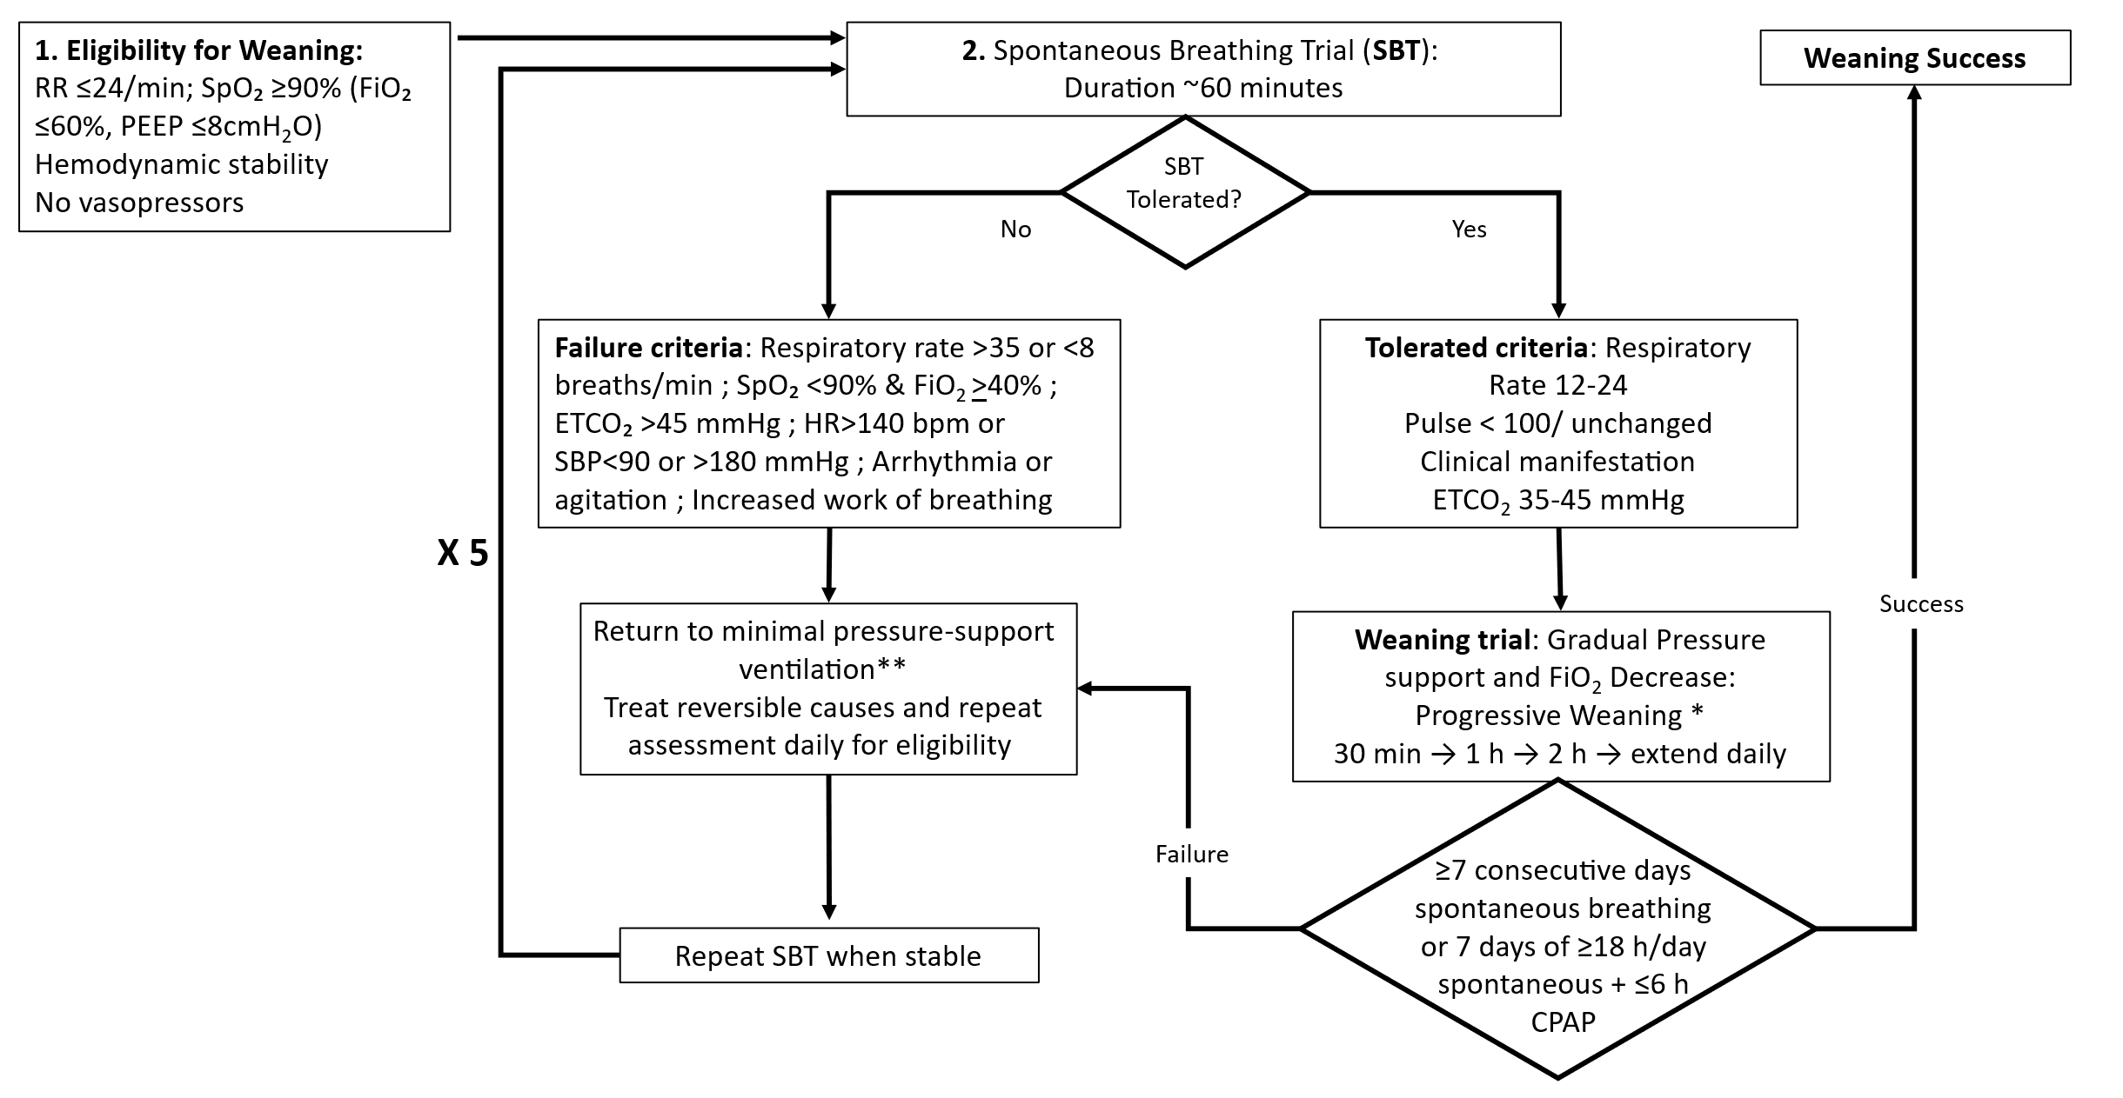
*Starting with 30 minutes every 8 hours and gradually increasing every 24 hours by multiplying the disconnected time (30 minutes times 2; 1-hour times 2; 2 hours time 2; etc...).
**Minimal ventilatory support: the lowest level of ventilatory assistance maintaining patient comfort and physiological stability (e.g., pressure support ventilation with low pressure support and PEEP ≈5 cmH₂O).
Figure S2, Time to successful weaning according to study arm within 4 months follow-up
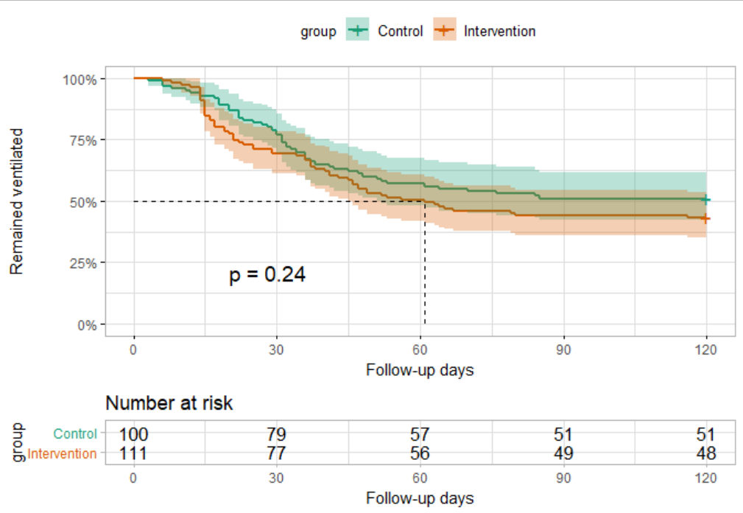
Figure S3. One-year Kaplan Meir curves of survival probability of the cohort according to study arm
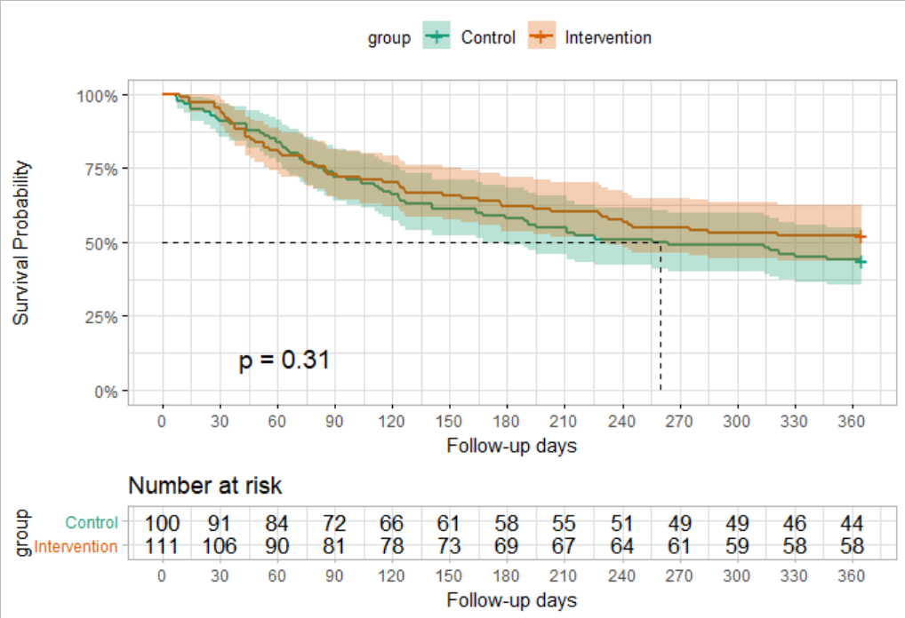

SUPPLEMENTARY RESULTS (Text for attributes)
Supplementary analyses provide additional information on safety monitoring, body composition trajectories, caloric delivery patterns, subgroup analyses, and reasons for censoring among participants who did not achieve ventilator liberation.

Time to Successful Weaning (Supplementary Figure S2):
Kaplan–Meier curves demonstrated largely overlapping trajectories between study arms during the first two weeks of follow-up. A modest separation favouring the IC arm was observed between approximately weeks 2 and 5, although this difference was not statistically significant by log-rank testing.

SUPPLEMENTARY TABLES

Table S1. Detailed laboratory safety monitoring
Safety monitoring included regular biochemical, hematologic, and nutritional markers.
Because IC-guided prescriptions could result in lower caloric delivery than predictive equations, all patients received a daily multivitamin supplement to prevent micronutrient deficiencies. To maintain blinding and ensure comparable micronutrient intake between groups, the same supplementation was provided to participants in both study arms. Blood tests, including complete blood count, electrolytes, kidney/liver function, and inflammatory markers were performed biweekly, and are presented in Table S1. Fat-soluble and water-soluble vitamins (A, B₁, B₆, B₁₂, E) were assessed at baseline and study completion. Enteral feed volumes were maintained ≥800 mL/day to ensure minimal nutritional adequacy and micronutrient provision in accordance with ICU nutrition recommendations (6).
As shown in Table S1, baseline and end-of-follow-up laboratory parameters, including markers of nutritional status, renal function, electrolytes, inflammatory indices, and micronutrient levels, were broadly comparable between the intervention and control groups. Changes over follow-up were similar across study arms, with no clinically meaningful or statistically significant between-group differences observed for the majority of parameters, supporting the metabolic and biochemical safety of the intervention. Although hemoglobin was modestly higher in the intervention group at both baseline and follow-up, and vitamin A concentrations were higher at follow-up, the longitudinal changes from baseline did not differ significantly between study arms (hemoglobin p=0.66; vitamin A p=0.42). Because both groups received identical multivitamin supplementation throughout the study, these isolated between-group differences most likely reflect random baseline variation rather than an intervention effect. Minor differences at baseline or follow-up for selected variables (e.g., hemoglobin, vitamin A) did not translate into differential longitudinal trends.

Table S1: Baseline and end-of-study blood test results and their change according to study arm
 |  | Baseline |  |  | End of FU |  |  | Change (End minus Baseline)
Arm |  | Intervention | Control | p | Intervention | Control | p | Intervention | Control | p
Blood parameter | %missingª | Mean ± SD | Mean ± SD |  | Mean ± SD | Mean ± SD |  | Mean ± SD | Mean ± SD
Albumin | 4, 18 | 33.58±6.09 | 33.54±6.04 | 0.96 | 32.12±4.80 | 32.51±4.00 | 0.58 | -1.48±5.53 | -1.46±5.06 | 0.98
Calcium | 6, 20 | 9.05±0.68 | 9.10±0.80 | 0.67 | 8.76±0.72 | 8.78±0.66 | 0.81 | -0.34±0.81 | -0.35±0.81 | 0.92
Creatinine | 3, 16 | 0.88±0.68 | 0.94±0.65 | 0.56 | 0.76±0.49 | 0.75±0.57 | 0.95 | -0.16±0.51 | -0.17±0.42 | 0.93
Magnesium | 3, 17 | 2.00±0.31 | 2.07±0.32 | 0.13 | 1.97±0.27 | 1.95±0.29 | 0.77 | -0.04±0.35 | -0.12±0.37 | 0.19
Potassium | 1, 14 | 5.69±13.51 | 4.37±0.51 | 0.34 | 5.77±13.63 | 4.33±0.60 | 0.34 | -0.14±1.10 | -0.07±0.67 | 0.64
Sodium | 2, 13 | 137.27±5.29 | 138.41±5.77 | 0.15 | 136.38±5.09 | 136.77±4.14 | 0.58 | -1.27±6.17 | -1.73±5.79 | 0.62
CRP | 4, 18 | 77.02±74.90 | 84.90±93.87 | 0.52 | 65.33±55.25 | 57.50±42.48 | 0.32 | -6.41±76.89 | -20.61±90.06 | 0.28
Phosphorus | 4, 16 | 4.99±12.24 | 3.66±0.91 | 0.30 | 3.50±0.76 | 3.59±0.97 | 0.52 | -1.65±13.11 | -0.07±1.13 | 0.28
WBC | 2, 14 | 10.91±5.63 | 11.29±5.01 | 0.62 | 10.80±3.66 | 11.39±5.28 | 0.40 | 0.01±5.46 | 0.23±4.76 | 0.78
Haemoglobin | 2, 13 | 10.46±1.81 | 9.79±1.88 | 0.01 | 9.81±1.41 | 9.39±1.46 | 0.05 | -0.71±1.95 | -0.57±1.94 | 0.66
Zinc | 6, 31 | 59.65±17.99 | 64.26±71.53 | 0.54 | 58.77±17.97 | 58.40±18.86 | 0.91 | -0.74±16.98 | -8.49±86.38 | 0.45
Vitamin E | 17, 65 | 17.60±9.38 | 16.88±5.21 | 0.55 | 17.66±4.58 | 15.95±4.67 | 0.13 | 1.13±3.73 | 0.40±4.78 | 0.48
Vitamin A | 17. 65 | 54.76±26.29 | 51.45±22.91 | 0.39 | 58.70±27.24 | 45.66±17.42 | 0.02 | 1.34±19.26 | -2.59±20.94 | 0.42
Vitamin B-6 | 16, 65 | 27.10±11.50 | 30.44±20.57 | 0.19 | 27.89±7.79 | 89.36±303.81 | 0.22 | 1.34±6.88 | 52.82±297.43 | 0.30
Vitamin B1 | 16, 65 | 80.05±22.19 | 76.99±19.18 | 0.35 | 75.69±21.13 | 73.28±21.48 | 0.64 | -3.66±18.94 | -6.68±23.05 | 0.55
Vitamin B12 | 92, 100 | 883.11±553.23 | 1152.50±531.79 | 0.34 | - | - | - | - | - | -
Vitamin D-3 | 25, 92 | 23.96±6.84 | 23.49±6.38 | 0.66 | 25.88±11.63 | 23.12±10.38 | 0.63 | -1.50±5.32 | -3.86±4.02 | 0.36
ª % missing at baseline, at end of FU
Table S2: Weekly energy and protein delivery by study week according to study arm
Daily Energy intakeª (Kcal/day) |  |  |  |  |  | Daily Protein intake^{b} (gr/Kg/day)
 | control |  | intervention |  | p | control |  | intervention |  | p
week | n^{c} | median [IQR] | n^{c} | median [IQR] |  | n^{c} | median [IQR] | n^{c} | median [IQR]
1 | 94 | 1715 [1601, 1895] | 100 | 1716 [1525, 1896] | 0.72 | 93 | 1.30 [1.24, 1.39] | 102 | 1.32 [1.26, 1.4] | 0.35
2 | 87 | 1710 [1574, 1851] | 95 | 1484 [1250, 1762] | <0.001 | 74 | 1.30 [1.24, 1.39] | 86 | 1.34 [1.22, 1.40] | 0.36
3 | 75 | 1690 [1570, 1888] | 82 | 1469 [1199, 1761] | <0.001 | 65 | 1.31 [1.25, 1.38] | 78 | 1.35 [1.26, 1.40] | 0.25
4 | 63 | 1690 [1540, 1912] | 73 | 1450 [1230, 1740] | <0.001 | 53 | 1.31 [1.24, 1.39] | 66 | 1.37 [1.26, 1.44] | 0.15
5 | 54 | 1666 [1500, 1894] | 58 | 1452 [1201, 1742] | <0.001 | 44 | 1.32 [1.24, 1.40] | 52 | 1.36 [1.25, 1.43] | 0.60
6 | 37 | 1690 [1572, 1900] | 39 | 1430 [1133, 1764] | 0.001 | 33 | 1.34 [1.27, 1.41] | 33 | 1.39 [1.30, 1.43] | 0.55
7 | 29 | 1715 [1600, 1900] | 31 | 1422 [1205, 1672] | <0.001 | 25 | 1.33 [1.23, 1.39] | 26 | 1.39 [1.31,1.43] | 0.13
8 | 21 | 1710 [1600, 1900] | 23 | 1360 [1098, 1710] | 0.003 | 20 | 1.33 [1.28, 1.39] | 21 | 1.38 [1.30, 1.45] | 0.28
9 | 15 | 1715 [1632, 1895] | 17 | 1550 [1293, 1810] | 0.082 | 16 | 1.33 [1.23, 1.39] | 15 | 1.36 [1.32, 1.43] | 0.41
10 | 10 | 1818 [1778, 1886] | 6 | 1470 [1398, 1594] | 0.017 | 6 | 1.34 [1.23, 1.39] | 5 | 1.39 [1.36, 1.4] | 0.27
11 | 7 | 1786 [1775, 1948] | 5 | 1291 [1180, 1390] | 0.028 | 5 | 1.39 [1.28, 1.39] | 2 | 1.40 [1.40, 1.41] | 0.25
12 | 4 | 1788 [1783, 1902] | 3 | 1180 [ 998, 1495] | 0.289 | 3 | 1.30 [1.25, 1.40] | 1 | 1.40 | 0.65
13 | 3 | 1786 [1780, 1793] | 1 | 1445 | 0.18 | 3 | 1.26 [1.24, 1.38] | 1 | 1.46 | 0.65
14 | 3 | 1786 [1780, 1793] | 1 | 1880 | 0.18 | 3 | 1.26 [1.24, 1.32] | 1 | 1.44 | 0.18
15 | 2 | 1793 [1790, 1796] | 0 | - | - | 3 | 1.21 [0.62, 1.24] | 0 | - | -
16 | 2 | 1793 [1790, 1796] | 0 | - | - | 2 | 1.24 [1.22, 1.25] | 0 | - | -
17 | 1 | 1800 | 0 | - | - | 1 | 1.26 |  | - | -
ªEnergy intake is presented as the median absolute daily energy delivery (kcal/day).
^{b}Protein intake is expressed as g/kg/day based on the body weight used for nutritional calculations according to institutional nutritional assessment guidelines (actual, target-range, or adjusted body weight depending on the patient’s weight category).
^{c}The number of patients contributing data decreases over time due to successful weaning, censoring, or competing clinical events.

Table S2. Weekly energy delivery (calories)
Median daily energy intake was similar between groups during the first study week but became consistently lower in the IC-guided arm from week 2 onward (Table S2), reflecting energy prescriptions based on mEE. In contrast, protein intake remained stable and comparable between study arms throughout follow-up (≈1.3–1.4 g/kg/day), confirming that the intervention primarily affected energy delivery rather than protein provision.

Table S2. Weekly energy delivery by study week
Table S2 presents median daily energy delivery and daily protein intake according to study arm, by study week. Table S2 demonstrates that the nutritional intervention effectively modified caloric delivery while maintaining comparable protein intake between groups, confirming that differences between study arms were attributable to the energy-targeting strategy rather than differences in protein provision.
1. Energy delivery differed between study arms after week 1. At week 1, median daily energy intake was similar between groups (≈1715 kcal/day in both arms; p=0.72), indicating comparable initial nutritional delivery. From week 2 onward, energy intake became consistently lower in the IC-guided arm compared with the control arm. For example:
- Week 2: 1710 kcal/day (control) vs. 1484 kcal/day (IC), p<0.001
- Week 4: 1690 vs. 1450 kcal/day, p<0.001
- Week 7: 1715 vs. 1422 kcal/day, p<0.001
This pattern persisted through most weeks of observation. The lower energy delivery in the IC group reflects energy prescriptions based on measured energy expenditure, whereas the control group received nutrition based on predictive equations. As a result, IC-guided feeding generally resulted in more conservative energy delivery.
2. Protein intake remained similar between groups: Despite differences in total energy intake, protein intake remained stable and comparable between arms throughout the study, typically ranging between 1.30–1.40 g/kg/day in both groups. None of the weekly comparisons reached statistical significance.
This finding confirms that protein targets were maintained consistently across both study arms, in accordance with institutional PMV nutritional guidelines, and that the intervention primarily influenced energy delivery rather than protein provision.
3. Declining sample size reflects clinical course: The number of patients contributing data gradually decreased over time (e.g., from ~100 participants at week 1 to fewer than 10 by weeks 10–12). This reduction reflects the dynamic nature of the cohort, as patients were progressively weaned, censored, or experienced competing clinical events, rather than loss of follow-up.
4. Overall interpretation: Taken together, Table S2 demonstrates that the intervention successfully modified energy delivery while maintaining comparable protein intake between groups. This supports the internal validity of the study intervention, indicating that differences between study arms were attributable to the energy-targeting strategy rather than differences in protein provision or nutritional management.

Distribution of vegetative state, minimally conscious state, and full consciousness among patients who achieved successful liberation from mechanical ventilation.

Table S3. Baseline state of consciousness among successfully weaned patients according to study arm.
State of Consciousness | intervention | control
Vegetative State | 15 (23) | 13 (26)
Minimally Conscious State | 9 (14) | 10 (20)
Full Conscious | 40 (63) | 27 (54)
Total | 64 (100) | 50 (100)

The neurological status of successfully weaned patients varied widely. Among these patients, 23–26% were in a vegetative state and 14–20% in a minimally conscious state at the time of weaning, while the remaining patients were fully conscious.

Supplementary Results – One-Year Mortality:
Table S4: Cox regression models for 1-year mortality of the total cohort
 |  | Intention To Treat analysis  N=211 |  | Per protocol analysis  n=198
Arm | reference | HR (95% CI) | p | HR (95% CI) | p
Age, years
50-69 | <50 | 2.16 (0.84, 5.50) | 0.11 | 1.98 (0.77, 5.07) | 0.15
70-79 | " | 2.82 (1.10, 7.18) | 0.03 | 2.47 (0.97, 6.30) | 0.06
80+ | " | 4.84 (1.84, 12.73) | 0.001 | 5.27 (1.99, 13.94) | 0.0008
Sex, female | Male | 0.80 (0.53, 1.21) | 0.29 | 0.76 (0.51, 1.15) | 0.20
Weaning status, weaned | No | 0.54 (0.36, 0.82) | 0.004 | 0.48 (0.31, 0.73) | 0.0007
Study arm, intervention | Control | 0.91 (0.62, 1.33) | 0.62 | 1.07 (0.73, 1.59) | 0.73

One-year all-cause mortality was 48% in the IC arm and 56% in the control arm (p = 0.29). Kaplan–Meier survival curves showed no statistically significant difference in 1-year mortality between study arms (log-rank test) (Supplementary Figure S3). In multivariable Cox proportional hazards models adjusting for age, sex, and study arm, successful weaning was independently associated with improved survival (ITT HR = 0.54, 95% CI 0.36–0.82; per-protocol HR = 0.48, 95% CI 0.31–0.73) (Supplementary Table S4). Increasing age was associated with higher mortality, with the greatest risk observed among patients ≥80 years (HR = 4.84, 95% CI 1.84–12.73), whereas sex and study arm were not independently associated with survival.

Table S5, Number of adverse events by study arm
 | Intervention  n=111 | Control  n=100 | p
Recurrent Infections / sepsis ª | 15 | 11 | 0.68
Respiratory failure ^{e} | 10 | 4 | 0.17
Deterioration of brain injury ^{c} | 6 | 8 | 0.58
Acute abdomen/ abdominal emergency | 3 | 5 | 0.48
Death | 1 | 2 | 0.67
ª acute infection with uncontrolled sepsis/urosepsis, recurrent pneumonia
^{b} Respiratory failure: recurrent pneumothorax/diaphragmatic paralysis/COPD exacerbation
^{c} Due to Central Respiratory suppression

Table S6, reasons for censoring / non-weaning by study arm
 | Intervention  111 (100%) | Control  100 (100%) | p
Reasons for censoring / non-weaning | n (%) | n (%)
Recurrent Infections / sepsis ª | 13 (11.7) | 11 (11.0) | 1
Weaning failure ^{b} | 11 (9.9) | 10 (10.0) | 1
Respiratory failure ^{c} | 10 (9.0) | 4 (4.0) | 0.17
Deterioration of brain injury ^{e} | 6 (5.4) | 8 (8.0) | 0.58
Withdrew consent | 2 (1.8) | 2 (2.0) | 1
Acute abdomen/ abdominal emergency | 3 (2.7) | 4 (4.0) | 1
Protocol deviation ^{d} | 2 (1.8) | 1 (1.0) | 1
Death | 1 (0.9) | 2 (2.0) | 0.67
ª acute infection with uncontrolled sepsis/urosepsis, recurrent pneumonia
^{b} 5 weaning attempts failed
^{c} Respiratory failure: recurrent pneumothorax/diaphragmatic paralysis/COPD exacerbation
^{d} Protocol deviation due to IC appliance dysfunction (n=2); Failure to obey the protocol (n=1).
^{e} Due to Central Respiratory suppression

Table S6 presents reasons for censoring / non-weaning by study arm. Over the trial period, 47 patients in the intervention arm (42.3%) and 50 patients in the control arm (50%) were early terminated or censored (p=0.33) with no weaning success. As shown in Table S6, 11% had persistent or recurrent infections and 10% received 5 weaning attempts per study protocol after which they were deemed failed weaning. Other reasons for censoring prior to exhaustion of 5 weaning cycle attempt included recurrent pneumothorax/diaphragmatic paralysis/COPD exacerbation, IC appliance dysfunction; Failure to obey the protocol by oral feeding in addition to the nutritional prescription, deterioration in brain-injury with respiratory failure, acute abdomen, and death.
Table S7: Body composition trajectories - Bioimpedance measurements according to study arm (n=87 in the intervention and n=79 in the control arm)
 | Baseline Bioimpedance |  |  | Last measurement Bioimpedance
 | Intervention  n (%) | Control  n (%) | p | Intervention  n (%) | Control  n (%) | p | P_{baseline} _{to FU} Int. |  | P_{baseline} _{to FU} Cont.
Ventilation days by study entry  Median [IQR]  Mean ± SD | 47 [32,72.5]  66.8 ± 76.7 | 39.5 [28.8, 62.3]  60.2 ± 81.8 | 0.12 | - | - | - | - |  | -
BMI, Kg/m²  Median [IQR]  Mean± SD | 24.4 [21.8, 28.2]  25.5±6.5 | 26.4 [22.2, 31.9]  27.8±7.9 | 0.09 | 24.4 [21.8, 27.8]  25.1±5.9 | 25.4 [22.1, 31.8]  27.5±8.1 | 0.16 | 0.38 |  | 0.12
Phase Angle1  Median [IQR]  Mean ± SD | 3.3 [2.7, 3.8]  3.5±1.4 | 3.2 [2.7, 4.0]  3.5±1.5 | 0.94 | 3.3 [2.7, 3.8]  3.5±1.6 | 3.3 [2.7, 3.9]  3.4±1.2 | 0.96 | 0.61 |  | 0.72
Fat-Free Mass, Kg  Median [IQR]  Mean ± SD | 46.8 [40.6, 53.9]  48.2±11.6 | 50.1 [42.2, 56.9]  50.6±11.2 | 0.12 | 43.4 [39.6, 51.7]  45.3±10.4 | 47.5 [41.4, 53.5]  48.9±10.1 | 0.06 | 0.04 |  | 0.04
Fat Mass, Kg  Median [IQR]  Mean ± SD | 22.0 [13.8, 29.8]  23.2±14.2 | 22.5 [16.2, 34.2]  26.5±16.3 | 0.26 | 22.8 [15.1, 31.6]  24.6±14.5 | 24.2 [18.7, 36.6]  28.5±17.0 | 0.17 | 0.32 |  | 0.05
Extra cellular Water, Kg  Median [IQR]  Mean ± SD | 23.9 [19.0, 27.4]  24.7±7.9 | 24.5 [20.2, 30.1]  25.8±8.4 | 0.42 | 20.7 [18.4, 25.8]  22.5±7.1 | 23.2 [19.1, 28.8]  24.1±6.7 | 0.10 | 0.0004 |  | 0.23

Table S7. Body composition trajectories
Table S7 demonstrates that bioimpedance-derived body composition measures were generally comparable between groups at baseline and at the last available assessment. Body mass index, phase angle, fat mass, and extracellular water showed no significant between-group differences over time. Both groups exhibited a modest decline in fat-free mass during follow-up, consistent with the expected trajectory in chronically ventilated patients, with similar within-group changes observed in the intervention and control arms. Overall, these findings indicate that indirect calorimetry–guided feeding did not adversely affect body composition or fluid balance compared with standard care.

Table S8 presents a post-hoc subgroup analysis examining effect modification of study intervention by baseline demographic characteristics on weaning outcomes.

Table S8: Subgroup Analysis of the Per-Protocol cohort on weaning outcomes
 | Intervention  Weaned/N (%) | Control  Weaned/N (%) | HR (95%CI) | p interaction
Sex
Women | 27/44 (61) | 16/38 (42) | 0.71 (0.38, 1.33) | 0.55
Men | 33/59 (56) | 34/57 (60) | 0.91 (0.56, 1.48)
Age, years
70+ | 28/52 (54) | 25/53 (47) | 0.87 (0.50, 1.50) | 0.64
< 70 | 32/51 (63) | 25/42 (60) | 0.73 (0.43, 1.23)
Hypertension
Yes | 35/66 (53) | 29/55 (53) | 1.02 (0.62, 1.69) | 0.19
No | 25/37 (68) | 21/40 (53) | 0.61 (0.33, 1.11)
Days of ventilation at entry
43+ | 28/56 (50) | 21/44 (48) | 0.76 (0.42, 1.36) | 0.69
<43 | 32/47 (68) | 29/51 (57) | 0.89 (0.53, 1.50)
Diabetes
Yes | 26/51 (51) | 25/46 (54) | 1.05 (0.60, 1.85) | 0.19
No | 34/52 (65) | 25/49 (51) | 0.63 (0.38, 1.07)

Across all examined subgroups, weaning rates were broadly comparable between the intervention and control groups. Hazard ratios for successful weaning generally favoured the intervention arm in several strata (e.g., women, patients <70 years, those without hypertension, those without diabetes), but confidence intervals consistently crossed unity, indicating no statistically significant differential effect. Importantly, no statistically significant interaction was observed between treatment assignment and any subgroup variable. Interaction p-values were non-significant for sex (p=0.55), age (p=0.64), hypertension (p=0.19), duration of ventilation at entry (p=0.69), and diabetes (p=0.19), suggesting that the effect of the intervention on weaning outcomes was consistent across these clinically relevant subpopulations.
Overall, no evidence of effect modification by baseline demographic characteristics or major comorbidities was observed.

Table S9, Ventilatory parameters of a subsample (n=48) at study entry according to study arm
 | Control | Intervention
n/N | 25/100 | 23/111
ETCO2, mmHg, mean ± SD | 35.62 ± 5.34 | 37.14 ± 8.19
FiO2, %, mean ± SD | 30.64 ± 7.49 | 32.43 ± 8.17
Flow, mean ± SD | 34.00 ± 2.24 | 32.00 ± 10.00
RR Ventilation, breaths/min, mean ± SD | 18.95 ± 7.08 | 17.65 ± 5.02
PEEP, cmH₂O, n (%)
5 | 19 (76.0) | 21 (91.3)
6 | 5 (20.0) | 2 (8.7)
7 | 1 (4.0) | 0 (0.0)
Pressure Support, cmH₂O, mean ± SD | 11.75 ± 3.65 | 10.96 ± 2.95
Tidal Volume, mL, mean ± SD | 483.33 ±18.62 | 486.00 ± 21.91
Mask, n (%) | 5 (20.0) | 6 (26.1)
T-tube, n (%) | 1 (4.0) | 0 (0.0)

Ventilatory parameters at study entry were available for a subset of 48 participants (25 in the control arm and 23 in the intervention arm), reflecting variability in ventilator monitoring documentation in this rehabilitation setting.
Overall, ventilatory settings were broadly comparable between the two groups, suggesting similar respiratory status at baseline.
Gas exchange and oxygenation: End-tidal CO₂ levels were similar between groups, with mean values of 35.6 ± 5.3 mmHg in the control group and 37.1 ± 8.2 mmHg in the intervention group, indicating comparable ventilatory adequacy.
Fraction of inspired oxygen requirements were also similar (30.6 ± 7.5% vs 32.4 ± 8.2%), consistent with relatively moderate oxygen support in both groups.
Ventilator settings: The mean ventilator respiratory rate was slightly higher in the control group (18.9 ± 7.1 breaths/min) compared with the intervention group (17.7 ± 5.0 breaths/min), although the difference was small and unlikely to be clinically meaningful.
Positive end-expiratory pressure (PEEP) settings were low in both groups, reflecting the relative respiratory stability of this chronically ventilated population. Most patients received PEEP of 5 cmH₂O (76% in the control group and 91% in the intervention group), with only a minority requiring higher levels.
Pressure support levels were also comparable (11.8 ± 3.7 cmH₂O in the control group vs 11.0 ± 3.0 cmH₂O in the intervention group), indicating similar degrees of ventilatory assistance.
Tidal volume and ventilatory mechanics: Mean tidal volumes were almost identical between groups (483 mL vs 486 mL), suggesting similar ventilatory mechanics and respiratory drive at baseline.
Weaning interface: A small proportion of patients had already transitioned to spontaneous breathing interfaces at the time of data collection. Mask ventilation was used in 20% of control patients and 26% of intervention patients, while T-tube trials were rare.
Taken together, these findings indicate that patients with available ventilatory data had very similar respiratory status and ventilator settings at study entry, with comparable oxygen requirements, similar ventilatory support levels, and with nearly identical tidal volumes and end-tidal CO₂ values.
These similarities suggest no meaningful baseline imbalance in respiratory severity between study arms, supporting the internal validity of the randomization for this subgroup.

Table S10. Weekly proportion of participants achieving the prescribed energy target (± 50kcal/day) relative to measured energy expenditure by study arm.ª
Study Arm
Intervention |  |  |  |  | Control
week | N | reached target | % | week |  | N | reached target | %
1 | 100 | 19 | 19% | 1 |  | 92 | 10 | 11%
2 | 90 | 18 | 20% | 2 |  | 76 | 7 | 9%
3 | 69 | 17 | 25% | 3 |  | 63 | 10 | 16%
4 | 50 | 18 | 36% | 4 |  | 54 | 5 | 9%
5 | 37 | 12 | 32% | 5 |  | 41 | 2 | 5%
6 | 28 | 5 | 18% | 6 |  | 24 | 0 | 0%
7 | 22 | 9 | 41% | 7 |  | 19 | 2 | 11%
8 | 14 | 2 | 14% | 8 |  | 15 | 1 | 7%
9 | 8 | 2 | 25% | 9 |  | 11 | 0 | 0%
10 | 3 | 2 | 67% | 10 |  | 5 | 0 | 0%
11 | 1 | 1 | 100% | 11 |  | 3 | 0 | 0%
12 | 1 | 1 | 100% | 12 |  | 2 | 0 | 0%
13 | 1 | 1 | 100% | 13 |  | 1 | 0 | 0%
14 | 1 | 1 | 100% | 14 |  | 1 | 0 | 0%
15 | 0 | - |  | 15 |  | 1 | 0 | 0%
16 | 0 | - |  | 16 |  | 1 | 0 | 0%
ªTarget achievement was defined as delivered daily energy intake within ±50 kcal/day of the measured resting energy expenditure determined by indirect calorimetry. Percentages were calculated among participants with available calorimetry and dietary intake data for each study week. For the control group, target achievement was assessed retrospectively by comparing delivered energy intake with measured energy expenditure obtained from study indirect calorimetry measurements.

Table S10 demonstrates that participants assigned to IC-guided nutrition achieved the predefined energy target (±50 kcal/day of measured energy expenditure) more frequently throughout follow-up than those receiving predictive-equation–guided nutrition (Table S10). This finding complements the weekly energy-gap distributions (Figure 2) and confirms that IC-guided prescriptions resulted in closer alignment between delivered energy intake and measured metabolic requirements. In contrast, participants in the control group more frequently received energy intake exceeding measured energy expenditure, consistent with the positive energy-gap observed during follow-up.
References
1. Bendavid I, Lobo DN, Barazzoni R, Cederholm T, Coëffier M, de van der Schueren M, et al. The centenary of the Harris-Benedict equations: how to assess energy requirements best? Recommendations from the ESPEN expert group. Clin Nutr. 2021;40(3):690–701.
2. Duan JY, Zheng WH, Zhou H, et al. Energy delivery guided by indirect calorimetry in critically ill patients: A systematic review and meta-analysis. Crit Care. 2021;25:88.
3. Singer P, Blaser AR, Berger MM, Alhazzani W, Calder PC, Casaer MP, et al. ESPEN guideline on clinical nutrition in the intensive care unit. Clin Nutr. 2019;38(1):48-79.
4. Singer P, Blaser AR, Berger MM, et al. ESPEN practical and partially revised guideline: Clinical nutrition in the intensive care unit. Clin Nutr. 2023;42(9):1671–1689.
5. Boles JM, Bion J, Connors A, Herridge M, Marsh B, Melot C, et al. Weaning from mechanical ventilation. Eur Respir J. 2007;29(5):1033–1056.
6. Damuth E, Mitchell JA, Bartock JL, Roberts BW, Trzeciak S. Long-term survival of critically ill patients treated with prolonged mechanical ventilation: a systematic review and meta-analysis. Lancet Respir Med. 2015;3(7):544–553.

