Online supplement

Treatment and outcomes of difficult-to-treat Stenotrophomonas maltophilia pneumonia in the intensive care unit: a multinational retrospective cohort study
David Mokrani, Antoine Piantoni, Laurence Drieux-Rouzet, Patricio Ross, Inès Gragueb-Chatti, Marion Giry, Marc Le Pape, Antoine Studer, João Ferreira-Coimbra, Julien Charpentier, Éric Maury, Pierre Bay, Carine Thivilier, Xavier Brousse, Florian Blanchard, Nacim Benchabane, Romaric Larcher, Ignacio Martin-Loeches, Marta Hernández-Meneses, Nicolas Mongardon, Olivier Mascle, Alice Jacquens, Leila S Hojat, Lukas Antonitsch, Antonio Vena, Giorgia Montrucchio, Marine Amiot, Sophie Nagle, Adrien Bouglé, Alexandre Sitbon, Charles-Edouard Luyt; SMR-ICU Study Group

Table of contents
Table S1. STROBE Statement – Checklist of items that should be included in reports of cohort studies 2
Table S2. Participating centers 3
Table S3. Minimum Inhibitory Concentrations and clinical outcomes in patients treated with aztreonam/ceftazidime-avibactam or cefiderocol regimens 4
Table S4. Distribution of propensity-score covariates before and after overlap weighting: combination therapy model (aztreonam/ceftazidime-avibactam classified as monotherapy) 6
Table S5. Distribution of propensity-score covariates before and after overlap weighting: treatment duration model (≤8 days vs >8 days) 7
Table S6. Distribution of propensity-score covariates before and after overlap weighting: sensitivity analysis with aztreonam/ceftazidime-avibactam classified as combination therapy 8
Table S7. Microbiological characteristics of DTR S. maltophilia ICU-acquired pneumonia 9
Table S8. Baseline characteristics of patients stratified by the resistance profile of the first documented S. maltophilia strain 10
Table S9. Crude clinical outcomes by antibiotic exposure 11
Table S10. Characteristics of antibiotic recipients, by agent 12
Fig. S1. Standardized mean differences before and after overlap weighting — combination therapy model. 13
Fig. S2. Standardized mean differences before and after overlap weighting — treatment duration model. 14
Fig. S3. Propensity-score overlap before and after weighting — combination therapy model. 15
Fig. S4. Propensity-score overlap before and after weighting — treatment duration model. 15
Fig. S5. Kaplan-Meier survival curves by treatment duration group. 16
Fig. S6. Combination regimens for DTR S. maltophilia pneumonia. 17
Fig. S7. Adjusted associations between antibiotic exposures and clinical outcomes in monomicrobial infections. 18
Fig. S8. Sensitivity analysis adjusting for co-administered agents. 19
Fig. S9. Sensitivity analysis classifying aztreonam/ceftazidime-avibactam as combination therapy. 20
SMR-ICU Study Group 21

Table S1. STROBE Statement – Checklist of items that should be included in reports of cohort studies
 | Item | Recommendation | Page
Title and abstract | 1 | (a) Indicate the study’s design with a commonly used term in the title or the abstract | 1
Title and abstract | 1 | (b) Provide in the abstract an informative and balanced summary of what was done and what was found | 3
Introduction
Background/rationale | 2 | Explain the scientific background and rationale for the investigation being reported | 5
Objectives | 3 | State specific objectives, including any prespecified hypotheses | 5
Methods
Study design | 4 | Present key elements of study design early in the paper | 5-6
Setting | 5 | Describe the setting, locations, and relevant dates, including periods of recruitment, exposure, follow-up, and data collection | 5-8
Participants | 6 | (a) Give the eligibility criteria, and the sources and methods of selection of participants. Describe methods of follow-up | 5-6
Participants | 6 | (b) For matched studies, give matching criteria and number of exposed and unexposed | NA
Variables | 7 | Clearly define all outcomes, exposures, predictors, potential confounders, and effect modifiers. Give diagnostic criteria, if applicable | 7-8
Data sources/ measurement | 8 | For each variable of interest, give sources of data and details of methods of assessment (measurement). Describe comparability of assessment methods if there is more than one group | 7-8
Bias | 9 | Describe any efforts to address potential sources of bias | 8-10
Study size | 10 | Explain how the study size was arrived at | 6
Quantitative variables | 11 | Explain how quantitative variables were handled in the analyses. If applicable, describe which groupings were chosen and why | 8
Statistical methods | 12 | (a) Describe all statistical methods, including those used to control for confounding | 8-10
Statistical methods | 12 | (b) Describe any methods used to examine subgroups and interactions | 8-10
Statistical methods | 12 | (c) Explain how missing data were addressed | 10
Statistical methods | 12 | (d) If applicable, explain how loss to follow-up was addressed | NA
Statistical methods | 12 | (e) Describe any sensitivity analyses | 8-10
Results
Participants | 13* | (a) Report numbers of individuals at each stage of study—eg numbers potentially eligible, examined for eligibility, confirmed eligible, included in the study, completing follow-up, and analysed | 10
Participants | 13* | (b) Give reasons for non-participation at each stage | 10
Participants | 13* | (c) Consider use of a flow diagram | 10
Descriptive data | 14* | (a) Give characteristics of study participants (eg demographic, clinical, social) and information on exposures and potential confounders | 10-11
Descriptive data | 14* | (b) Indicate number of participants with missing data for each variable of interest | Table
Descriptive data | 14* | (c) Summarise follow-up time (eg, average and total amount) | 10
Outcome data | 15* | Report numbers of outcome events or summary measures over time | 11
Main results | 16 | (a) Give unadjusted estimates and, if applicable, confounder-adjusted estimates and their precision (eg, 95% confidence interval). Make clear which confounders were adjusted for and why they were included | 11-12
Main results | 16 | (b) Report category boundaries when continuous variables were categorized | NA
Main results | 16 | (c) If relevant, consider translating estimates of relative risk into absolute risk for a meaningful time period | NA
Other analyses | 17 | Report other analyses done—eg analyses of subgroups and interactions, and sensitivity analyses | 11-12
Discussion
Key results | 18 | Summarise key results with reference to study objectives | 12-13
Limitations | 19 | Discuss limitations of the study, taking into account sources of potential bias or imprecision. Discuss both direction and magnitude of any potential bias | 12-14
Interpretation | 20 | Give a cautious overall interpretation of results considering objectives, limitations, multiplicity of analyses, results from similar studies, and other relevant evidence | 12-15
Generalisability | 21 | Discuss the generalisability (external validity) of the study results | 12-14
Other information
Funding | 22 | Give the source of funding and the role of the funders for the present study and, if applicable, for the original study on which the present article is based | 19

Table S2. Participating centers
Center | Country | Center type | Number of inclusions
Réanimation médicale (Institut de cardiologie), Hôpital de la Pitié Salpêtrière, Paris | France | University Hospital Center | 12
Réanimation chirurgicale polyvalente Husson Mourier, Hôpital de la Pitié Salpêtrière, Paris | France | University Hospital Center | 11
Pôle de médecine intensive et réanimation, CHU de Lille, Lille | France | University Hospital Center | 10
Departamento de Medicina Intensiva, Hospital Clínico de la Universidad Católica, Santiago | Chile | University Hospital Center | 8
Réanimation de chirurgie cardiaque, Hôpital de la Pitié Salpêtrière, Paris | France | University Hospital Center | 8
Service de médecine intensive réanimation, DRIS, CHU Nord, Marseille | France | University Hospital Center | 6
Médecine Intensive Réanimation, CHU Rouen, Rouen | France | University Hospital Center | 6
Médecine Intensive Réanimation, CH d’Orléans, Orléans | France | Regional Hospital Center | 5
Médecine Intensive Réanimation, Nouvel Hôpital Civil, Strasbourg | France | University Hospital Center | 5
Médecine Intensive Réanimation, CHU Saint-Antoine, Paris | France | University Hospital Center | 5
Médecine Intensive Réanimation, CHU Cochin, Paris | France | University Hospital Center | 5
Intensive Care Department, Centro Hospitalar Universitário São João, Porto | Portugal | University Hospital Center | 5
Médecine Intensive Réanimation, CHU Mondor, Créteil | France | University Hospital Center | 4
Médecine Intensive et Réanimation Médicale Brabois, CHU Nancy-Brabois, Nancy | France | University Hospital Center | 4
Médecine Intensive et Réanimation, CHU Bordeaux, Bordeaux | France | University Hospital Center | 4
Réanimation chirurgicale polyvalente Gaston Cordier, Hôpital de la Pitié Salpêtrière, Paris | France | University Hospital Center | 3
Médecine Intensive et Réanimation, CHU Montpellier, Montpellier | France | University Hospital Center | 3
Service de maladies infectieuses et tropicales, CHU Nîmes, Nîmes | France | University Hospital Center | 3
Intensive Care Department, St James's Hospital, Dublin | Ireland | University Hospital Center | 3
Acute Cardiac Care Unit, Hospital Clinic of Barcelona, Barcelona | Spain | University Hospital Center | 2
Réanimation chirurgicale, CHU Mondor, Créteil | France | University Hospital Center | 2
Médecine Intensive Réanimation, CHU Clermont-Ferrand, Clermont-Ferrand | France | University Hospital Center | 2
Réanimation neurochirurgicale, Hôpital de la Pitié Salpêtrière, Paris | France | University Hospital Center | 2
UH Cleveland Medical Center, Cleveland | US | University Hospital Center | 2
Department of Anesthesiology, Emergency and Critical Care Medicine, Hospital Wiener Neustadt | Austria | Regional Hospital Center | 1
Médecine Intensive Réanimation, CHU Avicennes, Bobigny | France | University Hospital Center | 1
Médecine Intensive Réanimation, CHU Hôpital Européen Georges-Pompidou, Paris | France | University Hospital Center | 1
Médecine Intensive Réanimation et Maladies Infectieuses, CHU Bichat Claude Bernard, Paris | France | University Hospital Center | 1
Réanimation Polyvalente, Centre hospitalier d'Arles, Arles | France | Regional Hospital Center | 1
Infectious Diseases Unit, Policlinico San Martino Hospital, Genoa | Italy | University Hospital Center | 1
Anestesia and Intensive Care Unit, AR1U, Città della Salute e della Scienza Hospital, Turin | Italy | University Hospital Center | 1

Table S3. Minimum Inhibitory Concentrations and clinical outcomes in patients treated with aztreonam/ceftazidime-avibactam or cefiderocol regimens
Patients treated with an aztreonam/ceftazidime-avibactam-based regimen
Patients | MIC (mg/L) | Clinical cure | Relapse | Death at day-30
A1 | NA | Yes | Yes | No
A2 | NA | No | No | No
A3 | 1.5 | Yes | No | No
A4 | 2 | Yes | Yes | No
A5 | 1.5 | Yes | Yes | No
A6 | 3 | Yes | Yes | No
A7 | 3 | Yes | No | No
A8 | 4 | Yes | No | No
A9 | NA | Yes | No | No
A10 | NA | Yes | No | No
A11 | NA | No | No | Yes
A12 | NA | No | No | Yes
A13 | NA | Yes | No | No
A14 | 1 | Yes | No | No
A15 | 0.5 | Yes | No | No
A16 | 4 | No | No | Yes
A17 | NA | Yes | No | No
A18 | NA | No | No | No
Patients treated with a cefiderocol-based regimen
Patients | MIC (mg/L) | Clinical cure | Relapse | Death at day-30
C1 | NA | Yes | Yes | No
C2 | NA | Yes | No | No
C3 | <0.25 | Yes | Yes | No
C4 | NA | Yes | No | No
C5 | 0.125 | No | No | Yes
C6 | 1.0 | Yes | No | Yes
C7 | NA | No | No | Yes
C8 | NA | Yes | Yes | Yes
C9 | 0.125 | Yes | No | No
C10 | 0.047 | Yes | No | No
C11 | 0.19 | No | No | Yes
C12 | NA | Yes | No | No
C13 | 0.5 | Yes | No | No
C14 | 0.25 | No | No | Yes
C15 | 0.5 | Yes | No | No
C16 | NA | No | No | Yes
C17 | NA | Yes | No | No
C18 | 0.5 | Yes | Yes | No
C19 | NA | No | No | Yes
C20 | 0.125 | Yes | No | No
MIC=minimum inhibitory concentration. NA=MIC not routinely determined (categorical susceptibility was available for all isolates; see Methods).

Table S4. Distribution of propensity-score covariates before and after overlap weighting: combination therapy model (aztreonam/ceftazidime-avibactam classified as monotherapy)
 | Before weighting |  |  | After weighting
Covariate | Monotherapy (n=94) | Combination  (n=25) | SMD | Monotherapy (n=94) | Combination  (n=25) | SMD
Age, years | 58.96 | 58.58 | 0.026 | 58.64 | 58.64 | 0.000
ECMO | 0.18 | 0.12 | 0.198 | 0.13 | 0.13 | 0.000
Lactate on D0 | 1.80 | 1.52 | 0.366 | 1.59 | 1.59 | 0.000
ARDS on D0 | 0.52 | 0.58 | 0.122 | 0.53 | 0.53 | 0.000
Immunosuppression | 0.39 | 0.35 | 0.086 | 0.34 | 0.34 | 0.000
Admission for COVID-19 | 0.11 | 0.38 | 0.650 | 0.24 | 0.24 | 0.000
ICU length of stay before infection | 32.48 | 29.27 | 0.120 | 29.88 | 29.88 | 0.000
Septic shock on D0 | 0.44 | 0.42 | 0.036 | 0.48 | 0.48 | 0.000
Dialysis on D0 | 0.31 | 0.31 | 0.009 | 0.34 | 0.34 | 0.000
Polymicrobial infection | 0.41 | 0.38 | 0.050 | 0.37 | 0.37 | 0.000
Dominant centre (PSL) | 0.33 | 0.19 | 0.368 | 0.18 | 0.18 | 0.000
Calendar era (2019–2024) | 0.61 | 0.58 | 0.072 | 0.51 | 0.51 | 0.000
Data are mean or % (proportions from ATO-weighted regression). Day 0 refers to the date of the respiratory specimen positive for DTR S. maltophilia. ARDS=acute respiratory distress syndrome. ATO=average treatment effect in the overlap population. ECMO=extracorporeal membrane oxygenation. LOS=length of stay. PSL=Pitié-Salpêtrière (dominant recruiting centre). SMD=standardized mean difference. Effective sample size after weighting: 66.5.

Table S5. Distribution of propensity-score covariates before and after overlap weighting: treatment duration model (≤8 days vs >8 days)
 | Before weighting |  |  | After weighting
Covariate | ≤8 days (n=36) | >8 days (n=69) | SMD | ≤8 days (n=36) | >8 days (n=69) | SMD
Age, years | 54.92 | 60.80 | 0.405 | 57.97 | 57.97 | 0.000
ECMO | 0.19 | 0.14 | 0.141 | 0.14 | 0.14 | 0.000
Lactate on D0 | 1.82 | 1.41 | 0.552 | 1.52 | 1.52 | 0.000
ARDS on D0 | 0.39 | 0.61 | 0.445 | 0.42 | 0.42 | 0.000
Immunosuppression | 0.39 | 0.38 | 0.024 | 0.42 | 0.42 | 0.000
Admission for COVID-19 | 0.08 | 0.23 | 0.455 | 0.12 | 0.12 | 0.000
ICU length of stay before infection | 30.44 | 34.19 | 0.136 | 31.87 | 31.87 | 0.000
Septic shock on D0 | 0.42 | 0.36 | 0.112 | 0.37 | 0.37 | 0.000
Dialysis on D0 | 0.25 | 0.29 | 0.091 | 0.26 | 0.26 | 0.000
Polymicrobial infection | 0.42 | 0.43 | 0.037 | 0.43 | 0.43 | 0.000
Dominant centre (PSL) | 0.33 | 0.29 | 0.095 | 0.30 | 0.30 | 0.000
Calendar era (2019–2024) | 0.64 | 0.62 | 0.033 | 0.65 | 0.65 | 0.000
Data are mean or % (proportions from ATO-weighted regression). Day 0 refers to the date of the respiratory specimen positive for DTR S. maltophilia. ARDS=acute respiratory distress syndrome. ATO=average treatment effect in the overlap population. ECMO=extracorporeal membrane oxygenation. LOS=length of stay. PSL=Pitié-Salpêtrière (dominant recruiting centre). SMD=standardized mean difference. Effective sample size after weighting: 75.5.

Table S6. Distribution of propensity-score covariates before and after overlap weighting: sensitivity analysis with aztreonam/ceftazidime-avibactam classified as combination therapy
 | Before weighting |  |  | After weighting
Covariate | Monotherapy (n=85) | Combination  (n=34) | SMD | Monotherapy (n=85) | Combination  (n=34) | SMD
Age, years | 60.26 | 55.54 | 0.313 | 56.75 | 56.75 | 0.00
ECMO | 0.15 | 0.20 | 0.114 | 0.20 | 0.20 | 0.00
Lactate on D0 | 1.72 | 1.79 | 0.050 | 1.78 | 1.78 | 0.00
ARDS on D0 | 0.50 | 0.60 | 0.203 | 0.58 | 0.58 | 0.00
Immunosuppression | 0.38 | 0.37 | 0.020 | 0.37 | 0.37 | 0.00
Admission for COVID-19 | 0.12 | 0.29 | 0.406 | 0.21 | 0.21 | 0.00
ICU length of stay before infection | 31.79 | 31.77 | 0.000 | 32.49 | 32.49 | 0.00
Septic shock on D0 | 0.42 | 0.49 | 0.138 | 0.49 | 0.49 | 0.00
Dialysis on D0 | 0.31 | 0.31 | 0.010 | 0.32 | 0.32 | 0.00
Polymicrobial infection | 0.42 | 0.37 | 0.094 | 0.36 | 0.36 | 0.00
Dominant centre (PSL) | 0.33 | 0.23 | 0.249 | 0.23 | 0.23 | 0.00
Calendar era (2019–2024) | 0.57 | 0.69 | 0.236 | 0.63 | 0.63 | 0.00
Data are mean or % (proportions from ATO-weighted regression). Day 0 refers to the date of the respiratory specimen positive for DTR S. maltophilia. ARDS=acute respiratory distress syndrome. ATO=average treatment effect in the overlap population. ECMO=extracorporeal membrane oxygenation. LOS=length of stay. PSL=Pitié-Salpêtrière (dominant recruiting centre). SMD=standardized mean difference. Effective sample size after weighting: 90.2.

Table S7. Microbiological characteristics of DTR S. maltophilia ICU-acquired pneumonia
 | Total (n = 119) | Alive at Day-30  (n = 74) | Deceased at Day-30  (n = 45) | p-value
Positive blood culture | 8 (6.7%) | 6 (8.1%) | 2 (4.4%) | 0.71
Polymicrobial infection | 48 (40%) | 34 (46%) | 14 (31%) | 0.13
Co-pathogens identified on Day 0
Enterobacterales | 30 (25%) | 20 (27%) | 10 (22%) | ..
Nonfermenting Gram-negative bacilli | 21 (18%) | 13 (18%) | 8 (18%) | ..
Pseudomonas aeruginosa | 14 (12%) | 8 (11%) | 6 (13%) | ..
Acinetobacter baumannii | 1 (0.8%) | 1 (1.4%) | 0 (0%) | ..
Achromobacter xylosoxidans | 3 (2.5%) | 1 (1.4%) | 2 (4.4%) | ..
Burkholderia spp | 3 (2.5%) | 3 (4.1%) | 0 (0%) | ..
Gram-positive bacteria
Staphylococcus aureus | 2 (1.7%) | 2 (2.7%) | 0 (0%) | ..
Fungi
Aspergillus spp | 2 (1.7%) | 2 (2.7%) | 0 (0%) | ..
Other* | 1 (0.8%) | 0 (0.0%) | 1 (2.2%) | ..
Data are n (%). *Bacteroides fragilis (n = 1).

Table S8. Baseline characteristics of patients stratified by the resistance profile of the first documented S. maltophilia strain
 | Total  (n = 119) | First Sma DTR  (n = 50) | First Sma non-DTR (n = 69) | p-value
Age at admission (years) | 60 (52, 70) | 62 (54, 70) | 58 (48, 68) | 0.17
Male sex | 87 (73%) | 30 (60%) | 57 (83%) | 0.011
Body Mass Index (kg/m²) | 25.0 (22.8, 29.2) | 24.7 (21.3, 29.8) | 25.4 (23.1, 28.7) | 0.60
Missing | 13 | 5 | 8
Comorbidities
Hypertension | 51 (43%) | 21 (42%) | 30 (43%) | >0.99
Congestive heart failure | 19 (16%) | 9 (18%) | 10 (14%) | 0.62
Insulin-dependent diabetes | 13 (11%) | 9 (18%) | 4 (5.9%) | 0.071
Missing | 1 | 0 | 1
COPD | 28 (24%) | 15 (30%) | 13 (19%) | 0.19
Chronic respiratory failure* | 10 (8.4%) | 6 (12%) | 4 (5.8%) | 0.32
Cystic fibrosis | 2 (1.7%) | 1 (2.0%) | 1 (1.4%) | >0.99
Chronic dialysis | 2 (1.7%) | 1 (2.0%) | 1 (1.4%) | >0.99
Cirrhosis | 8 (6.7%) | 2 (4.0%) | 6 (8.7%) | 0.47
Immunosuppression | 45 (38%) | 26 (52%) | 19 (28%) | 0.008
Solid organ transplantation | 16 (13%) | 7 (14%) | 9 (13%) | >0.99
Lung transplantation | 5 (4.2%) | 3 (6.0%) | 2 (2.9%) | 0.65
Hematologic malignancy | 12 (10%) | 7 (14%) | 5 (7.2%) | 0.36
Allo- or autologous stem cell transplantation | 6 (5.0%) | 3 (6.0%) | 3 (4.3%) | 0.69
Ongoing chemotherapy for solid tumor | 9 (7.6%) | 6 (12%) | 3 (4.3%) | 0.16
Corticosteroid therapy† | 21 (18%) | 11 (22%) | 10 (14%) | 0.33
Prophylactic TMP/SMX | 20 (17%) | 13 (26%) | 7 (10%) | 0.027
S. maltophilia colonization | 11 (9.2%) | 6 (12%) | 5 (7.2%) | 0.52
Time from ICU admission to diagnosis (days) | 27 (10, 44) | 11 (3, 27) | 35 (24, 54) | <0.001
Duration of mechanical ventilation prior to diagnosis for ventilated patients (days) | 26 (8, 41) | 10 (3, 26) | 33 (22, 44) | <0.001
Antibiotic lines in ICU prior to the first episode of Sma pneumonia (DTR or non-DTR)‡ | 3.0 (2.0, 4.0) | 2.0 (1.0, 3.0) | 3.0 (2.0, 4.0) | 0.12
Empirical treatment | 59 (50%) | 31 (62%) | 28 (41%) | 0.040
Missing | 1 | 1 | 0
Effective empirical treatment | 13 (22%) | 7 (23%) | 6 (21%) | >0.99
Time to administration of effective antibiotic (days) | 3.0 (2.0, 4.0) | 3.0 (2.0, 4.0) | 3.0 (2.0, 5.0) | 0.74
Missing | 3 | 2 | 1
Data are median (IQR) or n/N (%). Missing data for categorical variables are shown as a separate row where applicable. COPD=chronic obstructive pulmonary disease. DTR=difficult-to-treat resistance. Sma=S. maltophilia. TMP/SMX= trimethoprim-sulfamethoxazole. *Defined by PaO2 < 70 mmHg at rest, room air and stable condition. †Equivalent prednisone >10 mg per day for at least 3 weeks. ‡The index case refers to the first episode of ICU-acquired pneumonia documented with the DTR strain.

Table S9. Crude clinical outcomes by antibiotic exposure
Regimen | N | 30-day mortality | Clinical cure | Survival w/o failure
Monotherapy | 94 | 38/94 (40%) | 55/94 (59%) | 49/94 (52%)
Combination | 25 | 7/25 (28%) | 18/25 (72%) | 16/25 (64%)
Aztreonam/ceftazidime-avibactam | 18 | 3/18 (17%) | 13/18 (72%) | 13/18 (72%)
Cefiderocol | 20 | 8/20 (40%) | 14/20 (70%) | 12/20 (60%)
Tigecycline | 18 | 10/18 (56%) | 8/18 (44%) | 6/18 (33%)
Minocycline | 16 | 5/16 (31%) | 10/16 (62%) | 10/16 (62%)
Colistin | 23 | 5/23 (22%) | 15/23 (65%) | 14/23 (61%)
Ticarcillin-clavulanate | 20 | 8/20 (40%) | 13/20 (65%) | 12/20 (60%)
Cephalosporins | 23 | 11/23 (48%) | 14/23 (61%) | 11/23 (48%)
Data are n/N (%). Agents are non-mutually-exclusive; patients may appear in more than one row. Monotherapy and combination therapy rows are mutually exclusive.

Table S10. Characteristics of antibiotic recipients, by agent
 | Aztreonam/ceftazidime-avibactam (n=18) | Cefiderocol  (n=20) | Tigecycline  (n=18) | Minocycline  (n=16) | Colistin  (n=23) | Ticarcillin-clavulanate  (n=20) | Cephalosporins (n=23)
Age, years | 52 (39, 64) | 58 (47, 62) | 62 (56, 68) | 64 (55, 72) | 63 (55, 73) | 61 (55, 70) | 62 (54, 73)
Immunosuppression | 6 (33%) | 7 (35%) | 9 (50%) | 2 (13%) | 9 (39%) | 10 (50%) | 8 (35%)
Calendar era (2019-2024) | 17 (94%) | 20 (100%) | 12 (67%) | 11 (69%) | 10 (43%) | 1 (5.0%) | 15 (65%)
COVID-19 as reason for ICU admission | 5 (28%) | 7 (35%) | 6 (33%) | 3 (19%) | 6 (26%) | 0 (0%) | 2 (8.7%)
SAPS II at admission | 54 (41, 66) | 55 (36, 74) | 49 (41, 58) | 58 (47, 71) | 58 (36, 65) | 64 (39, 81) | 57 (40, 74)
SOFA at admission | 9.0 (5.0, 10.0) | 10.0 (8.0, 12.2) | 7.50 (5.00, 9.00) | 9.5 (7.5, 11.0) | 9.0 (4.0, 12.0) | 8.5 (6.0, 10.8) | 10.0 (6.0, 12.0)
ICU length of stay before infection, days | 34 (20, 49) | 36 (21, 52) | 28 (12, 67) | 28 (13, 50) | 23 (7, 51) | 18 (10, 33) | 23 (7, 35)
Polymicrobial infection | 7 (39%) | 8 (40%) | 7 (39%) | 9 (56%) | 9 (39%) | 6 (30%) | 10 (43%)
Septic shock at D0 | 8 (44%) | 9 (45%) | 4 (22%) | 8 (50%) | 12 (52%) | 9 (45%) | 10 (43%)
Lactate at D0 | 1.62 (1.20, 2.10) | 1.30 (0.85, 2.08) | 1.31 (1.00, 1.70) | 1.48 (1.25, 2.00) | 1.70 (0.90, 2.00) | 1.38 (1.10, 1.82) | 1.30 (0.94, 2.00)
ECMO at D0 | 5 (28%) | 6 (30%) | 3 (17%) | 2 (13%) | 3 (13%) | 0 (0%) | 4 (17%)
ARDS at D0 | 12 (67%) | 12 (60%) | 9 (50%) | 6 (38%) | 16 (70%) | 7 (35%) | 12 (52%)
Antibiotic-therapy duration, days | 11 (7, 21) | 9 (7, 16) | 11.5 (8.0, 15.0) | 12 (7, 14) | 10 (8, 15) | 8.5 (7.0, 14.0) | 10 (7, 15)
Combination therapy | 9 (50%) | 2 (10%) | 7 (39%) | 5 (31%) | 11 (48%) | 7 (35%) | 4 (17%)
Data are median (IQR) or n (%). Groups are not mutually exclusive; patients may appear in more than one column. Presented descriptively, without formal statistical comparison.

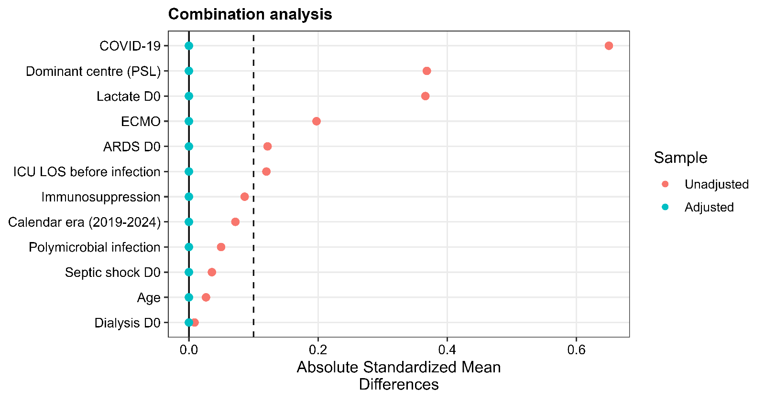
Fig. S1. Standardized mean differences before and after overlap weighting — combination therapy model. Absolute standardized mean differences for each covariate in the propensity score, comparing patients receiving combination therapy with those receiving monotherapy, before (red) and after (blue) overlap weighting. The dashed line marks the balance threshold (|SMD| = 0.10).

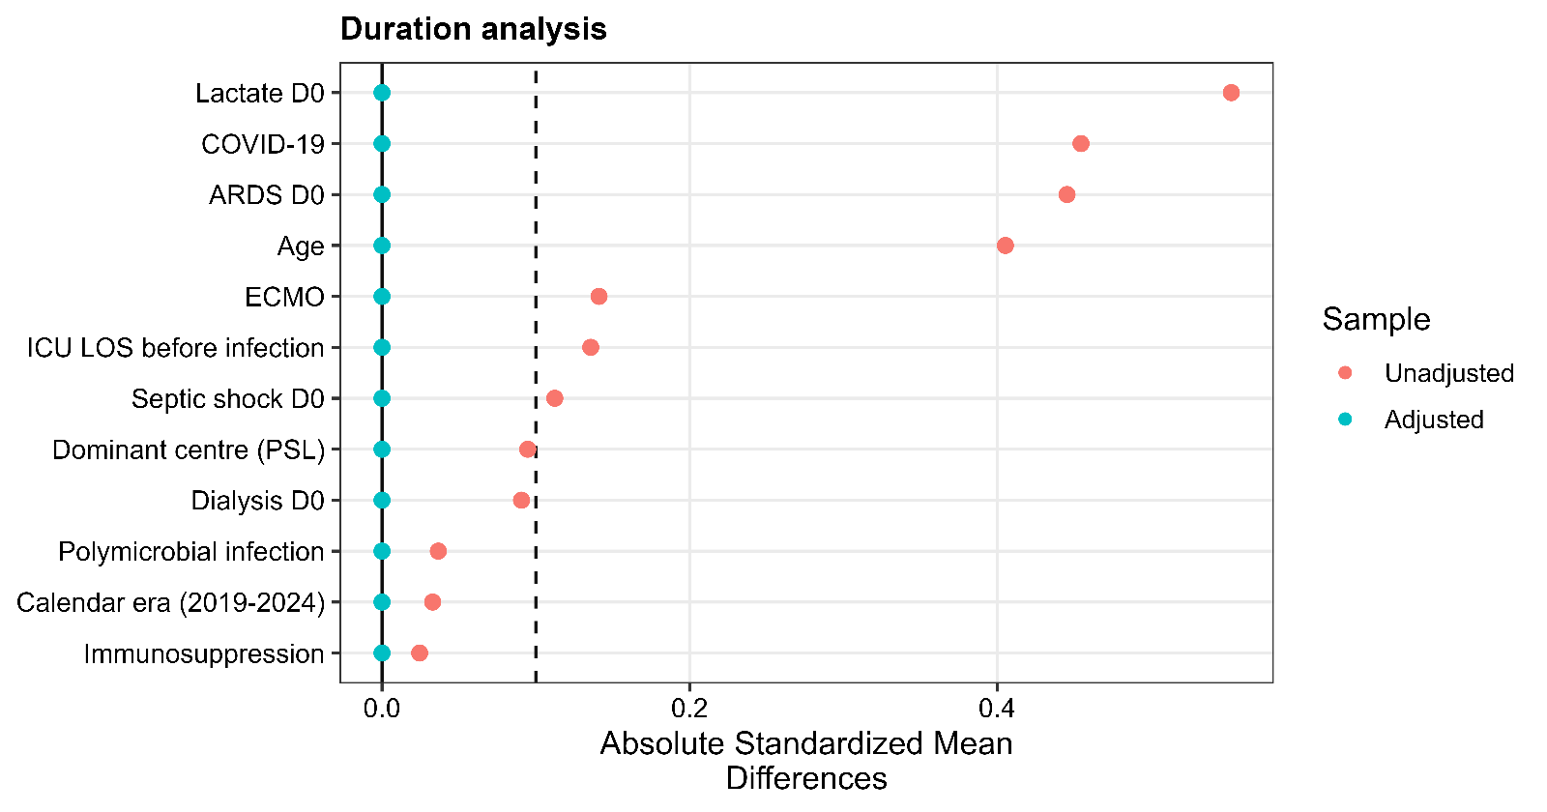
Fig. S2. Standardized mean differences before and after overlap weighting — treatment duration model. Absolute standardized mean differences for each covariate in the propensity score, comparing patients receiving more than 8 days of therapy with those receiving 8 days or less, before (red) and after (blue) overlap weighting. The dashed line marks the balance threshold (|SMD| = 0.10).

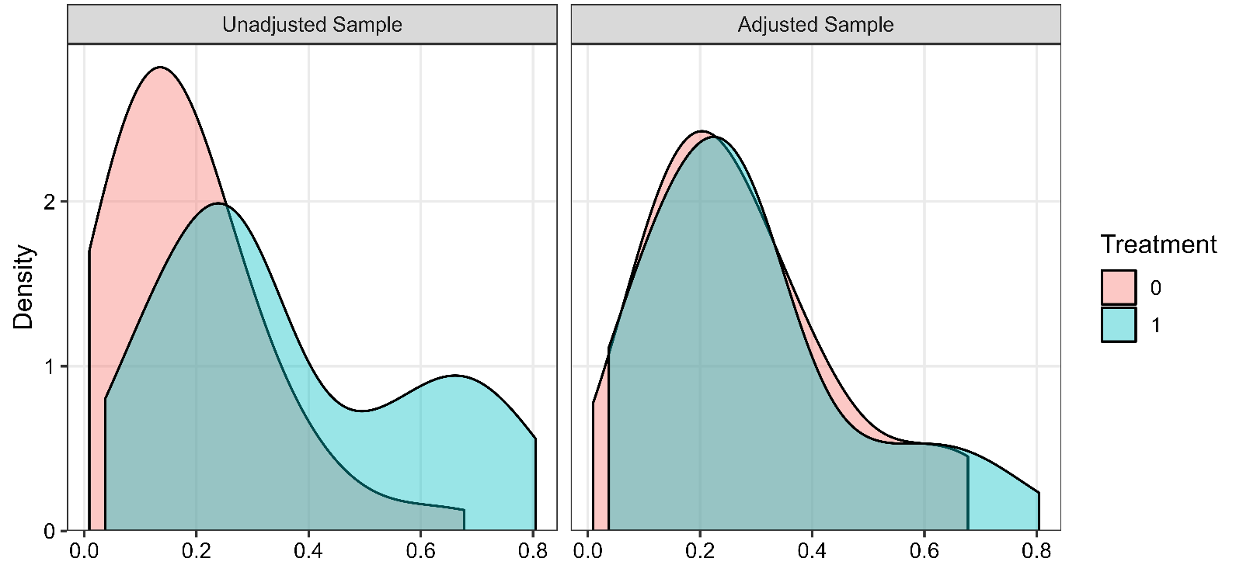
Fig. S3. Propensity-score overlap before and after weighting — combination therapy model. Density distributions of the propensity score for combination therapy versus monotherapy, before overlap weighting (left) and after overlap weighting (right).

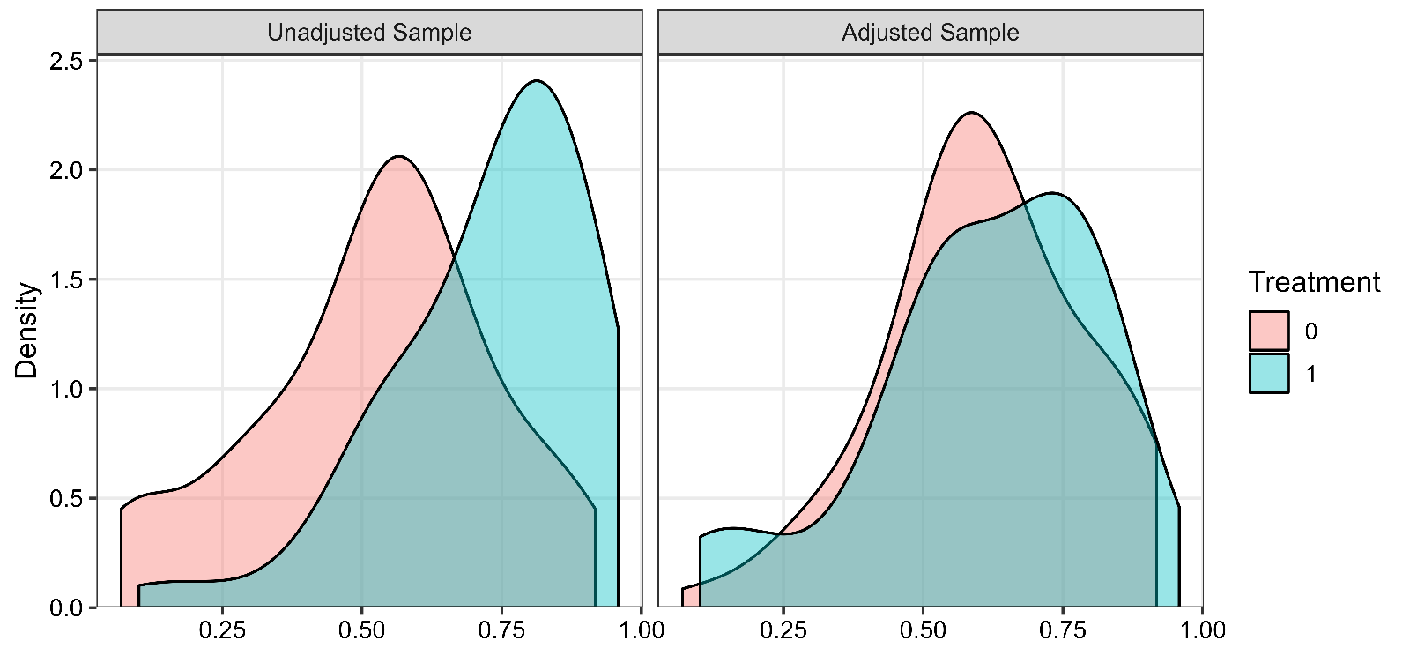
Fig. S4. Propensity-score overlap before and after weighting — treatment duration model. Density distributions of the propensity score for treatment duration >8 days versus ≤8 days, before overlap weighting (left) and after overlap weighting (right).
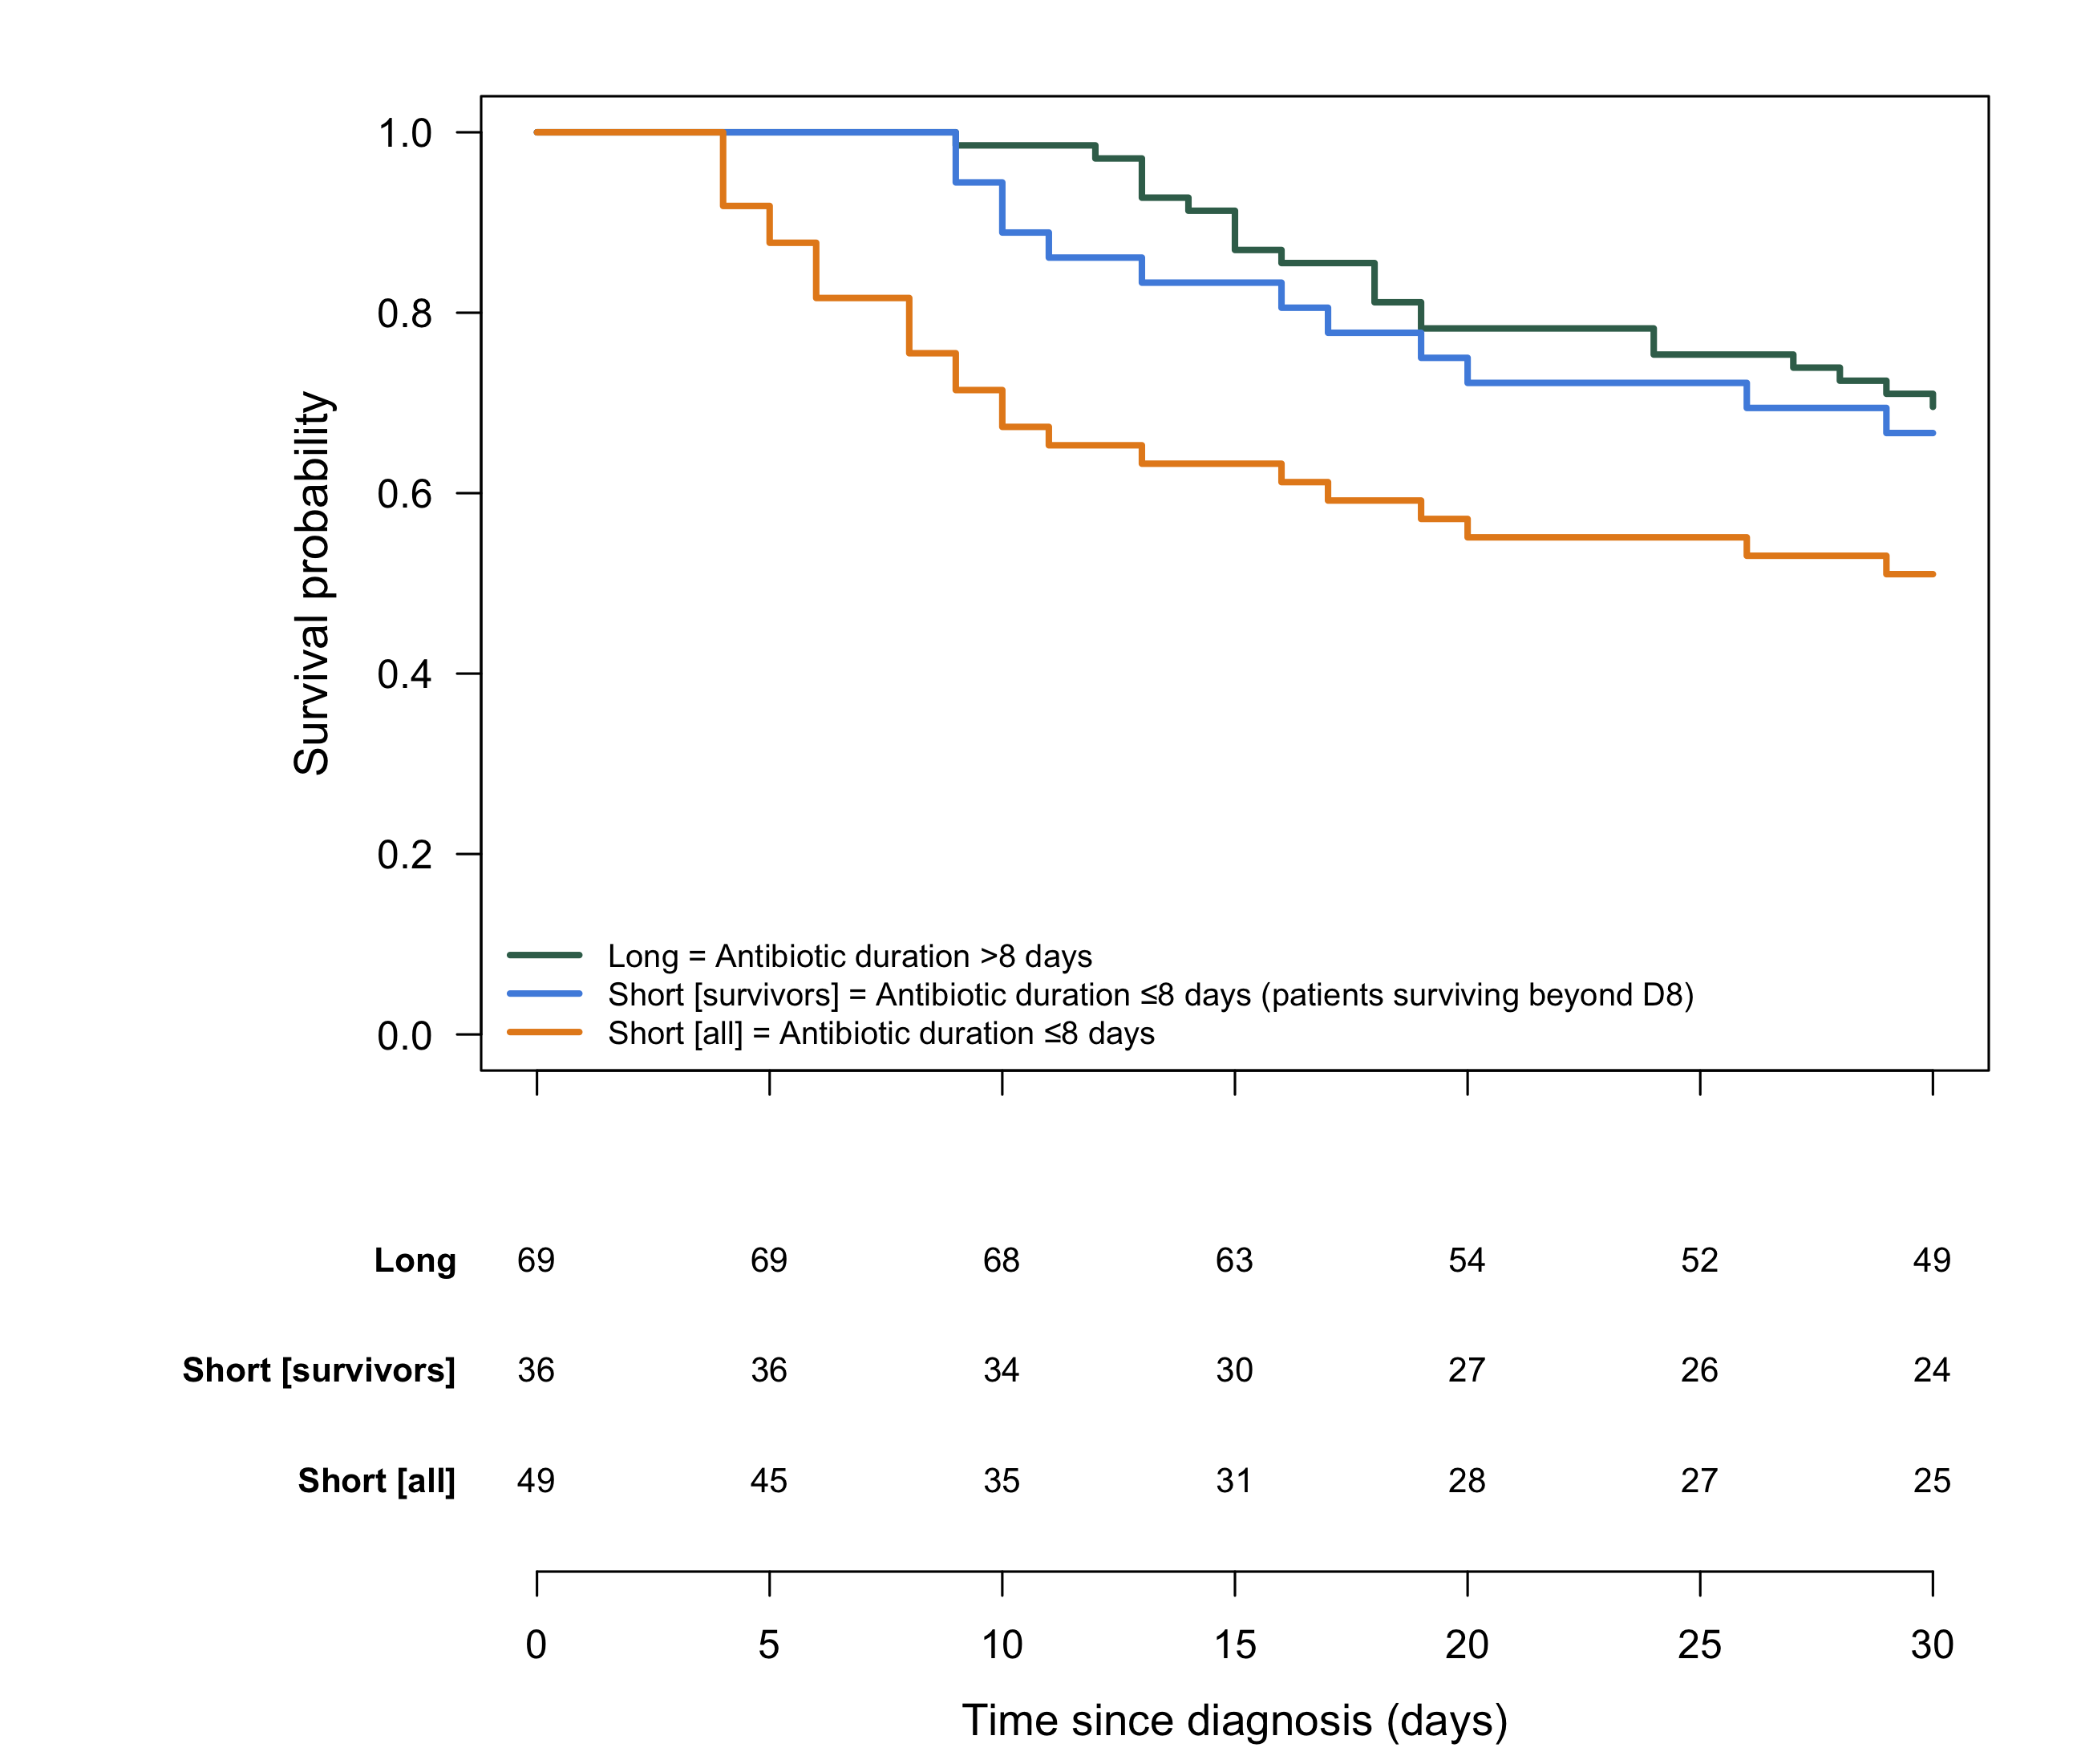

Fig. S5. Kaplan-Meier survival curves by treatment duration group. Kaplan-Meier survival curves for patients receiving antibiotic therapy for more than 8 days ("Long"), 8 days or less in the entire cohort ("Short [all]"), and 8 days or less restricted to patients alive at day 8 ("Short [survivors]").

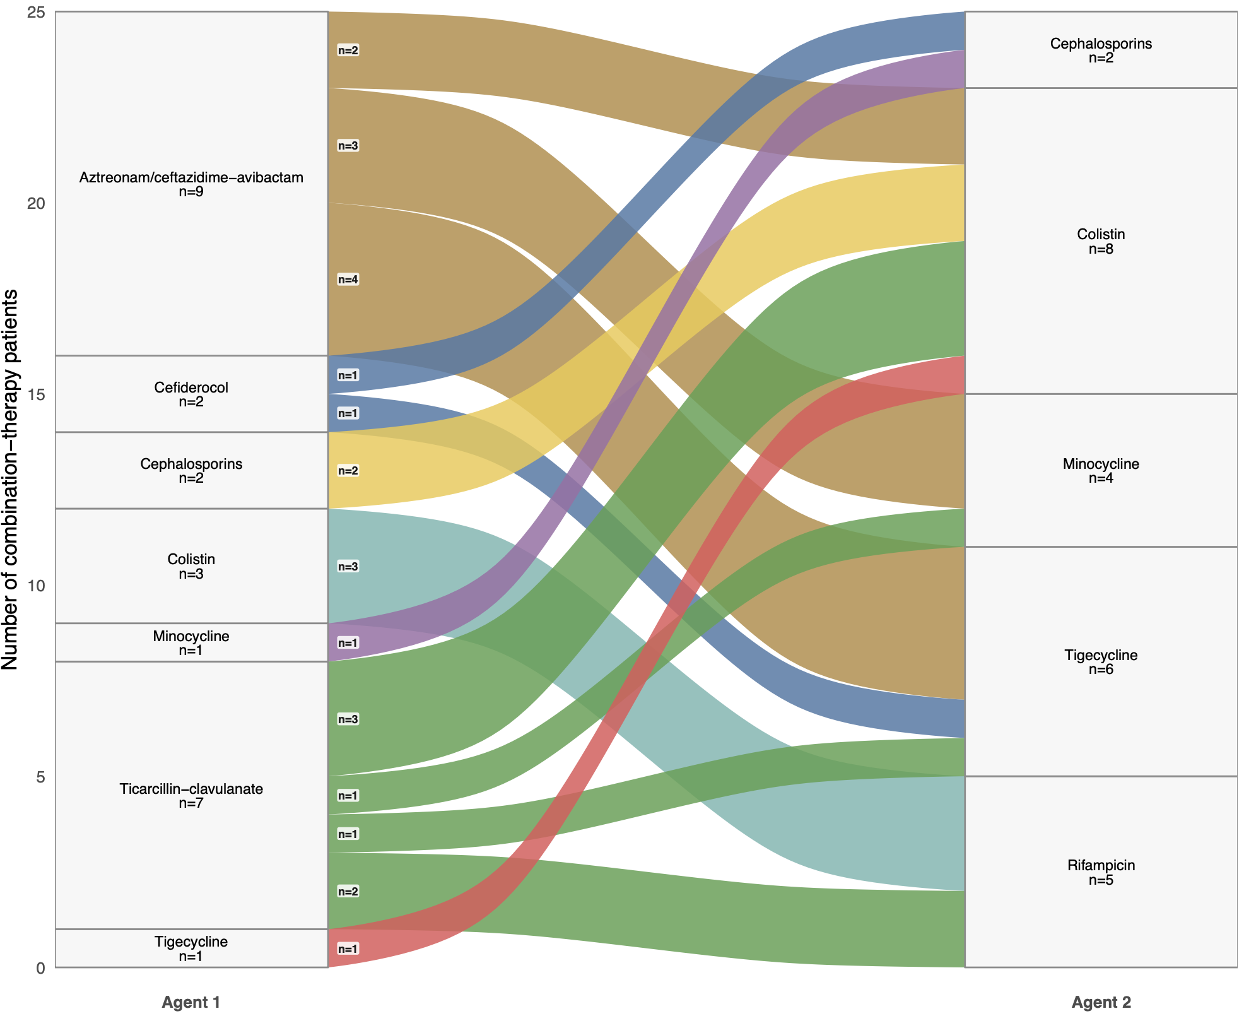
Fig. S6. Combination regimens for DTR S. maltophilia pneumonia. Alluvial diagram showing the first and second antibiotic received by combination-therapy patients, with the number of patients per branch (stratum) and per flow.

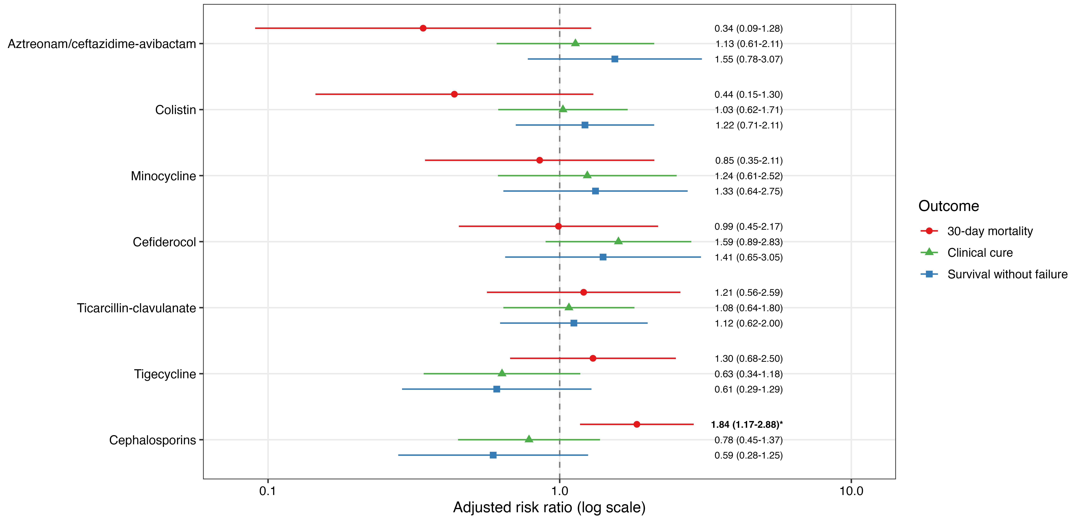
Fig. S7. Adjusted associations between antibiotic exposures and clinical outcomes in monomicrobial infections. Forest plot from the same multivariable modified Poisson regression models as the primary analysis, restricted to the monomicrobial subgroup. Risk ratios and 95% confidence intervals are shown on a logarithmic scale. Asterisks denote statistically significant associations.

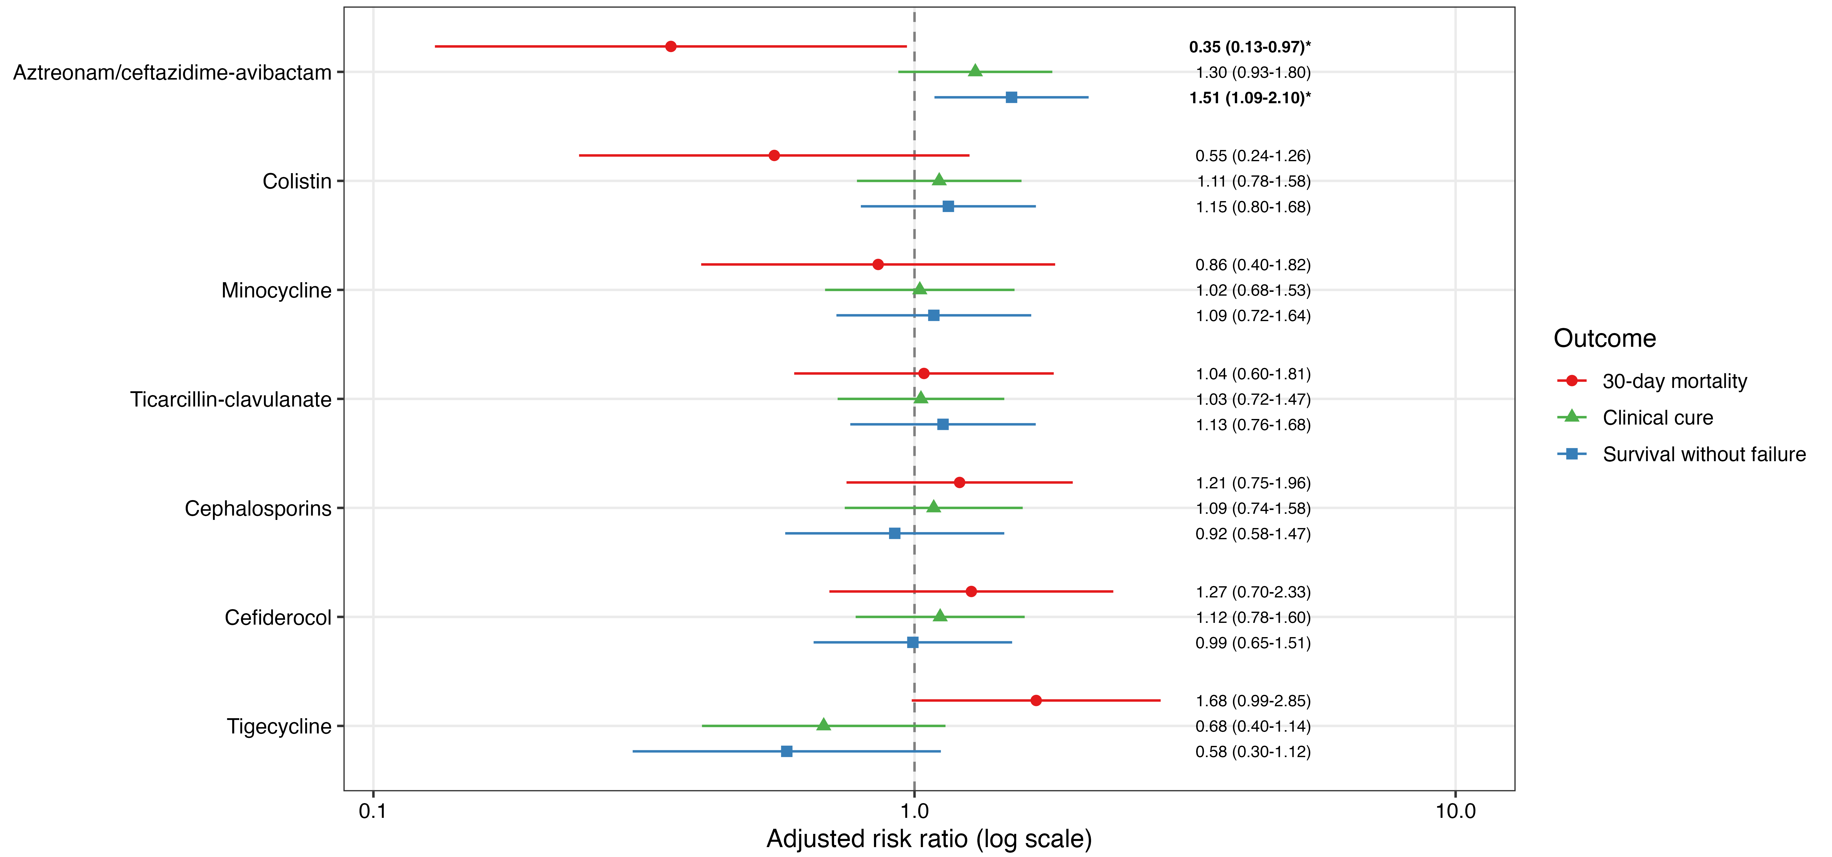
Fig. S8. Sensitivity analysis adjusting for co-administered agents. Forest plot from multivariable modified Poisson regression models identical to the primary per-agent analysis, except that the calendar-period and dominant-centre indicators were replaced by indicators of the other panel agents actually co-administered with each exposure. Risk ratios and 95% confidence intervals are shown on a logarithmic scale. Asterisks denote statistically significant associations.

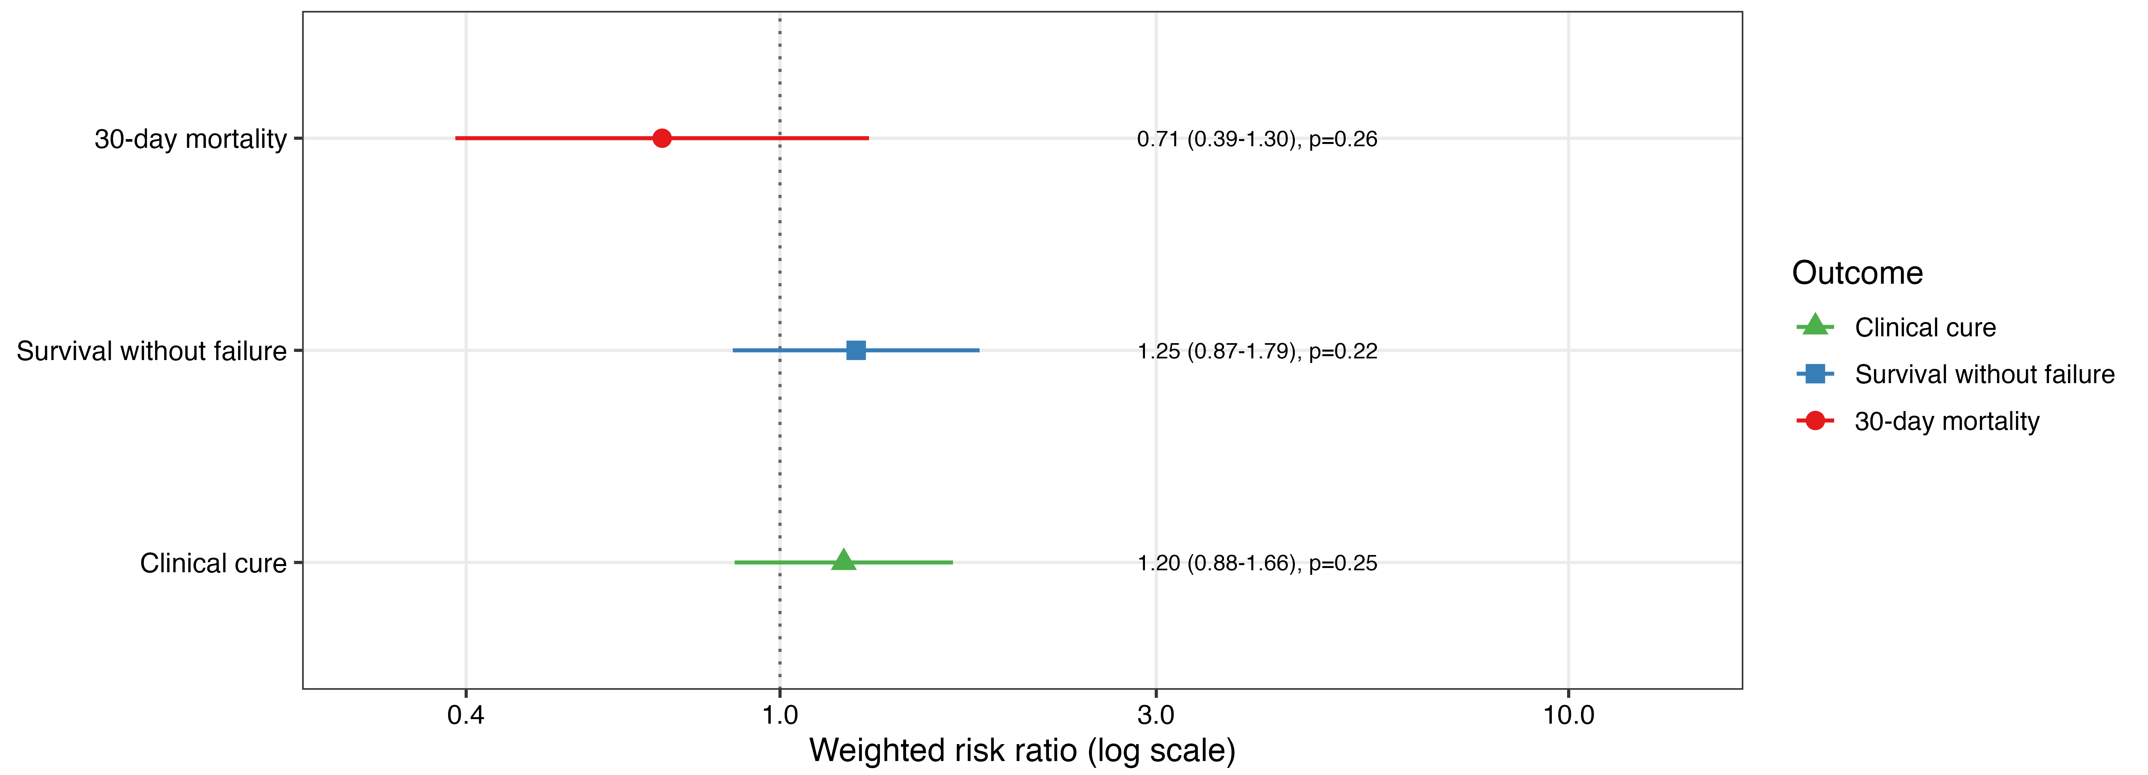

Fig. S9. Sensitivity analysis classifying aztreonam/ceftazidime-avibactam as combination therapy. Weighted risk ratios and 95% confidence intervals for 30-day mortality, clinical cure, and survival without failure, from an overlap-weighted model identical to the primary combination-therapy analysis, except that aztreonam/ceftazidime-avibactam was classified as combination therapy rather than monotherapy. Risk ratios and 95% confidence intervals are shown on a logarithmic scale. Asterisks denote statistically significant associations.

SMR-ICU Study Group
Affiliation | First name | Last name
Centre Hospitalier Universitaire de Lille, Lille, France | Anahita | Rouzé
Centre Hospitalier Universitaire de Lille, Lille, France | Caroline | Loiez
Hospital Clínico de la Univerdad Catóica, Santiago, Chile | Jaime | Labarca
Centre Hospitalier Universitaire Nord, Marseille, France | Sami | Hraiech
Centre Hospitalier Universitaire Rouen, Rouen, France | Fabienne | Tamion
Centre Hospitalier Universitaire Rouen, Rouen, France | Ludovic | Lemée
Centre Hospitalier Universitaire Rouen, Rouen, France | Soumaya | Skalli
Centre Hospitalier Universitaire d’Orléans, Orléans, France | François | Barbier
Centre Hospitalier Universitaire d’Orléans, Orléans, France | Maxime | Desgrouas
Centre Hospitalier Universitaire d’Orléans, Orléans, France | Jérôme | Guinard
Nouvel Hôpital Civil, Strasbourg, France | Ferhat | Meziani
Nouvel Hôpital Civil, Strasbourg, France | Anaïs | Curtiaud
Nouvel Hôpital Civil, Strasbourg, France | Antoine | Grillon
Centre Hospitalier Universitaire Saint-Antoine, Paris, France | Jacques | Tankovic
Centre Hospitalier Universitaire Cochin, Paris, France | Alexandra | Doloy
Centro Hospitalar Universitário São João, Porto, Portugal | José Artur | Paiva
Clinical Pathology Department, Unidade Local de Saúde São João | Edgar | Botelho-Moniz
Centre Hospitalier Universitaire Henri Mondor, Créteil, France | Keyvan | Razazi
Centre Hospitalier Universitaire Henri Mondor, Créteil, France | Jean-Winoc | Decousser
Centre Hospitalier Universitaire Henri Mondor, Créteil, France | Minh-Pierre | Lê
Centre Hospitalier Universitaire Bordeaux, Bordeaux, France | Alexandre | Boyer
Centre Hospitalier Universitaire Bordeaux, Bordeaux, France | Alicia | Silvant
Centre Hôpital Universitaire de la Pitié Salpêtrière, Paris, France | Antoine | Monsel
Centre Hôpital Universitaire de la Pitié Salpêtrière, Paris, France | Juliette | Chommeloux
Centre Hôpital Universitaire de la Pitié Salpêtrière, Paris, France | Quentin | Moyon
Centre Hôpital Universitaire de la Pitié Salpêtrière, Paris, France | Jean-Michel | Constantin
Centre Hôpital Universitaire de la Pitié Salpêtrière, Paris, France | Vincent | Degos
Centre Hôpital Universitaire Nancy-Brabois, Nancy, France | Bruno | Levy
Centre Hôpital Universitaire Nancy-Brabois, Nancy, France | Yann | Dumont
Centre Hôpital Universitaire Montpellier, Montpellier, France | Kada | Klouche
Centre Hôpital Universitaire Montpellier, Montpellier, France | Anne-Laure | Michon
Centre Hôpital Universitaire Montpellier, Montpellier, France | Marie-Noelle | Didelot
Centre Hôpital Universitaire Nîmes, Nîmes, France | Alix | Pantel
Hospital Clinic of Barcelona, Barcelona, Spain | Catia | Cilloniz
Hospital Clinic of Barcelona, Barcelona, Spain | Antoni | Torres
Hospital Clinic of Barcelona, Barcelona, Spain | Cristina | Pitart
Centre Hôpital Universitaire Clermont-Ferrand, Clermont-Ferrand, France | Bertrand | Souweine
Centre Hôpital Universitaire Clermont-Ferrand, Clermont-Ferrand, France | Renaud | Guérin
Centre Hôpital Universitaire Clermont-Ferrand, Clermont-Ferrand, France | Eugénie | Maurin
UH Cleveland Medical Center, Cleveland, United States | Robert A. | Bonomo
UH Cleveland Medical Center, Cleveland, United States | Maria F. | Mojica
Policlinico San Martino Hospital, Genoa, Italy | Matteo | Bassetti
Policlinico San Martino Hospital, Genoa, Italy | Laura | Mezzogori
Città della Salute e della Scienza Hospital, Turin, Italy | Antonio | Curtoni
Centre Hôpital Universitaire Avicenne, Bobigny, France | Khalil | Chaïbi
Centre Hôpital Universitaire Avicenne, Bobigny, France | Françoise | Jaureguy
Centre Hôpital Universitaire Européen Georges-Pompidou, Paris, France | Nicolas | Brechot
Centre Hôpital Universitaire Européen Georges-Pompidou, Paris, France | Isabelle | Podglajen
Centre Hôpital Universitaire Européen Georges-Pompidou, Paris, France | Amira | Jomli
Centre Hôpital Universitaire Bichat Claude Bernard, Paris, France | Jean-François | Timsit
Centre Hôpital Universitaire Bichat Claude Bernard, Paris, France | Etienne | de Montmollin
Centre Hôpital Universitaire Bichat Claude Bernard, Paris, France | Philippe | Montravers
Centre Hôpital Universitaire Bichat Claude Bernard, Paris, France | Naouale | Maataoui
Centre Hôpital Universitaire Bichat Claude Bernard, Paris, France | Stéphane | Lo
Centre Hôpital Universitaire Bichat Claude Bernard, Paris, France | Laurence | Armand-Lefèvre
Centre hospitalier d'Arles, Arles, France | Florent | Montini
Centre Hôpital Universitaire Grenoble, Grenoble, France | Carole | Schwebel
Centre Hôpital Universitaire Grenoble, Grenoble, France | Anaïs | Dartevel
Centre Hôpital Universitaire Grenoble, Grenoble, France | Grégoire | Fourcade
Centre Hôpital Universitaire Pontchaillou, Rennes, France | Jean-Marc | Tadié
Centre Hôpital Universitaire Pontchaillou, Rennes, France | Pauline | Guillot
Centre Hôpital Intercommunal André Grégoire, Montreuil, France | Vincent | Das
Centre Hôpital Universitaire Saint-Etienne, Saint-Etienne, France | Guillaume | Thiery
Centre Hôpital Argenteuil, Argenteuil, France | Gaëtan | Plantefève
Groupe Hospitalier de la Région de Mulhouse et Sud-Alsace, Mulhouse, France | Khaldoun | Kuteifan
Groupe Hospitalier de la Région de Mulhouse et Sud-Alsace, Mulhouse, France | Joy | Mootien
Groupe Hospitalier de la Région de Mulhouse et Sud-Alsace, Mulhouse, France | Alain | Gravet
Centre Hôpital Le Mans, Le Mans, France | Christophe | Guitton
Centre Hôpital Le Mans, Le Mans, France | Thomas | Douillard
Hôpital Nord, Marseille, France | Marc | Leone
Hôpital Nord, Marseille, France | Marie | Fleury
Centre Hôpital Universitaire Poitiers, Poitiers, France | Arnaud | Thille
Centre Hôpital Universitaire Poitiers, Poitiers, France | François | Arrivé
Centre Hôpital Victor Jousselin, Dreux, France | Florent | Bavozet
Centre Hôpital Universitaire Limoges, Limoges, France | Philippe | Vignon
Centre Hôpital Universitaire Dijon, Dijon, France | Jean-Pierre | Quenot
Centre Hôpital Universitaire Ambroise Paré, Boulogne Billancourt, France | Antoine | Vieillard-Baron
Centre Hôpital Universitaire Ambroise Paré, Boulogne Billancourt, France | Matthieu | Petit
Centre Hôpital Universitaire Tenon, Paris, France | Alexandra | Beurton
Centre Hôpital Universitaire Tenon, Paris, France | Laila | Fassi Fihri
Centre Hôpital Louis Mourier, Colombes, France | Damien | Roux
Hospital Hygeia, Athens, Greece | Ilias | Karaiskos
Azienda Ospedaliero-Universitaria Pisana, Pisa, Italy | Marco | Falcone
Azienda Ospedaliero-Universitaria Pisana, Pisa, Italy | Giusy | Tiseo
Ospedale San Raffaele, Milano, Italy | Marco | Ripa
University of North Carolina Hospital, Chapel Hill, NC, US | David | Van Duin
University of North Carolina Hospital, Chapel Hill, NC, US | Trieu-Vi | Khuu

