Supplementary Material B

The MIME Model

Previous models and the problem during spontaneous breathing
The objective of the MIME method is to estimate the patient respiratory mechanics (elastance, E and resistance, R), as well as the respiratory muscle pressure (Pmus) signal, in order to minimize the gap between the estimated and measured airway pressure (Paw). More formally, the objective is to minimise the distance between the two Paw signals as detailed in (Eq. Supp. 7).
In the presence of patient breathing efforts (i.e., $\left|P_{mus}\right|>0$), the model described by Equation (3) – where Q and V are measured flow and volume respectively, and Paw is the estimated airway pressure – becomes underdetermined. More specifically, if the modelled Pmus signal can take on any shape, an infinite number of combinations of E, R, and Pmus exist that equally minimize the distance between estimated and measured airway pressures.
Supplementary Figure 1 provides an example where the modelled Pmus signal is unconstrained. Considering Equation (3), in this example, any values for [E, R] can be considered and a corresponding Pmus can be determined that ensures a perfect fitting (i.e., measured and modelled Paw signals perfectly overlap). In fact, a perfect model fit can be obtained with various combination of values for [E,R], regardless of the physiological accuracy of the estimates for respiratory mechanics and the muscle pressure signal.

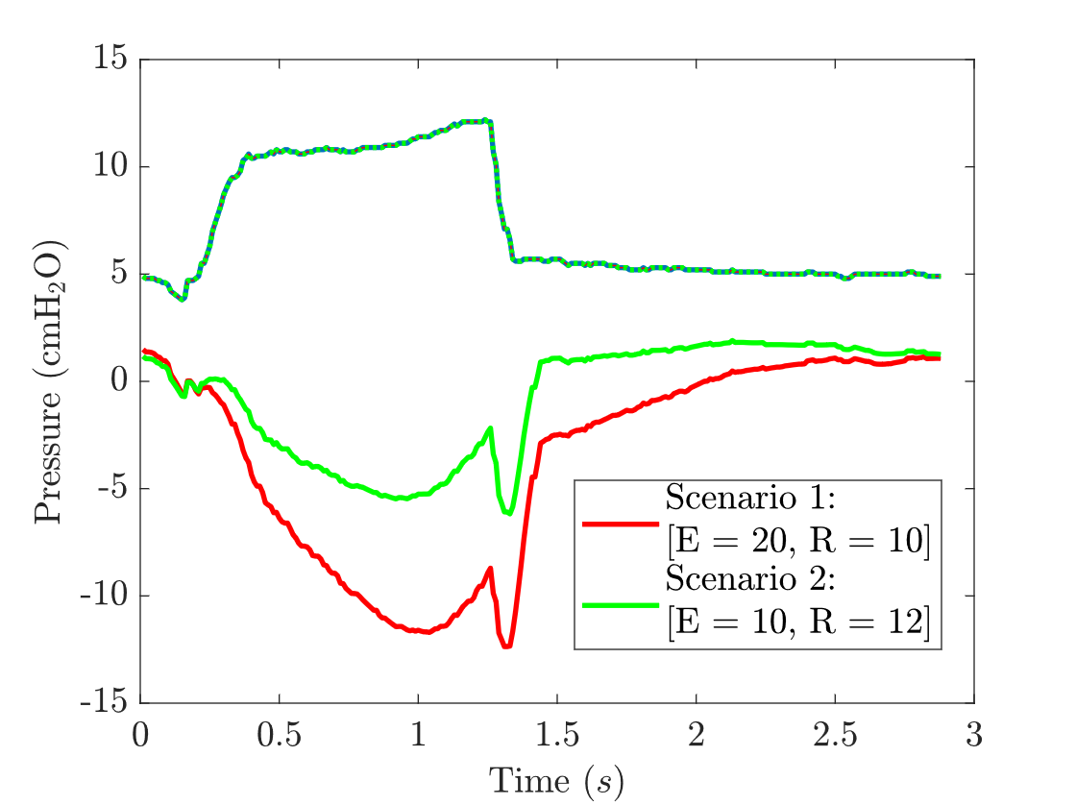
Supplementary Figure 1 considers two scenarios where the respiratory mechanics values (E and R) are arbitrarily chosen and subsequently, Pmus is calculated by Equation (3) to ensure a perfect fitting where modelled and measured Paw perfectly overlap. Two sets of respiratory mechanics are arbitrarily chosen and subsequently, two different Pmus signals are calculated with different shapes and magnitudes. In Scenario 1 (Red), E = 20 cmH₂O/L and R = 10 cmH₂O/L/s; Scenario 2 (Green), E = 10 cmH₂O/L and R = 12 cmH₂O/L/s. In both scenarios, the corresponding modelled Paw signals both perfectly overlap measured Paw (shown by the dotted and dashed lines) indicating a perfect fitting. Therefore, where modelled Pmus is unconstrained, perfect model fittings can be achieved with inaccurate estimations of respiratory mechanics and the muscle pressure signal.
Supplementary Figure S1 Two perfect fittings of modelled airway pressure signal to measured airway pressure signal. Respiratory mechanics are arbitrarily chosen, and a modelled muscle pressure is determined from Equation 3 to achieve the perfect fitting. In Scenario 1) E = 20 cmH₂O/L and R = 10 cmH₂O/L/s, and in Scenario 2) E = 10 cmH₂O/L and R = 12 cmH₂O/L/s.
The MIME model
A complete description of the MIME model is provided. MIME aims to extend upon the work of previous model-based estimation methods to improve accuracy and computational performance (3-6). The MIME model yields constant estimates for a patient’s respiratory mechanics over multiple breaths, and a waveform representing the pressure generated by the patient’s inspiratory muscles (Pmus) via solving a minimisation problem. The aim of the minimisation problem is to minimise the difference between the measured and modelled airway pressure.
Airway pressure has previously been modelled in literature (1), as described by Eq. (3). A number of additions to this model have been considered in this study. First, separate respiratory mechanics for ventilator inspiratory ([Rinsp, Einsp]) and expiratory ([Rexp, Eexp]) portions of the breath are considered. Second, Pmus is described by the summation of a series b-spline functions scaled by corresponding spline coefficients ($P_{s}$):
$Pmus\left(t\right)=\sum_{i=1}^{N_{b}}{\sum_{j=1}^{M_{i}}{-P_{s,i, j}}ϕ_{i,j,2}\left(t\right)},$ (Eq. Supp. 3)
where, $ϕ_{i,j,2}$ are 2nd order (d =2) b-spline functions, defined recursively as:
$ϕ_{i,j,0}\left(t\right) = \{\begin{matrix}1, & T_{j}<t<T_{j+1} \\ 0, & \text{otherwise},\end{matrix}$ (Eq. Supp. 4)
$ϕ_{i,j,d}\left(t\right)=\frac{t-T_{j}}{T_{j+d}-T_{j}}ϕ_{i,j,d-1}\left(t\right)+\frac{T_{j+d+1}-t}{T_{j+d+1}-T_{j+1}}ϕ_{i,j+1,d-1}\left(t\right), d≥1,$ (Eq. Supp. 5)
where $T$ represents equal spaced points in time with a length between successive points equal to the knot width ($k_{w}=0.05$). $M_{i}=\frac{T_{max, i}}{k_{w}}+d$ number of splines are used to describe the $i$-th breath. $T_{max, i}$ represents the total time considered in the model fitting for breath $i$ rounded to the nearest multiple of $k_{w}$. The total number of splines used to describe Pmus per model fitting can therefore be determined as $M_{total}=\sum_{i=1}^{Nb}{M_{i}}$ for $N_{b}=20$ breaths.
Incorporating (Eq. Supp. 3), as well as separate inspiratory/expiratory respiratory mechanics parameters ([Einsp, Rinsp], [Eexp,Rexp]), the B-MIQP model can then be fully described as:
$Paw\left(t\right)=PEEP+{Ei}_{nsp}V\left(t\right)\left(1-γ\left(t\right)\right)+R_{insp}Q\left(t\right)\left(1-γ\left(t\right)\right)+E_{exp}V\left(t\right)γ\left(t\right)+R_{exp}Q\left(t\right)γ\left(t\right)+\sum_{i=1}^{\left\{Nb\right\}}{\sum_{j=1}^{M}{-P_{s,i,j}Φ_{i,j,2}\left(t\right)},}$ (Eq. Supp. 6)
where $γ$ is a binary vector that is equal to 0 during ventilator inspiration and 1 during ventilator expiration. Solving the model is achieved by least squares minimisation of the difference between the modelled Paw (Paw,est) and measured Paw, yielding the smallest objective cost (J).
$J=\sum_{t_{start}}^{t_{end}}{{\left(P_{aw}\left(t\right)-P_{aw,est}\left(t\right)\right)}^{2}}$ (Eq. Supp. 7)
The model (Eq. Supp. 6) is subject to a number of constraints used to implement domain knowledge that improves estimation performance by excluding non-physiological solutions.

Constraints
Assumptions about the shape of Pmus are incorporated into the model to encourage the model towards a unique numerical solution. First, it is assumed that Pmus will be first monotonically decreasing and subsequently increasing during inspiration, and absent during expiration. Second, we assume that the breathing effort shall finish prior to ventilator cycling. As discussed in (Vicario, et al., 2016), model estimates are uniquely identifiable (i.e., only one numerical solution exists) if patient efforts finish prior to ventilator cycling. In this scenario, any variation in the airway pressure signal in between the end of patient inspiratory effort and ventilator cycling can only be described by the resistance dependent ($P_{res}=QR$) and elastance dependent ($P_{elas}=VE$) pressures.
During this period, $P_{mus}=0$ and therefore:
$$△P_{aw}\left(t\right)=△V\left(t\right)E+△Q\left(t\right)R$$
This effectively decouples the problem as E and R can be estimated over this period independently from Pmus. Subsequently, the respiratory mechanics estimates can then be used to uniquely identify Pmus over the earlier part of ventilator inspiration.
As clinicians aim to adjust the ventilator settings such that neural and ventilator inspiration occur concurrently, this period of the breath can be quite short in length and therefore comparatively more prone to estimation error due to the small number of data points available for fitting. Furthermore, noise present in the ventilator signals can further corrupt the underlying signal, making fitting over a small portion of the breath difficult. This negative effect is mitigated by fitting the model to 20 breaths at a time, such that more data points are available for fitting and therefore, the potential for estimation error is minimized. In addition, fitting to multiple breaths at a time ensures that any variation in Paw between breaths is captured as changes in breathing effort, rather than non-physiological changes in respiratory mechanics. To this end, using a b-spline based solution is critical as it extensively reduces the computation complexity to solve the model, thereby allowing multiple breaths to be considered concurrently without incurring prohibitive computation times.
Three constraint regions have been defined which enforce assumptions about the shape of $P_{mus}$. Consecutive $P_{s}$ values are constrained relative to one another to enforce the assumed regions of monotonicity. A unique relationship between consecutive $P_{s}$ values was enforced for each region.
$\begin{matrix}\text{Region 1}: & P_{s,i,j+1}≥P_{s,i,j}+ ϵ, \\ \text{Region 2}: & P_{s,i,j+1}+ ϵ{≤P}_{s,i,j}, \\ \text{Region 3}: & P_{s,i,j}=0,\end{matrix}$ (supp. 8)
where $ϵ$ is a small constant to drive a minimum variation between successive $P_{s}$ values in region’s 1 and 2. Combined, the three regions enforce the assumption that a breathing effort will be first monotonically decreasing and then monotonically increasing during an inspiratory effort, and that no expiratory effort is present. The boundaries between regions for each breath are determined using three switching point binary decision variables ($b_{i,j,k}$) per breath. $b_{i,j,k}$ for breath $i$ is a vector equal in length to $M_{i}$, sampled at a rate $j$ that aligns with the peaks of each b-spline curve, for all $k=\left[1,2,3\right]$. The value of $b_{i,j,k}$ (i.e, whether $b_{i,j,k}$ is 0 or 1) at each sampled point in time $j$ is determined by the model within a mixed integer framework.
For each b-spline in each breath, relevant $b_{i,j,k}$ are evaluated against a set of inequalities, to determine which region constraint (Eq. Supp. 8) to enforce. Considering the $l$-th b-spline in the $i$-th breath, the following inequalities are evaluated:
$\begin{matrix}\sum_{j=1}^{l}{b_{i-1,j,3}- \sum_{j=1}^{l}{b_{i,j,1}≥ }} 0.5 & → & \{\text{Region 3}\}, & \\ \sum_{j=1}^{l}{b_{i,j,1}}-\sum_{j=1}^{l}{b_{i,j,2}}≥ 0.5 & → & \{\text{Region 1}\}, & \\ \sum_{j=1}^{l}{b_{i,j,2}}-\sum_{j=1}^{l}{b_{i,j,3}}≥ 0.5 & → & \{\text{Region 2}\}, & \\ \sum_{j=1}^{l}{b_{i,j,3}}-\sum_{j=1}^{l}{b_{i+1,j,1}}≥ 0.5 & → & \{\text{Region 3}\}, & ∀1<i<N_{b}\end{matrix}$ (Eq. Supp. 9)
for $b_{i,j,k}$ $i=2, …., N_{b}-1$, $j=1,…,M_{i}$ and $k=1,…,N_{s}$. Three switching points are used per breath considered (i.e., $N_{s}=3$ for all $i$). For breath $i=1$, inequality 1 is instead evaluated as $\sum_{j=1}^{l}{b_{1,j,1}}≤0.5→\{\text{Region 3\}}$. Similarly, for breath $i=N_{b}$, inequality 4 is instead evaluated as $\sum_{j=1}^{l}{b_{N_{b},j,3}≥0.5→\{\text{Region 3\}}}$.
The time location of the $k$-th switching point for the $i$-th breath can be recovered as:
$T_{s,i,k}=\sum_{j=1}^{M_{i}}{t_{peak, i, j}}⋅b_{i,j,k},$ (Eq. Supp. 10)
where $t_{peak,i,j}$ represents a vector containing the location of the peak of each b-spline function used to describe breath $i$. Of note, $ϕ_{i,j,2}$ and $t_{peak,i,j}$ are arranged such that switching points align with peaks of b-spline functions.
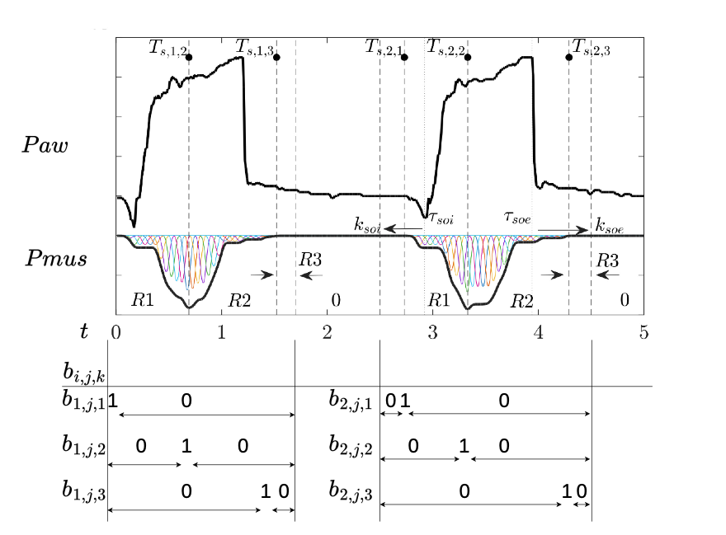
To further illustrate the model, Supplementary Figure 2 shows the construction of two subsequent breathing estimates (Pmus) utilising $ϕ_{i, j,2}$, $P_{s,k}$, and $b_{i,j,k}$. Considering breath $i=2$, the location of the second (i.e., $k=2$) switching point $T_{s,2,2}$ can be determined as $T_{s,2,2}=\sum_{j=1}^{M_{2}}{t_{peak,2}\left(τ\right)⋅b_{2,2}\left(τ\right)}= 3.25$ seconds, where $b_{2,2}\left(k\right)=1$ at time, $t_{peak,2}\left(τ\right)=3.25$ (i.e., aligning with the peak of b-spline $j=τ$).
Supplementary Figure S2 Construction of patient effort estimate waveform (Pmus) for 2 breaths using b-spline curves (multi-color) and binary decision variables ($b_{i,j}$). Switching points ($T_{s,i,j}$) represents the boundaries between Regions (R) 1,2, and 3; and the additional region between breaths (identified by “0”) where Pmus = 0 at each point in time. $k_{soi}$ and $k_{soe}$ relative to ventilator triggering ($τ_{soi}$) and cycling ($τ_{soe}$), define the length of each breath where Pmus is described using b-spline curves ($T_{max}$).
As shown in Supplementary Figure 2, b-spline functions for each breath $i$, are defined only over the intervals [$τ_{soi,i} - k_{soi}$, $τ_{soe,i}+k_{soe}$]. As such, the duration of the section of Pmus described for breath $i$ is given by:
$T_{max,i}=$ $τ_{soe,i}+k_{soe}-\left(τ_{soi,i}-k_{soi}\right).$ (Eq. Supp. 11)
Outside of the aforementioned intervals, breathing effort is assumed to be absent for all breaths (i.e., $Pmus\left(t\right) = 0$) at each point in time.
The locations of switching points are constrained relative to the triggering and cycling of the ventilator. For each breath $i$, the location of the inspiratory switching point ($T_{s,i,1}$) is constrained to occur prior to or at the point of ventilator triggering ($τ_{soi,i}$) within $k_{soi}=0.6$ seconds, such that:
$τ_{soi, i}-k_{soi}≤T_{s,i,1}≤τ_{soi, i}$ (Eq. Supp. 12)
Similarly, the expiratory switching point for a given breath ($T_{s, i,3}$) must occur prior to $k_{soe}=0.5$ seconds after the point of ventilator cycling ($τ_{soe,i}$) for breath $i$.
$T_{s, i,3}≤k_{soe}+τ_{soe, i}$ (Eq. Supp. 13)
Switching points are constrained such that only one switching point can occur at any one point in time:
$\sum_{k=1}^{N_{s}}{b_{i,j,k}}≤1 ∀i ∀j.$ (Eq. Supp. 14)
Finally, switching points are constrained such that they must occur sequentially. As such, for a given b-spline $l$, the following two inequalities hold true:
$\sum_{j=1}^{l}{b_{i,l,2}}-\sum_{j=1}^{l}{b_{i,l,1}}≤0 ∀i ∀l∈\{1,…,M_{i}\},$
$\sum_{j=1}^{l}{b_{i,l,3}}-\sum_{j=1}^{l}{b_{i,l,1}}≤0 ∀i ∀l∈\{1,…,M_{i}\},$ (Eq. Supp. 15)

References
- Bates, JH. Lung mechanics: an inverse modeling approach. Cambridge: Cambridge University Press. 2009.
- Bertoni M, Telias I, Urener M, Long M, Del Sorbo L, Fan E. A novel non-invasive method to detect excessively high respiratory effort and dynamic transpulmonary driving pressure during mechanical ventilation. Critical Care. 2019; 23:346.
- Vicario F, Albanese A, Karamolegkos N, Wang D, Seiver A, Chbat N W. Noninvasive Estimation of Respiratory Mechanics in Spontaneously Breathing Ventilated Patients: A Constrained Optimization Approach. IEEE Transactions on Biomedical Engineering.2016,63(4): 775-787.
- Knopp JL, Chase JG, Kim KT, Shaw GM. Model-based estimation of negative inspiratory driving pressure in patients receiving invasive NAVA mechanical ventilation. Computer Methods Programs in Biomedicine. 2021 Sept;208:106300.
- Guy EF, Chase JG, Knopp JL, Shaw GM. Quantifying ventilator unloading in CPAP ventilation. Computers in Biology and Medicine. 2022;142:105225.
- Victor Jr MH, Maximo MR, Matsumoto MM, Pereira SM, Tucci MR. Mixed‐integer quadratic programming approach for noninvasive estimation of respiratory effort profile during pressure support ventilation. International Journal for Numerical Methods in Biomedical Engineering. 2023;39(1):e3668.

