Supplementary Material C

$P_{pl}$ estimate conversion to $P_{mus}$
As described in Section Model set-up and optimization, when first developing the Mixed Integer Multi-Effort (MIME) model, it was observed that the recovered effort signal could be consistent with different physiologically plausible pressure dynamics. For the purpose of the present post-processing procedure, two clinically relevant cases were operationally considered: signals more closely aligned with pleural pressure (Ppl) dynamics and signals more closely aligned with inspiratory muscle pressure (Pmus) dynamics. These represent two relevant interpretations rather than the full range of physiologically plausible solutions.
These findings align with those of Vicario et al. (1) where it was demonstrated that ventilator signals alone cannot guarantee a physiologically consistent solution when considering estimates of patient breathing effort derived from the equation of motion. In both cases, esophageal pressure (Pes) derived signals provide a physiological reference for Ppl and Pmus. Specifically, in the first case, where the modeled inspiratory effort signal aligns with ΔPes, we expect that the estimated (Einsp) value estimated represents an estimate of the patient’s lung elastance (i.e., $Einsp=El$) and the modelled inspiratory effort signal provides an estimate of pleural pressure (Ppl) .
$Paw\left(t\right)=V\left(t\right)El+Q\left(t\right)Rinsp+PEEP+Ppl\left(t\right)$ (Eq. Supp. 16)
Comparatively, where modelled Pmus better aligns with Pes-derived Pmus, we expect that Einsp represents the overall elastance of the respiratory system, including contributions from the chest wall (i.e., $E={Ers}_{ }=El+Ecw$).
$Paw\left(t\right)=V\left(t\right)Ers+Q\left(t\right)R+PEEP+Pmus\left(t\right)$ (Eq. Supp. 17)
As a useful clinical tool, it is desired that the MIME method consistently provides estimates of the patient’s muscle pressure. A protocol has been implemented that identifies instances where the model likely produces a Ppl estimate and converts these estimates to Pmus, utilizing empirically estimated chest wall elastance values.
It was identified that in the Pmus case, the identified inspiratory resistance (Rinsp) values where consistently larger (16.71 [ 15.33, 21.21] cmH₂O/L/s) than the those when MIME outputs aligned better with Pes dynamics (12.07 [ 9.92, 13.50] cmH₂O/L/s) (Supplementary Figure 3). Of note, the physiological interpretation of the numerical solution may be influenced by inspiratory effort magnitude, measurement noise, and the imposed assumption that estimated Pmus returns to zero during expiration. Nonetheless, the model convergence characteristics could not be conclusively determined by physiological reasoning in this study.
Rather, in this study, the two cases could be systematically categorised considering estimated Rinsp values. Subsequently, a conversion protocol was implemented such that solutions that most plausibly aligned with Ppl could be converted to estimates of Pmus. This ensures that a physiologically consistent estimate of Pmus can be provided in all cases.
It was concluded that breathing effort estimates most often agree better with Ppl where Rinsp < 15 cmH₂O/L/s. In these instances, Einsp is assumed to represent the patient’s lung elastance (E_{L}), reflecting the scenario described by (Eq. Supp. 16). As such, to obtain an estimate of Pmus, an empirical estimate of the patient’s chest wall elastance (Ecw) was summated with the initial Einsp, in order to obtain an estimate of the patient’s overall respiratory system elastance (Ers).
$Ers =Einsp+Ecw$ (Eq. Supp. 18)
For all patients, for which this post-processing step was applied, Ecw was estimated from the Baldwin–Cournand–Richards prediction equations based on predicted vital capacity (discussed in Supplementary Material A) (2).
Therefore, using Ers, the model could be resolved with fixed values for [Ers, Rinsp], such that the solution better represented the scenario described by Equation (Supp. 16).
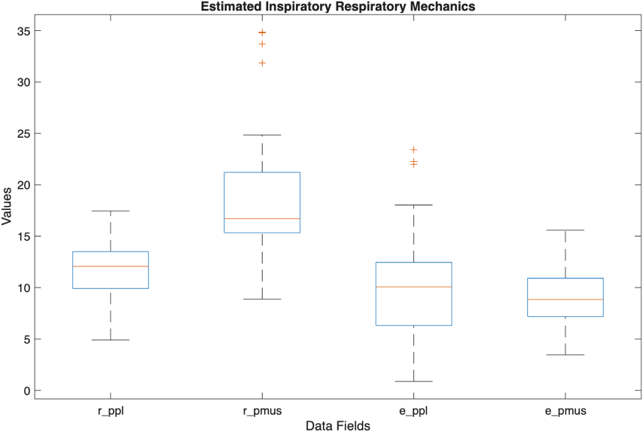

Supplementary Figure S3. Respiratory mechanics estimates derived from the MIME model where the patient effort estimate best aligns with the pleural pressure solution (Ppl) or the Pes-derived muscle pressure solutions (Pmus). Abbreviations: MIME, mixed integer multi-effort; [X]ppl and [X]pmus, MIME derived inspiratory respiratory values aligning with Ppl and Pmus model solutions.
Sensitivity Analysis 1: threshold for classification of solution
The post-processing procedure considered in this study, although physiologically motivated, is empirical. In particular, the inspiratory resistance (Rinsp) threshold for classification of MIME solutions is tuned to the current cohort and may not immediately generalize to other populations. As such, to evaluate the robustness of MIME to moderate variation in the Rinsp threshold, the method’s breath-by-breath discrimination performance to detect excessive respiratory efforts was evaluated for different classification thresholds: Rinsp = [12.5, 15, 17.5] cmH₂O/L/s. As in the main study, excessive high and low breathing efforts were defined by Pes-derived peak muscle pressure > 10 cmH₂O and < 5 cmH₂O respectively. The outcomes of the sensitivity analysis are listed in the Supplementary Table 1.

Supplementary Table S1 Discrimination performance of MIME considering Rinsp = [12, 15, 17.5] cmH2O/L/s thresholds for post-processing procedure.
Threshold  Rinsp  (cmH₂O/L/s) | Agreement  Mean Bias (LOA)  (cmH₂O) | AUROC Detect High Effort  Pes-derived Pmus > 10 cmH₂O | AUROC Detect Low Effort  Pes-derived Pmus < 5 cmH₂O
12.5 | 0.67 (-4.75 to 6.1) | 0.83 | 0.80
15 | 0.4 (-3.4 to 4.2) | 0.83 | 0.88
17.5 | -0.15 (-4.89 to 4.6) | 0.86 | 0.88

Performance quantified by area under receiver operating characteristic curve (AUROC) values. Abbreviations: MIME, mixed integer multi-effort; Rinsp, MIME-derived inspiratory resistance; LOA, limits of agreement; Pes, esophageal pressure; Pmus, inspiratory muscle pressure
Overall, MIME performance remains relatively stable for moderate variation in the Rinsp threshold, although changes in the classification threshold produced a trade-off between agreement and discriminative performance. For detection of high inspiratory effort (Pes-derived Pmus > 10 cmH₂O), Area under the receiver operating characteristic curve (AUROC) values remained consistent when the threshold was reduced (0.83) and showed a modest increase at the higher threshold (0.86). However, both alternative thresholds produced wider limits of agreement compared to the nominal value of Rinsp = 15 cmH₂O/L/s.
A similar pattern was observed for detection of low inspiratory effort (Pes-derived Pmus < 5 cmH₂O). Discriminative performance was preserved at the higher threshold (AUROC 0.88), while a reduction in performance was observed at the lower threshold (AUROC 0.80). Again, these changes were accompanied by reduced agreement, particularly at the lower threshold.
Taken together, these findings indicate that the principal conclusions of this study were not substantially altered by moderate variation in the Rinsp threshold. Nevertheless, the selected threshold influenced the balance between agreement with the physiological reference and the discrimination of excessive breathing efforts. The nominal threshold of Rinsp = 15.0 cmH₂O/L/s provided the narrowest limits of agreement while maintaining strong discrimination for both high and low inspiratory effort. Evaluation of the selected threshold in external cohorts should be independently validated.
Sensitivity Analysis 2: discriminative performance of MIME limited to measured chest-wall elastance patients
In 11/18 of the patients considered in this study, Ecw values could be obtained from analysis of Pes during a period of controlled mechanical ventilation in the complete absence of patient respiratory effort. For the remaining 7 patients, Ecw values were instead obtained empirically using the Baldwin–Cournand–Richards equations based on predicted vital capacity (see Supplementary Material A) (2). As such, for these patients, empirical Ecw values were considered to determine both the physiological reference for inspiratory muscle pressure and the MIME-derived muscle pressure signal where the post-processing step was applied. This created a potential risk of mathematical coupling that could potentially artificially inflate the reported performance of MIME.
To assess this risk, a sensitivity analysis performed which the discriminative performance of MIME was re-evaluated, limiting the patient cohort to the 11 patients (41 model fittings) where measured Ecw values could be obtained. First agreement was assessed considering the Bland-Altman plot. Mean bias between Pes- and MIME-derived peak Pmus values was -0.6 (95% CI -1.5 to 0.3) cmH₂O. Limits of Agreement (LOA) were -4.7 to 3.6 cmH₂O with wider 95% CIs (lower LOA, -5.1 to -3.3 cmH₂O and upper LOA, 2.1 to 4 cmH₂O) as compared to agreement reflecting the entire cohort (reported in the main manuscript). Overall, the widening of the LOA may suggest a small decrease in agreement while the wider confidence intervals around the bias and LOA primarily reflect the greater uncertainty associated with the smaller patient cohort size.
Supplementary Figure S4 Bland–Altman analysis comparing esophageal pressure- derived and MIME-derived peak inspiratory muscle pressure (Pmus), restricted to the measured Ecw cohort. Agreement was assessed using linear mixed-effects models accounting for repeated measurements within patients. Solid blue lines indicate mean bias, dashed blue lines indicate 95% confidence intervals for mean bias, solid red lines indicate limits of agreement, and dashed red lines indicate 95% confidence intervals for limits of agreement.
Abbreviations: Pmus, inspiratory muscle pressure; MD, mean difference; LOA, limits of agreement; MIME, Mixed Integer Multi-Effort; Ecw, chest wall elastance

As in Sensitivity Analysis 1, the discriminative performance of MIME to detect excessive high and low breathing efforts, defined by Pes-derived peak muscle pressure > 10 cmH₂O and < 5 cmH₂O respectively, was also evaluated. Confidence intervals (CI) were obtained using bootstrapping analysis, resampling at a patient level with replacement (n = 5000). As shown in the Supplementary Figure 4, for low inspiratory efforts (peak Pes-derived Pmus < 5 cmH₂O), the AUROC and CI values remain largely unchanged. Considering ROC curves for detection of high inspiratory efforts (peak Pes-derived Pmus > 10 cmH₂O), AUROC values decreased modestly from 0.83 to 0.78. Further, CIs were substantially wider in the restricted cohort (95% CI = 0.44–0.99, compared with 0.61–0.98 in the overall cohort), as expected, reflecting the smaller number of independent patients available for this analysis. Overall, these findings suggest that the principal conclusions are not solely dependent on the use of empirically estimated chest-wall elastance. Although the modest reduction in AUROC is consistent with the possibility that mathematical coupling contributed to the apparent performance in the full cohort, this sensitivity analysis cannot distinguish the effects of reduced mathematical coupling from those of the smaller and potentially different patient cohort. The substantial overlap between the CIs indicates that the data do not provide strong evidence of a clinically meaningful difference in discrimination between the two analyses.

Supplementary Figure S5: Discriminative performance of the MIME method for detection of high and low inspiratory effort assessed by receiver operating characteristic curves restricted to patients with measured chest wall elastance.
Abbreviations: MIME, mixed integer multi-effort; Pmus, inspiratory muscle pressure; AUROC, area under the receiver operating characteristic curve; CI, confidence interval

References
- Vicario F, Albanese A, Karamolegkos N, Wang D, Seiver A, Chbat NW. Noninvasive estimation of respiratory mechanics in spontaneously breathing ventilated patients: a constrained optimization approach. IEEE Transactions on Biomedical Engineering. 2015;63:775-87.

- Baldwin E D, Cournand A, Richards D W. Pulmonary insufficiency; physiological classification, clinical methods of analysis, standard values in normal subjects. Medicine. 1948;27:243–278.

