Supplementary material

Sensitivity analysis in the MARS cohort with the modified criteria used in ATLANREA
Due to unavailability of CRP, we used a modified definition of early treatment response (day 3) and treatment outcome (day 10) in the ATLANREA cohort. Instead of requiring improvement in both P/F ratio and 2 out of 3 markers of inflammatory improvement, we required improvement in P/F ratio and 1 out of 2 remaining markers (either absence of leukocytosis or absence of fever). This had implications for the reported incidences of response, treatment success and failure in the ATLANREA cohort: the incidence of treatment failure is likely to be lower than it would have been if CRP was available. To estimate the magnitude of this effect, we applied the modified definition in the MARS cohort and found a slight increase in the number of episodes classified as clinical resolution (965/1,301 vs. 953/1,301). This minimal reclassification observed in the MARS cohort suggests that any impact of this modified definition on construct validity is likely modest. Moreover, the predictive validity of the framework remained excellent (Table 2B).
Correlation between outcome domains
The relationships between clinical, radiological, and microbiological outcome domains are visualized in Figure 3. To quantify these associations, we calculated Cohen’s κ for each pairwise comparison and Fleiss’ κ as a measure of overall agreement. The agreement between the clinical and radiological domains was fair (Cohen’s κ, 0.242; p < 0.001), whereas the clinical and microbiological domains exhibited lower concordance (Cohen’s κ, 0.0614; p < 0.001), likely reflecting the high proportion of indeterminate results in the microbiological domain. The radiological and microbiological domains showed slight agreement (Cohen’s κ, 0.128; p < 0.001). Overall concordance across all three domains, assessed using Fleiss’ κ, was low (0.050; p < 0.001), indicating that clinical, radiological, and microbiological criteria capture largely distinct aspects of treatment response and may therefore provide complementary information. We know that radiological and microbiological resolution often lag behind clinical improvement. Nevertheless, in patients with pneumonia resolution but concurrent extrapulmonary infections (e.g., peritonitis), in whom systemic inflammatory criteria may remain abnormal, radiological and microbiological assessments may be the only reliable means to document resolution of the pulmonary infection.

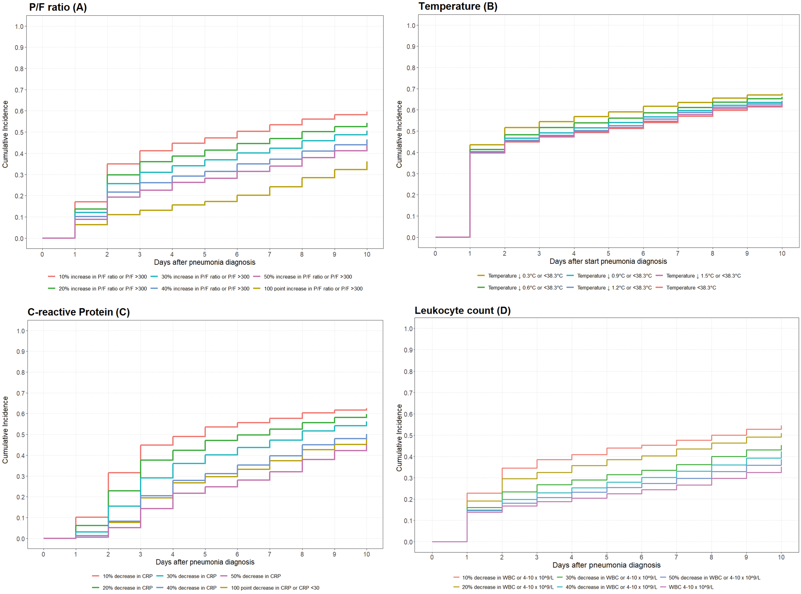

e-Figure 1. Cumulative incidence of clinical cure at different cut-off levels for: (A) P/F ratio,
(B) Temperature (C) C-reactive protein and (D) Leukocyte count. WBC = White blood cell count (MARS).
Table S1. Validation of HAP/VAP treatment outcome criteria in derivation cohort (MARS) including only first episode of nosocomial pneumonia per ICU admission
 | Treatment response  (day 3) |  |  |  | Treatment outcome  (day 10)
 |  | Early Responders  (n = 370) | Early non-responders  (n = 894) | p-values | Treatment success  (n = 907) | Treatment failure  (n = 238) | p-values
Predictive validity
Death in ICU |  | 15/357 (4.2%) | 81/720 (11.3%) | <0.01 | 49/876 (5.6%) | 47/201 (23.4%) | <0.01
90-day mortality ª |  | 71/359 (19.8%) | 179/740 (24.2%) | 0.17 | 183/890 (20.6%) | 67/209 (32.1%) | <0.01
1-year mortality ª |  | 105/359 (29.2%) | 253/740 (34.2%) | 0.17 | 268/890 (30.1%) | 90/209 (43.1%) | <0.01
Readmission to the ICU ^{b} |  | 25/340 (7.4%) | 52/620 (8.4%) | 0.66 | 60/823 (7.3%) | 17/137 (12.4%) | 0.07
Length of ICU stay (days) ^{a,c} |  | 20 (13-32) | 22 (15-34) | 0.40 | 18 (12-28) | 29 (20-42) | <0.01
Duration of mechanical ventilation (days) ^{a,d} |  | 20 (12-34) | 24 (16-39) | 0.02 | 21 (14-36) | 27 (19-40) | <0.01
Criterion validity
PHOENYCS subphenotype 2 ^{e} |  | 209/369 (56.6%) | 281/776 (63.8%) | 0.05 | 543/907 (59.9%) | 161/238 (67.6%) | <0.01
CPIS score at diagnosis |  | 5 (4-6) | 5 (4-7) | 0.05 | 5 (4-7) | 5 (4-7) | 0.25
CPIS score on day 3 |  | 4 (3-5) | 5 (3-6) | <0.01 | 4 (3-5) | 5 (4-6) | <0.01
Antibiotic use for any infection at day 10 ^{c,f} |  | 31/80 (38.8%) | 246/518 (47.5%) | 0.23 | 134/360 (37.2%) | 143/238 (60.1%) | <0.01
Continued antibiotic use for pneumonia beyond day 10 ^{c,g} |  | 11/80 (13.8%) | 99/518 (19.1%) | 0.38 | 56/360 (15.6%) | 54/238 (22.7%) | 0.05
Antibiotic switch within 3 days ^{g} |  | 49/370 (13.2%) | 187/894 (20.9%) | <0.01 | 160/907 (17.6%) | 47/238 (19.7%) | 0.51
Empirical switch within 3 days ^{h} |  | 25/370 (6.8%) | 103/894 (11.5%) | 0.04 | 80/907 (8.8%) | 290/238 (12.2%) | 0.04
Data are presented as n (%) or median (interquartile range). Reported p-values are FDR-corrected (Benjamini-Hochberg).
ª Calculated from the date of pneumonia onset (start of antibiotics)
^{b} Within the same hospital stay among patients discharged from the ICU alive and not transferred to another hospital
^{c} Among patients still admitted to the index ICU at day 10
^{d} Among patients still mechanically ventilated in the index ICU at day 10
^{e} PHOENYCS subphenotype 2 is characterized by increased age, higher ICU admission severity scores, lower body temperature, higher rates of abnormal leukocyte count, more septic shock, lower PaO2/FiO2 ratio at the time of HAP onset and more Pseudomonas aeruginosa as causative organism [21]. Patients not meeting criteria for subphenotype 2 were classified as subphenotype 1
^{f} Empirical or targeted antibiotics (excluding prophylaxis)
^{g} Any modification of the antibiotic regimen for pneumonia, including adjustment to targeted therapy after identification of a (resistant) causative pathogen
^{h} Modification of the initial empirical regimen to an alternative empirical antibiotic regimen for pneumonia (due to clinical deterioration)

